Kia ora,

We would like to inform you about a proposed change in your neighbourhood.

Proposal:

Reference | - TR71-26 Moana Road, Kelburn – No Stopping At All Times
Location – where we propose to make the change | Moana Road, Kelburn between no.17 and no.29
What we’d like to do | - Install No Stopping At All Times (Broken Yellow Lines)
Why we are proposing the change | - Council has received concerns from the public regarding vehicles parking in a manner that obstructs access for buses and emergency service vehicles.  - Council officers inspected Moana Road and determined that much of the access issue is attributable to poor parking behaviour rather than the road layout itself. However, officers identified that the section of road between No. 17 and No. 29 is of insufficient width to safely accommodate parking on both sides while maintaining adequate access for passing vehicles in particular buses and emergency service vehicles.  - Council's standard practice is to restrict parking to one side of the road where the carriageway width is less than 6.9 metres. Much of this section of Moana Road is significantly narrower than this minimum requirement, making parking on both sides unsuitable for the road function to maintain accessibility.  - Council contacted Metlink, which advised that its bus drivers have experienced ongoing difficulties navigating Moana Road.  - To mitigate the ongoing obstruction issues, officers are proposing a stretch of broken yellow lines as per the attached plan.
Impact | Improvements  - Improves safety and accessibility for waste service vehicles  - Improves safety and accessibility for emergency vehicles  - Improves bus service  - Improves driver forward visibility  Net Parking Impact  - Removal of 13 unrestricted parking spaces that obstruct accessibility.  Pedestrian impact  - No Change
Other options considered | Option 1:  - Moana Road has been assessed along its full length, and officers have determined that the primary accessibility issues are generally related to parking behaviour rather than the road layout itself. However, within the section of Moana Road addressed in this report, these issues are exacerbated by a particularly narrow section of roadway that cannot safely accommodate parking on both sides of the street. Other options along Moana Road were considered such as installing L-bar adjacent to driveways but will not prevent vehicles parking on both sides of the road to maintain accessibility.
How this relates to the parking policy | - Support safe movement – facilitate the safe and efficient movement of people and goods by focusing on people moving along transport corridors rather than people parking or storing stationary vehicles.
Additional Information | - Average daily traffic count – 415  - An electronic copy of the report will be available on the Council’s website from 9.00am 10 August 2026 at https://www.letstalk.wellington.govt.nz/
Privacy | - Your privacy is important to us. Please DO NOT add specific personal details to your feedback (i.e.: full name, address, etc)  - What we do with your personal information:  All submissions (including your first name, but not contact details) are provided in their entirety to elected members and made available to the public on our website and at our office. Personal information (including contact details) will also be used for the administration of the consultation process including informing you of the outcome of the consultation. All information collected will be held by Wellington City Council, with submitters having the right to access and correct personal information.  - For more information regarding our Privacy Statement please check our webpage: Privacy statement - Wellington City Council.
Feedback | - If you would like to provide us with specific feedback, which will be added to the Traffic Resolution following consultation and made public in full, you can do so by filling out an online submission form, downloading a printable submission form on https://www.letstalk.wellington.govt.nz/ or emailing us at trfeedback@wcc.govt.nz.  Please note if you are giving feedback the consultation period opens at 9.00 am 10 August 2026 and finishes at 5.00 pm 24 August 2026.
Next Steps | - Feedback collated by 25 August 2026.  - The proposal will go to the Te Takere|Regulatory Processes Committee meeting on 7 October 2026.  - If approved, the proposal will be installed within the following six months.

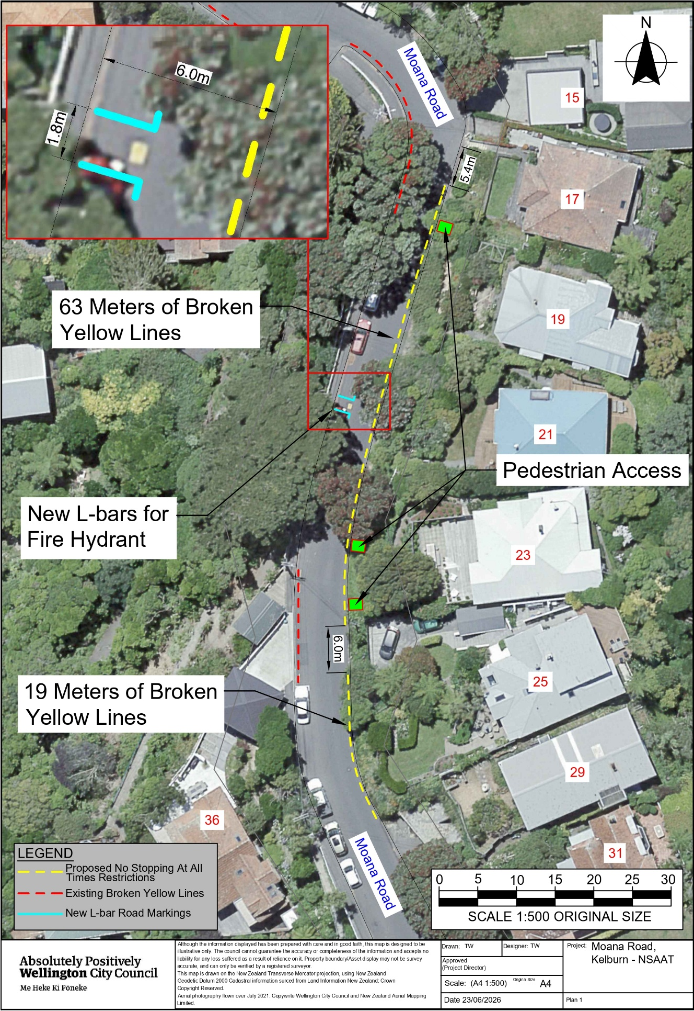
Traffic Resolution Plan: TR71-26 Moana Road, Kelburn – No Stopping At All Times

Legal Description:

Delete from Schedule D (No Stopping) of the Traffic Restrictions Schedule

Column One | Column Two | Column Three
Moana Road | No Stopping At All Times | West side, commencing 251 metres west of its intersection with Disley Street and extending in a northerly direction following the western kerbline for 15.5 metres.

Add to Schedule D (No stopping) of the Traffic Restrictions Schedule

Column One | Column Two | Column Three
Moana Road | No Stopping At All Times | West side, commencing 152 metres from its intersection with Raroa Crescent (Grid coordinates x= 1,746,993.05m, y=5,427,866.08m) and extending in an southerly direction following the western kerb line for 25 metres.
Moana Road | No Stopping At All Times | West side, commencing 224 metres from its intersection with Raroa Crescent (Grid coordinates x= 1,746,993.05m, y=5,427,866.08m) and extending in an southerly direction following the western kerb line for 15 metres.
Moana Road | No Stopping At All Times | East side, commencing 161 metres from its intersection with Raroa Crescent (Grid coordinates x= 1,747,008.61m, y=5,427,849.96m) and extending in an southerly direction following the eastern kerb line for 63 metres.
Moana Road | No Stopping At All Times | East side, commencing 226 metres from its intersection with Raroa Crescent (Grid coordinates x= 1,747,008.61m, y=5,427,849.96m) and extending in an southerly direction following the eastern kerb line for 19 metres.

Prepared By: | Tommy Wilson | (Transport Engineering Assistant)
Approved By: | Kate Gourdie | (Team Leader Traffic & Resolutions)
Approved Date: | 8/07/2026

