Kia ora,

We would like to inform you about a proposed change in your neighbourhood.

Proposal:

Reference | - TR54-26 The Parade, Island Bay – P60 Time Limited Parking
Location – where we propose to make the change | The Parade, Island Bay between No.150 and No.154
What we’d like to do | - Remove the existing broken yellow lines and install an additional four P60 parking spaces.
Why we are proposing the change | - A recent development at No. 152 The Parade removed several vehicle crossings and installed additional road separators for the existing Cycleway.  - With this change allows Council to install more parking due to this location no longer obstructing vehicle access.  - An additional four P60 parking spaces will be returned at this location increasing parking availability.  - The changes have already been implemented on the street to allow further parking; the proposed traffic resolution is to formalise these changes.
Impact | Improvements  - Improves parking availability  Net Parking Impact  - Increase of four P60 time limited parking spaces  Pedestrian impact  - No Change
Other options considered | Option 1:  - No other option was considered as this aligns with the current layout of the street which was implemented by the consultants after the recent building developments in the area. The P60 restriction also aligns with the other restrictions in the area due to the proximity to the Island Bay shopping centre.
How this relates to the parking policy | - Support city place-making, amenity and safety – ensure on-street parking design and placement supports overall city amenity, safety, community building, heritage, creative arts, good urban design outcomes and attractive streetscapes.
Additional Information | - Average daily traffic count – 6,101  - An electronic copy of the report will be available on the Council’s website from 9.00am 10 June 2026 at https://www.letstalk.wellington.govt.nz/
Privacy | - Your privacy is important to us. Please DO NOT add specific personal details to your feedback (i.e.: full name, address, etc)  - What we do with your personal information:  All submissions (including your first name, but not contact details) are provided in their entirety to elected members and made available to the public on our website and at our office. Personal information (including contact details) will also be used for the administration of the consultation process including informing you of the outcome of the consultation. All information collected will be held by Wellington City Council, with submitters having the right to access and correct personal information.  - For more information regarding our Privacy Statement please check our webpage: Privacy statement - Wellington City Council.
Feedback | - If you would like to provide us with specific feedback, which will be added to the Traffic Resolution following consultation and made public in full, you can do so by filling out an online submission form, downloading a printable submission form on https://www.letstalk.wellington.govt.nz/ or emailing us at trfeedback@wcc.govt.nz.  Please note if you are giving feedback the consultation period opens at 9.00 am 10 June 2026 and finishes at 5.00 pm 24 June 2026.
Next Steps | - Feedback collated by 25 June 2026.  - The proposal will go to the Te Takere|Regulatory Processes Committee meeting on 5 August 2026.  - If approved, the proposal will be installed within the following six months.

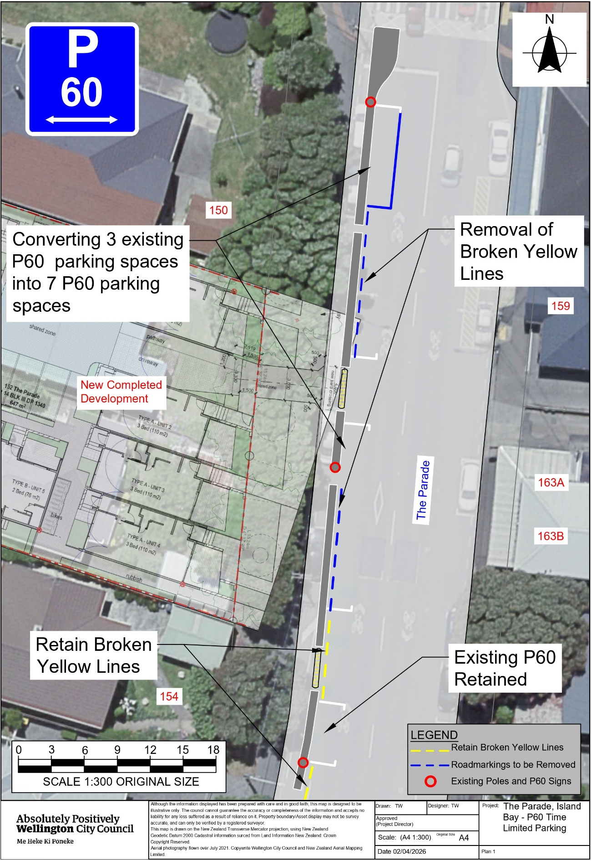
Traffic Resolution Plan: TR54-26 The Parade, Island Bay – P60 Time Limited Parking
Legal Description:

Delete From Schedule D (No Stopping) of the Traffic Restrictions Schedule

Column One | Column Two | Column Three
The Parade | No stopping, at all times | West side, commencing at its intersection with Medway Street (Grid Coordinates X = 1748385.417m, Y = 5422550.92m and extending in a southerly direction following the western kerbline for 42 metres.
The Parade | No stopping, at all times | West side, commencing 49.5 metres south of its intersection with Medway Street (Grid Coordinates X = 1748385.417m, Y = 5422550.92m and extending in a southerly direction following the western kerbline for 23.5 metres.

Delete From Schedule A (Time Limited) of the Traffic Restrictions Schedule

Column One | Column Two | Column Three
The Parade | P60, Monday to Sunday, 8:00am - 6:00pm | West side, commencing 42 metres south of its intersection with Medway Street (Grid Coordinates X = 1748385.417m, Y = 5422550.92m and extending in a southerly direction following the western kerbline for 7.3 metres.

Add to Schedule D (No Stopping) of the Traffic Restrictions Schedule

Column One | Column Two | Column Three
The Parade | No stopping, at all times | West side, commencing 62.5 metres south of its intersection with Medway Street (Grid coordinates X= 1,748,381.61m Y= 5,422,548.94m) and extending in a southerly direction following the western kerb line for 7 metres

Add to Schedule A (Time Limited) of the Traffic Restrictions Schedule

Column One | Column Two | Column Three
The Parade | P60, Monday to Sunday, 8:00am - 6:00pm | West side, commencing 15.5 metres south of its intersection with Medway Street (Grid coordinates X= 1,748,381.61m Y= 5,422,548.94m) and extending in a southerly direction following the western kerb line for 24 metres
The Parade | P60, Monday to Sunday, 8:00am - 6:00pm | West side, commencing 44.5 metres south of its intersection with Medway Street (Grid coordinates X= 1,748,381.61m Y= 5,422,548.94m) and extending in a southerly direction following the western kerb line for 18 metres

Prepared By: | Tommy Wilson | (Transport Engineering Assistant)
Approved By: | Kate Gourdie | (Team Leader Traffic & Resolutions)
Approved Date: | 19/05/2026

