Kia ora,

We would like to inform you about a proposed change in your neighbourhood.

Proposal:
Reference | - TR30-25 Murphy Street, Thorndon – No Stopping At All Times
Location – where we propose to make the change | Murphy Street, Thorndon – outside no. 24
What we’d like to do | - Install 28 metres of No Stopping At All Times
Why we are proposing the change | - The Council has received safety concerns from nearby institutions and regular commuters, highlighting that poor compliance with the clearway restriction in this parking space is leading to congestion and delays during peak hours.  - Additionally, a safety audit of the area has raised that the number of accessways and complex traffic flows in this area, even during off-peak hours, represents a safety risk. As such, Council Officers are proposing to remove this parking space and install broken yellow lines.
Impact | Improvements  - Improves safety and accessibility for vehicles  Net Parking Impact  - Removing one P120 Clearway Metered Parking space  Pedestrian Impact  - No change
Other options considered | Option 1:  - Retain the existing clearway parking and increase signage and enforcement. However, this option is not preferred, as the location is already adequately signed, and additional enforcement would divert important resources from other key areas.
How this relates to the parking policy | - Support shift in type of transport used – facilitate a shift to using active (e.g., walking and cycling) and public transport through parking management and pricing, to move more people driving fewer vehicles.  - Support safe movement – facilitate the safe and efficient movement of people and goods by focusing on people moving along transport corridors rather than people parking or storing stationary vehicles.  - Support move to becoming an eco-city – facilitate the uptake of car sharing, electric vehicles and other transport with low carbon emissions. Manage parking and incentivise a decrease in vehicle use to contribute to a reduced carbon 12 Parking Policy August 2020 emissions, better water quality, air quality, stormwater management and biodiversity outcomes
Additional Information | - Average daily traffic count – 8,309  - Annual parking revenue impact – $5,219 revenue loss (removal of one metered parking space).  - To view the legal description for this Traffic Resolution, an electronic copy of the report will be available on the Council’s website from 9.00am Friday 21 March 2025 at https://www.letstalk.wellington.govt.nz/ or you can call (04) 499 4444 and we will send one out to you.
Privacy | - Your privacy is important to us. Please DO NOT add specific personal details to your feedback (i.e.: full name, address, etc)  - What we do with your personal information:  All submissions (including your first name, but not contact details) are provided in their entirety to elected members and made available to the public on our website and at our office. Personal information (including contact details) will also be used for the administration of the consultation process including informing you of the outcome of the consultation. All information collected will be held by Wellington City Council, 113 The Terrace, Wellington, with submitters having the right to access and correct personal information.  - For more information regarding our Privacy Statement please check our webpage: Privacy statement - Wellington City Council.
Feedback | - If you would like to provide us with specific feedback, which will be added to the Traffic Resolution following consultation and made public in full, you can do so by filling out an online submission form, downloading a printable submission form on https://www.letstalk.wellington.govt.nz/ or emailing us at trfeedback@wcc.govt.nz.  Please note if you are giving feedback the consultation period opens at 9.00am Friday 21 March 2025 and finishes at 5.00pm Friday 4 April 2025.
Next Steps | - Feedback collated by Monday 7 April 2025.  - The proposal will go to the Koata Hātepe|Regulatory Processes Committee meeting on Thursday 15 May 2025.  - If approved, the proposal will be installed within the following three months.

Traffic Resolution Plan: TR30-25 Murphy Street, Thorndon – No Stopping At All Times

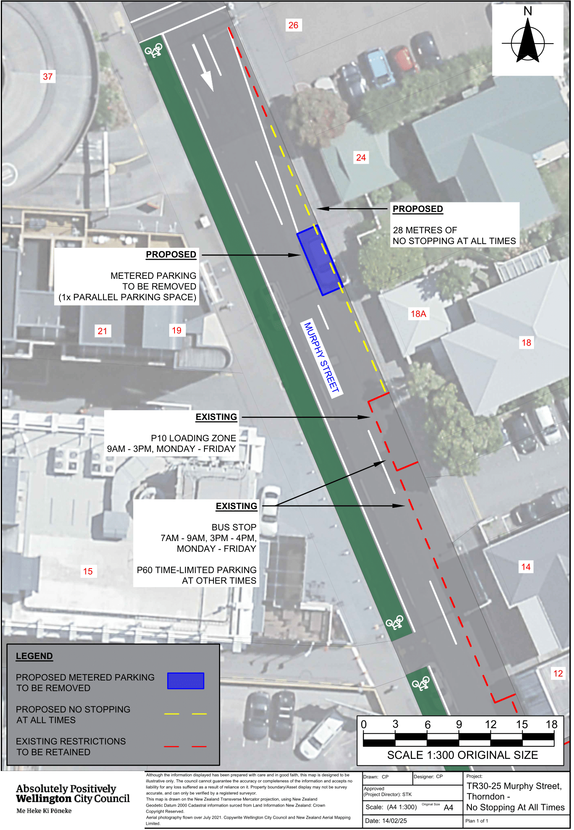

Legal Description:

Legal Descriptions

Delete from Schedule D (No Stopping) of the Traffic Restrictions Schedule

Column One | Column Two | Column Three
Murphy Street | P120 Maximum, Monday to Friday 9:00am - 6:00pm, Saturday 8:00am - 6:00pm | East side, commencing 61.5 metres south of its intersection with Turnbull Street (Grid Coordinates X=2659023.198672 m, Y=5990993.606174 m) and extending in a southerly direction following the kerbline for 6 metres. (1 parallel carpark)

Add to Schedule D (No Stopping) of the Traffic Restrictions Schedule

Column One | Column Two | Column Three
Murphy Street | No Stopping at All Times | East side, commencing 55.62 metres south of its intersection with Turnbull Street (Grid Coordinates X=2659023.198672 m, Y=5990993.606174 m) and extending in a southerly direction following the kerbline for 28 metres.

Prepared By: | Jacob Wahry | (Project Lead)
Approved By: | Kate Gourdie | (Team Leader Traffic & Resolutions)
Approved Date: | 26/02/2025

