Kia ora,

This leaflet is to let you know about a change we are proposing to make in your neighbourhood.

Proposal:

Reference | - TR116-25 Broderick Road, Johnsonville – P60 Time Limited Parking
Location – where we propose to make the change | Broderick Road, Johnsonville – outside no. 3
What we’d like to do | - Convert one P5 Time Limited Parking space to P60 Time Limited Parking space
Why we are proposing the change | - Council officers have received a request from an elected member regarding the P5 time limited parking space outside no. 3 Broderick Road.  - In 2010, under TR63-10, this space was converted from a P60 time limited parking space to a P5 time limited parking space, to increase the flow of short-term parking available outside the Johnsonville Library for pick-up and drop-off of library materials.  - Johnsonville Library | Waitohi has since relocated to 34 Moorefield Road, and the council public toilets previously operating at this location are now closed, having been replaced by the public toilets near Waitohi at 11 Frankmoore Avenue. As a result, the shorter time limit of the P5 parking space is no longer required for library pick-ups and drop-offs, nor for those using the former public toilet facilities.  - Council officers therefore propose to convert the P5 time limited parking space outside no. 3 Broderick Road to a P60 time limited parking space. This is compatible with other parking restrictions in this location, as the remaining parking spaces on this section of Broderick Road also have a P60 time restriction.  - This change will be beneficial to local businesses as it will allow individuals more time to park and shop, whilst still being a short enough to encourage parking turnover.
Impact | Improvements  - Improves viability of business wellbeing.  Net Parking Impact  - Converting one P5 Time Limited Parking to P60 Time Limited Parking.  Pedestrian impact  - No change.
Other options considered | - Option 1: Convert the P5 Parking Space into a P15 Parking Space  This option is not preferred as many nearby businesses have a higher turnaround time than 15 minutes, making it impractical for those requiring a longer staying time. There are also both P5 and P10 spots available on Johnsonville Road on either side of its intersection with Broderick Road, so a quick turnaround time for pick up/drop off for nearby businesses such as takeaway shops is still available.  - Option 2: Convert the P5 Parking Space to Unrestricted Parking  This option is not preferred as it does not facilitate parking turnover for local businesses, and it is inconsistent with the other parking restrictions on Broderick Road. Additionally, there are options for longer term parking available nearby.
How this relates to the parking policy | - Support business wellbeing – ensure parking management and pricing controls support economic activity in the central city, suburban centres and mobile trades and services.  - Support city place-making, amenity and safety – ensure on-street parking design and placement supports overall city amenity, safety, community building, heritage, creative arts, good urban design outcomes and attractive streetscapes.
Additional Information | - Average daily traffic count - 9,629 (2025 count)  - Annual parking revenue impact – N/A  - To view the legal description for this Traffic Resolution, an electronic copy of the report will be available on the Council’s website from 9.00am Friday the 11 July 2025 at https://www.letstalk.wellington.govt.nz/
Privacy | - Your privacy is important to us. Please DO NOT add specific personal details to your feedback (i.e.: full name, address, etc)  - What we do with your personal information:  All submissions (including your first name, but not contact details) are provided in their entirety to elected members and made available to the public on our website and at our office. Personal information (including contact details) will also be used for the administration of the consultation process including informing you of the outcome of the consultation. All information collected will be held by Wellington City Council, 113 The Terrace, Wellington, with submitters having the right to access and correct personal information.  - For more information regarding our Privacy Statement please check our webpage: Privacy statement - Wellington City Council.
Feedback | - If you would like to provide us with specific feedback, which will be added to the Traffic Resolution following consultation and made public in full, you can do so by filling out an online submission form, downloading a printable submission form on https://www.letstalk.wellington.govt.nz/ or emailing us at trfeedback@wcc.govt.nz.  Please note if you are giving feedback the consultation period opens at 9.00 am Friday the 11 July 2025 and finishes at 5.00 pm Friday the 25 July 2025.
Next Steps | - Feedback collated by Monday the 28 July 2025.  - The proposal will go to the Koata Hātepe|Regulatory Processes Committee meeting on Thursday the 28 August 2025.  - If approved, the proposal will be installed within the following six months.

Traffic Resolution Plan: TR116-25 Broderick Road, Johnsonville – P60 Time Limited Parking

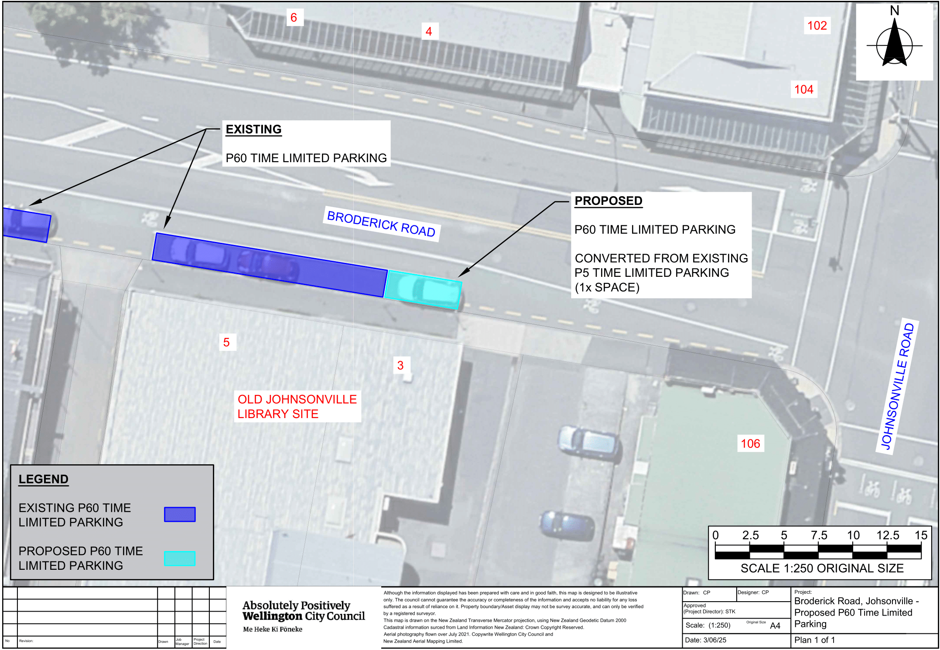

Legal Description:

Delete from Schedule A (Time Limited) of the Traffic Restrictions Schedule

Column One | Column Two | Column Three
Broderick Road | P5,  Monday to Saturday, 8:00am – 6:00pm | South side, commencing 29.5 metres west of its intersection with Johnsonville Road (Grid Coordinates x= 1751475.6 m, y= 5434711.8 m), and extending in a westerly direction following the southern kerbline for 5 metres.
Broderick Road | P60,  Monday to Saturday, 8:00am – 6:00pm | South side, commencing 34.5 metres west of its intersection with Johnsonville Road (Grid Coordinates x= 1751475.6 m, y= 5434711.8 m), and extending in a westerly direction following the southern kerbline for 17 metres.

Add to Schedule A (Time Limited) of the Traffic Restrictions Schedule

Column One | Column Two | Column Three
Broderick Road | P60,  Monday to Sunday, 8:00am – 6:00pm | South side, commencing 29.5 metres west of its intersection with Johnsonville Road, and extending in a westerly direction following the southern kerbline for 22 metres (4 parking spaces).

Prepared By: | Charlotte Poi | (Transport Engineer Assistant)
Approved By: | Kate Gourdie | (Team Leader Traffic & Resolutions)
Approved Date: | 19/06/2025

