We are proposing a change in your area

Kia ora,

This leaflet is to let you know about a change we are proposing to make in your neighbourhood.

Proposal

Reference
TR22-24 Dixon Street, Te Aro – Proposed P20 Time-Limited Parking

Location – where we propose to make the change
Dixon Street, outside no.64

What we’d like to do
Convert one Metred Parking to P20 Time-Limited Parking, 8am – 6pm Mon – Sun outside no.64

Why we are proposing the change
Wellington City Council (WCC) have received a request from a local business to assist their patients to access their services. Many of their patients have restricted mobility and are unable to find available parking spaces close to the business.
WCC proposes to convert one Metered Parking to one P20 Time-Limited Parking during business hours. These changes will encourage parking turnover and cater for people to access nearby businesses along Dixon Street.

Impact
- Improves accessibility for people with restricted mobility and support business activities in the vicinity.
- Convert one metred park into one P20 time limited park

How this relates to the parking policy
Support safe movement – facilitate the safe and efficient movement of people and goods by focusing on people moving along transport corridors rather than people parking or storing stationary vehicles.
Support business wellbeing – ensure parking management and pricing controls support economic activity in the central city, suburban centres and mobile trades and services.

Additional information
Average daily traffic count – 5538
Annual parking revenue impact – $14,730 revenue loss
To view the legal description for this Traffic Resolution, an electronic copy of the report will be available on the Council’s Let’s Talk engagement website from 9.00am Wednesday 6 December 2023 at https://www.letstalk.wellington.govt.nz/ or you can call (04) 499 4444 and we will send one out to you.

Privacy
Your privacy is important to us. Please DO NOT add specific personal details to your feedback (i.e.: full name, address, etc)

What we do with your personal information:
All submissions (including your first name, but not contact details) are provided in their entirety to elected members and made available to the public on our website and at our office. Personal information (including contact details) will also be used for the administration of the consultation process including informing you of the outcome of the consultation. All information collected will be held by Wellington City Council, 113 The Terrace, Wellington, with submitters having the right to access and correct personal information.
For more information regarding our Privacy Statement please check our webpage: Privacy statement – Wellington City Council.

Feedback
If you would like to provide us with specific feedback, which will be added to the Traffic Resolution following consultation and made public in full, you can do so by filling out an online submission form, downloading a printable submission form on https://www.letstalk.wellington.govt.nz/ or emailing us at trfeedback@wcc.govt.nz.
Please note if you are giving feedback the consultation period opens at 9.00 am Wednesday 6 December 2023 and finishes at 5.00 pm Monday 15 January 2024.

Next steps
Feedback collated by Tuesday 16 January 2024.
2The proposal will go to the Koata Hātepe Regulatory Processes Committee meeting on Thursday 22 February 2024.
If approved, the proposal will be installed within the following three months.

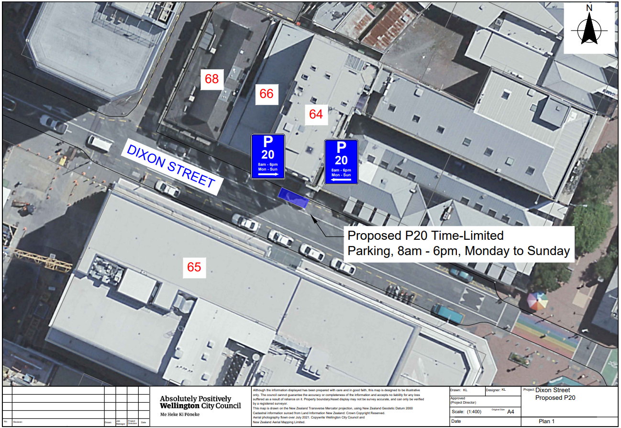

Legal description

Delete from Schedule F (Metered Parking) of the Traffic Restrictions Schedule

Column One
Dixon Street

Column Two
P120 Maximum, Monday to Thursday 8:00am – 6:00pm, Friday 8:00am – 8:00pm, Saturday and Sunday 8:00am – 6:00pm

Column Three
North side, commencing 243.7 metres north-west of its intersection with Taranaki Street (Grid coordinates, x= 1748935.0 m, y= 5427254.7 m), and extending in a north-westerly direction following the northern kerb line for 5.5 metres (1 parallel parking space).

Add to Schedule A (Time Limited) of the Traffic Restrictions Schedule

Column One
Dixon Street

Column Two
P20, 8:00am – 6:00pm Monday to Sunday

Column Three
North side, commencing 231 metres north-west of its intersection with Taranaki Street (Grid coordinates, x= 1748935.0 m, y= 5427254.7 m), and extending in a westerly direction following the northern kerb line for 6 metres.

Legal description
- Prepared by Keren Love (Transport Engineering Assistant)
- Approved by Soon Teck Kong (Engineering and Operations Manager)
- Date prepared: 21/11/2023

