Kia ora,

We would like to inform you about a proposed change in your neighbourhood.

Proposal:

Reference | - TR08-26 Aotea Quay, Pipitea – Proposed Speed Limit Change
Location – where we propose to make the change | Aotea Quay, Pipitea
What we’d like to do | - This letter is seeking feedback on changing the permanent speed limit on Aotea Quay from 70km/h to 50km/h.  - Since the installation of the roundabout on Aotea Quay, the current applicable speed limit on Aotea Quay is a temporary speed limit of 50km/h.  - The permanent speed limit in the National Speed Limit Register (NSLR) is 70km/h.  - We propose to change the permanent speed limit on Aotea Quay within the NSLR to 50km/h to ensure safe speeds around the new roundabout.
Why we are proposing the change | - In June 2024, Wellington City Council (WCC) consulted on changing the speed limit on Aotea Quay from 70km/h to 50km/h (TR86-24). This consultation was prompted by the newly completed Aotea Quay roundabout at its intersection with the KiwiRail Container Terminal (CT) yard. Due to the site constraints, the diameter of this roundabout was designed for a 50km/h operating speed. The design was approved by the Pūroro Waihanga | Infrastructure Committee on 24 August 2022.  - TR86-24 did not receive any public feedback and was approved by the Koata Hātepe | Regulatory Processes Committee on 8 August 2024.  - This speed limit change was not submitted the NSLR (National Speed Limit Register) before the new Land Transport Rule: Setting of Speed Limits 2024 (the Rule) was signed by the Minister of Transport on 28 September 2024. Therefore, the permanent speed limit of 50km/h cannot be legally changed and enforced.  - The new Rule gives effect to the mandatory requirements for changing any speed limits- which includes a six-week consultation period. We are reconsulting in order to meet these new mandatory requirements and gather further feedback.  - The speed limit change is being proposed to bring the speed limit down to the operating and design speed of the new roundabout, which acts as a speed calming device. If we were to retain the speed limit at 70km/h, the roundabout would need to be rebuilt to enable the roundabout to safely operate with this speed limit.
Supporting Documents | - As per clause 2.6(2)(iv) of the Rule, to change a speed limit under the alternative method, the Territorial Authority must:  (iv) have recently consulted on the proposed speed limit in accordance with clause 3.8 and included in the consultation documentation the cost benefit disclosure statement and an explanation of how the road safety aspects of the GPS have been had regard to;  - The cost benefit disclosure statement and the statement of how we have had regard to the road safety aspects in the Government Policy Statement on Land Transport (GPS) can be found on https://www.letstalk.wellington.govt.nz/.
Impact | - Strategic Drivers: Improves safety for all vehicles and accessibility to freight  - Net parking impact: No change  - Pedestrian impact: No change to the existing pedestrian facilities
Other options considered | - Option 1: Retain speed limit as 70km/h - This option is not preferred as the roundabout was constructed for a design speed of 50km/h, so retaining the speed limit at 70km/h would be unsafe for the travelling public including freight movements. To retain the 70km/h speed limit, the roundabout would need to be completely removed and reconstructed. Therefore, this option is not recommended by officers.
How this relates to the parking policy | - Support safe movement – facilitate the safe and efficient movement of people and goods by focusing on people moving along transport corridors rather than people parking or storing stationary vehicles.
Additional Information | - Role and function of the road – Aotea Quay is classified as an urban connector in the One Network Framework. The purpose of urban connectors is to provide efficient movement from A to B. There are low levels of interaction between the adjacent land use and the street – the road is used to move vehicles along them rather than accessing adjacent properties.  - How this road is used – The Annual Average Daily Traffic count is 29,087 vehicles per day, and the road has a relatively high Heavy Commercial Vehicle (HCV) percentage of 8 – 22%.  - The road is used by HCV accessing the ferry terminal, the CT yard, other freight companies and CentrePort.  - The road is also used by light private vehicles accessing Hutt Road, State Highway 1, the ferry terminal and the northern end of the CBD.  - An electronic copy of the report will be available on the Council’s website from 9.00am Tuesday 28 October 2025 at https://www.letstalk.wellington.govt.nz/
Privacy | - Your privacy is important to us. Please DO NOT add specific personal details to your feedback (i.e.: full name, address, etc)  - What we do with your personal information:  All submissions (including your first name, but not contact details) are provided in their entirety to elected members and made available to the public on our website and at our office. Personal information (including contact details) will also be used for the administration of the consultation process including informing you of the outcome of the consultation. All information collected will be held by Wellington City Council, 113 The Terrace, Wellington, with submitters having the right to access and correct personal information.  - For more information regarding our Privacy Statement please check our webpage: Privacy statement - Wellington City Council.
Feedback | - If you would like to provide us with specific feedback, which will be added to the Traffic Resolution following consultation and made public in full, you can do so by filling out an online submission form, downloading a printable submission form on https://www.letstalk.wellington.govt.nz/ or emailing us at trfeedback@wcc.govt.nz.  Please note if you are giving feedback the consultation period opens at 9.00am 28 October 2025 and finishes at 5.00pm 9 December 2025.
Next Steps | - Feedback collated by 10 December 2025.  - The proposal will go to the first available Koata Hātepe|Regulatory Processes Committee or relevant Council Committee meeting in 2026.  - If approved, the proposal will be added into the NSLR within the following two months.

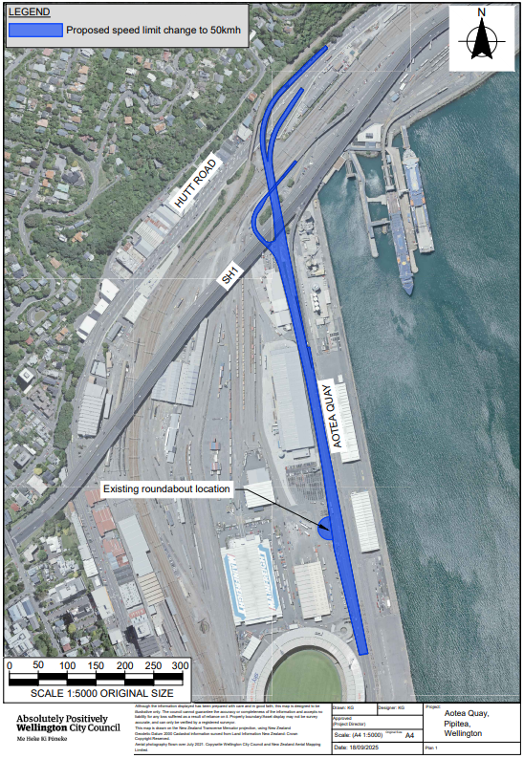
Traffic Resolution Plan: TR08-26 Aotea Quay, Pipitea – Proposed Speed Limit Change

Legal Description:

Table 1: Proposed speed limits for road sections on Aotea Quay.

Carriageway Section | Proposed speed limit | Description
Aotea Quay | 50km/h | Commencing 139 metres north of its intersection with Waterloo Quay (Grid coordinates X=  1,749,672.94m Y=5,429,336.91m) and extending in a northerly direction for 1,100 metres, including the roundabout to its intersection with the northbound lane of Hutt Road.
Aotea Quay South | 50km/h | Commencing at its intersection with Hutt Road (Grid coordinates X= 1,749,568.71m, Y= 5,430,445.82m) in a southerly direction for 440 metres.
Aotea Quay-South-Slip | 50km/h | Commencing at its intersection with Aotea Quay South (Grid coordinates X=1,749,537.87, Y=5,430,215.37) following the slip lane in a south-westerly direction for 53 metres.
Aotea Quay - Slip | 50km/h | Commencing at its intersection with Aotea Quay On Ramp State Highway 1 (Grid coordinates X=1,749,572.64 m Y= 5,430,336.50 m) in a south-westerly direction for 236 metres.
State Highway 1 off-ramp to Aotea Quay | 50km/h | Commencing at its boundary in the NSLR with State Highway 1 (Grid coordinates X=1,749,578.10, Y = 5,430,029.23) in a southerly direction for 102 metres.

Prepared By: | Kaylie Gleeson | (Intermediate Transport Engineer)
Approved By: | Kate Gourdie | (Team Leader Traffic & Resolutions)
Approved Date: | 10/10/2025

