Kia ora,

We would like to inform you about a proposed change in your neighbourhood.

Proposal:

Reference | - TR130-24 Sutherland Road, Lyall Bay - No Stopping At All Times
Location – where we propose to make the change | Sutherland Road – No.167 Extension (Ext), Lyall Bay – outside Nos. 167 to 185
What we’d like to do | - Install No Stopping At All Times (Broken Yellow Lines)
Why we are proposing the change | - Council have received accessibility concerns from residents and Council Parking Enforcement Officers about access for large vehicles, including rubbish trucks and emergency vehicles, to the Sutherland Road Extension, between nos. 167 and 185.  - The Sutherland Road Extension is 4.6m or narrower on the straight sections, which is too narrow to allow parking on one side of the road while still enabling access for larger vehicles.  - Following consultation and feedback from residents on a previously proposed traffic resolution (TR84-24), officers are proposing to retain one existing carpark at the top of the Sutherland Road extension, outside no. 169.  - To improve accessibility and safety by enabling larger vehicles to travel almost to the end of the street, officers are proposing to install No Stopping At All Times (broken yellow lines) along the Sutherland Road extension between property nos. 167 and 185, retaining one existing marked parking space outside no. 169, as per the attached plan.
Impact | Improvements  - Improves safety and accessibility for large vehicles, especially emergency vehicles such as ambulances  - Improves safer turning movements  Net Parking Impact  - Removal of seven unrestricted parking spaces  Pedestrian impact  - No Change
Other options considered | Option 1:  - Broken Yellow Lines entirely on both sides of the Sutherland Road extension. This option is not preferred as it would remove all on-street parking for residents.  Option 2:  - Broken Yellow Lines only around the bend of the Sutherland Road extension. This option is not preferred as the beginning straight section of Sutherland Road extension is still too narrow for access by larger vehicles and would not resolve the concerns raised.
How this relates to the parking policy | - Support safe movement – facilitate the safe and efficient movement of people and goods by focusing on people moving along transport corridors rather than people parking or storing stationary vehicles.
Additional Information | - Average daily traffic count – 110 (2023 Estimate. No counts available)  - To view the legal description for this Traffic Resolution, an electronic copy of the report will be available on the Council’s website from 9.00am Thursday 26 September at https://www.letstalk.wellington.govt.nz/ or you can call (04) 499 4444 and we will send one out to you.
Privacy | - Your privacy is important to us. Please DO NOT add specific personal details to your feedback (i.e.: full name, address, etc)  - What we do with your personal information:  All submissions (including your first name, but not contact details) are provided in their entirety to elected members and made available to the public on our website and at our office. Personal information (including contact details) will also be used for the administration of the consultation process including informing you of the outcome of the consultation. All information collected will be held by Wellington City Council, 113 The Terrace, Wellington, with submitters having the right to access and correct personal information.  - For more information regarding our Privacy Statement please check our webpage: Privacy statement - Wellington City Council.
Feedback | - If you would like to provide us with specific feedback, which will be added to the Traffic Resolution following consultation and made public in full, you can do so by filling out an online submission form, downloading a printable submission form on https://www.letstalk.wellington.govt.nz/ or emailing us at trfeedback@wcc.govt.nz.  Please note if you are giving feedback the consultation period opens at 9.00am Thursday 26 September and finishes at 5.00pm Thursday 10 October.
Next Steps | - Feedback collated by Friday 11 October.  - The proposal will go to the Koata Hātepe|Regulatory Processes Committee meeting on Thursday 14 November.  - If approved, the proposal will be installed within the following three months.

Traffic Resolution Plan: TR130-24 Sutherland Road, Lyall Bay - No Stopping At All Times

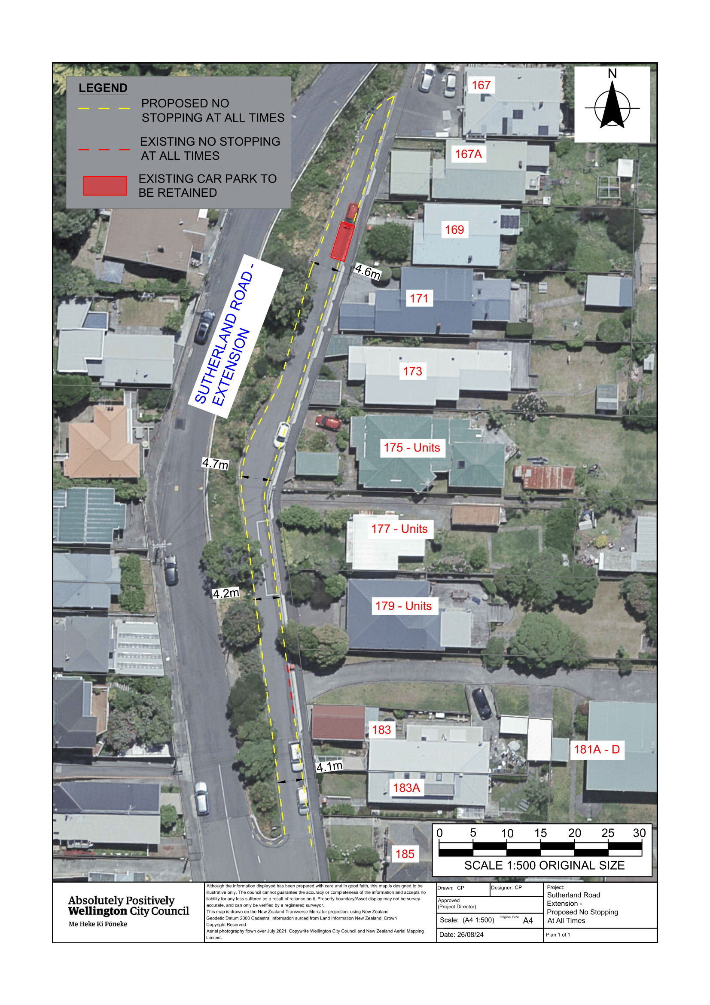

Legal Description:

Add to Schedule D (No Stopping) of the Traffic Restrictions Schedule

Column One | Column Two | Column Three
Sutherland Road - #167 Extension | No Stopping, At All Times | West side, commencing 7 metres south then east of its intersection with Sutherland Road (Grid coordinates X = 1,749,786.37m, Y = 5,423,127.79m) and extending in a northerly direction following the western kerb line for 115 metres, then extending in a southerly direction following the eastern kerb line for 19.5m.
Sutherland Road - #167 Extension | No Stopping, At All Times | East side, commencing 83.5 metres north-east of its intersection with Sutherland Road (Grid coordinates X = 1,749,786.37m, Y = 5,423,127.79m) and extending in a southerly direction following the northern kerb line for 61 metres.
Sutherland Road - #167 Extension | No Stopping, At All Times | East side, commencing 17.5 metres north-east of its intersection with Sutherland Road (Grid coordinates X = 1,749,786.37m, Y = 5,423,127.79m) and extending in a southerly direction following the northern kerb line for 20 metres.

Prepared By: | Charlotte Poi | (Transport Engineering Assistant)
Approved By: | Kate Gourdie | (Team Leader Traffic & Resolutions)
Approved Date: | 4/9/2024

