Kia Ora,

This leaflet is to let you know about the changes we are proposing to make in your neighbourhood.

Proposal

Reference | - TR 06-24 – Hutt Road from Aotea Quay overbridge to Jarden Mile intersection with Centennial Highway
What we’d like to do | Proposed changes:  - Changes to the existing road corridor layout, lane markings and class restricted movements from Aotea Quay Overbridge 9 (no.87 Hutt Road) to Jarden Mile intersection with Centennial Highway. This includes the following proposed changes:  - Install a Bus Lane on the eastern side of Centennial Highway between the hours of 6:30am to 9:30am Monday to Friday  - Install a Bus Stop on the eastern side of Centennial Highway  - Install a Bus Lane on the eastern side of Hutt Road between the hours of 6:30am to 9:30am Monday to Friday  - Install a Bus Lane on the western side of Hutt Road between the hours of 4:30pm to 6:30pm Monday to Friday  - Install an extended Bus Stop on the western side of Hutt Road next to #7 Jarden Mile  - Install No U-Turn restrictions along Hutt Road at Rangiora Avenue, intersection, prior to Onslow Road, at Onslow Road intersection and at Jarden Mile intersection.  - Install No Right Turn restriction on Rangiora Avenue at its intersection with Hutt Road  - Install P10 Loading Zone outside no.172 Hutt Road.  - Install a Bi-directional Cycle Path from Jarden Mile tying into the existing Cycle Lane outside the Caltex station on Hutt Road.  - Install signalised pedestrian crossing points at Rangiora Avenue and Jarden Mile intersection
Why we are proposing the change | - As part of Let’s Get Wellington Moving (LGWM) the Hutt Road project for Thorndon Quay and Hutt Road (TQHR project) is proposing to replace the existing traffic lane and road markings to implement an improved shared and safe travel corridor along Hutt Road and Centennial Highway.  - With growing numbers of people living and working in Wellington City and the Northern suburbs, more people are expected to travel along Thorndon Quay and Hutt Road. This forecast growth suggests the need to improve safety and travel conditions for people who move through and access the corridor.  - Hutt Road is a busy Arterial Road (AADT 18,000 ~ 30,000, HCV 14%). It is a two-way two-lane road with a raised median in the form of a narrow, kerbed (solid) island separated by wide flush (painted) median. The posted speed on Hutt Road is 50 km/h from the intersection of Thorndon Quay with Hutt Road through to the intersection of Aotea Quay Overbridge and Hutt Road and it is 60 km/h to the intersection of Onslow Road and Hutt Road. The posted speed limit is 80 km/h for the rest of the section to the Hutt Road and Jarden Mile intersection and along Centennial Highway. There are six major intersections along Hutt Road.  - There are approximately 10,000 bus passengers on an average day, using the corridor (two-way), making it the busiest corridor outside the Wellington City Centre.  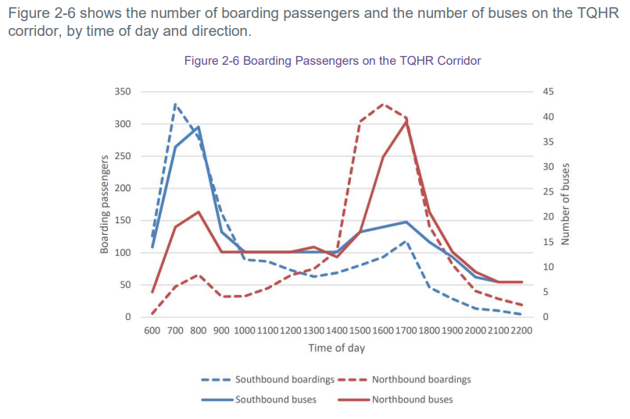  - The chart above shows existing bus numbers travelling towards the City Centre in the morning (AM) peak period and away from the City Centre in the evening (PM) peak period, averaging 40 buses with passengers of around 300 in a day. Demand is greatest at the southern end of the corridor since more bus services join Hutt Road at Onslow Road and Kaiwharawhara Road.  - Bus reliability is most severely affected in the AM peak southbound direction and is caused by a combination of factors (intersection delays, crossing delays and bus stop layouts). At other times of the day the delay is not significant.  - If no improvements are made on Hutt Road, by 2026 bus travel time baseline is approximately 14 minutes travel time in the morning peak 2-hour period (southbound) and with these changes presented, reducing travel time to 5 minutes. And 2026 evening travel time is 9 minutes in the evening peak 2-hour period (northbound) and with changes, reducing to 1 minute in travel time. This was determined by analysing TomTom data for 2019. The data obtained is for private vehicles but gives a good indication of where buses would also experience delays, given that there are no bus priority measures currently on the TQHR corridor.  - The TQHR corridor is also the busiest commuter cycling route in Wellington. On average the weekday cycle flow varies between approximately 700 and 1,300 trips and the weekend average cycle flow varies between 160 and 360 trips per day. The estimates also assume that the number of users will grow by 10% per annum between 2025 and 2030.  - The cycle facilities are located on the eastern side of Hutt Road which has multiple access points to commercial properties, some with high traffic volumes across the driveways with turning traffic conflicting with a high and growing number of cyclists travelling through Hutt Road.  - Along Hutt Road the most common cause of cyclist injury crash is interacting with vehicles at an access point across the shared path (19/43 cyclist injury crashes between 2010 to 2019 inclusive). The most common time period for a cyclist injury crash is during the morning peak period and typically involves cyclists in the 40 to 49 age group (i.e. adult commuters). A review of CAS data suggests that there are many cycle crashes that are not captured via police record.  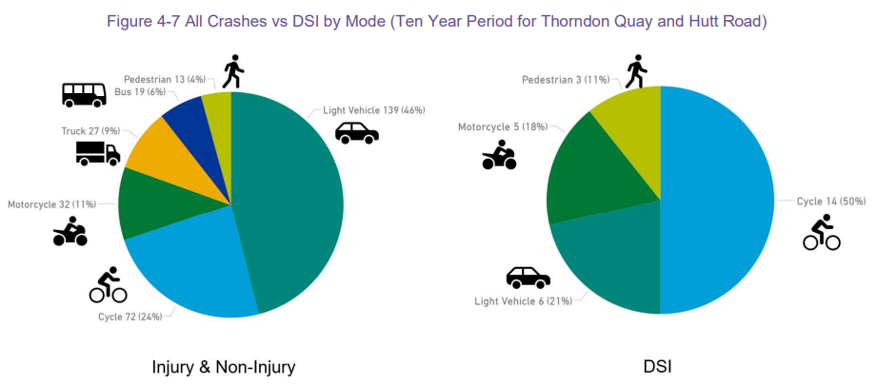  - Growth in cycling demand will therefore not be supported by the current cycle facilities and infrastructure.  - Safe System Assessment was used to highlight key risks on Hutt Road. A significant safety risk for people is the exposure of pedestrians, cyclists and motorcyclists along Hutt Road, is when vehicles are turning right across traffic on Hutt Road to enter and exit the driveways. To improve safety on this Arterial Road, a central raised solid median is adopted to prevent traffic making right turns into and out of the driveways. A turnaround facility will be provided using Aotea Quay Roundabout, a location on Hutt Road and an existing facility at Centennial Highway. Aotea Quay Roundabout and Centennial Highway will provide safe turning location for larger vehicles. A turnaround facility close to Hutt Road for smaller vehicles northbound on Hutt Road wanting to head south to a property on the eastern side along Hutt Road.
Location – where we propose to make the change | Aotea Quay Overbridge 9 at no.87 Hutt Road to Jarden Mile intersection with Centennial Highway
Impact | - The changes will contribute to achieving the four goals of Wellington Towards 2040:  - People-centred city  - Connected city  - Eco-city  - Dynamic central city  - Support Council’s policies such as Te Atakura and the Parking Policy  - Improve the level of service for bus users including improved access, journey times and reliability. Provide increased capacity for growth in public transport.  - Improve level of service and reduce the safety risk for people walking and cycling along and across Thorndon Quay and Hutt Road.  - Reduce the frequency and severity of crashes in particular vulnerable road users.  - Maintain similar access for people and freight to the ferry terminal.  - The parking impact from this project is the removal of 2 x P10 Parking 7am-9.30am, 4pm-6pm Monday-Friday parking spaces to accommodate a new P10 Loading Zone Goods and Service Vehicles Only, At All Times outside no.72 Hutt Road.
Additional Information | Timeline  - Discussions with key stakeholders in May/June 2020 to understand the problems and opportunities.  - May – June 2021 consultation on Thorndon Quay Hutt Road proposal.  - Late 2021 - Consultation report published Preferred option shared  - 24 February 2022 - Council approved the Thorndon Quay Hutt Road Single-Stage Business Case (SSBC) confirming the preferred option (option 4A) to take through to detailed design. This includes:  - peak time bus lanes in both directions  - upgrading and extending a two-way cycle path  - dedicated footpath along the entire corridor,  - bus priority at key intersections,  - a raised median to prevent right turns between Aotea Quay and Ngā Ūranga (Ngauranga),  - bus stop optimisation,  - pedestrian safety and amenity improvements.  - The preferred option was endorsed by the LGWM Board in August 2021.  - 24 August 2022 - The Infrastructure Committee approved TR 133-22 for a roundabout on Aotea Quay in order to create better facilities for freight and ferry terminal traffic at the entrance to the container terminal to provide a more direct route than using Hutt Road  - 29 June 2023 - Council approved the funding for the Let’s Get Wellington Moving Golden Mile and Thorndon Quay Hutt Road projects.  Identification of options  - Building on previous consultation and studies, and evidence gathered, the following objectives were defined for Thorndon Quay Hutt Road.  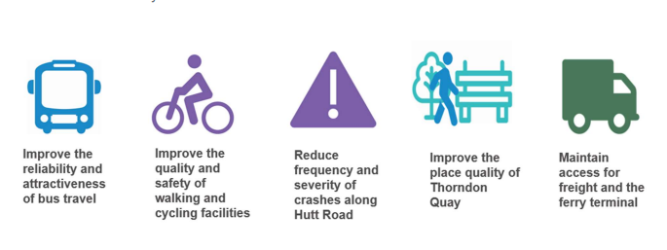  - The Figure below shows the current problems worsening to a future problematic state if nothing is done to the corridor and the current layout remains in places to 2026.  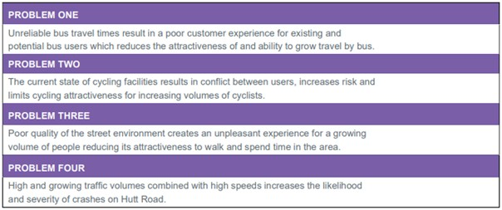  - Hutt Road project used a multi-stage process to develop and assess options that would achieve the above objectives. This process is summarised below.  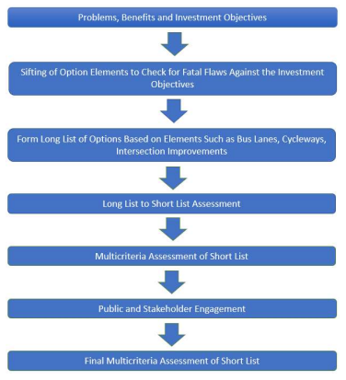  - Four Short list core options were therefore defined as follows:  - Option 1 – Southbound bus lane on Thorndon Quay/ Special Vehicle Lane (SVL) on Hutt Road, with a bi-directional cycleway on Thorndon Quay (A Special vehicle lane means a lane defined by signs or markings and restricted to a specified class or classes of vehicle. Defined in TQHR as a traffic lane which can be used only by buses and trucks)  - Option 2 – Bus lanes on Thorndon Quay/ SVLs on Hutt Road in both directions, with a unidirectional cycleway on Thorndon Quay  - Option 3 – Southbound bus lane on Thorndon Quay/ SVL on Hutt Road, with a uni-directional cycleway on Thorndon Quay  - Option 4 – Bus lanes on Thorndon Quay/ SVLs on Hutt Road in both directions, with a bidirectional cycleway on Thorndon Quay  - The assessment also identified that the provision of a bus or SVL on Hutt Road added additional risks, therefore sub options that included a central median (option A) and a service lane sub-option (option B) were developed and assessed.  - Option 4A was identified as the preferred option  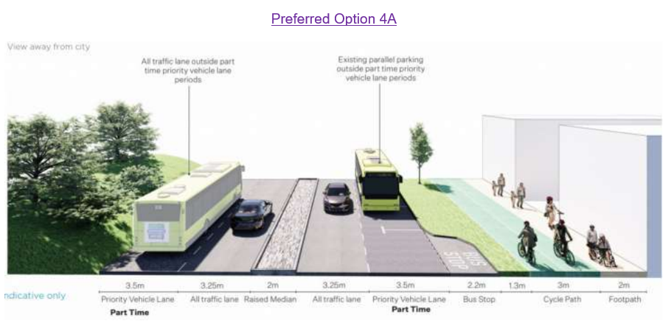  - Aotea Quay Roundabout, at the KiwiRail container terminal entrance, would provide a safe place to turn for drivers of large vehicles intending to travel north from a business on Hutt Road. It would also reduce the amount of traffic on Hutt Road by providing alternative access to the Kaiwharawhara ferry terminal from State Highway 1.  - Public engagement on TQHR was undertaken between 11th May and 8th June 2021. Over 1,600 responses were received, largely via an online survey, which is considered as an adequate response rate. The proposed Traffic Resolution incorporates responses to feedback received during previous consultation.  - Following consultation, a decision was made by the full Council in February 2022 on the preferred option to take through to detailed design.  - More detail on the identification and analysis of options can be found in the Approved Single Stage Business Case Documents at https://lgwm.nz/all-projects/tqhr/related-documents/  - Average daily traffic count – 19,865  This proposed Traffic resolution does not address speed reduction proposals. It is currently planned to address speed reduction proposals as part of the Speed Management Plan process.
Privacy | - Your privacy is important to us. Please DO NOT add specific personal details to your feedback (i.e.: full name, address, etc)  - What we do with your personal information:  All submissions (including your first name, but not contact details) are provided in their entirety to elected members and made available to the public on our website and at our office. Personal information (including contact details) will also be used for the administration of the consultation process including informing you of the outcome of the consultation. All information collected will be held by Wellington City Council, 113 The Terrace, Wellington, with submitters having the right to access and correct personal information.  - For more information regarding our Privacy Statement please check our webpage: https://wellington.govt.nz/contact-us/privacy-statement.
Feedback | - To view the legal description for this Traffic Resolution, an electronic copy of the report will be available on the Council’s website from 13th November 2023 at https://www.letstalk.wellington.govt.nz/ or you can call (04) 499 4444 and we will send one out to you  - If you would like to provide us with specific feedback you can do so by filling out an online submission form, downloading a printable submission form on https://www.letstalk.wellington.govt.nz/ or emailing us at trfeedback@wcc.govt.nz.  Please note if you are giving feedback the consultation period opens at 9.00 am 13th November 2023 and finishes at 11:59 pm 8th December 2023
Next Steps | - Feedback collated by 9th February 2024.  - The proposal will go to the Regulatory Processes Committee by 4th April 2024.  - If approved, the proposal will be completed in 2025

Traffic Resolution Plan: TR 06-24 – Hutt Road from Aotea Quay overbridge to Jarden Mile intersection – Proposed Changes (Overall Plan 1 of 7)
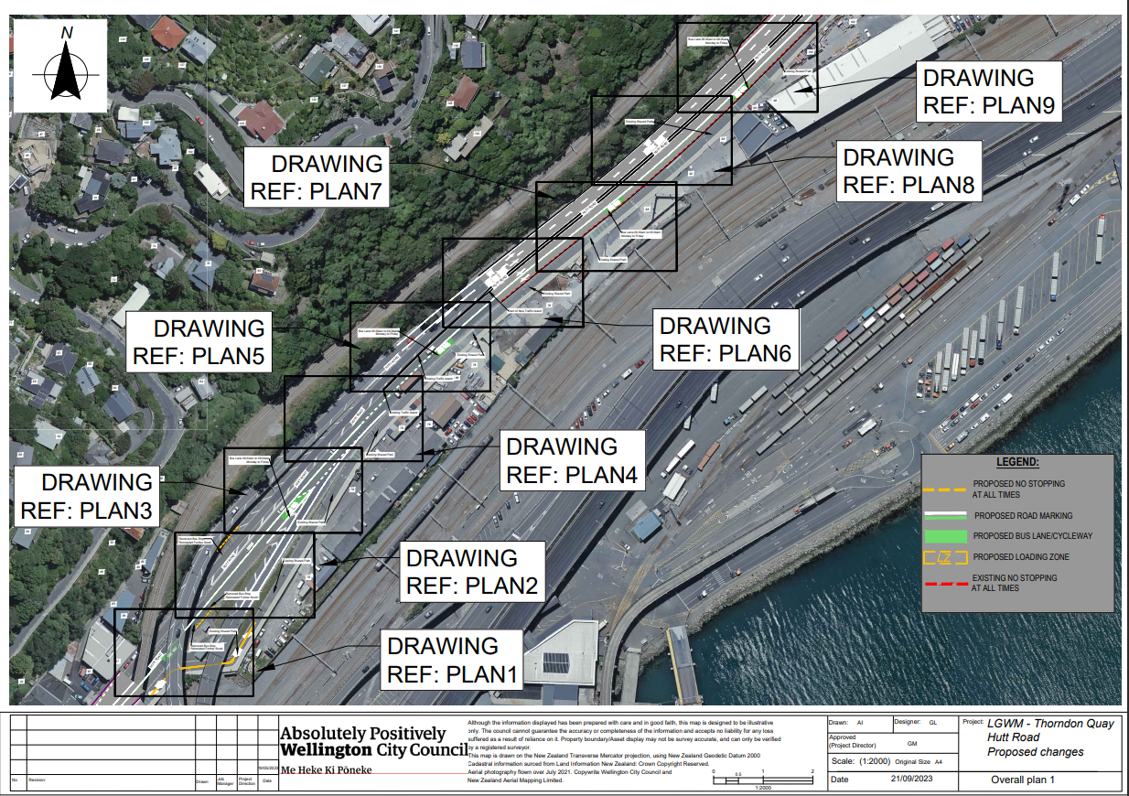
Traffic Resolution Plan: TR 06-24 – Hutt Road from Aotea Quay overbridge to Jarden Mile intersection – Proposed Changes (Overall Plan 2 of 7)
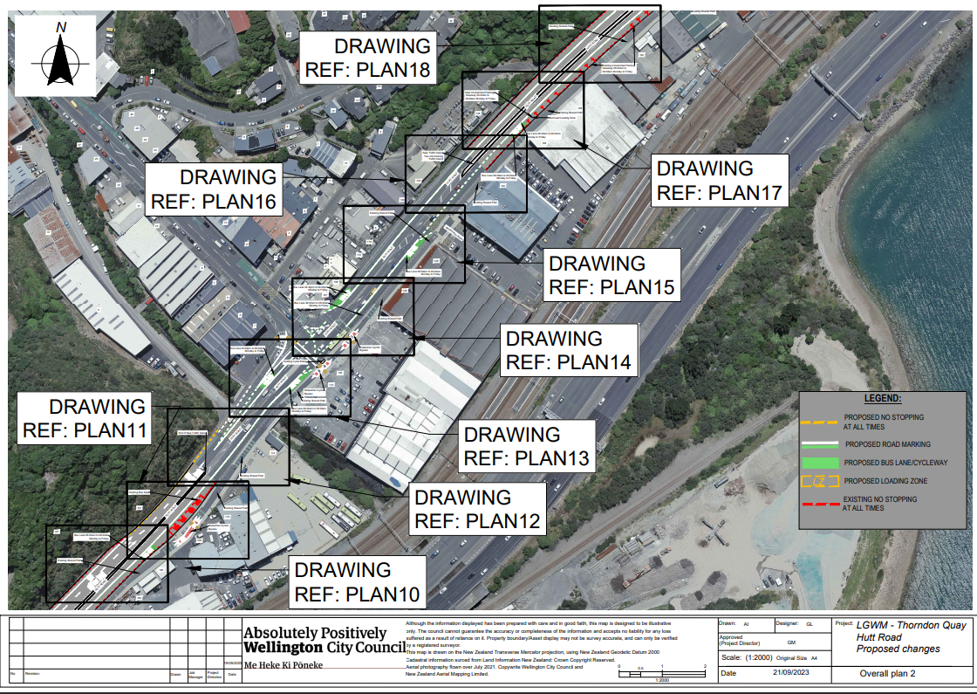
Traffic Resolution Plan: TR 06-24 – Hutt Road from Aotea Quay overbridge to Jarden Mile intersection – Proposed Changes (Overall Plan 3 of 7)
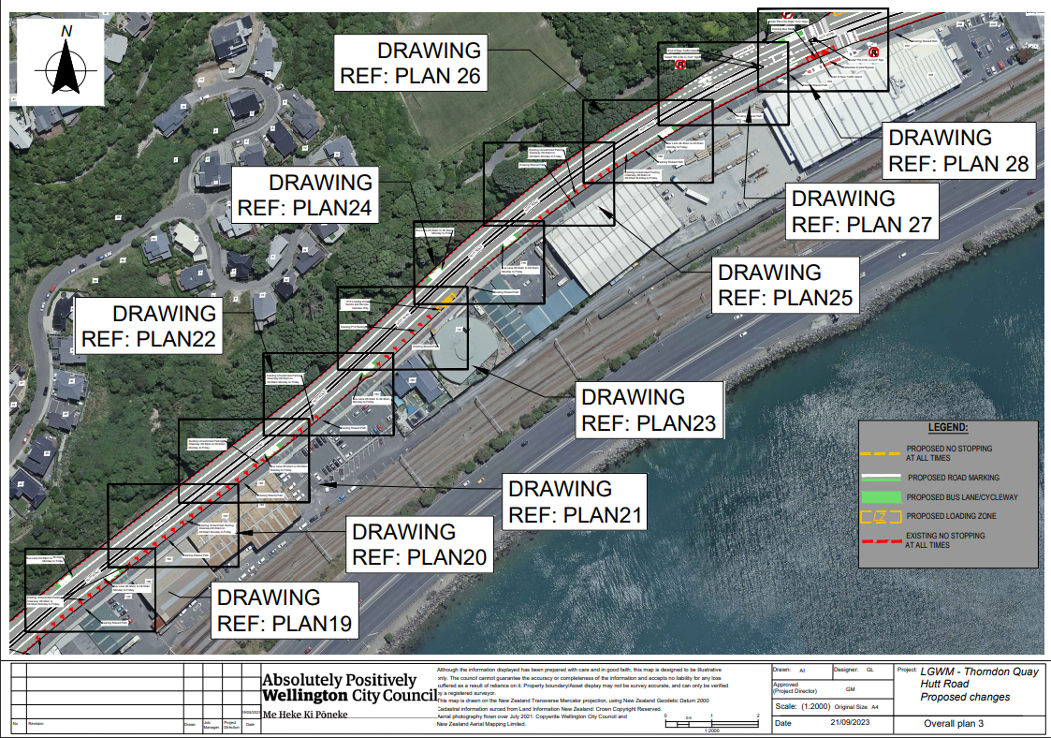
Traffic Resolution Plan: TR 06-24 – Hutt Road from Aotea Quay overbridge to Jarden Mile intersection – Proposed Changes (Overall Plan 4 of 7)
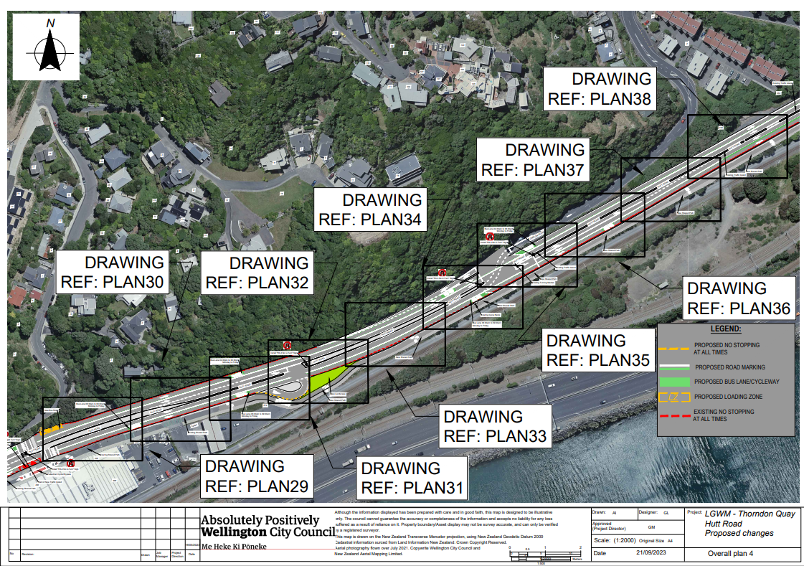
Traffic Resolution Plan: TR 06-24 – Hutt Road from Aotea Quay overbridge to Jarden Mile intersection – Proposed Changes (Overall Plan 5 of 7)
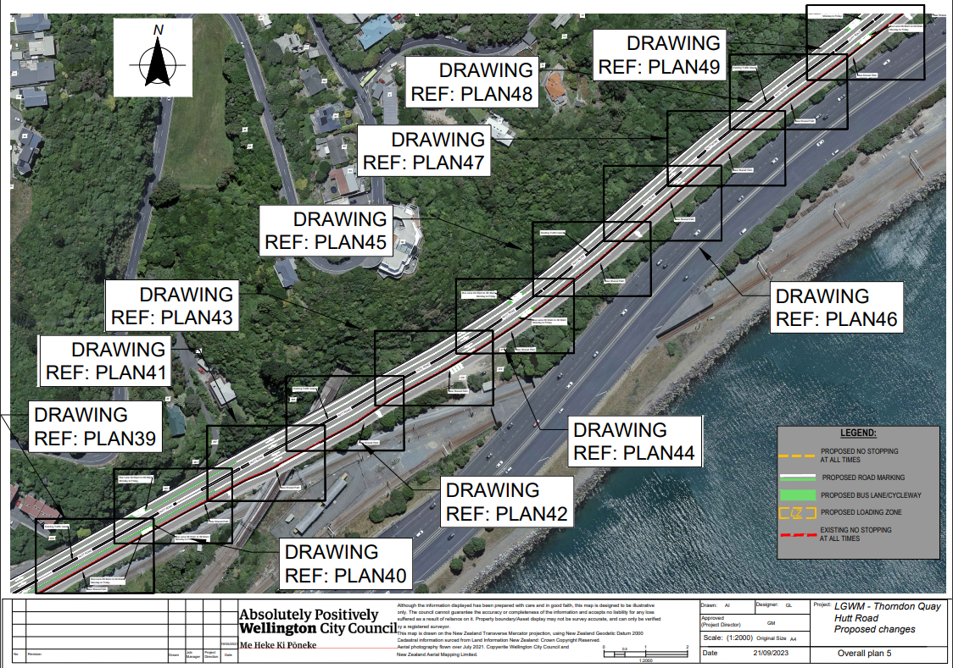
Traffic Resolution Plan: TR 06-24 – Hutt Road from Aotea Quay overbridge to Jarden Mile intersection – Proposed Changes (Overall Plan 6 of 7)
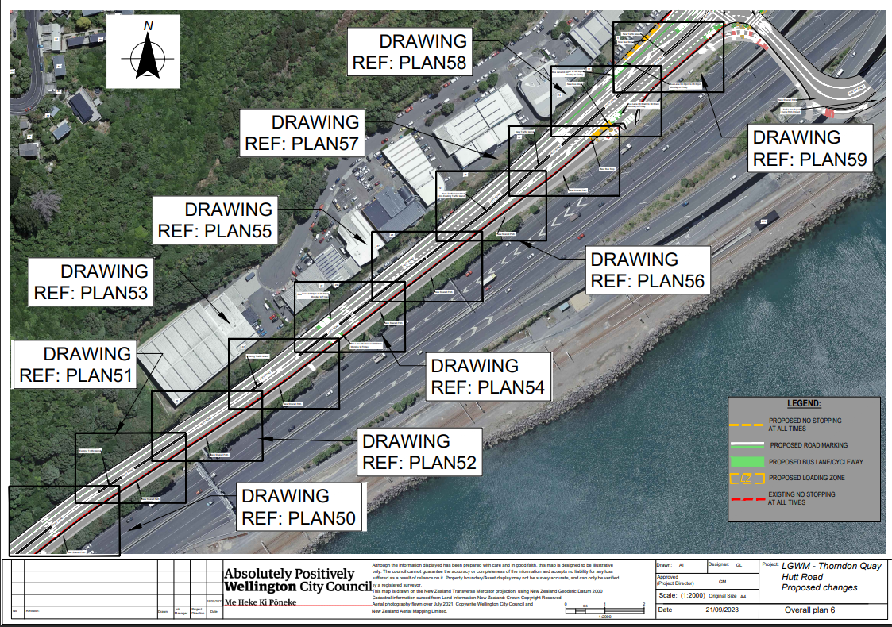
Traffic Resolution Plan: TR 06-24 – Hutt Road from Aotea Quay overbridge to Jarden Mile intersection – Proposed Changes (Overall Plan 7 of 7) 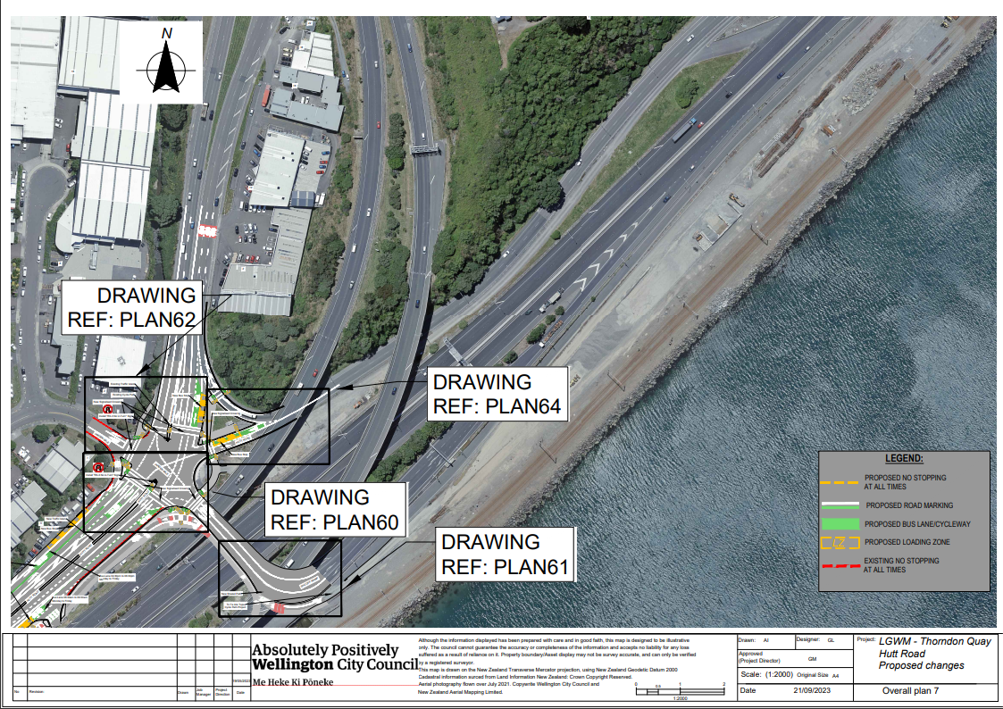
Traffic Resolution Plan: TR 06-24 – Hutt Road from Aotea Quay overbridge to Jarden Mile intersection – Proposed Changes (Plan 1)
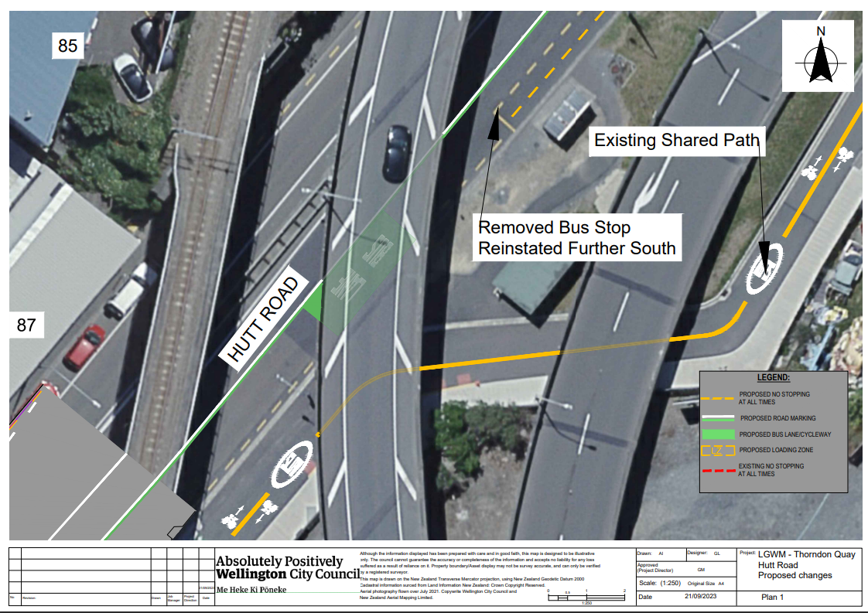
Traffic Resolution Plan: TR 06-24 – Hutt Road from Aotea Quay overbridge to Jarden Mile intersection – Proposed Changes (Plan 2)
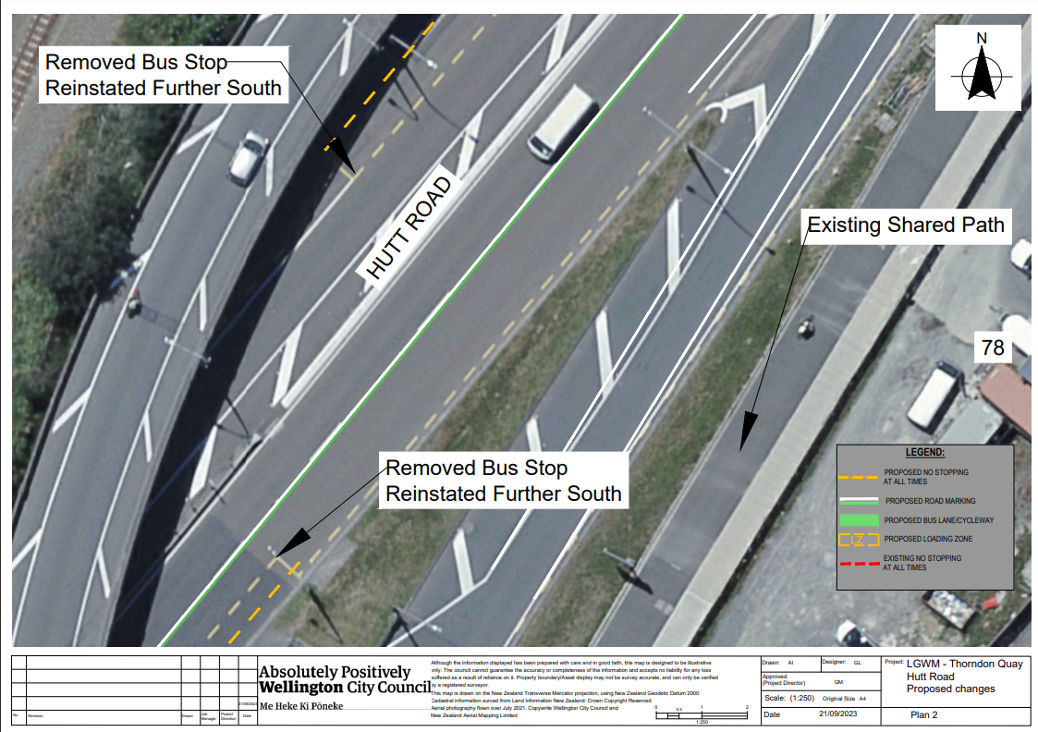
Traffic Resolution Plan: TR 06-24 – Hutt Road from Aotea Quay overbridge to Jarden Mile intersection – Proposed Changes (Plan 3)
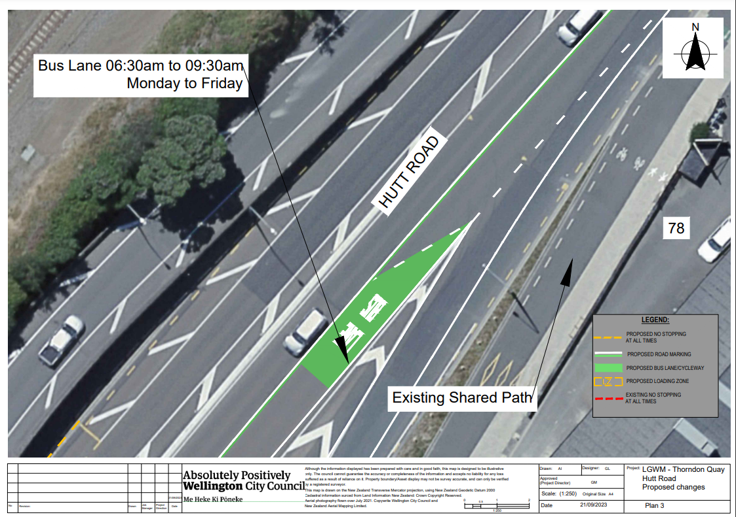
Traffic Resolution Plan: TR 06-24 – Hutt Road from Aotea Quay overbridge to Jarden Mile intersection – Proposed Changes (Plan 4)
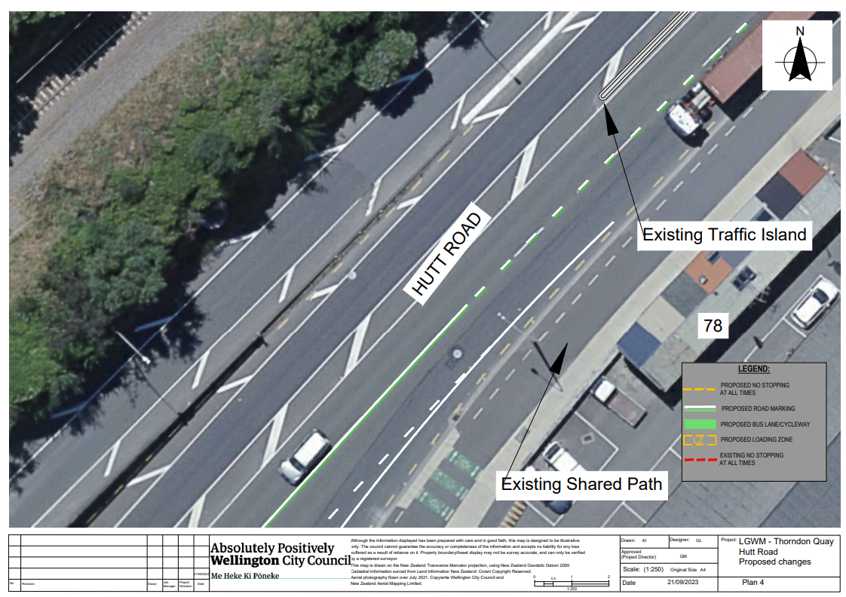
Traffic Resolution Plan: TR 06-24 – Hutt Road from Aotea Quay overbridge to Jarden Mile intersection – Proposed Changes (Plan 5)
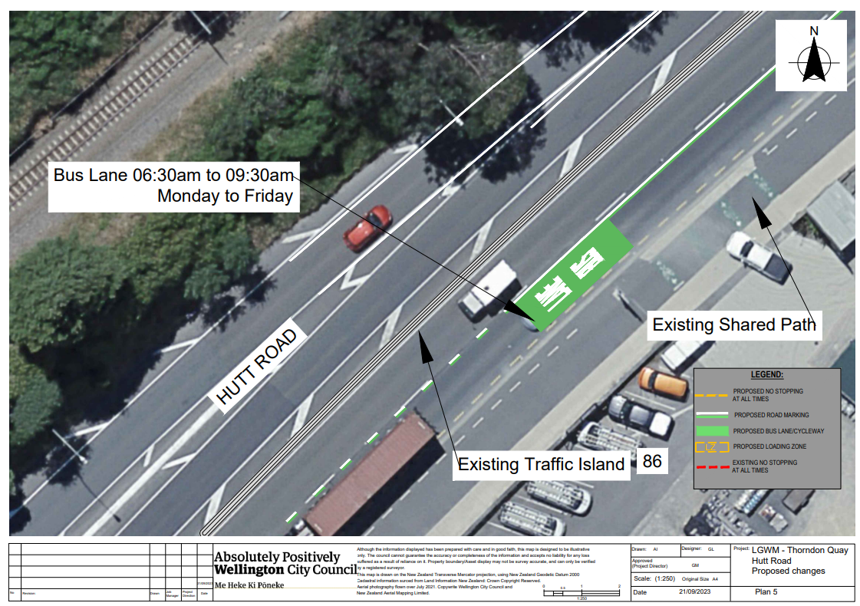
Traffic Resolution Plan: TR 06-24 – Hutt Road from Aotea Quay overbridge to Jarden Mile intersection – Proposed Changes (Plan 6)
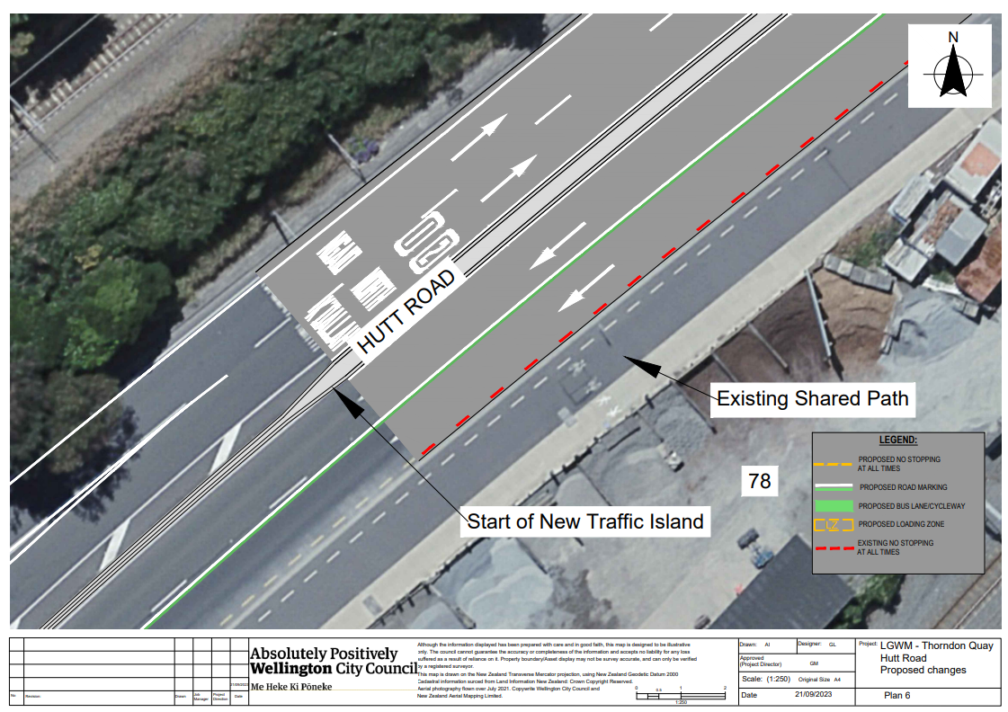
Traffic Resolution Plan: TR 06-24 – Hutt Road from Aotea Quay overbridge to Jarden Mile intersection – Proposed Changes (Plan 7)

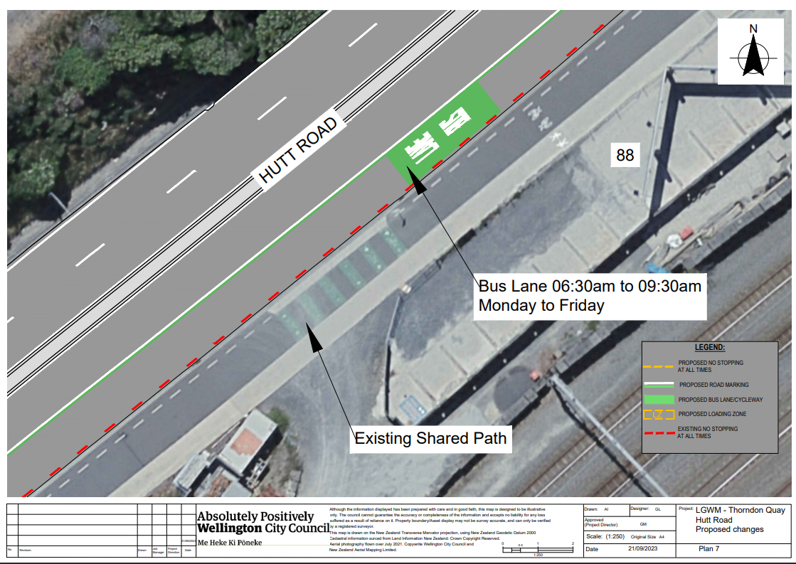
Traffic Resolution Plan: TR 06-24 – Hutt Road from Aotea Quay overbridge to Jarden Mile intersection – Proposed Changes (Plan 8)
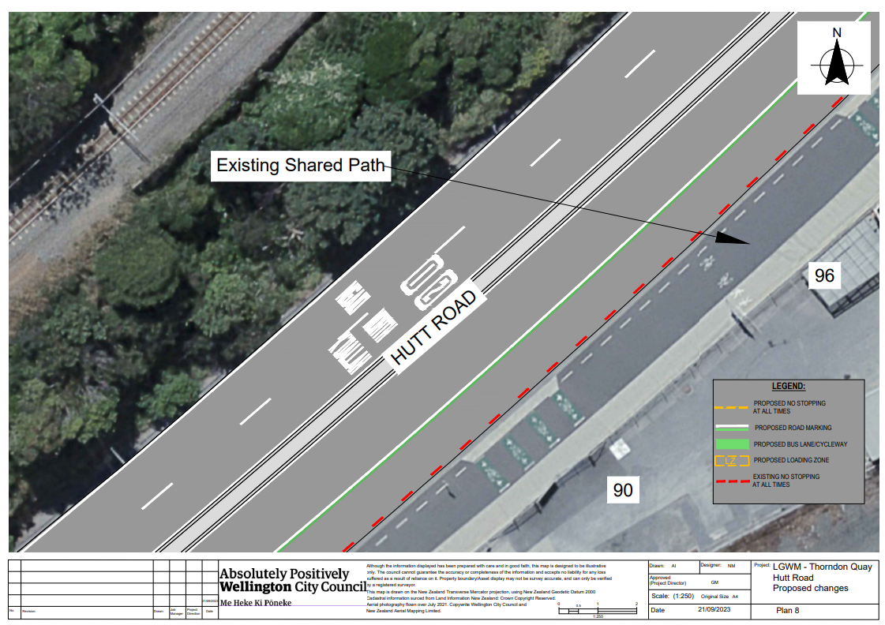
Traffic Resolution Plan: TR 06-24 – Hutt Road from Aotea Quay overbridge to Jarden Mile intersection – Proposed Changes (Plan 9)
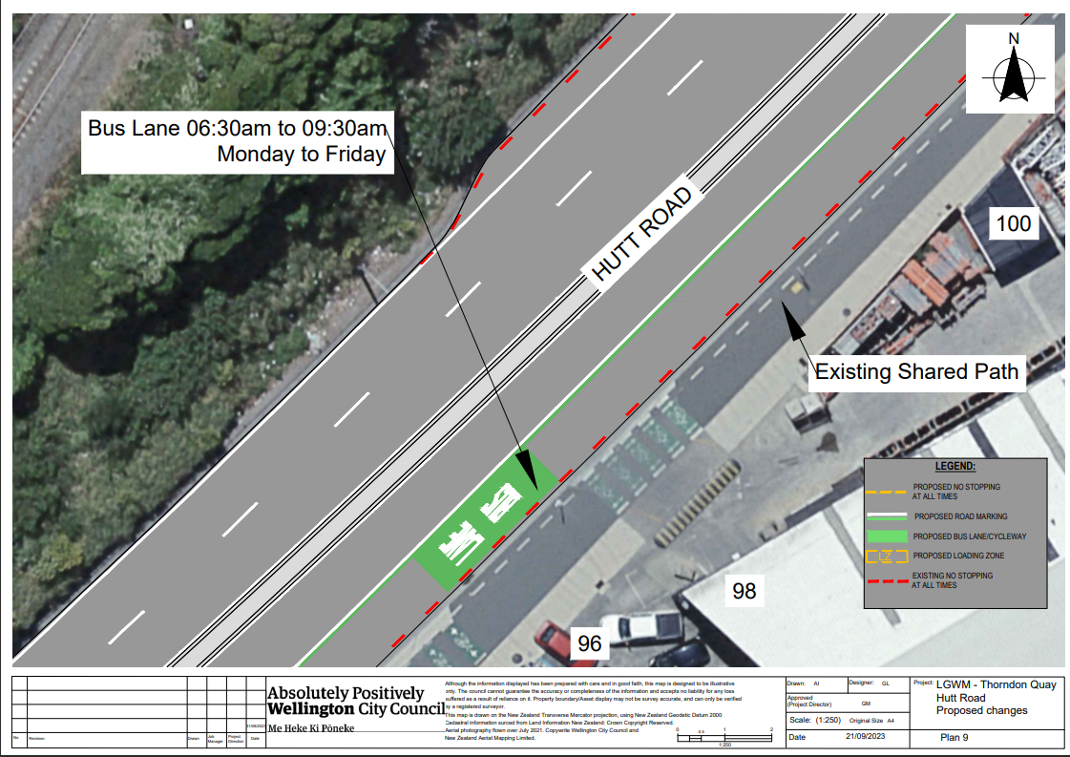

Traffic Resolution Plan: TR 06-24 – Hutt Road from Aotea Quay overbridge to Jarden Mile intersection – Proposed Changes (Plan 10)
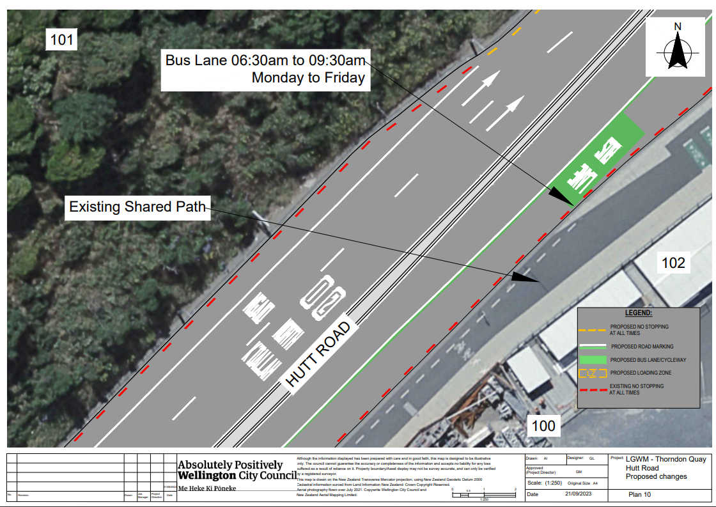
Traffic Resolution Plan: TR 06-24 – Hutt Road from Aotea Quay overbridge to Jarden Mile intersection – Proposed Changes (Plan 11)
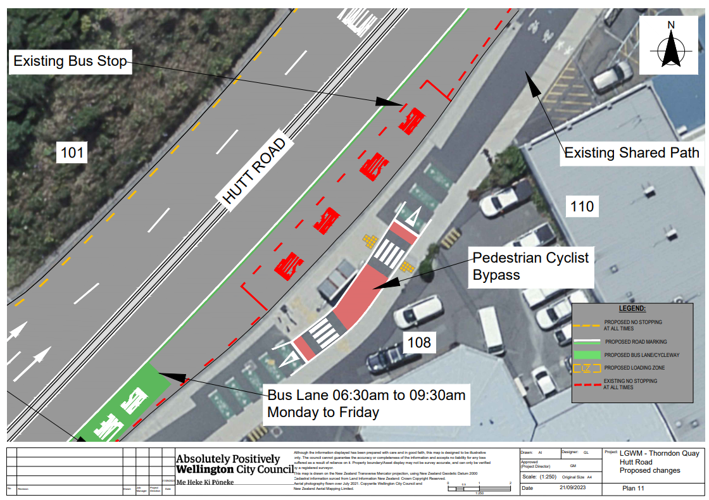
Traffic Resolution Plan: TR 06-24 – Hutt Road from Aotea Quay overbridge to Jarden Mile intersection – Proposed Changes (Plan 12)
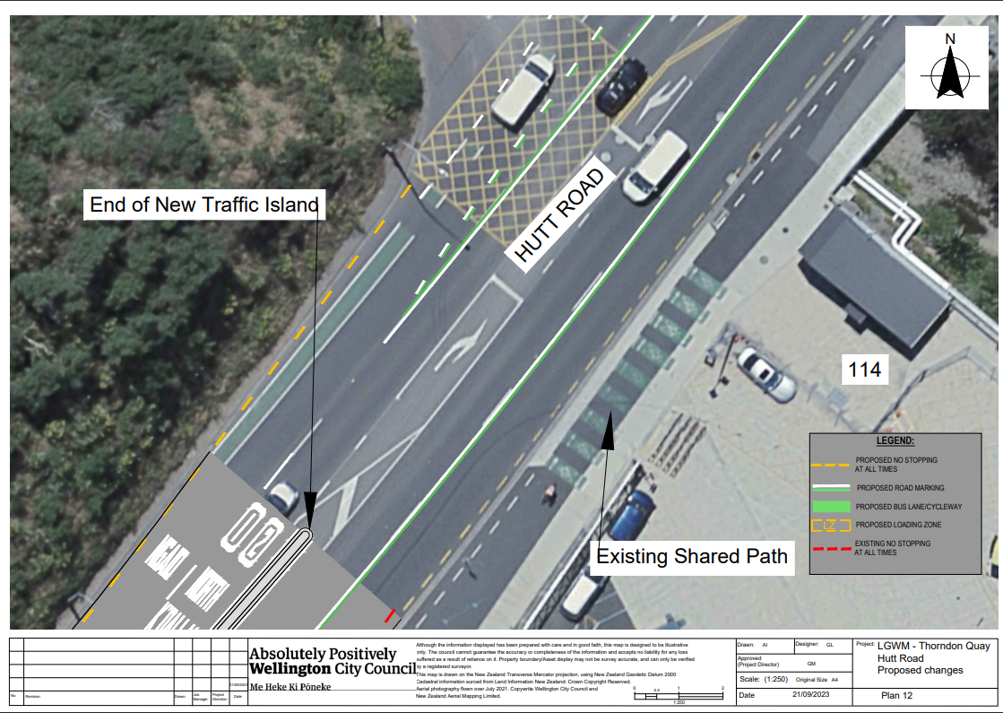
Traffic Resolution Plan: TR 06-24 – Hutt Road from Aotea Quay overbridge to Jarden Mile intersection – Proposed Changes (Plan 13)
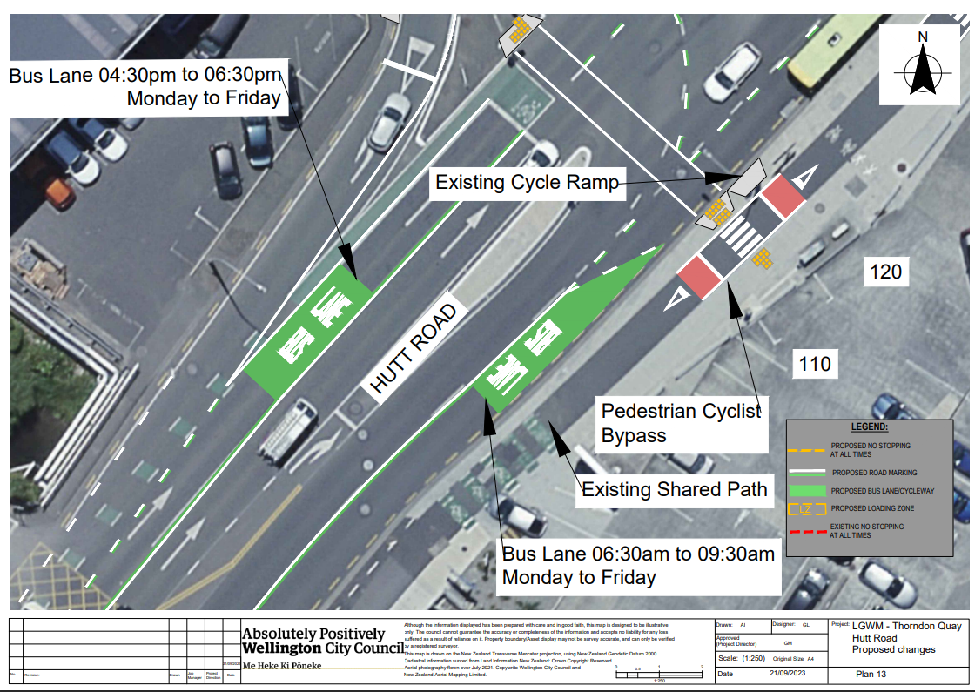
Traffic Resolution Plan: TR 06-24 – Hutt Road from Aotea Quay overbridge to Jarden Mile intersection – Proposed Changes (Plan 14)
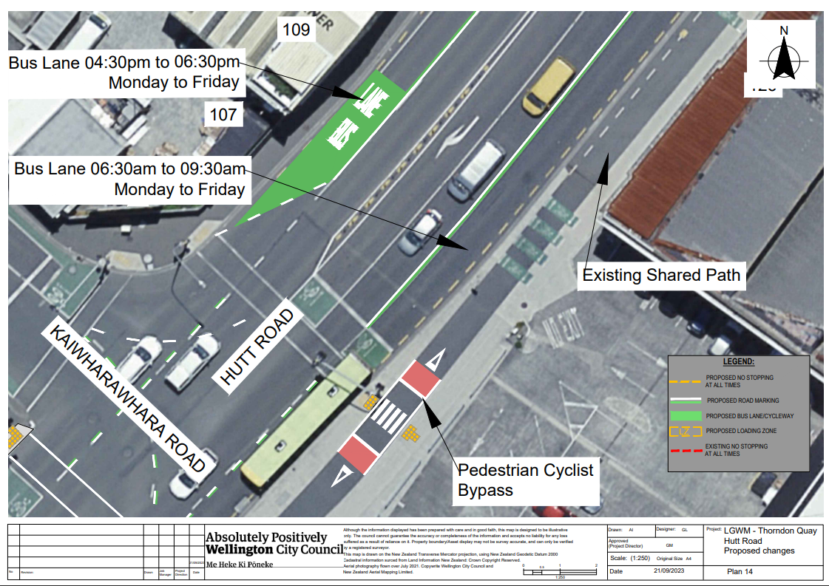
Traffic Resolution Plan: TR 06-24 – Hutt Road from Aotea Quay overbridge to Jarden Mile intersection – Proposed Changes (Plan 15)


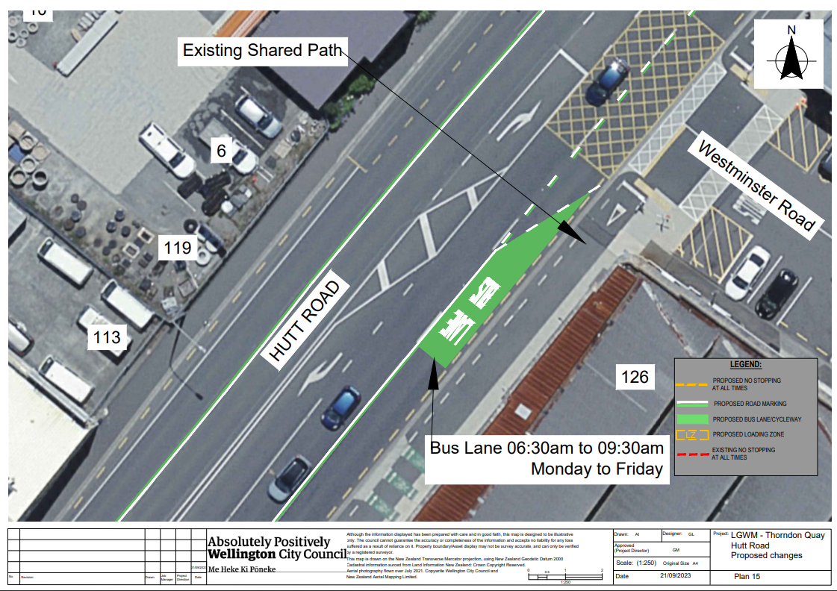
Traffic Resolution Plan: TR 06-24 – Hutt Road from Aotea Quay overbridge to Jarden Mile intersection – Proposed Changes (Plan 16)
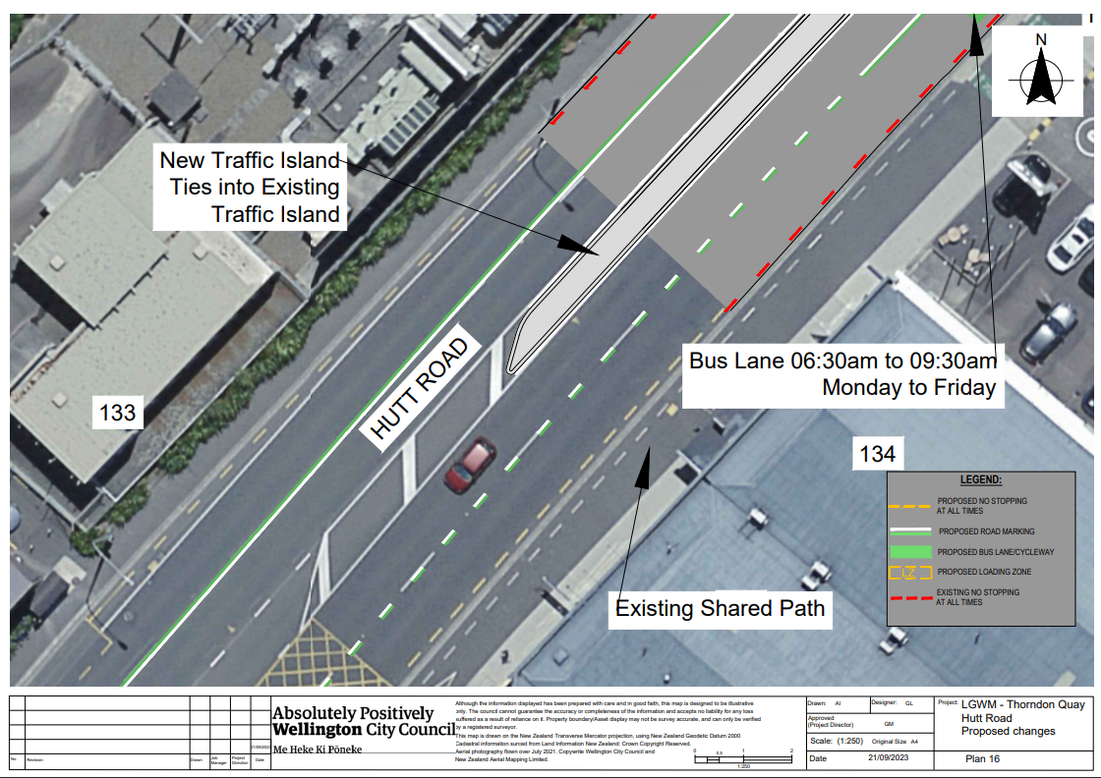
Traffic Resolution Plan: TR 06-24 – Hutt Road from Aotea Quay overbridge to Jarden Mile intersection – Proposed Changes (Plan 17)
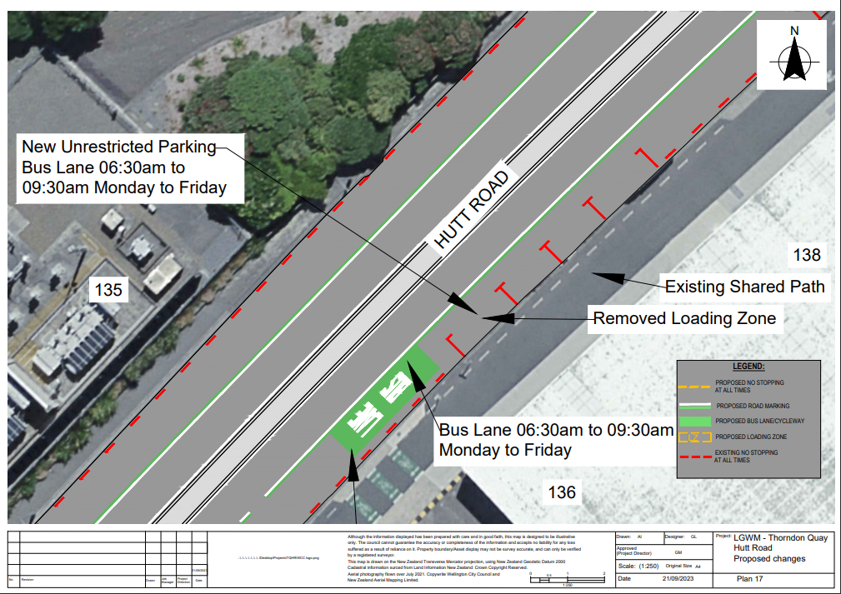
Traffic Resolution Plan: TR 06-24 – Hutt Road from Aotea Quay overbridge to Jarden Mile intersection – Proposed Changes (Plan 18)

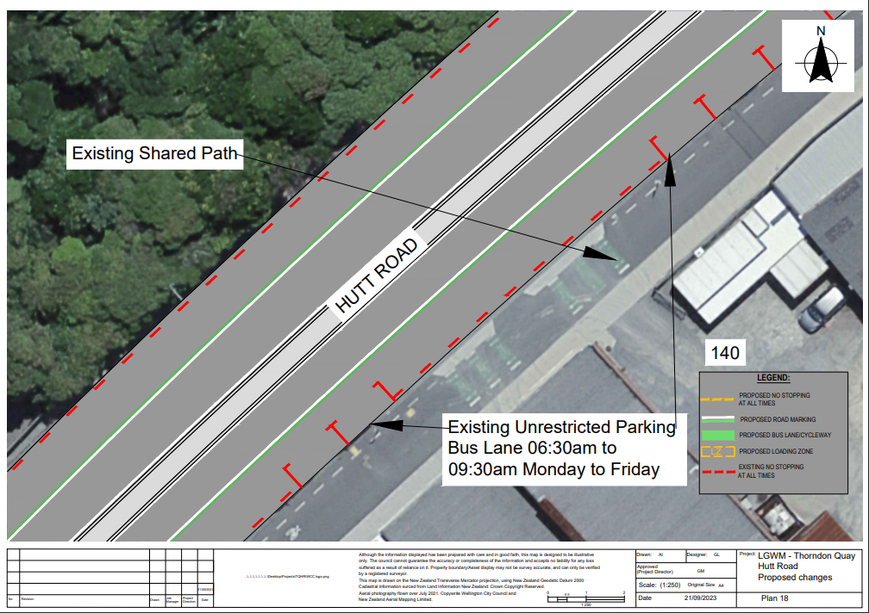
Traffic Resolution Plan: TR 06-24 – Hutt Road from Aotea Quay overbridge to Jarden Mile intersection – Proposed Changes (Plan 19)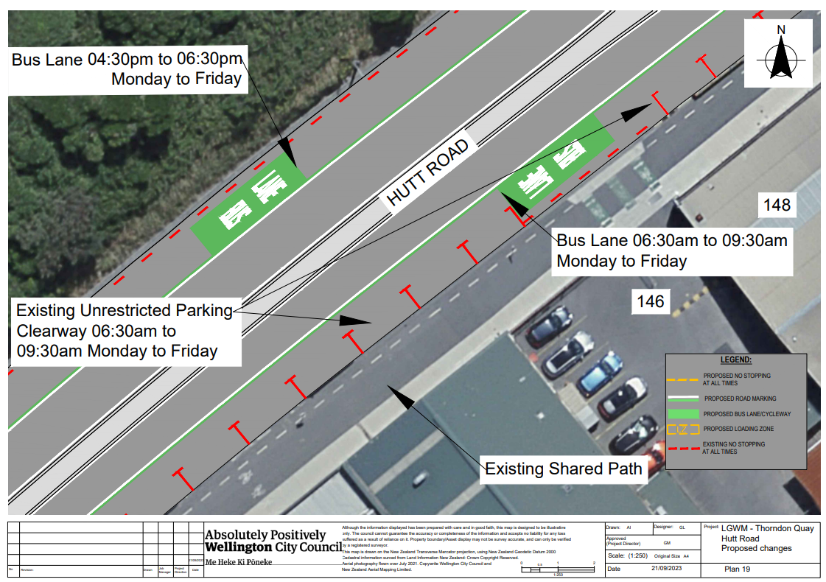
Traffic Resolution Plan: TR 06-24 – Hutt Road from Aotea Quay overbridge to Jarden Mile intersection – Proposed Changes (Plan 20)
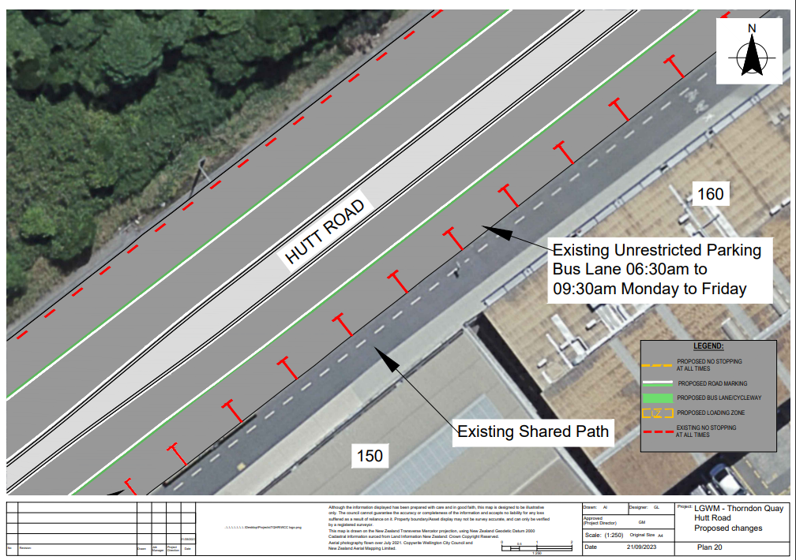
Traffic Resolution Plan: TR 06-24 – Hutt Road from Aotea Quay overbridge to Jarden Mile intersection – Proposed Changes (Plan 21)
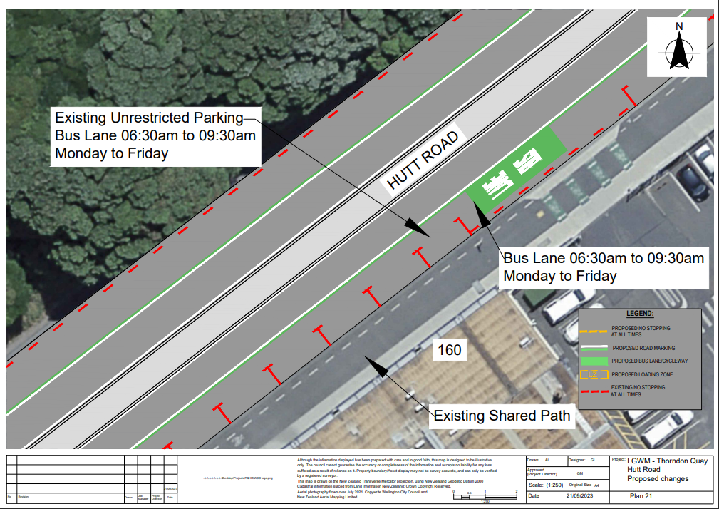
Traffic Resolution Plan: TR 06-24 – Hutt Road from Aotea Quay overbridge to Jarden Mile intersection – Proposed Changes (Plan 22)
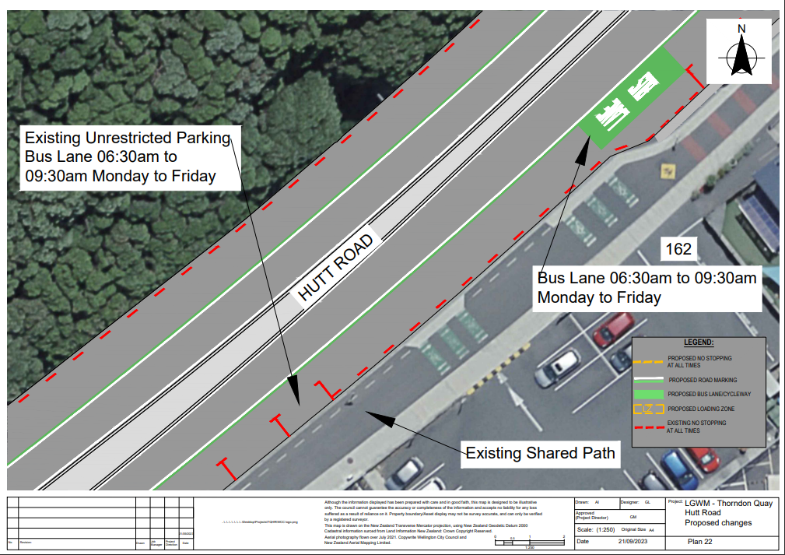
Traffic Resolution Plan: TR 06-24 – Hutt Road from Aotea Quay overbridge to Jarden Mile
intersection – Proposed Changes (Plan 23) 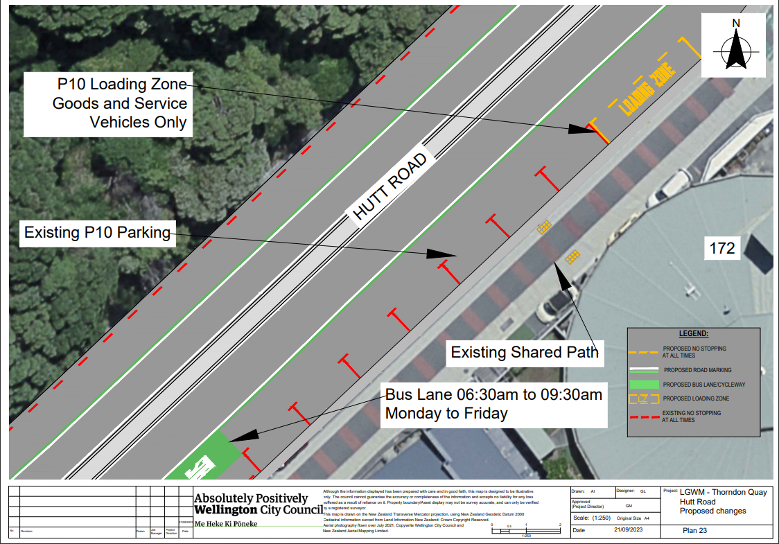￼Traffic Resolution Plan: TR 06-24 – Hutt Road from Aotea Quay overbridge to Jarden Mile intersection – Proposed Changes (Plan 24)

P10 Loading Zone Goods and Service Vehicles Only “At All Times”
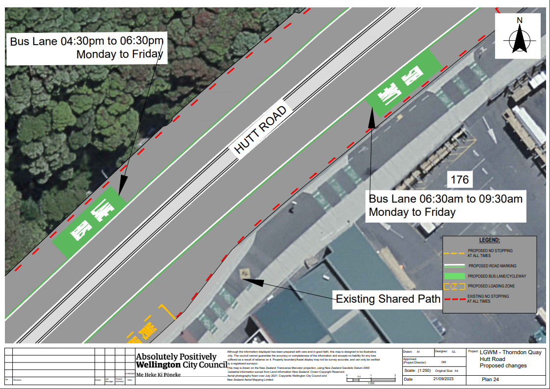
Traffic Resolution Plan: TR 06-24 – Hutt Road from Aotea Quay overbridge to Jarden Mile intersection – Proposed Changes (Plan 25) 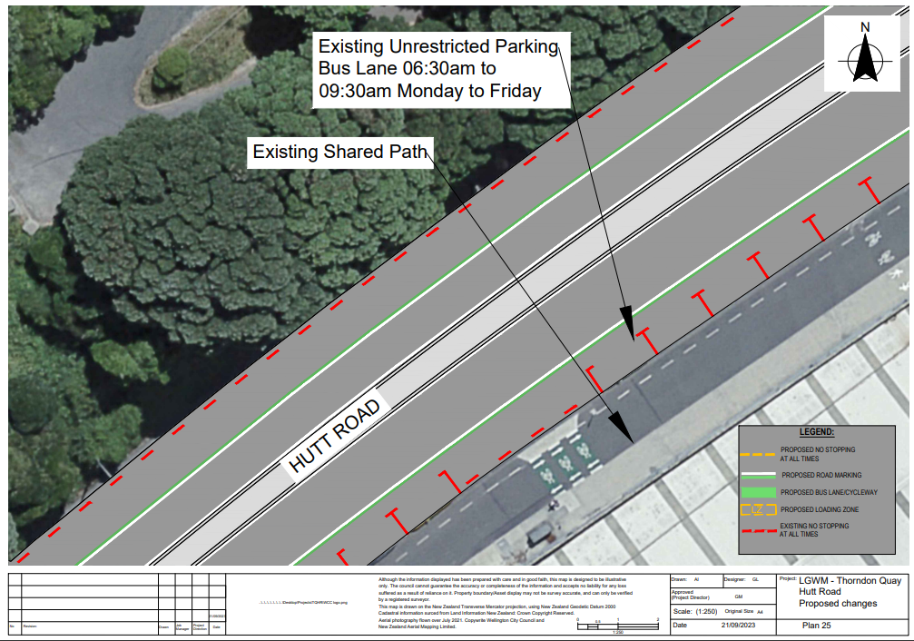
Traffic Resolution Plan: TR 06-24 – Hutt Road from Aotea Quay overbridge to Jarden Mile intersection – Proposed Changes (Plan 26) 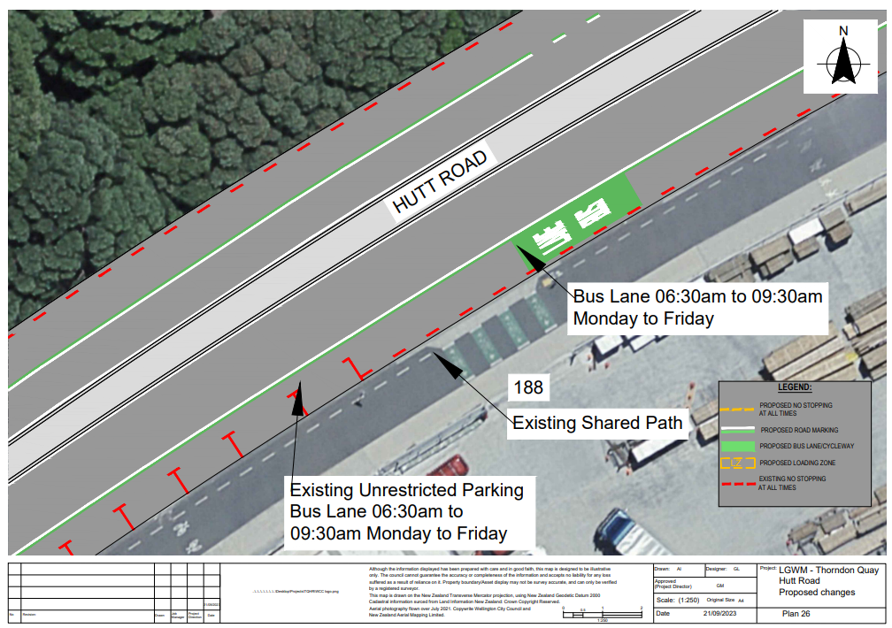
Traffic Resolution Plan: TR 06-24 – Hutt Road from Aotea Quay overbridge to Jarden Mile intersection – Proposed Changes (Plan 27)

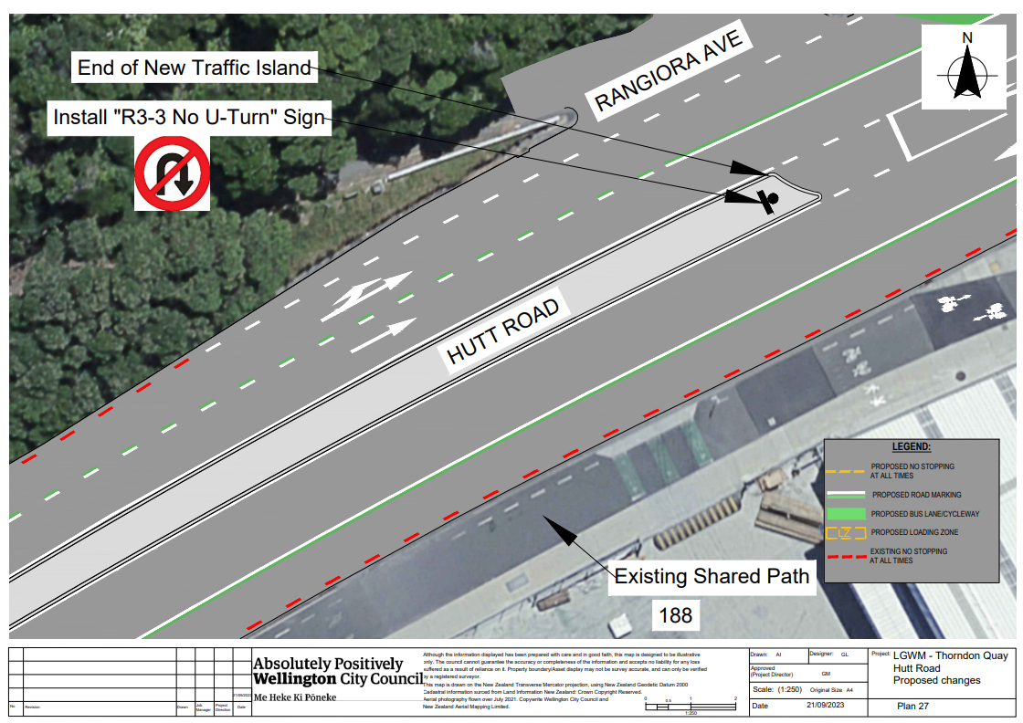
Traffic Resolution Plan: TR 06-24 – Hutt Road from Aotea Quay overbridge to Jarden Mile intersection – Proposed Changes (Plan 28)
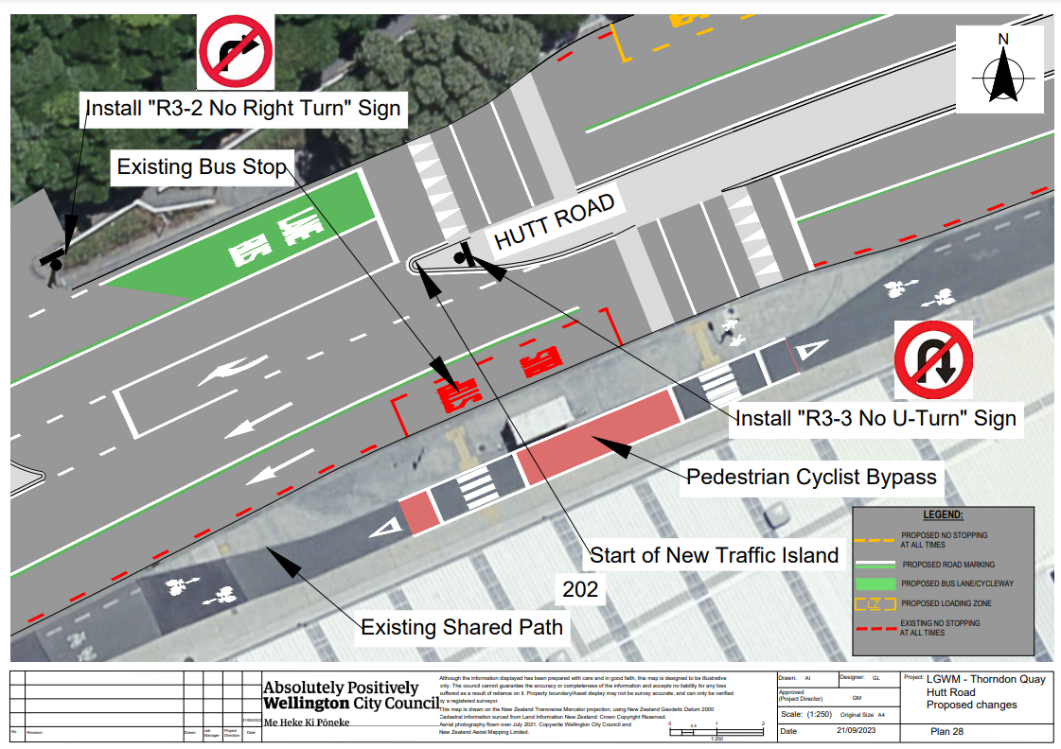
Traffic Resolution Plan: TR 06-24 – Hutt Road from Aotea Quay overbridge to Jarden Mile intersection – Proposed Changes (Plan 29)
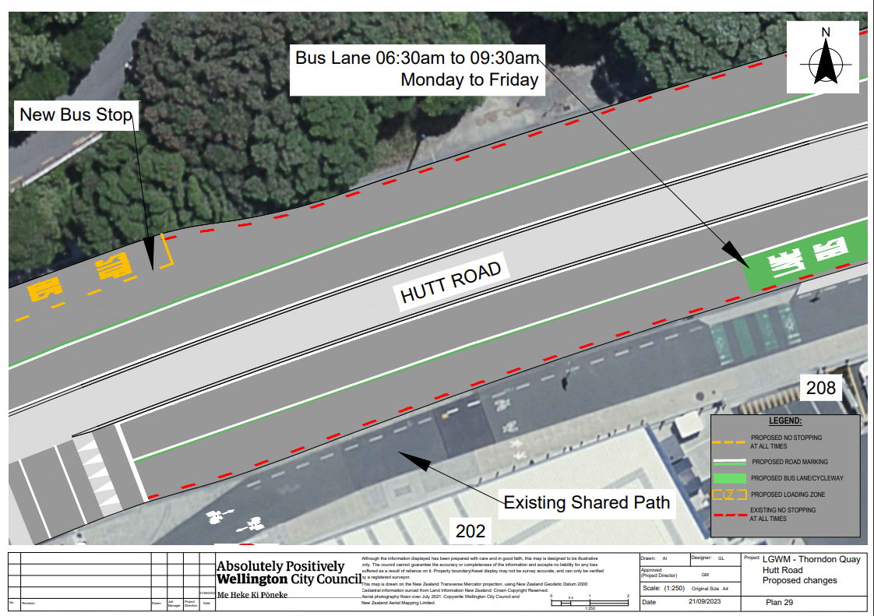
Traffic Resolution Plan: TR 06-24 – Hutt Road from Aotea Quay overbridge to Jarden Mile intersection – Proposed Changes (Plan 30)
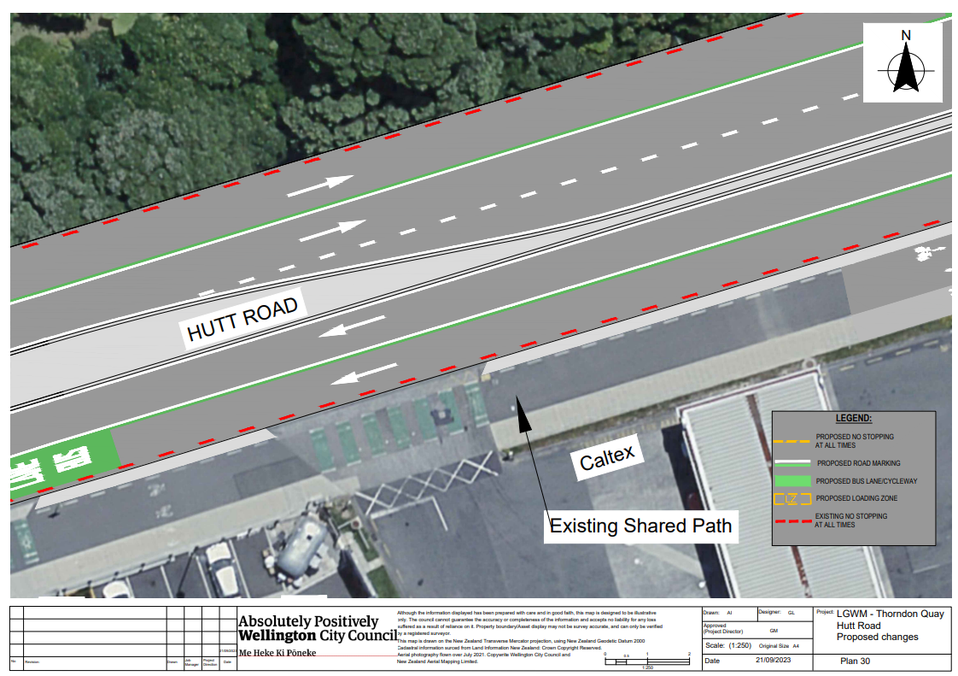
Traffic Resolution Plan: TR 06-24 – Hutt Road from Aotea Quay overbridge to Jarden Mile intersection – Proposed Changes (Plan 31)
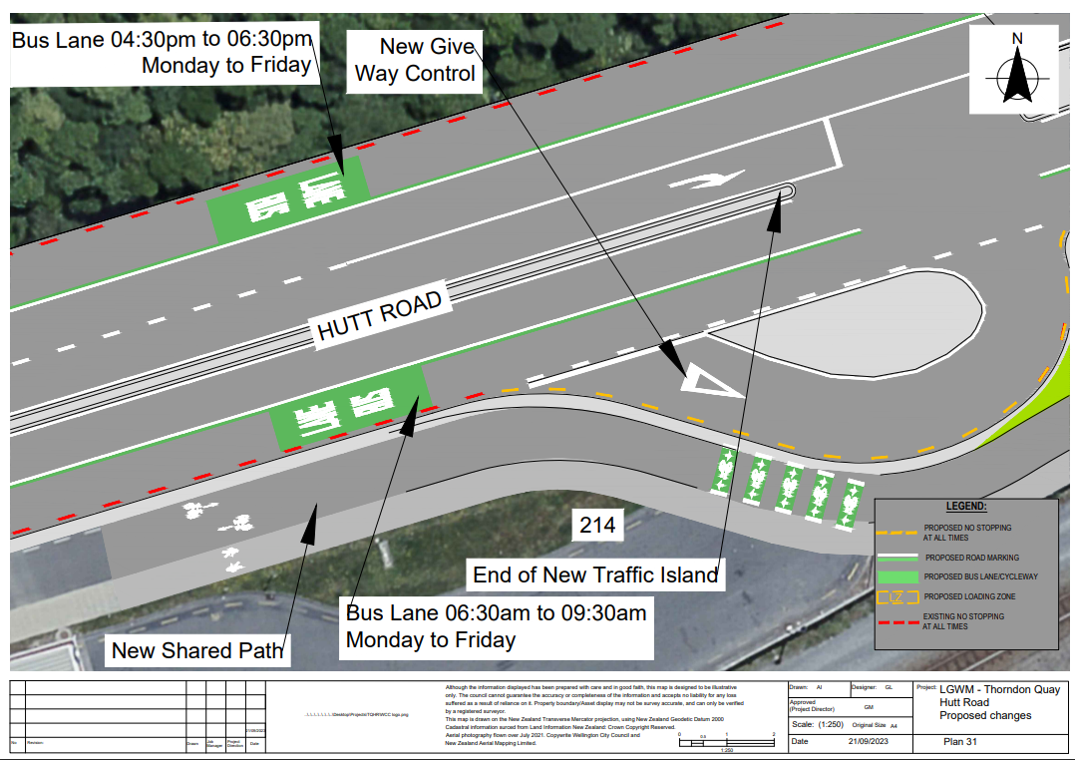
Traffic Resolution Plan: TR 06-24 – Hutt Road from Aotea Quay overbridge to Jarden Mile intersection – Proposed Changes (Plan 32)
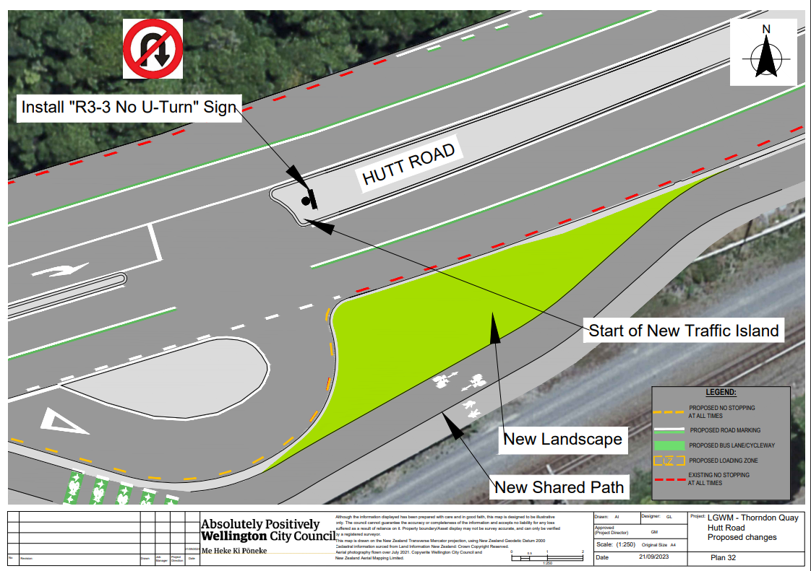
Traffic Resolution Plan: TR 06-24 – Hutt Road from Aotea Quay overbridge to Jarden Mile intersection – Proposed Changes (Plan 33)
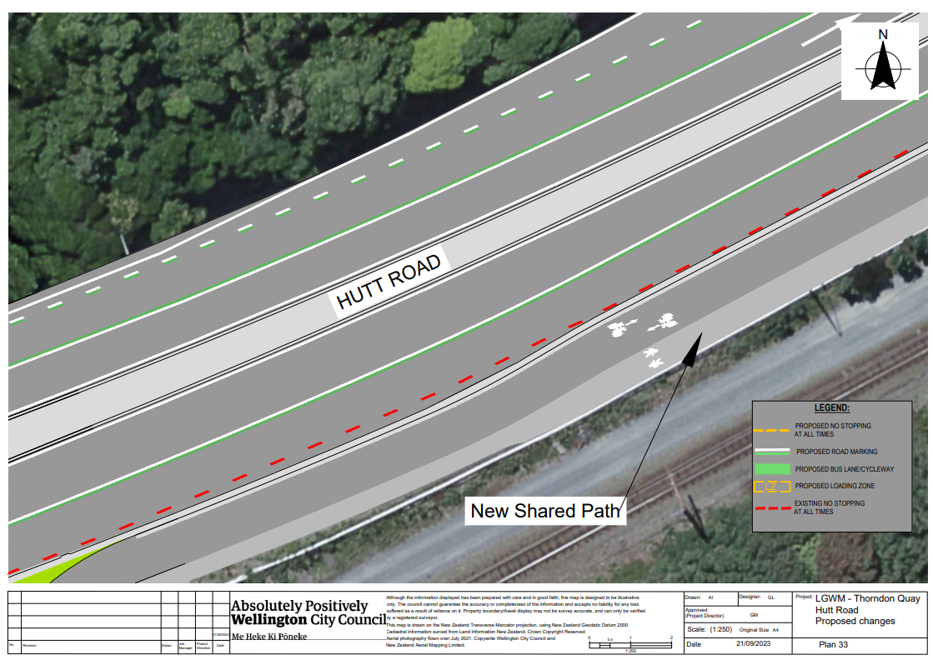
Traffic Resolution Plan: TR 06-24 – Hutt Road from Aotea Quay overbridge to Jarden Mile intersection – Proposed Changes (Plan 34)
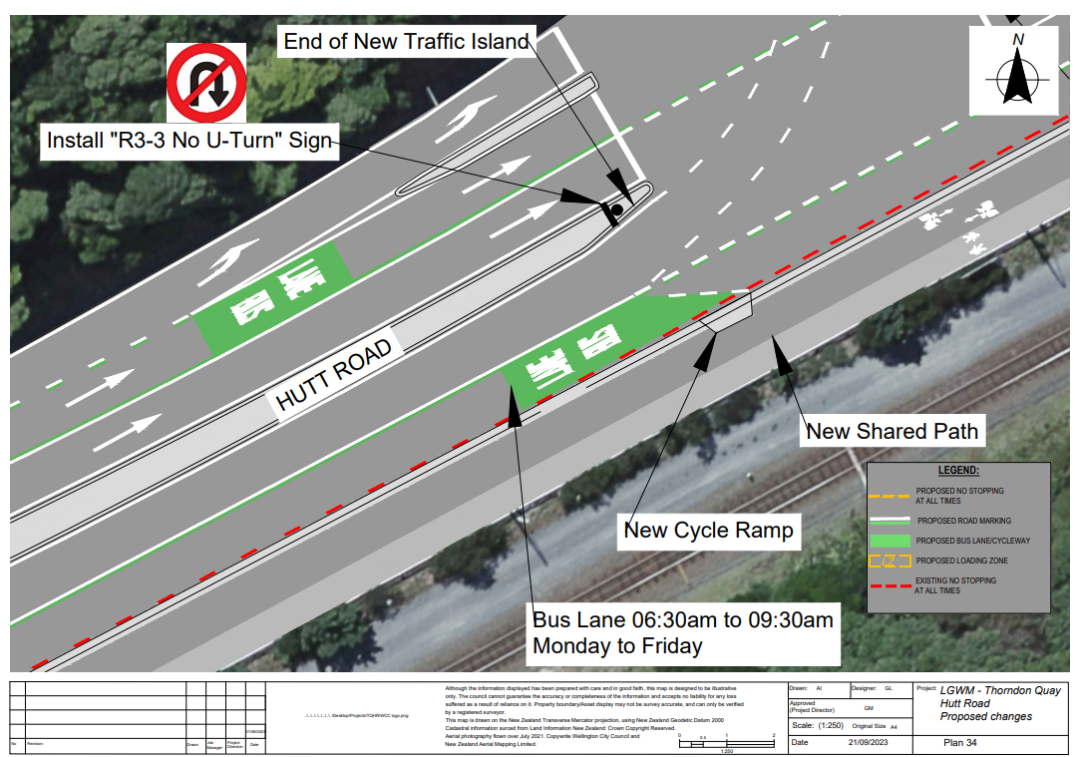
Traffic Resolution Plan: TR 06-24 – Hutt Road from Aotea Quay overbridge to Jarden Mile intersection – Proposed Changes (Plan 35)
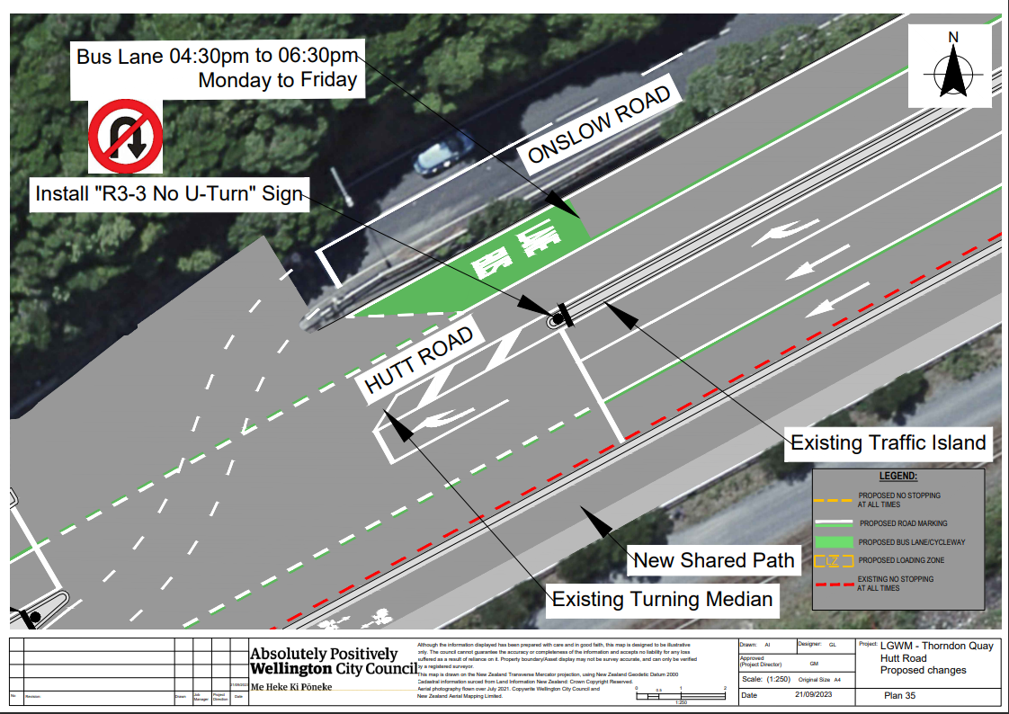
Traffic Resolution Plan: TR 06-24 – Hutt Road from Aotea Quay overbridge to Jarden Mile intersection – Proposed Changes (Plan 36)
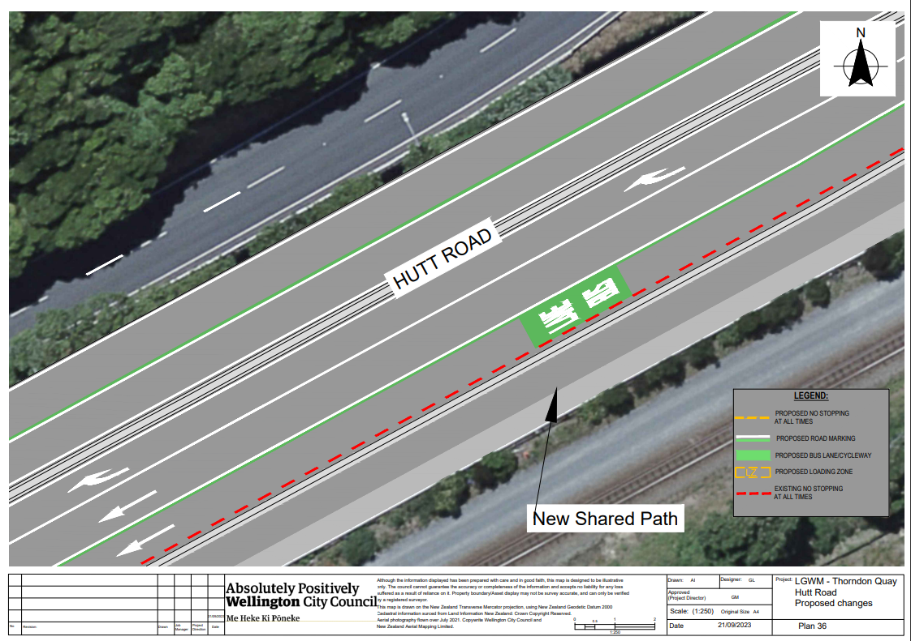
Traffic Resolution Plan: TR 06-24 – Hutt Road from Aotea Quay overbridge to Jarden Mile intersection – Proposed Changes (Plan 37)
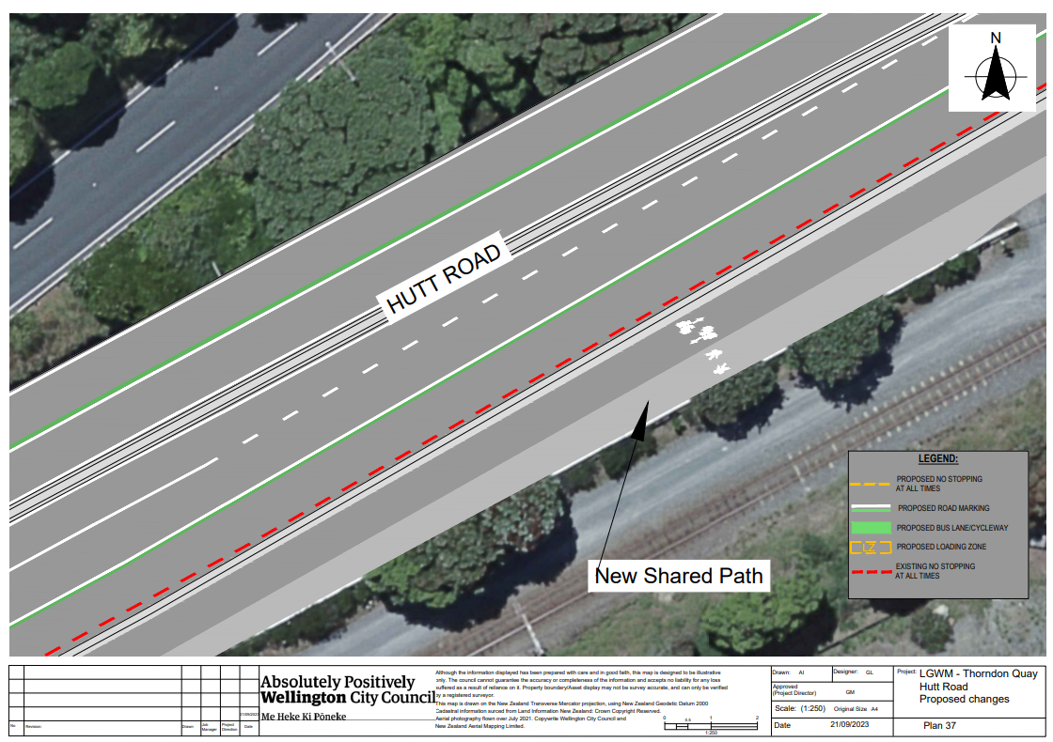
Traffic Resolution Plan: TR 06-24 – Hutt Road from Aotea Quay overbridge to Jarden Mile intersection – Proposed Changes (Plan 38)
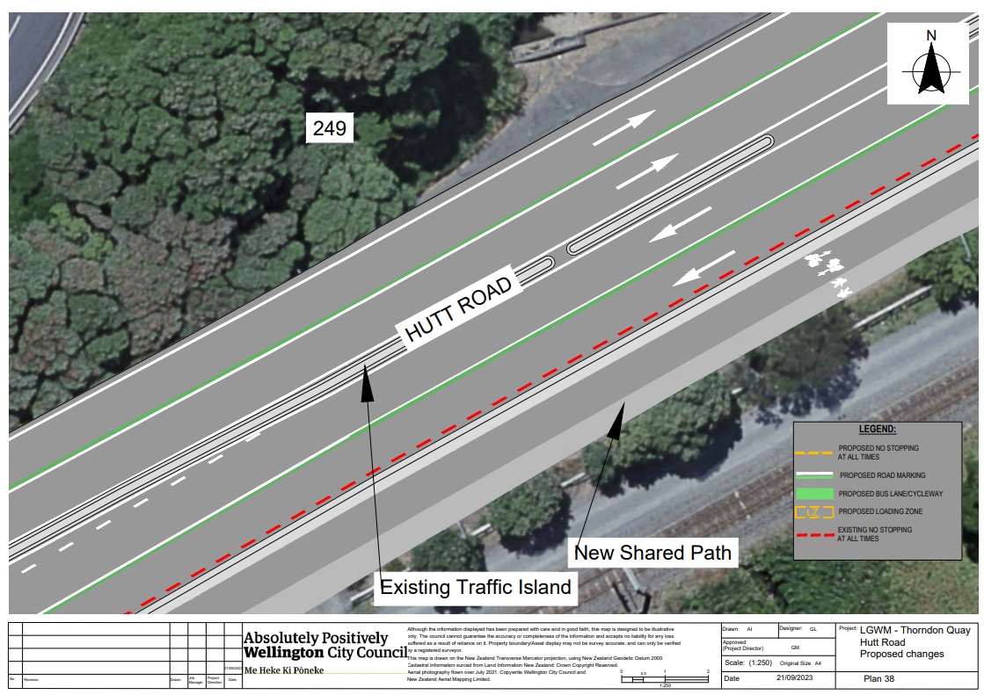
Traffic Resolution Plan: TR 06-24 – Hutt Road from Aotea Quay overbridge to Jarden Mile intersection – Proposed Changes (Plan 39)
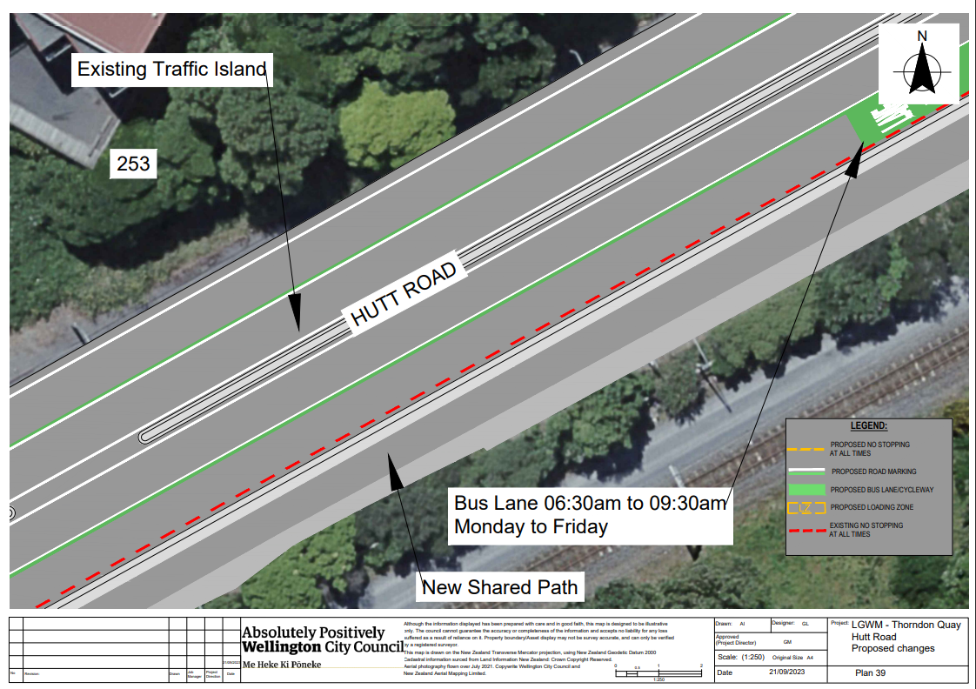
Traffic Resolution Plan: TR 06-24 – Hutt Road from Aotea Quay overbridge to Jarden Mile intersection – Proposed Changes (Plan 40) 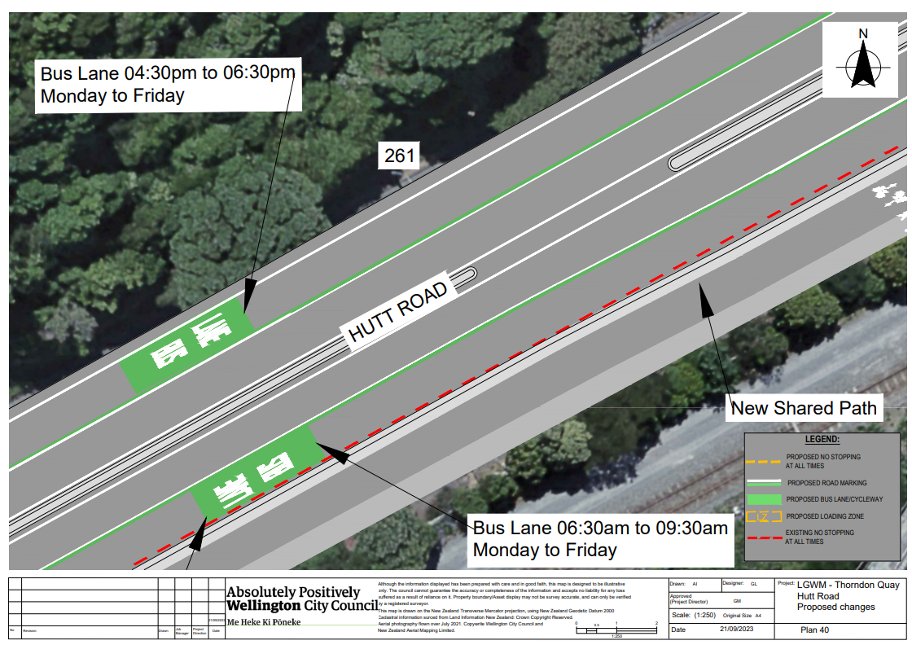
Traffic Resolution Plan: TR 06-24 – Hutt Road from Aotea Quay overbridge to Jarden Mile intersection – Proposed Changes (Plan 41) 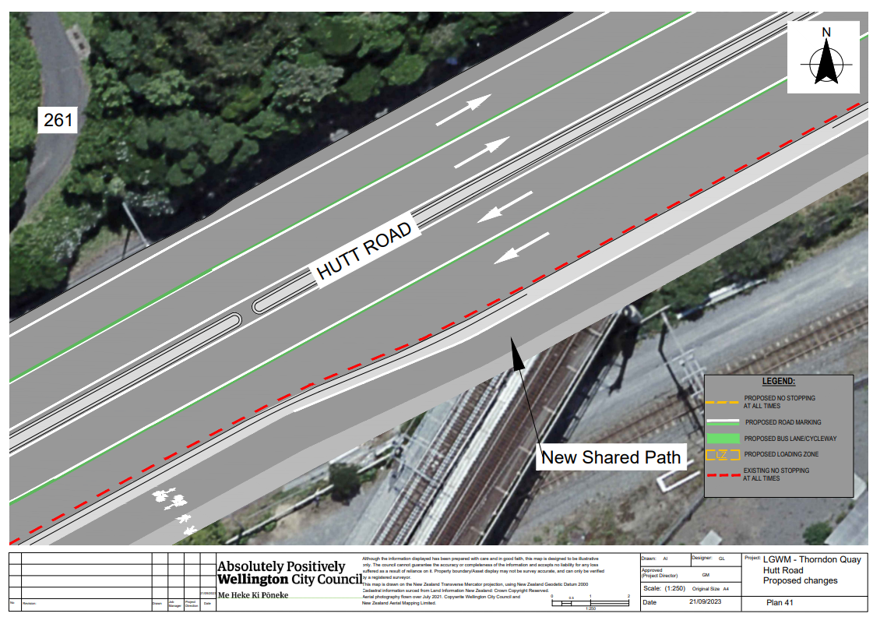
Traffic Resolution Plan: TR 06-24 – Hutt Road from Aotea Quay overbridge to Jarden Mile intersection – Proposed Changes (Plan 42)
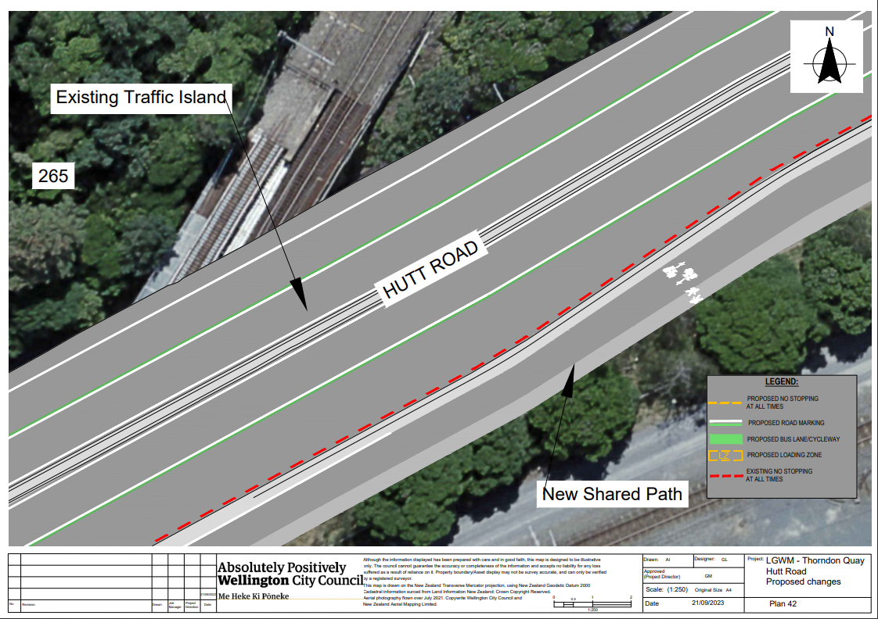
Traffic Resolution Plan: TR 06-24 – Hutt Road from Aotea Quay overbridge to Jarden Mile intersection – Proposed Changes (Plan 43) 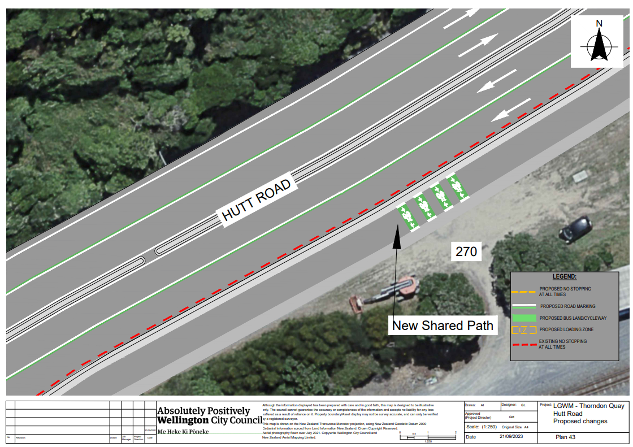
Traffic Resolution Plan: TR 06-24 – Hutt Road from Aotea Quay overbridge to Jarden Mile intersection – Proposed Changes (Plan 44) 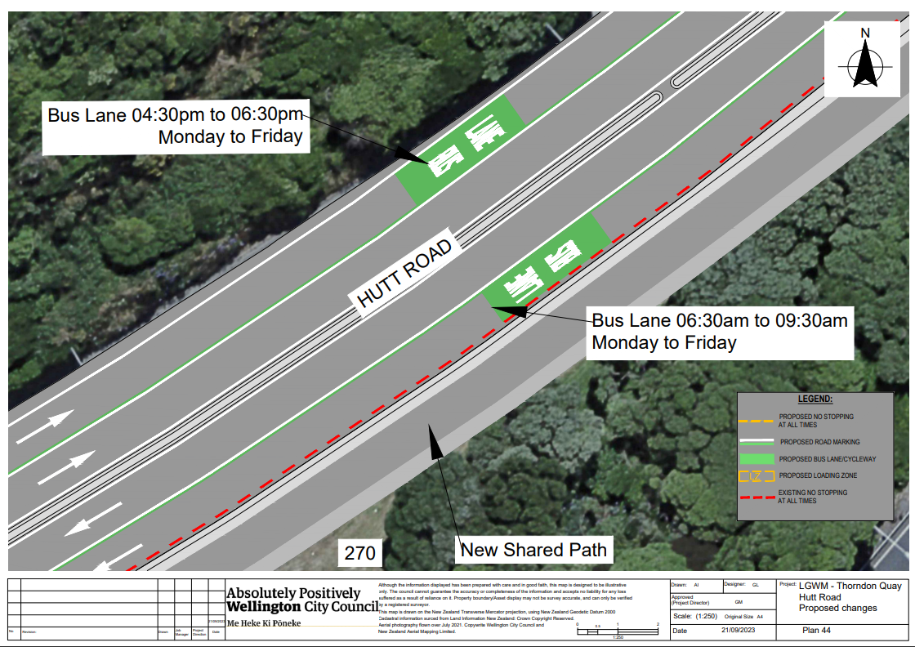
Traffic Resolution Plan: TR 06-24 – Hutt Road from Aotea Quay overbridge to Jarden Mile intersection – Proposed Changes (Plan 45) 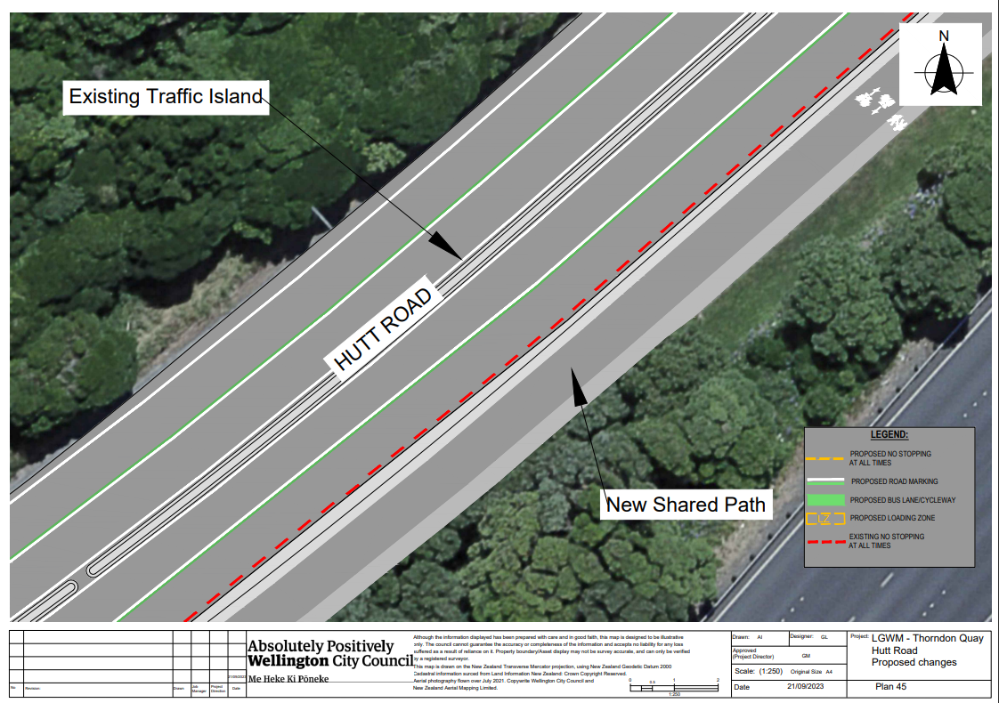
Traffic Resolution Plan: TR 06-24 – Hutt Road from Aotea Quay overbridge to Jarden Mile intersection – Proposed Changes (Plan 46) 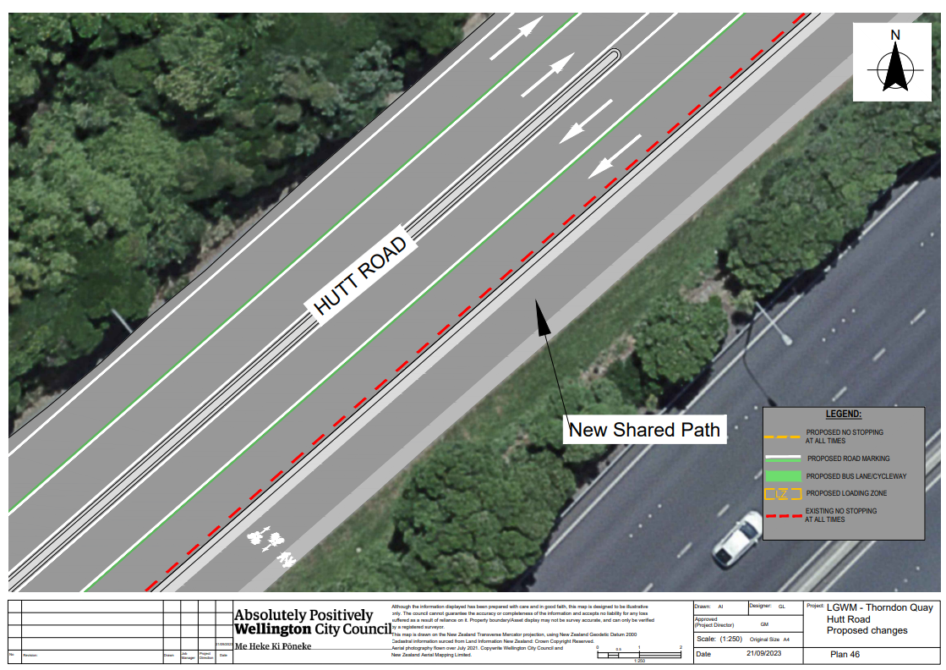
Traffic Resolution Plan: TR 06-24 – Hutt Road from Aotea Quay overbridge to Jarden Mile intersection – Proposed Changes (Plan 47) 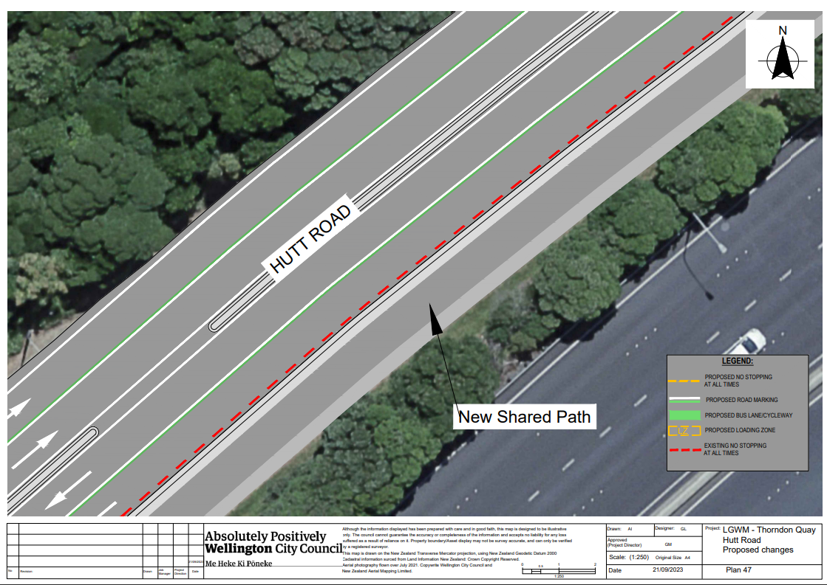
Traffic Resolution Plan: TR 06-24 – Hutt Road from Aotea Quay overbridge to Jarden Mile intersection – Proposed Changes (Plan 48) 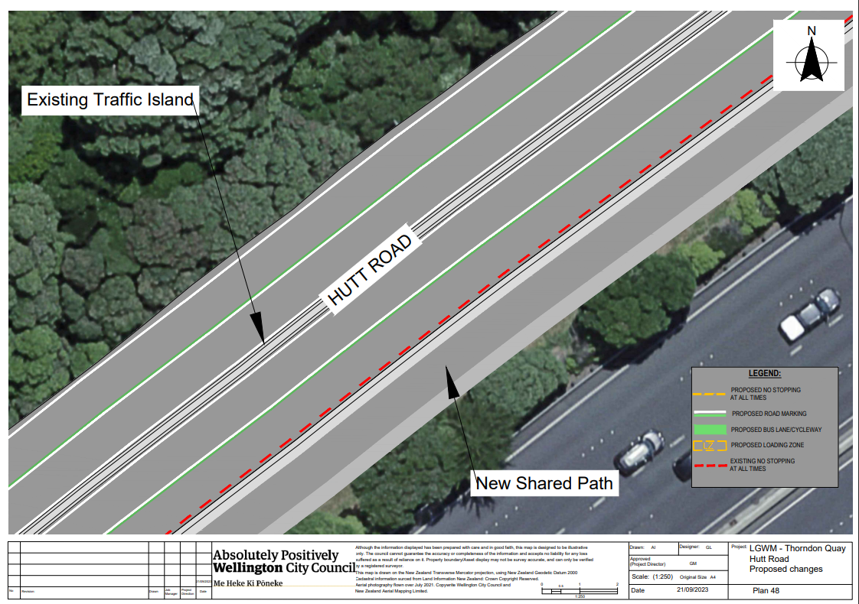
Traffic Resolution Plan: TR 06-24 – Hutt Road from Aotea Quay overbridge to Jarden Mile intersection – Proposed Changes (Plan 49) 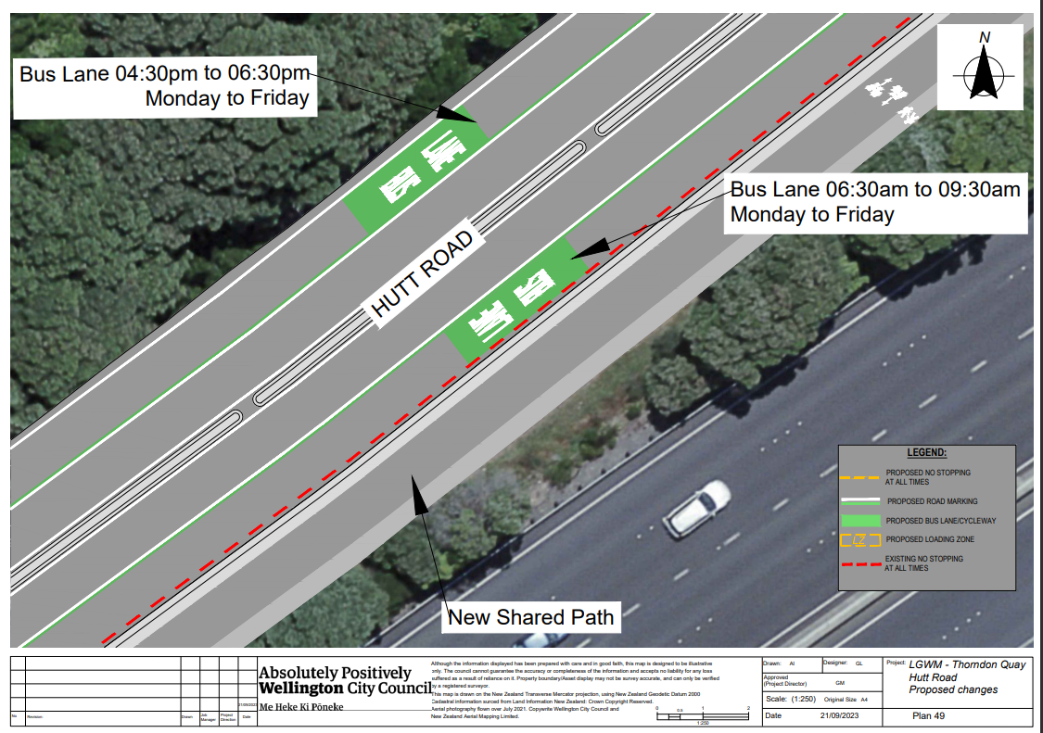
Traffic Resolution Plan: TR 06-24 – Hutt Road from Aotea Quay overbridge to Jarden Mile intersection – Proposed Changes (Plan 50) 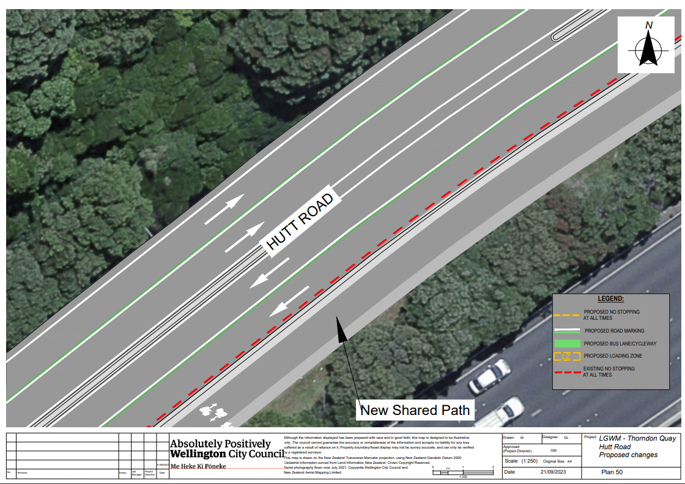
Traffic Resolution Plan: TR 06-24 – Hutt Road from Aotea Quay overbridge to Jarden Mile intersection – Proposed Changes (Plan 51) 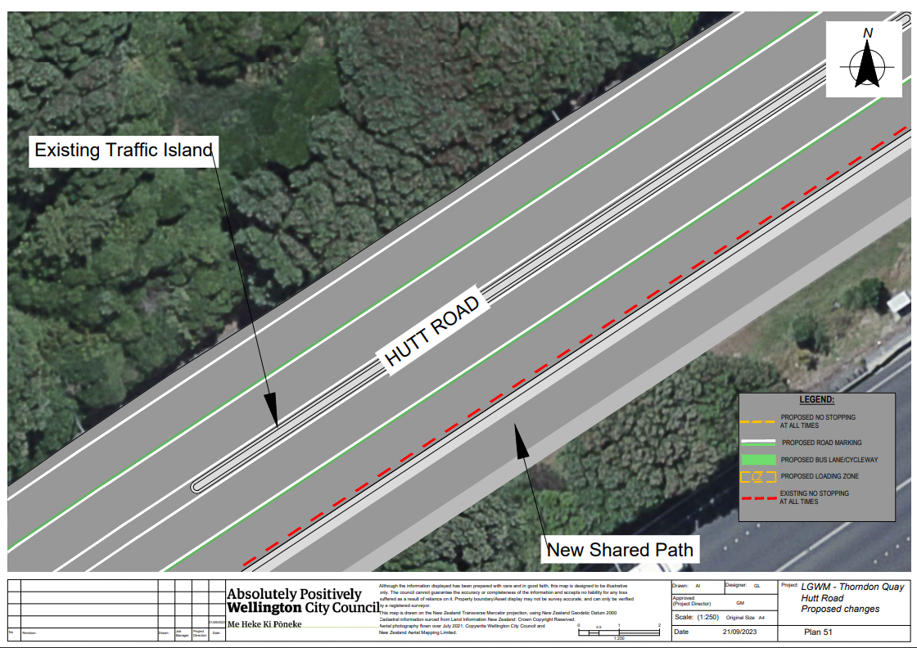
Traffic Resolution Plan: TR 06-24 – Hutt Road from Aotea Quay overbridge to Jarden Mile intersection – Proposed Changes (Plan 52) 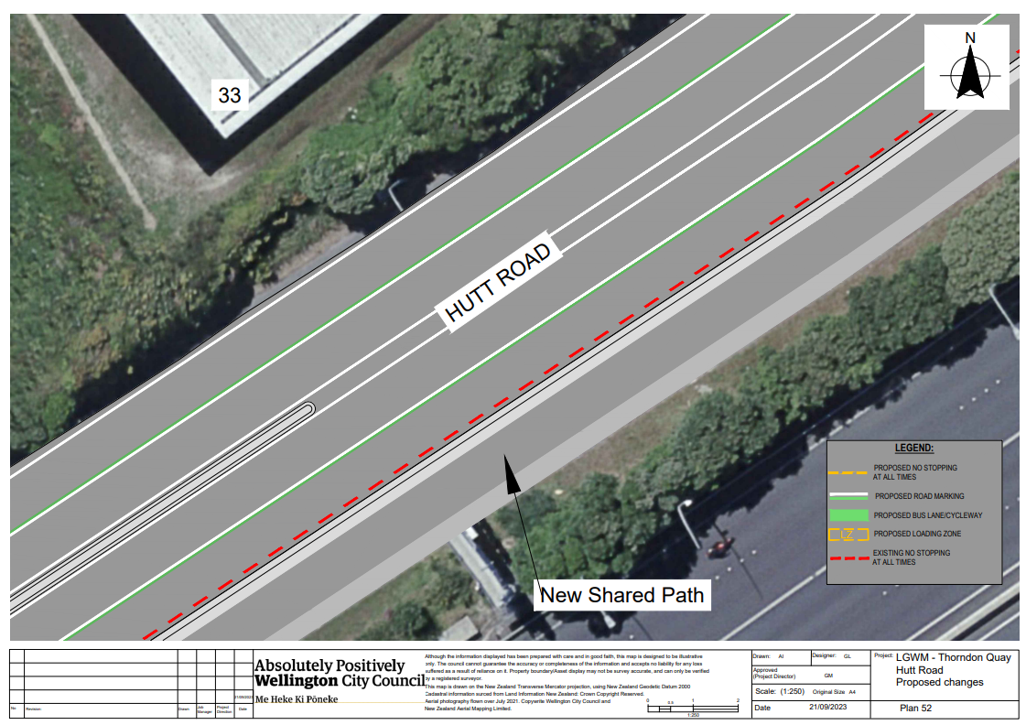
Traffic Resolution Plan: TR 06-24 – Hutt Road from Aotea Quay overbridge to Jarden Mile intersection – Proposed Changes (Plan 53) 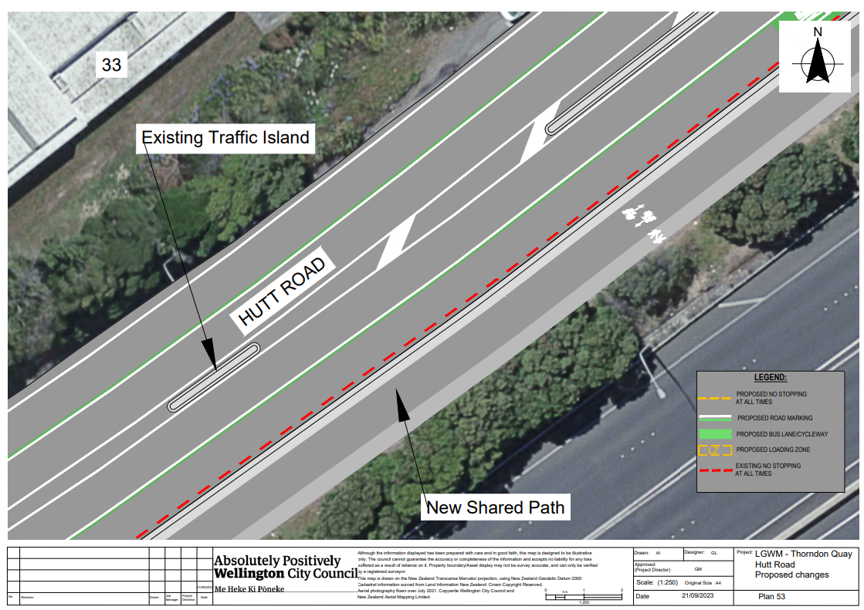
Traffic Resolution Plan: TR 06-24 – Hutt Road from Aotea Quay overbridge to Jarden Mile intersection – Proposed Changes (Plan 54)
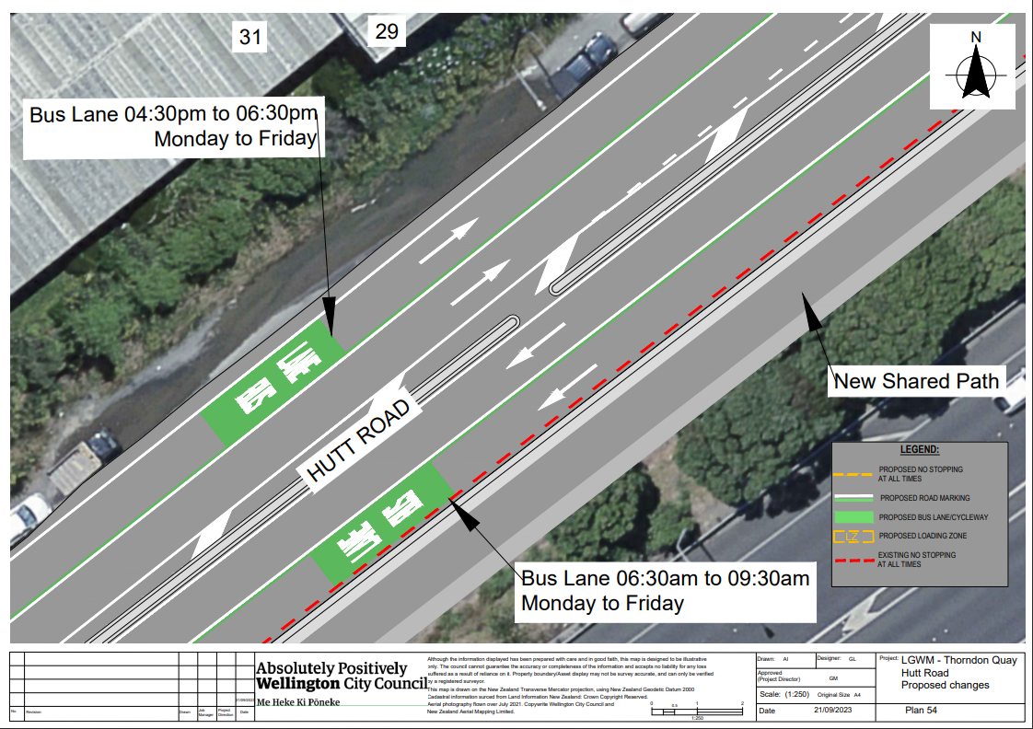
Traffic Resolution Plan: TR 06-24 – Hutt Road from Aotea Quay overbridge to Jarden Mile intersection – Proposed Changes (Plan 55) 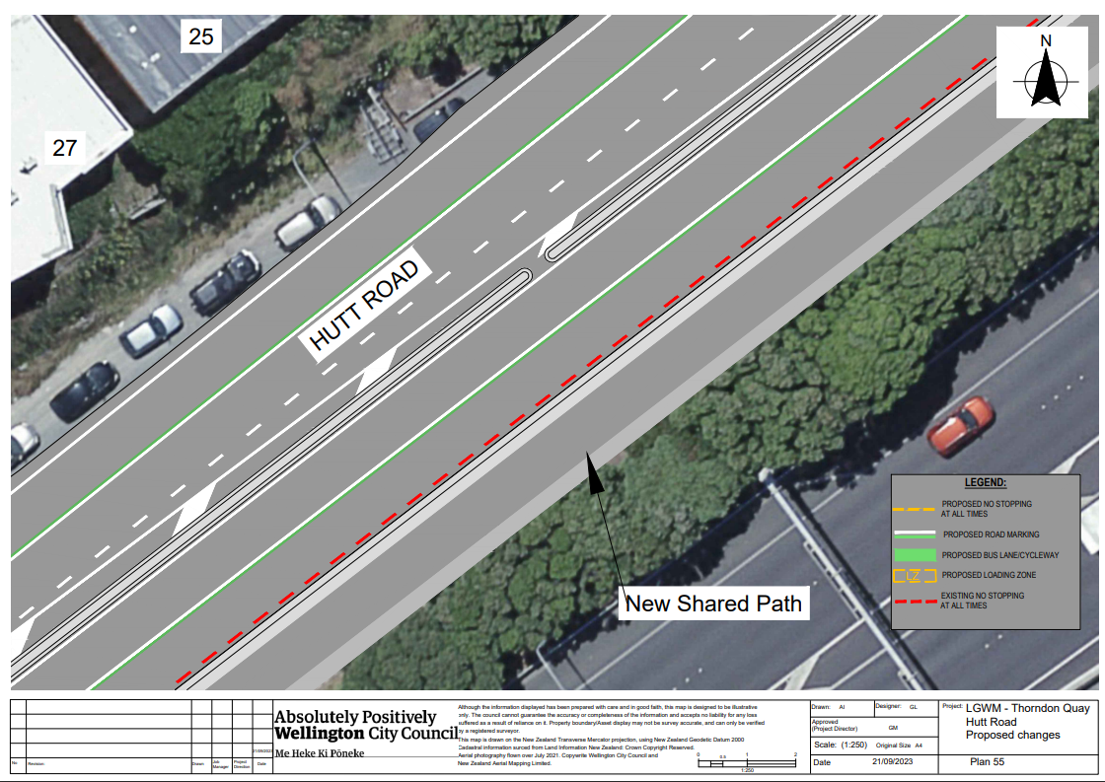
Traffic Resolution Plan: TR 06-24 – Hutt Road from Aotea Quay overbridge to Jarden Mile intersection – Proposed Changes (Plan 56) 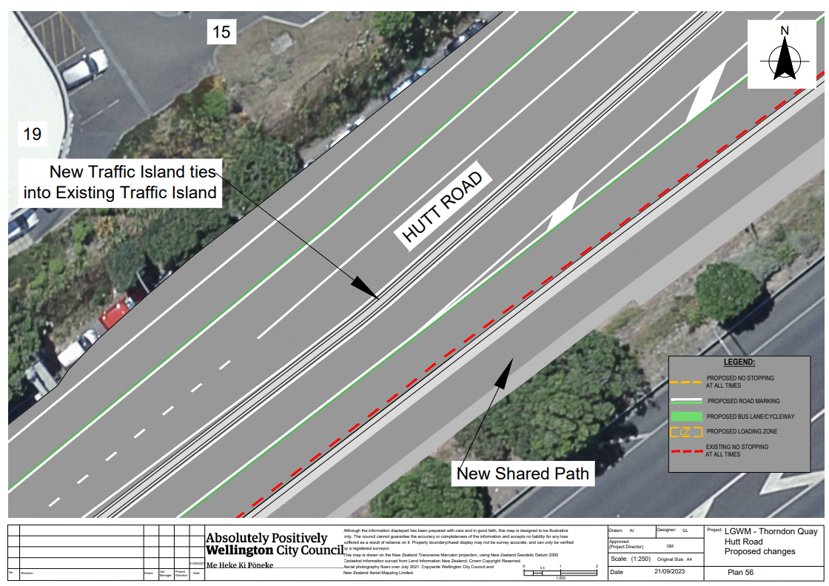
Traffic Resolution Plan: TR 06-24 – Hutt Road from Aotea Quay overbridge to Jarden Mile intersection – Proposed Changes (Plan 57)
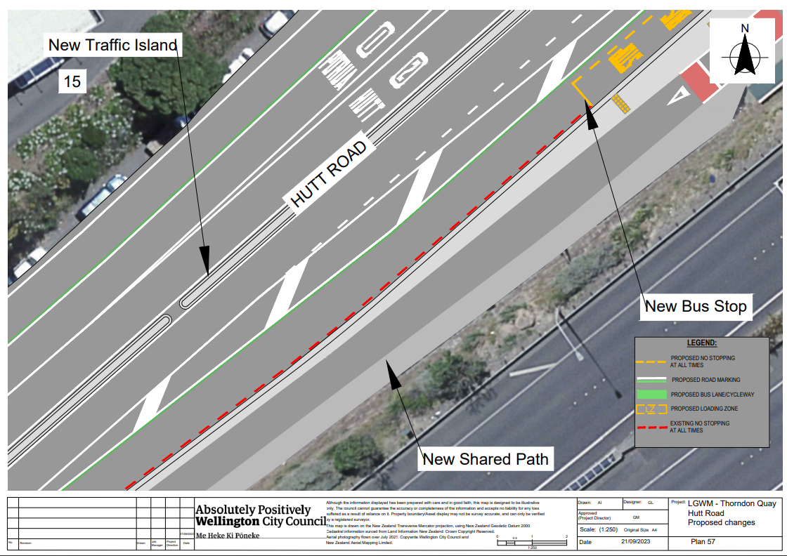
Traffic Resolution Plan: TR 06-24 – Hutt Road from Aotea Quay overbridge to Jarden Mile intersection – Proposed Changes (Plan 58)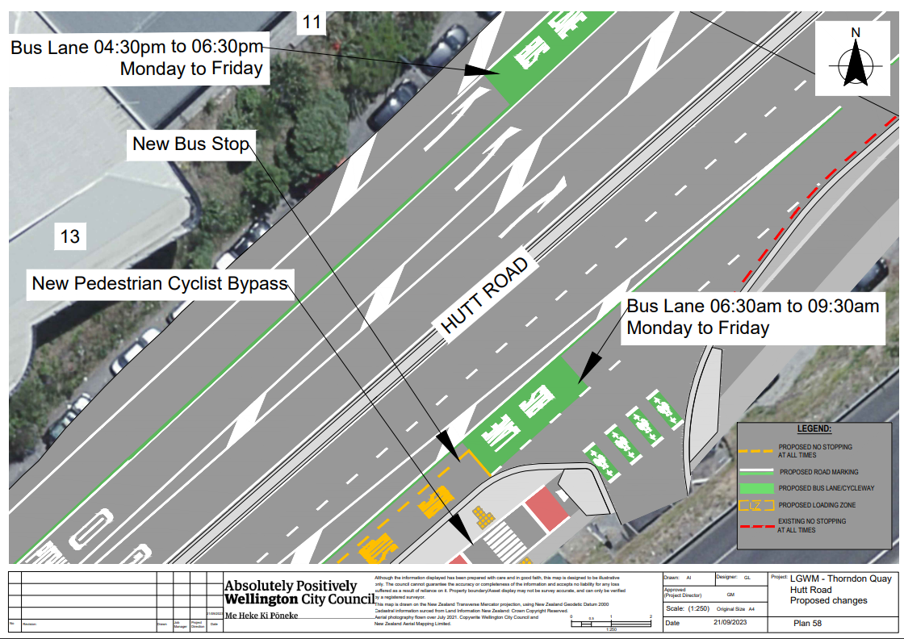 Traffic Resolution Plan: TR 06-24 – Hutt Road from Aotea Quay overbridge to Jarden Mile intersection – Proposed Changes (Plan 59) 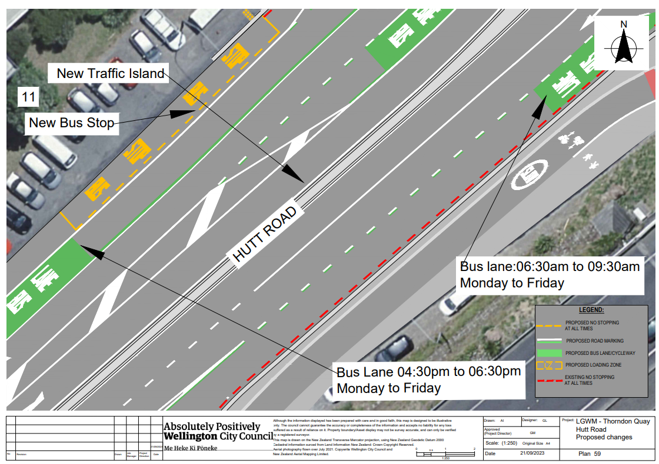 Traffic Resolution Plan: TR 06-24 – Hutt Road from Aotea Quay overbridge to Jarden Mile intersection – Proposed Changes (Plan 60) 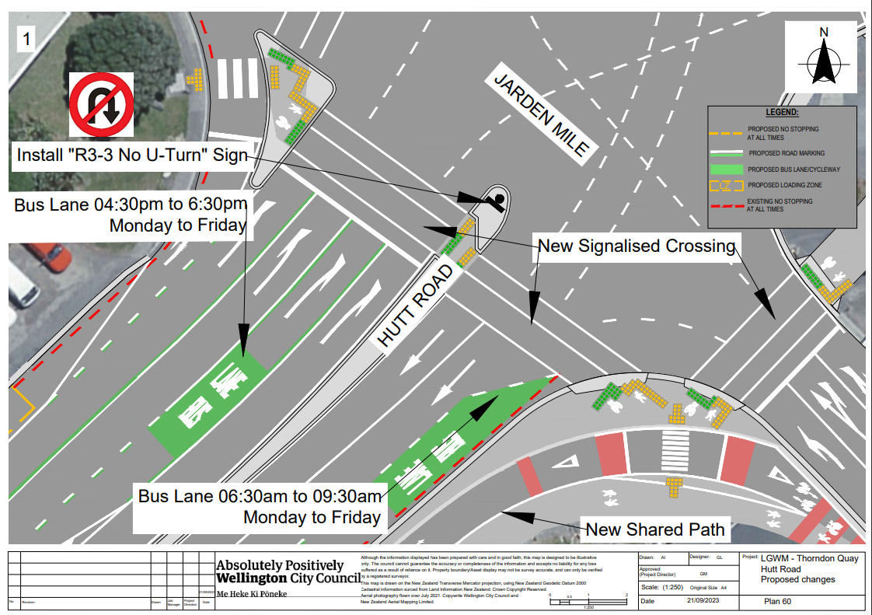 Traffic Resolution Plan: TR 06-24 – Hutt Road from Aotea Quay overbridge to Jarden Mile intersection – Proposed Changes (Plan 61)
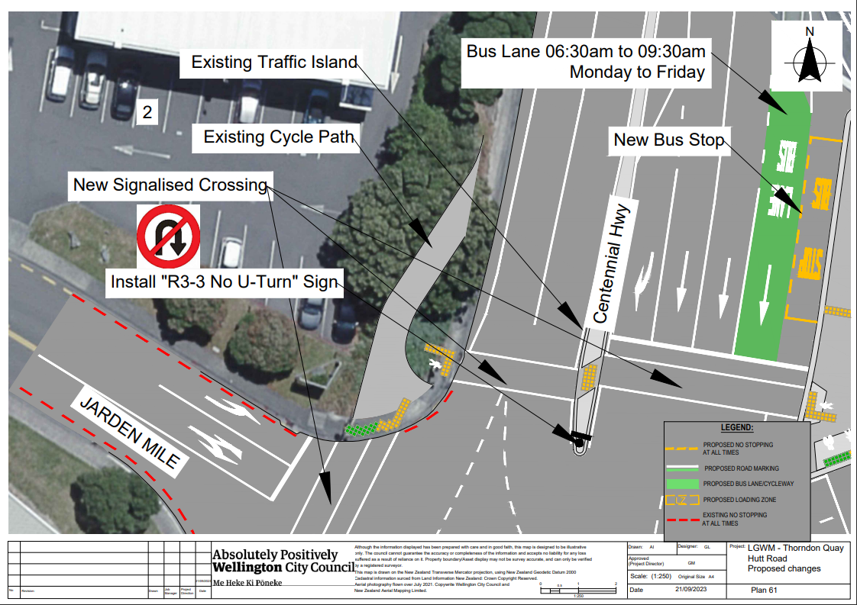
Traffic Resolution Plan: TR 06-24 – Hutt Road from Aotea Quay overbridge to Jarden Mile intersection – Proposed Changes (Plan 62)
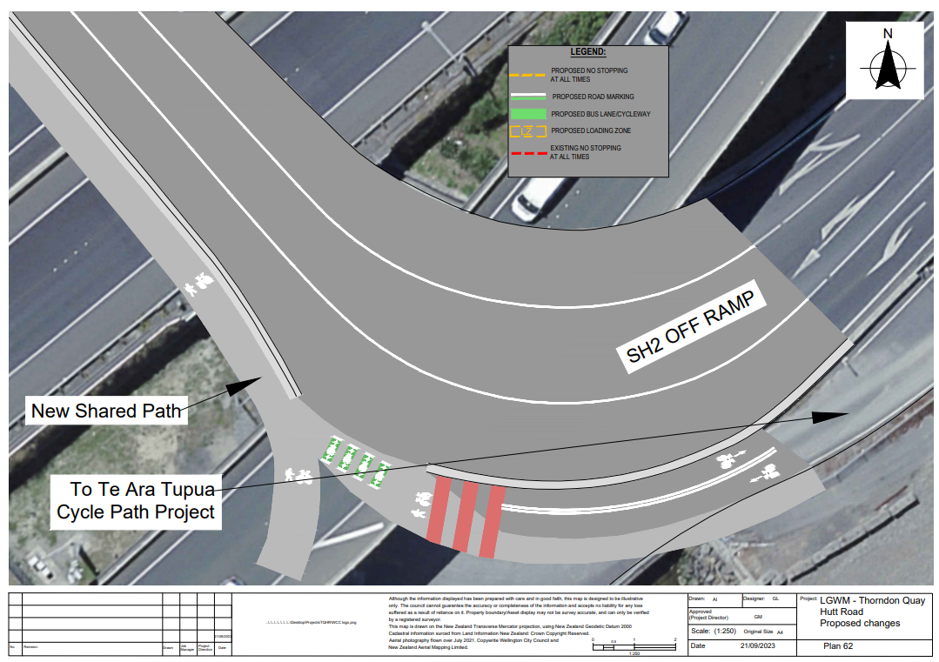
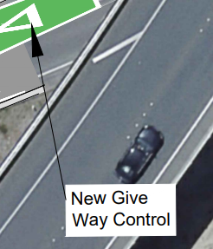
Traffic Resolution Plan: TR 06-24 – Hutt Road from Aotea Quay overbridge to Jarden Mile intersection – Proposed Changes (Plan 63) 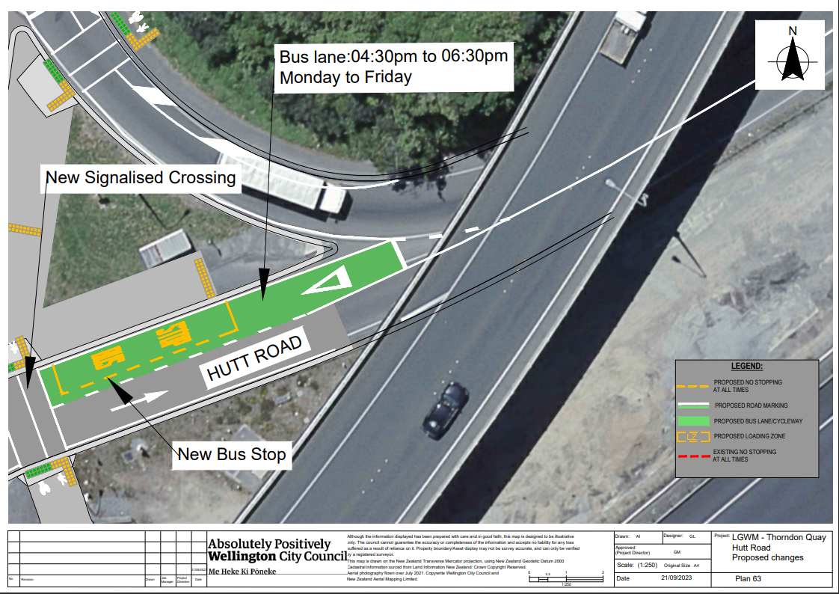 Traffic Resolution Plan: TR 06-24 – Hutt Road from Aotea Quay overbridge to Jarden Mile intersection – Proposed Changes (Plan 64)
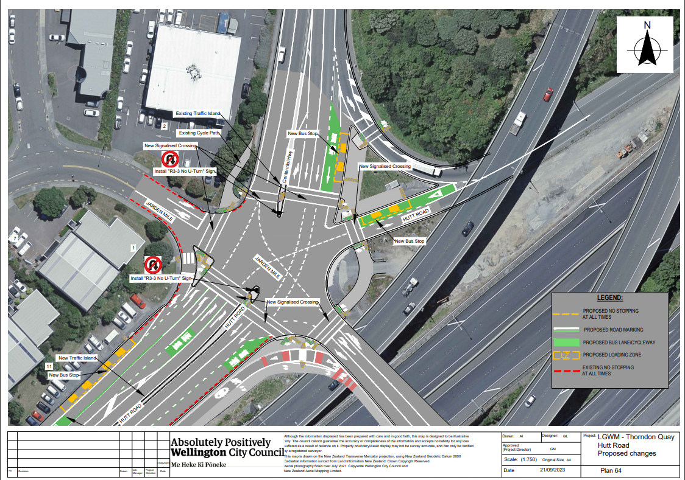
Legal Descriptions:
Delete from Schedule A (Time Limited) of the Traffic Resolutions Schedule
Column One | Column Two | Column Three
Hutt Road | P10, At All Times | East side, following the kerbline 540 metres North of its intersection with Kaiwharawhara Road (Grid coordinates 1750314.3 m,5431166.7 m) and extending in the North direction for 11 metres. (2 Car Parks)

Delete from Schedule B (Class Restricted) of the Traffic Resolutions Schedule
Column One | Column Two | Column Three
Hutt Road | Bus Stop,  At All Times | East side, following the kerbline 129 metres South of its intersection with Jarden Mile (Grid coordinates 1751866.9 m,5432122.2 m) and extending in the South direction for 11 metres.
Hutt Road | Bus Stop,  At All Times | West side, following the kerbline 595 metres South of its intersection with Kaiwharawhara Road (Grid coordinates 1749536.7 m,5430431.6 m) and extending in the South direction for 15 metres.
Hutt Road | Bus Stop,  At All Times | East side, following the kerbline 560 metres South of its intersection with Kaiwharawhara Road (Grid coordinates 1749521.9 m,5430395.2 m) and extending in the South direction for 13 metres.
Hutt Road | Loading Zone | East side, following the kerbline 195 metres North of its intersection with Kaiwharawhara (Grid coordinates 1750050.221m, 5430941.095m) and extending in the North direction for 6 metres. (1 Space)

Delete from Schedule D (No Stopping) of the Traffic Resolutions Schedule
Column One | Column Two | Column Three
Centennial Highway | Clearway:  7:00am to 9:30am Monday to Friday | East side, following the kerbline 30 metres South of its intersection with Jarden Mile (Grid coordinates 1751949.632m, 5432246.4504 m) and extending in the South direction for 3200 metres.
Hutt Road | Clearway:  7:00am to 9:30am Monday to Friday | East side, commencing 662 metres north of its intersection with Kaiwharawhara Road, (Grid coordinates x= 1750364.0m, y= 5431208.3m) and extending in a southerly direction for 143.1 metres

Add to Schedule B (Class Restricted) of the Traffic Resolutions Schedule
Column One |  | Column Two | Column Three
Hutt Road | Bus Stop,  At All Times |  | West side, following the kerbline 820 metres North of its intersection with Kaiwharawhara Road (Grid coordinates 1750521.2 m,5431318.4 m) and extending in the Northerly direction for 15 metres.
Hutt Road | Bus Stop,  At All Times |  | West side, following the kerbline 60 metres South of its intersection with Jarden Mile (Grid coordinates 1751890.8 m,5432173.6 m) and extending in the Southerly direction for 30 metres.
Hutt Road | Bus Stop,  At All Times |  | East side, following the kerbline 140 metres South of its intersection with Jarden Mile (Grid coordinates 1751859.2 m,5432115.7 m) and extending in the Southerly direction for 15 metres.
Centennial Highway | Bus Stop,  At All Times |  | East side, following the kerbline 30 metres North of its intersection with Jarden Mile (Grid coordinates 1751950.3 m,5432222.7 m) and extending in the Easterly direction for 10 metres.
Hutt Road On Ramp | Bus Stop,  At All Times |  | North side, following the kerbline 30 metres East of its intersection with Jarden Mile (Grid coordinates 1751959.5 m,5432209.6 m) and extending in the Northerly direction for 20 metres.
Centennial Highway | Bus lane: 6:30am to 9:30am Monday to Friday |  | East side, following the kerbline 30 metres North of its intersection with Jarden Mile (Grid coordinates 1751949.632m, 5432246.4504 m) and extending in the Southerly direction for 3200 metres.
Hutt Road | Bus lane: 4:30pm to 6:30pm Monday to Friday |  | West side, following the kerbline 20 metres South of its intersection with Kaiwharawhara Road (Grid coordinates 1749874.200m, 5430759.348m) and extending in the Northerly direction for 2600 metres.
Hutt Road |  | P10 Loading Zone, At All Times, Goods Vehicles and Authorised Vehicles Only | East side, following the kerbline 540 metres North of its intersection with Kaiwharawhara Road (Grid coordinates 1750314.3 m,5431166.8 m) and extending in the Northerly direction for 11 metres.

Add to Schedule C (Turning and One Way Restrictions) of the Traffic Resolutions Schedule
Column One | Column Two | Column Three
Rangiora Avenue | No Right Turn,  At All Times | At the intersection with Hutt Road. Southbound traffic, no right turn to Hutt Road. (Grid coordinates 1750484.673m, 5431305.401m).
Hutt Road | No U-Turn,  At All Times | Northbound traffic, no u-turn at Rangiora Avenue intersection at #188 Hutt Road. (Grid coordinates 1750480.733m, 5431291.645m).
Hutt Road | No U-Turn,  At All Times | Southbound traffic, no u-turn at #202 Hutt Road. (Grid coordinates 1750510.606m, 5431305.871m).
Hutt Road | No U-Turn,  At All Times | Southbound traffic, no u-turn to Hutt Road northbound. At #214 Hutt Road (Caltex turn around area) (Grid coordinates 1750700.908 m, 5431366.283 m).
Hutt Road | No U-Turn,  At All Times | Northbound traffic, no u-turn at Onslow Road intersection to Hutt Road southbound. (Grid coordinates 1750819.220m, 5431420.300m).
Hutt Road | No U-Turn,  At All Times | Southbound traffic, no u-turn at Onslow Road intersection to Hutt Road northbound (Grid coordinates 1750854.579m, 5431440.520m).
Hutt Road | No U-Turn,  At All Times | Northbound traffic, no u-turn at Jarden Mile intersection to Hutt Road southbound. (Grid coordinates 1751927.412m, 5432190.078m).
Centennial Highway | No U-Turn,  At All Times | Southbound traffic, no u-turn at Jarden Mile intersection to Centennial Highway northbound. (Grid coordinates 1751934.081m, 5432212.837m).

Add to Schedule D (No Stopping) of the Traffic Resolutions Schedule
Column One | Column Two | Column Three
Hutt Road | No Stopping,  At All Times | East side, following the kerbline 920 metres North of its intersection with Kaiwharawhara Road (Grid coordinates 1750667.103 m, 5431347.012 m) and extending in the North direction for 46 metres.
Hutt Road | No Stopping,  At All Times | West side, following the kerbline 75 metres South of its intersection with Kaiwharawhara Road (Grid coordinates 1749876.031 m, 5430770.019 m) and extending in the South direction for 75 metres.
Hutt Road | No Stopping,  At All Times | West side, following the kerbline 595 metres South of its intersection with Kaiwharawhara Road (Grid coordinates 1749536.7 m,5430431.6 m) and extending in the South direction for 15 metres.
Hutt Road | No Stopping,  At All Times | East side, following the kerbline 560 metres South of its intersection with Kaiwharawhara Road (Grid coordinates 1749521.9 m,5430395.2 m) and extending in the South direction for 13 metres.

Add to Schedule G (Give Way & Stop) of the Traffic Resolutions Schedule
Column One | Column Two | Column Three
Hutt Road | Give Way | East side, following the kerbline 920 metres At its western approach to its intersection with Kaiwharawhara Road (Grid coordinates 1750668.773m, 5431347.511m) and extending in the North direction for 12 metres. Adjacent to #214 Hutt Road.
Hutt Road | Give Way | East side, following the kerbline 55 metres North of its intersection with Jarden Mile (Grid coordinates 1751986.941m, 5432221.067m). At Bus Stop on northbound onramp Hutt Road / SH2.

Add to Schedule I (Cycle Lane) of the Traffic Resolutions Schedule
Column One | Column Two | Column Three
Hutt Road | Bi-directional Shared Path | East side, following the kerbline 40 metres south of its intersection with Jarden Mile (Grid coordinates 1751946.4 m,5432167.4 m) and extending in the Southwesterly direction for 1620 metres.

Prepared By: | Kylie Hook | Principal Advisor – Transport LGWM
Approved By: | Brad Singh | Manager Transport and Infrastructure
Date: | 2 November 2023

