Kia ora,

We would like to inform you about a proposed change in your neighbourhood.

Proposal:

Reference | - TR44-26 Glasgow Street & Central Terrace, Kelburn – No Right Turn
Location – where we propose to make the change | At the intersection of Glasgow Street and Central Terrace, Kelburn.
What we’d like to do | - Install a No Right Turn sign from Central Terrace onto Glasgow Street.  - Formalise the existing give way control at the intersection of Central Terrace and Glasgow Street. This would add the resolution to our database and not result in any physical changes.
Why we are proposing the change | - We have received public concerns through feedback on a recently consulted Traffic Resolution (TR11-26) regarding this intersection, specifically about limited sight distance for vehicles looking right at the intersection of Central Terrace and Glasgow Street.  - The public feedback stated that while many local vehicles already only make a left turn from Central Terrace at this intersection to then do a u-turn at the roundabout of Glasgow Street and Upland Road, there are visitors or taxi drivers departing Central Terrace who may still make a right turn here.  - A site visit has identified that the minimum sight distance length looking in both directions at this intersection is not achieved due to the horizontal and vertical curves of Glasgow Street and Central Terrace.  - Removing the right turn from Central Terrace onto Glasgow Street will decrease the risk of a crash at this intersection as vehicles won’t need to cross two lanes of traffic and will spend less time waiting for gaps.  - Feedback identified that there is local support for a No Right Turn restriction from Central Terrace at this intersection.  - Vehicles will be able to make a left turn from Central Terrace onto Glasgow Street and then use the roundabout at Glasgow Street and Upland Road to turn around and drive southbound on Glasgow Street.
Impact | - Improves safety and accessibility for vehicles.  - Net parking impact – none.
Other options considered | Option 1:  - Redesigning the intersection will be major to improve the sight distance which is not possible under a Low-cost Low risk programme.  Option 2:  - Slowing vehicles down on Glasgow Street which would decrease the minimum sight distance required is not permitted as we are not able to change the speed limit to under 50km/h for Glasgow Street as it is in the category of Urban Connector in the One Network Framework. The Land Transport Rule: Setting of Speed Limits 2024 sets out permissible speed limits for different categories of roads, and Urban Connectors cannot be less than 50km/h. Additionally, 85% of current speeds driven down Glasgow Street are below 50km/h, which is low enough that it would not be justifiable to install traffic calming devices on Glasgow Street.
How this relates to the parking policy | - Support safe movement – facilitate the safe and efficient movement of people and goods by focusing on people moving along transport corridors rather than people parking or storing stationary vehicles.
Additional Information | - Average daily traffic count - Central Terrace 470 vehicles per day, Glasgow Street 9,461 vehicles per day.  - An electronic copy of the report will be available on the Council’s website from 9.00am 15 April 2026 at https://www.letstalk.wellington.govt.nz/
Privacy | - Your privacy is important to us. Please DO NOT add specific personal details to your feedback (i.e.: full name, address, etc)  - What we do with your personal information:  All submissions (including your first name, but not contact details) are provided in their entirety to elected members and made available to the public on our website and at our office. Personal information (including contact details) will also be used for the administration of the consultation process including informing you of the outcome of the consultation. All information collected will be held by Wellington City Council, with submitters having the right to access and correct personal information.  - For more information regarding our Privacy Statement please check our webpage: Privacy statement - Wellington City Council.
Feedback | - If you would like to provide us with specific feedback, which will be added to the Traffic Resolution following consultation and made public in full, you can do so by filling out an online submission form, downloading a printable submission form on https://www.letstalk.wellington.govt.nz/ or emailing us at trfeedback@wcc.govt.nz.  Please note if you are giving feedback the consultation period opens at 9.00am 15 April 2026 and finishes at 5.00pm 30 April 2026.
Next Steps | - Feedback collated by 1 May 2026.  - The proposal will go to the Te Takere|Regulatory Processes Committee meeting on 3 June 2026.  - If approved, the proposal will be installed within the following six months.

Traffic Resolution Plan: TR44-26 Glasgow Street and Central Terrace, Kelburn – No Right Turn

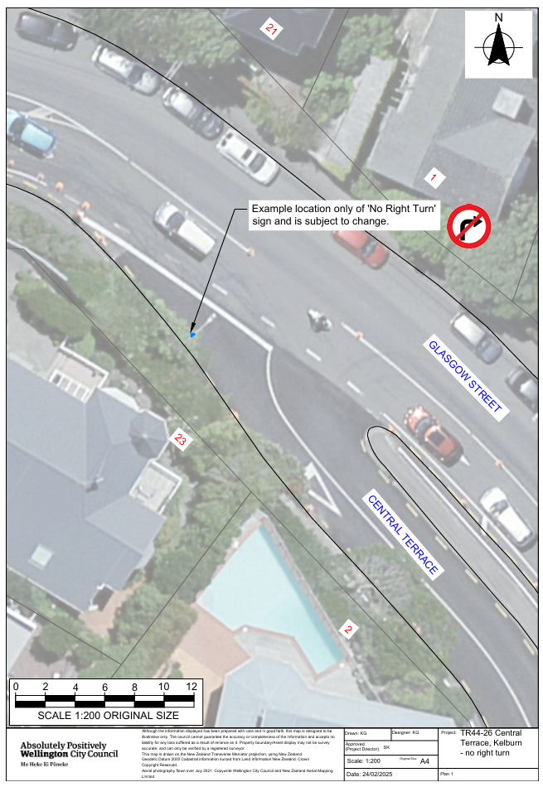

Legal Description:

Add to Schedule C (Direction) of the Traffic Restrictions Schedule

Column One | Column Two | Column Three
Central Terrace | No Right Turn, at all times | At its intersection with Glasgow Street.

Add to Schedule G (Give Way and Stop Control) of the Traffic Restrictions Schedule

Column One | Column Two | Column Three
Central Terrace | Give Way Control | At its intersection with Glasgow Street.

Prepared By: | Kaylie Gleeson | Intermediate Transport Engineer
Approved By: | Kate Gourdie | (Team Leader Traffic & Resolutions)
Approved Date: | 16/03/2026

