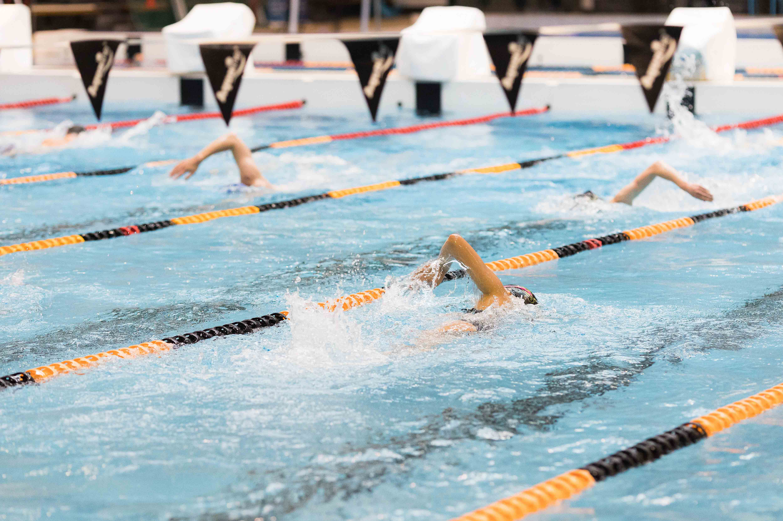

Ngā whare me ngā ratonga mahi ā-rēhia
Recreation facilities and services
Background report

March 2026
January 2026

Contents

Purpose 2
Council Activities 2
What we do as a Council 3
Budget 4
Recreation Funding Sources 6
Why is this activity important? 7
Current direction 8
Direction from legislation and national regulations 8
Regional settings 8
Wellington City Council settings 9
Indicators and trends 11
Stakeholder views about recreation facilities and services 12
Māori and Tākai Here partners’ views and aspirations for recreation 14
Key issues and opportunities 15
Ageing infrastructure, financial constraints, and geographic disparity in recreation provision 16
Ageing and outdated infrastructure 16
Financial constraints 16
Geographic disparity and equity gaps 16
Future Directions 17
Changing patterns of recreation and greater diversity of needs 17
Not all facilities are fully accessible 18
Cultural inclusion 19
Māori inclusion and te ao Māori partnerships 19
Addressing climate resilience and sustainable development 19
Climate action and resilience 20
Ensuring strategic and sustainable development 21

Purpose
This background report provides a clear, evidence‑based overview of Wellington City Council’s Recreation facilities and services activity. It sets out what the Council does, why it does it, how it is funded, how it is performing, and the key issues shaping future choices.

The report is intended to support informed engagement with the Council’s role in Recreation facilities and services. It provides advisory groups with shared context on Council responsibilities, settings, constraints, and strategic direction, and supports elected members by bringing together relevant information, performance insights, stakeholder views, and emerging challenges to inform deliberations through the Long-term Plan (LTP) 2027–2037 process.

This is not a strategy or a set of recommendations. Rather, it is a foundation document that identifies current settings, pressures, and opportunities, and surfaces the key trade‑offs that will need to be considered as the Council refreshes its strategic direction and investment approach for Recreation facilities and services within a constrained fiscal environment.

Council Activities
A Council ‘activity’ is a formal Local Government Act 2002 (LGA 2002) term to refer to Council goods and services. Council activities are grouped for the purposes of the Long-term Plan and budgets – some are relatively stand-alone like transport.

This group of activities includes:
5.1 Recreation Facilities and Services
5.1.1 Swimming Pools
5.1.2 Sportsfields
5.1.3 Recreation Programmes
5.1.4 Recreation Centres
5.1.5 Recreation Partnerships
5.1.6 Playgrounds
5.1.7 Marinas
5.1.8 Golf Course
5.1.9 LeisureCard

What we do as a Council
The Council manages an extensive and diverse network of recreational facilities and services to support Wellingtonians’ active lifestyles and community engagement.
This includes 7 public swimming pools, 4 indoor recreation centres, and the 12-court Ākau Tangi Sports Centre.

Across the city, residents have access to 44 natural sports fields and 11 artificial turfs, catering to various sports throughout the year. There are approximately 107 playgrounds and 7 skate parks, providing spaces for children and young people to play and connect.
In addition, the Council manages two fitness centres, a 'Learn to Swim' programme, athletics track, tennis and netball courts.

The Council also manages specialised facilities such as a marina, 7 public boat ramps, a boat harbour and an 18-hole golf course.

The Council also runs initiatives like the LeisureCard, a programme to support discounting of recreation activities so they remain accessible to everyone, and maintains strong relationships with Sport NZ, Regional Sports Organisations (RSOs), and Nuku Ora to support the broader sport ecosystem.

Budget
You can find more information in the LTP 2024 Amendment.
Percentage of total council spend:
Opex – 6.3%
Capex – 2.1%

Operational Expenditure
Activity Component Name | Income/ Expense | 2024/25 | 2025/26 | 2026/27 | 2027/28 | 2028/29 | 2029/30 | 2030/31 | 2031/32 | 2032/33 | 2033/34
5.1.1 Swimming Pools | Expense | 35,409 | 35,909 | 37,867 | 38,684 | 40,089 | 41,423 | 42,571 | 44,038 | 44,889 | 46,209
5.1.1 Swimming Pools | Income | (8,900) | (9,257) | (9,521) | (9,543) | (10,052) | (9,885) | (10,351) | (10,497) | (10,584) | (10,801)
5.1.2 Sportsfields | Expense | 7,886 | 7,587 | 8,095 | 8,751 | 9,467 | 9,860 | 10,090 | 10,408 | 10,507 | 10,929
5.1.2 Sportsfields | Income | (1,023) | (1,121) | (1,087) | (1,111) | (1,134) | (1,157) | (1,179) | (1,201) | (1,224) | (1,246)
5.1.3 Recreation Programmes | Expense | 637 | 617 | 631 | 642 | 634 | 647 | 658 | 668 | 677 | 690
5.1.3 Recreation Programmes | Income | (105) | (61) | (63) | (64) | (65) | (67) | (68) | (69) | (70) | (72)
5.1.4 Recreation Centres | Expense | 13,305 | 13,718 | 14,475 | 14,737 | 15,103 | 15,779 | 16,024 | 16,447 | 17,114 | 17,458
5.1.4 Recreation Centres | Income | (2,763) | (2,999) | (2,912) | (2,976) | (3,039) | (3,100) | (3,159) | (3,219) | (3,280) | (3,339)
5.1.5 Recreation partnerships | Expense | 2,691 | 2,727 | 3,128 | 3,081 | 3,204 | 3,366 | 3,717 | 4,076 | 4,367 | 4,584
5.1.6 Playgrounds | Expense | 1,768 | 1,981 | 2,365 | 2,609 | 2,810 | 2,951 | 3,087 | 3,239 | 3,381 | 3,549
5.1.7 Marinas | Expense | 976 | 977 | 1,012 | 1,084 | 1,129 | 1,231 | 1,275 | 1,362 | 1,371 | 1,419
5.1.7 Marinas | Income | (795) | (951) | (1,066) | (1,090) | (1,112) | (1,135) | (1,156) | (1,178) | (1,201) | (1,222)
5.1.8 Golf Course | Expense | 291 | 269 | 281 | 288 | 295 | 304 | 311 | 317 | 323 | 331
5.1.8 Golf Course | Income | (81) | (82) | (84) | (86) | (88) | (90) | (91) | (93) | (95) | (97)
5.1.9 LeisureCard | Expense | 101 | 144 | 145 | 148 | 150 | 155 | 158 | 161 | 164 | 168
Total |  | 49,396 | 49,457 | 53,265 | 55,154 | 57,390 | 60,283 | 61,888 | 64,460 | 66,340 | 68,561
Capital Expenditure
Activity Component Name | 2024/25 Published budget | 2024/25 Amendment budget | 2025/26 | 2026/27 | 2027/28 | 2028/29 | 2029/30 | 2030/31 | 2031/32 | 2032/33 | 2033/34
5.1.1 Swimming Pools | 4,450 | 1,982 | 7,410 | 7,120 | 8,878 | 5,989 | 6,085 | 1,398 | 2,340 | 2,784 | 2,622
5.1.2 Sportsfields | 2,490 | 2,283 | 1,711 | 9,063 | 5,760 | 1,220 | 2,055 | 2,196 | 574 | 3,111 | 4,960
5.1.4 Recreation Centres | 240 | 240 | 755 | 2,962 | 132 | 550 | 432 | 138 | 1,182 | 1,590 | 8,479
5.1.5 Recreation partnerships | 437 | 1,037 | 136 | 184 | 314 | 690 | 2,883 | 969 | 1,668 | 406 | 304
5.1.6 Playgrounds | 2,699 | 2,599 | 6,125 | 3,411 | 3,196 | 2,080 | 1,852 | 1,759 | 2,082 | 2,700 | 2,002
5.1.7 Marinas | 1,231 | 1,891 | 254 | 1,225 | 166 | 2,357 | 201 | 59 | 479 | 109 | 177
Total | 11,547 | 10,032 | 16,391 | 23,966 | 18,447 | 12,888 | 13,508 | 6,521 | 8,324 | 10,700 | 18,544

Design and engagement of Grenada North Park sports field upgrades and commence works in Year 2. This will result in an improvement to sports field provision in Grenada North. A destination skate park is to be constructed at Kilbirnie Park.
Through the 2024 LTP, Council also agreed to allocate $14m from the Climate Resilience Fund to degasify the full pool network.

Recreation Funding Sources

Recreation Activity | User Fees | Rates
Swimming Pools | 20-30% | 70-80%
Sports Fields | 10-20% | 80-90%
Recreation Programmes | 0-10% | 90-100%
Recreation Centres | 20-30% | 70-80%
Recreation Partnerships | 0% | 100% (Residential targeted)
Playgrounds | 0% | 100%
Marinas | 100% | 0%
Golf Course | 30-40% | 60-70%
Leisure Card | 0% | 100%
Source: 2024 LTP Volume 2

Why is this activity important?
Recreational opportunities support improving the quality of life for residents. Recreation is a top priority for many Wellingtonians. By providing a diverse range of facilities and programmes, the Council aims to create an environment where people can engage in activities that bring joy, relaxation, and a sense of community, which helps build a stronger, more resilient community. Activities such as sports leagues and competitions not only strengthen social ties but also promote inclusivity and diversity within the community.

The Council also seeks to provide recreational facilities and programmes that are accessible to everyone, regardless of age, ability, or background. This includes maintaining parks, sports fields, pools and recreation facilities, and offering a variety of activities to keep residents active and engaged. This supports enabling physical activity and social interaction which are key components of a healthy lifestyle.

The Open Space and Recreation Strategy states that open spaces are “crucial to mental health, physical health, and feeling connected to nature and one another.” Recreational opportunities not only enhance physical health but are also vital for mental health and wellbeing. The strategy explicitly recognises that access to open spaces and participation in recreation activities are crucial for emotional restoration, reducing anxiety, and improving overall mental wellness, a sentiment strongly reflected in community engagement and supported by research. The Council has pledged to deliver recreation programmes and spaces that explicitly support mental health and wellbeing for all residents. This includes prioritising activities and facilities that foster relaxation, community connection, and access to nature, as well as designing inclusive environments that encourage physical activity and social interaction, with mental wellbeing as a core outcome.

Investing in recreational infrastructure also brings economic and environmental benefits. Well-maintained parks and recreational facilities attract visitors, sporting competitions, boost local businesses, and enhance the city's appeal as a great place to live and work.
Additionally, participation in outdoor recreational activities contribute to environmental sustainability by promoting conservation and encouraging people to engage with nature.

Current direction

Direction from legislation and national regulations
The Council’s responsibilities for recreation are shaped by a comprehensive legislative and policy framework that incorporates national legislation, regional strategies, and local council strategies and plans. This framework ensures that the Council’s approach to recreation is robust, inclusive, and responsive to the evolving needs of the community.
Key statutes such as the Local Government Act 2002 (LGA 2002), the Health Act 1956, and the Sport and Recreation Act 2002, among others, set out the Council’s obligations to deliver and maintain public amenities, protect public health, and foster participation in sport and recreation.

Additional legislation, including the Reserves Act, Resource Management Act, and Treaty Settlement Acts, further define council responsibilities in managing public spaces, engaging with mana whenua, and ensuring the protection and accessibility of recreation assets.

The purpose of local government requires councils to promote social, economic, environmental and cultural wellbeing (the four wellbeings) of communities (LGA 2002 section 10 refers).

The Local Government (System Improvements) Amendment Bill proposes to remove the four wellbeings from this purpose, but “libraries, museums, reserves, and other community and recreational facilities” would be included in the list of core services to be considered in the Council’s role (proposed new section 11A of the LGA 2002).

Regional settings
At the regional level, the Council’s work is guided by strategies and policies that promote sustainable management of natural and physical resources, equitable access to recreation, and inclusive economic development.

These regional settings also require the Council to align its recreation planning with broader goals for urban development, climate resilience, and social inclusion.
The Greater Wellington Regional Policy Statement and Natural Resources Plan provide the overarching direction for how land, water, and other resources are to be managed, directly influencing recreation planning and facility provision.

Regional frameworks, such as the Nuku Ora Regional Spaces & Places Strategy 2025 and the Wellington Regional Economic Development Plan, emphasise provision of collaborative multi-use spaces, equitable access, sustainability, and the importance of recreation in supporting community wellbeing and economic vitality.

There are five key objectives of the Nuku Ora Regional Spaces & Places Framework.
- Create an accessible, fit-for-purpose regional network of spaces and places
- Promote equitable and inclusive access to facilities
- Support sustainability and resilience of facilities
- Encourage collaboration and multi-use design
- Apply a principle-based decision-making framework

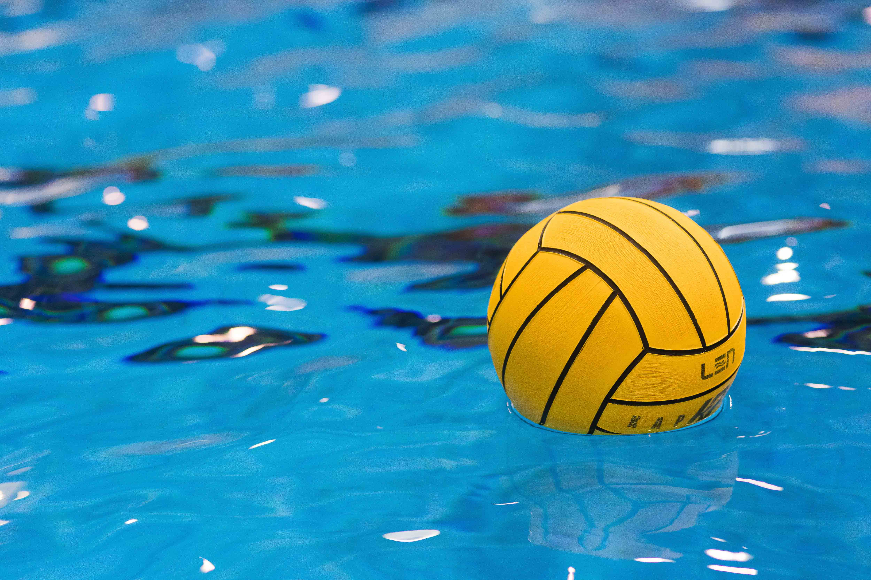

Wellington City Council settings
At the city level, the Council has developed strategies that articulate a clear vision for the future of recreation in Wellington.

Te Whai Oranga Pōneke – The Open Space and Recreation Strategy sets the long-term direction for managing and enhancing public open spaces and recreation facilities, aiming to build healthy, connected, and resilient communities.

The strategy emphasises ensuring facilities meet growing demand, enhancing access for all communities, and responding to population changes and shifting recreation trends.
Five strategic focus areas have been identified as follows:
- Pāhekohekotanga – Integrated: Deliver a well-distributed, multifunctional, and connected network of open spaces and recreation facilities that is woven into everyday life and responds to current and future needs.
- Whai Wāhitanga – Inclusive: Ensure spaces, places, and programmes are accessible, equitable, and welcoming for all communities, applying universal design principles and addressing barriers to participation.
- Te Whakahaumanu me te Manawaroa – Regenerating & Resilient: Support a flourishing natural environment and climate resilience by integrating biodiversity, greening, and sustainable practices into recreation planning and facility design.
- Whakamāori mai anō – Re-indigenising: Embed Te Ao Māori values and mātauranga across open spaces and recreation services, normalising Māori narratives, games, and customary practices, and partnering with mana whenua as kaitiaki.
- Kanorau – Diverse: Provide a variety of recreation experiences that reflect changing trends and community needs, supporting diverse clubs and activities and ensuring equitable access to nature and facilities.

Complementary plans, such as Te Awe Māpara – Community Facilities Plan, the Wellington Town Belt Management Plan, and the Strategy for Children & Young People, focus on accessibility, inclusion, and the creation of spaces that foster belonging and wellbeing.

The Council’s climate action plan, Te Atakura – First to Zero, further commits the city to reducing emissions and adapting recreation services to the impacts of climate change. Together, these strategies ensure that the Council’s recreation services remain responsive to demographic trends, community expectations, and the challenges of a changing environment.

Additionally, participation in outdoor recreational activities contribute to environmental sustainability by promoting conservation and encouraging people to engage with nature.

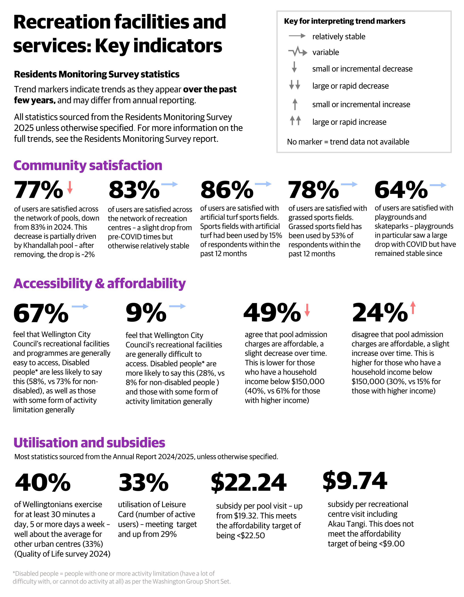

Indicators and trends

Stakeholder views about recreation facilities and services
User satisfaction levels reported in the Residents’ Monitoring Survey (RMS) have remained consistently high across the Council’s sport and recreation facilities, and pools (all except one facility) at above 70% satisfaction.

Strong public interest in maintaining and improving recreation services is consistently reported across surveys and community engagement, while there are also growing calls for greater transparency, affordability, and responsiveness from the Council.

The 2025 Residents Monitoring Survey (RMS) found that just under half of respondents had used the sport grounds, pools or recreation services in the past year. Kilbirnie Recreation Centre and Ākau Tangi Sports Centre were the most used recreation centres (17% and 16% respectively), the Wellington Regional Aquatic Centre was the most used pool (22%), and 40% said they had used a grass sports field.

Usage of each facility was variable depending on which area of the city respondents lived in. Overall usage (of pools, recreation centres or sport fields) showed respondents with dependent children and respondents aged 30-44 tended to be higher users, and respondents aged 60+ lower users.

Customer experience monitoring at recreation centres and pools has also shown strong results with overall satisfaction rates at 71% for pools and 78% for recreation centres. The key strength identified through this monitoring has been the frontline staff, with the bathrooms/changing rooms identified as the key area for improvement.

When asked about barriers for using the Council's facilities, the most significant factor was "not having time", with a similar proportion saying they had no barriers (around 30% for each). Other less significant barriers included no interest in the offering, facilities being too busy and facilities not being open at convenient times for them.

Submissions to the 2024 Long-term Plan (LTP) and its amendment consistently called for the Council to “focus on core services”, including safe and well-maintained recreational spaces.

Stakeholders emphasised the need for visible improvements, such as fixing playground equipment and enhancing lighting in parks, and recommended stronger partnerships with community groups, especially Māori and diverse communities.

Climate change is increasingly shaping the future of Wellington’s recreation infrastructure, with stakeholders and Council records highlighting both the risks and the need for strategic adaptation. Stakeholder feedback, including the Citizens Assembly Pilot, supports embedding climate action into infrastructure planning. There is a clear call for strategic adaptation to climate risks, and for the Council to “look after the assets we’ve got” and to ensure that infrastructure investments and future upgrades deliver intergenerational benefits while aligning with Wellington’s zero-carbon goals outlined in the Council’s climate change strategy: Te Atakura – First to Zero (such as degasification of pools).

Public consultation on the Te Awe Māpara Community Facilities Plan (2023) highlighted strong community support for recreation facilities as vital spaces for connection, wellbeing, and active participation. Feedback emphasised the importance of maintaining and upgrading existing recreation centres and swimming pools to ensure they remain accessible, inclusive, and fit for purpose. Respondents highlighted barriers such as affordability, physical accessibility, and geographic gaps in provision, particularly in areas underserved by recreation infrastructure. There was a clear call for smarter investment in multi-use, flexible venues that cater to diverse needs and evolving recreation trends.
The community also expressed a desire for better coordination across facilities, improved digital access to services, and stronger partnerships with local groups to enhance programming. This feedback has directly informed the plan’s strategic direction, reinforcing a holistic, equitable approach to recreation facility planning that aligns with broader wellbeing and urban development goals.

Survey data from the Community Facilities Plan Needs Analysis (2023) highlighted that youth are active users of recreation facilities, with 11% of public survey respondents aged 20–29 and 1% aged 15–19. The report revealed that there are demographic gaps in provision.The analysis also found that although youth visits to community facilities are significant, there is a need for more youth-friendly spaces and programmes, with youth reporting that they feel there is a lack of spaces that are “for them”.
Overall, city residents have been asking the Council to strike a balance between maintaining Wellington’s vibrancy and addressing residents' everyday needs. Recreation services are seen as vital to community wellbeing, but must be delivered in ways that are inclusive, fiscally responsible, and responsive to the voices of Wellingtonians.
Advisory groups have provided consistent feedback highlighting the need for recreation facilities and services to be more inclusive, accessible, and responsive to the diverse needs of Wellington’s communities.
- Youth Council feedback (via Annual Reports and Work Plans) consistently emphasises the need for practical, safe, and youth-friendly recreational spaces, such as parks and skateparks with adequate street lighting and appealing aesthetics. They stressed the value of pools, recreation centres, parks, and green spaces as places for youth to meet, play, connect. They advocate strongly for transparent information about available spaces. They also stressed the importance of maintaining concession pricing for recreation services and simplifying access to programmes like the LeisureCard.
- The Accessibility Advisory Group (AAG) emphasise that accessibility must be embedded across all Council operations, not just in physical infrastructure but also in communications, service design, and staff capability. Universal design principles should be embedded and applied across the Council’s planning and delivery of all new and upgraded community facilities, including pools, parks, and public toilets, and integrating co-design with disabled communities to ensure meaningful participation and equitable outcomes. For example, AAG recommended that all indoor pools include private change facilities and hoists or ramp access, noting that facilities like Keith Spry Pool (part of the new Waitohi Community hub) currently lack these features.
- AAG also advocated for accessible signage, mobility parking, and ramp access across all Council buildings and infrastructure, and again highlighted the need for co-design with disabled communities in the development of play spaces and youth facilities. They stressed that accessibility must go beyond just compliance to reflect dignity, equity, and timely access. They raised concerns about communication gaps; many services are poorly promoted, and they urged the Council to improve public awareness and feedback mechanisms. They also emphasised the importance of staff training in disability equity, including NZSL and Deaf culture.
- The Rainbow Advisory Council has highlighted barriers to participation in recreation due to affordability, safety, and cultural exclusion. They also emphasised that inclusion must incorporate emotional and cultural safety, and recommended training for frontline staff.

Collectively, advisory groups have been urging the Council to move beyond minimum standards towards a proactive, equity-driven approach to accessibility and inclusion. They seek a city where all residents participate fully, safely, and with dignity in the city’s recreational opportunities.

Māori and Tākai Here partners’ views and aspirations for recreation
Tākai Here partners emphasise that recreation planning and delivery must move beyond consultation to genuine partnership and co-design. Their feedback highlights cultural visibility, inclusion, and governance as critical priorities, aligning with Te Tiriti o Waitangi and Tūpiki Ora principles. Partners expect early and continuous involvement in planning and renewal of recreation facilities. They call for co-design processes that reflect iwi priorities and capacity, supported by governance arrangements enabling shared decision-making.

Feedback from Tākai Here partners strongly advocates for increasing the visibility of te reo Māori and Māori culture in recreation spaces, through bilingual signage, Māori names, and culturally resonant wellbeing initiatives. Partners also support programming that revives traditional Māori games and play practices. Inclusion must go beyond physical accessibility to encompass emotional and cultural safety, ensuring facilities feel welcoming for Māori and other diverse communities.

Tākai Here partners also note they have limited capacity to engage deeply without adequate resourcing. They expect the Council to provide support for co-design processes and partnership forums to make collaboration sustainable.

Key issues and opportunities
This section presents a structured analysis of the principal strategic issues shaping the effectiveness and future direction of Wellington City Council’s recreation facilities and services.

The main issue is ensuring recreation facilities remain relevant and accessible as community expectations and demographics change. Several interconnected challenges exist, including the need for adaptive, multi-use spaces, renewal of ageing assets, bridging geographic and service gaps, managing rising costs, overcoming accessibility barriers, fostering inclusion and cultural partnership, and ensuring resilience against environmental risks.

Addressing these will require ongoing innovation, robust data-driven planning, and a commitment to equity and partnership with all communities.

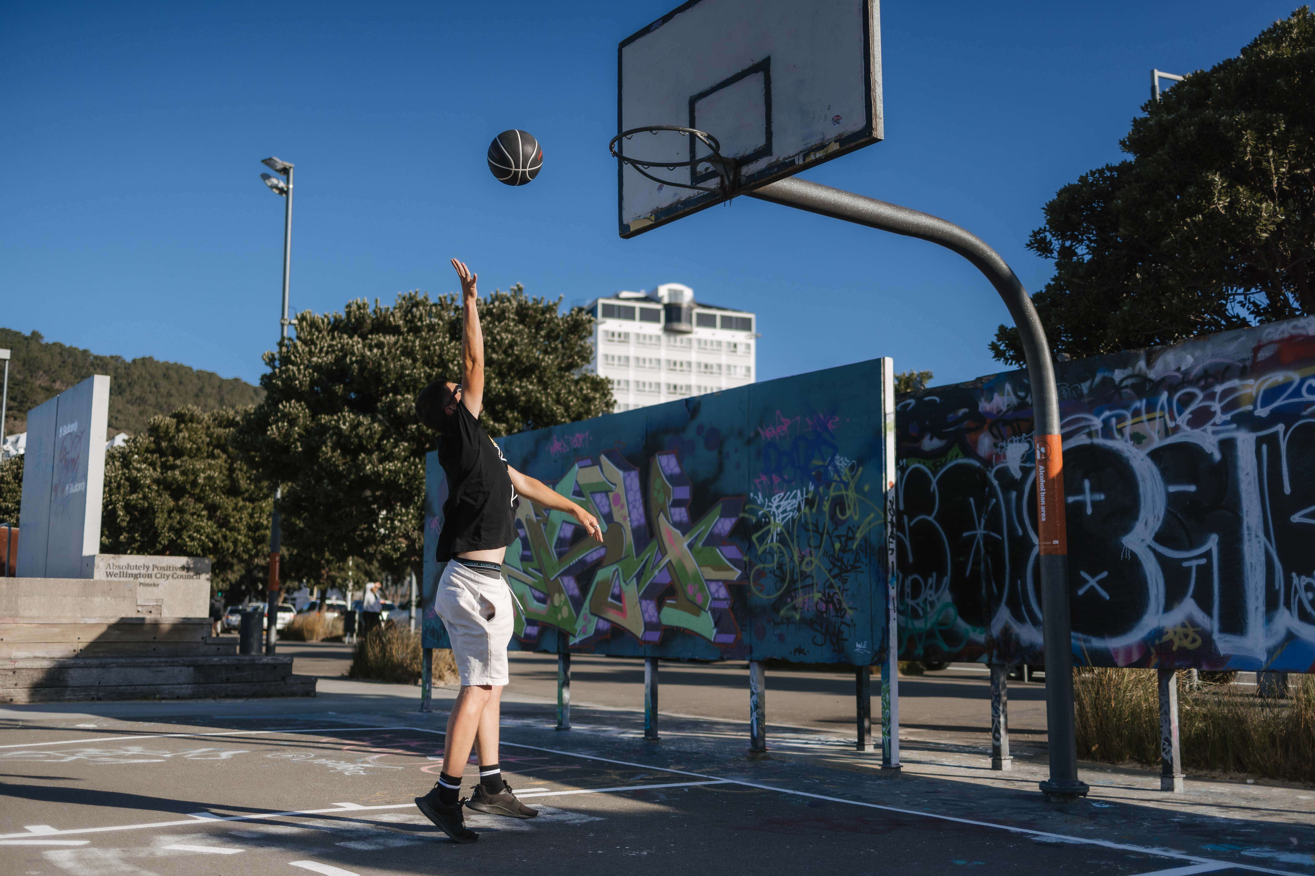

Ageing infrastructure, financial constraints, and geographic disparity in recreation provision

Ageing and outdated infrastructure
A significant proportion of Wellington’s recreation facilities are old, single-purpose, and deteriorating. Many require renewal or replacement, which presents substantial barriers to equitable access. The outdated nature of these assets results in poor functionality, limited flexibility, and higher maintenance needs, making them less appealing and harder to use for the community. Rising costs in construction, operations, maintenance, and insurance further compound these challenges, stretching available resources and limiting the pace of necessary upgrades. Additionally, inconsistent asset data and increasing customer expectations add complexity to planning and delivering improvements, making it difficult to prioritise investments and ensure the efficient use of the facility portfolio.

Financial constraints
Financial pressures are mounting on the Council’s ability to deliver recreation services. Rising operational and maintenance costs strain budgets, often leading to deferred upgrades and reduced service quality. Limited funding options exacerbate the challenge of sustaining facilities and programmes. The funding landscape is further complicated by declining benefactor and grant support, legislative changes affecting the distribution of gambling proceeds, increased competition for limited resources, and high maintenance costs, particularly for ageing infrastructure and facilities in climate risk areas. Economic factors such as inflation and rising insurance costs also limit discretionary spending for both residents and the Council. The Revenue and Financing Policy, as required by the Local Government Act 2002, signals expectations for community cost recovery through user fees and charges. Recent initiatives, such as the Wellington Region Sports Fees and Charges Review (2024), aim to address affordability concerns and improve transparency around cost allocation and maintenance of sports fields.

Geographic disparity and equity gaps
Provision of recreation facilities is uneven across Wellington. This uneven distribution creates inequities in access, limiting opportunities for communities in underserved areas. Additionally, a lack of coordination between sites results in inefficiencies and duplication of services, further fragmenting the network. The Council’s diverse asset base supports a wide range of recreational activities and major events, but Wellington City currently shoulders a disproportionate share of regional facility provision. Strategic responses identified in Te Awa Māpara and Te Whai Oranga Pōneke include optimising the facility portfolio, maximising the use of existing assets, reducing duplication, and fostering partnerships with community and sporting groups. Future opportunities involve unlocking underused spaces, strengthening community relationships, investing in artificial turfs and indoor venues to address service gaps, and planning for climate resilience and environmental risks.

Future Directions
To address these interconnected challenges, the Council is committed to promoting service value, communicating transparent fee review processes, regionalising service delivery, aligning with central government funding for targeted groups, and seeking legislative relief for seismic resiliency of earthquake-prone buildings. Ongoing collaboration, benchmarking, and alignment of fees across territorial authorities are also priorities, supporting the broader goals outlined in the Te Whai Oranga Pōneke strategy.

Changing patterns of recreation and greater diversity of needs
Wellington City Council faces the challenge of ensuring recreation facilities remain relevant and responsive to evolving community expectations and demographic trends. The changing patterns of recreation, greater diversity in community needs, and an increasing preference for informal and self-directed activities require facilities capable of accommodating a wide range of uses and users.

For instance, static programme offerings have proven insufficient in engaging younger demographics and accommodating emerging activities. Recreation programmes have seen little modification over recent years, despite significant shifts in social trends and population demographics. As a result, new and evolving interests, such as alternative sports and informal recreation, are not adequately addressed. This conflict is particularly apparent during high-demand times (after school, evenings). There is therefore a need to reassess current programmes and consider reallocating space, particularly during peak periods.

Survey data and Youth Council feedback highlight that young people are active users of recreation facilities but feel there is a lack of spaces “for them”. They want practical, safe, and youth-friendly environments such as skateparks, well-lit parks, and hubs for social connection. Engagement methods tailored to youth (e.g., social media polls) are also seen as critical.

Another recurring theme is amenity and usability, such as seating, shade, toilets, and spaces for social interaction. Environmental considerations like preserving green areas, biodiversity, and sustainability also feature strongly, alongside calls for better connectivity, safe walking and cycling routes linking parks to neighbourhoods. Overall, residents seek spaces that feel welcoming, well-maintained, and reflective of community identity.

The Council’s adoption of a network approach through plans such as Te Awe Māpara and Te Whai Oranga Pōneke, have focused on making facilities more fit for purpose, accessible, multi-use, and flexible. The establishment of community hubs like Waitohi (Johnsonville) and Toitū Pōneke (Kilbirnie), and the integration of universal design principles in renewals, demonstrate efforts to enhance service cohesiveness and resilience. Council initiatives also encompass support for alternative facility use (e.g., informal pay-for-play, outdoor activities), digital self-service options, and ongoing innovation in recreation delivery.

Future opportunities include learning from successful co-design initiatives, investing in identified service and facility gaps, expanding targeted outreach to schools and community groups, fostering sector-wide collaboration, increasing commercial use of spaces to help fund facilities, co-developing culturally resonant wellbeing initiatives with mana whenua, and further innovating through digital platforms and automation to broaden reach and improve service delivery.

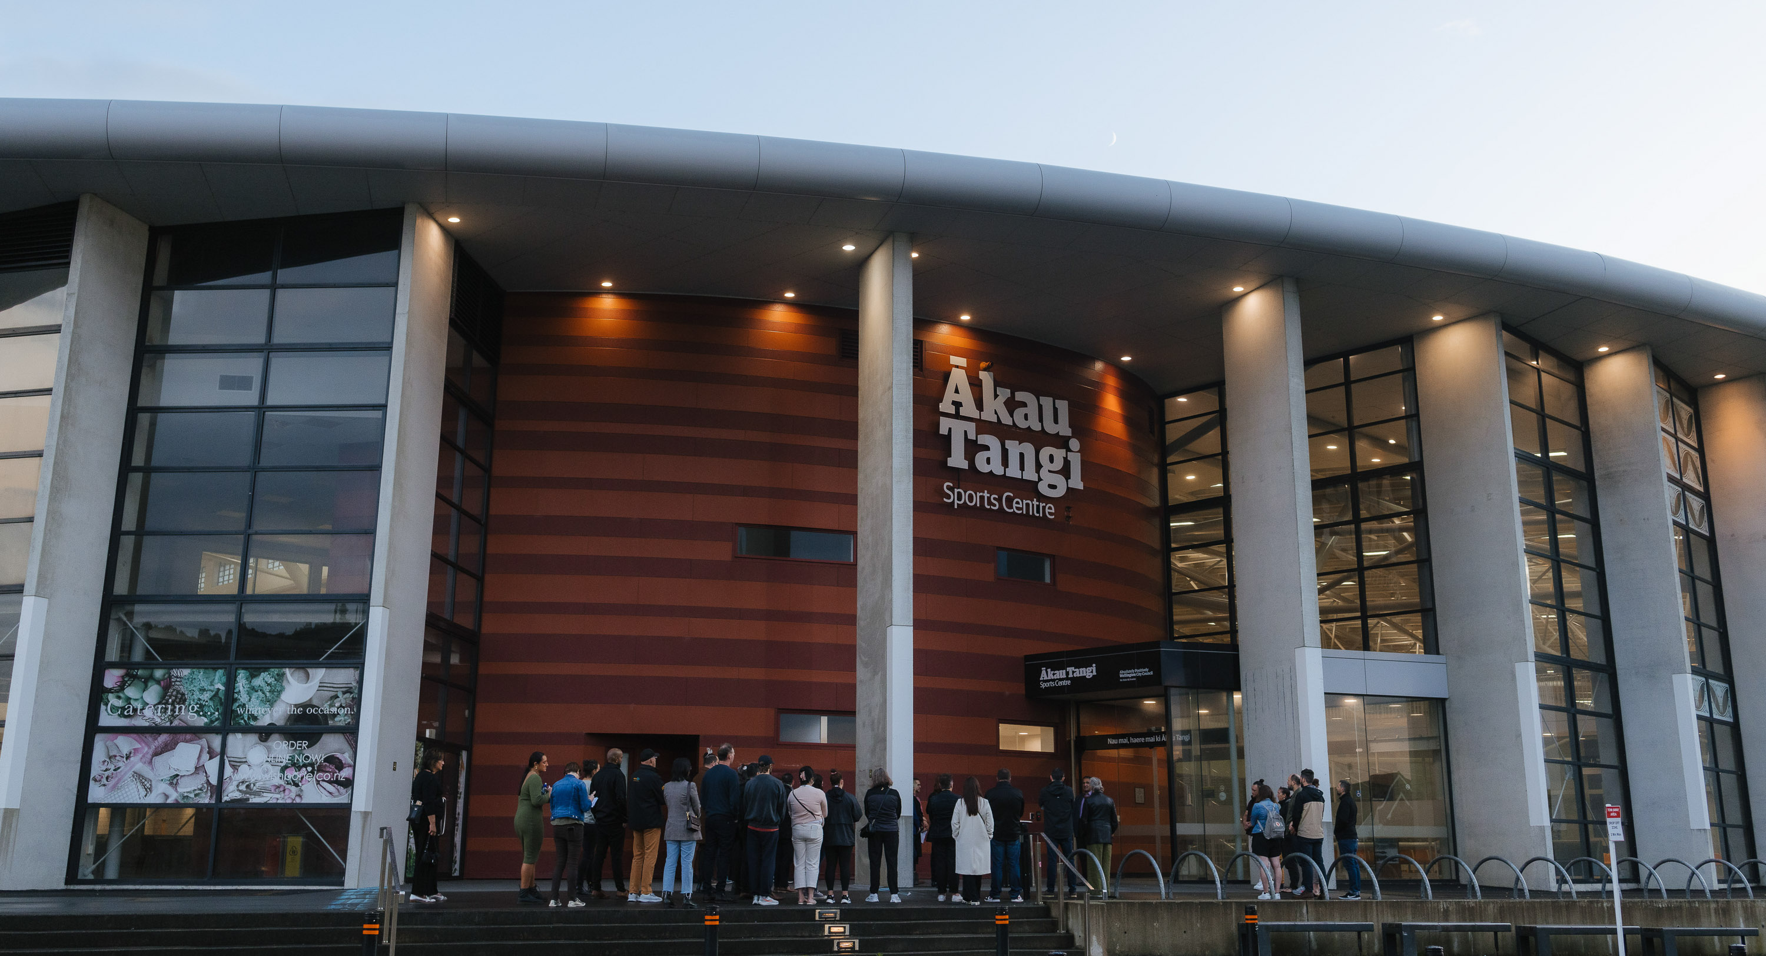

Not all facilities are fully accessible
Accessibility remains a persistent issue across Wellington City Council’s recreation facilities, with physical, financial, and digital barriers limiting equitable access for many residents. Many facilities lack features that enable full participation for people with disabilities, older adults, and culturally diverse communities. While initiatives such as the LeisureCard programme and citywide accessibility audits are in place, not all facilities are fully accessible due to legacy design constraints, challenging topography, and incomplete connections to active transport networks. Financial constraints, such as user fees, and limited digital integration also restrict participation for residents with disabilities or on low incomes.

Continuous improvements are needed in providing accessible information, enhancing digital self-service platforms, and embedding universal design principles in all upgrades. The Council is focusing on incorporating universal design principles in renewals, prioritising flexible multi-use venues, and expanding digital solutions that are usable by people with disabilities. Regular citywide accessibility audits for play areas and recreation facilities ensure best practice and prioritise improvements based on robust data and community needs. Recent findings highlight the importance of integrating accessible features into all play area designs, such as accessible paths, disability parking, sensory and tactile elements, communication board signage, and ground-level play equipment, with inclusive swings now standard in upgrades.

Improving the quality and detail of accessibility information provided on the Council website is a priority, with a focus on making listings and maps screen-reader friendly and resources available in multiple formats. For pools, there is an identified need to meet the growing demand from older people and disabled residents, supported by a planned needs assessment and feasibility study. The Council also recognises the importance of monitoring the use of accessible changing rooms to ensure equitable access, and is working to standardise signage citywide, including consistent placement, braille, and essential information, while addressing physical barriers such as heavy doors in future upgrades.

Cultural inclusion
Inclusion in Wellington’s recreation network goes beyond physical accessibility, focusing on ensuring that all community groups, regardless of age, background, cultural identity, or socioeconomic status, feel welcome and able to participate. Some groups continue to face barriers to inclusion, including youth, ethnic minorities, and older adults, often due to small standalone facilities, limited collaboration among stakeholders, and gaps in the recreation network. Challenges remain in identifying and delivering the right opportunities for all communities, especially for vulnerable and marginalised populations.
Stakeholder feedback underscores the need for culturally safe, welcoming, and responsive spaces for rangatahi, disabled people, Rainbow communities, and others. Ensuring recreation spaces are accessible, inclusive, and culturally safe is essential for achieving equitable participation in recreation.

Māori inclusion and te ao Māori partnerships
Māori inclusion is a strategic priority for Wellington City Council, with efforts focused on strengthening partnerships with Tākai Here partners and embedding Māori identity and values within recreation spaces. Collaborations with partners have resulted in co-designed facilities like Ākau Tangi Sports Centre, which incorporate cultural narratives and foster inclusion. The visibility of te reo Māori and Māori culture is enhanced through bilingual signage and culturally resonant wellbeing initiatives, honouring Te Tiriti obligations and enriching Wellington’s recreation offerings. The Council continues to co-design services, expand Māori recreation activities, and celebrate Māori identity and values across the network. Future opportunities include further expanding co-designed services, increasing cultural representation, and learning from successful collaborations to ensure recreation spaces reflect and celebrate Māori identity throughout Wellington.

Addressing climate resilience and sustainable development
Planning for climate resilience and sustainable development has become increasingly significant. This includes environmental risks such as sea level rise and earthquakes, investing in resilient infrastructure, and promoting sustainable operations. Existing facilities are vulnerable to climate impacts and often operate with high energy and water consumption, raising sustainability concerns. Strategic responses include unlocking underused spaces, optimising facility use, and building robust partnerships with community, sporting, and iwi groups to ensure shared stewardship of resources. Climate resilience is essential for future-proofing recreation services, with a focus on sustainability, and finding new ways to adapt to increasing environmental pressures.

Climate action and resilience
Wellington City Council faces significant climate resilience challenges in planning and maintaining recreation facilities. The city’s geography, steep hills, reclaimed land, and fault lines, make it especially vulnerable to environmental risks such as sea level rise, flooding, earthquakes, tsunami, and storm surges. Many recreation assets are located in areas at considerable risk from these hazards. Existing facilities are already experiencing the impacts of climate disruption, with older swimming pools facing accessibility limitations, seismic vulnerability, and exposure to flooding. Upgrading facilities to meet resilience standards is becoming increasingly costly due to inflation, insurance premiums, consenting complexities, and limited construction market capacity. Some assets may need to be decommissioned or repurposed, and future investment decisions must be guided by climate risk assessments and long-term resilience goals. Strategic responses include unlocking underused spaces, optimising facility use, and building partnerships with community, sporting, and iwi groups to support shared stewardship of resources.
The Council is undertaking climate vulnerability analysis for some assets in high-risk coastal areas. The Te Atakura - First to Zero Strategy outlines opportunities for climate action, while the Local Adaptation Plans will support local area decision making in the face of climate related risks. Embedding these considerations into Asset Management Plans will be important for managing the risks to recreation facilities.

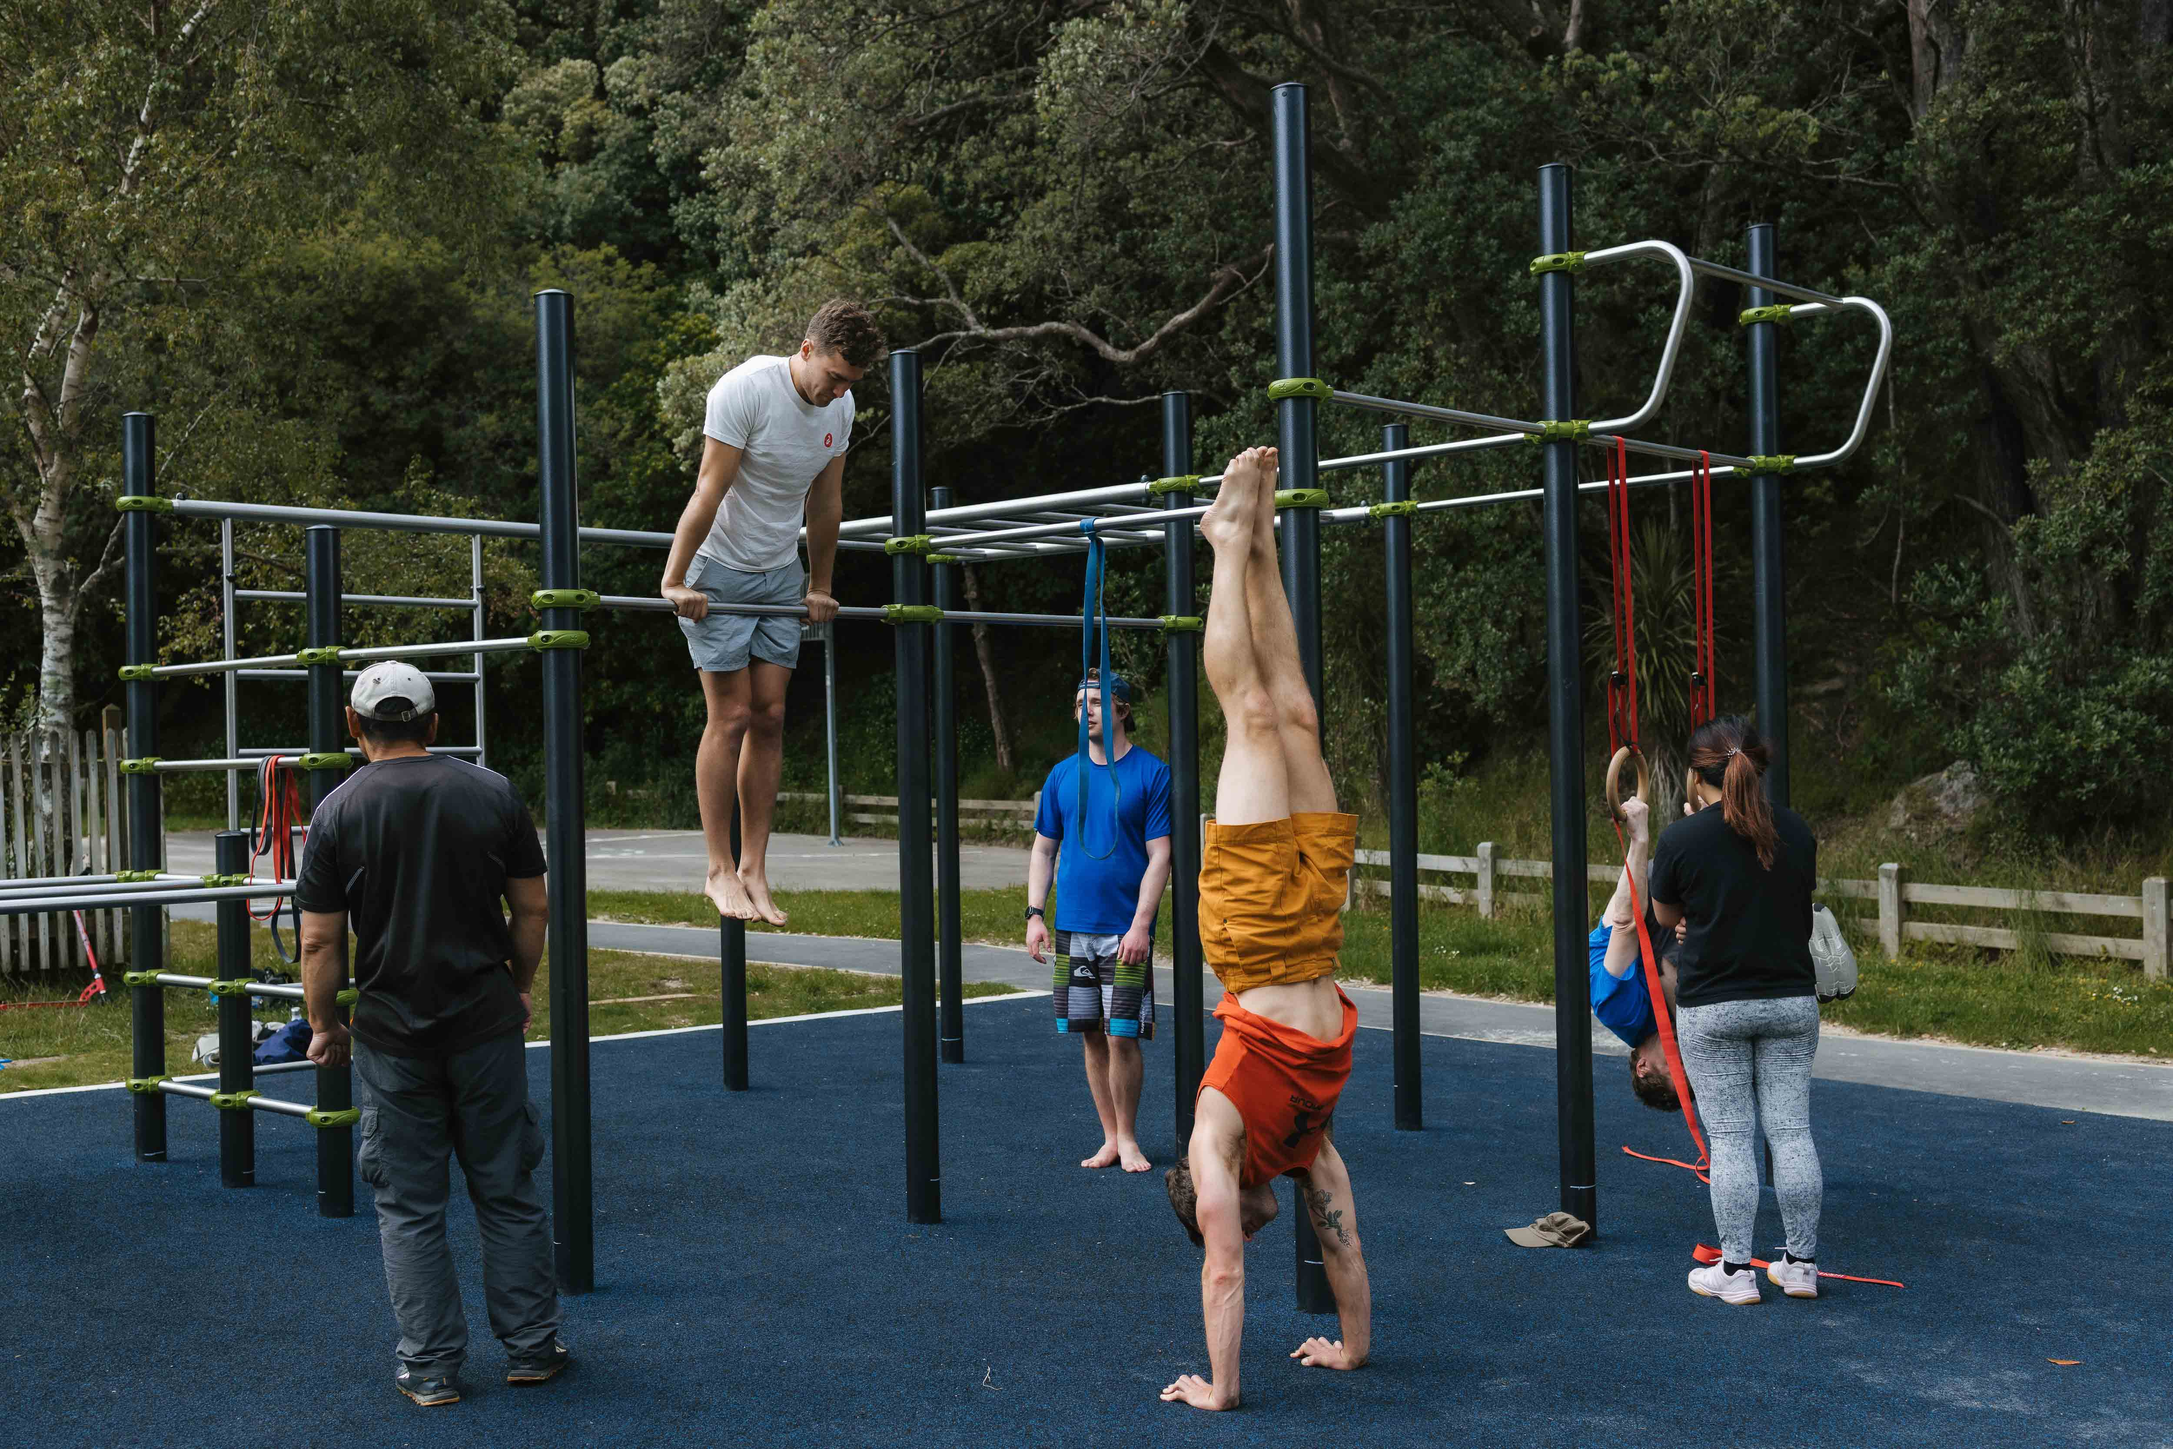

Ensuring strategic and sustainable development
Sustainability is a key focus for the Council in developing and maintaining recreation facilities. Many existing facilities operate with high energy and water consumption, raising concerns about their environmental footprint.

The Council is implementing measures such as the Energy Decarbonisation Plan for swimming pools, retrofitting facilities for energy efficiency, and integrating nature-based solutions like stormwater management.

Maintaining affordable pricing and leveraging internal operational teams are part of the approach to balance affordability, accessibility, and long-term sustainability. Legacy and gifted assets (e.g. as a result of a club no longer being able to manage them) can become costly to maintain or difficult to remove, especially when residents are attached to them, complicating decisions about investment or divestment. Award-winning strategies such as Te Awe Māpara and Te Whai Oranga Pōneke provide frameworks for guiding decisions across the network.

However, challenges remain, including disproportionate provision for some sport facilities, inconsistent support for sporting codes, and the cost and complexity of managing legacy and gifted assets (as identified in Te Awe Māpara). Improving transparency of information and enabling better decision-making are ongoing opportunities. Continued investment in sustainability initiatives will help ensure recreation facilities are both resilient and responsive to community needs.

Wellington City Council. (2024). Long-term Plan.
Open Space and Recreation Strategy - Plans, policies and bylaws - Wellington City Council
Nuku Ora. (2025). Wellington Regional Spaces and Place Strategy.
WellingtonNZ. (2024). Wellington Regional Economic Development Plan 2022-2032 (V2).
Wellington City Council. (June 2023). Te Whai Oranga Pōneke – Open space and recreation strategy.
Wellington City Council. (June 2023). Te Whai Oranga Pōneke – Open space and recreation strategy.
Wellington City Council. (2023). Te Awe Māpara - Community Facilities Plan.
Wellington City Council. (2018). Wellington Town Belt Management Plan.
Wellington City Council. (2021). Strategy for Children and Young People.
Wellington City Council. (2019). Te Atakura - First to Zero.
Refer to Te Awe Māpara - Community Facilities Plan - Plans, policies and bylaws - Wellington City Council

