Kia ora,

We would like to inform you about a proposed change in your neighbourhood.

Proposal:

Reference | - TR76-26 Peter Button Place, Johnsonville - No Stopping At All Times
Location – where we propose to make the change | Peter Button Place, Johnsonville – from Cunliffe St.
What we’d like to do | - Install No Stopping At All Times (Broken Yellow Lines) and one L-bar
Why we are proposing the change | - Council have received concerns from a local resident regarding the parking situation along the entirety of Peter Button Place. Due to the narrow width of the road, the current parking practices are causing significant congestion and making it difficult for vehicles to access properties.  - Council officers found that parked vehicles on both sides of the road obstruct traffic flow, however the more critical issue is the obstruction for emergency vehicles. FENZ vehicles, and ambulance will be unable to access the area if needed when vehicles are parked on both sides of the road. To ensure safe access for both private and emergency vehicles, a minimum road width of 6.9 metres is required for parking on both sides of the road. The existing carriageway width along Peter Button Place is significantly narrower than the minimum width required and unrestricted parking could impede daily vehicle movements and FENZ and ambulance vehicle access during an emergency event.  - Council officers also consulted with Fire and Emergency New Zealand (FENZ) who expressed support for these changes.  - Vehicle tracking checks for a FENZ truck were also conducted which confirmed that emergency vehicles would be impeded along this section of Peter Button Place if vehicles are parked on both sides in certain locations.  - To mitigate this accessibility issue and ensure emergency vehicle access, Council officers are proposing the installation of Broken Yellow Lines (No Stopping At All Times restriction) along sections of Peter Button Place. This mitigation measure will maintain access for emergency vehicles while also guiding drivers to in appropriate parking areas that do not obstruct accessibility.  - On June 21, 2026, Council officers distributed letters to affected residents to inform them of the proposed changes to invite their feedback. During a two-week pre-consultation period, residents provided constructive input, leading to several amendments to the original proposal.  - The attached plan reflects the pre-consultation feedback received from affected residents.
Impact | Improvements  - Improves safety and accessibility for general traffic and emergency vehicles  - Improves driver forward visibility  Net Parking Impact  - Removal of 11 unrestricted parking spaces is proposed which are currently unsuitable for kerbside parking due to the narrow width of the road.  Pedestrian impact  - No Change
Other options considered | Option 1:  - A plan was proposed during pre-consultation in which BYL’s were arranged along the entire northern kerbline, resulting in the highest number of legal parks (13) along the southern kerbline. This option is not supported due to residents preferring current parking behaviour along the northern kerbline. Seven car parks along the eastern end of the street would also have no pavement to step onto.  Option 2:  - Another plan proposed engaging speed calming measures by moving two of option 1’s parks to the northern kerbline while maintaining 13 legal parks. This results in a ‘staggered’ effect that encourages drivers to slow down due to a narrower field of view and need to navigate the ‘chicane’. This option was also not preferred as residents preferred the current parking behaviour along the northern kerbline. Seven car parks along the eastern end of the street would also have no pavement to step onto.
How this relates to the parking policy | - Support safe movement – facilitate the safe and efficient movement of people and goods by focusing on people moving along transport corridors rather than people parking or storing stationary vehicles.
Additional Information | - An electronic copy of the report will be available on the Council’s website from 9.00am 19th October 2026 at https://www.letstalk.wellington.govt.nz/
Privacy | - Your privacy is important to us. Please DO NOT add specific personal details to your feedback (i.e.: full name, address, etc)  - What we do with your personal information:  All submissions (including your first name, but not contact details) are provided in their entirety to elected members and made available to the public on our website and at our office. Personal information (including contact details) will also be used for the administration of the consultation process including informing you of the outcome of the consultation. All information collected will be held by Wellington City Council, with submitters having the right to access and correct personal information.  - For more information regarding our Privacy Statement please check our webpage: Privacy statement - Wellington City Council.
Feedback | - If you would like to provide us with specific feedback, which will be added to the Traffic Resolution following consultation and made public in full, you can do so by filling out an online submission form, downloading a printable submission form on https://www.letstalk.wellington.govt.nz/ or emailing us at trfeedback@wcc.govt.nz.  Please note if you are giving feedback the consultation period opens at 9.00 am 19th October 2026 and finishes at 5.00 pm 3rd November.
Next Steps | - Feedback collated by 4th November.  - The proposal will go to the Te Takere|Regulatory Processes Committee meeting on 2nd December.  - If approved, the proposal will be installed within the following six months.

Traffic Resolution Plan: TR76-26 Peter Button Place, Johnsonville - No Stopping At All Times

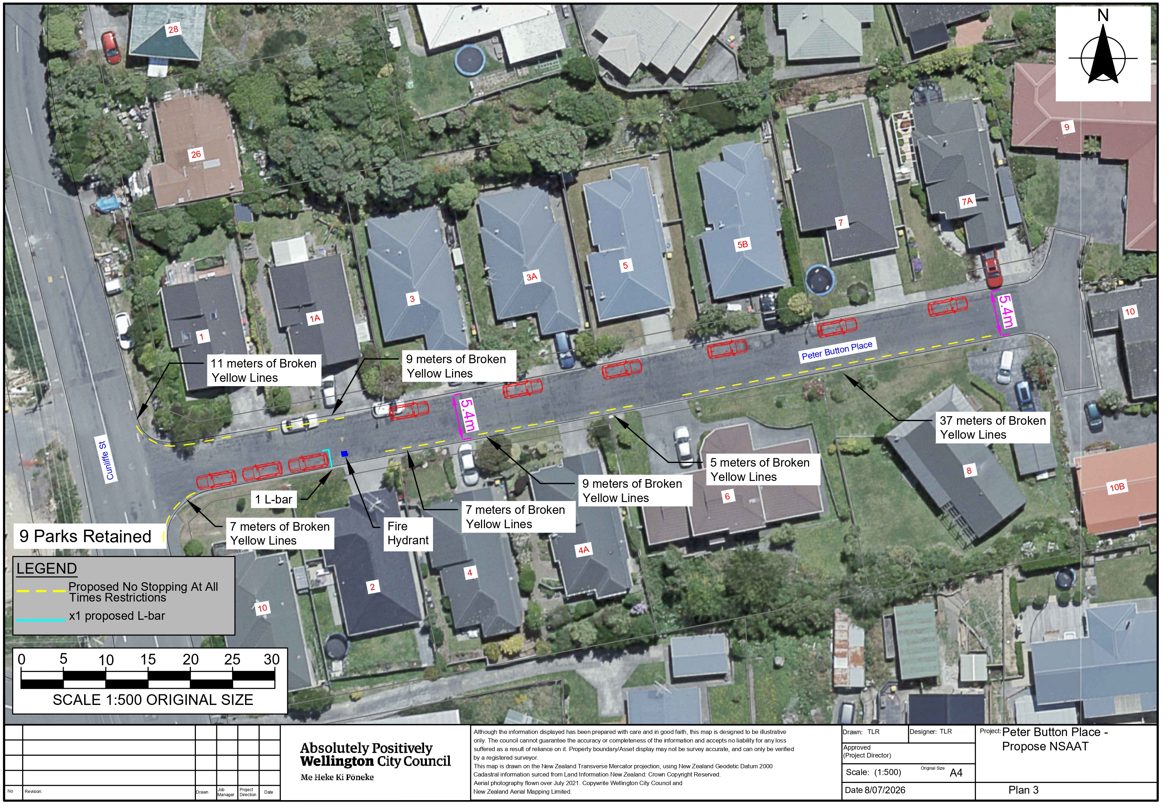

Legal Description:

Add to Schedule D (No stopping) of the Traffic Restrictions Schedule

Column One | Column Two | Column Three
Peter Button Place | No Stopping At All Times | North side, commencing from its intersection with Cunliffe St (Grid coordinates x= 1,751,088.32 y=5,435,838.46) and extending in an south easterly direction following the northern kerb line for 11 metres.
Peter Button Place | No Stopping At All Times | North side, commencing 17 metres from its intersection with Cunliffe St (Grid coordinates x= 1,751,088.32 y=5,435,838.46) and extending in a easterly direction following the northern kerb line for 9 metres.
Peter Button Place | No Stopping At All Times | South side, commencing from its intersection with Cunliffe St (Grid coordinates x= 1,751,091.70 y=5,435,824.53) and extending in a North Easterly direction following the southern kerb line for 7 metres.
Peter Button Place | No Stopping At All Times | South side, commencing 29 metres from its intersection with Cunliffe St (Grid coordinates x= 1,751,091.70 y=5,435,824.53) and extending in a Easterly direction following the southern kerb line for 7 metres.
Peter Button Place | No Stopping At All Times | South side, commencing 42 metres from its intersection with Cunliffe St (Grid coordinates x= 1,751,091.70 y=5,435,824.53) and extending in a Easterly direction following the southern kerb line for 9 metres.
Peter Button Place | No Stopping At All Times | South side, commencing 55 metres from its intersection with Cunliffe St (Grid coordinates x= 1,751,091.70 y=5,435,824.53) and extending in a Easterly direction following the southern kerb line for 5 metres.
Peter Button Place | No Stopping At All Times | South side, commencing 66 metres from its intersection with Cunliffe St (Grid coordinates x= 1,751,091.70 y=5,435,824.53) and extending in a Easterly direction following the southern kerb line for 37 metres.

Prepared By: | Theodore Robinson | (Transport Engineer Assistant)
Approved By: | Kate Gourdie | (Team Leader Traffic & Resolutions)
Approved Date: | 21/09/2026

