Kia ora,

We would like to inform you about a proposed change in your neighbourhood.

Proposal:

Reference | - TR37-25 Haumia Street, Johnsonville - No Stopping At All Times
Location – where we propose to make the change | Haumia Street, Johnsonville  - Between no.28 to 35  - Between no. 44 to 46
What we’d like to do | - Install No Stopping At All Times (Broken Yellow Lines) and remove 13 metres of No Stopping At All Times outside no.46.
Why we are proposing the change | - The Council has received safety concerns from members of the public regarding vehicles parking on both sides of the street, and on the bend causing obstructions and safety issues for drivers navigating the road.  - Officers conducted a physical inspection of this section of Haumia Street and found that the street's width is narrower than the required 6.9 metres needed for vehicles to park on both sides while allowing vehicles to pass.  - This section of Haumia Street measures 6.4 metres, which is too narrow and causes obstruction, particularly for emergency and waste collection vehicles when parking occurs on both sides.  - Additionally, the Council has received parking complaints in this area, particularly during pick-up and drop-off times for the school, which are contributing to increased congestion and safety concerns near the bend outside no.44 Haumia Street.  - To improve safety and accessibility, officers propose installing No Stopping At All Times (broken yellow lines) long the bend outside No. 44 and in a chicane pattern between properties 28 to 35. This will ensure clear passage for vehicles while also serving as a traffic-calming measure, as illustrated in the attached plans.  - To offset the parking loss, 13 metres of broken yellow lines are proposed to be removed outside No. 46 on the straight section of the road, creating space for two vehicles to park.
Impact | Improvements  - Improves safety and accessibility for all vehicles  Net Parking Impact  - Removal of 16 parking spaces; however, these spaces are currently unsuitable for parking due to the road’s narrow width and blind bend  - Adding two unrestricted parking spaces  Pedestrian impact  - Improves access and visibility for pedestrians crossing the road
Other options considered | Option 1:  - Other options were considered to install broken yellow lines along one side of the street to prevent parking on both sides however, this will not act in a chicane pattern to reduce speed and may cause issues for vehicles pulling over to allow on coming vehicles to pass.
How this relates to the parking policy | - Support safe movement – facilitate the safe and efficient movement of people and goods by focusing on people moving along transport corridors rather than people parking or storing stationary vehicles.  - Support city place-making, amenity and safety – ensure on-street parking design and placement supports overall city amenity, safety, community building, heritage, creative arts, good urban design outcomes and attractive streetscapes.
Additional Information | - Average daily traffic count – 3290  - To view the legal description for this Traffic Resolution, an electronic copy of the report will be available on the Council’s website from 9.00am Wednesday 30 April 2025 at https://www.letstalk.wellington.govt.nz/ or you can call (04) 499 4444 and we will send one out to you.
Privacy | - Your privacy is important to us. Please DO NOT add specific personal details to your feedback (i.e.: full name, address, etc)  - What we do with your personal information:  All submissions (including your first name, but not contact details) are provided in their entirety to elected members and made available to the public on our website and at our office. Personal information (including contact details) will also be used for the administration of the consultation process including informing you of the outcome of the consultation. All information collected will be held by Wellington City Council, 113 The Terrace, Wellington, with submitters having the right to access and correct personal information.  - For more information regarding our Privacy Statement please check our webpage: Privacy statement - Wellington City Council.
Feedback | - If you would like to provide us with specific feedback, which will be added to the Traffic Resolution following consultation and made public in full, you can do so by filling out an online submission form, downloading a printable submission form on https://www.letstalk.wellington.govt.nz/ or emailing us at trfeedback@wcc.govt.nz.  Please note if you are giving feedback the consultation period opens at 9.00am Wednesday 30 April 2025 and finishes at 5.00pm Wednesday 14 May 2025.
Next Steps | - Feedback collated by Thursday 15 April 2025.  - The proposal will go to the Koata Hātepe|Regulatory Processes Committee meeting on Wednesday 18 June 2025.  - If approved, the proposal will be installed within the following three months.

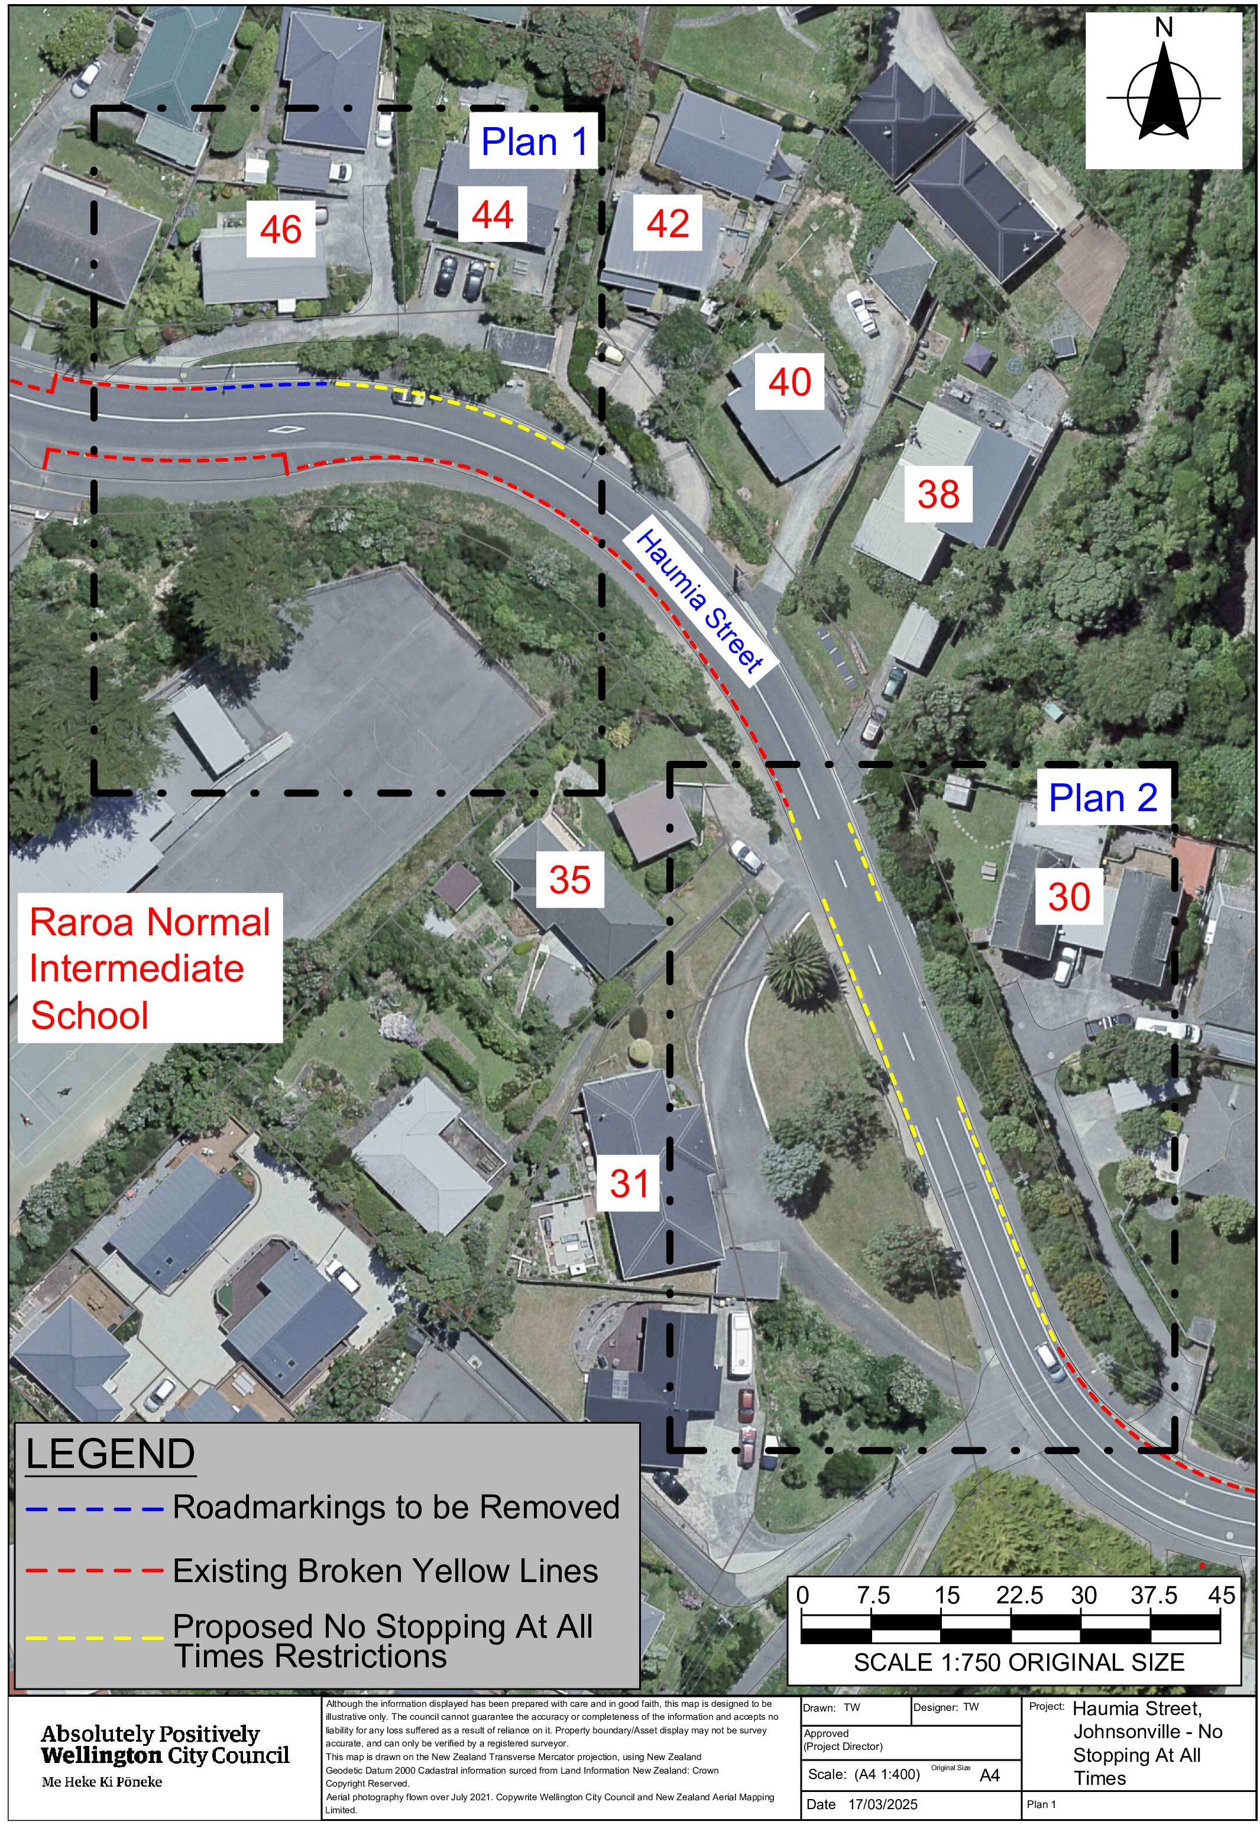
Traffic Resolution Plan: TR37-25 Haumia Street, Johnsonville - No Stopping At All Times

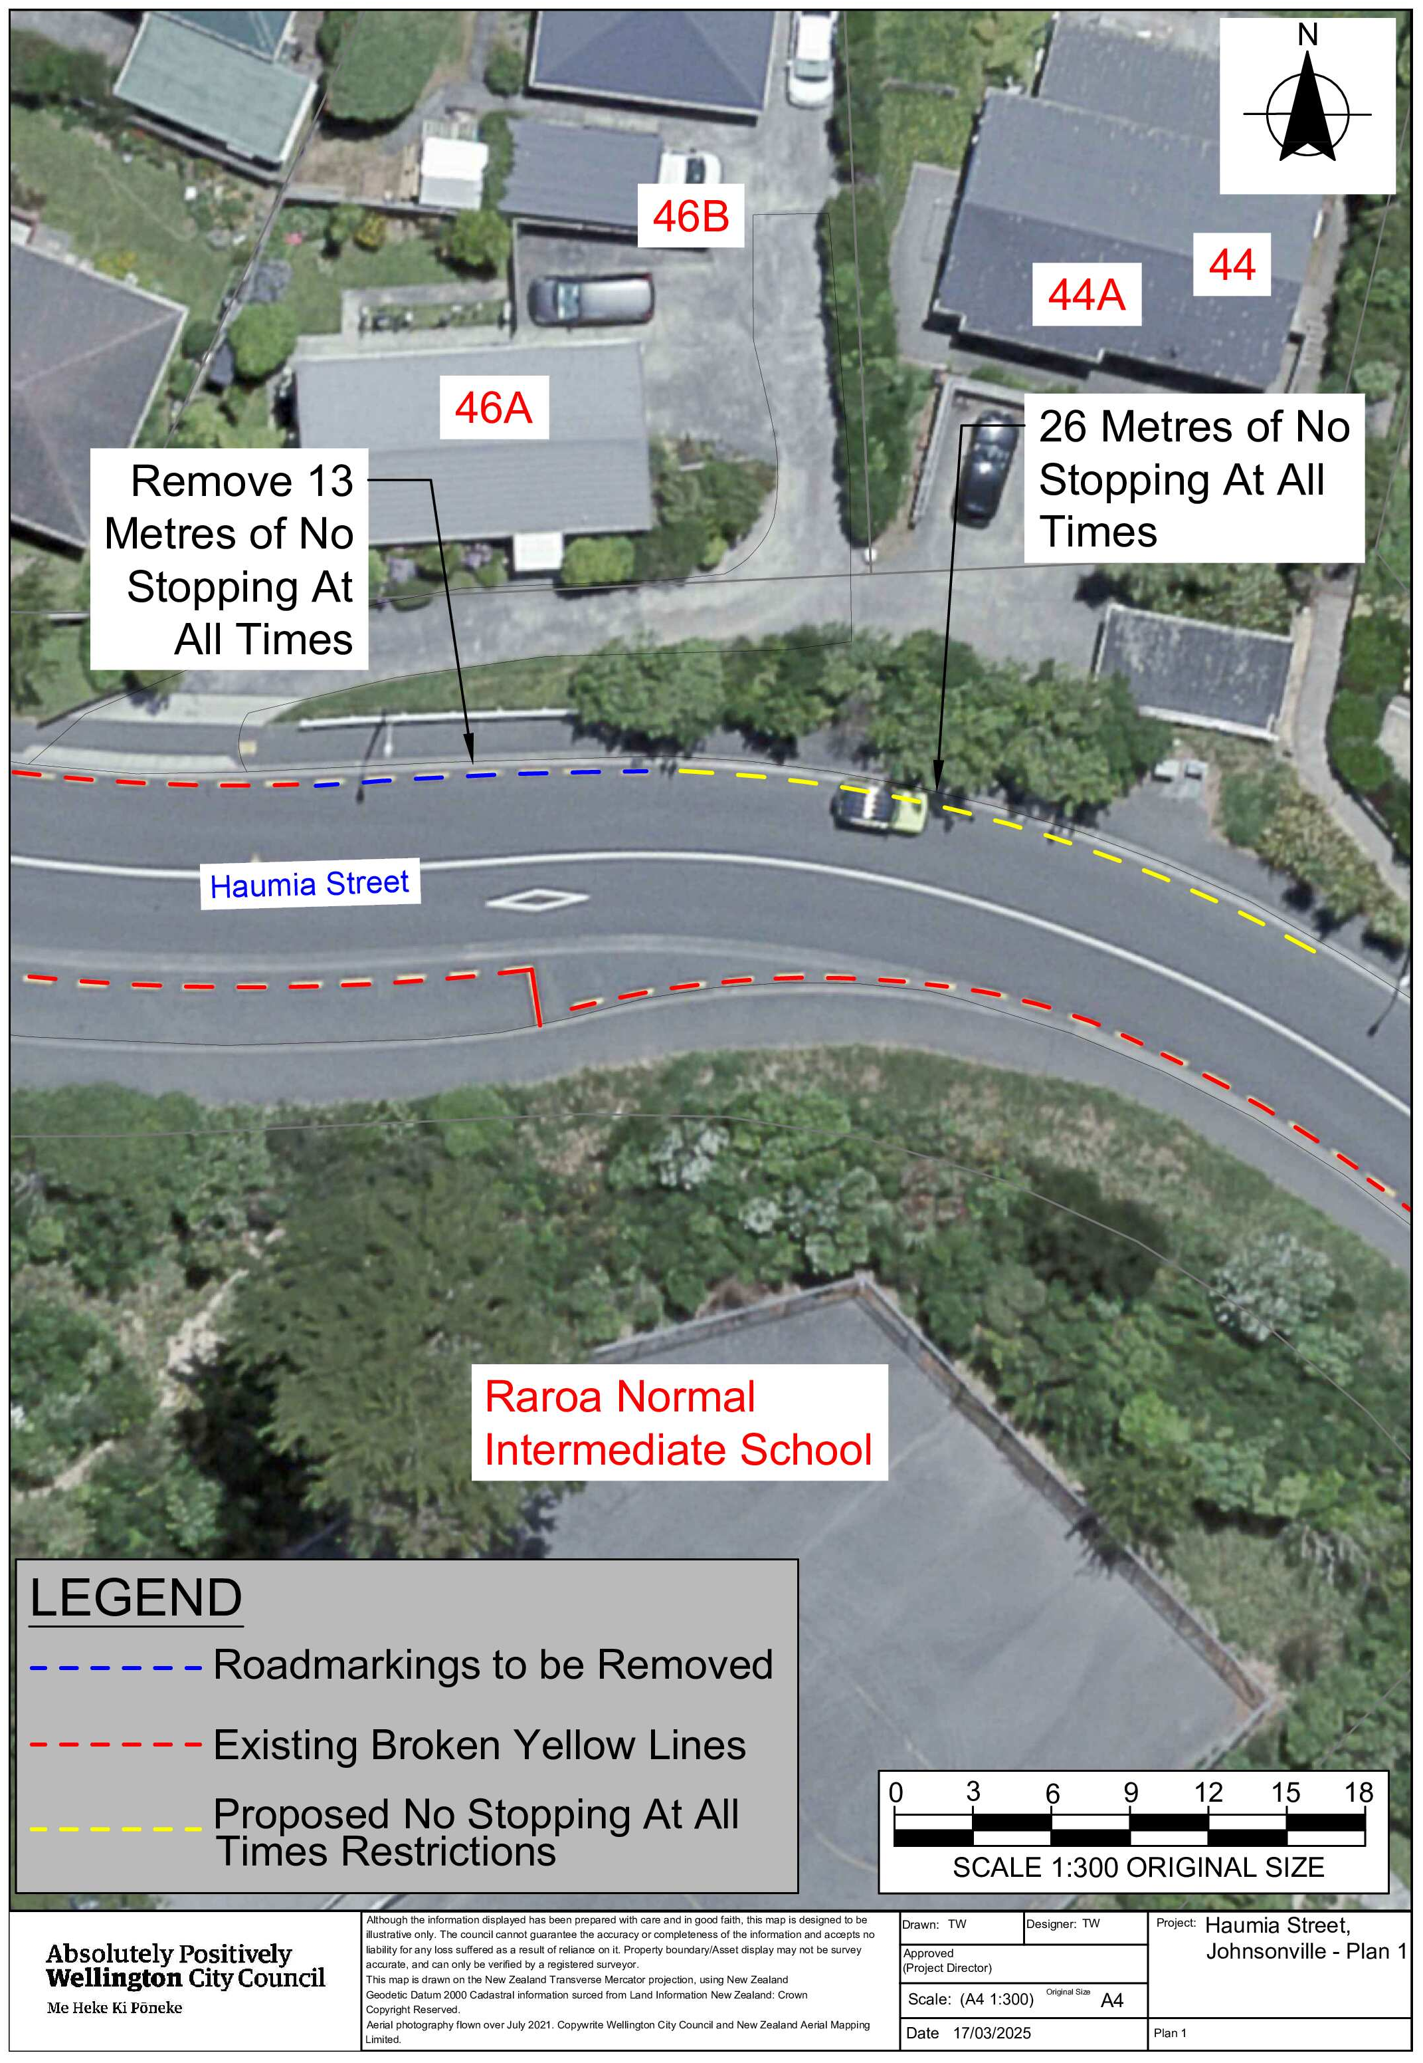
Traffic Resolution Plan: TR37-25 Haumia Street, Johnsonville - No Stopping At All Times Plan 1

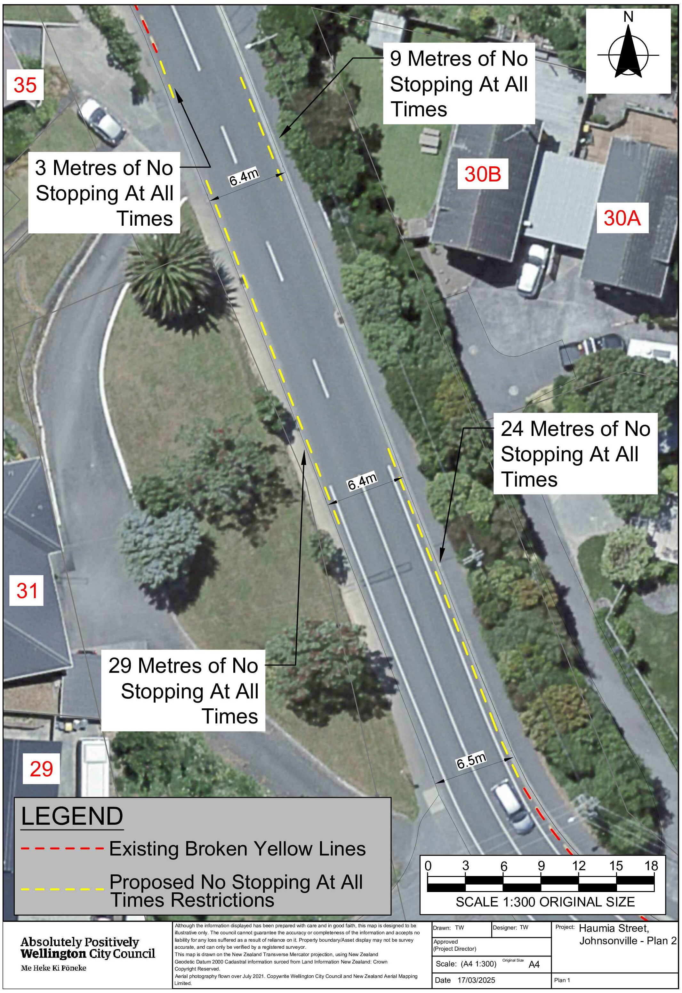
Traffic Resolution Plan: TR37-25 Haumia Street, Johnsonville - No Stopping At All Times Plan 2

Legal Description:

Delete from Schedule D (No Stopping) of the Traffic Restrictions Schedule

Column One | Column Two | Column Three
Haumia Street | No Stopping At All Times | North side, commencing 90 metres east of its intersection with Moorefield Road (Grid coordinates X=1,750,899.21m Y=5,434,208.19m) and extending in an easterly direction following the northern kerb line for 13 metres.

Add to Schedule D (No Stopping) of the Traffic Restrictions Schedule

Column One | Column Two | Column Three
Haumia Street | No Stopping At All Times | North side, commencing 103 metres east of its intersection with Moorefield Road (Grid coordinates X=1,750,899.21m Y=5,434,208.19m) and extending in an easterly direction following the northern kerb line for 26 metres.
Haumia Street | No Stopping At All Times | East side, commencing 120 metres west of its intersection with Fraser Avenue (Grid coordinates X=1,751,175.27m Y=5,434,034.26m) and extending in an northerly direction following the eastern kerb line for 28 metres.
Haumia Street | No Stopping At All Times | East side, commencing 171 metres west of its intersection with Fraser Avenue (Grid coordinates X=1,751,175.27m Y=5,434,034.26m) and extending in an northerly direction following the eastern kerb line for 9 metres.
Haumia Street | No Stopping At All Times | West side, commencing 150 metres west of its intersection with Fraser Avenue (Grid coordinates X=1,751,169.64m Y=5,434,023.17m) and extending in an northerly direction following the western kerb line for 29 metres.
Haumia Street | No Stopping At All Times | West side, commencing 150 metres west of its intersection with Fraser Avenue (Grid coordinates X=1,751,169.64m Y=5,434,023.17m) and extending in an northerly direction following the western kerb line for 3 metres.

Prepared By: | Tommy Wilson | (Transport Engineering Assistant)
Approved By: | Kate Gourdie | (Team Leader Traffic & Resolutions)
Approved Date: | 15/04/2025

