Kia ora,

We would like to inform you about a proposed change in your neighbourhood.

Proposal:

Reference | - TR16-26 Regent Street, Newtown – Mobility Park
Location – where we propose to make the change | Outside the entrance to Carrara Park on Regent Street (Opposite no.15 Regent Street).
What we’d like to do | - Install one Mobility Parking space At All Times
Why we are proposing the change | - The installation of a mobility carpark at the entrance of Carrara Park is proposed to support the accessibility objectives of the Carrara Park Public Toilet Project.  - The new toilet facilities have been designed to be accessible, and the addition of a designated mobility parking space will ensure that individuals with limited mobility can safely and conveniently access both the public toilets and the surrounding park amenities. This change aligns with our commitment to inclusive community infrastructure and supports equitable access for all users of the park.
Impact | Improvements  - Improves safety and accessibility for mobility users  Parking impact  - This proposes to replace an existing carpark with a mobility specific park
Other options considered | Option 1:  - Installing a mobility car park on Daniell Street outside the walkway entrance to Carrara Park. This location is unsuitable as the road gradient exceeds safe accessibility standards. This is essential for ensuring safety and usability for all mobility park users, including those with wheelchairs or mobility aids.
How this relates to the parking policy | - Support access for all – ensure disabled people, older people, people who are pregnant, and people with babies can access the city, Council facilities, and venues. This will be achieved, in part, through an improvement in mobility parking across the city.
Additional Information | - Average daily traffic count - 199 (2023 estimate)  - An electronic copy of the report will be available on the Council’s website from 9.00am Wednesday the 14 January 2026 at https://www.letstalk.wellington.govt.nz/
Privacy | - Your privacy is important to us. Please DO NOT add specific personal details to your feedback (i.e.: full name, address, etc)  - What we do with your personal information:  All submissions (including your first name, but not contact details) are provided in their entirety to elected members and made available to the public on our website and at our office. Personal information (including contact details) will also be used for the administration of the consultation process including informing you of the outcome of the consultation. All information collected will be held by Wellington City Council, 113 The Terrace, Wellington, with submitters having the right to access and correct personal information.  - For more information regarding our Privacy Statement please check our webpage: Privacy statement - Wellington City Council.
Feedback | - If you would like to provide us with specific feedback, which will be added to the Traffic Resolution following consultation and made public in full, you can do so by filling out an online submission form, downloading a printable submission form on https://www.letstalk.wellington.govt.nz/ or emailing us at trfeedback@wcc.govt.nz.  Please note if you are giving feedback the consultation period opens at 9.00am Wednesday the 14 January 2026 and finishes at 5.00pm Thursday the 29 January 2026.
Next Steps | - Feedback collated by Friday the 30 January 2026.  - The proposal will go to the Te Takere|Regulatory Processes Committee meeting on Wednesday the 4 March 2026.  - If approved, the proposal will be installed within the following six months.

Traffic Resolution Plan: TR16-26 Regent Street, Newtown - Mobility Parking At All Times

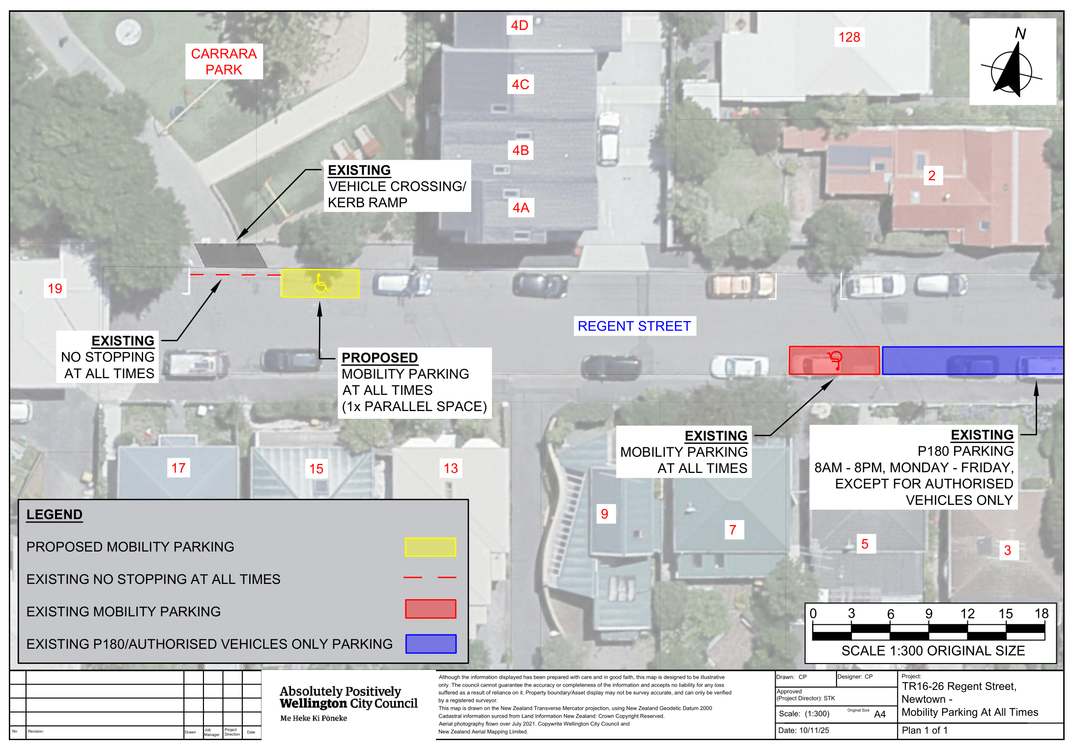
Legal Description:

Add to Schedule B (Class Restricted) of the Traffic Restrictions Schedule

Column One | Column Two | Column Three
Regent Street | Mobility Parking,  At All Times | North side, commencing 87.6 metres west of its intersection with Owen Street (Grid coordinates x= 1,749,413.97m, y= 5,424,699.75) and extending in a western direction for 6 metres following the northern kerbline.

Prepared By: | Jordan Brain | (Programme Manager Facilities PSR)
Approved By: | Kate Gourdie | (Team Leader Traffic & Resolutions)
Approved Date: | 19/11/2025

