Kia ora,

We would like to inform you about a proposed change in your neighbourhood.

Proposal:

Reference | TR138-24 Johnsonville Pool & Library Carpark, Johnsonville - Carpark Changes
Location – where we propose to make the change | Johnsonville Pool and Library Carpark, Johnsonville
What we’d like to do | - Change the parking restrictions to At All Times  - P120 8am-6pm to P120 At All Times  - Mobility to Mobility At All Times  - P10 Loading Zone to P10 Loading Zone At All Times  - Authorised Vehicles Only to Authorised Vehicles Only At All Times
Why we are proposing the change | - The Council has received complaints from facility users about vehicles exceeding their time limits, particularly during the morning and afternoon hours.  - The Keith Spry Pool is open from 6am to 9pm, but the current parking restrictions are only enforceable between 8am and 6pm. This leaves a four-hour period each day when these restrictions cannot be enforced.  - To enhance parking turnover, Council Officers propose changing the existing parking restrictions to “At All Times” to ensure equitable use of these parking spaces.
Impact | Improvements  - Improves safety and accessibility for Council facilities  - Improves safety and accessibility for mobility park users  - Improves parking availability  Net Parking Impact  - No loss of parking  Pedestrian impact  - No Change
Other options considered | Option 1:  - Change the existing parking restrictions from 8am – 6pm to 6am – 9pm in lieu of “At All Times” – this is not preferred as this may encourage people to leave vehicles overnight.
How this relates to the parking policy | - Support business wellbeing – ensure parking management and pricing controls support economic activity in the central city, suburban centres and mobile trades and services.  - Support city place-making, amenity and safety – ensure on-street parking design and placement supports overall city amenity, safety, community building, heritage, creative arts, good urban design outcomes and attractive streetscapes.
Additional Information | - To view the legal description for this Traffic Resolution, an electronic copy of the report will be available on the Council’s website from 9.00am Thursday 26 September at https://www.letstalk.wellington.govt.nz/ or you can call (04) 499 4444 and we will send one out to you.
Privacy | - Your privacy is important to us. Please DO NOT add specific personal details to your feedback (i.e.: full name, address, etc)  - What we do with your personal information:  All submissions (including your first name, but not contact details) are provided in their entirety to elected members and made available to the public on our website and at our office. Personal information (including contact details) will also be used for the administration of the consultation process including informing you of the outcome of the consultation. All information collected will be held by Wellington City Council, 113 The Terrace, Wellington, with submitters having the right to access and correct personal information.  - For more information regarding our Privacy Statement please check our webpage: Privacy statement - Wellington City Council.
Feedback | - If you would like to provide us with specific feedback, which will be added to the Traffic Resolution following consultation and made public in full, you can do so by filling out an online submission form, downloading a printable submission form on https://www.letstalk.wellington.govt.nz/ or emailing us at trfeedback@wcc.govt.nz.  Please note if you are giving feedback the consultation period opens at 9.00am Thursday 26 September and finishes at 5.00pm Thursday 10 October.
Next Steps | - Feedback collated by Friday 11 October.  - The proposal will go to the Koata Hātepe|Regulatory Processes Committee meeting on Thursday 14 November 2024.  - If approved, the proposal will be installed within the following three months.

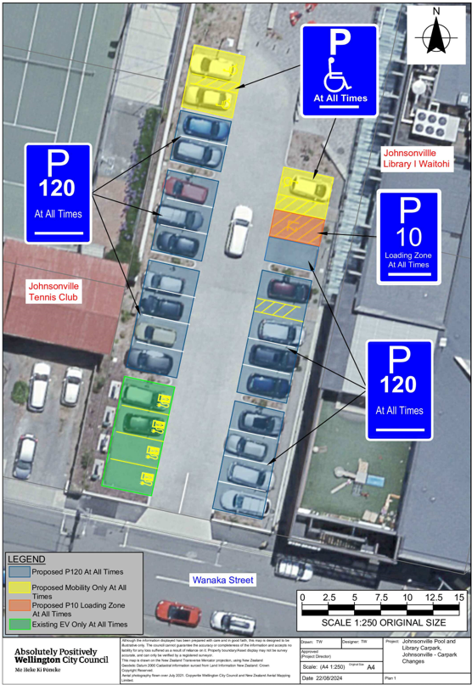
Traffic Resolution Plan: TR138-24 Johnsonville Pool and Library Carpark, Johnsonville - Carpark Changes

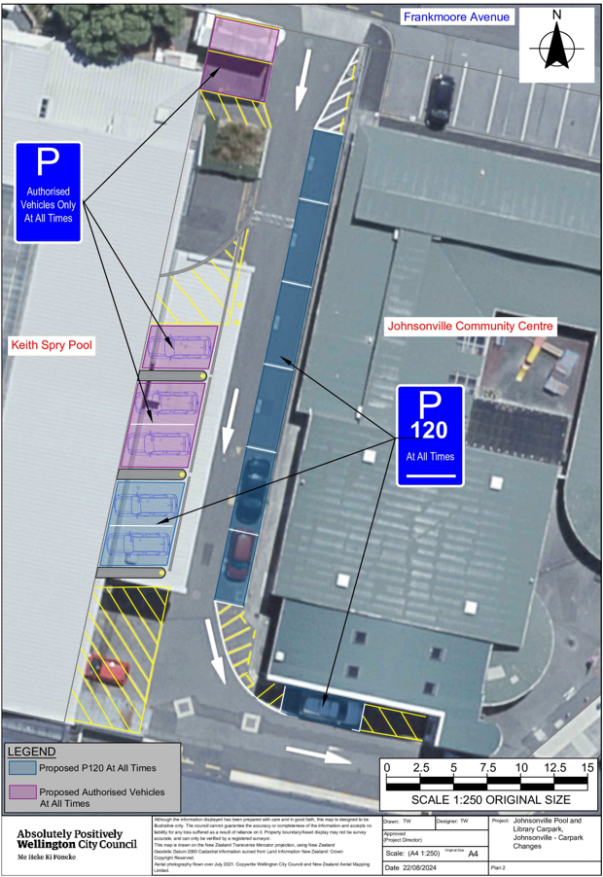
Traffic Resolution Plan: TR138-24 Johnsonville Pool and Library Carpark, Johnsonville - Carpark Changes

Legal Description:

Delete to Schedule A (Time Limited) of the Traffic Restrictions Schedule

Column One | Column Two | Column Three
Johnsonville Pool and Library Carpark | P120, Monday to  Sunday 8:00am -  6:00pm. Angle parking | West side, commencing at its intersection with the Northern kerbline of Wanaka St (Grid X= 1,751,223.49 m, Y= 5,434,913.23 m) and extending in a northerly direction for 44 metres.
Johnsonville Pool and Library Carpark | P120, Monday to  Sunday 8:00am -  6:00pm. Angle parking | East side, commencing at its intersection with the Northern kerbline of Wanaka St (Grid X= 1,751,242.94 m, Y= 5,434,909.53 m) and extending in a northerly direction for 36 metres.
Johnsonville Community Centre Carpark | Authorised volunteer  and staff parking | East side, commencing at its intersection with the South side of Frankmoore Avenue (Grid Coordinates X= 1,751,305.37 m, Y= 5,435,011.14 m) and extending in a southerly direction following the building line for 43 metres.
Johnsonville Community Centre Carpark | P120 angle parking | West side, commencing at its intersection with the South side of Frankmoore Avenue (Grid Coordinates X= 1,751,299.29 m, Y= 5,435,012.33 m) and extending in a southerly direction following the building line for 43 metres.

Delete to Schedule B (Class Restricted) of the Traffic Restrictions Schedule

Column One | Column Two | Column Three
Johnsonville Pool and Library Carpark | Mobility Parking,  displaying a mobility  parking permit only at  all times | West side, commencing 44m north of its intersection with the Northern kerbline  of Wanaka St (Grid X= 1,751,223.49 m, Y=  5,434,913.23 m) and extending in a northerly direction for 7 metres
Johnsonville Pool and Library Carpark | P10 Loading Zone | East side, commencing 36m north of its intersection with the Northern kerbline of Wanaka St (Grid X= 1,751,242.94 m, Y= 5,434,909.53 m)) and extending in a northerly direction for 3 metres
Johnsonville Pool and Library Carpark | Mobility Parking,  displaying a mobility  parking permit only at  all times | East side, commencing 39m north of its intersection with the Northern kerbline of Wanaka St (Grid X= 1,751,242.94 m, Y= 5,434,909.53 m) and extending in a northerly direction for 5 metres

Add to Schedule A (Time Limited) of the Traffic Restrictions Schedule

Column One | Column Two | Column Three
Johnsonville Pool and Library Carpark | P120, At All Times | West side, commencing 15.7 metres of the Northern kerbline of Wanaka St (Grid X= 1,751,223.49 m, Y= 5,434,913.23 m) and extending in a northerly direction for 25 metres.
Johnsonville Pool and Library Carpark | P120, At All Times | East side, commencing 3.2 metres of the Northern kerbline of Wanaka St (Grid X= 1,751,242.94 m, Y= 5,434,909.53 m) and extending in a northerly direction for 26.5 metres.
Johnsonville Community Centre Carpark | P120, At All Times | East side, commencing 9 metres south of the southern kerb line of Frankmoore Avenue (Grid Coordinates X= 1,751,305.37 m, Y= 5,435,011.14 m) and extending in a southerly direction following the building line for 36 metres.
Johnsonville Community Centre Carpark | P120 At All Times | West side, commencing 38 metres south of the southern kerb line of Frankmoore Avenue (Grid Coordinates X= 1,751,299.29 m, Y= 5,435,012.33 m) and extending in a southerly direction following the building line for 6.4 metres.
Johnsonville Community Centre Carpark | P120 At All Times, | North side, commencing 16.5 metres west of the western kerb line of Moorefield Road (Grid Coordinates X= 1,751,319.49 m, Y= 5,434,954.53 m) and extending in a westerly direction for 6 metres.

Add to Schedule B (Class Restricted) of the Traffic Restrictions Schedule

Column One | Column Two | Column Three
Johnsonville Pool and Library Carpark | Mobility Parking At All Times,  Displaying a mobility  parking permit only at  all times | West side, commencing 40m north of the Northern kerbline of Wanaka St (Grid X= 1,751,223.49 m, Y= 5,434,913.23 m) and extending in a northerly direction for 6 metres
Johnsonville Pool and Library Carpark | P10 Loading Zone, At All Times | East side, commencing 29.7 metres north of the Northern kerbline of Wanaka St (Grid X= 1,751,242.94 m, Y= 5,434,909.53 m) and extending in a northerly direction for 2.6 metres
Johnsonville Pool and Library Carpark | Mobility Parking At All Times,  Displaying a mobility  parking permit only at  all times | East side, commencing 32.4 metres north of the Northern kerbline of Wanaka St (Grid X= 1,751,242.94 m, Y= 5,434,909.53 m) and extending in a northerly direction for 4 metres
Johnsonville Community Centre Carpark | Authorised Vehicles only At All Times | West side, commencing 26 metres south of the southern kerb line of Frankmoore Avenue (Grid Coordinates X= 1,751,299.29 m, Y= 5,435,012.33 m) and extending in a southerly direction following the building line for 11 metres.
Johnsonville Community Centre Carpark | Authorised Vehicles only At All Times | West side, commencing 2.5 metres south of the southern kerb line of Frankmoore Avenue (Grid Coordinates X= 1,751,299.29 m, Y= 5,435,012.33 m) and extending in a southerly direction for 5.5 metres.

Add to Schedule D (No Stopping) of the Traffic Restrictions Schedule

Column One | Column Two | Column Three
Johnsonville Community Centre Carpark | No Stopping At All Times | East side, commencing 26 metres west of the western kerb line of Moorefield Road (Grid Coordinates X= 1,751,319.49 m, Y= 5,434,954.53 m) and extending in a northerly direction for 6 metres.
Johnsonville Community Centre Carpark | No Stopping At All Times | East side, commencing 4 metres south of the southern kerb line of Frankmoore Avenue (Grid Coordinates X= 1,751,319.49 m, Y= 5,434,954.53 m) and extending in a southerly direction for 5 metres.

Prepared By: | Tommy Wilson | (Transport Engineering Assistant)
Approved By: | Kate Gourdie | (Team Leader Traffic & Resolutions)
Approved Date: | 9/9/2024

