Kia ora,

This leaflet is to let you know about a change we are making in your neighbourhood. These changes are required by the Land Transport Rule: Setting of Speed Limits 2024. We are seeking your feedback on specific parts of the changes.

Reference | - TR36-26 Altum Classical Academy – Variable speed limit
Location – where we propose to make the change | Walworth Road, Wilton road, Worchester Street, Curtis Street and Albemarle Road from 8:20am-9:10am and 2:50pm-5:10pm School Days Only
What is the change | - Change the posted speed limit from 50 kilometres per hour (kph) to 30kph during morning drop off and afternoon pick up school times.  - The times for the variable speed limit will be based on the starting and finishing times of the school.  - The proposed variable speed zones will be indicated by one of two variable speed zone sign types – either a static sign, or an electronic sign. The type of sign used is guided by the One Network Framework and engineering judgment.  - For more information on the types of signs and which sign will be used in your area visit Safe speed limits outside schools - Projects - Wellington City Council.  - Static signs show the timeframes when 30kph applies on the road.  - Electronic signs are turned on/off or show the applicable speed limit.  - Sign type one is a static variable speed limit sign. This sign type will show 30kph with the time frames when the variable speed limit is valid on a supplementary sign below the 30kph sign. When motorists are travelling through the variable speed limit zone outside the times depicted on the sign the speed limit will revert to the posted speed limit indicated by other non-variable speed limit signs in the area.  - Sign type two is an electronic variable speed limit sign. This sign type will activate by turning on and showing that 30km per hour is the posted speed limit during the times of day when the variable speed limit is valid. During other times of the day, the electronic sign will be turned off, and the posted speed limit will be indicated by non-variable speed limit signs in the area.  - The only exception to this is when the proposed variable speed limit is partially encapsulated by an existing permanent posted speed limit change. An example of a situation like this is when an urban shopping area currently posted at 30kph changes to 50kph when exiting the shopping area. In circumstances like this where the variable speed limit zone is partially encapsulated by the existing 50kph zone and 30kph zone, the electronic variable speed signs will be utilised and will be on at all times of day. This will allow for the electronic sign to display 30kph during the variable speed limit times and revert to 50kph during non-variable speed limit times. This setup is required as a static sign would be unable to indicate the speed limit change from 30kph to 50kph outside of the designated variable speed limit times.  - The size of the variable speed limit zones is set by the Land Transport Rule: Setting of Speed Limits. It states that all school gates and extending 150 metres in both directions from all school gates are to be included within the variable speed limit zone.  - The decision to use sign type one, or sign type two is based on the One Network Framework. This framework ranks all roads and categorises the roads according to places for people and transport corridor movements. All roads categorised as anything other than an ‘Urban Connector’ is required to use sign type one – Static VSL sign. The only exception to this is where engineers have recommended that the specific location requires sign type two, and instead sign type two will be utilised.
Why is the change being made | - These changes are required by the Land Transport Rule: Setting of Speed Limits 2024 which is required to be implemented by 1 July 2026.
What we would like your feedback on | - We would like to hear your feedback on the location of the signs themselves if they are located near your place of residence, please note however that these signs will need to be installed 150m from the school gate to be in line with the Rule. If you would like to view each sign location in detail, please go to Safe speed limits outside schools - Projects - Wellington City Council.
Impact | - Pedestrian/vehicle impact – Improves pedestrian safety by slowing down vehicle speed around schools during drop off and pick up times. In the event of an incident lower vehicle speed reduces the risk for the crash and the severity of injury. As a result, the outcome of the incident is likely to be less severe than if the vehicle was travelling at a higher speed.
Additional Information | - An electronic copy of the report will be available on the Council’s website from 9.00am 9 March 2026 at https://www.letstalk.wellington.govt.nz/
Privacy | - Your privacy is important to us. Please DO NOT add specific personal details to your feedback (i.e.: full name, address, etc)  - What we do with your personal information:  All submissions (including your first name, but not contact details) are provided in their entirety to elected members and made available to the public on our website and at our office. Personal information (including contact details) will also be used for the administration of the feedback process including informing you of the outcome of the consultation. All information collected will be held by Wellington City Council, 113 The Terrace, Wellington, with submitters having the right to access and correct personal information.  - For more information regarding our Privacy Statement please check our webpage: Privacy statement - Wellington City Council.
Feedback | - If you would like to provide us with specific feedback, which will be added to the Traffic Resolution following consultation and made public in full, you can do so by filling out an online submission form, downloading a printable submission form on https://www.letstalk.wellington.govt.nz/ or emailing us at trfeedback@wcc.govt.nz.  - Please note if you are giving feedback the consultation period opens at 9.00 am 9 March 2026 and finishes at 5.00 pm 23 March 2026.
Next Steps | - Feedback collated by 24 March 2026.  - The proposal will go to the Te Takere|Regulatory Processes Committee meeting on 6 May 2026.  - If approved, the proposal will be installed within the following six months.

- Traffic Resolution Plan: TR36-26 Altum Classical Academy – Variable speed limit

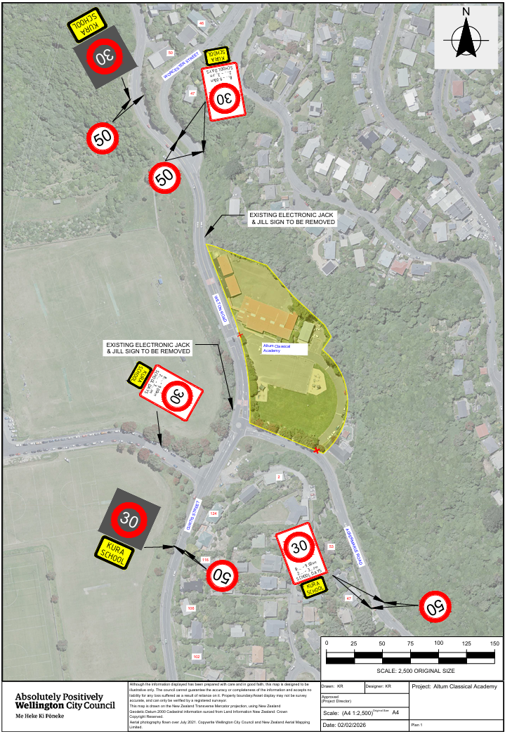

Legal Description:

Table 1: Proposed speed limits for Altum Classical Academy
Column One | Column Two | Column Three
Curtis Street | 30kph  8:20am-9:10am 4:20pm-5:10pm  (expect on Fridays 2:50-3:30pm)  School Days Only | Beginning 65 meters north its intersection with Worchester Street (Grid coordinates X= 1,747,000.741 Y= 5,429,403.821) and extending in a southerly direction following the eastern kerb line for 439 meters.
Worchester Street | 30kph  8:20am-9:10am 4:20pm-5:10pm  (expect on Fridays 2:50-3:30pm)  School Days Only | Beginning 20 meters north its intersection with Curtis Street (Grid coordinates X= 1,747,052.718 Y= 5,429,357.120) and extending in a southerly direction following the eastern kerb line for 20 meters.
Albemarle Road | 30kph  8:20am-9:10am 4:20pm-5:10pm  (expect on Fridays 2:50-3:30pm)  School Days Only | Beginning 350 meters west of its intersection with Pembrooke Road (Grid coordinates X= 1,747,214.892 Y= 5,428,950.364) and extending in a northerly direction following the eastern kerb line for 213 meters.
Walworth Road | 30kph  8:20am-9:10am 4:20pm-5:10pm  (expect on Fridays 2:50-3:30pm)  School Days Only | Beginning 47 meters west of its intersection with Curtis Street (Grid coordinates X= 1,747,019.924 Y= 5,429,089.878) and extending in an easterly direction following the northern kerb line for 47 meters.

Prepared By: | Karl Rudge | (Transport Engineer)
Approved By: | Kate Gourdie | (TL Traffic & Resolutions)
Approved Date: | 13/02/2026

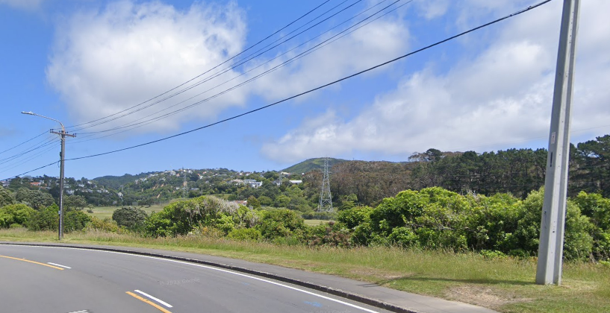


Opposite and South of 233 Wilton Road

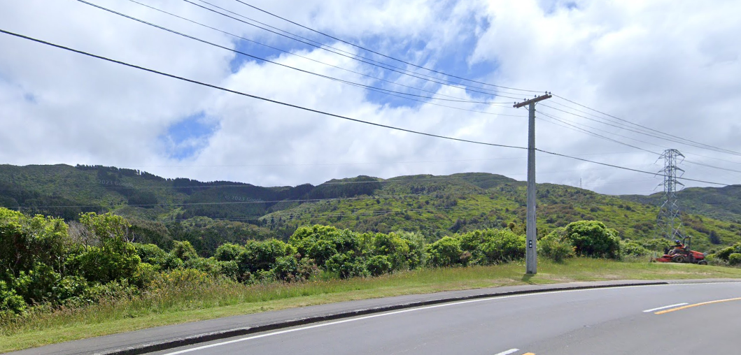

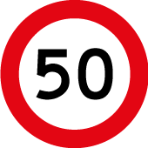

Opposite and South of 233 Wilton Road

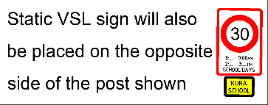

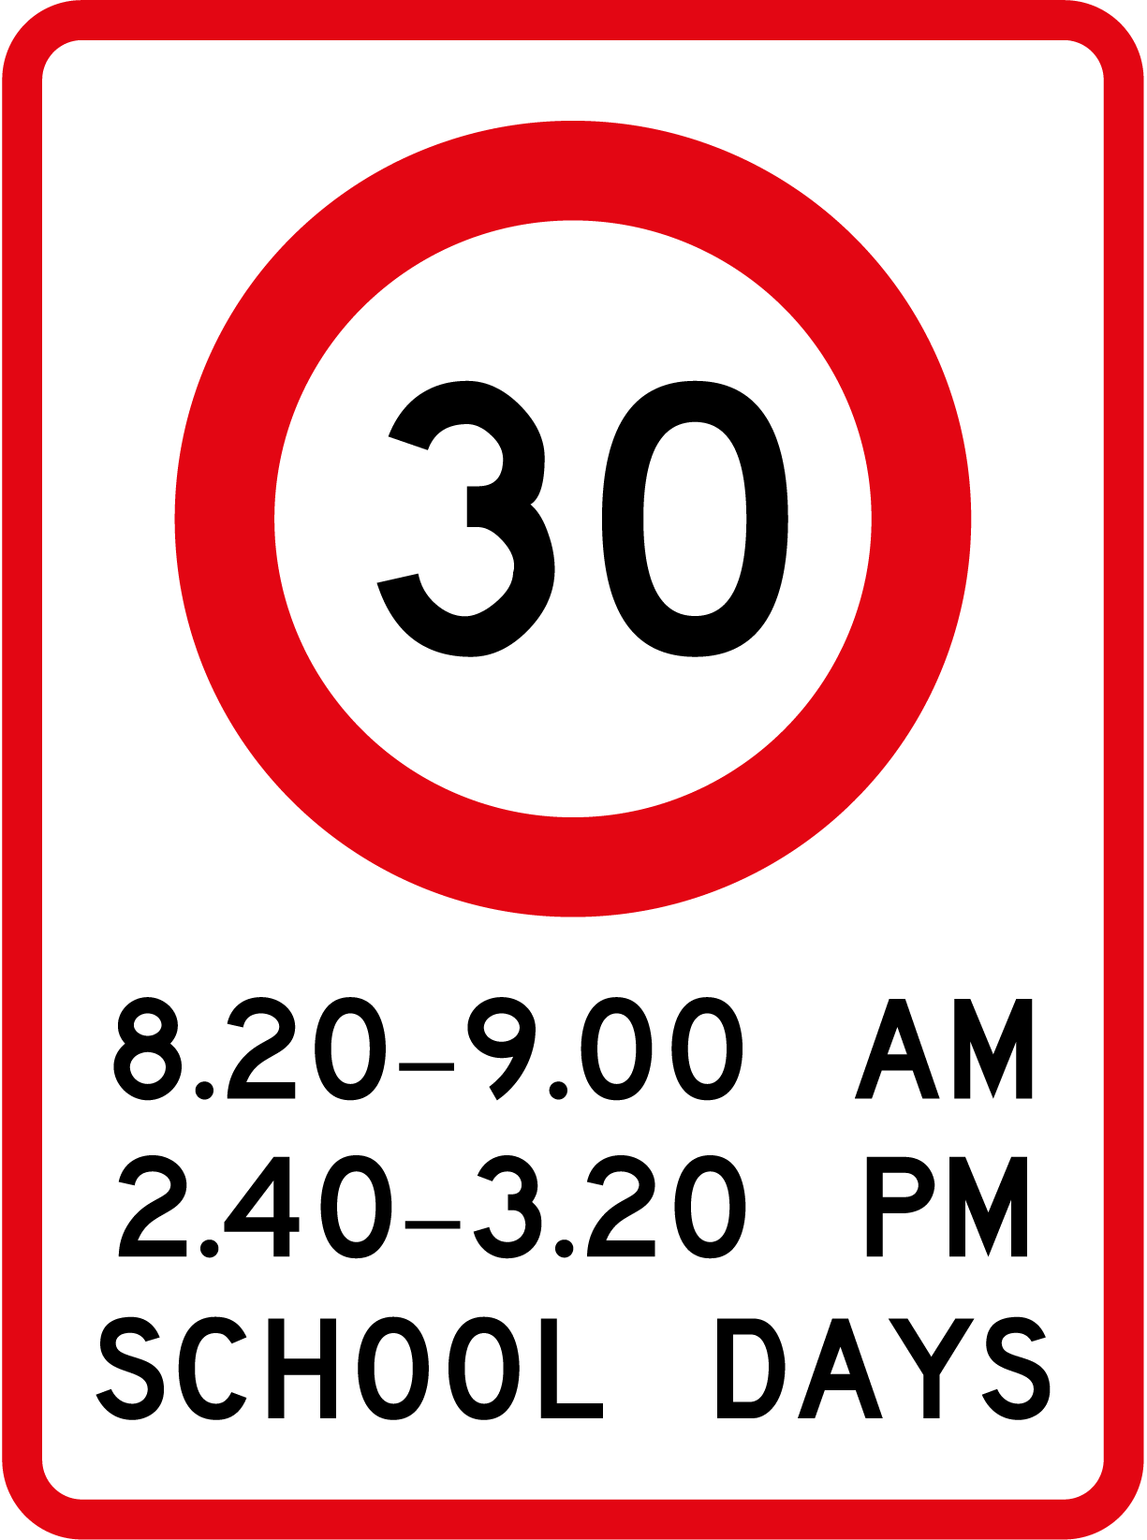
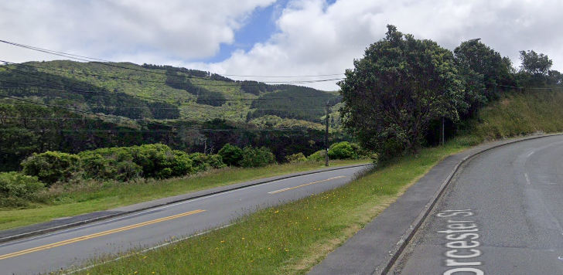
Opposite 47 Worcester Street Road

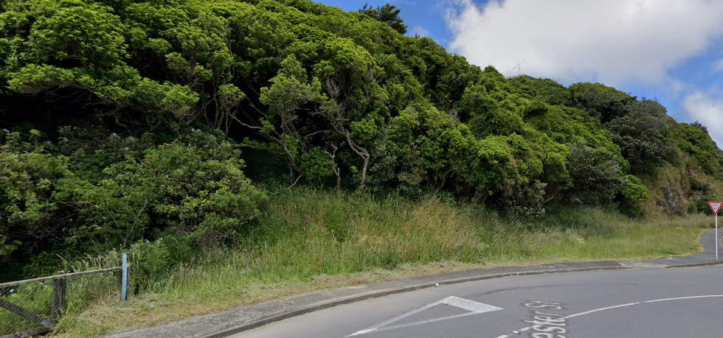
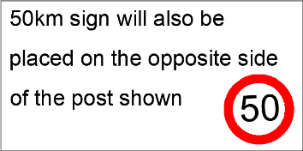

Intersection of Worchester Street and Wilton Road

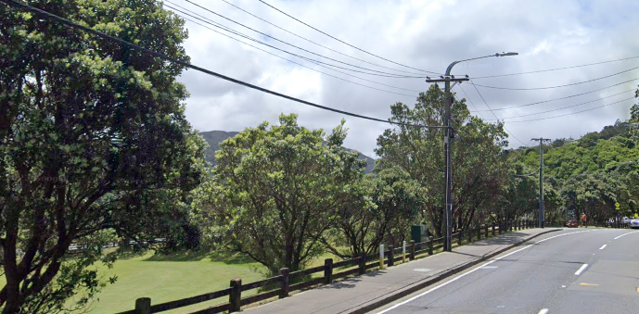

Opposite 116 Wilton Road

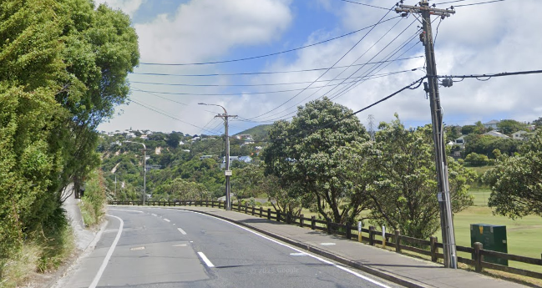

Opposite 116 Wilton Road

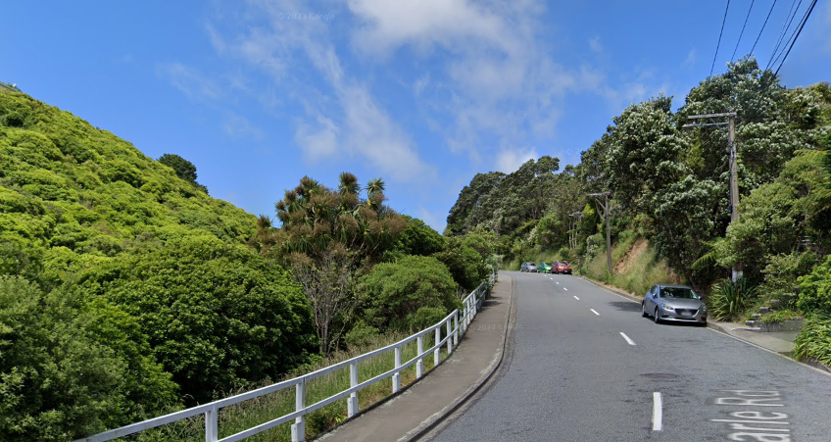

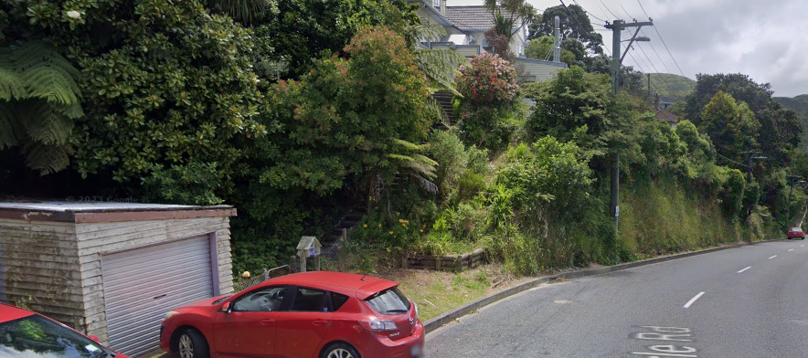
Opposite 47 Albemarle Road

47 Albemarle Road

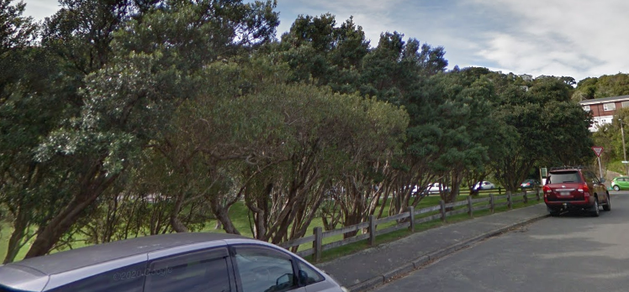
Intersection of Walworth Road and Wilton Road

