Kia ora,

We would like to inform you about a proposed change in your neighbourhood.

Proposal:

Reference | - TR22-25 Ganges Road, Khandallah – Proposed P60 Time Limited Parking
Location – where we propose to make the change | Ganges Road, Khandallah between nos. 1 and 5
What we’d like to do | - Convert eight P10 Time Limited Parking spaces into eight P60 Time Limited Parking spaces
Why we are proposing the change | - Council has received a petition from local businesses requesting the conversion of the P10 parking spaces between numbers 1 and 5 Ganges Road to be changed to P60 time-limited restriction.  - The Council reviewed the petition and carried out initial consultation by hand delivering letters to local businesses. The proposal recommended converting five P10 spaces to P60, while maintaining three P10 spaces to support short-term parking for businesses like takeaway shops.  - The feedback largely supported converting all eight spaces to P60, and as a result, Council officers have decided to go with the community’s preference.  - The Council’s original proposal to keep a mix of P10 and P60 spaces will remain as a secondary option, pending further feedback from businesses and the public as part of this traffic resolution.
Impact | Improvements  - Improves the viability of business wellbeing  Net Parking Impact  - Converting eight P10 parking spaces to P60 parking spaces  Pedestrian impact  - No Change
Other options considered | Option 1:  - Convert five spaces to P60 and retain three P10 spaces, this option is not preferred after consulting with local businesses in the area, however we will continue to receive feedback regarding this option.
How this relates to the parking policy | - Support business wellbeing – ensure parking management and pricing controls support economic activity in the central city, suburban centres and mobile trades and services.
Additional Information | - Average daily traffic count – 3394  - To view the legal description for this Traffic Resolution, an electronic copy of the report will be available on the Council’s website from 9.00am Friday 21 February 2025 at https://www.letstalk.wellington.govt.nz/ or you can call (04) 499 4444 and we will send one out to you.
Privacy | - Your privacy is important to us. Please DO NOT add specific personal details to your feedback (i.e.: full name, address, etc)  - What we do with your personal information:  All submissions (including your first name, but not contact details) are provided in their entirety to elected members and made available to the public on our website and at our office. Personal information (including contact details) will also be used for the administration of the consultation process including informing you of the outcome of the consultation. All information collected will be held by Wellington City Council, 113 The Terrace, Wellington, with submitters having the right to access and correct personal information.  - For more information regarding our Privacy Statement please check our webpage: Privacy statement - Wellington City Council.
Feedback | - If you would like to provide us with specific feedback, which will be added to the Traffic Resolution following consultation and made public in full, you can do so by filling out an online submission form, downloading a printable submission form on https://www.letstalk.wellington.govt.nz/ or emailing us at trfeedback@wcc.govt.nz.  Please note if you are giving feedback the consultation period opens at 9.00am Friday 21 February 2025 and finishes at 5.00pm Friday 7 March 2025.
Next Steps | - Feedback collated by Monday 10 March 2025.  - The proposal will go to the Koata Hātepe|Regulatory Processes Committee meeting on Wednesday 9 April 2025.  - If approved, the proposal will be installed within the following three months.

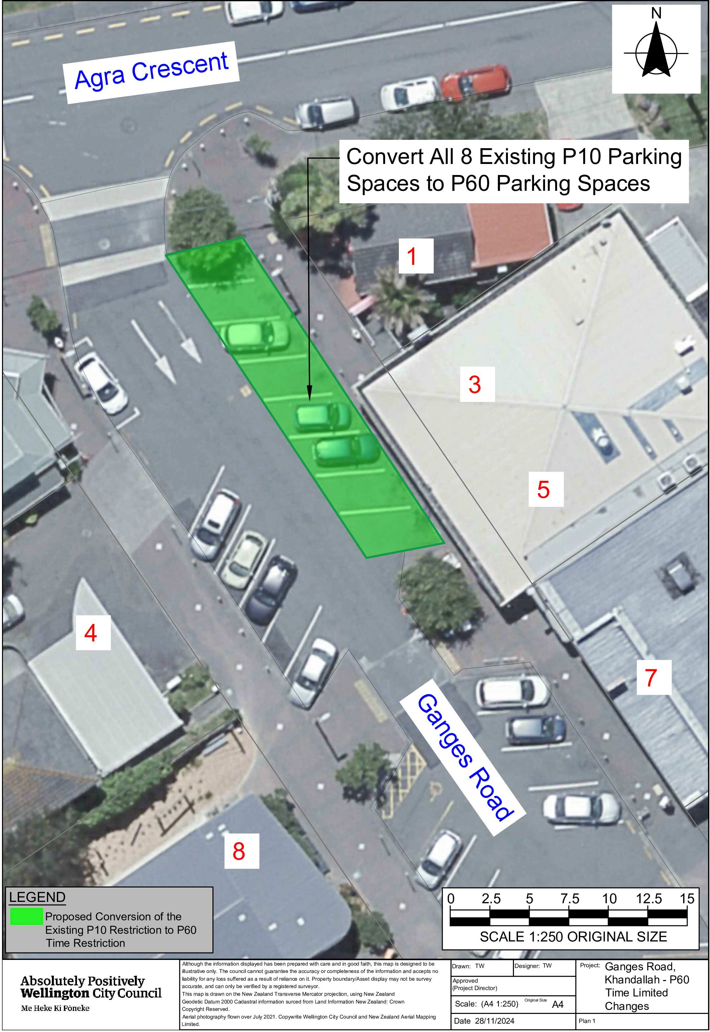
Traffic Resolution Plan: TR22-25 Ganges Road, Khandallah - Proposed P60 Time Limited Parking

Legal Description:

Delete from Schedule A (Time Limited Parking) of the Traffic Restrictions Schedule

Column One | Column Two | Column Three
Ganges Road | P10  8:00am – 6:00pm  (Monday – Sunday) | East side, commencing 11.5 metres south of its intersection with Agra Crescent (Grid  Coordinates x= 1750049.0 m, y= 5432350.7 m), and extending in a southerly direction following the eastern kerbline for 20.0m metres.

Delete from Schedule B (Class Restricted) of the Traffic Restrictions Schedule

Column One | Column Two | Column Three
Ganges Road | Electric vehicles only parking, P120 Maximum, at all times | East side, commencing 31.5 metres south of its intersection with Agra Crescent (Grid  Coordinates x= 1750049.0 m, y= 5432350.7 m), and extending in a southerly direction following the eastern kerbline for 3.4m metres. (1 angled park)

Add to Schedule A (Time Limited Parking) of the Traffic Restrictions Schedule

Column One | Column Two | Column Three
Ganges Road | P60  8:00am – 6:00pm  (Monday – Sunday) | East side, commencing 11.5 metres south of its intersection with Agra Crescent (Grid  Coordinates x= 1750049.0 m, y= 5432350.7 m), and extending in a southerly direction following the eastern kerbline for 23.4m metres.

Prepared By: | Tommy Wilson | (Transport Engineering Assistant)
Approved By: | Kate Gourdie | (Team Leader Traffic & Resolutions)
Approved Date: | 30/1/2025

