Kia ora,

We would like to inform you about a proposed change in your neighbourhood.

Proposal:

Reference | - TR131-24 Kaiwharawhara Road, Kaiwharawhara - P180 Restriction
Location – where we propose to make the change | Kaiwharawhara Road by scenic reserve
What we’d like to do | - Propose P180 8am – 6pm, Monday – Friday Time Limited Parking Restrictions
Why we are proposing the change | - Council have received a request to install a time limit on the existing unlimited parking located on Kaiwharawhara Road.  - These parking spaces are located near the entrance to Trelissick Park and installed as part of the Ngaio Gorge stabilisation project.  - Reports from the public have made officers aware that these parking spaces are being used as all day parking, likely by those who are working further down Kaiwharawhara Road.  - As the location is very close to Trelissick Park, officers have discussed this with the Parks, Sport and Recreation team who have confirmed they have had reports of this issue occurring causing issues with those trying to access the park.  - To improve parking turn-over and reduce congestion problems, Council Officers are proposing the P180 8am-6pm Monday – Friday parking restriction.
Impact | Improvements  - Improves parking availability.  Net Parking Impact  - Converting of five unrestricted parking spaces to P180.  - Formalising three unrestricted parking spaces into P180.  Pedestrian impact  - No Change.
Other options considered | Option 1:  - P120 – This time limit is too short for this location and would not be consistent with the parking restrictions further down Kaiwharawhara Road.
How this relates to the parking policy | - Support safe movement – facilitate the safe and efficient movement of people and goods by focusing on people moving along transport corridors rather than people parking or storing stationary vehicles.  - Support city place-making, amenity, and safety – ensure on-street parking design and placement supports overall city amenity, safety, community building, heritage, creative arts, good urban design outcomes and attractive streetscapes.
Additional Information | - Average daily traffic count – 7885 (2023)  - To view the legal description for this Traffic Resolution, an electronic copy of the report will be available on the Council’s website from 9.00am Thursday 26 September at https://www.letstalk.wellington.govt.nz/ or you can call (04) 499 4444 and we will send one out to you.
Privacy | - Your privacy is important to us. Please DO NOT add specific personal details to your feedback (i.e.: full name, address, etc)  - What we do with your personal information:  All submissions (including your first name, but not contact details) are provided in their entirety to elected members and made available to the public on our website and at our office. Personal information (including contact details) will also be used for the administration of the consultation process including informing you of the outcome of the consultation. All information collected will be held by Wellington City Council, 113 The Terrace, Wellington, with submitters having the right to access and correct personal information.  - For more information regarding our Privacy Statement please check our webpage: Privacy statement - Wellington City Council.
Feedback | - If you would like to provide us with specific feedback, which will be added to the Traffic Resolution following consultation and made public in full, you can do so by filling out an online submission form, downloading a printable submission form on https://www.letstalk.wellington.govt.nz/ or emailing us at trfeedback@wcc.govt.nz.  Please note if you are giving feedback the consultation period opens at 9.00am Thursday 26 September and finishes at 5.00pm Thursday 10 October.
Next Steps | - Feedback collated by Friday 11 October.  - The proposal will go to the Koata Hātepe|Regulatory Processes Committee meeting on Thursday 14 November.  - If approved, the proposal will be installed within the following three months.

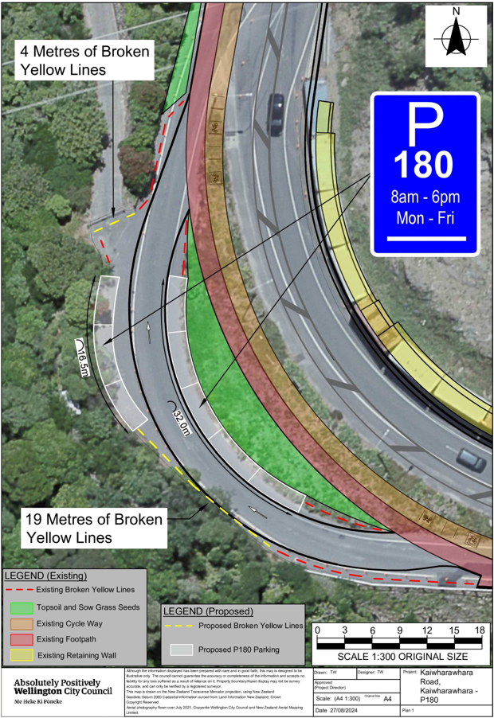
Traffic Resolution Plan: TR131-24 Kaiwharawhara Road, Kaiwharawhara - P180 Restriction

Legal Description:

Add to Schedule A (Time Limited) of the Traffic Restrictions Schedule

Column One | Column Two | Column Three
Kaiwharawhara Road Slip Lane | P180  8:00am – 6:00pm  (Monday – Friday) | East side, commencing 19 metres west of its intersection with Kaiwharawhara Road (Grid coordinates X= 1,749,091.37m Y= 5,431,119.43m) and extending in a westerly direction following the eastern kerb line for 32 metres.

Add to Schedule A (Time Limited) of the Traffic Restrictions Schedule

Column One | Column Two | Column Three
Kaiwharawhara Road Slip Lane | P180  8:00am – 6:00pm  (Monday – Friday) | West side, commencing 49 metres west of its intersection with Kaiwharawhara Road (Grid coordinates X= 1,749,099.05m Y= 5,431,116.91m) and extending in a northerly direction following the western kerb line for 16.5 metres.

Add to Schedule D (No Stopping) of the Traffic Restrictions Schedule

Column One | Column Two | Column Three
Kaiwharawhara Road Slip Lane | No Stopping At All Times | East side, commencing 12 metres west of its intersection with Kaiwharawhara Road (Grid coordinates X= 1,749,091.37m Y= 5,431,119.43m) and extending in a westerly direction following the eastern kerb line for 9 metres.
Kaiwharawhara Road Slip Lane | No Stopping At All Times | West side, commencing 9 metres west of its intersection with Kaiwharawhara Road (Grid coordinates X= 1,749,099.05m Y= 5,431,116.91m) and extending in a north westerly direction following the western kerb line for 42 metres.
Kaiwharawhara Road Slip Lane | No Stopping At All Times | West side, commencing 4.5 metres west of its intersection with Kaiwharawhara Road (Grid coordinates X= 1,749,065.02m Y= 5,431,165.82m) and extending in a southerly direction following the western kerb line for 22 metres.
Kaiwharawhara Road Slip Lane | No Stopping At All Times | East side, commencing 4.5 metres west of its intersection with Kaiwharawhara Road (Grid coordinates X= 1,749,065.13m Y= 5,431,155.01m) and extending in a southerly direction following the Eastern kerb line for 6 metres.

Prepared By: | Tommy Wilson | (Transport Engineering Assistant)
Approved By: | Kate Gourdie | (Team Leader Traffic & Resolutions)
Approved Date: | 4/9/2024

