Kia ora,

We would like to inform you about a proposed change in your neighbourhood.

Proposal:

Reference | - TR25-25 Newtown East Parking Scheme Zone – Parking Restriction Amendments
Location – where we propose to make the change | Newtown East Parking Scheme Zone – Daniell, Wilson and Owen Street
What we’d like to do | - The traffic resolution (TR157-23) for the Newtown and Berhampore parking scheme was approved at Koata Hātepe | Regulatory Processes Committee 18 April 2024. This approval was required to formalise the new parking restrictions on the street as part of the Newtown and Berhampore parking zones.  - The proposed traffic resolution addresses a few minor discrepancies without altering the originally consulted scheme. The adjustments are simply a refinement following installation, construction, and correcting a few inaccurately identified parking restrictions in the original resolution. The specific changes, detailed in the attached plans, are as follows:  - Outside no. 35 Daniell Street – Amended to three pick-up and drop-off parking spaces, 8:30-9am, 2:45-3:15pm Monday – Friday, During School Terms Only  - Outside no. 33 Wilson Street – Amended to three P60 parking spaces, 8am-6pm Monday – Sunday  - Outside no. 11 Owen Street – Amended to four P180 parking spaces, 8am-8pm Monday – Friday, Resident Permit Exempt  - Outside no. 2 Wilson Street – Amended to four P60 parking spaces, 8am-6pm Monday – Sunday  - Outside no. 17 Wilson Street – Removal of one P180 8am-8pm Monday – Friday, resident permit exempt spaces to an unrestricted space
Why we are proposing the change | - During the installation of the new signs, poles, and markings, we discovered minor discrepancies in the original traffic resolution for the Newtown East zone. These discrepancies are detailed in this amended traffic resolution.  - This traffic resolution aims to formalise the restrictions, update the plans, and ensure the changes made on the streets are legally enforceable.
Impact | Improvements  - Improves parking accessibility for residents and mobility users  - Improves short-stay accessibility for visitors, shoppers, and tradespeople  - Formalise existing restrictions, in order to be enforceable  Net Parking Impact  - Only formalising what is currently existing on-street  Pedestrian Impact  - No change
Other options considered | - Options were considered as part of the Newtown & Berhampore Parking Management Plan TR157-23 consultation (including letter drops and drop-in sessions), further information on this consultation can be found at Supporting documents | WCC Transport Projects.
How this relates to the parking policy | - Support safe movement – facilitate the safe and efficient movement of people and goods by focusing on people moving along transport corridors rather than people parking or storing stationary vehicles.  - Support city place-making, amenity, and safety – ensure on-street parking design and placement.
Additional Information | - To view the legal description for this Traffic Resolution, an electronic copy of the report will be available on the Council’s website from 9.00am Friday 21 February 2025 at https://www.letstalk.wellington.govt.nz/ or you can call (04) 499 4444 and we will send one out to you.
Privacy | - Your privacy is important to us. Please DO NOT add specific personal details to your feedback (i.e.: full name, address, etc.)  - What we do with your personal information:  All submissions (including your first name but not contact details) are provided in their entirety to elected members and made available to the public on our website and at our office. Personal information (including contact details) will also be used for the administration of the consultation process including informing you of the outcome of the consultation. All information collected will be held by Wellington City Council, 113 The Terrace, Wellington, with submitters having the right to access and correct personal information.  - For more information regarding our Privacy Statement please check our webpage: Privacy statement - Wellington City Council.
Feedback | - If you would like to provide us with specific feedback, which will be added to the Traffic Resolution following consultation and made public in full, you can do so by filling out an online submission form, downloading a printable submission form on https://www.letstalk.wellington.govt.nz/ or emailing us at trfeedback@wcc.govt.nz.  Please note if you are giving feedback the consultation period opens at 9.00am Friday 21 February 2025 and finishes at 5.00pm Friday 7 March 2025.
Next Steps | - Feedback collated by Monday 10 March 2025.  - The proposal will go to the Koata Hātepe|Regulatory Processes Committee meeting on Wednesday 9 April 2025.  - If approved, the proposal will be installed within the following three months.

A: Traffic Resolution Plan: TR25-25 Newtown East Parking Scheme Zone – Parking Restriction Amendments – Daniell Street
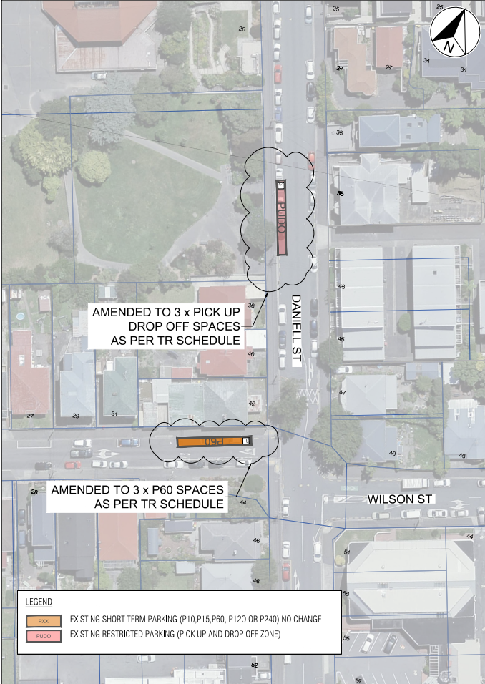

B: Traffic Resolution Plan: TR25-25 Newtown East Parking Scheme Zone – Parking Restriction Amendments – Owen Street

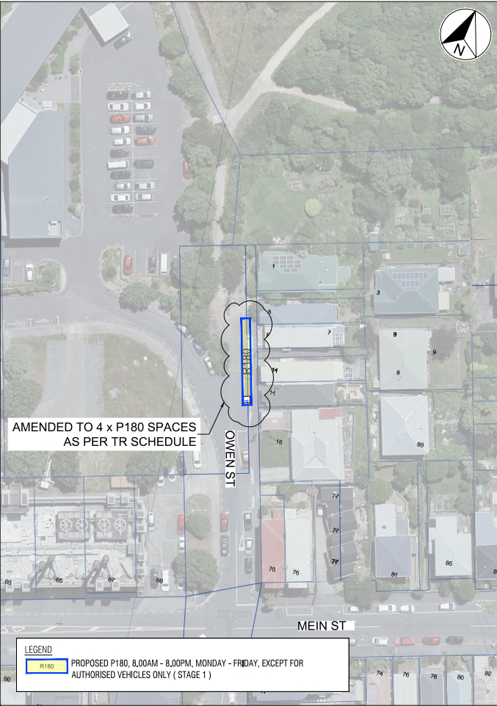
C: Traffic Resolution Plan: TR25-25 Newtown East Parking Scheme Zone – Parking Restriction Amendments – Wilson Street

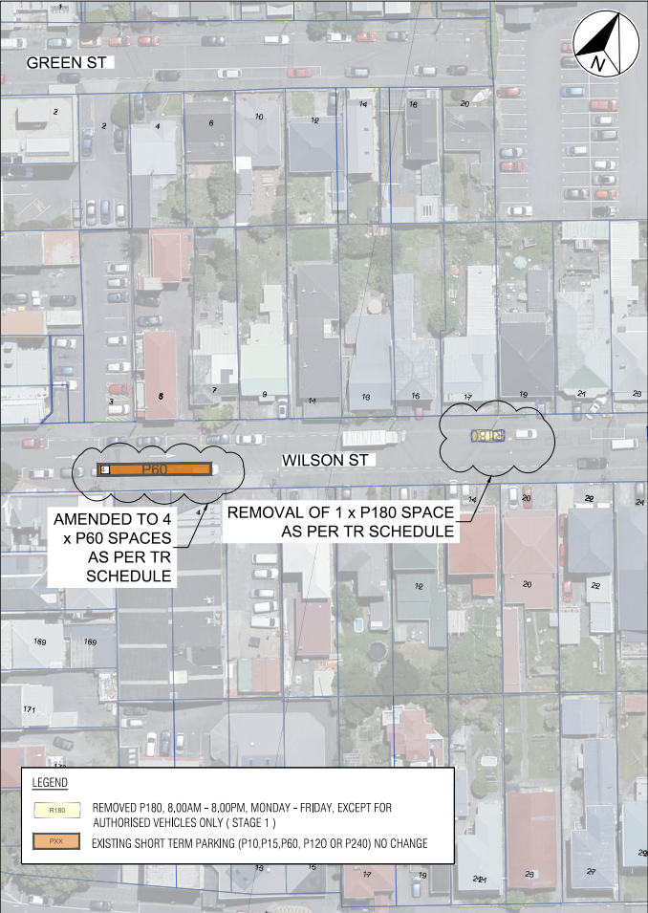
Legal Description:

Remove from Schedule A (Time Limited) of the Traffic Restrictions Schedule

Newtown East Phase 1
Column One | Column Two | Column Three
Owen Street | P180 8am-8pm Monday – Friday, Resident Permit Exempt | East side commencing from Grid Coordinates X=1749298.114 m, Y=5425326.442 m and extending in a Northerly direction, following the Eastern kerb line for 6 metres (1, Parallel park).
Wilson Street | P180 8am-8pm Monday – Friday, Resident Permit Exempt | North side commencing from Grid Coordinates X=1749068.882 m, Y=5424996.144 m and extending in a Westerly direction, following the Northern kerb line for 6 metres (1, Parallel park).
Wilson Street | P180 8am-6pm Monday – Saturday | South side commencing from Grid Coordinates X=1748999.543 m, Y=5424974.764 m and extending in an Easterly direction, following the Southern kerb line for 20 metres (4, Parallel parks).
Wilson Street | P180 8am-6pm Monday – Saturday | North side commencing from Grid Coordinates X=1749163.057 m, Y=5425015.458 m and extending in a Westerly direction, following the Northern kerb line for 18 metres (3, Parallel parks).

Remove from Schedule A (Time limited) of the Traffic Restrictions Schedule

Newtown East Phase 2
Column One | Column Two | Column Three
Daniell Street | P180 8am-8pm Monday – Friday, Resident Permit Exempt | West side commencing from Grid Coordinates X=1749148.129 m, Y=5425123.524 m and extending in a Southerly direction, following the Western kerb line for 66 metres (11, Parallel parks).

Add to Schedule A (Time Limited) of the Traffic Restrictions Schedule

Newtown East Phase 1
Column One | Column Two | Column Three
Owen Street | P180 8am-8pm Monday – Friday, Resident Permit Exempt | East side commencing from Grid Coordinates X=1749298.114 m, Y=5425326.442 m and extending in a Northerly direction, following the Eastern kerb line for 20 metres (4, Parallel parks).
Wilson Street | P60 8am-6pm Monday – Sunday | South side commencing from Grid Coordinates X=1748999.543 m, Y=5424974.764 m and extending in an Easterly direction, following the Southern kerb line for 20 metres (4, Parallel parks).
Wilson Street | P60 8am-6pm Monday – Sunday | North side commencing from Grid Coordinates X=1749163.057 m, Y=5425015.458 m and extending in a Westerly direction, following the Northern kerb line for 18 metres (3, Parallel parks).
Daniell Street | Pick-Up Drop-Off 8:30-9am & 2:45-3:15pm, Monday - Friday, During School Terms Only | West side commencing from Grid Coordinates X=1749157.759 m, Y=5425076.196 m and extending in a Southerly direction, following the Western kerb line for 18 metres (3, Parallel parks).

Add to Schedule A (Time limited) of the Traffic Restrictions Schedule
Newtown East Phase 2
Column One | Column Two | Column Three
Daniell Street | P180 8am-8pm Monday – Friday, Resident Permit Exempt | West side commencing from Grid Coordinates X=1749148.129 m, Y=5425123.524 m and extending in a Southerly direction, following the Western kerb line for 48 metres (8, Parallel parks).

Prepared By: | Andrea Holmes | (Project Manager Development)
Approved By: | Kate Gourdie | (Team Leader Traffic & Resolutions)
Approved Date: | 5/02/2025

