Kia ora,

We would like to inform you about a proposed change in your neighbourhood.

Proposal:

Reference | - TR53-26 Rowells Road, Glenside – Stop Control
Location – where we propose to make the change | The intersection of Rowells Road and Middleton Road
What we’d like to do | Install a Stop control on Rowells following recent development further up the Road.
Why we are proposing the change | - Installing a stop control at this intersection on the approach towards Middleton Road is a requirement of the consent decision for the new development of several new subdivisions further up Rowells Road.  - With the increase numbers of traffic entering and exiting, this will improve safer turning movements when exiting Rowells Road onto Middleton Road.
Impact | Improvements  - Improves safety and accessibility for the intersection  - Improves safer turning movements  Net Parking Impact  - No Change  Pedestrian impact  - No Change
Other options considered | Option one:  - Install a Give Way control at the intersection. This option is not preferred, as the consent conditions specifically require the intersection to be converted to a Stop control. A Stop control is considered more appropriate in this location to improve driver compliance, reinforce the need for vehicles to come to a complete stop, and provide a higher level of safety and visibility at the intersection.
How this relates to the parking policy | - Support safe movement – facilitate the safe and efficient movement of people and goods by focusing on people moving along transport corridors rather than people parking or storing stationary vehicles.
Additional Information | - Average daily traffic count – Rowells Road – 73, Middleton Road 4,320  - An electronic copy of the report will be available on the Council’s website from 9.00am 10 June 2026 at https://www.letstalk.wellington.govt.nz/
Privacy | - Your privacy is important to us. Please DO NOT add specific personal details to your feedback (i.e.: full name, address, etc)  - What we do with your personal information:  All submissions (including your first name, but not contact details) are provided in their entirety to elected members and made available to the public on our website and at our office. Personal information (including contact details) will also be used for the administration of the consultation process including informing you of the outcome of the consultation. All information collected will be held by Wellington City Council, with submitters having the right to access and correct personal information.  - For more information regarding our Privacy Statement please check our webpage: Privacy statement - Wellington City Council.
Feedback | - If you would like to provide us with specific feedback, which will be added to the Traffic Resolution following consultation and made public in full, you can do so by filling out an online submission form, downloading a printable submission form on https://www.letstalk.wellington.govt.nz/ or emailing us at trfeedback@wcc.govt.nz.  Please note if you are giving feedback the consultation period opens at 9.00 am 10 June 2026 and finishes at 5.00 pm 24 June 2026.
Next Steps | - Feedback collated by 25 June 2026.  - The proposal will go to the Te Takere|Regulatory Processes Committee meeting on 5 August 2026.  - If approved, the proposal will be installed within the following six months.

Traffic Resolution Plan: TR53-26 Rowells Road, Glenside – Stop Control

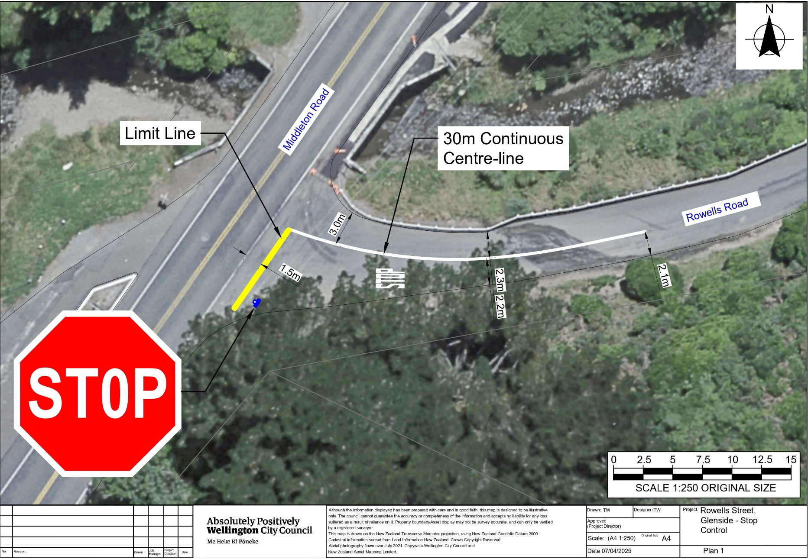

Legal Description:

Add to Schedule G (Give Way) of the Traffic Restrictions Schedule

Column One | Column Two | Column Three
Rowells Road | Stop Control | At its western approach to its intersection  with Middleton Road.

Prepared By: | Tommy Wilson | (Transport Engineering Assistant)
Approved By: | Kate Gourdie | (Team Leader Traffic & Resolutions)
Approved Date: | 19/05/2026

