Kia ora,

We would like to inform you about a proposed change in your neighbourhood.

Proposal:

Reference | - TR80-26 Victory Crescent, Tawa – P10 Pick-Up, Drop-Off
Location – where we propose to make the change | Victory Crescent, Tawa – between no.53 and Ngā hauranga Te Kōhanga Reo (no.55 Victory Crescent)
What we’d like to do | - Install P10 8:30-9:30am, 2:30-3:30pm, Mon-Fri, Time Limited Parking restriction between no.53 and no.55 Victory Crescent (Ngā hauranga Te Kōhanga Reo)
Why we are proposing the change | - Council have received a request from a member of Ngā hauranga Te Kōhanga Reo to install a pick-up and drop-off area for parents with children attending the kohanga.  - To improve parking turn-over and reduce congestion issues during pick-up and drop-off times, Council Officers are proposing twoP10 time limited parks from 8.30am-9:30am, 2:30pm-3:30pm, Mon-Fri.  - From a safety perspective, this provides caregivers with two dedicated short stay parking spaces directly outside the kōhanga, allowing sufficient time to assist and accompany their Tamariki safely in and out of the facility.
Impact | Improvements  - Improves safety and accessibility for parents  - Improves parking availability  Net Parking Impact  - Converting of two unrestricted parking spaces into two pick-up and drop-off P10 spaces  Pedestrian impact  - Positive for parents dropping off and picking up their Tamariki closer to the daycare safely
Other options considered | Option 1:  - The original request from a member of the Kohanga was to convert three unrestricted parking spaces outside the facility to three P10 8.30am-9:30am, 2:30pm-3:30pm, Mon-Fri, time limited parking restrictions. This option was revised to two parking spaces due to feedback received from the community during pre-consultation with immediate affected residents.
How this relates to the parking policy | - Support safe movement – facilitate the safe and efficient movement of people and goods by focusing on people moving along transport corridors rather than people parking or storing stationary vehicles.
Additional Information | - An electronic copy of the report will be available on the Council’s website from 9.00am 19th October 2026 at https://www.letstalk.wellington.govt.nz/
Privacy | - Your privacy is important to us. Please DO NOT add specific personal details to your feedback (i.e.: full name, address, etc)  - What we do with your personal information:  All submissions (including your first name, but not contact details) are provided in their entirety to elected members and made available to the public on our website and at our office. Personal information (including contact details) will also be used for the administration of the consultation process including informing you of the outcome of the consultation. All information collected will be held by Wellington City Council, with submitters having the right to access and correct personal information.  - For more information regarding our Privacy Statement please check our webpage: Privacy statement - Wellington City Council.
Feedback | - If you would like to provide us with specific feedback, which will be added to the Traffic Resolution following consultation and made public in full, you can do so by filling out an online submission form, downloading a printable submission form on https://www.letstalk.wellington.govt.nz/ or emailing us at trfeedback@wcc.govt.nz.  Please note if you are giving feedback the consultation period opens at 9.00 am 19th October 2026 and finishes at 5.00 pm 3rd November 2026.
Next Steps | - Feedback collated by 4th November 2026.  - The proposal will go to the Te Takere|Regulatory Processes Committee meeting on 2nd December 2026.  - If approved, the proposal will be installed within the following six months.

Traffic Resolution Plan: TR80-26 Victory Crescent, Tawa – P10 Pick-Up, Drop-Off

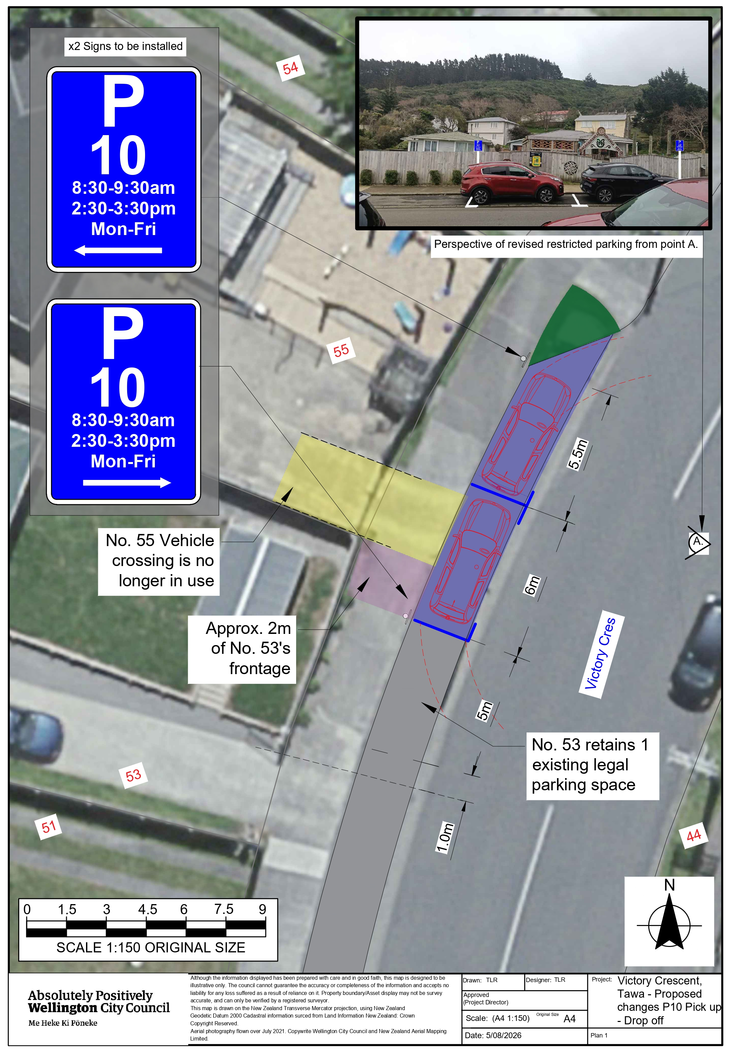

Legal Description:

Add to Schedule A (Time Limited) of the Traffic Restrictions Schedule

Column One | Column Two | Column Three
Victory Crescent | P10  8:30-9:30am, 2:30-3:30pm, Mon-Fri | West side, commencing 30 metres north of its intersection with Wakefield Terrace (Grid coordinates X=1,752,947.56m Y=5,441,521.26m) and extending in a Northerly direction following the Western kerb line for 11.5 metres.

Prepared By: | Theodore Robinson | (Transport Engineer Assistant)
Approved By: | Kate Gourdie | (Team Leader Traffic & Resolutions)
Approved Date: | 21/09/2026

