
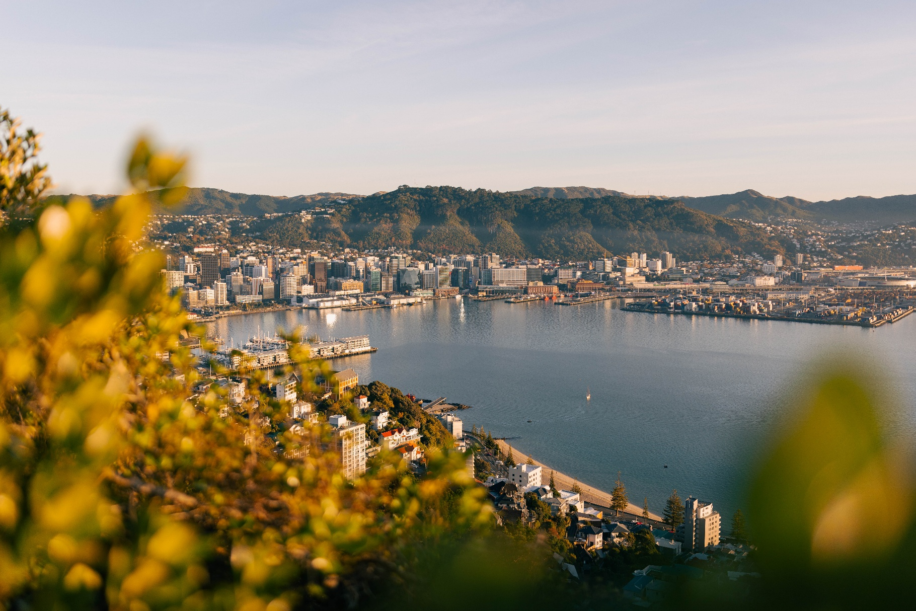
March 2026
  - Council and City overview
  - How the city is tracking towards its aspirations

Contents
Executive summary 4
Cultural outcome: A welcoming, diverse and creative city 5
Social outcome: A city of healthy and thriving whānau and communities 5
Economic outcome: An innovative business friendly city 5
Urban form Outcome: A liveable and accessible, compact city 6
Environmental outcome: A city restoring and protecting nature 6
Engaging our community 6
Value for money and effective delivery 7
Purpose of background report 8
National and Regional Governance Context 8
Wellington City Council settings 9
City Context 11
City demographics and community profile 11
Advisory group insights 14
Key issues and opportunities 17
Key challenges outlined in the pre-election report 19
Community Outcomes Current State Assessment 21
Cultural outcome: A welcoming, diverse and creative city 22
Indicators 22
Stakeholder views on culture 24
Tākai Here partners’ priorities 25
Key issues for “A welcoming and diverse, creative city” 25
Strategic Challenge for Wellington’s welcoming, diverse and creative city: 27
How the council is responding 27
Social outcome: A city of healthy and thriving whānau and communities 29
Indicators 29
Stakeholder views on social outcomes 31
Tākai Here partners’ priorities 32
Key issues for “A city of healthy and thriving whānau and communities” 32
Strategic Challenge for Wellington’s city of healthy and thriving whānau 35
How the council is responding 36
Economic outcome: An innovative, business friendly city 37
Indicators 38
Stakeholder views on the economy 39
Tākai Here partners’ priorities 40
Key issues for “An innovative business friendly city” 40
Strategic Challenge for an innovative business friendly city: 44
How the council is responding 44
Urban form outcome: A liveable and accessible, compact city 45
Indicators 45
Stakeholder views on urban form and transport 47
Stakeholder views on climate change 48
Tākai Here partners’ priorities 49
Key issues for “A liveable and accessible, compact city” 50
Strategic Challenge for a liveable and accessible, compact city: 52
How the council is responding 53
Environmental outcome: A city restoring and protecting nature 55
Indicators 55
Stakeholder views on the environment 57
Tākai Here partners’ priorities 58
Key issues for “A city restoring and protecting nature” 58
Strategic Challenge for a city restoring and protecting nature: 60
How the council is responding 61
Engaging our community 63
Stakeholder views on engaging the community 63
Key issues for “Engaging our community” 64
How the council is responding 64
Value for money and effective delivery 65
Value for money indicators 65
Stakeholder views on value for money 66
Key issues for “Value for money” 67
Appendices 69
Appendix 1: Wellington City demographics and outcome statistics 69
Appendix 2: Residents’ sentiment 72
Appendix 3: Advice from the citizens assembly 73
Appendix 4: Key facts relating to accessibility 75

Executive summary
This background report provides a high-level assessment of how Wellington City is currently tracking against its vision and community outcomes, and the strategic context within which future decisions will need to be made. It brings together demographic trends, resident sentiment, advisory group insights, and key performance indicators to present a shared evidence base for refreshing the Council’s vision and community outcomes as part of the next Long-term Plan.

Wellington is home to a youthful, highly educated and increasingly diverse population, with strong cultural identity and high participation in arts, culture and community life. While most residents continue to report a good quality of life, recent years have seen declining wellbeing, trust in decision making, and confidence in the city’s direction. These declines are not evenly distributed and are most pronounced for lower income households, Māori, disabled people, rainbow communities, and young people, highlighting the need for a more targeted and equity focused approach.

Across all community outcomes, the city is operating within a set of reinforcing constraints. Rising costs, ageing and underperforming assets, climate and seismic risk, delivery capacity pressures, and ongoing central government reform are limiting the Council’s ability to respond to all needs at once. The Council is also operating at or near its self-imposed debt limits, which are deliberately set to retain resilience and emergency response capacity, and this significantly constrains future investment choices.
Resident feedback shows a complex relationship between service delivery, governance and trust. While many frontline services are well used and valued, perceptions of overall Council performance remain low, driven by concerns about affordability, decision making, priorities and long-term direction. This signals that restoring confidence will require not only service improvements, but clearer strategic focus, transparent trade-offs, and stronger engagement with communities.
The Citizens’ Assembly and advisory groups reinforce this message, calling for greater financial sustainability, prioritisation of existing assets, inclusive and partnership-based engagement, and clearer alignment between investment decisions and community aspirations. Taken together, the evidence points to a need for sharper prioritisation, more integrated planning across outcomes, and a stronger focus on value for money and delivery discipline.

This report does not propose solutions. Instead, it sets out the current state and the key challenges and opportunities facing Wellington City. It is intended to support informed discussion with elected members and stakeholders as the Council considers how its vision and community outcomes should evolve to reflect current realities, future risks, and the kind of city Wellingtonians want to build together.

Cultural outcome: A welcoming, diverse and creative city
Wellington’s cultural outcome reflects the city’s identity as a place shaped by te ao Māori, a strong arts sector, and diverse communities. While residents continue to value and participate in arts, culture, libraries and heritage, perceptions of Wellington’s cultural vibrancy and civic pride have declined in recent years. People want the city to feel more lively, welcoming and expressive of its identity, with affordable and accessible creative spaces and stronger visibility of Māori culture across public life. Persistent inclusion gaps, accessibility barriers, and incomplete embedding of Māori worldviews limit the city’s ability to foster belonging and shared identity. Addressing these challenges requires coordinated action beyond the arts sector alone, including placemaking, accessibility, genuine partnership with mana whenua, and more inclusive engagement.

Social outcome: A city of healthy and thriving whānau and communities
Wellington’s social outcome focuses on safety, connection, equity and access to places that support wellbeing. While many residents continue to feel safe in their homes and neighbourhoods, perceptions of safety in the central city, experiences of loneliness, and overall wellbeing have declined. These impacts are felt most strongly by vulnerable communities, including Māori, disabled people, young people and rainbow communities. Ageing and unevenly distributed community facilities, alongside barriers to accessing information and services, further limit participation and inclusion. Low trust in Council decision making compounds these pressures, reducing engagement and collective action. Strengthening social wellbeing will require renewed focus on inclusive infrastructure, accessible services, and relationship-based engagement that rebuilds trust and connection.

Economic outcome: An innovative business friendly city
Wellington’s economic outcome is shaped by a prolonged downturn, employment losses, and declining perceptions of city centre vitality, alongside long-standing strengths in education, creativity and innovation. The city’s economy remains highly concentrated, making it vulnerable to sector specific shocks, while small businesses face rising costs, affordability pressures and reduced consumer spending. At the same time, residents and businesses see opportunities to revitalise the city and suburbs, support a more diverse and inclusive economy, and accelerate the transition to a zero-carbon circular economy. Achieving this outcome will require coordinated action to strengthen economic resilience, improve regulatory systems, support workforce pathways, and restore confidence in the city as a place to invest, work and spend time.

Urban form Outcome: A liveable and accessible, compact city
Wellington’s urban form outcome reflects the interconnected challenges of housing affordability and quality, transport congestion, ageing infrastructure, and climate and seismic risk. While there is strong support for a compact, low carbon city with good access to transport and services, confidence in delivery has weakened. Persistent housing pressures, accessibility gaps, and infrastructure vulnerability disproportionately affect vulnerable communities and undermine perceptions of fairness and resilience. These issues reinforce one another, increasing costs, emissions and inequity over time. Addressing them requires integrated planning that aligns growth with infrastructure investment, improves transport choices, embeds climate action, and ensures that accessibility and inclusion are built into the city’s physical form.

Environmental outcome: A city restoring and protecting nature
Wellington’s environmental outcome recognises the central role of nature, water, waste systems and biodiversity in supporting wellbeing and resilience. While the city is making progress across individual programmes, these efforts are not yet operating as a fully integrated system. Ageing water infrastructure, uneven access to green spaces, fragmented biodiversity investment, and slow progress on waste reduction continue to limit environmental outcomes. Residents strongly support climate action and environmental protection, but affordability and delivery constraints shape expectations. Strengthening this outcome will require clearer citywide direction, better integration across programmes, improved monitoring, and stronger partnerships with mana whenua and community groups to deliver long term environmental resilience.

Engaging our community
Engagement is a core function of Wellington City Council and is embedded across strategy development, decision‑making, and service delivery. Rather than being a standalone activity, engagement shapes how the Council works; through ongoing relationships, inclusive processes, and community participation. A key mechanism is the Council’s five strategic Advisory Groups, which represent disabled people, ethnic communities, Pacific peoples, Takatāpui and rainbow communities, and rangatahi. Together, these groups also form a Strategic Advisory Panel that provides intersectional advice on major initiatives.

Community feedback highlights strong support for inclusive, meaningful engagement that fosters social cohesion and ensures people feel welcome and able to participate.
Trust in Council decision‑making remains low, with engagement uneven across demographics. Younger people, renters, students, and mātāwaka Māori communities are consistently underrepresented in traditional consultation processes, reinforcing issues of equity and voice.

In response, the Council is shifting toward relationship‑based, partnership‑driven engagement, including initiatives like He Ara Mātāwaka and the Citizens’ Assembly. This approach aims to rebuild trust, strengthen participation, and ensure diverse communities are genuinely involved in shaping Wellington’s future.

Value for money and effective delivery
Value for money and effective delivery are critical enablers of all community outcomes. Wellington City Council is operating in a constrained financial environment, with rising costs, significant asset renewal needs, and limited borrowing capacity due to self-imposed debt limits designed to preserve resilience. Community confidence in spending decisions is low, driven by affordability concerns and perceptions of weak prioritisation. At the same time, indicators point to inconsistent project discipline and limited performance measurement. Strengthening value for money will require clearer prioritisation, stronger investment and delivery frameworks, improved performance management, and more transparent communication about trade-offs and outcomes.

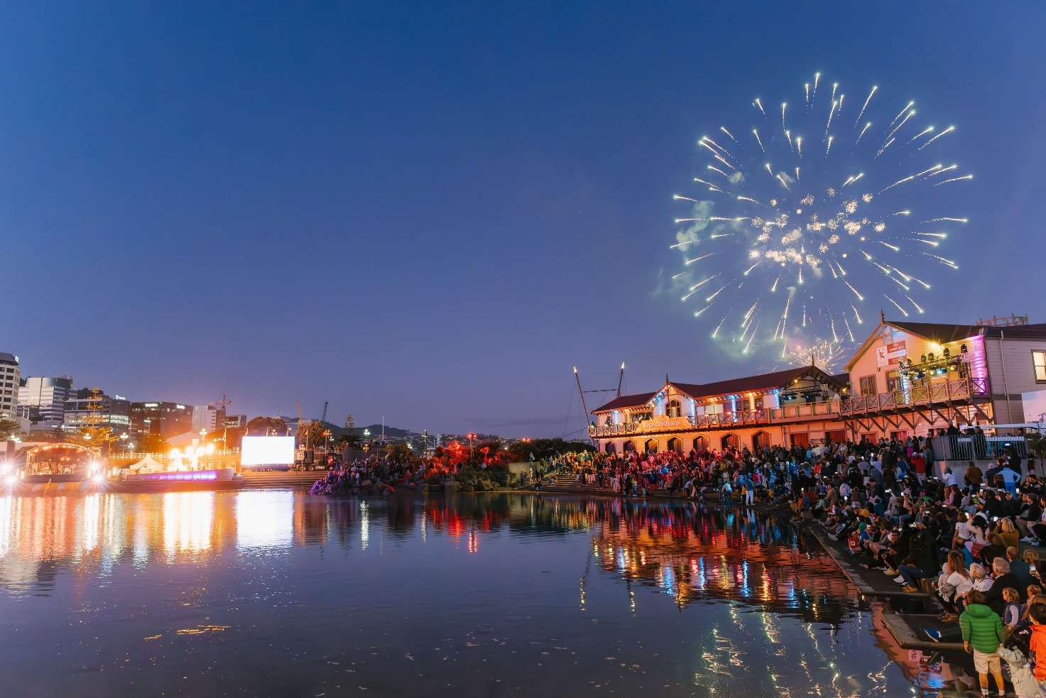

Purpose of background report
The purpose of this background report is to provide foundational information that will help set the Council’s strategic direction. This report is an important first step in planning for the Council’s next Long-term Plan for 2027. It is a current state analysis and provides an overarching view of the city and highlights progress toward the council’s current vision and community outcomes. It does not propose options or make recommendations. Instead, it provides an integrated evidence base to support elected members and stakeholders to consider priorities, trade‑offs, and sequencing of investment in a constrained operating environment. This background report is focused at a city overview level. It is intended to help understand how all aspects of city life are interconnected. It raises up issues to a high-level strategic view. However, there may be some repetition across the outcome themes. It is intended that a workshop will be held with councillors to consider how we can convey the city aspirations through the community outcomes in a more succinct way.

National and Regional Governance Context
Local government in New Zealand operates within a dynamic legislative environment, principally guided by the Local Government Act 2002 (LGA 2002). This Act establishes the Council’s purpose: to enable democratic decision-making and promote community well-being, requiring a balance of social, cultural, environmental, and economic outcomes. A core principle of this is meaningful community engagement, including consultation with Māori, which underpins transparency and trust.

The Local Government (System Improvements) Amendment Bill will remove the four well-beings and replacement content is “to meet the current and future needs of communities for good-quality, cost-effective, and local infrastructure, and public services, and performance of regulatory functions” (proposed amended section 10 of the LGA 2002 refers). Under a new section, “Core services to be considered in performing role” (proposed new section 11A of the LGA 2002) several Council activities are listed as needing to be considered with particular regard: “network infrastructure; public transport services; waste management and minimisation; civil defence emergency management; libraries, museums, reserves, and other community and recreational facilities”. The report back from the Select Committee to Parliament (24 November 2025) noted that the intention is to inform priorities, rather than be a comprehensive list.

Subject to final amendments to the LGA 2002, the role of the Council in delivering some programmes and services may need to be assessed, particularly those that are less clearly mentioned. This would be an incremental process, as any changes to services or levels of service would remain subject to the LTP and other democratic decision-making processes. Local authorities also have formal roles under a range of other acts and regulatory instruments that will remain in force, as well as Te Tiriti o Waitangi obligations. Officers are monitoring progress of the Bill. It should become clear in 2026 if changes are likely to apply to the LTP 2027. Other signalled legislative change with potential impacts for the council includes rates capping, simplifying local government, the planning bill and natural environment bill (RMA reform), and emergency management.

At the regional level, strategies and policies, developed in collaboration with the Greater Wellington Regional Council, local authorities, and iwi, provide direction for sustainable growth, resilience, and environmental protection. These frameworks guide council priorities in housing, transport, climate adaptation, economic development, and environmental management, ensuring alignment with regional and national objectives.

Wellington City Council settings
Wellington City’s strategic direction is established through its Long-term Plan 2024, which articulates a clear vision and a set of community outcomes, strategic priorities, and approaches designed to guide decision-making and city development. These are outlined below.

Vision
Pōneke, te wāhi auaha e whitawhita ai ōna tāngata me tōna taiao.
Pōneke, the creative capital where people and nature thrive.

Our commitment
- We're committed to Te Tiriti o Waitangi and strong partnerships with mana whenua.
- Tākai Here and Te Tiriti o Waitangi lay the foundation for everything the Council does.

Community Outcomes | Strategic Priorities
Cultural outcome: A welcoming, diverse and creative city  - that celebrates and uplifts te ao Māori, and  - champions the arts,  - embracing heritage, creativity, curiosity, and expression of our multi-cultural communities and identities | - Celebrate and make visible te ao Māori across our city  - Nurture and grow our arts sector
Social outcome: A city of healthy and thriving whānau and communities  - where people feel safe and connected  - that takes an equity approach to caring for its people and  - provides awesome, vibrant and diverse places to meet and play | - Increase access to good, affordable housing to improve the wellbeing of our communities  - Invest in sustainable, connected and accessible community and recreation facilities
Economic outcome: An innovative business friendly city  - providing good jobs for people  - successfully operating in a dynamic zero-carbon circular economy  - with efficient and fit for purpose regulatory processes | - Revitalise the city and suburbs to support a thriving and resilient economy and support job growth
Urban Form outcome: A liveable and accessible, compact city  - with affordable, warm, dry housing,  - zero-carbon accessible transport choices,  - resilient infrastructure fit for growth, and  - proudly visible Māori and multicultural heritage | - Transform our transport system to move more people with fewer vehicles  - Collaborate with our communities to mitigate and adapt to climate change
Environmental outcome: A city restoring and protecting nature  - providing easy access to nature,  - with systems to reduce waste and  - thriving biodiversity and nature-based solutions in natural and urban environments | - Fix our water infrastructure and improve the health of waterways  - Transform our waste system to enable a circular economy

Strategic Approaches (to be embedded into everything we do)
- Integrating te ao Māori
- Making our city accessible and inclusive for all
- Embedding climate action
- Engaging our community
- Value for money and effective delivery
The full Strategic Direction is available in Section 1 of the 2024 LTP volume 3.

City Context

City demographics and community profile
Wellington City, situated at the Southern tip of New Zealand’s North Island, Te Upoko-o-Ika (the head of the fish), is a diverse location made up of people from many different cultures, communities, and walks of life. In terms of demographics, Pōneke’s population of around 210,000 is characterised by high levels of education, higher incomes, and a larger proportion of young adults than the rest of the country. Wellington City has the highest rainbow identification in the country – almost double that of the rest of the country – and although the city is less ethnically diverse than other areas, this diversity has been increasing over time. Wellington City also sees a higher proportion of people born overseas as compared to the national level, and this too has been increasing over time.
Wellingtonians overall enjoy a high quality of life, one that has historically been rated more positively than that of many other NZ cities on average.

However, like for other cities, wellbeing indicators have seen a decline over recent years, and this decline has not been felt equally across the city. Although every person has their own unique background and lived experience within the city, on average, quality of life declines have impacted different groups in disproportionate ways. For example, comparing 2020 (pre-COVID) to 2025 data from the Residents Monitoring Survey shows that overall quality of life, as well as views on council performance, have been trending downwards over time for lower income groups. Whilst for those on higher incomes, these measures are trending upwards.

See Appendix 1 for more demographic insights.

Regional differences: Note that the commentary focuses on Wellington City rather than the wider region. Wellbeing, demographics, and resident sentiment can vary greatly between Wellington and nearby areas like Porirua, Kapiti, and the Hutt Valley. Some topline regional differences include:
- Population growth has been stronger in Wairarapa and Kāpiti, spurred by remote workers and infrastructure projects such as Transmission Gully and Kāpiti Expressway. Wellington City's growth has lagged, partly due to higher housing costs.
- Demographics differ – Kāpiti and Wairarapa have larger populations of over-65s, Wellington City has more young adults, and Porirua has a high proportion of people under 20. The region overall is ageing, with a rise in over-65s and a decline in children under 9.
- Employment patterns also vary. In Wellington City, 45% work in professional services (many remotely), compared to 25–35% elsewhere; Wairarapa's workforce is mainly in manufacturing, trades, and primary industries.
- Overall quality of life is ranked higher in Wellington City (81% rated it as good) than in Hutt City (77%) or Porirua (75%), as well as rating of own physical health and wellbeing (76% good for Wellington City, vs 71% for Porirua and 68% for Hutt).
- Mental health and wellbeing ratings are similar between areas, with Wellington City net good rating at 68%, Porirua at 70%, and Hutt City at 66%.
- The percentage of residents who agree they experience a sense of community is greater in Porirua (55%), than Wellington and Hutt City (both 43%).

Residents’ monitoring survey + Quality of Life survey
Regular research into resident wellbeing, views of the city, and views on the Council is conducted via our annual residents’ monitoring survey (RMS) and the biennial Quality of Life (QoL) survey, conducted in collaboration with other large urban areas in NZ. These surveys have highlighted generally high levels of wellbeing across a range of areas. Results also show residents have a high level of satisfaction for a range of our frontline services (for example pools, recreation centres, waste collection). However, the post-COVID era has seen notable declines in a range of key metrics. This has included declining perceptions of the city, dissatisfaction with decision making and overall Council performance, declining perceptions of safety in the city centre and declining financial wellbeing. More detail on these insights can be found throughout the report.

Residents’ sentiment research
Research into Wellington City residents’ perceptions of Council services reveals ongoing concerns about decision-making and overall performance, accompanied by low levels of trust. While most services, such as waste management, water, parks, and libraries, are widely recognised and considered important, their individual performance scores are generally higher than the rating given for the Council’s overall performance. While specific low-performing services such as parking often influence residents' perceptions of the Council, broader issues like rates and overall Council priorities also play a significant role in shaping satisfaction. This suggests that lower-performing individual service experiences and overarching governance decisions contribute to residents' views of the Council.
These findings highlight a complex relationship between resident sentiment, service quality, and trust in city leadership. A brief summary of the resident’s sentiment research in provided in Appendix 2.

In addition, a desktop survey in 2023 reviewing feedback from 26 community consultations over three years found that whilst residents support an idealised vision for Wellington and seek widespread opportunities, opinions differ on how to achieve this, particularly due to reluctance toward financial impact. Many admit they lack sufficient knowledge of Council budget priorities to comment effectively. Relevant community insight findings are highlighted in each outcome area of this report.

Citizen’s Assembly 2023
In response to declining community trust and satisfaction with overall Council performance, Wellington City Council initiated a Citizens’ Assembly in 2023 as part of its Long-Term Plan process. A Citizens’ Assembly is a form of deliberative democracy which focuses on collaborative decision-making by bringing a diverse and representative group together, to deliberate and make an informed decision on a complex topic where there is strong public interest.

This assembly provided a platform for residents to directly contribute to the city's future direction, culminating in ten core recommendations aimed at addressing key concerns. The advice reflected a strong community desire for the Council to:
- diversify revenue sources,
- prioritise the maintenance and optimisation of existing assets, and
- invest in green spaces that enhance urban wellbeing.

There was also a clear emphasis on inclusive engagement, with recommendations to:
- involve community volunteers in open space management,
- adjust grant funding to keep pace with inflation, and
- uphold commitments to mana whenua in funding decisions.

The assembly’s guidance underscored the importance of fostering collaboration among community groups, re-evaluating heritage criteria to balance sustainability and growth, and supporting higher-density housing.

The full report can be read online, or see the 10 recommendations attached in Appendix 3.

Advisory group insights
Wellington City Council’s Advisory Groups provide strategic, identity-informed advice to Councillors and Officers. Their insights help shape inclusive, future-focused decisions that reflect the diverse needs of Wellington’s communities.

A range of insights have been identified via these advisory groups, which reach across all community outcome areas.
- Ethnic Communities Advisory Group (ECAG)
- Wellington’s ethnic diversity is a major strength, with over 160 ethnic groups enriching the city’s culture, language, festivals, architecture, and cuisine.
- The ECAG emphasises that economic and lifestyle diversification attracts people and investment, especially in sectors like tech, healthcare, film, and education.
- ECAG members note that Wellington’s balanced lifestyle and welcoming environment make migrants feel proud to call the city home, directly supporting economic growth.
- Gaps identified by ECAG in the Council’s approach to city safety include inadequate structured engagement with those most affected, especially ethnic minorities, young women, and gender minorities.
- Ethnic Patrols are named as partners in the City Safety and Wellbeing Plan, but lack financial support from the Council.
- ECAG recommends implementing anti-racism training for nightlife safety, and publishing data on racially motivated incidents and gendered harassment to enable targeted interventions.
- Pacific Advisory Group (PAG)
- The Pacific community, though a smaller proportion of Wellington's population, is vibrant and influential, especially in Newtown, Berhampore, and the Northern suburbs.
- Pacific peoples make significant cultural, social, and economic contributions to Wellington.
- Key challenges faced by Pacific people include housing insecurity, displacement from gentrification, and underrepresentation in civic spaces.
- PAG call on the Council to safeguard the Fale Malae and Frank Kitts Park redevelopment, which are culturally significant for Pacific communities and represent Pacific identity and presence in Aotearoa New Zealand.
- PAG highlights the need for housing suitable for multi-generational Pasifika families. PAG also emphasises the importance of increasing Pasifika visibility in employment, internships, and opportunities within the Council.
- Takatāpui Rainbow Advisory Council (TRAC)
- TRAC identifies affordability, safety, and cultural exclusion as key barriers to recreational participation for rainbow communities.
- TRAC argues that becoming a genuinely queer-friendly city strengthens Wellington’s economic vitality and makes it an attractive place for queer people to live.
- TRAC emphasises that true inclusion must address both emotional and cultural safety needs. TRAC recommends targeted training for frontline staff to improve inclusive practices.
- Youth Council
- Youth Council consistently advocates for practical, safe, and youth-friendly recreational spaces (e.g. parks, skateparks) with good lighting and attractive design.
- Youth Council highlights the importance of pools, recreation centres, parks, and green spaces as key sites for youth to socialise, play, and connect. They stress the importance of maintaining concession pricing for recreation services and simplifying access to programmes like the LeisureCard, as well as call for clear and transparent information about recreational spaces available to youth.
- Youth Council identifies current economic challenges and emphasises the need for prudent, forward-looking planning. They view forward-thinking economic policies as essential for youth wellbeing and future job opportunities. In their 2024 Long Term Plan submission, they urge Council to invest responsibly in infrastructure to support future prosperity, without imposing financial burdens on future generations.
- Accessibility Advisory Group (AAG)
- AAG consists of members that hold a considerable range and depth of disability expertise. AAG highlights the following challenges for the disabled community:
- The previous accessibility plan (2019-2022 Accessible Action Plan) has expired and has not been replaced. Progress has been ad hoc, untracked, and lacks governance or measurement. There is no organisation-wide commitment or roadmap, nor a dedicated team, structure, or consistent reporting on accessibility. This lack of visibility affects accountability and progress.
- Engagement has been tokenistic or inconsistent at times, and many disabled people and advocates have lost confidence in the Council’s follow-through.
- Accessibility data is fragmented and underused. Key datasets (Census, Household Disability Survey, mobility parking, engagement feedback) are not systematically applied to planning.
- Council staff want to improve accessibility but lack skills, tools, or confidence. Disability awareness training is not yet mandatory or widely completed. Accessibility is often an afterthought.
- There is a lack of a formal mandate for accessibility standards in local government, inconsistent application of accessible formats, and need for a centralised definition of accessibility. Universal design is supported but not consistently applied, and standards are unevenly embedded across planning, procurement, and asset management.
- Accessibility information for facilities and venues is inconsistent or insufficient. Accessibility is not consistently built into systems and templates. Websites, documents, and maps are also often not accessible.
- Accessibility competes with other priorities and has no dedicated funding. The lack of a clear roadmap and prioritisation framework undermines progress towards greater accessibility. Overall, there is a need for early, strategic engagement with disabled communities and DCAG, as well as more accessible consultation processes.
- Environmental Reference Group (ERG)
- ERG emphasises that environmental wellbeing underpins all other outcomes and must not be traded off. Council decisions in response to social, cultural and economic needs should be provided for and promoted within environmental limits.
- Calls for stronger climate leadership, including full funding and acceleration of Te Atakura: First to Zero, with more ambitious emissions targets and tangible action.
- Advocates for urgent investment in water infrastructure and water-sensitive urban design to restore waterways and reduce pollution.
- Supports a zero-waste future, urging rapid rollout of organics processing and circular economy infrastructure to reduce landfill emissions.
- Recommends prioritising low-carbon transport and compact urban development, opposing projects that increase car dependency or sprawl.
- Stresses the importance of early, meaningful engagement with ERG and community groups, and honouring mana whenua as kaitiaki in environmental planning.

Key issues and opportunities
The issues outlined below reflect system‑level pressures identified consistently across the Council’s strategic activity background reports. They cut across multiple community outcomes and shape what can be delivered, at what pace, and with what trade‑offs over the next Long‑term Plan period.

Financial sustainability and affordability
Wellington City Council is operating in a constrained financial environment characterised by rising costs, significant asset renewal demands, and limited financial headroom. The Council is operating at or near its self‑imposed debt limits, which are deliberately set to retain resilience and emergency response capacity. While this approach supports long‑term stability, it significantly constrains future investment choices. At the same time, cost‑of‑living pressures are affecting households and businesses, shaping expectations around affordability and value for money. These pressures increase scrutiny of Council spending decisions and reinforce the need for clearer prioritisation and transparency about trade‑offs.

Ageing and under‑performing assets
Across multiple activity areas, the Council manages a large portfolio of ageing, single‑purpose, or misaligned assets. Many of these assets are expensive to maintain, increasingly vulnerable to climate and seismic risk, and not always well aligned to current or future community needs. Rising renewal and operating costs place sustained pressure on budgets and limit flexibility to adapt services. These challenges are not confined to individual asset classes and require a coordinated, citywide approach to asset management and investment sequencing.

Delivery capacity and organisational complexity
The scale and complexity of the Council’s responsibilities, combined with financial constraints and reform uncertainty, place ongoing pressure on delivery capacity. Competing priorities, interdependencies between activities, and the need to coordinate across Council and Council‑controlled organisations limit the pace and scale at which change can be implemented. This complexity reinforces the importance of clear strategic focus, sequencing of work programmes, and realistic expectations about what can be delivered within available resources.

Accessibility and equity gaps
Accessibility and equity challenges persist across multiple outcomes and activities. Accessibility functions as a system‑wide enabler or barrier, influencing participation and outcomes across transport, facilities, services, public spaces, and access to information.
Despite progress in some areas, barriers related to physical access, affordability, service design, and communication continue to disproportionately affect disabled people, Māori, young people, rainbow communities, and lower‑income households. These gaps limit participation, reduce trust, and undermine the ability of services and spaces to deliver equitable outcomes.

Climate change, resilience and hazard risk
Climate change and increasing hazard risk are reshaping the operating environment for Wellington City. More frequent and severe weather events, alongside seismic risk, increase costs, constrain where and how assets can be renewed, and place additional pressure on infrastructure and service delivery. These risks intersect with financial constraints and ageing assets, reinforcing the need to consider resilience and adaptation as core system pressures rather than discrete environmental issues.

Economic pressures and affordability
Wellington’s economy continues to experience structural pressures, including employment volatility, high operating costs, and declining perceptions of central city vibrancy. These conditions affect household incomes, business confidence, and demand for Council services. While many of these pressures sit outside the Council’s direct control, they shape affordability expectations, influence perceptions of value for money, and interact with social and wellbeing outcomes across the city.

Trust, confidence and engagement
Resident trust and confidence in Council decision‑making has declined, influenced by affordability concerns, perceptions of safety and vibrancy, and uncertainty about priorities and long‑term direction. Trust functions as a system condition, shaping engagement, perceptions of fairness, and the willingness of communities to support necessary trade‑offs. Low trust increases the challenge of delivering change, particularly where decisions involve visible impacts, reprioritisation, or long‑term investment.

Governance, coordination and reform uncertainty
The Council is operating amid ongoing central government reform affecting local government purpose, infrastructure delivery, water services, and planning systems. This creates uncertainty for long‑term planning and complicates decision‑making across multiple activity areas. At the same time, effective delivery increasingly depends on coordination across Council, Council‑controlled organisations, mana whenua, and regional partners. Reform uncertainty reinforces the need for flexibility, disciplined prioritisation, and clear roles and accountabilities.

Key challenges outlined in the pre-election report
In preparation for the 2025 local election, the Pre-election Report was published. It outlined four key challenges for the Council, which appear throughout the issues for each of the community outcomes discussed. For quick reference, the key challenges are summarised below:

Rates affordability and financial constraints
- Wellington is facing rising living costs and financial pressures, making it difficult for residents, businesses, and the Council to afford essential services and infrastructure upgrades.
- Nearly a third of Wellingtonians would struggle to cover an unexpected $2,000 expense without debt and both consumer spending and business investment are under strain.
- The Council’s ability to invest is limited by reliance on rates and borrowing, compounded by a significant underinsurance gap and rising costs for construction and services.
- As a result, meeting community expectations and maintaining city assets requires tough trade-offs, as it is not possible to deliver all services and prepare for the future without increasing rates or finding alternative funding sources.

Caring for infrastructure
- Wellington’s infrastructure, including pipes, roads, and public facilities, is ageing and increasingly vulnerable to natural hazards like earthquakes, flooding, and slips.
- Much of it was built decades ago and now requires significant investment for upgrades or replacement, but budget constraints and shifting community needs make this challenging.
- The city faces additional risks from its location on fault lines, with 45 Council-owned buildings now classified as earthquake-prone, and climate change is intensifying threats such as coastal erosion and extreme weather.
- Construction disruptions and rising costs further impact residents, businesses, and accessibility, highlighting the urgent need for resilient, inclusive, and future-proofed infrastructure planning.

Involving the community
- Trust and satisfaction in Wellington City Council’s decision-making are low, with only 32% of young adults and 7% of seniors believing decisions made are in the city’s best interest, and nearly half of residents expressing low trust in both government and the media.²
- Global trends of polarisation and rising misinformation, amplified by social media and events like the COVID-19 pandemic, have further eroded confidence in institutions.
- Council decisions on infrastructure and city upgrades have sparked community tensions, and many residents feel disengaged or unheard during consultation processes.
- Low voter turnout and limited engagement from groups such as youth, hapori Māori, ethnic communities, and disabled people highlight the ongoing challenge of building inclusive participation and trust in local governance.

Central government reform impacting local government
- Wellington City Council faces significant uncertainty and resource demands in responding to ongoing and proposed central government reforms, which frequently shift direction and priorities.
- Recent and upcoming legislative changes, such as reforms to the Resource Management Act, water services, local government structure, and funding for transport and waste, create operational challenges and make it difficult for the Council to plan, set budgets, and deliver services confidently.
- Each new government’s changes can conflict with previous policies, leading to inefficiencies and increased costs for local authorities. These reforms also highlight persistent affordability challenges for councils, prompting discussions about regional collaboration, reorganisation, and new funding models to ensure sustainable local government.

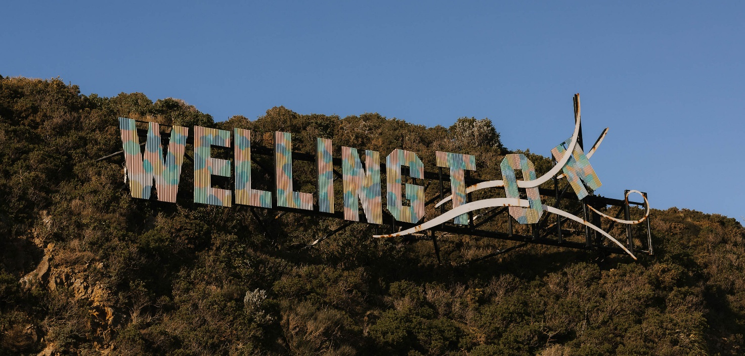

Community Outcomes Current State Assessment


The following section is presented by community outcome area (cultural, social, economic, urban form, environmental). It outlines key indicators and issues that signal how we’re doing in relation to the community outcome and the related strategic priorities. The information highlighted here is drawn from a combination of indicators (e.g. survey data), as well as recent submissions and feedback received from residents and stakeholders, to provide a picture of current challenges, current council responses, as well as emerging opportunities. Many of the identified issues are interconnected, and the council’s initiatives often respond to more than one concern simultaneously.

Cultural outcome: A welcoming, diverse and creative city
For Wellington, a welcoming, diverse and creative city is one that:
- celebrates and uplifts te ao Māori,
- champions the arts, and
- embraces heritage, creativity, curiosity, and expression of our multi-cultural communities and identities.
This outcome has two strategic priorities:
- celebrating and making visible te ao Māori
- nurturing and growing Wellington’s arts sector

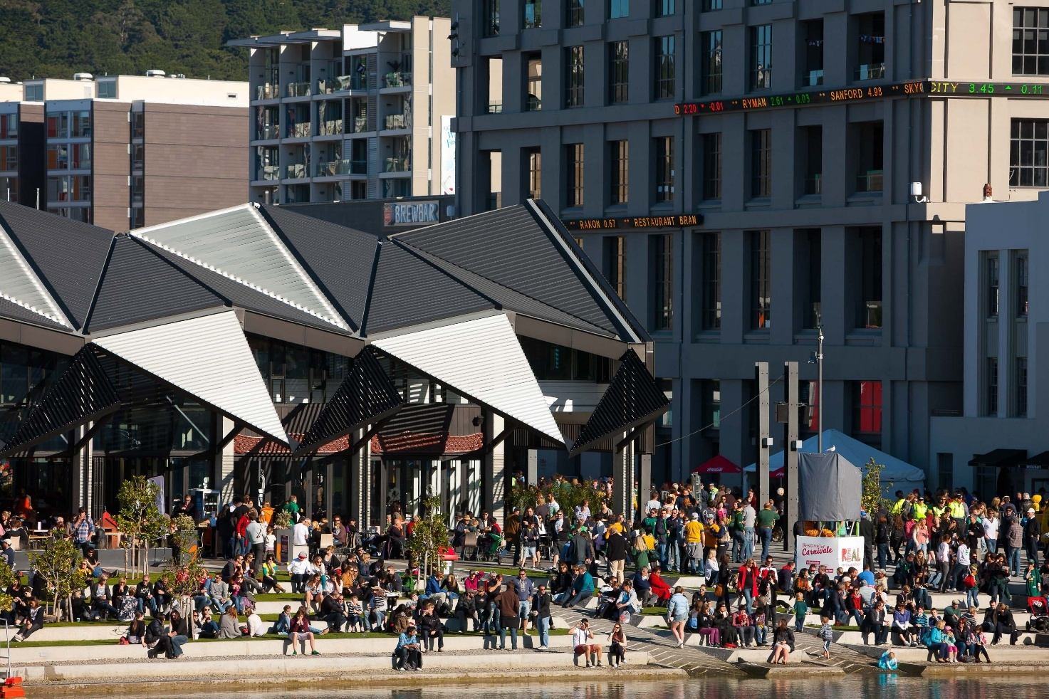

Indicators
Relevant indicators and trends for this outcome and its related priorities are presented below.
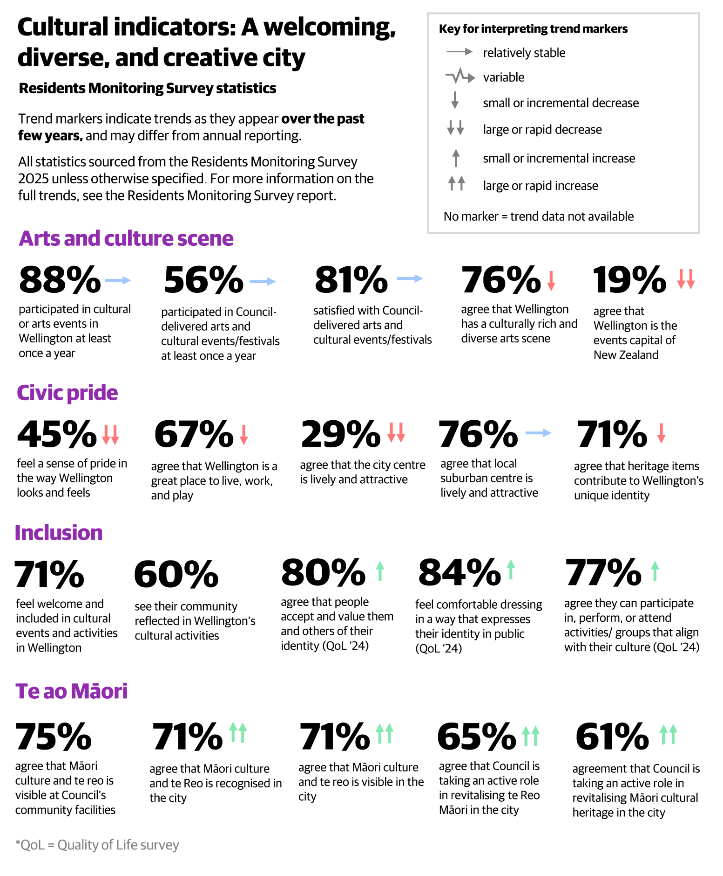

Stakeholder views on culture
From the Community Sentiment 2023 report:
- There is agreement that Wellington is an arts and cultural capital, a status which contributes to a sense of identity and civic pride. Wellingtonians regularly engage with and participate in the arts in different capacities, reporting general satisfaction with current offerings.
- People report feeling the city’s identity is not as strong as it has been, but they see great potential for improvement. In particular, there is support for creating desirable spaces within Wellington that can be used and enjoyed by residents and visitors alike.
- Libraries and heritage were explored in more detail. Libraries are seen as valued community assets and are well used and valued by a range of residents. The community space they provide is almost as important as the services available, with large numbers of people agreeing that libraries offer broad and varied social benefits. In terms of heritage, residents agree that older buildings contribute to the look and feel of Wellington, and they would like to see this protected, however what constitutes heritage is debated.
- Māori culture and values are seen as relevant to everyday life and are broadly supported. Though it is reasonable to expect that those who disagree are less likely to make submissions on the topic, support for the recognition and representation of te ao Māori in Wellington life can generally be seen across a range of different consultations (e.g. via support for Māori wards, support for strategies in which these topics are expanded upon, and so on).
- There is concern that arts funding does not always reach those who would benefit from it, and that community access to artistic and creative outlets is lacking. Although people don’t begrudge the high-profile arts receiving funding (as there is recognition of the broad value of this), people also want to see local art supported and promoted.

From the LTP 2024 and LTP 2024 amendment consultations:
- Wellington’s cultural vibrancy is a defining feature of the city, with strong community support for nurturing and growing the arts sector, celebrating te ao Māori, and ensuring diverse creative voices are visible and valued.
- Submissions highlight the importance of accessible, affordable spaces for artists and creative practitioners, such as Toi Pōneke Arts Centre, and the need for ongoing investment in venues, festivals, and public art.
- The city’s arts infrastructure, including the national music centre and community hubs, is seen as essential for fostering talent, supporting wellbeing, and attracting visitors. There is a call for the Council to prioritise funding for arts and culture, recognising the sector’s contribution to economic and social wellbeing, and to ensure that creative communities are involved in shaping the city’s future.
- Many submitters emphasise the role of arts in connecting people, supporting mental health, and reflecting Wellington’s unique identity. The creative sector is also seen as a key partner in urban revitalisation, placemaking, and climate action, with arts organisations ready to collaborate on city projects and strategies.
- Overall, Wellingtonians want their city to remain the creative capital, where people and nature thrive together through culture.

Tākai Here partners’ priorities
In the Council’s Tūpiki Ora Māori Strategy, Outcome 1 aligns with this Community Outcome, Wellington is recognised locally and globally as a culturally rich and creative city of Mana Whenua and Māori identities and histories. Tūpiki Ora outlines Mana Whenua aspirations for Wellington as “firmly fixed on elevating and celebrating te ao Māori in all spaces, normalising te reo Māori, and creating a sense of community pride for all things Māori within our city. Through increased visibility and presence of te ao Māori, Wellington will become a culturally rich city for all”.

Key issues for “A welcoming and diverse, creative city”

Wellington is operating in an increasingly competitive national arts and culture scene
Participation in and satisfaction with council-led arts and cultural events have remained relatively stable. However, perceptions of Wellington as a culturally rich city have steadily declined, falling from ~90% pre-COVID to 76% in 2025. Perceptions of Wellington as New Zealand’s events capital have also dropped sharply, from 27% in 2024 to just 19% in 2025. This may have a flow-on effect on other areas. For example, whilst international evidence suggestions that participation in cultural activities strengthens democracy, civic engagement, and social cohesion, consequently, declines in cultural participation also correlate with reduced civic engagement and weaker community ties.

Declining civic pride
Civic pride has seen a marked decline. Prior to the pandemic, about 85% of residents expressed pride in the way Wellington looks and feels, however by 2025 this figure had dropped to less than half (45%). Similarly, only 29% of residents viewed the city centre as lively or attractive in 2025, compared to about 85% pre-pandemic. This trend may negatively impact the city’s reputation, tourism, and local economy, further reinforcing the challenges faced by the arts and culture sector.

Māori voices and worldviews are not yet fully embedded
This issue is connected to the strategic approach: Embedding Te ao Māori.
Indicators related to the perception of te ao Māori’s visibility and revitalisation have improved by 10–15% in recent years, supported by visible design changes and increased presence of Māori perspectives in council reports. However, these indicators remain lower than desired, and there is a notable gap in consistently incorporating external Māori partners’ input into council decision-making. This incomplete integration signals that Māori voices and worldviews are not yet fully embedded in everything we do, such as city planning, economic development, parks and open spaces, and cultural initiatives. The lack of consistent engagement with Māori communities limits the authenticity and effectiveness of council initiatives, affecting both perceptions of inclusion and civic pride.

Persistent inclusion gaps for underrepresented Wellington communities
This issue is connected to the strategic approach: Making our city accessible and inclusive for all.
Wellington generally outperforms other cities in terms of residents feeling accepted, valued, and free to express their identities. However, as is seen across the country, disparities persist between groups, and this can be observed in particular for Asian, Māori, and Pacific Wellingtonians, as well as for rainbow, young, and disabled communities. Some examples include gaps in feeling accepted and represented in the city, discrimination and intolerance being an issue for some, as well as persisting differences across a range of measures relating to public participation, safety and mental health among other things. These disparities highlight that while overall inclusion is strong, gaps remain, particularly for underrepresented and marginalised communities.

Fragmented progress and unmet needs hinder true accessibility
This issue is connected to the strategic approach: Making our city accessible and inclusive for all.
Accessibility has emerged across multiple activity areas as a system‑level constraint rather than a standalone issue. Inconsistent governance, ageing assets, limited data, and uneven application of universal design principles continue to limit participation, utilisation, and trust across transport, recreation, parks, community facilities, and civic services.

Feedback from the Accessibility Advisory Group highlights that fragmented progress and unmet accessibility needs disproportionately affect disabled people and reduce confidence that the city is designed for everyone. These challenges indicate that accessibility remains inconsistently embedded in planning, design, and service delivery. (Key disability‑related data is provided in Appendix 4.)

Strategic Challenge for Wellington’s welcoming, diverse and creative city:

Wellington’s shared cultural and social foundations are under strain, limiting the city’s ability to foster belonging, cohesion, and a strong, inclusive identity.
While participation in arts and cultural activity remains relatively high, fewer residents now perceive Wellington as a lively, creative city, civic pride has declined, and not all communities experience the city as welcoming or designed for them. Incomplete integration of Māori worldviews, persistent inclusion gaps, and inconsistent progress on accessibility indicate that cultural identity and social cohesion are weakening at a citywide level.

Together, these issues signal that challenges facing Wellington’s cultural outcome extend beyond the arts sector and reflect broader pressures affecting place, identity, and connection across the city.

How the council is responding
The Council through decisions in the Long-term Plan is maintaining investment in arts organisations, public art, festivals, and cultural programming to support the city’s creative sector and connections to indigenous and multicultural heritage.

Collaborative initiatives with mana whenua and Māori artists are being prioritised, including the integration of mātauranga Māori into arts programming and urban design. Arts and cultural grants are directed toward local artists and cultural organisations, with an emphasis on improving accessibility for low-income earners, disabled individuals, and other underrepresented groups.

To address inclusion gaps, the Council is working to make public spaces more welcoming and accessible, celebrating diversity through te ao Māori and multicultural perspectives, and removing barriers to participation.

Examples of these actions include:
- Co-designing events and public art with Māori partners, supporting te reo Māori in signage and promotions, and revitalising public areas to reflect the city’s diverse identities (e.g. Te Aro Pā recognition, Frank Kitts Park playground, bilingual parking meters).
- Engaging external Māori partners more consistently in planning and decision-making and providing targeted support for emerging Māori artists, e.g. Te Pātaka (Māori resource hub), a coordinated platform connecting artists and programme owners with mana whenua to increase inclusive access to arts experiences city-wide.
- To rebuild civic pride and inclusive participation, the Council is shifting from transactional consultation to a partnership-based engagement model.
- While we do not have dedicated funding for accessibility, it is built into our approach by:
- using accessibility criteria in Arts & Culture and Social & Recreation funding decisions
- considering accessibility needs in event planning and production
- providing event guides in video and PDF formats
- developing accessibility guidelines to support more consistent practice across Council-led events.


Social outcome: A city of healthy and thriving whānau and communities
For Wellington, a city of healthy and thriving whānau and communities is a city:
- where people feel safe and connected
- that takes an equity approach to caring for its people and
- provides awesome, vibrant and diverse places to meet and play

This outcome has two strategic priorities:
- Increase access to good, affordable housing to improve the wellbeing of our communities (note: to reduce duplication, housing is discussed once, under “Urban form outcome: A liveable and accessible, compact city”)
- Invest in sustainable, connected and accessible community and recreation facilities
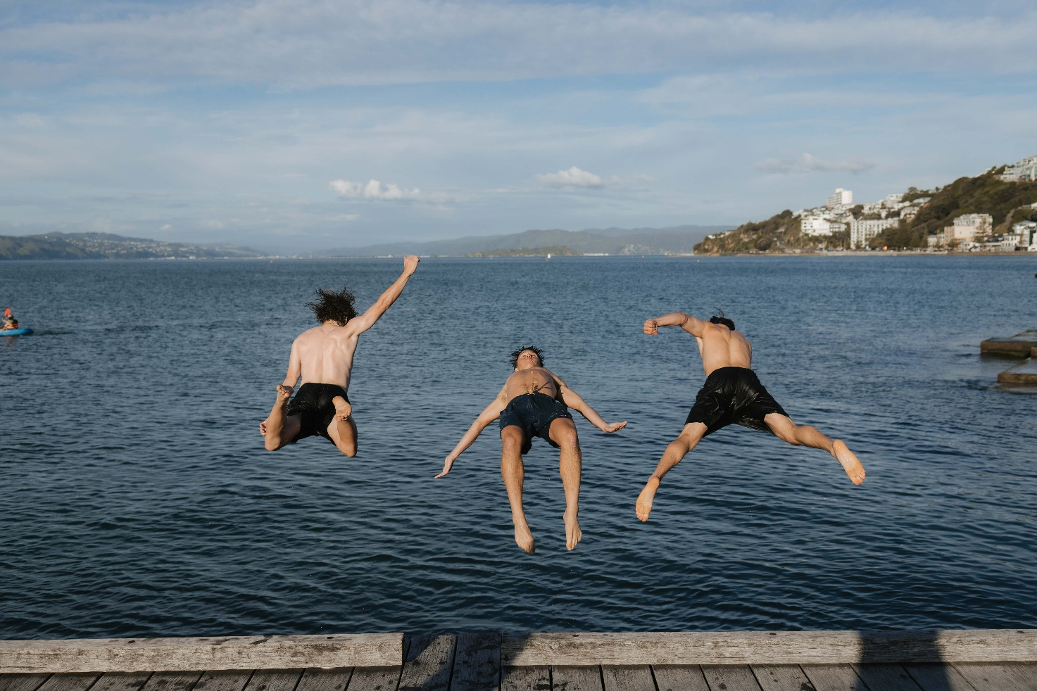

Indicators
Relevant indicators and trends for this outcome and its related priorities are presented below.

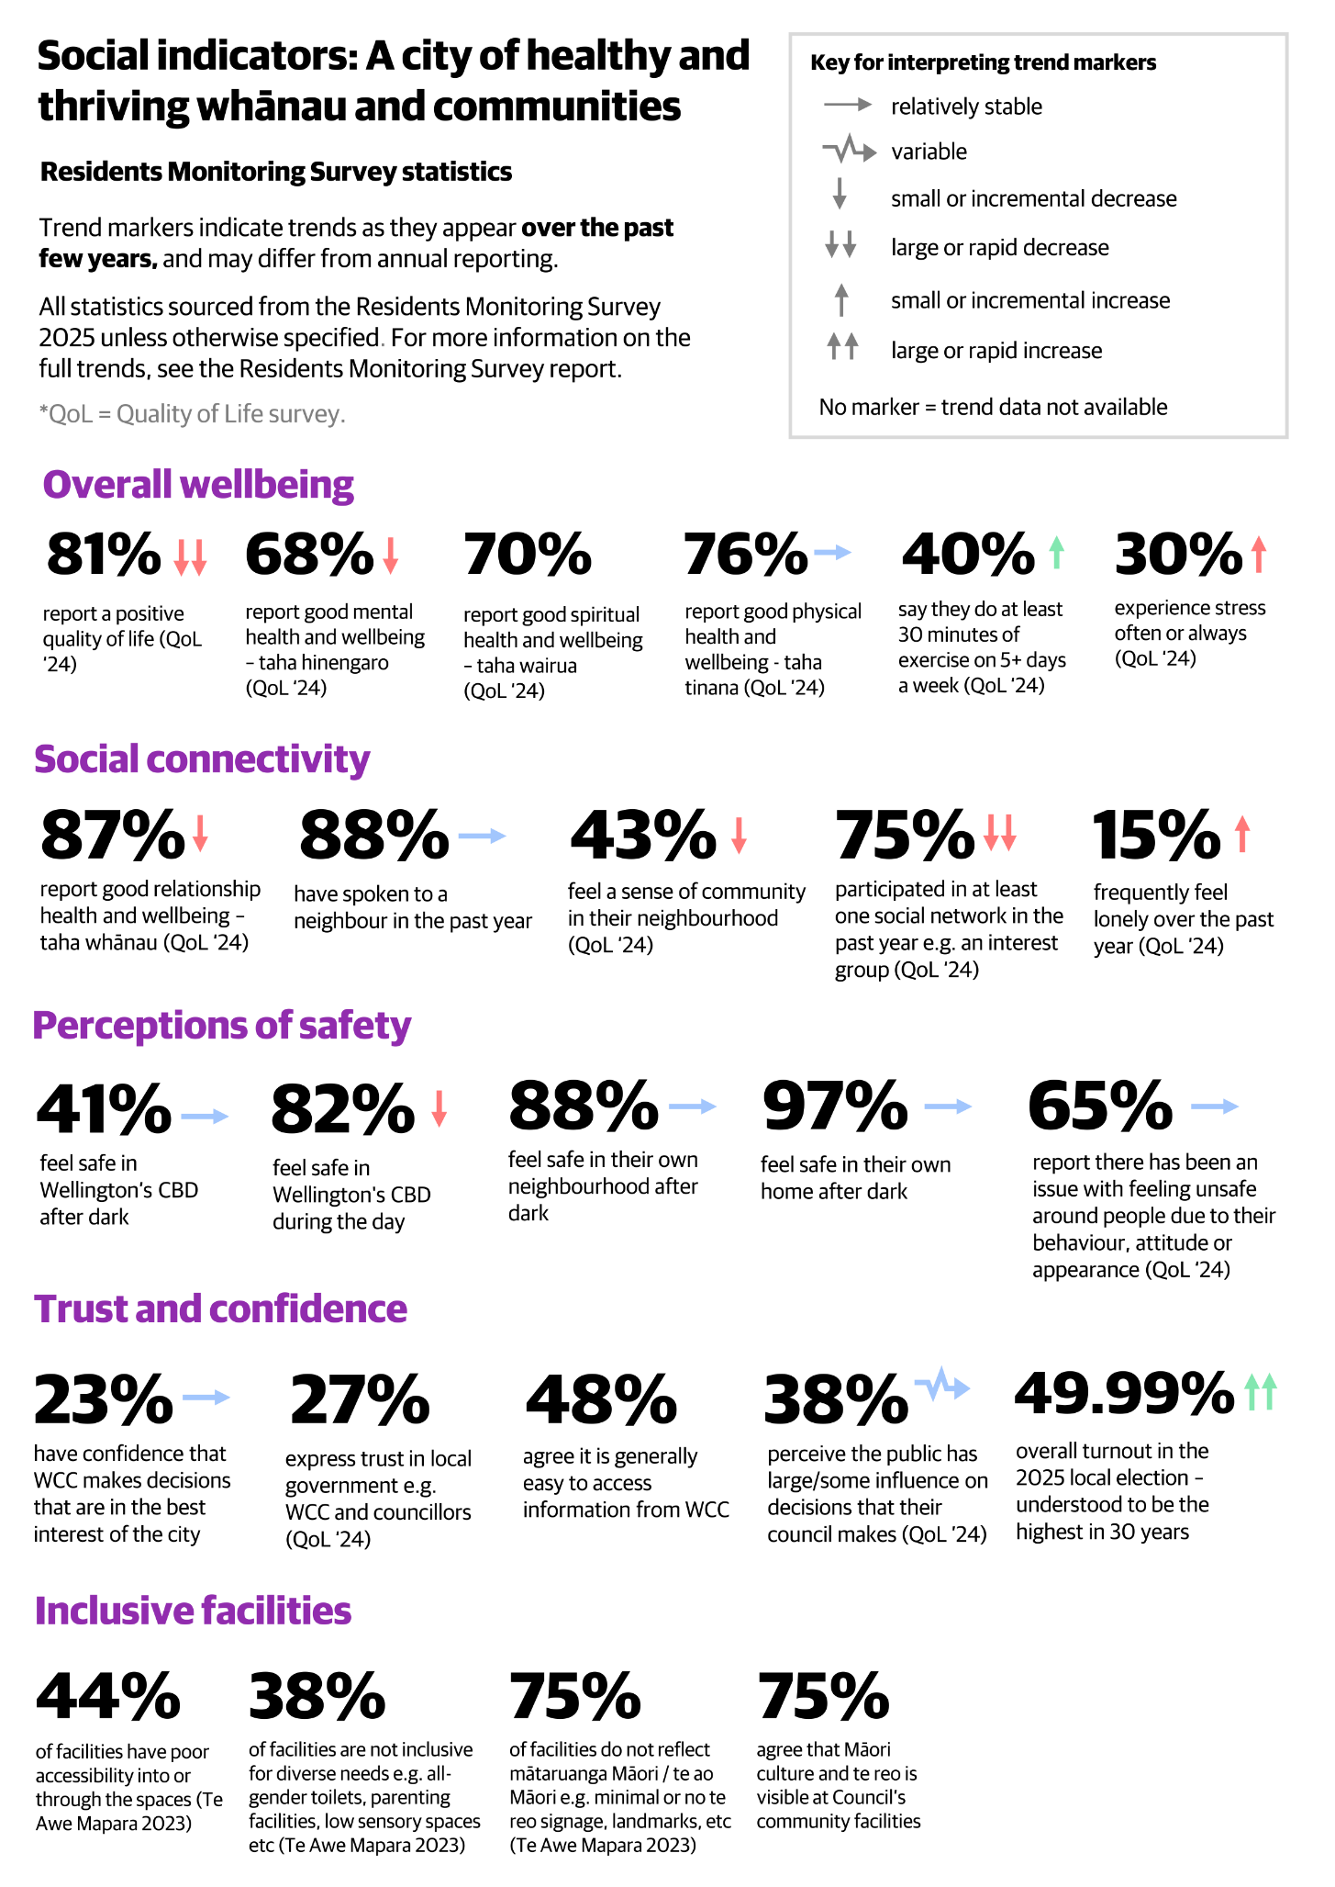

Stakeholder views on social outcomes
From the Community Sentiment 2023 report:
- There is a sense that social inequality is growing, and that some groups are being more negatively impacted than others. Growing cities where people do not feel safe, connected, or a sense of community can lead to growing social disparity and feelings of isolation. Residents report on a variety of areas that need improvements to ensure better social outcomes, discussing how wellbeing is determined by a wide range of factors – from housing quality to transport options, as well as personal safety, mental and physical health, and community connection.
- There is an overall perception among respondents across engagements that Wellington central city feels unsafe after dark, though people generally feel safe in their own homes and neighbourhood after dark. Feeling unsafe was most often attributed to the unpredictable, loud, or aggressive behaviour of others. Suggestions to improve safety included targeted behavioural and physical issues such as drunkenness and lighting, as well as broader societal issues like addressing root causes of homelessness, over-use of alcohol, and mental health.
- People want Wellington to be a vibrant and inclusive city that celebrates its diversity, even more than it already does. Ensuring that the city caters to a wide range of people is important to help people feel a sense of acceptance and belonging in the city. In terms of public spaces, there is demand for places for people to go and be with other people - People felt that public places open to all types of people are an important aspect of city life. Some common characteristics of these spaces were that they are welcoming, and are not necessarily commercially oriented.
- When looking at the area of sport and recreation, the reported use of facilities (e.g. pools and sports grounds) is fairly consistent or higher in 2023 than in previous years. Pools were the most used facility by those who gave feedback, whilst recreation centre use is declining overall. Sport and recreation is most likely to be self-directed (i.e. not through an organisation of club), and options are becoming more diverse; walking/running, cycling/mountain biking, dog walking, gardening, and skateboarding are popular.

From the LTP 2024 and LTP 2024 amendment consultations:
- Social wellbeing in Wellington is underpinned by a strong sense of community, inclusivity, and support for vulnerable groups. Submissions stress the importance of accessible community facilities, affordable housing, and services that foster connection and resilience.
- There is widespread concern about the impact of service cuts, such as the closure of libraries and community centres, on social cohesion and equity. Many residents highlight the need for spaces where people of all ages and backgrounds can gather, learn, and participate in activities that support mental and physical health.
- Initiatives like the Take 10 safe zone, community gardens, and youth programmes are valued for their role in building trust, reducing isolation, and supporting wellbeing.
- Submitters also call for the Council to prioritise accessibility, universal design, and meaningful engagement with disabled people and their organisations. The need for targeted support for children, young people, and older adults is emphasised, along with a focus on safety, public health, and opportunities for volunteering.
- Social wellbeing is seen as closely linked to cultural and environmental outcomes, with community resilience strengthened by investment in inclusive, fit-for-purpose spaces and services that reflect the city’s diversity and aspirations.

Tākai Here partners’ priorities
In the Council’s Tūpiki Ora Māori Strategy, Outcome 4 aligns with this Community Outcome, The social, cultural, environmental and economic wellbeing of Māori communities is prioritised, supported and invested in. Tūpiki Ora outlines Mana Whenua aspirations “Whānau wellbeing is important to our communities, and the Council will support communities to thrive. Specific areas for action include combating homelessness; supporting whānau Māori into their own homes; providing more options to access social services such as mental health for rangatahi Māori…and investing in greater representation and presence of Mana Whenua and Māori culture, language and identity within and across our city. These actions (and others) contribute to strong, vibrant whānau who are self-determining.”

Key issues for “A city of healthy and thriving whānau and communities”

Declining quality of life and wellbeing
Wellingtonians have historically enjoyed a high quality of life (and one which has typically been higher than other cities), with 87–91% rating their quality of life as good between 2014 and 2022. This figure dropped to 81% in 2024, aligning Wellington’s figure with the national urban average. This decline is mirrored in mental health and wellbeing indicators, with almost one in three residents experiencing frequent stress (30%). Furthermore, homelessness has increased overall, evidenced by a 24% rise in rough sleepers in early 2025 (to 141 people) and a 40% surge in requests for support from charitable organisations. There have been central government policy changes on eligibility for emergency housing, alongside tighter rules for social welfare.
It is important to note that declines in social measures are not unique to Wellington City (e.g. many other areas have also reported increases in homelessness). Overall wellbeing decreases have tended only to bring Wellington in line with other metro areas. Wellingtonians on average continue to maintain better than average self-rated physical and relationship health, high perceptions of safety within their own homes and neighbourhoods, and high levels of civic engagement – with the latest local election turnout being the highest in decades.

Rising loneliness, weakened social connectivity
Loneliness and social isolation have become increasingly prevalent, with the percentage of residents who frequently feel lonely rising from 6% in 2020 to 15% in 2024. This issue is particularly severe among Māori and disabled residents, with around a third of both groups (35% each) reporting experiencing frequent loneliness in the Quality of Life survey 2024. Participation in social networks is also down, dropping from 80% reporting participation in at least one group (e.g. a hobby group) in 2022, to 75% in 2024. Reassuringly, the number of people who speak with their neighbours or report a sense of community in their neighbourhood has remained stable – suggesting a more mixed picture – the overall reduction in social engagement heightens vulnerability to the serious risks associated with social disconnection (including impacts on mortality, physical and mental health, well-being, education, the economy, and wider society).

Safety concerns
Perceptions of safety, particularly in the CBD after dark, have deteriorated significantly – from 71% feeling safe in 2020 to 45% in 2022, with little improvement since. Perceptions of safety in the CBD during the day have also recently worsened, dropping from 90% in 2023 to 82% in 2025. When surveyed about what makes them feel unsafe, aggressive behaviour, alcohol and drug issues, and homelessness all remain persistent concerns for residents. Young people and the rainbow community are particularly concerned about safety.

These safety concerns are both a symptom and a driver of declining social cohesion and trust. The Koi Tū Centre for Informed Futures reports that fear and insecurity erode belonging and participation, amplifying polarisation and weakening civic engagement. The compact nature of Wellington’s central city and its role as a hub for regional services mean that even relatively small social issues become highly visible, amplifying their impact on community wellbeing and perceptions.

Low trust and confidence
Trust and confidence in Wellington City Council remains low, with only 36% of residents expressing satisfaction in the Council’s performance in 2025, while 52% were dissatisfied. The most common reasons for dissatisfaction, as cited in the Residents Monitoring Survey, were perceptions of excessive spending/non-essential spending, concerns around Council priorities, concern about Mayor/Councillors, dissatisfaction with cycle lane implementation, as well as concerns about rates/rates increases. Many residents feel disconnected from decision-making processes, although reassuringly, trust in local government is in line with that of other major cities. Recent analysis suggests that respondents aged 60+ and retired respondents have lower levels of trust in Wellington City Council – however, they do not necessarily differ in terms of trust in local government more generally or towards central government. This reflects broader patterns of declining confidence in government institutions rather than issues unique to Wellington.

Community facilities aging, inflexible and unevenly distributed
Wellington’s 277 community facilities face significant challenges that affect residents’ quality of life, social inclusion, and the city’s economic vitality. Many of these facilities are aging, inflexible, unevenly distributed, and increasingly costly to maintain, with maintenance expenses rising by 45% over the past seven years. The limited number and variable quality of facilities across suburbs create persistent barriers to access, particularly for Māori, disabled people, and other diverse groups, who often encounter physical, cultural, and financial obstacles when attempting to use these amenities. These inequities in facility use and cultural inclusion not only restrict opportunities for social connection and community engagement but also undermine wellbeing and equitable participation in civic life.

Climate vulnerability and sustainability concerns further threaten the long-term viability of Wellington’s community amenities, making it even more urgent to address these issues. Improving access and inclusion is essential to ensure that all residents can benefit from community facilities, participate fully in social and economic activities, and contribute to resilient, welcoming neighbourhoods. The Council recognises these challenges and has outlined targeted improvement steps in Te Awe Māpara, the Community Facilities Plan, which aims to maintain, upgrade, and better distribute amenities to meet evolving needs and support city-wide wellbeing, equity, and climate goals.

Not easy for disabled people to access Council information
This issue is connected to the strategic approach: Making our city accessible and inclusive for all.
Access to Council information and the ability to communicate easily are essential for disabled people to participate equally in civic life, but only 42% of people with activity limitations agree that information was easy to access from Wellington City Council. Barriers such as inaccessible websites, reliance on PDFs, or limited contact options can exclude people from key services. Ensuring information is easy to find and understand, and offering accessible communication channels, supports inclusion and independence.

Accessible community facilities and housing
This issue is connected to the strategic approach: Making our city accessible and inclusive for all.
A needs analysis for Te Awe Māpara found that 22 of the 49 libraries, community centres, pools, and recreation centres had poor accessibility. Information about how to access and navigate these spaces is often inconsistent or incomplete. These facilities are also important during civil defense emergencies, providing safe places for people to go. Their accessibility is vital so that disabled people are not put at greater risk in an emergency. Accessible housing supply is also limited. Only around 10% of Council housing stock is accessible, with only 30% of tenants in accessible units disabled. Data gaps further limit understanding of current and future housing needs for the disabled community.

Strategic Challenge for Wellington’s city of healthy and thriving whānau
Looking at the issues, there are three distinct but interconnected “pressure systems”:
- Wellington is facing increased loneliness, lower quality of life, and safety concerns, especially among vulnerable groups, weakening community cohesion and wellbeing.
Wellington is experiencing rising loneliness, declining quality of life, and worsening perceptions of safety, particularly among vulnerable groups such as young people, Māori, disabled people and rainbow communities. These trends reinforce each other: fear and insecurity reduce participation and connection, which in turn weakens the sense of belonging and shared social norms that keep communities strong. Without action that rebuilds everyday connection, visibility, trust, and safety, Wellington risks an entrenched erosion of social cohesion that suppresses recovery and long‑term wellbeing.
- Ageing and inaccessible infrastructure limits inclusion and civic participation, risking greater inequality.
Community facilities, accessible housing, and information systems are not keeping pace with demographic, cultural, and climate-related needs. Ageing assets, uneven distribution, and poor accessibility, combined with barriers to finding and understanding council information, restrict who can participate fully in civic life and who benefits from public investment. These structural constraints risk widening inequities and diminishing the social return on public investment.
- Low trust in the Council reduces engagement and slows collective action, making it harder to address key challenges.
Satisfaction with Council performance is low, with many residents feeling disconnected from decision-making and doubtful that the Council is focused on the right priorities. This dissatisfaction both stems from, and contributes to, wider social concerns about safety, spending, and wellbeing. Low trust suppresses willingness to engage, co‑create solutions, or support necessary changes (including climate adaptation and long‑term infrastructure renewal). These pressures risk a cycle where declining civic confidence makes it harder to act decisively on the very problems that most require collective effort.

How the council is responding
The Council is responding to recent declines in quality of life, social connectivity, perceptions of safety, and trust in local government through a range of coordinated strategic actions. These include:
- Targeted investment in homelessness services and affordable housing initiatives, such as the Homelessness Coordination Service and the Te Kāinga Programme, to address rising homelessness and housing pressures.
- Prioritising programmes and infrastructure that foster social connection and support community wellbeing, including partnerships with community groups and health providers.
- Improving public spaces and recreation facilities, guided by the Community Facilities Plan (Te Awe Māpara), which focuses on maintaining and upgrading amenities to meet evolving needs.
- Establishing mechanisms such as the Citizens’ Assembly and advisory groups to enhance transparency, inclusivity, and community participation in decision-making.
- Ongoing monitoring of resident sentiment and data-driven planning to ensure resources are aligned with strategic priorities and to maintain Wellington’s reputation as a liveable city.

Economic outcome: An innovative, business friendly city

For Wellington, an innovative business friendly city is:
- provide good jobs for people
- operates successfully in a dynamic zero-carbon circular economy, and
- has efficient and fit-for-purpose regulatory processes.
This outcome has one strategic priority:
- Revitalising the city and suburbs to support a thriving and resilient economy and support job growth



Indicators
Relevant indicators and trends for this outcome and its related priorities are presented below.
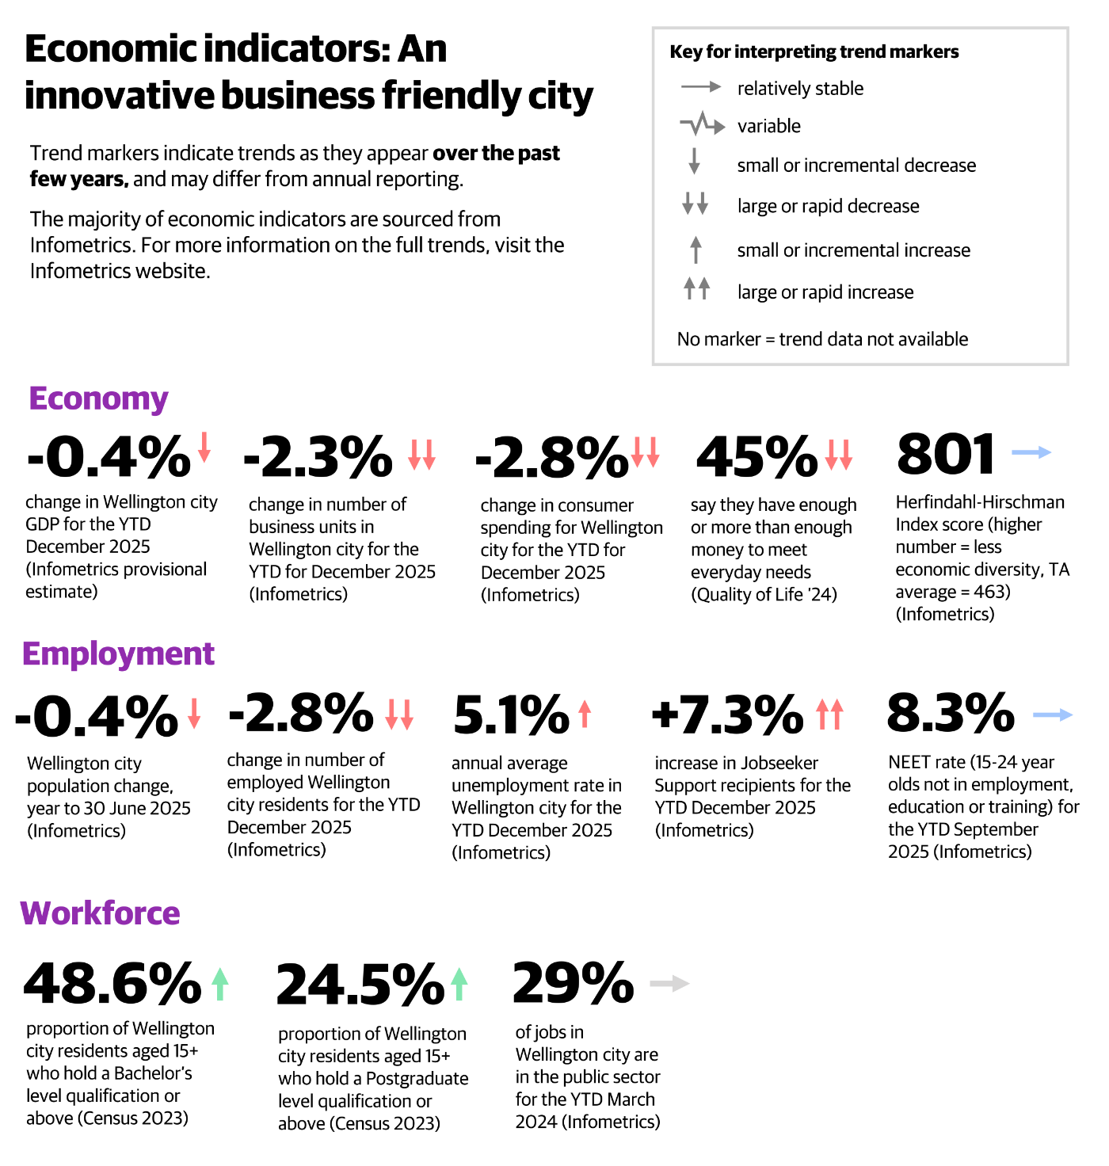

Stakeholder views on the economy
From the Community Sentiment 2023 report:
- People want WCC to take on clear actions to help the city’s economy function more smoothly and benefit all Wellingtonians. Housing affordability, a circular economy, and breaking down barriers to employment were important to Wellingtonians. Opportunities are seen for Wellington to develop its economy by harnessing and promoting itself as a centre of digital innovation.
- There was a lot of debate about council spending and how this reflected in rates and other costs to residents. Although ‘nice to haves’ are broadly thought less important than ‘necessary’ projects, each is defined and prioritised differently by groups with different interests.
- There were wide-ranging objections to rates increases. Whilst many simply stated their objections to rates rises, other characterised rates rises as an increasingly tough burden on residents. However, there was some support for targeted rates rises to fix infrastructure, for example.
- High costs associated with parking, entertainment, events, and recreation activities deter city residents’ participation in various activities. Statements such as “it’s getting too expensive” were made in relation to rates, fees, facilities use, entertainment and nightlife options, rent and housing, and parking.
- People support a future where employment, education, and volunteering opportunities are accessible to all Wellingtonians, including young people, people living with disabilities, and new residents. Ensuring support for groups that currently face barriers to employment and education was seen as important.
- Wellingtonians value the city’s nightlife, particularly it’s hospitality venues, and see the city as a place to connect socially and have fun. People want to enjoy nights out, but worry about aggressive behaviour and affordability. Fear of aggressive patrons, and the cost of things like parking and events are prohibitive factors, and people want a great variety of cheap/free things to do in the city. People believe that street and amenity upgrades, including better active transport infrastructure, beautification, enhanced lighting, more public seating, and more open and green spaces, will improve the experience of people visiting or working in the area.
From the LTP 2024 and LTP 2024 amendment consultations:
- Wellington’s economy is recognised as innovative, resilient, and closely tied to its creative and knowledge sectors. Submissions reflect concern about the pressures facing local businesses, including high rates, insurance costs, and the need for more transparent and equitable funding models.
- There is strong support for revitalising the city and suburbs to support job growth, attract investment, and ensure a thriving business environment. Many submitters advocate for a balanced approach to rates and user charges, with calls to reduce the commercial rates differential and ensure businesses are not unfairly burdened.
- The importance of events, tourism, and hospitality is highlighted, with suggestions to invest in infrastructure and streamline regulations to support economic activity. Submitters also emphasise the need for the Council to work collaboratively with central government, iwi, and the private sector to develop new funding tools and support economic development.
- The creative sector is seen as a key driver of economic wellbeing, contributing to GDP, employment, and the city’s reputation. There is a call for investment in skills, innovation, and infrastructure that supports both traditional and emerging industries, ensuring Wellington remains a competitive and attractive place to live, work, and do business.

Tākai Here partners’ priorities
In the Council’s Tūpiki Ora Māori Strategy, Outcome 4 aligns with this Community Outcome: The social, cultural, environmental and economic wellbeing of Māori communities is prioritised, supported and invested in. Tūpiki Ora outlines Mana Whenua aspirations “Specific areas for action include … increasing opportunities to grow Māori businesses, leaders and entrepreneurs; and investing in greater representation and presence of Mana Whenua and Māori culture, language and identity within and across our city.”

Key issues for “An innovative business friendly city”
Wellington is facing a convergence of economic and social pressures, including employment losses, a contracting city centre, and a lack of industry diversification, that are exacerbated by its dependence on government administration. These pressures are amplified by the city’s high reliance on government administration, increasing exposure to sector‑specific shocks and constraining long‑term economic resilience and growth.

Economic contraction, employment trends and disparities
Wellington City remains in recession, with the number of businesses falling and employment declining in the past year to September 2025. Job losses have contributed to population decline, further weakening economic activity. These trends are reflected in rising unemployment, which increased from 2.8% in September 2023 to 5.1% in December 2025, and a 8.1% rise in Jobseeker Support recipients in the 2025 calendar year, reaching the highest number since 2009.

Despite Wellington’s high median income ($83,000 for full-time workers, vs $66,500 in NZ overall) and GDP per capita ($162,065, more than twice the national average), significant disparities persist. Māori, Pacific, Asian communities, and disabled residents remain disproportionately affected, with all of these groups having a lower median income when compared to other groups (according to StatsNZ). For example, in the 2024 Census, the median total personal income for Pacific people in Wellington City was $62,800, whereas for the Wellington City population overall, it was $83,000.

The NEET rate (youth Not in Education, Employment, or Training), though traditionally lower than the national average, returned to 8% in 2024 after a low of 6.9% in 2023, an indicator of shifting economic pressures. Increasing youth unemployment among NEETs is a growing concern for Wellington’s future. The limited access to opportunities for young people results in untapped potential, diminished productivity, and long-term impacts on the city’s economic strength and social wellbeing.

These gaps restrict access to secure housing, education, and essential services, perpetuating disadvantage and undermining overall economic growth. Notably, higher educational attainment does not guarantee employment, indicating a disconnect between qualifications and labour market outcomes.

Lack of industry diversification and economic resilience
Wellington’s economy is highly concentrated in a few sectors: public administration (30% of workforce, 18% of GDP), professional/scientific/tech services (15.4% of GDP), and financial/insurance services (9.7% of GDP). Almost a third of the city’s jobs are in the public sector (29%). The Herfindahl-Hirschman Index for Wellington City, which measures economic stability, remains stable at 801, indicating limited economic diversification. This concentration makes Wellington vulnerable to sector-specific shocks, such as recent public sector job cuts, which have amplified unemployment and economic hardship.

Creative industries employ 6.7% of the workforce and generate 15% of the nation’s creative-sector GDP, reinforcing Wellington’s reputation as Aotearoa’s Creative Capital. However, broader economic pressures, declining consumer spending (notably in Courtenay Place and Lambton Quay), reduced migration (down 24%), and a 2% drop in tourism-related jobs, suggest challenges for population growth and the tourism sector.
Despite these challenges, there are signs of resilience. Some businesses have successfully adapted by embracing takeaway and online models. Council-led initiatives, such as hosting events, investing in precincts, and supporting public art, are revitalising the city’s vibrancy. While retail vacancies have risen, areas like Cuba Street continue to attract activity through renewed leasing.

These trends constrain population growth and limit the city’s capacity to absorb economic shocks, despite pockets of business adaptation and resilience.

Revitalising the city centre liveliness is a complex challenge
Perceptions of the city centre’s liveliness and attractiveness have declined sharply, falling from 86% agreement in 2018 to just 29% in 2025. In contrast, suburban centres have seen improved perceptions, rising from 48% in 2018 to 62% in 2020, and have remained steady since. This decline in perceptions of city centre liveliness and attractiveness has likely been exacerbated by the economic downturn, rising unemployment, and the closure of key venues such as Reading Cinema.

Alcohol-related violence is a significant concern. Recent tragedies, such as the death of a young man following an assault in 2024, underscore the seriousness of late-night violence. Police data shows that the Wellington CBD area has a high incidence of assaults and sexual offences (756 assaults and 77 sexual offences were recorded in the Willis St to Cambridge Tce and Lambton area units between October 2024 to September 2025), at similar levels to Auckland CBD (939 assaults and 64 sexual offences in Auckland Central East and West area units between October 2024 to September 2025). For both cities, the density of their urban centres may mean that victimisations tend to be concentrated in their CBD areas compared to city centres that are more spread out (such as Christchurch and Hamilton). Police data shows that year on year, between 2020 and 2023, the number of alcohol-related reported victimisations for assaults and aggravated robbery offences across Wellington City have decreased slightly (from 757 in 2020 to 650 in 2023).

Community feedback and council-led initiatives, such as the Take 10 safety service, aim to reduce harm, though significant challenges persist. Courtenay Place is experiencing reduced engagement and shorter visit durations, with a substantial portion of visitors simply passing through rather than participating in entertainment activities. Additional issues exist, such as noise complaints, limited shopping opportunities, the lack of late-night and varied food options, vacant shops, and concerns about safety and general maintenance, especially following the closure of Reading Cinema. People are looking for a greater variety of dining choices available late at night, more shopping options, particularly for clothing, and improvements to area upkeep and security to enhance their overall experience. The council’s investment prospectus indicates safety concerns and investment gaps, signalling that the precinct's entertainment economy is currently underperforming and in need of revitalisation.

Balancing economic growth with affordability and a dynamic zero-carbon circular economy
The Council’s Economic Wellbeing Strategy 2022 positions the city as a frontrunner in the transition to a dynamic zero carbon circular economy, prioritising both economic strength and environmental responsibility. In the 2025/26 financial year, 698 businesses have participated in WellingtonNZ’s circular economy programmes, with the aim to reach 2,500 by the end of the year. This reflects a strong commitment from local businesses and growing engagement across the sector.

However, affordability continues to be a key concern for residents and businesses alike. Small businesses play a vital role in Wellington’s economy but are facing significant obstacles due to higher costs, complex regulations, and lower consumer spending, making it harder to maintain premises, invest in growth, and keep staff. Stakeholders recommend more targeted support, such as grants, simplified compliance processes, and better access to advisory services.

There is also a strong call for transparent and fair funding practices, especially during economic downturns. Stakeholders urge the Council to work more closely with business groups, iwi, and community organisations to develop alternative funding models [to the Downtown Levy] that distribute costs fairly and support economic growth. This includes targeted assistance for sectors most affected by current challenges and ensuring rates and fees do not unfairly burden smaller businesses or vulnerable groups.
Collaboration is increasingly seen as essential for economic advancement. Stakeholders want the Council, central government, iwi, private sector, and community organisations to work together, co-design policies, share information, and invest jointly in infrastructure and workforce development.

Moving towards efficient and fit for purpose regulatory processes
Regulatory processes remain a significant factor shaping business confidence and operating costs. Recent improvements have reduced complexity and processing times for permits and consents, with customer satisfaction remaining relatively high. Increased use of online portals has improved transparency and accessibility. Average resource consent processing times have dropped by 12% year-on-year, and 80% of customers rate these services as “good” or “very good” (24/25 Annual Report). Most licence and permit applications are now processed through an online portal, improving accessibility and transparency.

Despite some progress, regulatory processes still need further improvement to be more streamlined and user-friendly, with ongoing efforts focused on enhancing customer-centric values and regular stakeholder engagement. The introduction of a Local Alcohol Policy (LAP) could further support streamlining by providing clearer guidelines for licensing and reducing uncertainty for businesses, helping to make the regulatory environment more efficient and predictable.

Strategic Challenge for an innovative business friendly city:

Wellington faces a systemic challenge to its economic resilience, marked by a prolonged downturn, reliance on a narrow economic base, declining city‑centre vitality, and mounting pressures on small businesses.
Rising unemployment, persistent income disparities, and limited diversification amplify the impact of sector‑specific shocks, particularly in public administration. These pressures intersect with declining perceptions of safety and attractiveness in the city centre, constraining economic and social participation. At the same time, affordability pressures and regulatory complexity limit the capacity of businesses to innovate, adapt, or transition toward lower‑carbon and circular models.

Together, these challenges indicate that Wellington’s ability to sustain an innovative and business‑friendly economy depends on addressing system‑level conditions affecting diversification, city‑centre function, affordability, and confidence across the local economy.

How the council is responding
The Council’s current actions to achieve the economic outcome of an innovative, business-friendly city include:
- Actively revitalising the city and its suburbs by investing in critical infrastructure such as transport and water, supporting urban renewal projects.
- Providing targeted ‘city growth’ funding to stimulate local economic activity.
- Funding WellingtonNZ to drive business innovation, attract new businesses, and promote tourism, while also delivering business capability programs like summer of tech and the pop-up business school to foster sustainable practices and support the transition to a circular economy.
- Collaborating with tertiary education providers to strengthen workforce development and education-to-employment pipelines.
- Streamlining regulatory processes to be more business-friendly, including digitising permit and consent applications and reducing processing times.
- As mentioned in the social outcome section, the Council has established a homelessness coordination service, increased investment in affordable housing, and launched public space activation projects to restore city centre vibrancy.
- Golden Mile Revitalisation: Paused for cost review, but aims to deliver wider footpaths, better lighting, and public seating for a safer, more vibrant street.

Urban form outcome: A liveable and accessible, compact city

For Wellington, a liveable and accessible, compact city has:
- affordable, warm, dry housing,
- zero-carbon accessible transport choices,
- resilient infrastructure fit for growth, and
- proudly visible te ao Māori and multicultural heritage.
This outcome has two strategic priorities:
- Collaborate with Our Communities to Mitigate and Adapt to Climate Change
- Transform our transport system to move more people with fewer vehicles
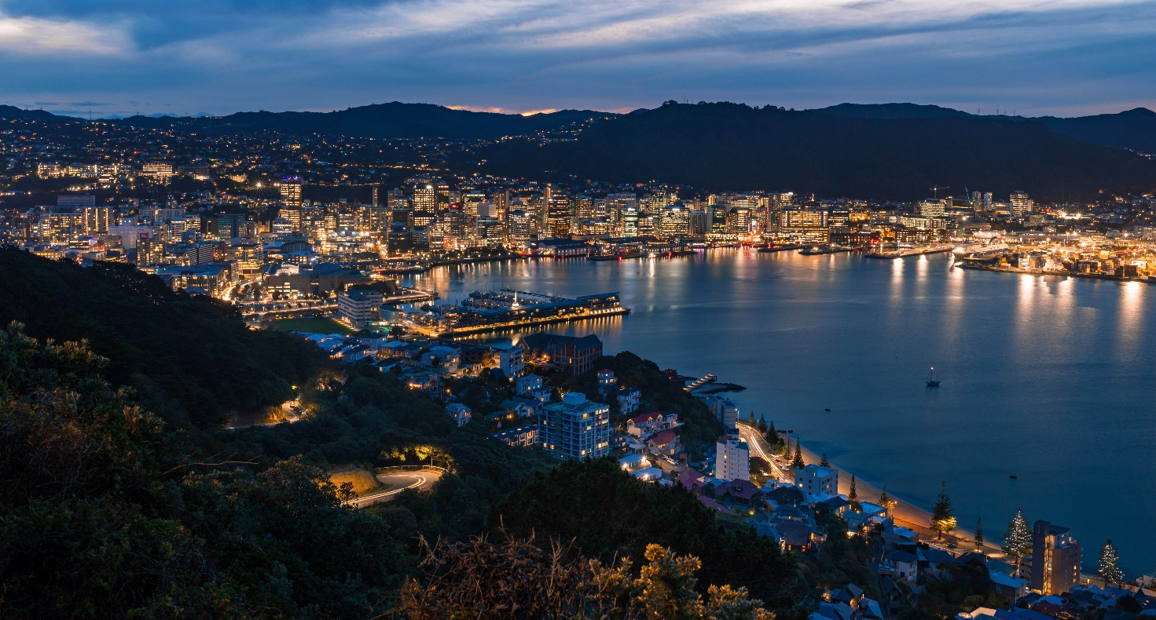

Indicators
Relevant indicators and trends for this outcome and its related priorities are presented below.
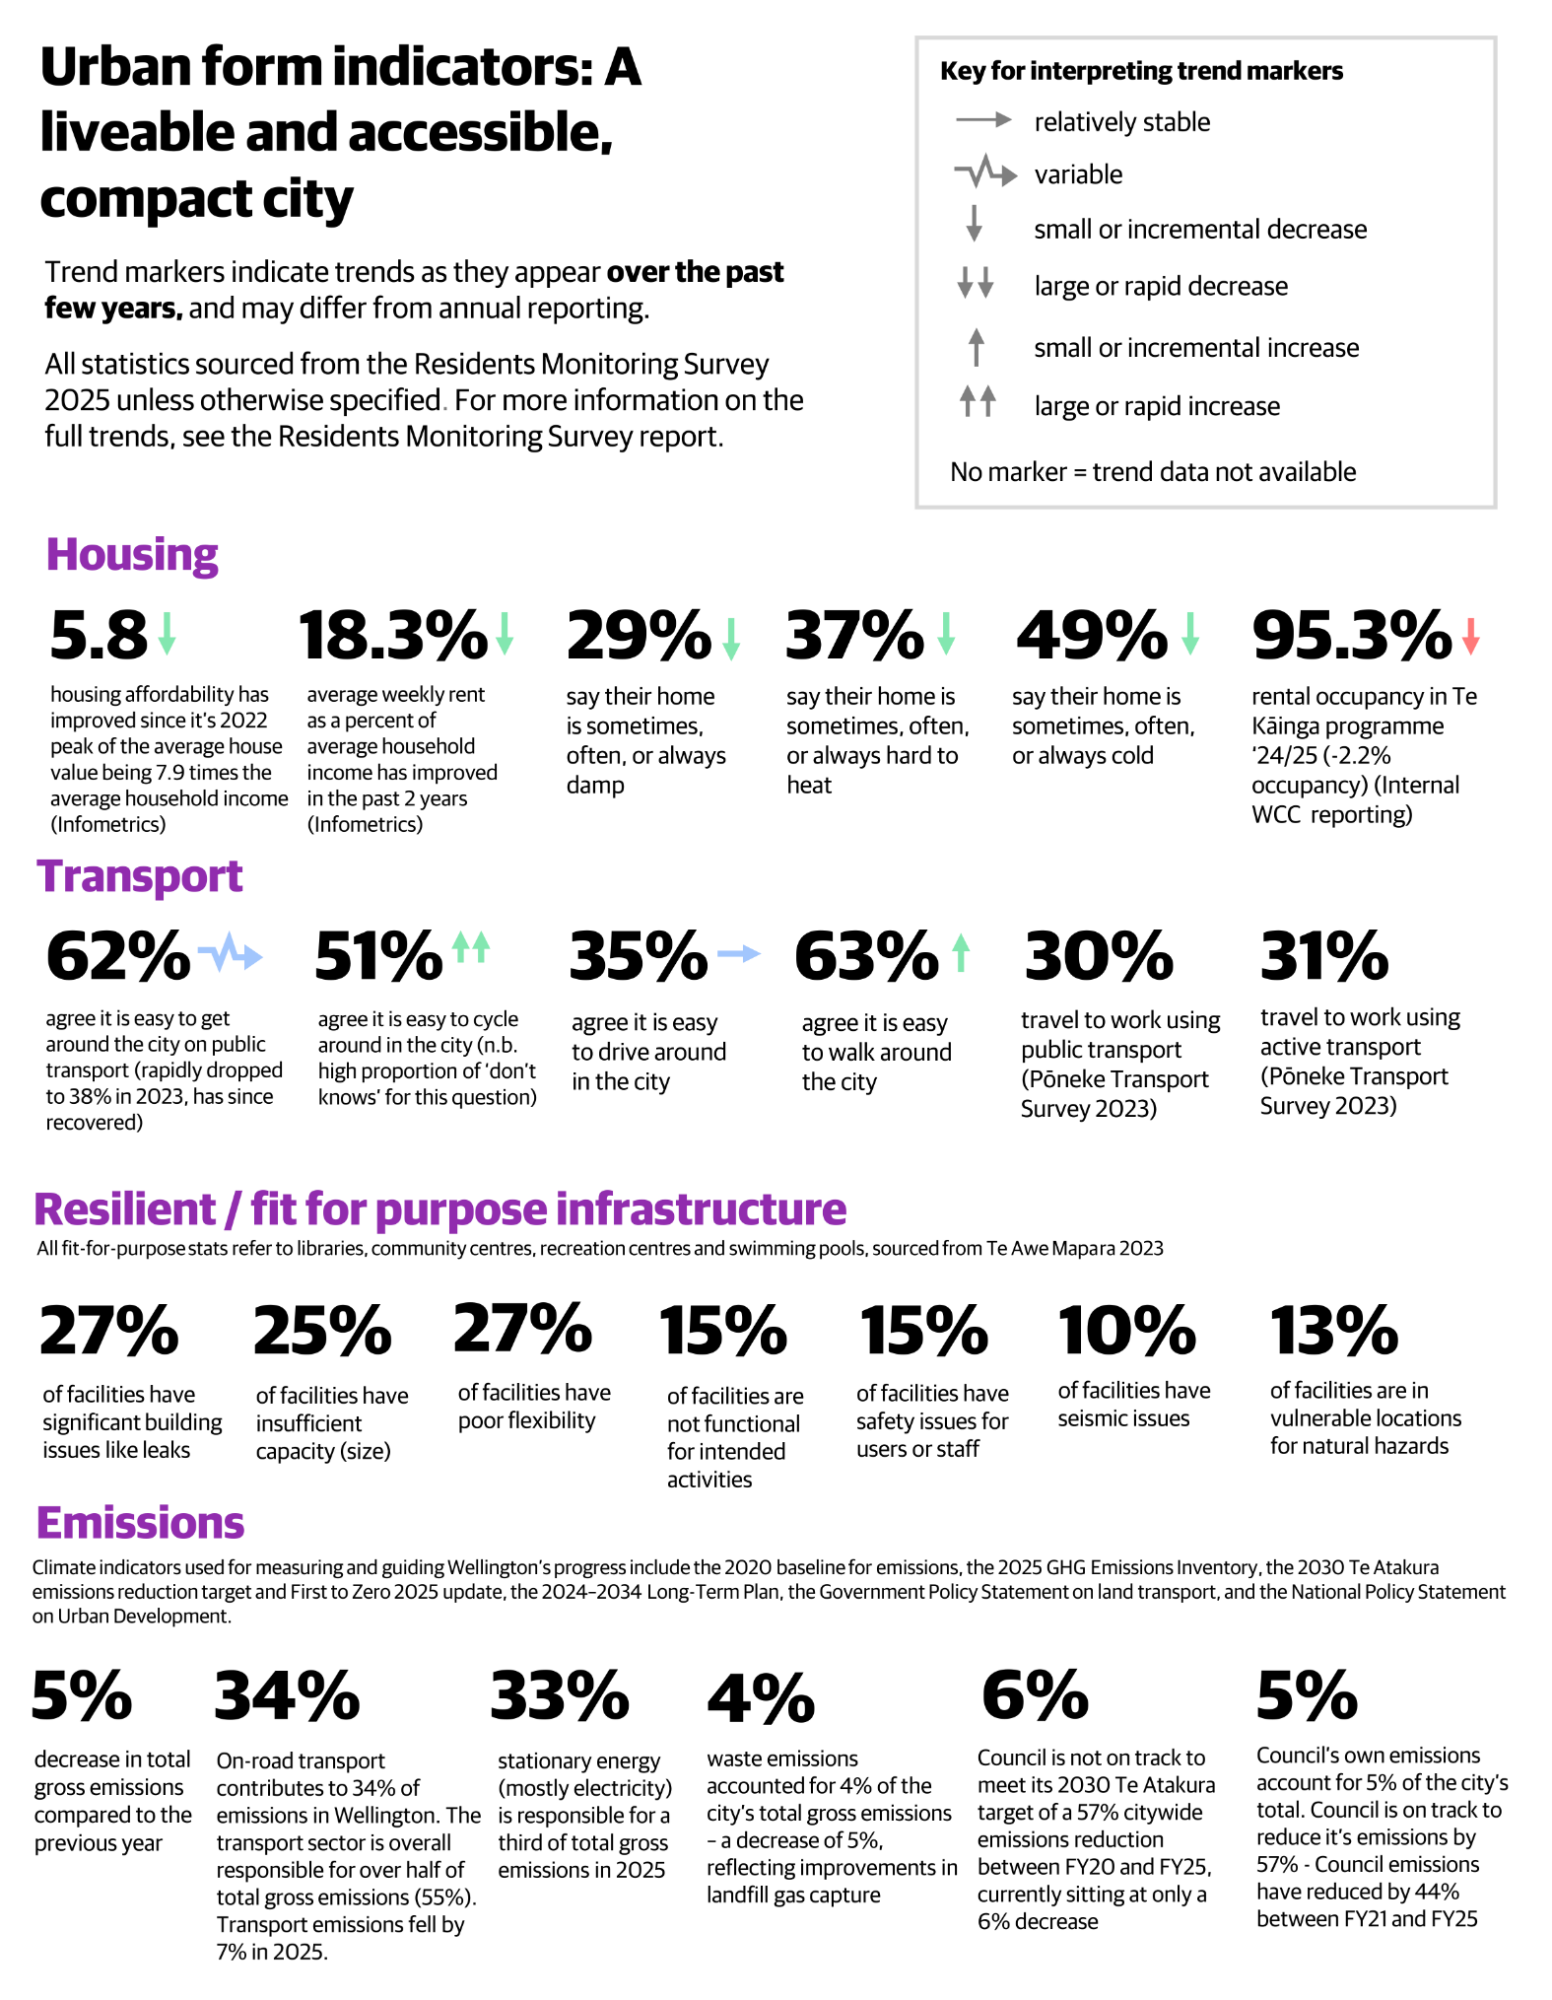

Stakeholder views on urban form and transport
From the Community Sentiment 2023 report:
- It is important to people that urban development is ‘done right’. While this means different things to different people, there was agreement that some degree of control is needed over development. However, there is declining confidence that this is being implemented. There is difficulty in striking the right balance between keeping costs down and catering for urban growth with appropriate development.
- The health of people’s homes is relatively stable and is generally improving, but there remain a large proportion of people who report cold and damp housing, and this was more likely for renters than for those who own homing. Housing affordability, in its broadest sense, is seen as a concern.
- In terms of facilities and amenities, people want to see lots of public amenities like public toilets, lighting, and rubbish bins out and about in Wellington, and want these to be well maintained so that people can comfortably use them. There is a perception that more could be done to encourage higher use for community facilities, particular among communities or groups that currently experience barriers to use, such as organisations with limited funds for venue hire. Amongst the community of Wellingtonians who are living with disabilities or accessibility needs, there is a perception that WCC facilities are more accessible than public amenities like toilets or public seating. However, it is also apparent that more needs to be done to ensure accessibility.
- In terms of transport, buses and cars are the most popular modes for commuting. People in general support providing good public and active transport infrastructure – responses across several community engagement projects indicated that people want a city that is well connected, enjoyable, and safe for people to move around in multiple ways. However, use of public and active transport modes is contingent on its ability to provide seamless, aligned, and connected travel experience, and whilst people want to move freely about their city and support ideals around emissions reduction (from vehicle use), they also view private vehicle use as their right and want to see cheaper and more widely available car parking.
- Respondents feel that there is more WCC could/should be doing to improve life in Wellington for people with disabilities or mobility issues. A significant proportion of respondents to engagements about proposed changes to the transport network felt that changes would not benefit those living with mobility issues. (e.g. in cycling consultations, cycleways in Wellington were said not to have been designed with accessibility in mind). Overall views were that accessibility is a good aim to ensure maximum participation, but some expressed concerns about the potential to reduce the experiences of the majority by focusing too much on small groups with specific needs.

From the LTP 2024 and LTP 2024 amendment consultations:
- Submissions consistently favour reallocating street space to people, public transport and active modes, but with a preference to stage and re‑phase delivery rather than stop projects altogether, reflecting affordability and disruption concerns (bike network, City Streets, Thorndon Quay/Hutt Road).
- Cycling: general support, but with strong calls to moderate pace and scope. Consultation feedback shows that many Wellingtonians recognise cycling infrastructure as important for safety, accessibility and long‑term mode shift, and do not want projects abandoned outright. However, a clear plurality favoured reducing or re‑phasing the bike network programme rather than continuing at full scale or stopping altogether, reflecting concerns about cost, disruption, topography and perceived low usage in some areas. This points to support for cycling as part of urban form, provided delivery is incremental, well‑justified and focused on high‑priority routes and safety outcomes.
- Parking: strong resistance to changes seen as unfair or harmful to local centres. Submissions expressed strong opposition to suburban parking charges, with many respondents citing impacts on small businesses, equity for people with limited transport alternatives, and fears that customers would avoid suburban centres. Parking was repeatedly framed as an enabler of local economic activity and daily access rather than simply a demand‑management tool. In contrast, views on motorcycle parking charges were more divided, with some support on user‑pays grounds and others arguing that motorcycles should be encouraged as a space‑efficient alternative to cars.
- Respondents repeatedly emphasised that fixing pipes and investing in three waters must precede or accompany growth and intensification, reinforcing resilient infrastructure as a prerequisite for a compact city.
- Strong support for partnership with Taranaki Whānui at Mātai Moana Reserve, and engagement with Māori and multicultural communities, signals that urban form should visibly express te ao Māori and diverse heritage.
- Overall, Wellingtonians want a transport system and urban form that supports low-carbon living, reduces congestion, and enhances the city’s unique character and quality of life.

Stakeholder views on climate change
From the Community Sentiment 2023 report:
- Respondents expressed doubt that enough was being done to prepare Wellington for the impacts of climate change. There is high awareness of the likely impacts of climate change, and many believe these impacts are starting to be felt. Strong, decisive action is required to manage climate change.
- Respondents want to see Wellington taking the lead of sustainability including sustainable building practices, and low or zero carbon transport options. They want to see improved public transport, better waste management or a circular economy, and a reduction in car use to protect the city against the impacts of climate change. Though respondents want improved waste management, owing to objections to rates increases, there was a preference for funding to originate from sources other than Council.
- Though discussion of sustainability as a concept often elicited support and sometimes urgent commentary, when respondents were asked to make trade-offs in real situations, sustainability did emerge as a key priority, with things like safety, resilience, and cost influencing decision-making more strongly.
- In terms of emergency preparedness, people indicated that there is work to do for Wellington to be considered a truly resilient city. Community preparedness and the resilience of buildings are important, but people also highlighted the need to consider a wide range of possible factors, such as climate change and sea level rise when talking about (and planning for) resilience.

From the LTP 2024 and LTP 2024 amendment consultations:
- Climate adaptation is widely framed through the lens of water resilience, with strong backing for higher investment and governance reform to ensure climate‑resilient drinking water, wastewater and stormwater systems.
- Many submitters support active transport and public transport investment as essential for emissions reduction, but prefer lower‑cost, incremental approaches that maintain progress toward mode shift during fiscal and cost‑of‑living pressures.
- While climate goals are broadly supported, there is resistance to measures seen as shifting costs onto communities (e.g. suburban parking fees), indicating expectations that climate‑aligned urban form changes be fair, accessible and clearly linked to emissions benefits.
- Support for intensification is implicit in backing for a compact city and reduced vehicle dependence. While not always stated explicitly, many comments suggest an understanding that locating housing close to jobs, services and low‑carbon transport is part of reducing emissions, even if concerns remain about cost, infrastructure readiness and delivery pace.

Tākai Here partners’ priorities
In the Council’s Tūpiki Ora Māori Strategy, Outcomes 1 and 4 align with this Community Outcome: Wellington is recognised locally and globally as a culturally rich and creative city of Mana Whenua and Māori identities and histories; and The social, cultural, environmental and economic wellbeing of Māori communities is prioritised, supported and invested in. Tūpiki Ora outlines Mana Whenua aspirations of “elevating and celebrating te ao Māori in all spaces, normalising te reo Māori, and creating a sense of community pride for all things Māori within our city”. Tūpiki Ora outlines support for climate change initiatives, “Support climate change efforts through increasing access and improving partnerships between mana whenua, Māori and key players (including the Council) who are advocating for climate change solutions, human behavioural changes and actions towards a more sustainable future.” Tūpiki Ora prioritises housing to support thriving and vibrant communities, “combating homelessness; supporting whānau Māori into their own homes”.

Key issues for “A liveable and accessible, compact city”

Persistent housing affordability and quality challenges
Housing affordability and quality continue to shape the wellbeing and future prospects of Wellingtonians. While there is strong consensus on the need for housing intensification and development to accommodate population growth, there is also concern for maintaining the city’s unique character and safeguarding green and open spaces.

Persistent issues with affordability and housing quality, especially for vulnerable groups such as young people, Māori, Pacific peoples, disabled, and gender-diverse residents, highlight the need for targeted and effective policy responses. These pressures affect public health, stress levels, educational outcomes, and economic stability, extending beyond individual households to influence the city’s overall resilience and prosperity.

Recent interventions, such as insulation upgrades and compliance with healthy homes standards, have contributed to improvements in housing quality. However, significant barriers remain, particularly regarding home ownership and access to affordable rentals. The Council continues to provide public housing at discounted rent levels through Te Toi Mahana, but the lack of ongoing access to the Income-Related Rent Subsidy (IRRS) makes financial viability challenging. Compounding this, Kāinga Ora (KO) has reduced its development programme for publicly funded social housing in Wellington, which means access to affordable rentals for the lowest-income households is tightly constrained. To address the needs of moderate-income earners, the Council has actively expanded the Te Kainga programme, offering more moderate rentals in the central city. Despite these targeted efforts, ongoing issues with equity persist, underscoring the need for sustained investment and innovative policy solutions. These challenges reinforce the importance of universal design, ongoing maintenance of existing public assets, and sustained investment in housing to support Wellington’s growing and diverse population.

Congestion and emissions in Wellington’s transport system
This issue is connected to the strategic approach: Embedding climate action
Wellington’s transport system faces two major challenges: congestion at peak times, and significant emissions, with 34% of the city’s emissions from on-road transport making it the single largest source. While there has been a 5% decrease in on-road transport emissions in the last two years, this has not translated into noticeably smoother traffic flow on the roads. Congestion remains a daily reality, especially during peak times on key routes connecting Lower Hutt, Miramar, and Wellington City. This disrupts daily routines, increases travel times, and negatively affects economic productivity.

There is strong public support for investment in public and active transport (such as buses, cycling, and walking infrastructure). However, many community members are also concerned about maintaining affordable parking and the ability to use private vehicles. This tension makes it challenging to achieve a shift away from car dependency.

Equity and accessibility challenges in Wellington’s transport system
This issue is connected to the strategic approach: Making our city accessible and inclusive for all
While some specific transport modes have seen improvements in recent years (e.g. the proportion of people who agree that it is easy to cycle around the city has increased from 17% in 2022 to 51% in 2025), perceptions of the ease of getting around the city otherwise have remained broadly stagnant, and these also differ between groups. For example, disabled people are more likely than non-disabled people to say it is difficult to get around the city by driving (54%, vs 38%). Barriers to accessing reliable, affordable, and effective transport make it more difficult for people to participate fully in work, education, and community life, increasing the risk of social exclusion. This highlights that the transport system can be a key enabler of broader accessibility and equity.

Infrastructure vulnerability to seismic events and climate change impacts
Wellington’s ageing urban infrastructure is becoming increasingly vulnerable to seismic events and the growing impacts of climate change. Problems such as leaking water pipes, safety risks, and insufficient capacity (where infrastructure systems cannot meet current or future demand, especially during peak use or extreme weather events) highlight the need for major investment and more consistent maintenance to keep pace with residents’ evolving needs. Gaps in data collection and monitoring also limit understanding of community needs and the performance of civic assets. Continued underinvestment and deferred maintenance risk worsening social inequities, eroding public trust, and reducing the city’s resilience to natural hazards. Climate change is intensifying these challenges by increasing the cost of storm recovery and requiring additional investment to strengthen resilience.

Integrating climate action to build a resilient Wellington
This issue is connected to the strategic approach: Embedding climate action
Climate change is reshaping Wellington’s operating environment, with direct impacts on people, infrastructure, and services, particularly in flood‑prone areas. Ageing infrastructure is increasingly vulnerable to seismic events and climate impacts, such as storms and flooding, requiring significant investment to maintain resilience standards.

As outlined in the Paris Agreement, joining global efforts to reduce emissions is the most impactful way to limit long-term future global climate impacts. Wellington has relatively low emissions per capita compared to other New Zealand cities but is not on track to meet its Te Atakura target of a 57% reduction by 2030. Reducing the Council’s own emissions is an important contribution, however that accounts for only 5% of the city’s total.

Some sectors in Wellington are well-positioned for a low-carbon future, while others may face significant economic pressures from decarbonisation, underscoring the importance of broader community and business engagement. To support city emissions reduction, the Council has unique levers to enable emissions reductions and resilience through urban planning, transport networks, and waste systems, with direct influence on ~40% of the city’s emissions.

Unfortunately, national policy settings are inconsistent and insufficient, with sector-specific directions (e.g., land transport, urban development) not always aligned with national emissions reduction and adaptation frameworks. These settings also impact the availability of central government funding for local government activities further constraining Wellington’s ability to plan and deliver effective local climate action, even in the areas in which the Council has direct influence, such as transport.

Strategic Challenge for a liveable and accessible, compact city:

The city is experiencing a reinforcing cycle where housing pressures, transport congestion, ageing infrastructure, and climate impacts compound one another and disproportionately affect vulnerable communities.
High housing prices and a shortage of homes are forcing people to move to areas with fewer services and less public transport, which means more people are using private cars. This leads to more traffic and higher emissions. At the same time, the city’s ageing infrastructure, especially water and stormwater systems, is struggling to cope, and these weaknesses are being made worse by climate change. This puts extra strain on city finances and makes the public less confident in the city’s ability to deliver essential services.

These overlapping problems show that Wellington can’t fix things by looking at housing, transport, infrastructure, and climate change separately. Instead, the city needs a joined-up approach that considers how these issues connect. This means planning for growth in a way that matches up with strong, resilient infrastructure, encouraging more people to use public and active transport, and making sure that everyone - including Māori, Pacific peoples, disabled people, young people, and gender-diverse communities - has the opportunity to fully take part in Wellington’s future. Only by tackling these challenges together can Wellington become a liveable, accessible, and compact city for all.



How the council is responding
The Council’s current strategy for creating a liveable, accessible, and compact city is multifaceted and addresses a range of interconnected challenges. This approach centres on fostering community partnerships to enhance climate resilience, reimagining transport systems to put people ahead of vehicles, and advancing housing affordability and quality.
- Strategic investments are also being made to build infrastructure that is resilient, inclusive, and adaptable for the future. Additionally, policy integration across sectors ensures a coordinated response to persistent inequities and supports vulnerable populations. Through these efforts, Wellington is committed to remaining a liveable, accessible, and future-ready city for everyone.
- The Council is embedding climate action at the core of its strategic approach by systematically integrating climate risk considerations across asset procurement, renewal, and operational processes. Long-term planning will soon incorporate scenario analysis and adaptive pathways, enabling the city to respond proactively to uncertainties and emerging climate risks. Ongoing investment is prioritised in public and active transport infrastructure, including buses, cycling, and walking networks, to reduce congestion and emissions, while ensuring that all residents have equitable access to transport options.
- In addition to transport, the Council is advancing upgrades to water networks and other core infrastructure to enhance resilience against climate change impacts and accommodate population growth.
- Strategic planning and targeted investments are focused on ensuring that community facilities are resilient, inclusive, and future-ready, with particular attention to addressing data gaps, upgrading facilities for evolving community needs, and improving equitable access for Māori, disabled people, and other underrepresented groups. The Community Facilities Plan (Te Awa Māpara) guides these improvements, and the Council continues to prioritise decarbonisation initiatives, such as energy-efficient upgrades and renewable energy adoption in aquatic facilities.
- Community engagement is central to the Council’s climate adaptation efforts. This includes co-designing adaptation plans with local communities, exemplified by the Island Bay pilot, as well as building enduring partnerships with Māori and other groups to ensure that diverse perspectives inform the city’s climate response. The Council is committed to science-based emissions reduction targets, transparent reporting, and regular updates on climate action progress. Building organisational capability remains a priority, with ongoing initiatives to enhance climate-related skills and knowledge among staff, supporting the effective delivery of climate action across all areas of Council responsibility.

Environmental outcome: A city restoring and protecting nature

For Wellington, a city restoring and protecting nature includes:
- providing easy access to nature,
- with systems to reduce waste and
- thriving biodiversity and nature-based solutions in natural and urban environments
This outcome has two strategic priorities:
- Transform Our Waste System to Enable a Circular Economy
- Fix Our Water Infrastructure and Improve the Health of Waterways
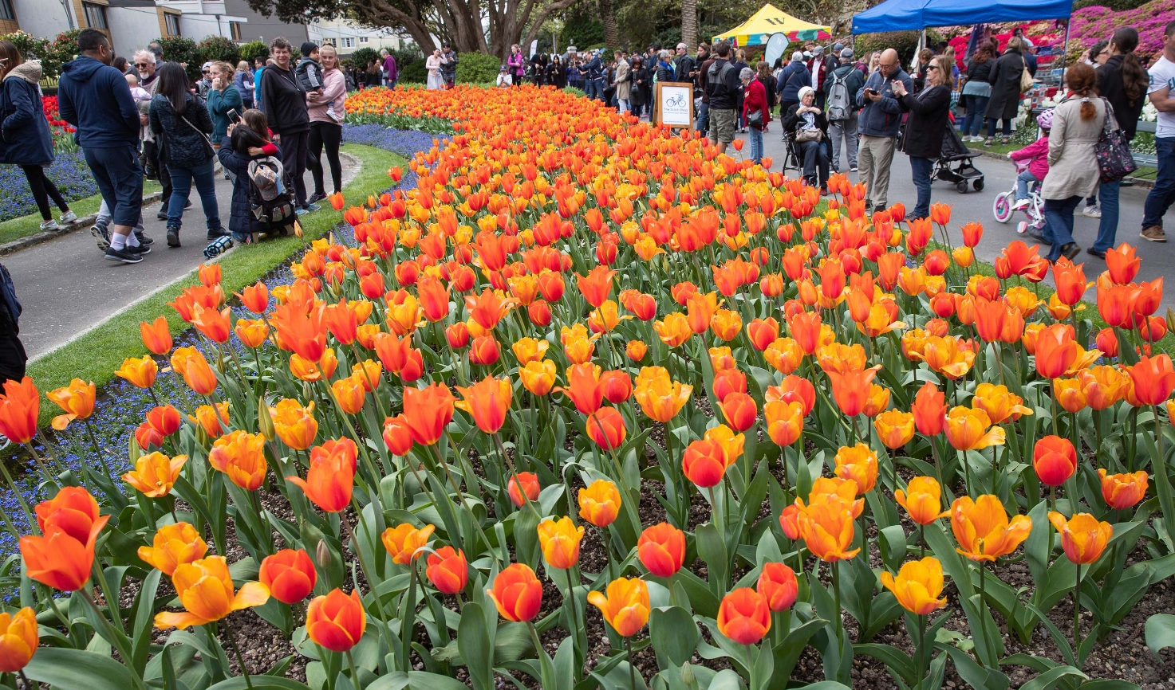

Indicators
Relevant indicators and trends for this outcome and its related priorities are presented below.

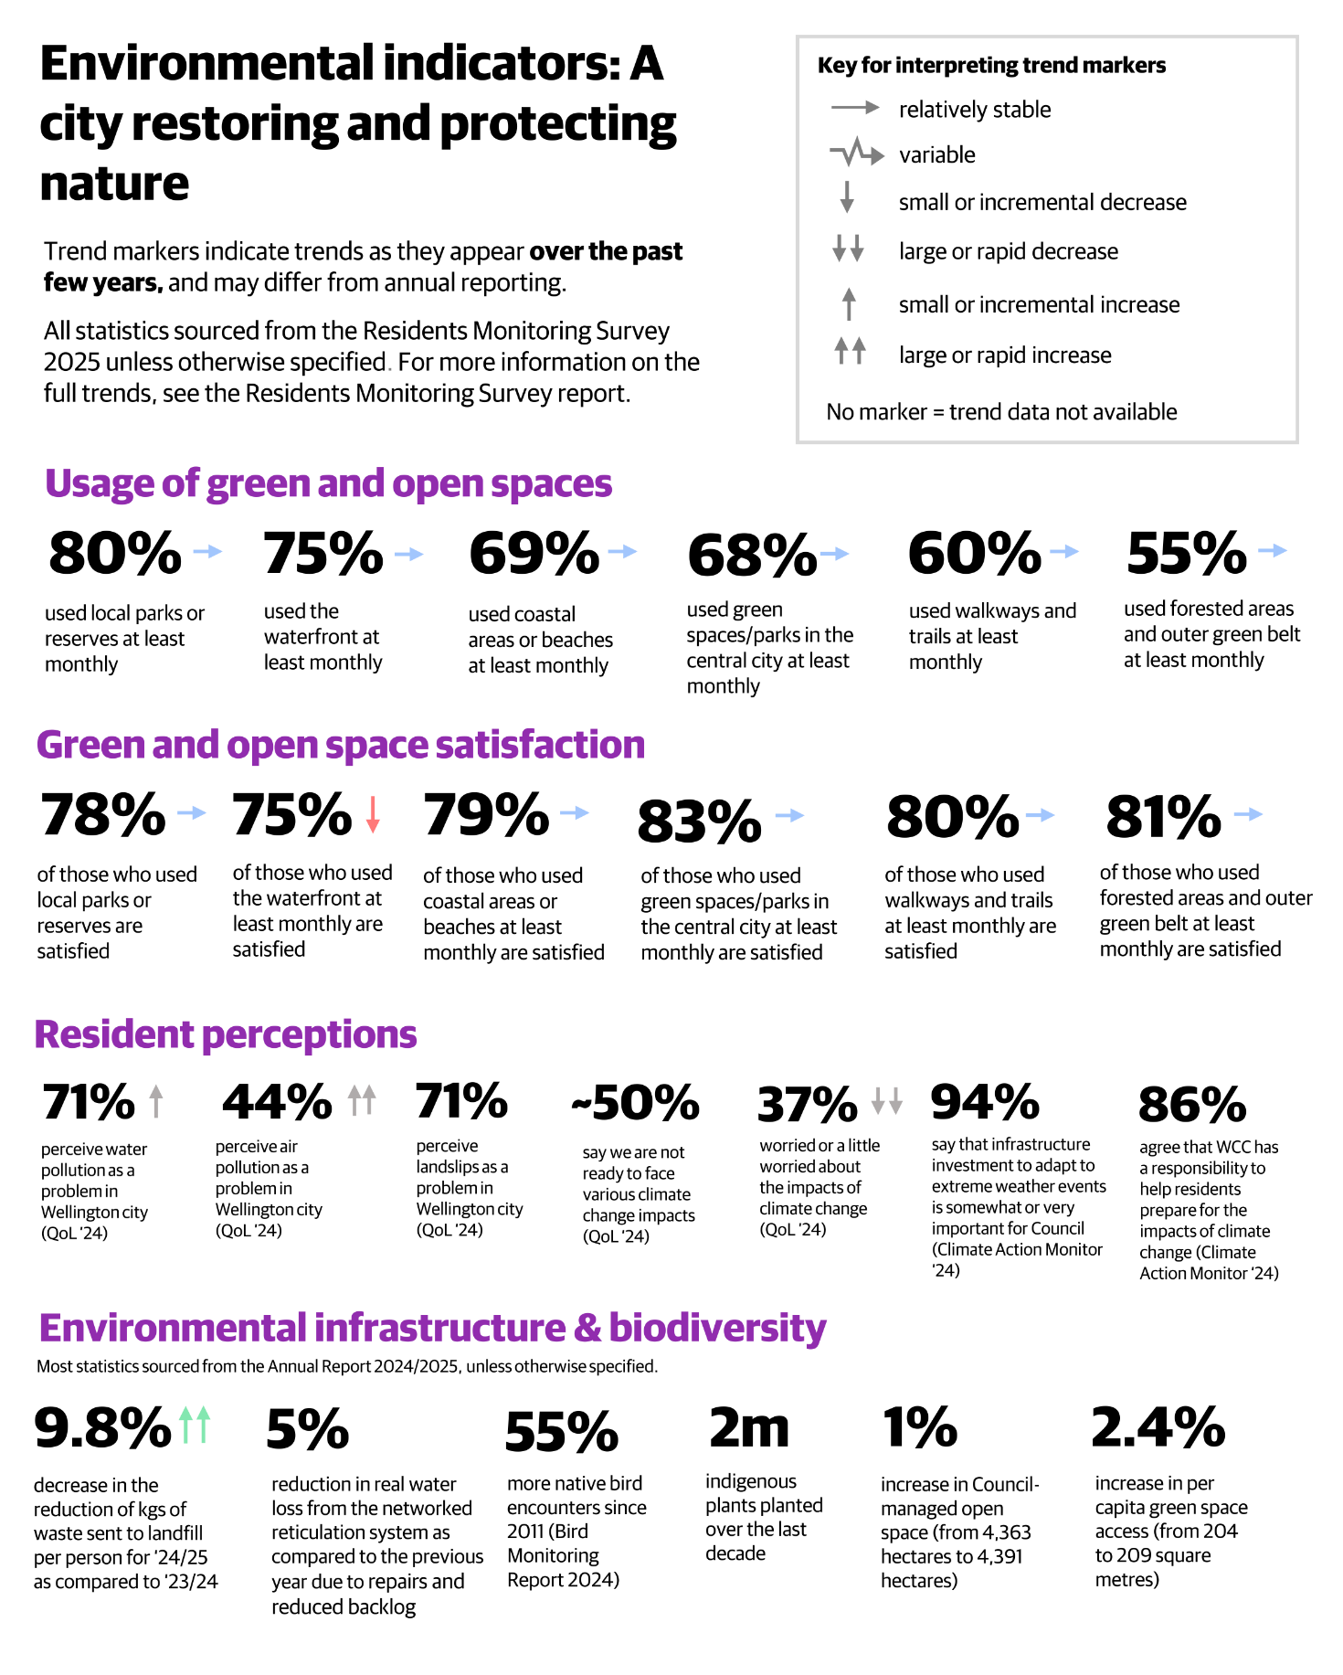

Stakeholder views on the environment
From the Community Sentiment 2023 report:
- Residents want stronger action on climate change: People believe more must be done to prepare Wellington for the impacts of climate change. There is widespread awareness of these challenges, and many feel the effects are already being experienced. Residents are calling for strong, decisive action from the Council to manage climate change risks.
- Wellingtonians value green and open spaces: City parks, reserves, and natural areas are highly valued for recreation, wellbeing, and environmental benefits; such as native planting, providing wildlife habitats, and acting as carbon sinks. There is a clear desire for these spaces to remain accessible, well-maintained, and plentiful, with concerns that development could put them under threat.
- People support sustainable initiatives, but not at any personal cost: While there is broad support for sustainability measures (like funding sustainable buildings and promoting carbon zero transport) many residents are reluctant to make personal sacrifices or bear additional costs to achieve these goals. Factors such as safety, resilience, and affordability often take priority in their decision-making.
- Residents want equitable access to green spaces: There is a strong call for green spaces in Wellington to be retained, well-maintained, and available for a wide range of uses, both active and passive. People want these spaces to remain accessible for all residents, recognising their varied uses and benefits.
- Concerns about Council action: Despite supporting sustainability in principle, many respondents feel that not enough is being done by the Council to address climate change and its impacts on Wellington. They want the Council to show leadership and take meaningful steps to ensure the city’s resilience and environmental wellbeing.

From the LTP 2024 and LTP 2024 amendment consultations:
Environmental wellbeing is a top priority for Wellingtonians, who value the city’s natural assets, biodiversity, and commitment to sustainability. Submissions call for urgent action to address climate change, protect waterways, and restore native habitats.

Submitters advocate for nature-based solutions, such as sponge city approaches, urban tree planting, and green infrastructure to manage stormwater and reduce flood risk. Community groups highlight the importance of supporting voluntary conservation efforts, environmental education, and partnerships with mana whenua. There is a call for Council to lead by example in reducing emissions, promoting active transport, and integrating environmental goals across all areas of planning and investment. Wellingtonians see environmental wellbeing as essential to the city’s resilience, liveability, and long-term prosperity. There is strong support for investment in water infrastructure to prevent pollution of streams, harbours, and the marine environment, with many residents expressing concern about sewage overflows and the health of Te Whanganui-a-Tara and Taputeranga Marine Reserve. Waste minimisation is also a key focus, with backing for kerbside organics collection, recycling, and the development of a circular economy.

Tākai Here partners’ priorities
In the Council’s Tūpiki Ora Māori Strategy, Outcome 1 aligns with this Community Outcome, The social, cultural, environmental and economic wellbeing of Māori communities is prioritised, supported and invested in. Tūpiki Ora outlines Mana Whenua aspirations “Environmental issues in our city require targeted resourcing, investment and strategy to support real change within communities. The Council, mana whenua, Māori and community groups will work together to support existing environmental initiatives and ensure there is a considered approach to addressing major environmental challenges for the next 10 years and beyond.”

Key issues for “A city restoring and protecting nature”

Maintaining access to nature and green spaces
Wellington’s parks, reserves, and natural areas are highly valued and contribute significantly to wellbeing, recreation, and biodiversity. However, maintaining equitable and high‑quality access to nature is becoming more challenging as the city grows. Gaps in green space provision persist, particularly in the central city and some suburbs such as Kilbirnie. Accessibility has declined for some residents, including those with limited mobility, highlighting emerging equity issues. Financial pressures, rising maintenance costs, and fewer visitors have affected affordability measures and increased the cost per visitor at key sites.

Ensuring fair access requires continued investment in inclusive design, targeted planning in areas of growth, and a balance between affordability, stewardship, and community expectations.

Biodiversity and nature-based solutions
Biodiversity is under strain across the world, with deforestation, wildlife populations plummeting, and 28% of all species assessed facing extinction. The 2019 Intergovernmental Science-Policy Platform on Biodiversity and Ecosystem Services (IPBES) Global Assessment warns that the Earth’s biodiversity and the benefits it provides are humanity’s most important life-supporting ‘safety net’, but this safety net is almost at its breaking point. Over 55% of the world’s population now lives in urban areas, a proportion projected to rise to 68–70% by 2050.

Biodiversity in Wellington is showing positive trends. Increased native bird sightings, large‑scale planting programmes, successful species translocations, and extensive pest control reflect meaningful progress. Community groups play a major role in restoration, and there is growing interest in nature‑based solutions for climate resilience.

At the same time, the current investment landscape is fragmented, and the overarching Biodiversity Strategy, Our Natural Capital, is outdated. Both the public and mana whenua have indicated that the Council’s direction is not clearly communicated. Ongoing pressures from urban development, climate change, and invasive species continue to affect ecological resilience.

While multiple initiatives are underway, limited integration, inconsistent monitoring, and unclear funding pathways constrain the ability to assess effectiveness and sustain long‑term biodiversity outcomes. Partnerships with mana whenua, schools, and community organisations are seen as key to fostering a culture of stewardship and shared responsibility for Wellington’s environment.

Waste reduction and a transition to a circular economy
Residents report high satisfaction with kerbside recycling and rubbish collection. However, stakeholders have raised concerns about rising costs and the lack of a city‑wide kerbside organics service. There is broad community backing for a circular‑economy approach, but progress is difficult to measure due to limited indicators showing behaviours such as reducing or repurposing waste.

Per‑capita landfill waste has fluctuated in line with economic conditions and construction activity rather than clear long‑term behavioural change. Key infrastructure, such as the sludge minimisation facility, is not yet operational. Achieving consistent, measurable waste reduction will require clear governance, reliable tracking, and a system‑wide network of resource recovery options.

Without improved measurement and coordinated investment, the city may find it difficult to meet its 2030 waste‑reduction target or demonstrate progress toward circularity.

Water infrastructure and waterway health
Wellington’s ageing water network continues to experience high leakage rates, despite recent improvements through the Leak Reduction Programme. Many pipes are beyond their intended lifespan, contributing to failures that can damage transport infrastructure and increase pollution risks in waterways.

Although real water loss has begun to decline, community concern is rising about the health of streams, rivers, lakes, and coastal areas. Persistent pressures and historic under‑investment mean that comprehensive network renewal will take decades.
The establishment of Tiaki Wai introduces a more integrated regional approach, but improving waterway health will also require strong collaboration with mana whenua, Greater Wellington Regional Council, and community environmental groups. There is also interest in expanding nature‑based stormwater approaches to improve resilience and reduce runoff impacts.

Cross‑cutting Issue: Need for an Integrated, Citywide Approach
Across green spaces, biodiversity, waste, and water, Wellington is making progress through individual programmes. However, these initiatives largely operate independently and are not yet functioning as part of a coherent, ecosystem‑based strategy.

Funding constraints, rising costs, and competing priorities have limited alignment across environmental programmes. This reduces the ability to prioritise investment, coordinate planning, and communicate a clear direction to the public and mana whenua.

Strategic Challenge for a city restoring and protecting nature:

Wellington is making progress across many individual environmental programmes, but these efforts are not yet operating as part of a fully integrated system.
Work on biodiversity, access to nature, waste reduction, and water infrastructure is advancing, yet each area is shaped by different funding pressures, regulatory demands, and delivery partners. This creates variation in pace, visibility, and clarity of direction, which can make it difficult for the public and mana whenua to understand how the Council’s environmental work fits together.

Environmental outcomes in Wellington are inherently interconnected: green‑space provision influences biodiversity; stormwater management affects waterway health; waste behaviours depend on available infrastructure; and nature‑based solutions span multiple activity areas. At the same time, rising maintenance costs, ageing infrastructure, climate impacts, and growth pressures place additional demands on Council services.

Together, these factors highlight a system‑level challenge: current planning and investment structures do not consistently reflect the interdependence of environmental outcomes, limiting the city’s ability to coordinate long‑term, resilient, and effective environmental stewardship.

How the council is responding
Wellington City Council is advancing a comprehensive approach to environmental stewardship, focusing on waste reduction, biodiversity enhancement, and improved water management. Through targeted investment, collaborative partnerships, and evidence-based policies, the Council aims to foster a resilient, inclusive, and sustainable urban environment for all residents.
Examples include:
- Developing robust infrastructure and governance to support long-term waste reduction, moving away from a linear “take, make, dispose” model toward a circular economy that emphasises reuse, sharing, durable product design, material recovery, and responsible recycling.
- The Council has made progress in reducing real water loss, signalling effective oversight and strategic direction in resource stewardship. The Council is working with partners such as mana whenua, Greater Wellington Regional Council (GWRC), and community groups to improve waterway habitats and restore river health, as demonstrated by initiatives like Zealandia Te Māra a Tane’s Kia Mouriora Te Kaiwharawhara project.
- With the transition of water infrastructure management to Tiaki Wai, the Council retains a governance role. The Council also retains responsibility for overland stormwater management, including on roads and through parks, and ensuring freshwater quality. This emphasises a need for improved communication, stakeholder engagement, and clear articulation of roles and responsibilities in water protection.
- Investment in parks, reserves, walkways, and other green spaces, working closely with community partners to improve inclusivity and accessibility, especially for disabled residents and those in rapidly growing neighbourhoods.
- Actively supporting projects like Predator Free Wellington and the Capital Kiwi project, which contribute to pest eradication, native species protection, and biodiversity restoration.
- Wellington is implementing nature-based solutions such as rain gardens and low-mow park areas to support biodiversity and climate resilience. While these initiatives are underway, the Council acknowledges the need for improved tracking and evaluation to better understand their effectiveness and impact.

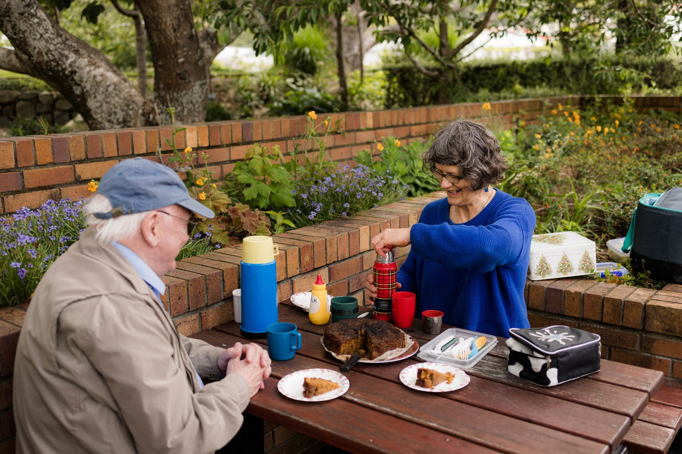

Engaging our community
As a core function of the Council, engagement is embedded throughout its strategic documents and work programmes. Engagement is present both in the development of strategies (where community and stakeholder views help shape priorities and direction) and in their delivery (where ongoing relationships, feedback, and participation support effective implementation and continuous improvement). Because of this, engagement is not a standalone activity, but rather, a way of working that influences how Council plans, makes decisions, and delivers services.

One form of engagement that is used to help shape decisions early on is the Advisory Groups. Their views have been described in the city context section.

Stakeholder views on engaging the community
From the Community Sentiment 2023 report:
- Engagement with the Wellington community is seen as essential for shaping a city that reflects the needs and aspirations of its residents.
- Wellingtonians want engagement to be meaningful, inclusive, and responsive, ensuring all voices are heard and everyone can contribute to the city’s future.

From the LTP 2024 and LTP 2024 amendment consultations:
- Engagement with the community is seen as fundamental to good decision-making and building trust in Council processes. Submissions emphasise the need for transparent, inclusive, and meaningful consultation, especially on major projects and changes to services.
- Many residents express consultation fatigue and scepticism about whether feedback is genuinely considered, calling for clearer communication about how input influences decisions. There is strong support for diverse engagement methods, including hui, online platforms, and targeted outreach to underrepresented groups such as young people, disabled people, and ethnic communities.
- Submitters highlight the value of co-design, partnership with mana whenua, and the involvement of community organisations in shaping policies and projects. The importance of accessible information, plain language, and proactive communication is stressed, along with the need for ongoing dialogue rather than one-off consultations.
- Wellingtonians want to see their voices reflected in Council decisions and for engagement to lead to tangible outcomes that benefit the whole community. Building trust and fostering active citizenship are seen as key to achieving the city’s vision and responding to future challenges.

Key issues for “Engaging our community”
Recent findings from the 2025 Council Residents’ Monitoring Survey and Audience Sentiment Research highlight several strategic concerns for Wellington City Council regarding public engagement, trust, and representation. These issues are deeply interconnected and have significant implications for the city’s governance, social cohesion, and ability to deliver on community outcomes.

Engagement with Council processes is uneven across the community. It is higher among older residents, homeowners, highly educated and higher‑income groups, and those with dependent children or accessibility concerns, while lower among renters, younger people, students, and those with lower educational attainment. As a result, some groups remain underrepresented in Council consultations.

Ensuring that Council governance structures and processes consistently include and value mātāwaka voices is a key issue. Authentic partnership, embedding Māori perspectives in all Council mahi, and upholding Te Tiriti o Waitangi principles are essential for building trust and strengthening relationships with all Māori communities in Wellington.

How the council is responding
In response to these challenges, Wellington City Council is moving away from transactional, project-specific consultations towards a more inclusive, relationship-based engagement model. This strategic shift aims to foster ongoing, authentic dialogue with all community segments, especially those previously marginalised. Initiatives such as He Ara Mātāwaka exemplify this approach, prioritising partnership-based Māori engagement and the establishment of culturally safe Māori hubs. Organisational changes, including dedicated engagement functions and enhanced digital platforms, are being implemented to support consistent and effective interaction with the community. The initial testing of a changing approach was through the Citizen’s Assembly as part of the 2024 LTP development.

This move towards partnership-driven, community-led engagement, is aimed at fostering ongoing reciprocal relationships and establishing culturally safe spaces to enable sustained engagement.

Value for money and effective delivery
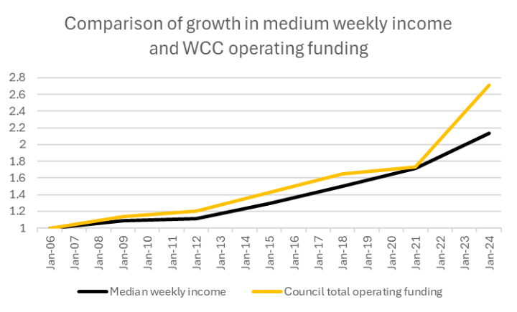
The Council is facing significant cost pressures, particularly in relation to the management of its assets. Alongside this the community and Elected members have expressed concerns as to the continued affordability of Council services as a result of recent and forecast rates increases. The chart illustrates this concern through the recent uplift in Council’s operational funding compared to incomes.

Alongside this affordability concern, the Council is also at or exceeding its self-imposed debt limits meaning availability of capital expenditure is diminishing with a need for greater level of trade-offs and prioritisation. These pressures are likely to continue into the foreseeable future as public infrastructure, particularly three waters, requires significant investment uplift over an extended period of time.

In this environment a focus on value for money is essential to be able to ensure that the Council is maintaining services in a way that maximises affordability for rate payers and users and makes the best use of constrained borrowing capacity.

Value for money indicators
There are limited indicators related to value for money in the Council. One metric available, on use of IDF practices for project investments, is shown below. This is not a direct measure of value for money, but an indirect measure as IDF practices are designed to ensure scrutiny of investments for value for money.

Self-reported compliance statistics with IDF stage gates for Significant Projects are as below. Note this records the self-reported completion of approved investment documentation, not the quality of that documentation. At the point of progressing to the next stage of the IDF:
- 25% of projects report not having an approved Project Brief
- 23% of projects report not having an approved Business Case
- 37% of projects report not having an approved Project Management Plan

These measures, if accurate, show weak adherence to core project investment requirements. Note that lower levels of adherence to early project investment decision processes reflect the historical reliance on LTP and Annual Plan processes for project decision making (approval processes will have been used but not core IDF disciplines).

The main residents monitoring question relevant to value for money is shown below.
RMS Question | 2021 | 2022 | 2023 | 2024 | 2025
Agreement that Wellington City Council makes decisions that are in the best interests of the city | 17% | 17% | 22% | 21% | 23%

Stakeholder views on value for money
From the Community Sentiment 2023 report:
- Value for money is a recurring theme in Wellingtonians’ feedback, particularly regarding Council spending and rates. Many residents express concern about ongoing rates rises and the increasing cost of living, preferring cost savings or alternative funding sources for Council initiatives. There is a clear expectation that the Council should deliver essential services efficiently and prioritise spending on critical infrastructure, such as water and housing, over less urgent projects.
- Opinions on Council budgets and annual plans are mixed, with a significant proportion of respondents feeling neutral or unsure about whether they support current spending priorities. Negative opinions are often driven by concerns about rates rather than opposition to specific initiatives. Residents support the idea of reviewing funding grants to ensure they deliver the best outcomes for community wellbeing and are wary of costs being passed on through higher rates. Affordability is also a concern in areas such as housing, recreation, and access to cultural events, with calls for more low-cost or free options.
- Overall, Wellingtonians want transparency, accountability, and prudent financial management from their Council, ensuring that public funds are used wisely and deliver tangible benefits for the community.

From the LTP 2024 and LTP 2024 amendment consultations:
- Value for money is a recurring theme in submissions, with residents and organisations urging the Council to focus on core services, prudent financial management, and transparent decision-making. There is widespread concern about rising rates, debt levels, and the affordability of proposed investments. Many submitters call for a root-and-branch review of Council spending, prioritising essential infrastructure such as water, transport, and housing over “nice to have” projects.
- There is support for deferring or scaling back non-essential capital works, reducing operational costs, and exploring alternative funding sources, including user charges and partnerships. Submitters stress the importance of clear cost–benefit analysis, robust business cases, and regular reporting on project outcomes. The need for accountability, independent oversight, and community input into budget decisions is highlighted, with calls for the Council to demonstrate how it is delivering value for ratepayers.
- Wellingtonians want assurance that their money is being spent wisely, with a focus on long-term sustainability, equity, and the delivery of high-quality services that meet the needs of all residents.

Key issues for “Value for money”
Wellington City Council is operating in a challenging financial environment, marked by significant cost pressures, asset management complexities, and rising community concerns about the affordability of council services. These pressures are compounded by the need to maintain essential infrastructure; particularly the three waters (drinking water, wastewater, stormwater) which require substantial investment over an extended period. Wellington City Council’s ability to deliver value for money and effective services is shaped by strategic concerns around financial sustainability, asset management, organisational performance, and governance. Addressing these interconnected issues is critical for maintaining public trust, ensuring affordability, and securing the city’s long-term resilience.

Escalating costs and funding shortfall threaten core services
The Council faces rising operational costs, a growing asset base, and constrained funding. Maintenance and renewal budgets have not kept pace with asset expansion, resulting in deferred maintenance and underinvestment. External factors such as escalating construction and insurance costs, economic uncertainty, and a tight labour market further intensify these pressures.

Community feedback consistently highlights concerns about rates affordability and the limited capacity of households and businesses to absorb further increases. Underinsurance of Council assets is estimated at $1.8–$2.6 billion, and reliance on uncertain external funding for key projects compounds financial vulnerability.

These conditions increase the risk that service reliability, quality, and scope could be reduced over time. Deferred maintenance and under‑investment may constrain future infrastructure investment and emergency response capacity, with implications for liveability, economic development, and public trust.

Debt constraints and weak project investment discipline threaten value
The Council is at or exceeding its self-imposed (to ensure buffer in case of emergencies) debt limits. As a result, capital expenditure capacity is diminishing and trade‑offs between investments are increasingly necessary.

In this constrained environment, evidence of value for money is limited. Indicators show weak adherence to Investment Delivery Framework (IDF) stage‑gate requirements for significant projects, suggesting inconsistent application of core investment discipline. These gaps reduce assurance that scarce capital is being allocated to projects with the strongest strategic and financial case.

Opportunity to evolve from budget management to performance management
There is a significant opportunity to evolve the Council’s organisational culture from a focus on budget management to one that prioritises performance management and strategy execution. Shifting to performance management means setting and tracking strategic KPIs, regularly reporting outcomes, and focusing on results over spending. This approach boosts accountability, supports service improvement, enables responsive decision-making, and better aligns resources with organisational goals.

Expanding the performance framework would provide greater insight into value for money, enabling decisions to be contextualised against objective organisational performance targets. Strengthening project and programme investment practices, embedding cost-benefit analysis, and elevating commercial management discipline are essential for delivering better service, reducing risks, and achieving cost savings.

Strategic planning hampered by limited data and constraints
Annual and long-term planning processes currently struggle to enable strategic prioritisation at a service or asset level, hindered by limited cost-to-serve information and statutory constraints. Improvements include building greater capacity and capability in service and asset planning, investing in analytical tools, and implementing targeted capability-building programmes.

Operational efficiencies can be realised by removing duplication and embracing innovation, such as consolidating contracts or automating services. The Future Fit Pōneke report identifies potential savings of up to 10% in operational costs.

Appendices

Appendix 1: Wellington City demographics and outcome statistics

See on next page.
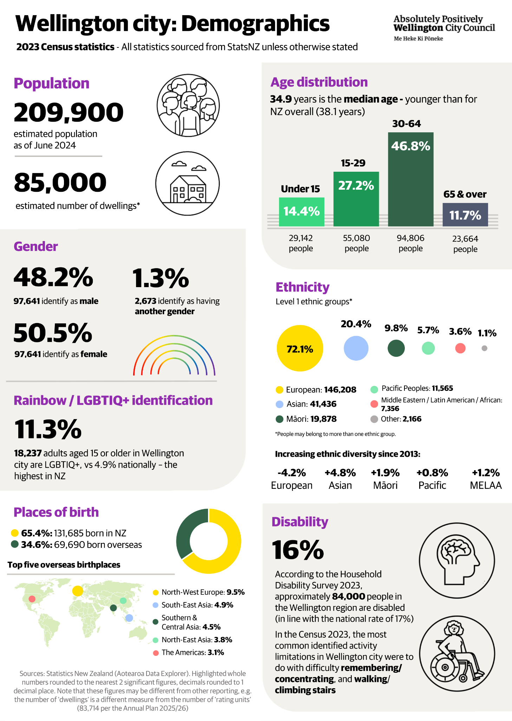
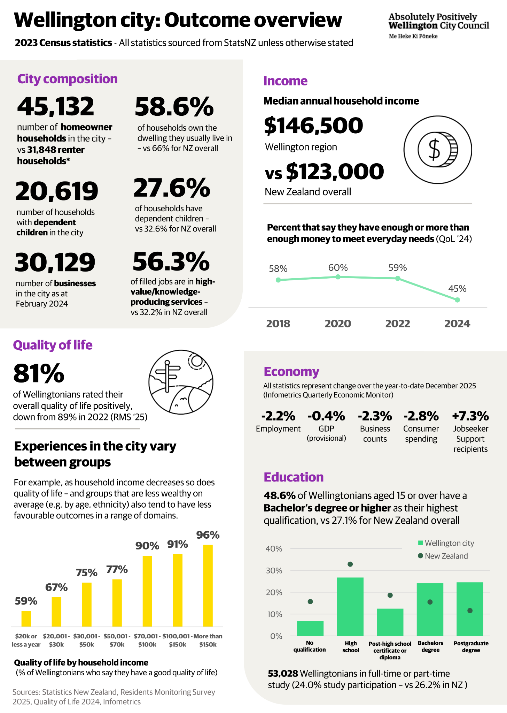

Appendix 2: Residents’ sentiment
Previous research among residents of Wellington City has shown concerns with Council decision making overall performance and low levels of trust (Residents Monitoring Survey (RMS) and Quality of Life survey). Recent research with the community has focused on residents’ awareness, perceived importance and perceived performance of our services. The research gathers views of 34 distinct services or functions provided by Council.
Services with the highest awareness amongst respondents (90%+ said they were aware Council provided these services) included: waste/rubbish/recycling services, public parks, reserves, and gardens, water services, library services, public toilets and changing rooms, parking, bike infrastructure / cycleways, pedestrian infrastructure / footpaths.

All services were seen as relatively important (73%+ said it was “very important or “somewhat important” for Council to provide these services, except “bike infrastructure”).

The services respondents saw as the most important (70%+ “very important” rating) included water services, waste/rubbish and recycling services, city safety, general transport network maintenance, and vehicle infrastructure.

All services were given a perceived “performance score” (score out of 5, which represents resident satisfaction with Council performance in relation to a given function/service area). These ranged from 3.9 for Library services, down to 2.5 for parking. Of particular note is that the overall performance rating in this survey was 2.65, which was lower than the performance rating for 33 of the 34 services asked about (only parking had a lower rating) – suggesting that perceptions of overall council performance may be influenced by something other than satisfaction with service performance.

Further exploration of perceived importance versus performance from this survey showed some interesting insights, particularly with respect to our “high awareness” services (15 services with 85%+ awareness). This data (graphed below) showed three clear groupings – our high performing front-line services (circled in green), our high importance but lower performance infrastructure (circled in orange) and our lowest performing services (circled in red).

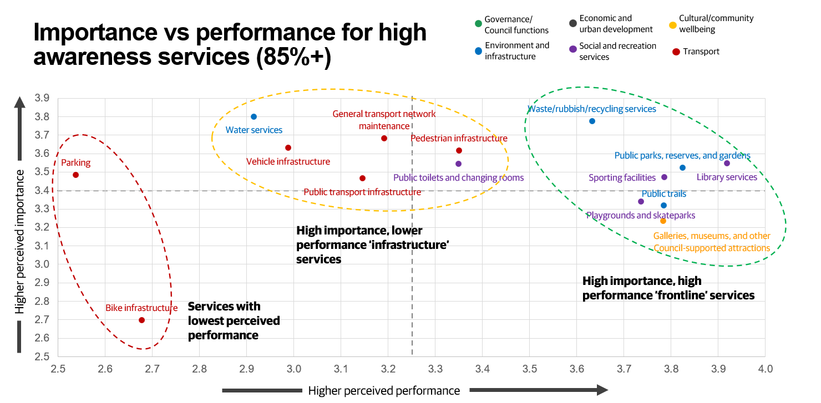
This survey highlights the complexity of resident perceptions regarding Council performance. The overall views of residents are influenced by more than just the range of services provided. Key findings include:
- There is a tendency for residents to hold unfavourable views of overall Council performance, which may not directly relate to their opinions on the performance of individual services.
- Low performing services often come to mind first when residents consider Council performance, potentially shaping their overall impression.
- Residents may focus less on specific service delivery and more on broader issues, such as rates, Council decision making, and the key priorities set by the Council.
- Previous Residents Monitoring Survey (RMS) results support these insights, with respondents frequently citing rates, decision making, and Council priorities as main reasons for dissatisfaction with overall performance.

Appendix 3: Advice from the citizens assembly
The Citizens’ Assembly provided Wellington City Council with ten core pieces of advice for shaping the 2024–34 Long-term Plan. Their advice is provided in a report. Here's a summary of their key recommendations:
- Diversify Revenue Streams
- Reduce reliance on rates by exploring alternative funding sources.
- Advocate for legislative changes to allow new revenue options.
- Consider partnerships and investments to supplement income.

- Review Capital Expenditure
- Prioritise spending based on utility, safety, and access.
- Spread capital investment over a longer timeframe to match available funds.

- Prioritise Existing Assets
- Focus on maintaining and optimising current assets before acquiring new ones.
- Choose cost-effective maintenance strategies with long-term value.

- Increase Green Spaces
- Repurpose underused Council buildings and land into green spaces where practical.
- Consider climate and health benefits in urban planning.

- Engage Communities in Open Space Management
- Use community volunteers to help maintain parks, walkways, and reserves.
- Promote biodiversity and local ownership of green spaces.

- Re-evaluate Heritage Criteria
- Prioritise sustainability, safety, and housing needs over aesthetic preservation.
- Consider climate resilience and population growth in heritage decisions.

- Support Medium to High-Density Housing
- Advocate for infrastructure that enables denser housing.
- Repurpose vacant buildings (e.g., offices) into residential spaces.

- Improve Community Funding and Collaboration
- Strengthen relationships with funded groups to improve allocation.
- Facilitate collaboration and reduce duplication among community services.
- Increase visibility of Council-funded services.

- Maintain Grant Funding with Inflation Adjustments
- Ensure community grants keep pace with cost of living.
- Include mana whenua (Tākai Here partners) in funding decisions to uphold Te Tiriti o Waitangi.

- Enhance Council Processes
- Develop more inclusive and engaging planning processes.
- Reduce costs from poor planning and rework.
- Continue supporting advisory groups and consider ongoing citizen involvement.

Appendix 4: Key facts relating to accessibility

Some key facts relating to disability include:
- Globally, about 1.3 billion people (16%) are disabled, according to the World Health Organisation. In Aotearoa New Zealand, the 2023 Household Disability Survey (HDS) reports one in six people (17% – 18% of adults, 10% of children) are disabled; approximately 73,000–95,000 in the Wellington region.
- Disability rates across New Zealand are higher for women (18%, vs 15% of men) and rainbow communities (29%, vs 17% of non-rainbow people). Disability rates also differ by ethnicity – with Māori for example having a noticeably higher disability prevalence (21% overall, 24% of adults, 14% of children), and Asians having a noticeably lower disability prevalence (9%).
- Disability likelihood increases with age; 35% of those aged 65+ as compared to the national average of 17%. Wellington’s population is ageing, with those aged 60+ projected to increase by about 3% over the next 30 years.
- According to the Census 2023, the most common activity limitations for people in Wellington City are related to cognition (difficulty remembering or concentrating), and mobility (difficulty walking or climbing steps).
- Disabled people in Aotearoa New Zealand continue to face barriers such as lower incomes and employment, poorer housing outcomes, higher exposure to crime or discrimination, and unmet needs for equipment, education, or workplace support.
- Mobility parking data shows 4,559 active permits in Wellington City (4,265 long-term, 294 short-term), and 15,516 across the wider region. Suburbs with the highest numbers include Tawa (around 400), Karori, Miramar, and Johnsonville (around 300 each).

The Tākai Here partnership agreement was signed in 2022, establishing a shared commitment to partnership between Wellington City Council, Te Rūnanga o Toa Rangatira, Taranaki Whānui ki Te Upoko o te Ika / Port Nicholson Block Settlement Trust, Te Rūnanganui o Te Āti Awa ki te Upoko o Te Ika a Māui.
Wellington Transport Analytics Unit. (June 2025). RLTP 2027 – State of Transport Network. Prepared for Greater Wellington Regional Council.
Statistics New Zealand. (2023). Aotearoa Data Explorer: Census 2023.
Infometrics. (2025). Regional Economic Profile.
The Quality of Life Project. (2024). Quality of Life Survey 2024.
The Quality of Life Project. (2024). Quality of Life Survey 2024.
The Quality of Life Project. (2024). Quality of Life Survey 2024.
Global Research. (June 2023). Wellington Community Sentiment – informing the 2023 Long Term Plan. Report prepared for Wellington City Council.
Wellington City Council. (June 2025). Residents monitoring survey
Hammonds. (2023). Culture and democracy: The evidence. European Union.
Wellington City Council. (June 2025). Residents monitoring survey
In the WCC Resident’s Monitoring Survey, ‘disabled people’ means people with at least one activity limitation as per the Washington Group short set of functioning (which is also used by Statistics New Zealand in the Census 2023). The activity areas assessed were: seeing, hearing, walking, remembering or concentrating, washing all over/dressing, and communicating.
In the Quality of Life Survey 2024, Asian Wellingtonians are less likely than others to agree that people in the area accept or value them and others of their identity (73%, vs 80% for the city overall). In the Resident’s Monitoring Survey, when combining data from 2020-2025 (unweighted, data combined due to the low Pacific sample size), Pacific Wellingtonians are less likely to feel welcome or included in cultural events and activities in Wellington as compared to non-Pacific Wellingtonians (47%, vs 65%).
In the Quality of Life survey 2024, people of Māori descent and disabled people both being more likely to report experiencing at least one form of discrimination in the (42% for Māori and 49% for disabled, vs 26% overall). Around one in five Māori and Asian people reported having had a personal experience of anger, intolerance, or having been treated unfairly in the city on the basis of ethnicity (18% and 23% respectively), as did young people on the basis of age (21% of under 25 year olds), disabled people on the basis of physical or mental health condition (25%), and rainbow people on the basis of sexual orientation (23%).
For example, in the Resident’s Monitoring Survey 2025, disabled Wellingtonians are less likely than non-disabled Wellingtonians to report using certain public spaces/facilities such as open spaces or pools. In the In the In the Alcohol Attitudes and Behaviours in Wellington survey 2024, rainbow young people are more likely report experiencing harms due to alcohol in the city as compared to non-rainbow young people (Wellington AABS 2024). In the Quality of Life Survey 2024, Māori as well as young Wellingtonians and disabled Wellingtonians are more likely to report feeling frequently lonely (Quality of Life 2024) – and so on.
The Quality of Life Project. (2024). Quality of Life Survey 2024.
Downtown Community Ministry. (2025). Homelessness insights, June 2025. Ministry of Housing and Urban Development.
The Quality of Life Project. (2024). Quality of Life Survey 2024.
The Quality of Life Project. (2024). Quality of Life Survey 2024.
World Health Organisation Commission on Social Connection. (2025). From loneliness to social connection: Charting a path to healthier societies.
Wellington City Council. (June 2025). Residents monitoring survey
Gluckman & Sridhar. (September 2025). Social cohesion: New Zealand’s precious and fragile asset. Koi Tū Centre for Informed Futures.
Wellington City Council. (June 2025). Residents monitoring survey
The Quality of Life Project. (2024). Quality of Life Survey 2024.
See Appendix 2
Wellington City Council. (June 2025). Residents monitoring survey.
Infometrics. (September 2025). Quarterly Economic Monitor for Wellington City.
Statistics New Zealand. (2023). Aotearoa Data Explorer: Census 2023.
Wellington City Council. (June 2025). Residents monitoring survey.
New Zealand Police database: ”National Alcohol Harm Viewer” via direct request (OIA IR-01-24-31450)
Truwind Research. (September 2024). Understanding demand for entertainment in the Courtenay Precinct. Wellington City Council.
Truwind Research. (September 2024). Understanding demand for entertainment in the Courtenay Precinct. Wellington City Council.
Wellington City Council. (2024). Pōneke’s premiere place to play: Courtenay Precinct investment prospectus 2024.
Aecom (September 2025). Wellington City GHG Emissions Inventory 2025. Report prepared for Wellington City Council.
Wellington City Council. (June 2025). Residents monitoring survey.
Wellington City Council. (June 2025). Residents monitoring survey.
Wellington City Council. (2025). Te Atakura First to Zero: Update 2025.
State and trends in the diversity, abundance and distribution of birds in Pōneke / Wellington City
The Residents Sentiment research gathered feedback from a sample of 780 Wellingtonians using an online survey (similar to the process used for our RMS). The sample was gathered via an external panel provider Dynata who provide market research services to a wide range of public and private clients across New Zealand and the world. The survey targeted a representative sample of Wellingtonians (based on age, gender and ward) with quotas based on Census 2023. Data was post weighted to align the final data with the population proportions for each age gender and ward group in Wellington City.
The Citizens’ Assembly was a group of 42 Wellington residents, selected to reflect the city’s diversity, who met over four Saturdays in 2023 to advise on priorities for the Council’s 2024–34 Long-term Plan. They provided a collective view on which services should be prioritised, balancing community benefits with delivery costs. - Phase 2: Citizens' Assembly - Let's Talk

