Kia ora,

We would like to inform you about a proposed change in your neighbourhood.

Proposal:

Reference | - TR07-26 Wanaka Street, Johnsonville - Stop control
Location – where we propose to make the change | Wanaka Street intersection with Moorefield Road, Johnsonville
What we’d like to do | - Convert the layout of the existing give way controlled intersection into a stop controlled intersection.
Why we are proposing the change | - Council have received safety concerns from residents regarding the intersection of Wanaka Street and Moorefield Road.  - The request from the public outlined concerns that the intersection is dangerous due to the busy nature of this intersection including bus stops and the pedestrian crossing.  - Officers have assessed the sight distance at this intersection and found that the lack of visibility on the approach to this intersection due to nearby properties meets the criteria for a stop-controlled intersection.  - To improve safety at this intersection, we are proposing to convert the existing give way control into a stop control.  - This proposal is part of a wider safety assessment of this area.
Impact | Improvements  - Improves safer turning movements  Net Parking Impact  - No Change  Pedestrian impact  - Positive, as it allows for safer pedestrian crossings.
Additional Information | - Average daily traffic count – 350 vehicles on Wanaka Street, 12718 vehicles on Moorefield Road.  - An electronic copy of the report will be available on the Council’s website from 9.00am Wednesday the 14 January 2026 at https://www.letstalk.wellington.govt.nz/
Privacy | - Your privacy is important to us. Please DO NOT add specific personal details to your feedback (i.e.: full name, address, etc)  - What we do with your personal information:  All submissions (including your first name, but not contact details) are provided in their entirety to elected members and made available to the public on our website and at our office. Personal information (including contact details) will also be used for the administration of the consultation process including informing you of the outcome of the consultation. All information collected will be held by Wellington City Council, 113 The Terrace, Wellington, with submitters having the right to access and correct personal information.  - For more information regarding our Privacy Statement please check our webpage: Privacy statement - Wellington City Council.
Feedback | - If you would like to provide us with specific feedback, which will be added to the Traffic Resolution following consultation and made public in full, you can do so by filling out an online submission form, downloading a printable submission form on https://www.letstalk.wellington.govt.nz/ or emailing us at trfeedback@wcc.govt.nz.  Please note if you are giving feedback the consultation period opens at 9.00 am Wednesday the 14 January 2026 finishes at 5.00 pm Thursday the 29 January 2026.
Next Steps | - Feedback collated by Friday the 30 January 2026.  - The proposal will go to the Te Takere|Regulatory Processes Committee meeting on Wednesday the 4 March 2026.  - If approved, the proposal will be installed within the following six months.

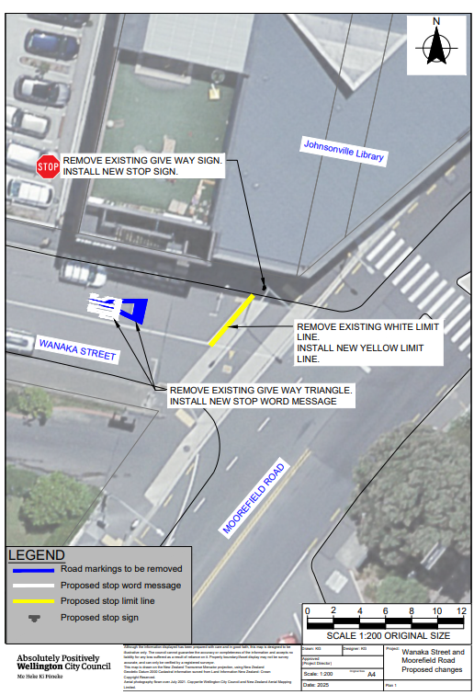
Traffic Resolution Plan: TR07-25 Wanaka Street and Moorefield Road, Johnsonville - Stop Control

Legal Description:

Add to Schedule G - Give Way and Stop Control of the Traffic Restrictions Schedule

Column One | Column Two | Column Three
Street name | Stop Control | At its eastern approach to its intersection with Moorefield Road.

Prepared By: | Kaylie Gleeson | (Intermediate Transport Engineer)
Approved By: | Kate Gourdie | (Team Leader Traffic & Resolutions)
Approved Date: | 19/11/2025

