Kia ora,

We would like to inform you about a proposed change in your neighbourhood.

Proposal:

Reference | TR63-26 Thorndon Quay, Pipitea – Amendment of Legal Descriptions
Location – where we propose to make the change | - Thorndon Quay from Featherston St to the intersection with Tinakori Road.  - Hutt Road from the intersection with Thorndon Quay and Tinakori Road to the Hutt Road Overbridge.  - Featherston Street from Bunny Street to its intersection with Mulgrave Street.  - Stout Street on the northern end at its intersection with Bunny Street and Featherston Street.
What we’d like to do | Traffic Resolution TR141-24 was approved by the Regulatory Processes Committee (RPC) on 14 November 2024 (link to TR found here: Regulatory Processes Committee 14 November 2024 ).  Following the completion of the Thorndon Quay project, some discrepancies were identified in the legal descriptions associated with the approved resolution.  This proposal seeks to amend TR141-24 to ensure the legal descriptions reflect the intended restrictions within the corridor, while also making minor adjustments to the parking restrictions in response to stakeholder feedback during implementation. The changes involve:  - Amend the legal description of the Time Limited Parking, Class Restricted Parking, Metered Parking, Metered Mobility Parking, No Stopping Lines and Cycleway.  - The west (north bound) afternoon peak Bus Lane on Thorndon Quay and Hutt Road hasn’t been implemented, references to this Bus Lane have been removed from the legal descriptions. The removal of the Hutt Road afternoon peak, northbound Bus Lane was withdrawn and fully cancelled through the Long-Term Plan to save costs in early 2024. The Council also endorsed delaying the operationalisation of the part-time northbound bus lane on Thorndon Quay to give local businesses time to adjust to the recent changes and to conduct further reviews while other major upgrades on Thorndon Quay (such as the bi-directional cycle path and the southbound Bus Lane were completed. The afternoon peak northbound Bus Lane can be reassessed and added back in a separate Traffic Resolution if Council decide to implement it at a later date.  - Relocate the Motorcycle Parking ‘At All Other Times’ at 38 Thorndon Quay on the east side (Capital Gateway) and relocate it to the west side of the road. Increase length by 1m from 5m to 6m in length and restriction updated to ‘At All Times’.  - Relocate Metered Parking P120 Mon to Fri, 8am-6pm, P180 Sat to Sun 8am-6pm near 49 Thorndon Quay on the west side (just south of Pipitea Marae) and relocate to the west side of the road near 38 Thorndon Quay (Capital Gateway).  - Move P10 Loading Zone and Mobility Park north by 1m at 38 Thorndon Quay on the east (Capital Gateway) to accommodate the relocation of the Motorcycle Parking and replacement with 1 x Metered Parking space P120 Mon to Fri, 8am-6pm, P180 Sat to Sun 8am-6pm.  - Remove the P10 Loading Zone to the north of the entrance to Capital Gateway (opposite 89 Thorndon Quay on the east side of Thorndon Quay). Convert to No Stopping Lines in this location to improve visibility between drivers, cyclists and pedestrians.  - Remove the P10 Loading Zone at 103 Thorndon Quay and convert to 2x P30 Monday to Friday 8am – 6pm Time Limited parking spaces and P180 Saturday and Sunday 8am – 6pm Metered Parking spaces to support businesses by increasing the time limit.  - Remove 2x Metered Parking spaces on the east side of the Thorndon Quay to the south of the intersection with Davis St and convert to No Stopping Lines to improve the visibility of vehicles exiting Davis St onto Thorndon Quay.  - Relocate 1x Metered Mobility Parking space and 1 x Metered Parking space opposite 268 Thorndon Quay on the east side and relocate them 39.5 m further north to improve sightlines for vehicles exiting an existing loading dock. This will make space for the nearby loading zone to be relocated further south to the existing Metered Mobility parking space and Metered Parking space improving sightlines to the north from the adjacent loading dock.  - Remove the existing P10 Loading Zone opposite 278 Thorndon Quay on the east side and relocate it to the south by 39.5m. Convert the existing P10 Loading Zone to 1x metered car park and 1 x Metered Mobility Park. Overall length of Loading Zone will reduce from 16.4m to 13.6m.  - Remove 1x Metered Mobility Parking space and convert to 1x Metered Parking Space opposite 278 Thorndon Quay on the west side. This Metered Mobility parking space does not service any nearby businesses as there are no businesses on the west side of the road in this location. There is a Metered Mobility Park directly opposite on the east side of the road outside businesses. This change is in response to nearby business observations for how the parking is working and what is required. An adjacent business also has their own designated Mobility parking space on their land, accessible to customers.
Why we are proposing the change | - In response to feedback from stakeholder engagement during the construction phase of the project.  - To reflect the western side (north bound) Bus Lane not being implemented on Thorndon Quay and Hutt Road.  - To improve accessibility along the route particularly for people who use loading zone and P30 and P10 parking.  - To formalise the existing restrictions to ensure the legal descriptions are accurate.  - To improve visibility between drivers, pedestrians and cyclists in some locations.
Impact | Improvements  - Improved levels of service for bus users including improved access, journey times and reliability. Provides sufficient capacity for growth in public transport.  - Improved levels of service and reduces the safety risk for people walking and cycling along and across Thorndon Quay and Hutt Road.  - Improves sight lines to the road carriageway from 1 x driveway and 1 x side road onto Thorndon Quay  - Improves loading logistics for businesses and their suppliers and/or customers  - Responds to business feedback on some operational improvements to improve both safety and logistics within the corridor  Net Parking Impact  - Remove 1x P10 Loading Zone and convert to No Stopping Lines opposite 89 Thorndon Quay, to the north of Capital Gateway on the east side.  - Remove 1x P10 Loading Zone and convert into 2x P30 Monday to Friday 8am – 6pm Time Limited parking spaces and P180 Saturday to Sunday 8am – 6pm Metered Parking spaces in front of 103 Thorndon Quay on the west side.  - Remove 2x Metered Parking spaces and convert to No Stopping Lines on Thorndon Quay, to the south of the intersection with Davis Street on the east side.  - Remove 1x Metered Mobility parking space and 1 x Metered Parking space and relocate 39.5 m further north to improve sightlines for vehicles exiting the privately owned loading dock. This will make space for the existing loading zone further north to be relocated to these 2 parking spaces (noted in bullet point below).  - Remove the existing P10 Loading Zone and relocate it to the south by 39.5m. Convert the existing P10 Loading Zone to 1x metered car park and 1x Metered Mobility Park. Overall length of Loading Zone will reduce from 16.4m to 13.6m.  - Remove 1x Metered Mobility Parking space and convert to 1x Metered Parking Space opposite 278 Thorndon Quay on the west side.  Pedestrian impact  - Improved visibility between pedestrians and drivers at the northern driveway into Capital Gateway through removing the Loading Zone and replacing with No Stopping Lines.  - Respond to business and customer needs by extending the period vehicles can park near 103 Thorndon Quay.  - Improve the visibility for vehicles exiting the lane behind VTNZ onto Thorndon Quay near the intersection with Davis Street.
How this relates to the parking policy | - Support safe movement – facilitate the safe and efficient movement of people and goods by focusing on people moving along transport corridors rather than people parking or storing stationary vehicles.  - Support business wellbeing – ensure parking management and pricing controls support economic activity in the central city, suburban centres and mobile trades and services.
Additional Information | - Average daily traffic count – 8,189  - Annual parking revenue impact - Loss of approx.$4,394.52 - $4,405.55 per annum due to removal of metered parking spaces.  - An electronic copy of the report will be available on the Council’s website from 9.00am, 19th October 2026 at https://www.letstalk.wellington.govt.nz/
Privacy | - Your privacy is important to us. Please DO NOT add specific personal details to your feedback (i.e. full name, address, etc)  - What we do with your personal information:  All submissions (including your first name but not contact details) are provided in their entirety to elected members and made available to the public on our website and at our office. Personal information (including contact details) will also be used for the administration of the consultation process including informing you of the outcome of the consultation. All information collected will be held by Wellington City Council, with submitters having the right to access and correct personal information.  - For more information regarding our Privacy Statement please check our webpage: Privacy statement - Wellington City Council.
Feedback | - If you would like to provide us with specific feedback, which will be added to the Traffic Resolution following consultation and made public in full, you can do so by filling out an online submission form, downloading a printable submission form on https://www.letstalk.wellington.govt.nz/ or emailing us at trfeedback@wcc.govt.nz.  Please note if you are giving feedback the consultation period opens at 9.00 am 19 October 2026 and finishes at 5.00 pm 3 November 2026.
Next Steps | - Feedback collated by 4th November 2026.  - The proposal will go to the Te Takere|Regulatory Processes Committee meeting on Wednesday 2 December 2026.  - If approved, the proposal will be installed within the following six months.

Traffic Resolution Plan 1: Featherston & Stout Street, Pipitea - Amendment of Legal Descriptions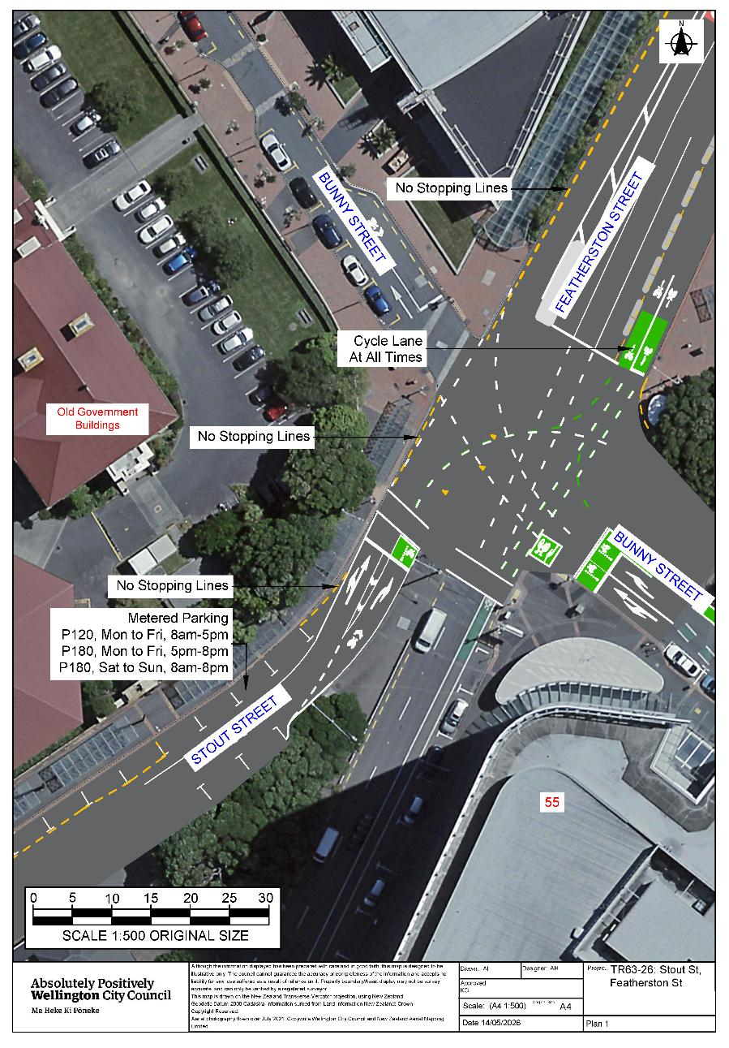Traffic Resolution Plan 2: Featherston Street, Pipitea - Amendment of Legal Descriptions
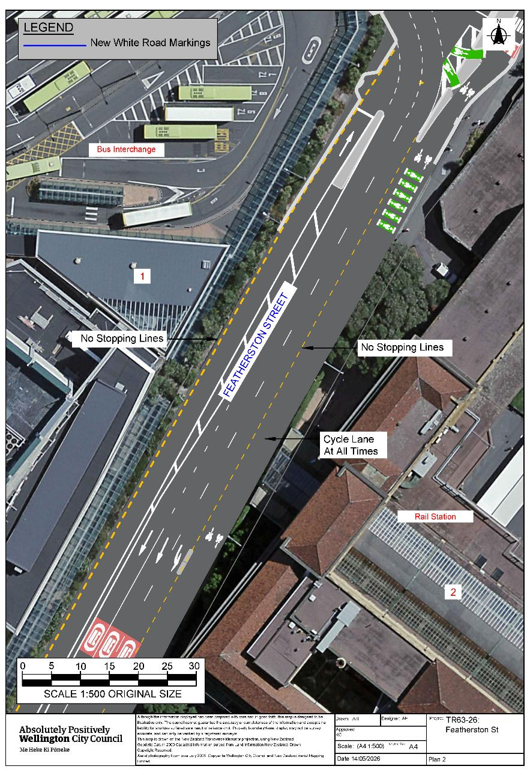
Traffic Resolution Plan 3: Thorndon Quay, Pipitea - Amendment of Legal Descriptions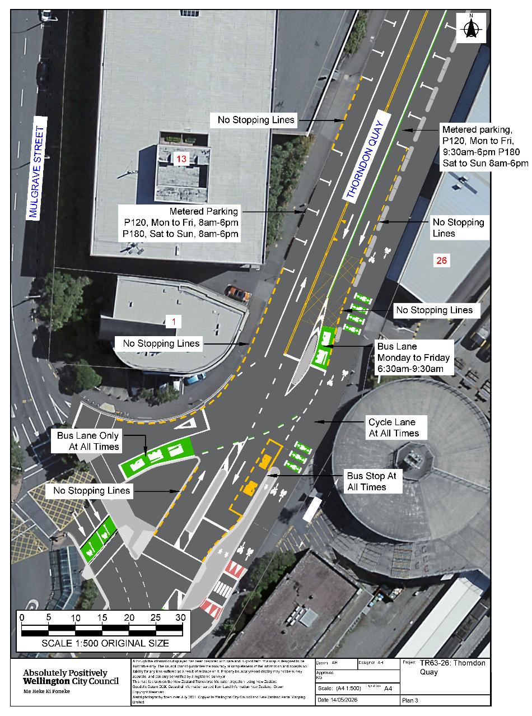Traffic Resolution Plan 4: Thorndon Quay, Pipitea - Amendment of Legal Descriptions
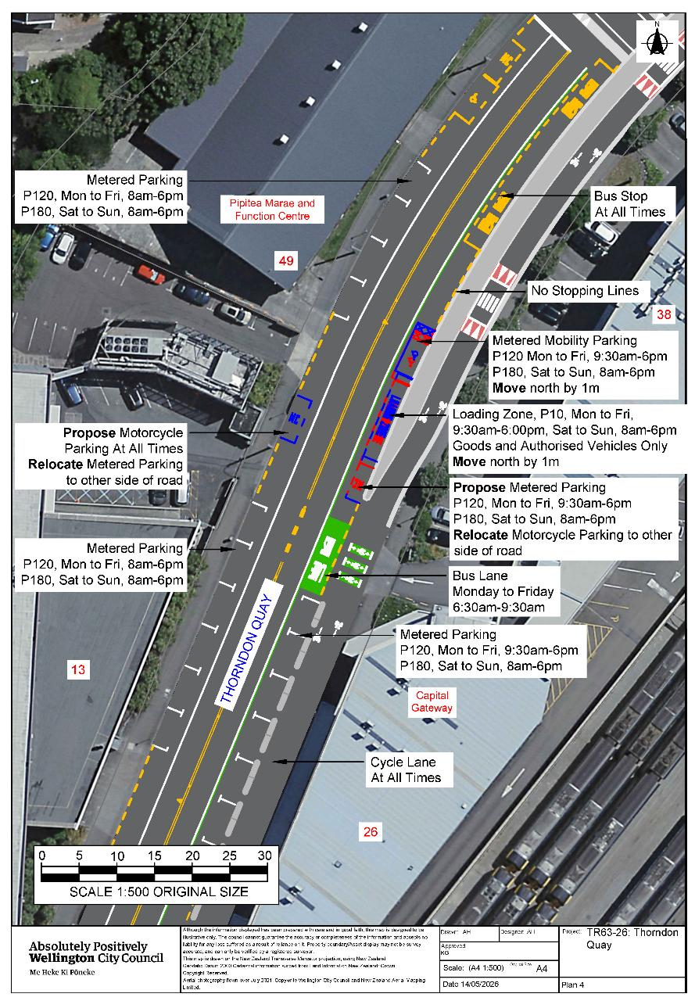
Traffic Resolution Plan 5: Thorndon Quay, Pipitea - Amendment of Legal Descriptions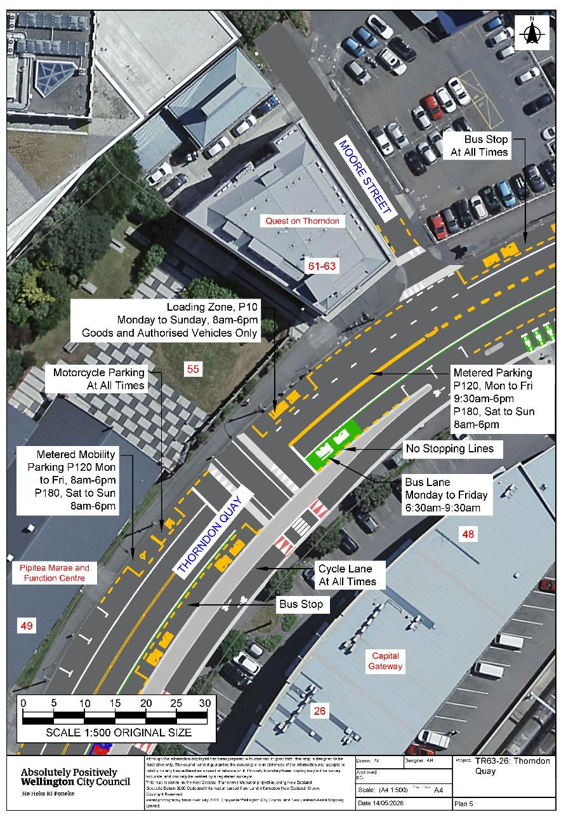
Traffic Resolution Plan 6: Thorndon Quay, Pipitea - Amendment of Legal Descriptions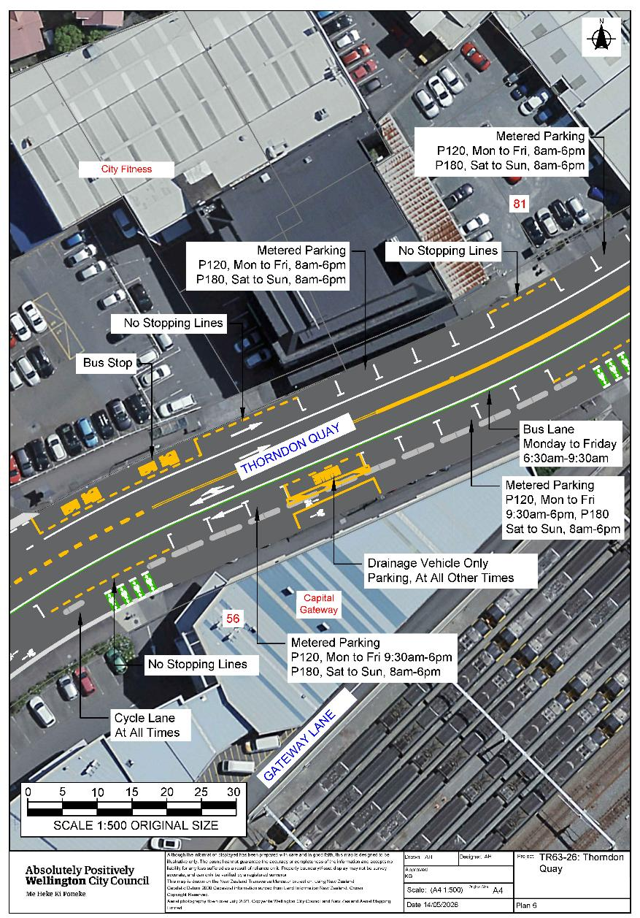

Traffic Resolution Plan 7: Thorndon Quay, Pipitea - Amendment of Legal Descriptions
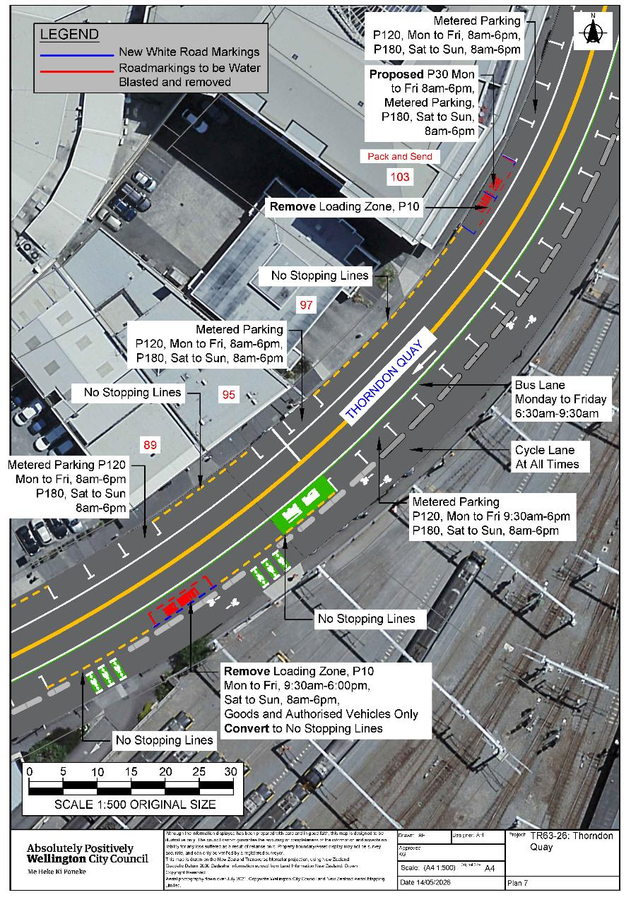
Traffic Resolution Plan 8: Thorndon Quay, Pipitea - Amendment of Legal Descriptions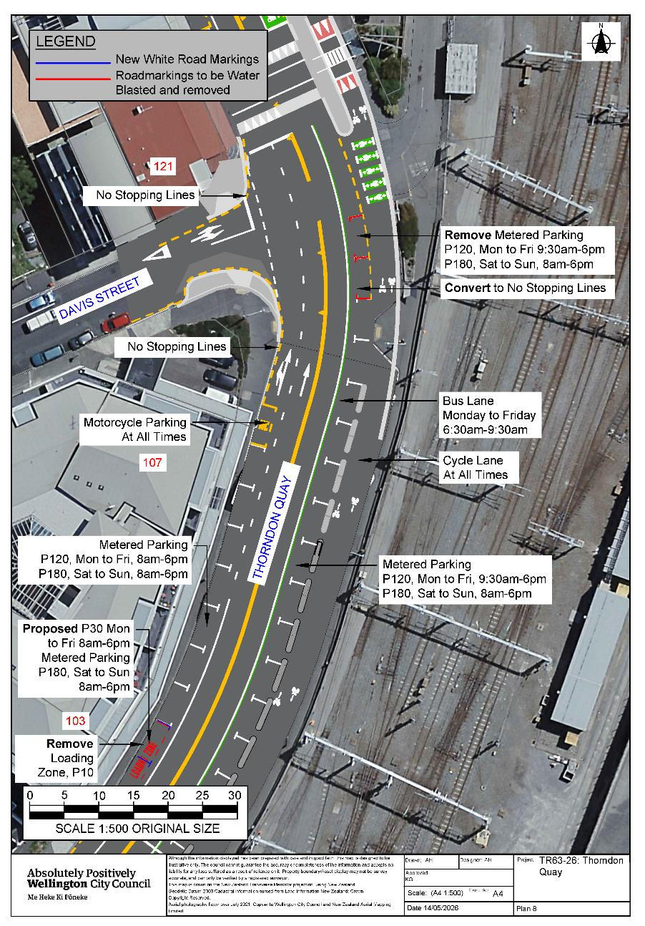Traffic Resolution Plan 9: Thorndon Quay, Pipitea - Amendment of Legal Descriptions
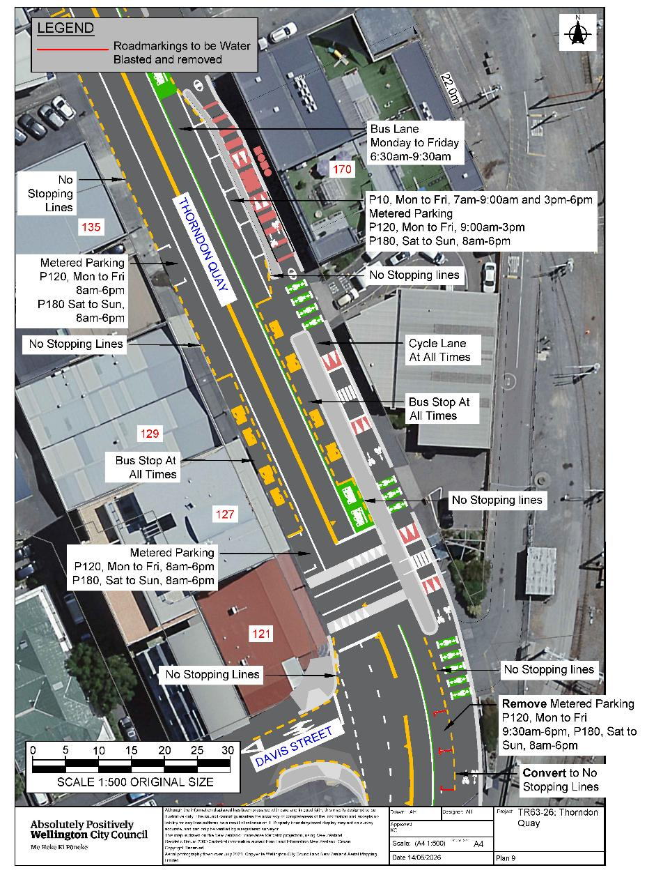

Traffic Resolution Plan 10: Thorndon Quay, Pipitea - Amendment of Legal Descriptions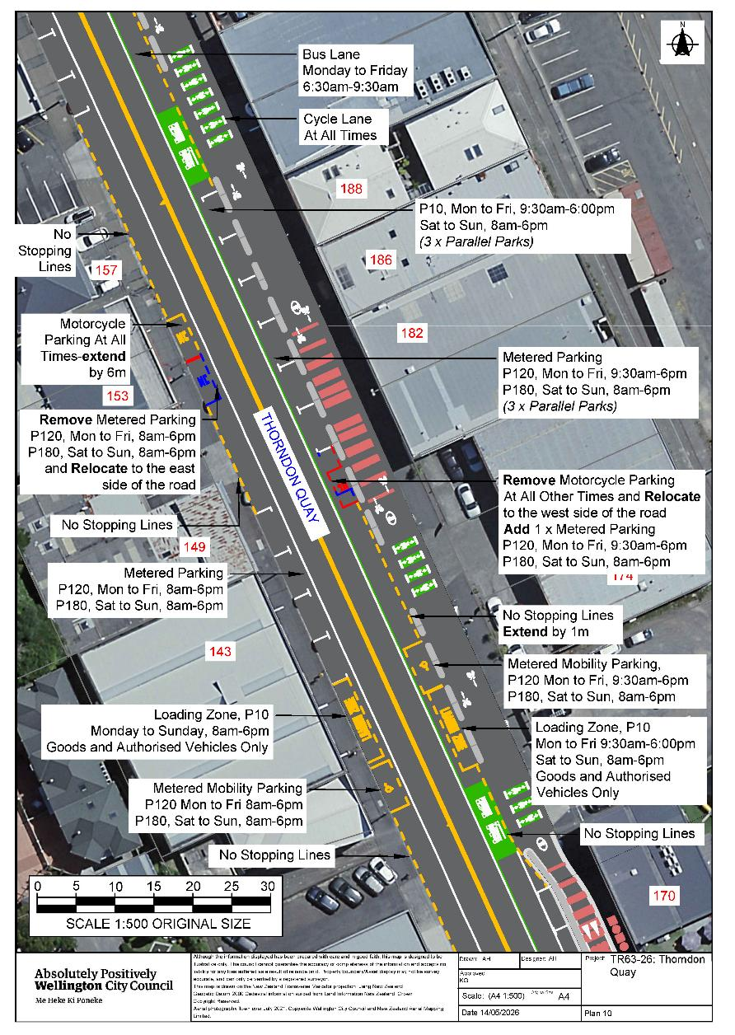
Traffic Resolution Plan 11: Thorndon Quay, Pipitea - Amendment of Legal Descriptions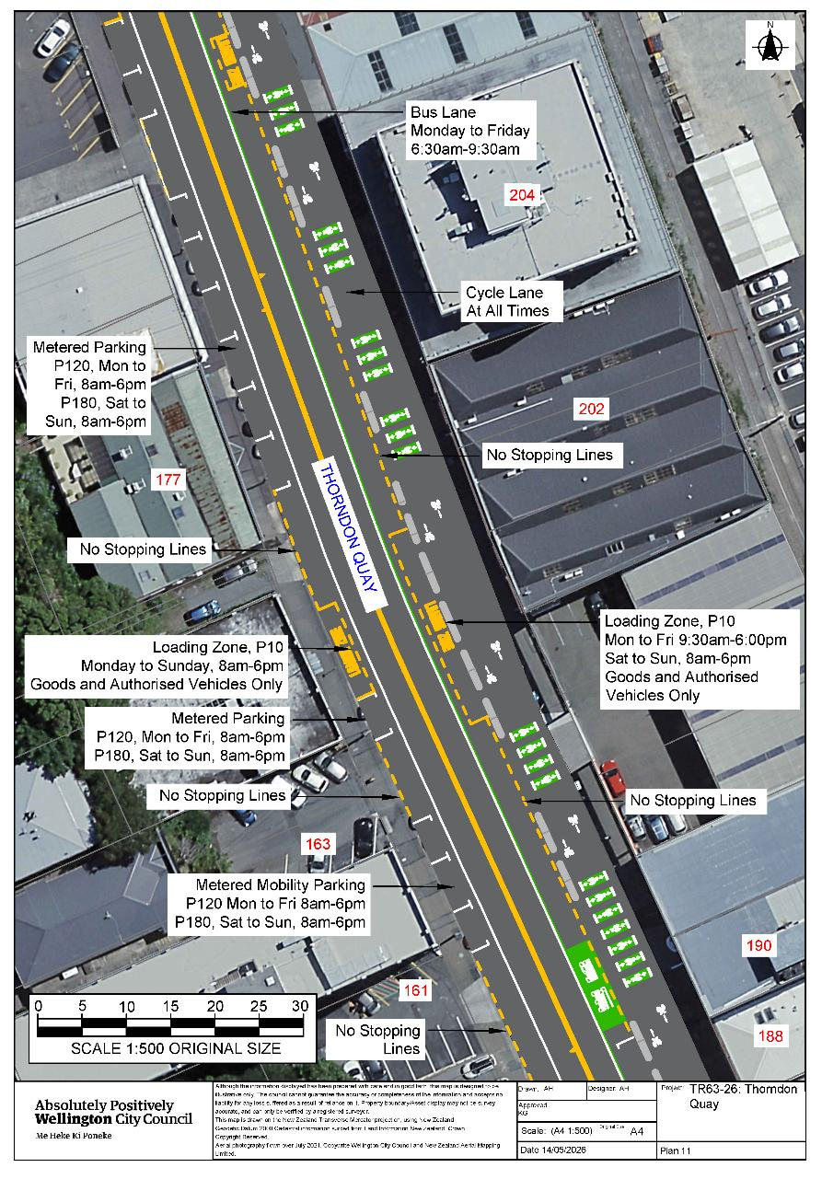
Traffic Resolution Plan 12: Thorndon Quay, Pipitea - Amendment of Legal Descriptions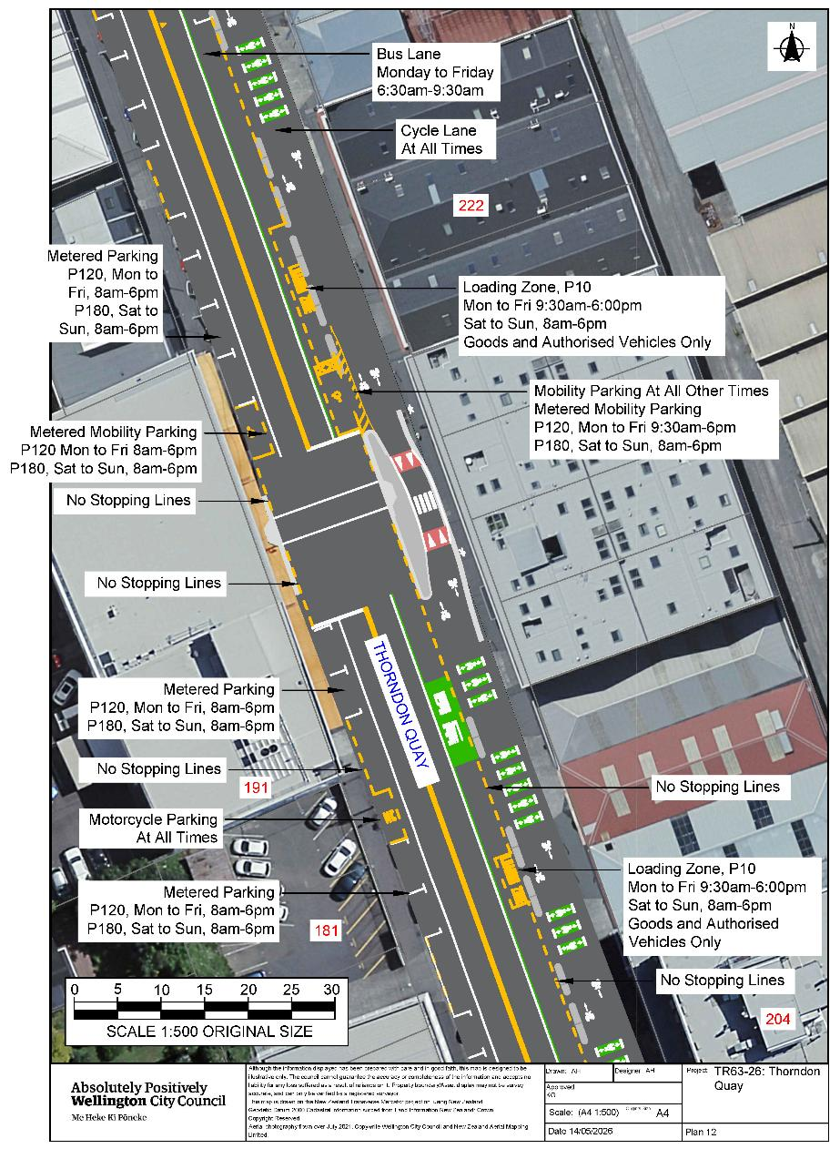
Traffic Resolution Plan 13: Thorndon Quay, Pipitea - Amendment of Legal Descriptions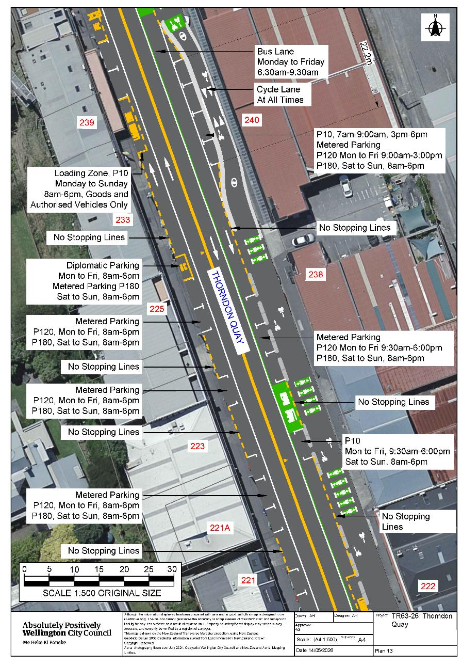
Traffic Resolution Plan 14: Thorndon Quay, Pipitea - Amendment of Legal Descriptions
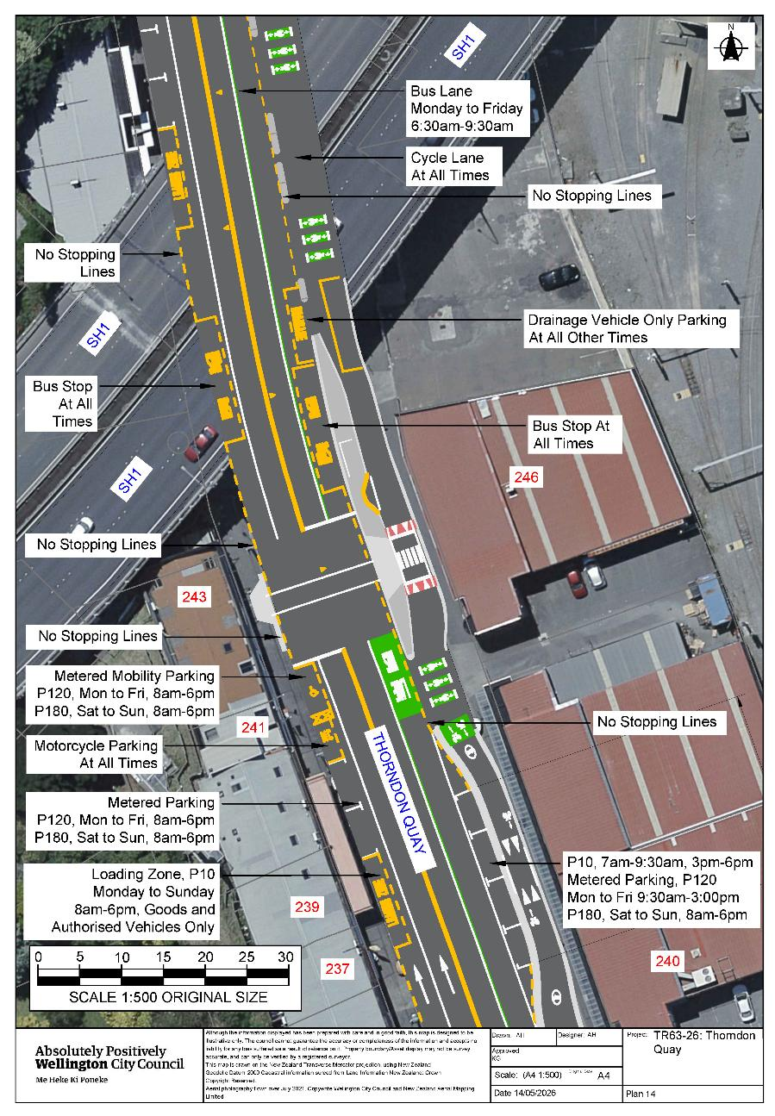
Traffic Resolution Plan 15: Thorndon Quay, Pipitea - Amendment of Legal Descriptions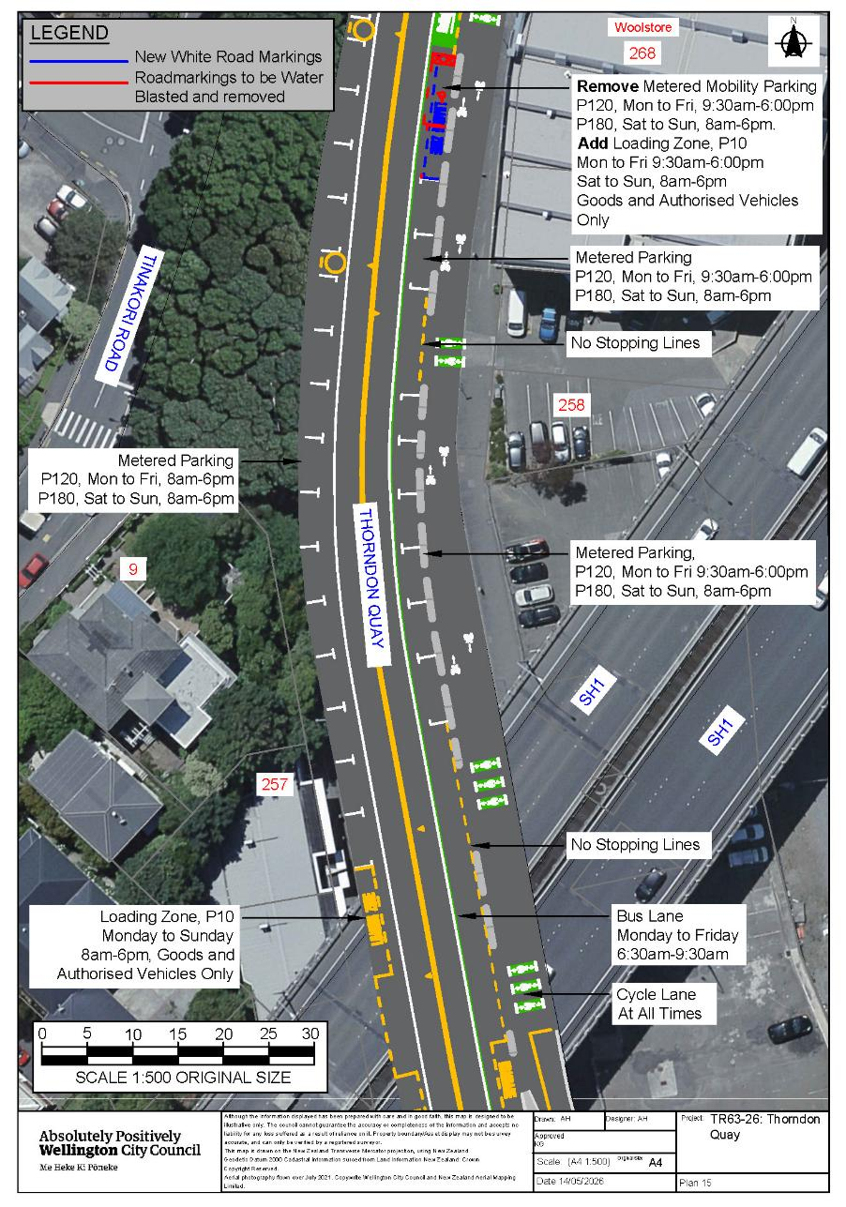Traffic Resolution Plan 16: Thorndon Quay, Pipitea - Amendment of Legal Descriptions
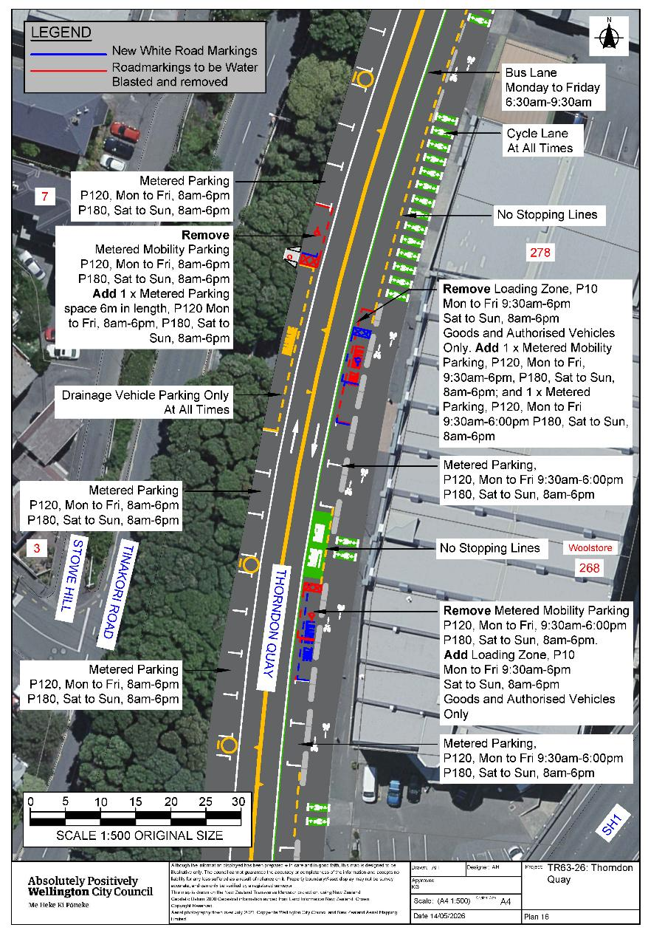
Traffic Resolution Plan 17: Thorndon Quay, Pipitea - Amendment of Legal Descriptions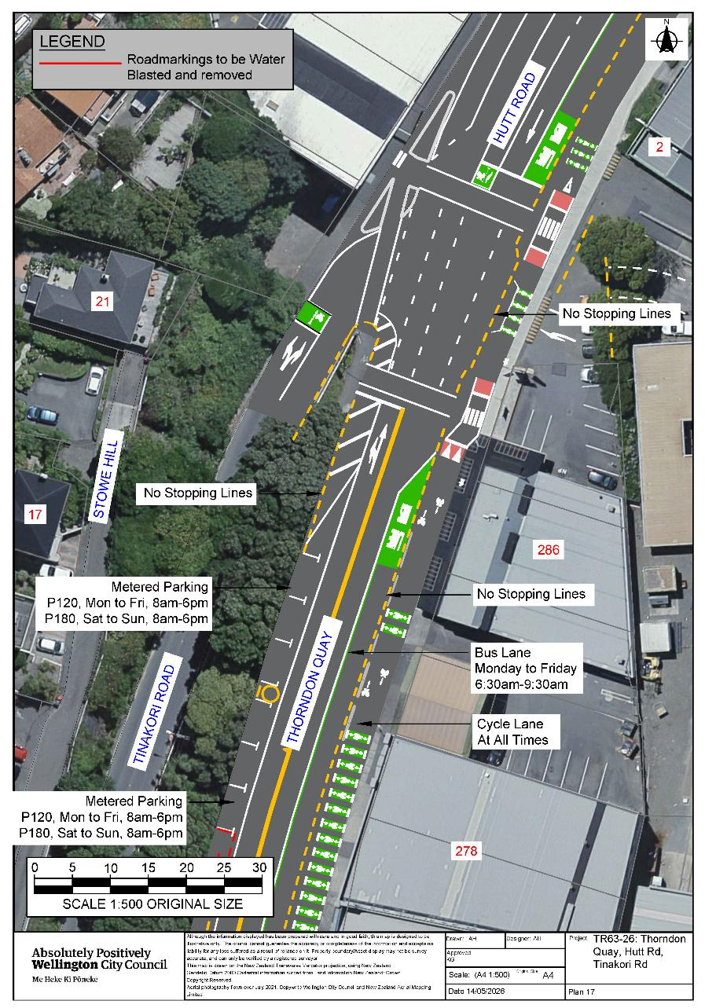
Traffic Resolution Plan 18: Hutt Road, Pipitea - Amendment of Legal Descriptions
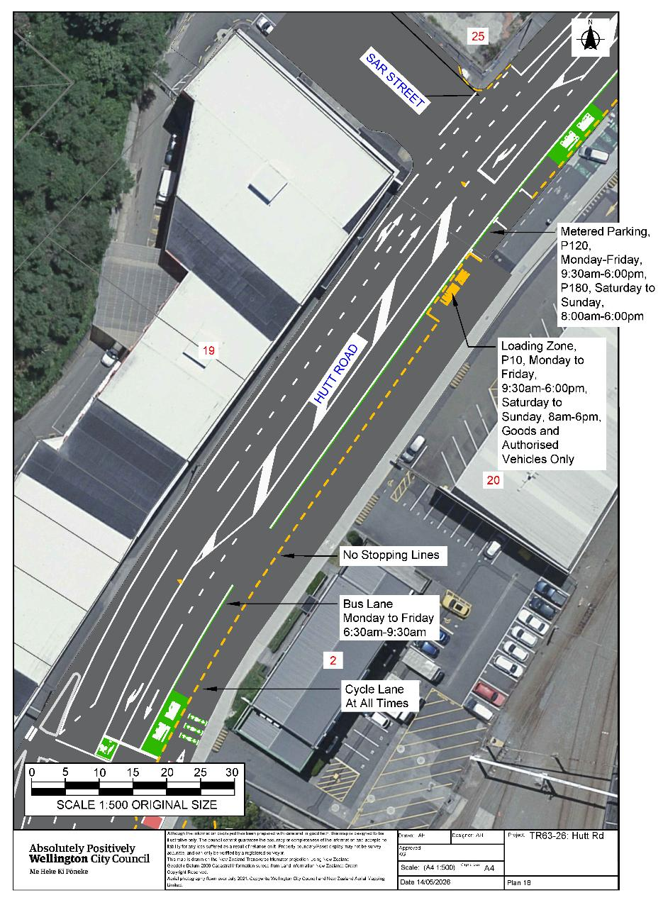
Traffic Resolution Plan 19: Hutt Road, Pipitea - Amendment of Legal Descriptions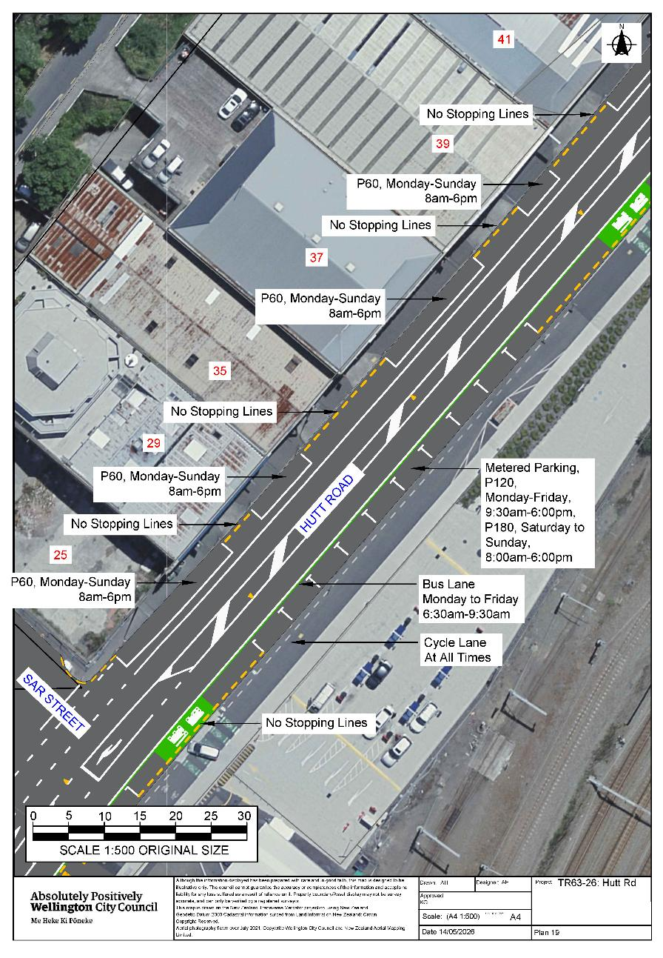
Traffic Resolution Plan 20: Hutt Road, Pipitea - Amendment of Legal Descriptions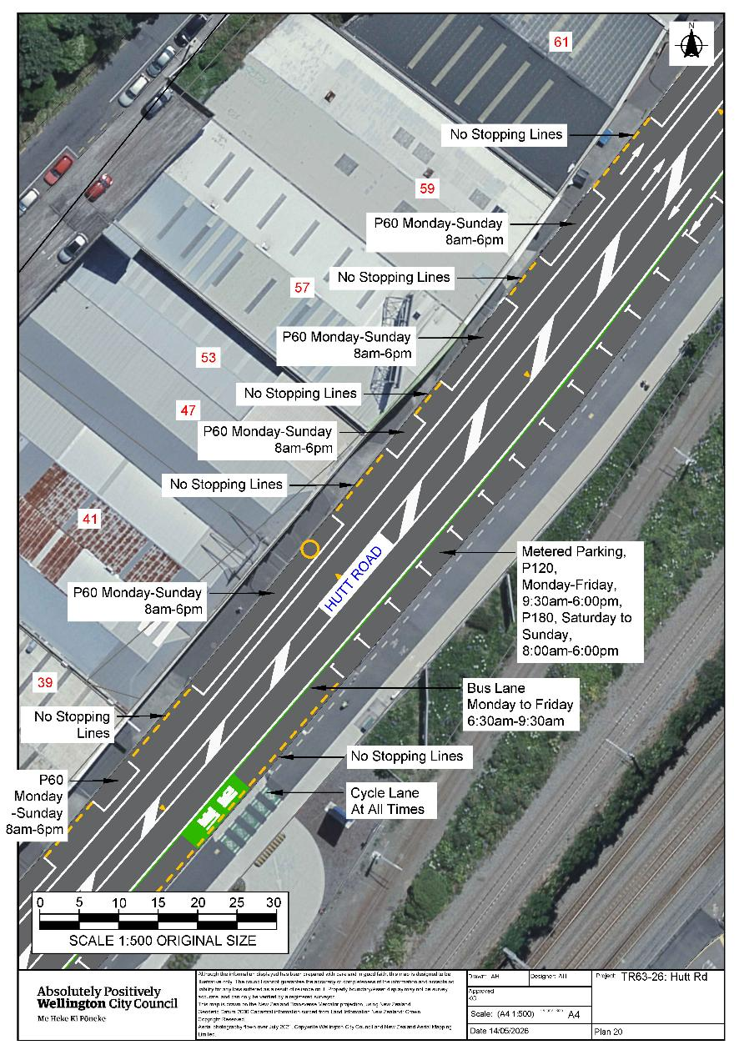
Traffic Resolution Plan 21: Hutt Road, Pipitea - Amendment of Legal Descriptions
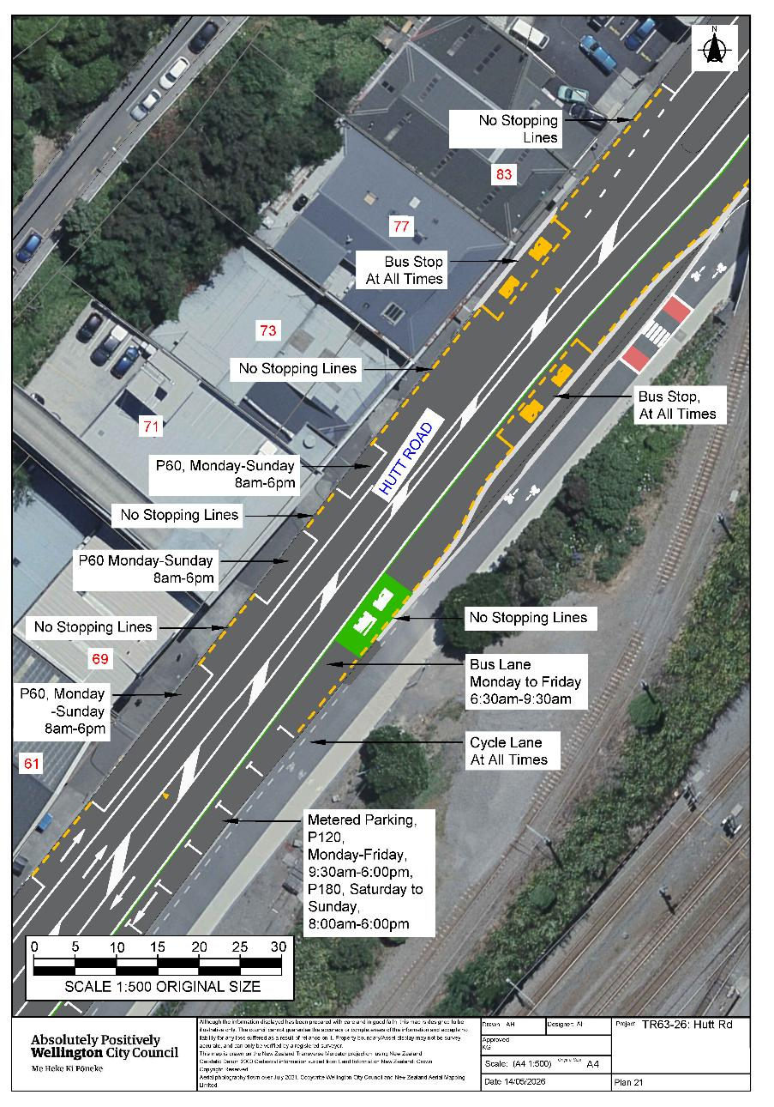
Traffic Resolution Plan 22: Hutt Road, Pipitea - Amendment of Legal Descriptions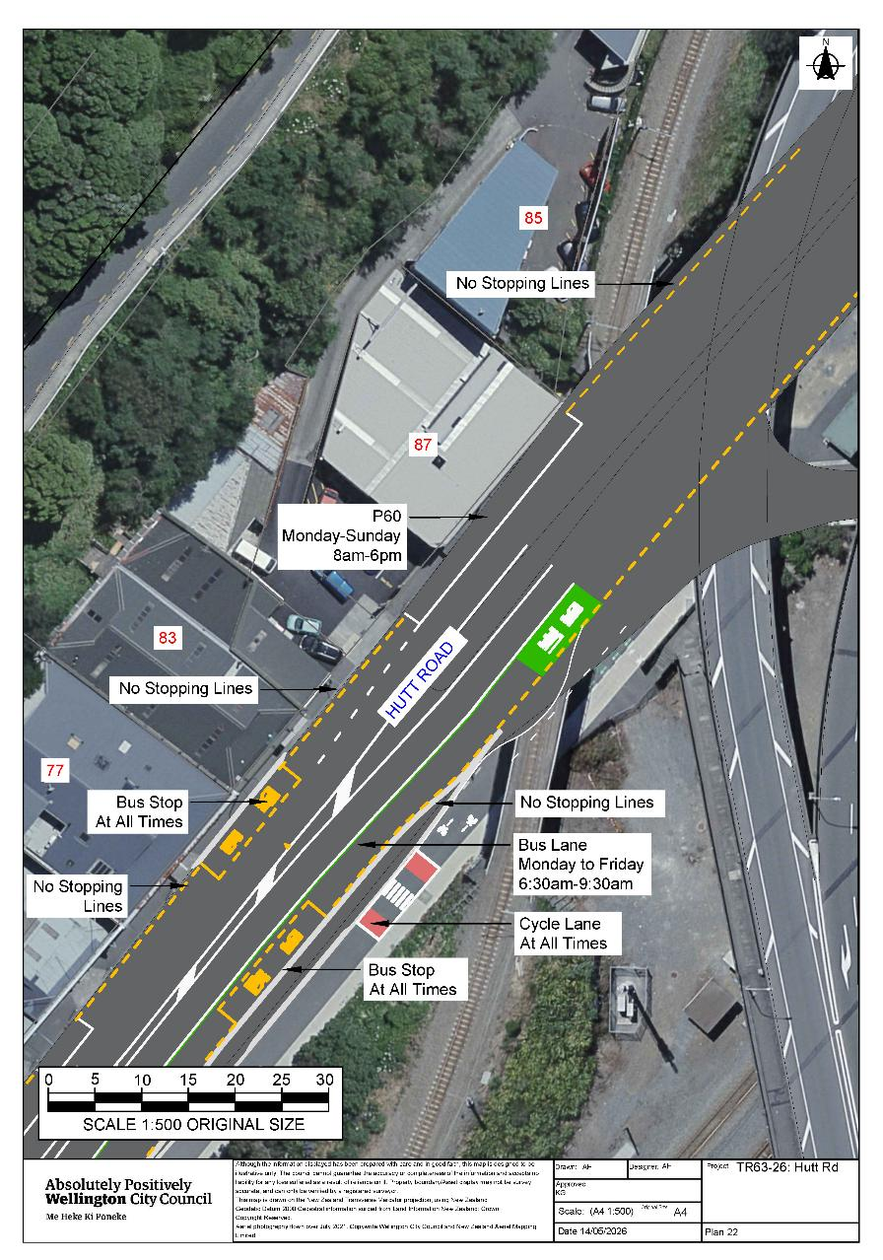Legal Description:

Delete all existing schedules A, B, C, D, E, F, G, H, and I Traffic Restrictions along Thorndon Quay.

Delete all existing schedules A, B, C, D, E, F, G, H, and I Traffic Restrictions along Featherston Street between its intersections with Bunny Street and Mulgrave Street.

Delete all existing schedules A, B, C, D, E, F, G, H, and I Traffic Restrictions along Hutt Road from its intersection with Thorndon Quay and extending in a northerly direction until the Hutt Road Onramp/overbridge.

Delete from Schedule F (Metered Parking) of the Traffic Restrictions Schedule

Column One | Column Two | Column Three
Stout Street | P120 Maximum, Monday to Thursday 8:00am - 6:00pm, Friday 8:00am - 8:00pm, Saturday and Sunday 8:00 - 6:00pm | Northwest side, following the kerbline 84.5 metres northeast of its intersection with Whitmore Street (Grid coordinates x= 1748870.8 m, y= 5428591.3 m), and extending in a north-easterly direction for 28.5 metres. (7 parallel carparks)

Delete from Schedule D (No Stopping) of the Traffic Restrictions Schedule

Column One | Column Two | Column Three
Davis Street | No Stopping, At All Times | South side, commencing from its intersection with Thorndon Quay and extending in a westerly direction following the southern kerbline for 35 metres.
Sar Street | No Stopping, At All Times | North side, commencing from its intersection with Thorndon Road and extending in a westerly direction following the northern kerbline for 6 metres.

Add to Schedule A (Time Limited) of the Traffic Restrictions Schedule

Column One | Column Two | Column Three
Thorndon Quay | P30, Monday to Friday, 8am – 6pm.  Metered parking P180, Saturday to Sunday, 8am – 6pm. | West side, commencing 162 metres north of its intersection with Moore Street (Grid coordinates x= 1749220.41 m, y= 5429069.66 m),and extending in a northerly direction following the western kerbline for 12 metres. (2 parallel parking spaces)
Thorndon Quay | P10: Monday to Friday, 07:00am -09:30am and 03:00pm -06:00pm  Metered Parking, P120, Monday to Friday, 9:30am- 3pm,  Metered Parking, P180, Saturday to Sunday, 8am-6pm | East side, commencing 613 metres north of its intersection with Featherston Street (Grid coordinates x= 1749092.37 m, y= 5428828.81 m), and extending in a north-westerly direction following the eastern kerbline for 22 metres. (4 parallel parking spaces)
Thorndon Quay | P10: Monday to Friday, 9:30am - 6:00pm,  P10 Saturday to Sunday, 8:00am-6:00pm | East side, commencing 716 metres north of its intersection with Featherston Street (Grid coordinates x= 1749092.37 m, y= 5428828.81 m), and extending in a north-westerly direction following the eastern kerbline for 18 metres. (3 parallel parking spaces)
Thorndon Quay | P10: Monday to Friday, 9:30am - 6:00pm, P10 Saturday to Sunday 8:00am to 6:00pm | East side, commencing 958 metres north of its intersection with Featherston Street (Grid coordinates x= 1749092.37 m, y= 5428828.81 m), and extending in a north-westerly direction following the eastern kerbline for 6 metres. (1 parallel parking spaces)
Thorndon Quay | P10: Monday to Friday, 07:00am -09:30am and 03:00pm -06:00pm  Metered Parking P120, Monday to Friday, 9:30am - 3pm,  Metered Parking P180 Saturday and Sunday, 8am – 6pm. | East side, commencing 1020 metres north of its intersection with Featherston Street (Grid coordinates x= 1749092.37 m, y= 5428828.81 m), and extending in a north-westerly direction following the eastern kerbline for 22 metres. (4 parallel parking spaces)
Hutt Road | P60, Monday to Sunday, 8:00am-6:00pm | West side, commencing 5 metres north of its intersection with Sar Street (Grid coordinates x= 1749269.17 m, y= 5430113.39 m), and extending in a northerly direction following the western kerbline for 22 metres.
Hutt Road | P60, Monday to Sunday, 8:00am-6:00pm | West side, commencing 33 metres north of its intersection with Sar Street (Grid coordinates x= 1749269.17 m, y= 5430113.39 m), and extending in a northerly direction following the western kerbline for 11 metres.
Hutt Road | P60, Monday to Sunday, 8:00am-6:00pm | West side, commencing 61 metres north of its intersection with Sar Street (Grid coordinates x= 1749269.17 m, y= 5430113.39 m), and extending in a northerly direction following the western kerbline for 19 metres.
Hutt Road | P60, Monday to Sunday, 8:00am-6:00pm | West side, commencing 89 metres north of its intersection with Sar Street (Grid coordinates x= 1749269.17 m, y= 5430113.39 m), and extending in a northerly direction following the western kerbline for 7 metres.
Hutt Road | P60, Monday to Sunday, 8:00am-6:00pm | West side, commencing 109metres north of its intersection with Sar Street (Grid coordinates x= 1749269.17 m, y= 5430113.39 m), and extending in a northerly direction following the western kerbline for 28 metres.
Hutt Road | P60, Monday to Sunday, 8:00am-6:00pm | West side, commencing 147metres north of its intersection with Sar Street (Grid coordinates x= 1749269.17 m, y= 5430113.39 m), and extending in a northerly direction following the western kerbline for 6 metres.
Hutt Road | P60, Monday to Sunday, 8:00am-6:00pm | West side, commencing 158metres north of its intersection with Sar Street (Grid coordinates x= 1749269.17 m, y= 5430113.39 m), and extending in a northerly direction following the western kerbline for 14 metres.
Hutt Road | P60, Monday to Sunday, 8:00am-6:00pm | West side, commencing 179metres north of its intersection with Sar Street (Grid coordinates x= 1749269.17 m, y= 5430113.39 m), and extending in a northerly direction following the western kerbline for 11 metres.
Hutt Road | P60, Monday to Sunday, 8:00am-6:00pm | West side, commencing 201metres north of its intersection with Sar Street (Grid coordinates x= 1749269.17 m, y= 5430113.39 m), and extending in a northerly direction following the western kerbline for 21 metres.
Hutt Road | P60, Monday to Sunday, 8:00am-6:00pm | West side, commencing 233 metres north of its intersection with Sar Street (Grid coordinates x= 1749269.17 m, y= 5430113.39 m), and extending in a northerly direction following the western kerbline for 10 metres.
Hutt Road | P60, Monday to Sunday, 8:00am-6:00pm | West side, commencing 249 metres north of its intersection with Sar Street (Grid coordinates x= 1749269.17 m, y= 5430113.39 m), and extending in a northerly direction following the western kerbline for 7 metres.
Hutt Road | P60, Monday to Sunday, 8:00am-6:00pm | West side, commencing 312 metres north of its intersection with Sar Street (Grid coordinates x= 1749269.17 m, y= 5430113.39 m), and extending in a northerly direction following the western kerbline for 28 metres.

Add to Schedule B (Class Restricted) of the Traffic Restrictions Schedule

Column One | Column Two | Column Three
Thorndon Quay | Motorcycle Parking,  At All Times | West side, commencing 131 metres north of its intersection with Mulgrave Street (Grid coordinates x= 1749073.1 m, y= 5428876.7 m), and extending in a north-easterly direction following the western kerbline for 6 metres.
Thorndon Quay | Mobility Park At All Times,  Metered P120, Monday to Friday 8:00am – 6:00pm,  Metered P180, Saturday & Sunday 8:00am – 6:00pm | West side, commencing 179 metres north of its intersection with Mulgrave Street (Grid x= 1749073.1 m, y= 5428876.7 m), and extending in a north-easterly direction following the western kerbline for 6 metres. (1 parallel parking space)
Thorndon Quay | Motorcycle Parking,  At All Times | West side, commencing 185 metres north of its intersection with Mulgrave Street (Grid coordinates x= 1749073.1 m, y= 5428876.7 m), and extending in a north-easterly direction following the western kerbline for 6 metres.
Thorndon Quay | Loading Zone (P10), Monday to Sunday 8am-6pm, Goods and Authorised Vehicles Only | West side, commencing 210 metres north of its intersection with Mulgrave Street (Grid coordinates x= 1749073.1 m, y= 5428876.7 m), and extending in a north-easterly direction following the western kerbline for 12 metres
Thorndon Quay | Bus Stop At All Times | West side, commencing 2 metres north of its intersection with Moore Street (Grid coordinates x= 1749220.41 m, y= 5429069.66 m), and extending in a north-easterly direction following the western kerbline for 26 metres.
Thorndon Quay | Motorcycle Parking:  At All Times | West side, commencing 242 metres north of its intersection with Moore Street (Grid coordinates x= 1749220.41 m, y= 5429069.66 m), and extending in a north-easterly direction following the western kerbline for 6 metres.
Thorndon Quay | Bus Stop At All Times | West side, commencing 20 metres north of its intersection with Davis Street (Grid coordinates x= 1749374.11 m, y= 5429246.71 m), and extending in a north-westerly direction following the western kerbline for 26 metres.
Thorndon Quay | Mobility Parking, At All Times  Metered, P120 Monday to Friday, 8am - 6pm  Metered, P180, Saturday to Sunday, 8am -6pm | West side, commencing 99 metres north of its intersection with Davis Street (Grid coordinates x= 1749374.11 m, y= 5429246.71 m), and extending in a north-westerly direction following the western kerbline for 6 metres. (1 parallel parking space)
Thorndon Quay | Loading Zone (P10):Monday to Sunday 8am-6pm, Goods and Authorised Vehicles Only | West side, commencing 106 metres north of its intersection with Davis Street (Grid coordinates x= 1749374.11 m, y= 5429246.71 m) and extending in a north-westerly direction following the western kerbline for 11 metres
Thorndon Quay | Motorcycle Parking,  At All Times | West side, commencing 157 metres north of its intersection with Davis Street (Grid coordinates x= 1749374.11 m, y= 5429246.71 m), and extending in a north-westerly direction following the western kerbline for 12 metres.
Thorndon Quay | Loading Zone (P10): Monday to-Sunday 8am-6pm, Goods and Authorised Vehicles Only | West side, commencing 229 metres north of its intersection with Davis Street (Grid coordinates x= 1749374.11 m, y= 5429246.71 m), and extending in a north-westerly direction following the western kerbline for 11 metres.
Thorndon Quay | Motorcycle Parking:  At All Times | West side, commencing311 metres north of its intersection with Davis Street (Grid coordinates x= 1749374.11 m, y= 5429246.71 m), and extending in a north-westerly direction following the western kerbline for 6 metres.
Thorndon Quay | Mobility Parking, At All Times  Metered, P120 Monday to Friday, 8am - 6pm  Metered, P180, Saturday to Sunday, 8am -6pm | West side, commencing 357 metres north of its intersection with Davis Street (Grid coordinates x= 1749374.11 m, y= 5429246.71 m), and extending in a north-westerly direction following the western kerbline for 6 metres. (1 parallel parking space)
Thorndon Quay | Diplomatic parking (DC,CC,FC): Monday to Friday, Registered vehicle only, 08:00am to 06:00pm,  Metered Parking, P180, Saturday to Sunday, 8:00am-6:00pm | West side, commencing 449 metres north of its intersection with Davis Street (Grid coordinates x= 1749374.11 m, y= 5429246.71 m), and extending in a north-westerly direction following the western kerbline for 6 metres. (1 parallel parking space)
Thorndon Quay | Loading Zone (P10): Monday to-Sunday 8am-6pm, Goods and Authorised Vehicles Only | West side, commencing 476 metres north of its intersection with Davis Street (Grid coordinates x= 1749374.11 m, y= 5429246.71 m), and extending in a north-westerly direction following the western kerbline for 12 metres.
Thorndon Quay | Motorcycle Parking,  At All Times | West side, commencing 499 metres north of its intersection with Davis Street (Grid coordinates x= 1749374.11 m, y= 5429246.71 m), and extending in a north-westerly direction following the western kerbline for 5 metres.
Thorndon Quay | Mobility Parking, At All Times  Metered, P120 Monday to Friday, 8am - 6pm  Metered, P180, Saturday to Sunday, 8am -6pm | West side, commencing505 metres north of its intersection with Davis Street (Grid coordinates x= 1749374.11 m, y= 5429246.71 m), and extending in a north-westerly direction following the kerbline for 6 metres. (1 parallel parking space)
Thorndon Quay | Bus Stop At All Times | West side, commencing 528 metres north of its intersection with Davis Street (Grid coordinates x= 1749374.11 m, y= 5429246.71 m), and extending in a north-westerly direction following the western kerbline for 15 metres.
Thorndon Quay | Loading Zone (P10): Monday to-Sunday 8am-6pm, Goods and Authorised Vehicles Only | West side, commencing 555 metres north of its intersection with Davis Street (Grid coordinates x= 1749374.11 m, y= 5429246.71 m), and extending in a north-westerly direction following the western kerbline for 12 metres.
Thorndon Quay | WCC Drainage Vehicle Parking, Drainage Vehicles Only, At All Times | West side, commencing 680 metres north of its intersection with Davis Street (Grid coordinates x= 1749374.11 m, y= 5429246.71 m), and extending in a northerly direction following the western kerbline of 24 metres.
Thorndon Quay | Bus Stop At All Times | East side, commencing 27 metres north of its intersection with Featherson Street (Grid coordinates x= 1749092.37 m, y= 5428828.81 m), and extending in a north-easterly direction following the eastern kerbline for 15 metres.
Thorndon Quay | Loading Zone (P10):  Monday to Friday, 09:30am-6pm,  Saturday to Sunday, 8am-6pm  Goods and Authorised Vehicles Only  Bus Lane, Monday to Friday, 6:30am-9:30am | East side, commencing 158 metres north of its intersection with Featherston Street (Grid coordinates x= 1749092.37 m, y= 5428828.81 m), and extending in a north-easterly direction following the eastern kerbline for 12 metres.
Thorndon Quay | Mobility Parking At all times, except during bus lane operating hours of Monday to Friday, 6:30am-9:30am  Metered, P120 Monday to Friday, 9:30am - 6pm  Metered, P180, Saturday to Sunday, 8am -6pm | East side, commencing 170 metres north of its intersection with Featherston Street (Grid coordinates x= 1749092.37 m, y= 5428828.81 m), and extending in a north-easterly direction following the eastern kerbline for 7 metres.
Thorndon Quay | Bus Stop At All Times | East side, commencing 190 metres north of its intersection with Featherston Street (Grid coordinates x= 1749092.37 m, y= 5428828.81 m), and extending in a north-easterly direction following the eastern kerbline for 30 metres.
Thorndon Quay | WCC Drainage Parking: Drainage Vehicles Only, At All Other Times  Bus Lane, Monday to Friday, 6:30am-9:30am | East side, commencing 298.8 metres north of its intersection with Featherston Street (Grid coordinates x= 1749092.37 m, y= 5428828.81 m), and extending in a north-easterly direction following the eastern kerbline for 12 metres.
Thorndon Quay | Bus Stop At All Times | East side, commencing 577 metres north of its intersection with Featherston Street (Grid coordinates x= 1749092.37 m, y= 5428828.81 m), and extending in a north-westerly direction following the eastern kerbline for 30 metres.
Thorndon Quay | Loading Zone (P10):  Monday to Friday, 09:30am-6pm  Saturday to Sunday, 8am-6pm  Goods and Authorised Vehicles Only | East side, commencing 653 metres north of its intersection with Featherston Street (Grid coordinates x= 1749092.37 m, y= 5428828.81 m), and extending in a north-westerly direction following the eastern kerbline for 11 metres.
Thorndon Quay | Mobility Parking At all times, except during bus lane operating hours of Monday to Friday, 6:30am-9:30am  Metered, P120 Monday to Friday, 9:30am - 6pm  Metered, P180, Saturday to Sunday, 8am -6pm | East side, commencing 664 metres north of its intersection with Featherston Street (Grid coordinates x= 1749092.37 m, y= 5428828.81 m), and extending in a north-westerly direction following the eastern kerbline for 6 metres. (1 parallel parking space).
Thorndon Quay | Loading Zone (P10):  Monday to Friday, 09:30am-6pm  Saturday to Sunday, 8am-6pm  Goods and Authorised Vehicles Only  Bus Lane, Monday to Friday, 6:30am-9:30am | East side, commencing 774 metres north of its intersection with Featherston Street (Grid coordinates x= 1749092.37 m, y= 5428828.81 m) and extending in a north-westerly direction following the eastern kerbline for 23 metres.
Thorndon Quay | Loading Zone (P10):  Monday to Friday, 09:30am-6pm  Saturday to Sunday, 8am-6pm  Goods and Authorised Vehicles Only  Bus Lane, Monday to Friday, 6:30am-9:30am | East side, commencing 827 metres north of its intersection with Featherston Street (Grid coordinates x= 1749092.37 m, y= 5428828.81 m) and extending in a north-westerly direction following the eastern kerbline for 6 metres.
Thorndon Quay | Mobility Parking At all times, except during bus lane operating hours of Monday to Friday, 6:30am-9:30am  Metered, P120 Monday to Friday, 9:30am - 6pm  Metered, P180, Saturday to Sunday, 8am -6pm | East side, commencing 885 metres north of its intersection with Featherston Street (Grid coordinates x= 1749092.37 m, y= 5428828.81 m) and extending in a north-westerly direction following the eastern kerbline for 8.5 metres.
Thorndon Quay | Loading Zone (P10):  Monday to Friday, 09:30am-6pm  Saturday to Sunday, 8am-6pm  Goods and Authorised Vehicles Only  Bus Lane, Monday to Friday, 6:30am-9:30am | East side, commencing 893 metres north of its intersection with Featherston Street (Grid coordinates x= 1749092.37 m, y= 5428828.81 m) and extending in a north-westerly direction following the eastern kerbline for 16.6 metres.
Thorndon Quay | Bus Stop At All Times | East side, commencing 1079 metres north of its intersection with Featherston Street (Grid coordinates x= 1749092.37 m, y= 5428828.81 m) and extending in a north-westerly direction following the eastern kerbline for 15 metres.
Thorndon Quay | WCC Drainage Parking: Drainage Vehicles Only, At All Other Times  Bus Lane, Monday to Friday, 6:30am-9:30am | East side, commencing 1094 metres north of its intersection with Featherston Street (Grid coordinates x= 1749092.37 m, y= 5428828.81 m) and extending in a north-westerly direction following the eastern kerbline for 9 metres.
Thorndon Quay | Mobility Parking At all times, except during bus lane operating hours of Monday to Friday, 6:30am-9:30am  Metered, P120 Monday to Friday, 9:30am - 6pm  Metered, P180, Saturday to Sunday, 8am -6pm | East side, commencing 1221 metres north of its intersection with Featherston Street (Grid coordinates x= 1749092.37 m, y= 5428828.81 m), and extending in a north-easterly direction following the eastern kerbline for 8 metres.
Thorndon Quay | Loading Zone (P10):  Monday to Friday, 09:30am-6pm  Saturday to Sunday, 8am-6pm  Goods and Authorised Vehicles Only  Bus Lane, Monday to Friday, 6:30am-9:30am | East side, commencing 1178 metres north of its intersection with Featherston Street (Grid coordinates x= 1749092.37 m, y= 5428828.81 m), and extending in a north-easterly direction following the eastern kerbline for 13.9 metres.
Hutt Road | Bus Stop, At All Times | West side commencing 270.3 metres north of its intersection with Sar Street (Grid coordinates x= 1749269.17 m, y= 5430113.39 m) and extending in a north easterly direction following the western kerbline for 13.6 meters.
Hutt Road | Loading Zone (P10):  Monday to Friday, 09:30am-6pm  Saturday to Sunday, 8am-6pm  Goods and Authorised Vehicles Only  Bus Lane, Monday to Friday, 6:30am-9:30am | East side, commencing 89 metres north of its intersection with Thorndon Quay (Grid coordinates x= 1749218.1 m, y= 5430001.8 m), and extending in a north-easterly direction following the eastern kerbline for 11 metres.
Hutt Road | Bus Stop, At All Times | East side, following the kerbline 276 metres north of its intersection with Sar Street (Grid coordinates x= 1749275.4 m, y= 5430095 m), and extending in a northerly direction for 15 metres.
Thorndon Quay-Slip Lane | Bus Only Lane, At All Times | South-East side, commencing from its intersection with Thorndon Quay (x=1749094.46 y=5428866.16) and extending in south-westerly direction following the south-eastern kerbline for 17 metres.
Hutt Road, Thorndon Quay, | Bus Lane, Monday to Friday, 6:30am – 9:30am | East side, commencing 89 metres south of its intersection with Aotea Quay (Grid coordinates x= 1749551.28 y=5430424.88), and extending in a southerly direction following the eastern kerbline for 1,747 metres.

Add to Schedule D (No Stopping) of the Traffic Restrictions Schedule

Column One | Column Two | Column Three
West side No Stopping Lines
Stout Street | No Stopping, At All Times | West side, commencing 26 metres south of its intersection with Bunny Street (Grid coordinates 1748989.4 m, 5428684.7 m) and extending in a southerly direction following the western kerbline for 9 metres.
Stout Street | No Stopping, At All Times | West side, commencing at its intersection with Bunny Street (Grid coordinates 1748989.4 m, 5428684.7 m) and extending in a southerly direction following the western kerbline for 12 metres.
Featherston Street | No Stopping, At All Times | West side, commencing from its intersection with Bunny Street (Grid coordinates 1748996.1 m, 5428692.4 m) and extending in a north-easterly direction following the western kerbline for 165 metres.
Thorndon Quay | No Stopping, At All Times | West side, commencing from its intersection with Mulgrave Street (Grid coordinates 1749082.89m, 5428848.46m) and extending in north-easterly direction following the western kerbline for 15 metres.
Thorndon Quay | No Stopping, At All Times | West side, commencing 7 metres north of its intersection with Mulgrave Street (Grid coordinates 1749073.1 m, y= 5428876.7 m) and extending in a north-easterly direction following the western kerbline for 47 metres.
Thorndon Quay | No Stopping, At All Times | West side, commencing 71 metres north of its intersection with Mulgrave Street (Grid coordinates 1749073.1 m, y= 5428876.7 m) and extending in a north-easterly direction following the western kerbline for 15 metres.
Thorndon Quay | No Stopping, At All Times | West side, commencing 128 metres north of its intersection with Mulgrave Street (Grid coordinates 1749073.1 m, y= 5428876.7 m) and extending in a north-easterly direction following the western for 9 metres.
Thorndon Quay | No Stopping, At All Times | West side, commencing134 metres north of its intersection with Mulgrave Street (Grid coordinates 1749073.1 m, y= 5428876.7 m) and extending in a north-easterly direction following the western kerbline for 12 metres.
Thorndon Quay | No Stopping, At All Times | West side, commencing 169 metres north of its intersection with Mulgrave Street (Grid coordinates 1749073.1 m, y= 5428876.7 m) and extending in a north-easterly direction following the western kerbline for 7 metres.
Thorndon Quay | No Stopping, At All Times | West side, commencing189 metres north of its intersection with Mulgrave Street (Grid coordinates 1749073.1 m, y= 5428876.7 m) and extending in a north-easterly direction following the western for 7 metres.
Thorndon Quay | No Stopping, At All Times | West side, commencing 220 metres north of its intersection with Mulgrave Street (Grid coordinates 1749073.1 m, y= 5428876.7 m) and extending in a north-easterly direction following the western kerbline for 19 metres.
Thorndon Quay | No Stopping, At All Times | West side, commencing 25 metres north of its intersection with Moore Street (Grid coordinates 1749220.4 m, y= 5429069.7 m) and extending in a north-easterly direction following the western kerbline for 15 metres.
Thorndon Quay | No Stopping, At All Times | West side, commencing 71 metres north of its intersection with Moore Street (Grid coordinates 1749220.4 m, y= 5429069.7 m) and extending in a north-easterly direction following the western kerbline for 11 metres.
Thorndon Quay | No Stopping, At All Times | West side, commencing 99 metres north of its intersection with Moore Street (Grid coordinates 1749220.4 m, y= 5429069.7 m) and extending in a north-easterly direction following the western kerbline for 17 metres.
Thorndon Quay | No Stopping, At All Times | West side, commencing129 metres north of its intersection with Moore Street (Grid coordinates 1749220.4 m, y= 5429069.7 m) and extending in a north-easterly direction following the western kerbline for 33 metres.
Thorndon Quay | No Stopping, At All Times | West side, commencing at its intersection with Davis Street (Grid coordinates 1749379.22m, y= 5429224.75m) and extending in a southerly direction following the western kerbline for 14 metres.
Davis Street | No Stopping, At All Times | South side, commencing at its intersection with Thorndon Quay (Grid coordinates 1749379.22m, y= 5429224.75m) and extending in a westerly direction following the southern kerbline for 35 metres.
Thorndon Quay | No Stopping, At All Times | West side, commencing at its intersection with Davis Street (Grid coordinates 1749374.1 m, y= 5429246.7 m) and extending in a north-westerly direction following the western kerbline for 35 metres.
Davis Street | No Stopping, At All Times | North side, commencing at its intersection with Thorndon Quay (Grid coordinates 1749374.1 m, y= 5429246.7 m) and extending in a westerly direction following the northern kerbline for 20 metres.
Thorndon Quay | No Stopping, At All Times | West side, commencing46 metres north of its intersection with Davis Street (Grid coordinates 1749374.1 m, y= 5429246.7 m) and extending in a north-westerly direction following the western for 15 metres.
Thorndon Quay | No Stopping, At All Times | West side, commencing 67 metres north of its intersection with Davis Street (Grid coordinates 1749374.1 m, y= 5429246.7 m) and extending in a north-westerly direction following the western kerbline for 31 metres.
Thorndon Quay | No Stopping, At All Times | West side, commencing 141 metres north of its intersection with Davis Street (Grid coordinates 1749374.1 m, y= 5429246.7 m) and extending in a north-westerly direction following the western kerbline for 15 metres.
Thorndon Quay | No Stopping, At All Times | West side, comemencing169 metres north of its intersection with Davis Street (Grid coordinates 1749374.1 m, y= 5429246.7 m) and extending in a north-westerly direction following the western kerbline for 29 metres.
Thorndon Quay | No Stopping, At All Times | West side, commencing214 metres north of its intersection with Davis Street (Grid coordinates 1749374.1 m, y= 5429246.7 m) and extending in a north-westerly direction following the western kerbline for 9 metres.
Thorndon Quay | No Stopping, At All Times | West side, commencing 240 metres north of its intersection with Davis Street (Grid coordinates 1749374.1 m, y= 5429246.7 m) and extending in a north-westerly direction following the western kerbline for 15 metres.
Thorndon Quay | No Stopping, At All Times | West side, commencing 267 metres north of its intersection with Davis Street (Grid coordinates 1749374.1 m, y= 5429246.7 m) and extending in a north-westerly direction following the western kerbline for 9 metres.
Thorndon Quay | No Stopping, At All Times | West side, commencing 267 metres north of its intersection with Davis Street (Grid coordinates 1749374.1 m, y= 5429246.7 m) and extending in a north-westerly direction following the western kerbline for 9 metres.
Thorndon Quay | No Stopping, At All Times | West side, commencing 287 metres north of its intersection with Davis Street (Grid coordinates 1749374.1 m, y= 5429246.7 m) and extending in a north-westerly direction following the western kerbline for 9 metres.
Thorndon Quay | No Stopping, At All Times | West side commencing 300 metres north of its intersection with Davis Street (Grid coordinates 1749374.1 m, y= 5429246.7 m) and extending in a north-westerly direction following the western kerbline for 5 metres.
Thorndon Quay | No Stopping, At All Times | West side, commencing 324 metres north of its intersection with Davis Street (Grid coordinates 1749374.1 m, y= 5429246.7 m) and extending in a north-westerly direction following the western kerbline for 7 metres.
Thorndon Quay | No Stopping, At All Times | West side, commencing 361 metres north of its intersection with Davis Street (Grid coordinates 1749374.1 m, y= 5429246.7 m) and extending in a north-westerly direction following the western for 11 metres.
Thorndon Quay | No Stopping, At All Times | West side, commencing 378 metres north of its intersection with Davis Street (Grid coordinates 1749374.1 m, y= 5429246.7 m) and extending in a north-westerly direction following the western kerbline for 9 metres.
Thorndon Quay | No Stopping, At All Times | West side, commencing 404 metres north of its intersection with Davis Street (Grid coordinates 1749374.1 m, y= 5429246.7 m) and extending in a north-westerly direction following the western kerbline for 21 metres.
Thorndon Quay | No Stopping, At All Times | West side, commencing 462 metres north of its intersection with Davis Street (Grid coordinates 1749374.1 m, y= 5429246.7 m) and extending in a north-westerly direction following the western kerbline for 6 metres.
Thorndon Quay | No Stopping, At All Times | West side, commencing 471 metres north of its intersection with Davis Street (Grid coordinates 1749374.1 m, y= 5429246.7 m) and extending in a north-westerly direction following the western kerbline for 19 metres.
Thorndon Quay | No Stopping, At All Times | West side, commencing 505 metres north of its intersection with Davis Street (Grid coordinates 1749374.1 m, y= 5429246.7 m) and extending in a north-westerly direction following the western kerbline for 11 metres.
Thorndon Quay | No Stopping, At All Times | West side, commencing 712 metres north of its intersection with Davis Street (Grid coordinates 1749374.1 m, y= 5429246.7 m) and extending in a northerly direction following the western kerbline for 21 metres.
Thorndon Quay | No Stopping, At All Times | West side, commencing at its intersection with Tinakori Road (Grid coordinates 1749200.91 m, y= 5429995.42m) and extending in a southerly direction following the western kerbline for 4 metres.
Tinakori Road | No Stopping, At All Times | East side, commencing at its intersection with Tinakori Road (Grid coordinates 1749200.91 m, y= 5429995.42m) and extending in a southerly direction following the eastern kerbline for 19 metres.
Hutt Road | No Stopping, At All Times | West side, commencing at its intersection with Sar Street (Grid coordinates 1749268.75m, y= 5430111.95 m) and extending in a north-easterly direction following the western kerbline for 5 metres.
Sar Street | No Stopping, At All Times | North side, commencing at its intersection with Hutt Road (Grid coordinates 1749268.75m, y= 5430111.95 m) and extending in a westerly direction following the northern kerbline for 6 metres.
Hutt Road | No Stopping, At All Times | West side, commencing 26 metres north of its intersection with Sar Street (Grid coordinates 1749268.75m, y= 5430111.95 m) and extending in a north-easterly direction following the western kerbline for 5 metres.
Hutt Road | No Stopping, At All Times | West side, commencing 43 metres north of its intersection with Sar Street (Grid coordinates 1749268.75m, y= 5430111.95 m) and extending in a north-easterly direction following the western kerbline for 17 metres.
Hutt Road | No Stopping, At All Times | West side, commencing 80 metres north of its intersection with Sar Street (Grid coordinates 1749268.75m, y= 5430111.95 m) and extending in a north-easterly direction following the western kerbline for 9 metres.
Hutt Road | No Stopping, At All Times | West side, commencing 96 metres north of its intersection with Sar Street (Grid coordinates 1749268.75m, y= 5430111.95 m) and extending in a north-easterly direction following the western kerbline for 11 metres.
Hutt Road | No Stopping, At All Times | West side, commencing 136 metres north of its intersection with Sar Street (Grid coordinates 1749268.75m, y= 5430111.95 m) and extending in a north-easterly direction following the western kerbline for 11 metres.
Hutt Road | No Stopping, At All Times | West side, commencing 153 metres north of its intersection with Sar Street (Grid coordinates 1749268.75m, y= 5430111.95 m) and extending in a north-easterly direction following the western kerbline for 5 metres.
Hutt Road | No Stopping, At All Times | West side, commencing 172 metres north of its intersection with Sar Street (Grid coordinates 1749268.75m, y= 5430111.95 m) and extending in a north-easterly direction following the western kerbline for 6 metres.
Hutt Road | No Stopping, At All Times | West side, commencing 189 metres north of its intersection with Sar Street (Grid coordinates 1749268.75m, y= 5430111.95 m) and extending in a north-easterly direction following the western kerbline for 11 metres.
Hutt Road | No Stopping, At All Times | West side, commencing 222 metres north of its intersection with Sar Street (Grid coordinates 1749268.75m, y= 5430111.95 m) and extending in a north-easterly direction following the western kerbline for 10 metres.
Hutt Road | No Stopping, At All Times | West side, commencing 243 metres north of its intersection with Sar Street (Grid coordinates 1749268.75m, y= 5430111.95 m) and extending in a north-easterly direction following the western kerbline for 6 metres.
Hutt Road | No Stopping, At All Times | West side, commencing 256 metres north of its intersection with Sar Street (Grid coordinates 1749268.75m, y= 5430111.95 m) and extending in a north-easterly direction following the western kerbline for 21 metres.
Hutt Road | No Stopping, At All Times | West side, commencing 291 metres north of its intersection with Sar Street (Grid coordinates 1749268.75m, y= 5430111.95 m) and extending in a north-easterly direction following the western kerbline for 20 metres.
East Side No Stopping Lines
Featherston Street | No Stopping, At All Times | East side, commencing from its intersection with Bunny Street (Grid coordinates 1749016.6 m, 5428680.5 m) and extending in a north-easterly direction following the eastern kerbline for 7 metres.
Featherston Street | No Stopping, At All Times | East side, commencing 7 metres north of its intersection with Bunny Street (Grid coordinates 1749016.6 m, 5428680.5 m) and extending in a north-easterly direction following the eastern kerbline for 149 metres.
Thorndon Quay | No Stopping, At All Times | East side, commencing 16 metres north of its intersection with Featherston Street (Grid coordinates 1749092.4 m, 5428828.9 m) and extending in a north-easterly direction following the western kerbline for 11 metres.
Thorndon Quay | No Stopping, At All Times | East side, commencing 59 metres north of its intersection with Featherston Street (Grid coordinates 1749092.4 m, 5428828.9 m) and extending in a north-easterly direction following the eastern kerbline for 43 metres.
Thorndon Quay | No Stopping, At All Times | East side, commencing 94 metres north of its intersection with Featherston Street (Grid coordinates 1749092.4 m, 5428828.9 m) and extending in a north-easterly direction following the eastern kerbline for 13 metres.
Thorndon Quay | No Stopping, At All Times | East side, commencing 134 metres north of its intersection with Featherston Street (Grid coordinates 1749092.4 m, 5428828.9 m) and extending in a north-easterly direction following the eastern kerbline for 11 metres.
Thorndon Quay | No Stopping, At All Times | East side, commencing 189 metres north of its intersection with Featherston Street (Grid coordinates 1749092.4 m, 5428828.9 m) and extending in a north-easterly direction following the eastern kerbline for 19 metres.
Thorndon Quay | No Stopping, At All Times | East side, commencing 221 metres north of its intersection with Featherston Street (Grid coordinates x= 1749092.4 m, y= 5428828.9 m) and extending in a north-easterly direction following the eastern kerbline for 20 metres.
Thorndon Quay | No Stopping, At All Times | East side, commencing 344 metres north of its intersection with Featherston Street (Grid coordinates x= 1749092.4 m, y= 5428828.9 m) and extending in a north-easterly direction following the eastern kerbline for 51 metres.
Thorndon Quay | No Stopping, At All Times | East side, commencing 522 metres north of its intersection with Featherston Street (Grid coordinates x= 1749092.4 m, y= 5428828.9 m) and extending in a north- westerly direction following the eastern kerbline for 24 metres.
Thorndon Quay | No Stopping, At All Times | East side, commencing 565 metres north of its intersection with Featherston Street (Grid coordinates x= 1749092.4 m, y= 5428828.9 m) and extending in a north-westerly direction following the eastern kerbline for 7 metres.
Thorndon Quay | No Stopping, At All Times | East side, commencing 603 metres north of its intersection with Featherston Street (Grid coordinates x= 1749092.4 m, y= 5428828.9 m) and extending in a north-westerly direction following the eastern kerbline for 5 metres.
Thorndon Quay | No Stopping, At All Times | East side, commencing 631 metres north of its intersection with Featherston Street (Grid coordinates x= 1749092.4 m, y= 5428828.9 m) and extending in a north-westerly direction following the eastern kerbline for 19 metres.
Thorndon Quay | No Stopping, At All Times | East side, commencing 667 metres north of its intersection with Featherston Street (Grid coordinates x= 1749092.4 m, y= 5428828.9 m) and extending in a north-westerly direction following the eastern kerbline for 22 metres.
Thorndon Quay | No Stopping, At All Times | East side, commencing 691 metres north of its intersection with Featherston Street (Grid coordinates x= 1749092.4 m, y= 5428828.9 m) and extending in a north-westerly direction following the eastern kerbline for 3 metres.
Thorndon Quay | No Stopping, At All Times | East side, commencing 731 metres north of its intersection with Featherston Street (Grid coordinates x= 1749092.4 m, y= 5428828.9 m) and extending in a north-westerly direction following the eastern kerbline for 40 metres.
Thorndon Quay | No Stopping, At All Times | East side, commencing 794 metres north of its intersection with Featherston Street (Grid coordinates x= 1749092.4 m, y= 5428828.9 m) and extending in a north-westerly direction following the eastern kerbline for 54 metres.
Thorndon Quay | No Stopping, At All Times | East side, commencing 853 metres north of its intersection with Featherston Street (Grid coordinates x= 1749092.4 m, y= 5428828.9 m) and extending in a north-westerly direction following the eastern kerbline for 42 metres.
Thorndon Quay | No Stopping, At All Times | East side, commencing 899 metres north of its intersection with Featherston Street (Grid coordinates x= 1749092.4 m, y= 5428828.9 m) and extending in a north-westerly direction following the eastern kerbline for 3 metres.
Thorndon Quay | No Stopping, At All Times | East side, commencing 929 metres north of its intersection with Featherston Street (Grid coordinates x= 1749092.4 m, y= 5428828.9 m) and extending in a north-westerly direction following the eastern kerbline for 25 metres.
Thorndon Quay | No Stopping, At All Times | East side, commencing 961 metres north of its intersection with Featherston Street (Grid coordinates x= 1749092.4 m, y= 5428828.9 m) and extending in a north-westerly direction following the eastern kerbline for 9 metres.
Thorndon Quay | No Stopping, At All Times | East side, commencing 989 metres north of its intersection with Featherston Street (Grid coordinates x= 1749092.4 m, y= 5428828.9 m) and extending in a north-westerly direction following the western kerbline for 27 metres.
Thorndon Quay | No Stopping, At All Times | East side, commencing 1012 metres north of its intersection with Featherston Street (Grid coordinates x= 1749092.4 m, y= 5428828.9 m) and extending in a north-westerly direction following the eastern kerbline for 27 metres.
Thorndon Quay | No Stopping, At All Times | East side commencing 1042 metres north of its intersection with Featherston Street (Grid coordinates x= 1749092.4 m, y= 5428828.9 m) and extending in a north-westerly direction following the eastern kerbline for 9 metres.
Thorndon Quay | No Stopping, At All Times | East side, commencing 1075 metres north of its intersection with Featherston Street (Grid coordinates x= 1749092.4 m, y= 5428828.9 m) and extending in a north-westerly direction following the eastern kerbline for 36 metres.
Thorndon Quay | No Stopping, At All Times | East side, commencing 1149 metres north of its intersection with Featherston Street (Grid coordinates x= 1749092.4 m, y= 5428828.9 m) and extending in a northerly direction following the eastern kerbline for 9 metres.
Thorndon Quay | No Stopping, At All Times | East side, commencing 1185 metres north of its intersection with Featherston Street (Grid coordinates x= 1749092.4 m, y= 5428828.9 m) and extending in a northerly direction following the eastern kerbline for 11 metres.
Thorndon Quay | No Stopping, At All Times | East side, commencing 1301 metres north of its intersection with Featherston Street (Grid coordinates x= 1749092.4 m, y= 5428828.9 m) and extending in a northerly direction following the eastern kerbline for 75 metres.
Thorndon Quay | No Stopping, At All Times | East side, commencing 1327 metres north of its intersection with Featherston Street (Grid coordinates x= 1749092.4 m, y= 5428828.9 m) and extending in a northerly direction following the eastern kerbline for 23 metres.
Hutt Road | No Stopping, At All Times | East side, commencing 9 metres north of its intersection with Thorndon Quay (Grid coordinates 1749218.1 m, 5430001.8 m) and extending in a north-easterly direction following the eastern kerbline for 80 metres.
Hutt Road | No Stopping, At All Times | East side, commencing 112 metres north of its intersection with Thorndon Quay (Grid coordinates 1749218.1 m, 5430001.8 m) and extending in a north-easterly direction following the eastern kerbline for 27 metres.
Hutt Road | No Stopping, At All Times | East side, commencing 199 metres north of its intersection with Thorndon Quay (Grid coordinates 1749218.1 m, 5430001.8 m) and extending in a north-easterly direction following the eastern kerbline for 44 metres.
Hutt Road | No Stopping, At All Times | East side, commencing 344 metres north of its intersection with Thorndon Quay (Grid coordinates 1749218.1 m, 5430001.8 m) and extending in a north-easterly direction following the eastern kerbline for 44 metres.
Hutt Road | No Stopping, At All Times | East side, commencing 403 metres north of its intersection with Thorndon Quay (Grid coordinates 1749218.1 m, 5430001.8 m) and extending in a north-easterly direction following the eastern kerbline for 139 metres.

Add to Schedule F (Metered Parking) of the Traffic Restrictions Schedule

Column One | Column Two | Column Three
Thorndon Quay | Metered Parking  P120, Monday to Friday, 8am - 6pm  P180, Saturday to Sunday, 8am-6pm | West side, commencing 47 metres north of its intersection with Mulgrave Street (Grid coordinates x= 1749073.1 m, y= 5428876.7 m), and extending in a north-easterly direction following the western kerbline for 24 metres. (4 parallel parking spaces).
Thorndon Quay | Metered Parking  P120, Monday to Friday, 8am - 6pm  P180, Saturday to Sunday, 8am-6pm | West side, commencing 86 metres north of its intersection with Mulgrave Street (Grid coordinates x= 1749073.1 m, y= 5428876.7 m), and extending in a north-easterly direction following the western kerbline for 36 metres. (6 parallel parking spaces).
Thorndon Quay | Metered Parking  P120, Monday to Friday, 8am - 6pm  P180, Saturday to Sunday, 8am-6pm | West side, commencing 147 metres north of its intersection with Mulgrave Street (Grid coordinates x= 1749073.1 m, y= 5428876.7 m), and extending in a north-easterly direction following the western kerbline for 22 metres (4 parallel parking spaces).
Thorndon Quay | Metered Parking  P120, Monday to Friday, 8am - 6pm  P180, Saturday to Sunday, 8am-6pm | West side, commencing 41 metres north of its intersection with Moore Street (Grid coordinates x= 1749220.4 m, y= 5429069.7 m), and extending in a north-easterly direction following the western kerbline for 30 metres. (5 parallel parking spaces).
Thorndon Quay | Metered Parking  P120, Monday to Friday, 8am - 6pm  P180, Saturday to Sunday, 8am-6pm | West side, commencing 81 metres north of its intersection with Moore Street (Grid coordinates x= 1749220.4 m, y= 5429069.7 m), and extending in a north-easterly direction following the western kerbline for 18 metres. (3 parallel parking spaces).
Thorndon Quay | Metered Parking  P120, Monday to Friday, 8am - 6pm  P180, Saturday to Sunday, 8am-6pm | West side, commencing 117 metres north of its intersection with Moore Street (Grid coordinates x= 1749220.4 m, y= 5429069.7 m), and extending in a north-easterly direction following the western kerbline for 12 metres. (2 parallel parking spaces).
Thorndon Quay | Metered parking P180, Saturday to Sunday, 8am – 6pm.  P30, Monday to Friday, 8am – 6pm. | West side, commencing 162 metres north of its intersection with Moore Street (Grid coordinates x= 1749220.41 m, y= 5429069.66 m), and extending in a northerly direction following the western kerbline for 12 metres (2 parallel parking spaces).
Thorndon Quay | Metered Parking  P120, Monday to Friday, 8am - 6pm  P180, Saturday to Sunday, 8am-6pm | West side, commencing 174 metres north of its intersection with Moore Street (Grid coordinates x= 1749220.4 m, y= 5429069.7 m), and extending in a northerly direction following the western kerbline for 42.5 metres. (7 parallel parking spaces).
Thorndon Quay | Metered Parking  P120, Monday to Friday, 8am - 6pm  P180, Saturday to Sunday, 8am-6pm | West side, commencing 14 metres north of its intersection with Davis Street (Grid coordinates x= 1749374.1 m, y= 5429246.7 m), and extending in a north-westerly direction following the western kerbline for 6 metres. (1 parallel parking space).
Thorndon Quay | Metered Parking  P120, Monday to Friday, 8am - 6pm  P180, Saturday to Sunday, 8am-6pm | West side, commencing 61 metres north of its intersection with Davis Street (Grid coordinates x= 1749374.1 m, y= 5429246.7 m), and extending in a north-westerly direction following the western kerbline for 6 metres. (1 parallel parking space).
Thorndon Quay | Metered Parking  P120, Monday to Friday, 8am-6pm,  P180, Saturday to Sunday 8am–6pm | West side, commencing 117 metres north of its intersection with Davis Street (Grid coordinates x= 1749374.1 m, y= 5429246.7 m), and extending in a north-westerly direction following the western kerbline for 24 metres. (4 parallel parking spaces).
Thorndon Quay | Metered Parking  P120, Monday to Friday, 8am-6pm,  P180, Saturday to Sunday 8am–6pm | West side, commencing 198 metres north of its intersection with Davis Street (Grid coordinates x= 1749374.1 m, y= 5429246.7 m), and extending in a north-westerly direction following the western kerbline for 16 metres. (3 parallel parking spaces).
Thorndon Quay | Metered Parking  P120, Monday to Friday, 8am-6pm,  P180, Saturday to Sunday 8am–6pm | West side, commencing 224 metres north of its intersection with Davis Street (Grid coordinates x= 1749374.1 m, y= 5429246.7 m), and extending in a north-westerly direction following the western kerbline for 5 metres. (1 parallel parking space).
Thorndon Quay | Metered Parking  P120, Monday to Friday, 8am-6pm,  P180, Saturday to Sunday 8am–6pm | West side, commencing 254 metres north of its intersection with Davis Street (Grid coordinates x= 1749374.1 m, y= 5429246.7 m), and extending in a north-westerly direction following the western kerbline for 35 metres. (6 parallel parking spaces).
Thorndon Quay | Metered Parking  P120, Monday to Friday, 8am-6pm,  P180, Saturday to Sunday 8am–6pm | West side, commencing 299 metres north of its intersection with Davis Street (Grid coordinates x= 1749374.1 m, y= 5429246.7 m), and extending in a north-westerly direction following the western kerbline for 11.5 metres. (2 parallel parking spaces).
Thorndon Quay | Metered Parking  P120, Monday to Friday, 8am-6pm,  P180, Saturday to Sunday 8am–6pm | West side, commencing 326 metres north of its intersection with Davis Street (Grid coordinates x= 1749374.1 m, y= 5429246.7 m), and extending in a north-westerly direction following the western kerbline for 10.5 metres. (2 parallel parking spaces).
Thorndon Quay | Metered Parking  P120, Monday to Friday, 8am-6pm,  P180, Saturday to Sunday 8am–6pm | West side, commencing 370 metres north of its intersection with Davis Street (Grid coordinates x= 1749374.1 m, y= 5429246.7 m), and extending in a north-westerly direction following the western kerbline for 23 metres. (4 parallel parking spaces).
Thorndon Quay | Metered Parking  P120, Monday to Friday, 8am-6pm,  P180, Saturday to Sunday 8am–6pm | West side, commencing 395 metres north of its intersection with Davis Street (Grid coordinates x= 1749374.1 m, y= 5429246.7 m), and extending in a north-westerly direction for following the western kerbline 16 metres. (3 parallel parking spaces).
Thorndon Quay | Metered Parking  P120, Monday to Friday, 8am-6pm,  P180, Saturday to Sunday 8am–6pm | West side, commencing 422 metres north of its intersection with Davis Street (Grid coordinates x= 1749374.1 m, y= 5429246.7 m), and extending in a north-westerly direction following the western kerbline for 6 metres. (1 parallel parking spaces).
Thorndon Quay | Metered Parking  P120, Monday to Friday, 8am-6pm,  P180, Saturday to Sunday 8am–6pm | West side, commencing 438 metres north of its intersection with Davis Street (Grid coordinates x= 1 1749374.1 m, y= 5429246.7 m), and extending in a north-westerly direction following the western kerbline for 11.5 metres. (2 parallel parking spaces).
Thorndon Quay | Metered Parking  P120, Monday to Friday, 8am-6pm,  P180, Saturday to Sunday 8am–6pm | West side, commencing 487 metres north of its intersection with Davis Street (Grid coordinates x= 1 1749374.1 m, y= 5429246.7 m), and extending in a north-westerly direction following the western kerbline for 12 metres. (2 parallel parking spaces).
Thorndon Quay | Metered Parking  P120, Monday to Friday, 8am-6pm,  P180, Saturday to Sunday 8am–6pm | West side commencing 578 metres north of its intersection with Davis Street (Grid coordinates x= 1749374.1 m, y= 5429246.7 m), and extending in a northerly direction following the western kerbline for 66 metres. (11 parallel parking spaces).
Thorndon Quay | Metered Parking  P120, Monday to Friday, 8am-6pm,  P180, Saturday to Sunday 8am–6pm | West side, commencing 647 metres north of its intersection with Davis Street (Grid coordinates x= 1749374.1 m, y= 5429246.7 m), and extending in a northerly direction following the western kerbline for 24 metres. (4 parallel parking spaces).
Thorndon Quay | Metered Parking  P120, Monday to Friday, 8am-6pm,  P180, Saturday to Sunday 8am–6pm | West side, commencing 673 metres north of its intersection with Davis Street (Grid coordinates x= 1749374.1 m, y= 5429246.7 m), and extending in a northerly direction following the western kerbline for 18 metres. (3 parallel parking spaces).
Thorndon Quay | Metered Parking  P120, Monday to Friday, 8am-6pm,  P180, Saturday to Sunday 8am–6pm | West side, commencing 724 metres north of its intersection with Davis Street (Grid coordinates x= 1749374.1 m, y= 5429246.7 m), and extending in a northerly direction following the western kerbline for 26 metres. (4 parallel parking spaces).
Thorndon Quay | Metered Parking  P120, Monday to Friday, 8am-6pm,  P180, Saturday to Sunday 8am–6pm | West side, commencing 751 metres north of its intersection with Davis Street (Grid coordinates x= 1749374.1 m, y= 5429246.7 m), and extending in a northerly direction following the western kerbline for 17 metres. (3 parallel parking spaces).
Thorndon Quay | Metered Parking  P120, Monday to Friday, 9:30am-6:00pm  P180, Saturday to Sunday, 8:00am–6:00pm  Bus Lane, Monday to Friday, 6:30am-9:30am | East side, commencing 103 metres from its intersection with Featherston Street (Grid coordinates x= 1749092.37 m, y= 5428828.81 m), and extending in a north-easterly direction following the eastern kerbline for 35 metres. (6 parallel parking spaces).
Thorndon Quay | Metered Parking  P120, Monday to Friday, 9:30am-6:00pm  P180, Saturday to Sunday, 8:00am–6:00pm  Bus Lane, Monday to Friday, 6:30am-9:30am | East side, commencing 152 metres north of its intersection with Featherson Street (Grid coordinates x= 1749092.37 m, y= 5428828.81 m), and extending in a north-easterly direction following the eastern kerbline for 6 metres. (1 parallel parking space).
Thorndon Quay | Metered Parking  P120, Monday to Friday, 9:30am-6:00pm  P180, Saturday to Sunday, 8:00am–6:00pm  Bus Lane, Monday to Friday, 6:30am-9:30am | East side, commencing 252 metres north of its intersection with Featherson Street (Grid coordinates x= 749092.37 m, y= 5428828.81 m), and extending in a north-easterly direction following the eastern kerbline for 12 metres. (2 parallel parking spaces).
Thorndon Quay | Metered Parking  P120, Monday to Friday, 9:30am-6:00pm  P180, Saturday to Sunday, 8:00am–6:00pm  Bus Lane, Monday to Friday, 6:30am-9:30am | East side, commencing 285 metres north of its intersection with Featherston Street (Grid coordinates x= 1749092.4 m, y= 5428828.9 m), and extending in a north-easterly direction following the eastern kerbline for 18 metres. (3 parallel parking spaces).
Thorndon Quay | Metered Parking  P120, Monday to Friday, 9:30am-6:00pm  P180, Saturday to Sunday, 8:00am–6:00pm  Bus Lane, Monday to Friday, 6:30am-9:30am | East side, commencing 315 metres north of its intersection with Featherston Street (Grid coordinates x= 1749092.4 m, y= 5428828.9 m), and extending in a north-easterly direction following the eastern kerbline for 30 metres. (5 parallel parking spaces).
Thorndon Quay | Metered Parking  P120, Monday to Friday, 9:30am-6:00pm  P180, Saturday to Sunday, 8:00am–6:00pm  Bus Lane, Monday to Friday, 6:30am-9:30am | East side, commencing 396 metres north of its intersection with Featherston Street (Grid coordinates x= 1749092.4 m, y= 5428828.9 m), and extending in a north-easterly direction following the eastern kerbline for 124 metres. (21 parallel parking spaces).
Thorndon Quay | Metered Parking  P120, Monday to Friday, 9:00am-3pm  P180, Saturday to Sunday, 8am–6pm  P10, Monday to Friday, 7:00am-9:00am and 3:00pm-6:00pm | East side, commencing 613 metres north of its intersection with Featherston Street (Grid coordinates x= 1749092.4 m, y= 5428828.9 m), and extending in a north-westerly direction following the eastern kerbline for 22 metres. (4 parallel parking spaces).
Thorndon Quay | Metered Parking  P120, Monday to Friday, 9:30am-6pm  P180, Saturday to Sunday, 8am–6pm  Bus Lane, Monday to Friday, 6:30am-9:30am | East side, commencing 692 metres north of its intersection with Featherston Street (Grid coordinates x= 1749092.4 m, y= 5428828.9 m), and extending in a north-westerly direction following the eastern kerbline for 24 metres. (4 parallel parking spaces).
Thorndon Quay | Metered Parking  P120, Monday to Friday, 9:30am-6:00pm  P180, Saturday to Sunday, 8:00am–6:00pm  Bus Lane, Monday to Friday, 6:30am-9:30am | East side, commencing 975 metres north of its intersection with Featherston Street (Grid coordinates x= 1749092.4 m, y= 5428828.9 m), and extending in a north-westerly direction following the eastern kerbline for 18 metres. (3 parallel parking spaces).
Thorndon Quay | Metered Parking  P120, Monday to Friday, 9:00am-3pm  P180, Saturday to Sunday, 8am–6pm  P10, Monday to Friday, 7:00am-9:00am and 3:00pm-6:00pm | East side, commencing 1020 metres north of its intersection with Featherston Street (Grid coordinates x= 1749092.4 m, y= 5428828.9 m),and extending in a north-westerly direction following the eastern kerbline for 22 metres. (4 parallel parking spaces).
Thorndon Quay | Metered Parking  P120, Monday to Friday, 9:30am-6:00pm  P180, Saturday to Sunday, 8:00am–6:00pm  Bus Lane, Monday to Friday, 6:30am-9:30am | East side, commencing 1142 metres north of its intersection with Featherston Street (Grid coordinates x= 1749092.4 m, y= 5428828.9 m), and extending in a northerly direction following the eastern kerbline for 36 metres. (6 parallel parking space).
Thorndon Quay | Metered Parking  P120, Monday to Friday, 9:30am-6:00pm  P180, Saturday to Sunday, 8:00am–6:00pm  Bus Lane, Monday to Friday, 6:30am-9:30am | East side, commencing 1190 metres north of its intersection with Featherston Street (Grid coordinates x= 1749092.4 m, y= 5428828.9 m), and extending in a northerly direction following the eastern kerbline for 12 metres. (2 parallel parking spaces).
Thorndon Quay | Metered Parking  P120, Monday to Friday, 9:30am-6:00pm  P180, Saturday to Sunday, 8:00am–6:00pm  Bus Lane, Monday to Friday, 6:30am-9:30am | East side, commencing 1,227 metres north of its intersection with Featherston Street (Grid coordinates x= 1749092.4 m, y= 5428828.9 m), and extending in a northerly direction following the eastern kerbline for 18 metres (3 parallel parking spaces)
Hutt Road | Metered Parking  P120, Monday to Friday, 9:30am-6:00pm  P180, Saturday to Sunday, 8:00am–6:00pm  Bus Lane, Monday to Friday, 6:30am-9:30am | East side, commencing 100 metres north of its intersection with Thorndon Quay (Grid coordinates x= 1749218.09 m, y= 5430001.83 m), and extending in a north-easterly direction following the eastern kerbline for 12 metres (2 parallel parking spaces).
Hutt Road | Metered Parking  P120, Monday to Friday, 9:30am-6:00pm  P180, Saturday to Sunday, 8:00am–6:00pm  Bus Lane, Monday to Friday, 6:30am-9:30am | East side, commencing 139 metres north of its intersection with Thorndon Quay (Grid coordinates x= 1749218.09 m, y= 5430001.83 m), and extending in a north-easterly direction following the eastern kerbline for 60 metres (10 parallel parking spaces).
Hutt Road | Metered Parking  P120, Monday to Friday, 9:30am-6:00pm  P180, Saturday to Sunday, 8:00am–6:00pm  Bus Lane, Monday to Friday, 6:30am-9:30am | East side, commencing 243 metres north of its intersection with Thorndon Quay (Grid coordinates x= 1749218.09 m, y= 5430001.83 m), and extending in a north-easterly direction following the eastern kerbline for 101 metres (17 parking spaces).
Stout Street | Metered Parking  P120 Maximum, Monday to Friday 8:00am – 5:00pm  P180 Maximum, Monday to Friday 5:00pm – 8:00pm  P180 Maximum, Saturday to Sunday 8:00am – 8:00pm | Northwest side, commencing 84 metres northeast of its intersection with Whitmore Street (Grid coordinates x= 1748887.63 m, y= 5428592.56 m), and extending in a north-easterly direction following the north-western kerbline for 24 metres. (4 parallel carparks)

Add to Schedule I (Cycle Lane) of the Traffic Resolutions Schedule

Column One | Column Two | Column Three
Featherston Street, Thorndon Quay, Hutt Road | Cycle Lane, At All Times | East side, commencing 6 metres north of its intersection with Bunny Street (Grid coordinates x= 1749016.6m, y= 5428680.5m), and extending in a northerly direction following the eastern kerbline for 1,968 metres.

Prepared By: | Amy Hobbs | (Design Manager)
Approved By: | Kate Gourdie | (Team Leader Traffic & Resolutions)
Approved Date: | 15/09/2026

