Kia ora,

We would like to inform you about a proposed change in your neighbourhood.

Proposal:

Reference | - TR18-26 Springfield Terrace, Kelburn – Coupon Parking
Location – where we propose to make the change | Springfield Terrace, Kelburn outside No.3
What we’d like to do | - Convert two unrestricted parking spaces to two Coupon Parking Spaces
Why we are proposing the change | - Council have received request to alter the two unrestricted parking spaces at this location due to their concerns of low vehicle turn over.  - To improve parking turnover and maintain consistency with the existing coupon parking scheme in this area, Council Officers are proposing the Coupon parking restriction.
Impact | Improvements  - Improves parking availability  Net Parking Impact  - Converting of two unrestricted parking spaces to two Coupon Parking Spaces  Pedestrian impact  - No Change
Other options considered | Option 1:  - The alternative option is to leave this small section without updated coupon signage. This is not the preferred approach, as this area falls within the existing coupon zone under the Kelburn Coupon Parking Scheme and should therefore be restricted accordingly.
How this relates to the parking policy | - Support city place-making, amenity and safety – ensure on-street parking design and placement supports overall city amenity, safety, community building, heritage, creative arts, good urban design outcomes and attractive streetscapes.
Additional Information | - To view the legal description for this Traffic Resolution, an electronic copy of the report will be available on the Council’s website from 9.00am Wednesday the 14 January 2026 at https://www.letstalk.wellington.govt.nz/
Privacy | - Your privacy is important to us. Please DO NOT add specific personal details to your feedback (i.e.: full name, address, etc)  - What we do with your personal information:  All submissions (including your first name, but not contact details) are provided in their entirety to elected members and made available to the public on our website and at our office. Personal information (including contact details) will also be used for the administration of the consultation process including informing you of the outcome of the consultation. All information collected will be held by Wellington City Council, 113 The Terrace, Wellington, with submitters having the right to access and correct personal information.  - For more information regarding our Privacy Statement please check our webpage: Privacy statement - Wellington City Council.
Feedback | - If you would like to provide us with specific feedback, which will be added to the Traffic Resolution following consultation and made public in full, you can do so by filling out an online submission form, downloading a printable submission form on https://www.letstalk.wellington.govt.nz/ or emailing us at trfeedback@wcc.govt.nz.  Please note if you are giving feedback the consultation period opens at 9.00 am Wednesday the 14 January 2026 and finishes at 5.00 pm Thursday the 29 January 2026.
Next Steps | - Feedback collated by Friday the 30 January 2026.  - The proposal will go to the Te Takere|Regulatory Processes Committee meeting on Wednesday the 4 March 2026.  - If approved, the proposal will be installed within the following six months.

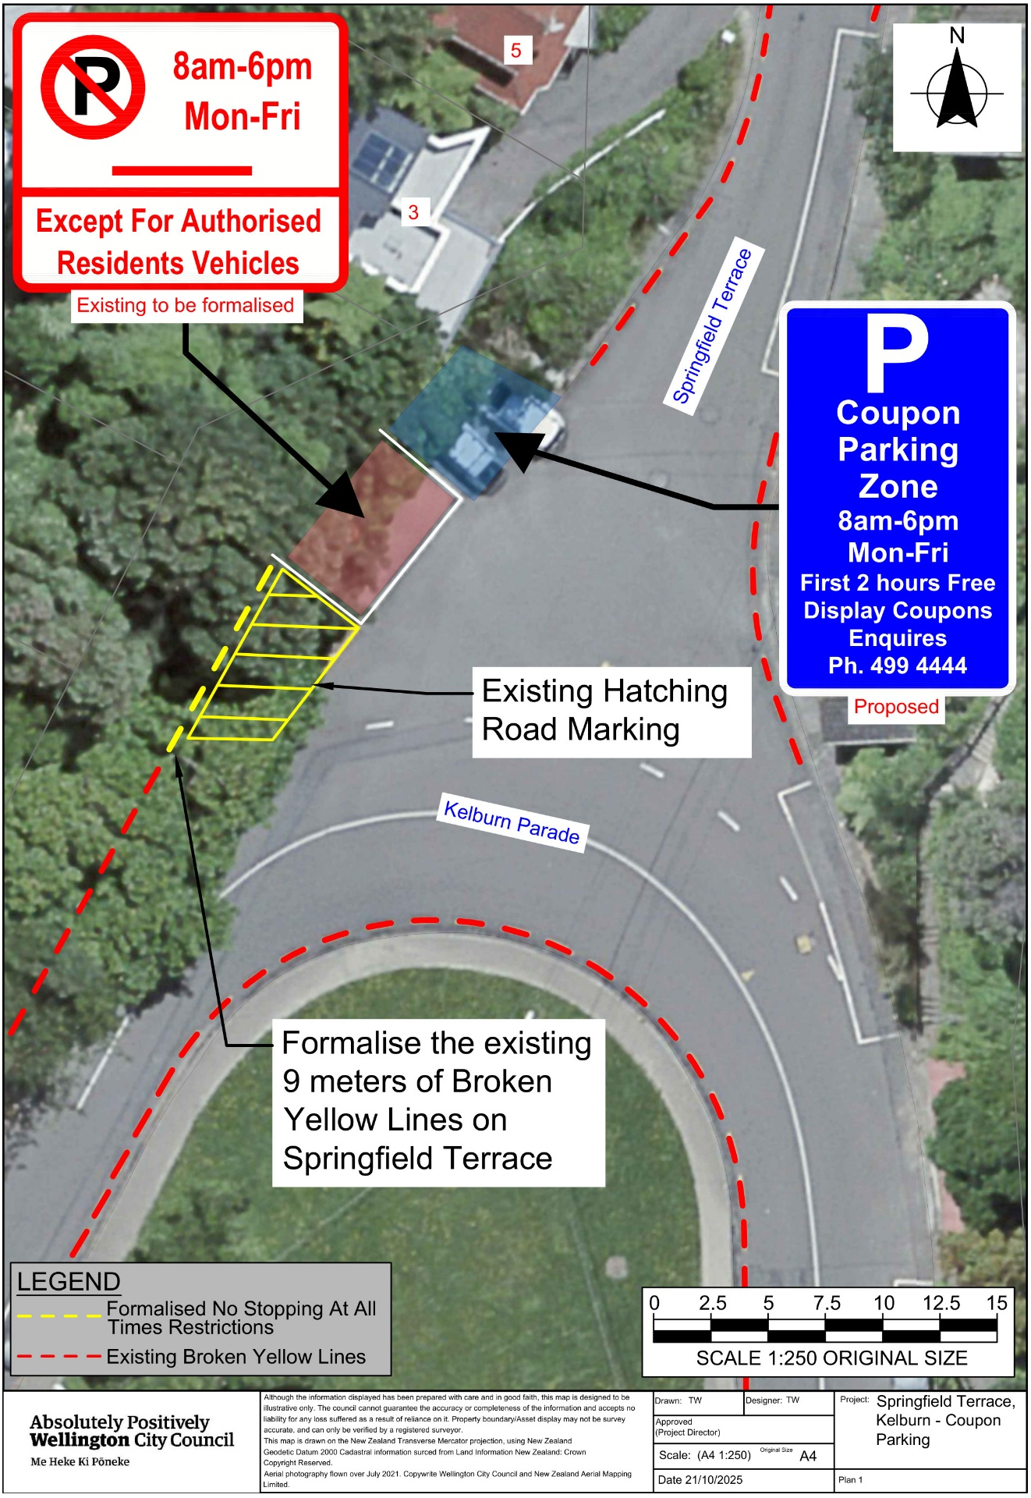
Traffic Resolution Plan: TR18-26 Springfield Terrace, Kelburn – Coupon Parking
Legal Description:

Delete from Schedule D (No Stopping) of the Traffic Restrictions Schedule

Column One | Column Two | Column Three
Springfield Terrace | No Stopping At All Times | West side, commencing from its intersection with Kelburn Parade and extending in a northerly direction following the western kerbline for 16 metres.

Delete from Schedule E (Resident Parking) of the Traffic Restrictions Schedule

Column One | Column Two | Column Three
Springfield Terrace | No Stopping Except for Authorised Resident Vehicles, Monday to Friday, 8:00am - 6:00pm | West side, commencing 16 metres from its intersection with Kelburn Parade and extending in a northerly direction following the western kerbline for 7 metres.

Add to Schedule D (No Stopping) of the Traffic Restrictions Schedule

Column One | Column Two | Column Three
Springfield Terrace | No Stopping At All Times | West side, beginning at its intersection with Kelburn Parade (X = 1,747,807.34 Y = 5,427,404.46) and extending in a northerly direction for 9 meters following the western kerbline.

Add to Schedule E (Resident Parking) of the Traffic Restrictions Schedule

Column One | Column Two | Column Three
Springfield Terrace | No Stopping Except for Authorised Resident Vehicles, Monday to Friday, 8:00am - 6:00pm | West side, beginning 9 meters from its intersection with Kelburn Parade (X = 1,747,807.34 Y = 5,427,404.46) and extending in a northerly direction for 7 meters following the western kerbline.

Prepared By: | Tommy Wilson | (Transport Engineering Assistant)
Approved By: | Kate Gourdie | (Team Leader Traffic & Resolutions)
Approved Date: | 19/11/2025

