Kia ora,

We would like to inform you about a proposed change in your neighbourhood.

Proposal:

Reference | - TR39-25 Sar Street, Pipitea - P60 Time Restriction
Location – where we propose to make the change | Sar Street, Pipitea outside 25 Hutt Road.
What we’d like to do | - Install P60 time limited parking restriction
Why we are proposing the change | - Council have received the reinstatement application of the vehicle crossing on Sar Street which is being obstructed by existing parking lines. Council have removed these lines of unrestricted parking and propose to resolute the remaining area to P60.  - To improve parking turn-over and increase parking availability for nearby businesses, Council Officers are proposing P60 parking restrictions.  - The proposed changes are outside of the Wadestown Parking Management changes and are not included in the residents exempt parking scheme to be installed in other parts of Sar Street.
Impact | Improvements  - Improves the viability of business wellbeing  - Improves parking availability  Net Parking Impact  - Converting eight unrestricted parking spaces to P60 parking spaces  Pedestrian impact  - No Change
Other options considered | Option 1:  - Retain section two as unrestricted parking. This option is not preferred, as it does not facilitate parking turnover in the area and is inconsistent with the existing parking restrictions on Hutt Road.
How this relates to the parking policy | - Support business wellbeing – ensure parking management and pricing controls support economic activity in the central city, suburban centres and mobile trades and services.
Additional Information | - Average daily traffic count – 751.7 (2014)  - To view the legal description for this Traffic Resolution, an electronic copy of the report will be available on the Council’s website from 9.00am Wednesday 30 April 2025 at https://www.letstalk.wellington.govt.nz/ or you can call (04) 499 4444 and we will send one out to you.
Privacy | - Your privacy is important to us. Please DO NOT add specific personal details to your feedback (i.e.: full name, address, etc)  - What we do with your personal information:  All submissions (including your first name, but not contact details) are provided in their entirety to elected members and made available to the public on our website and at our office. Personal information (including contact details) will also be used for the administration of the consultation process including informing you of the outcome of the consultation. All information collected will be held by Wellington City Council, 113 The Terrace, Wellington, with submitters having the right to access and correct personal information.  - For more information regarding our Privacy Statement please check our webpage: Privacy statement - Wellington City Council.
Feedback | - If you would like to provide us with specific feedback, which will be added to the Traffic Resolution following consultation and made public in full, you can do so by filling out an online submission form, downloading a printable submission form on https://www.letstalk.wellington.govt.nz/ or emailing us at trfeedback@wcc.govt.nz.  Please note if you are giving feedback the consultation period opens at 9.00am Wednesday 30 April 2025 and finishes at 5.00pm Wednesday 14 May 2025.
Next Steps | - Feedback collated by Thursday 15 April 2025.  - The proposal will go to the Koata Hātepe|Regulatory Processes Committee meeting on Wednesday 18 June 2025.  - If approved, the proposal will be installed within the following three months.

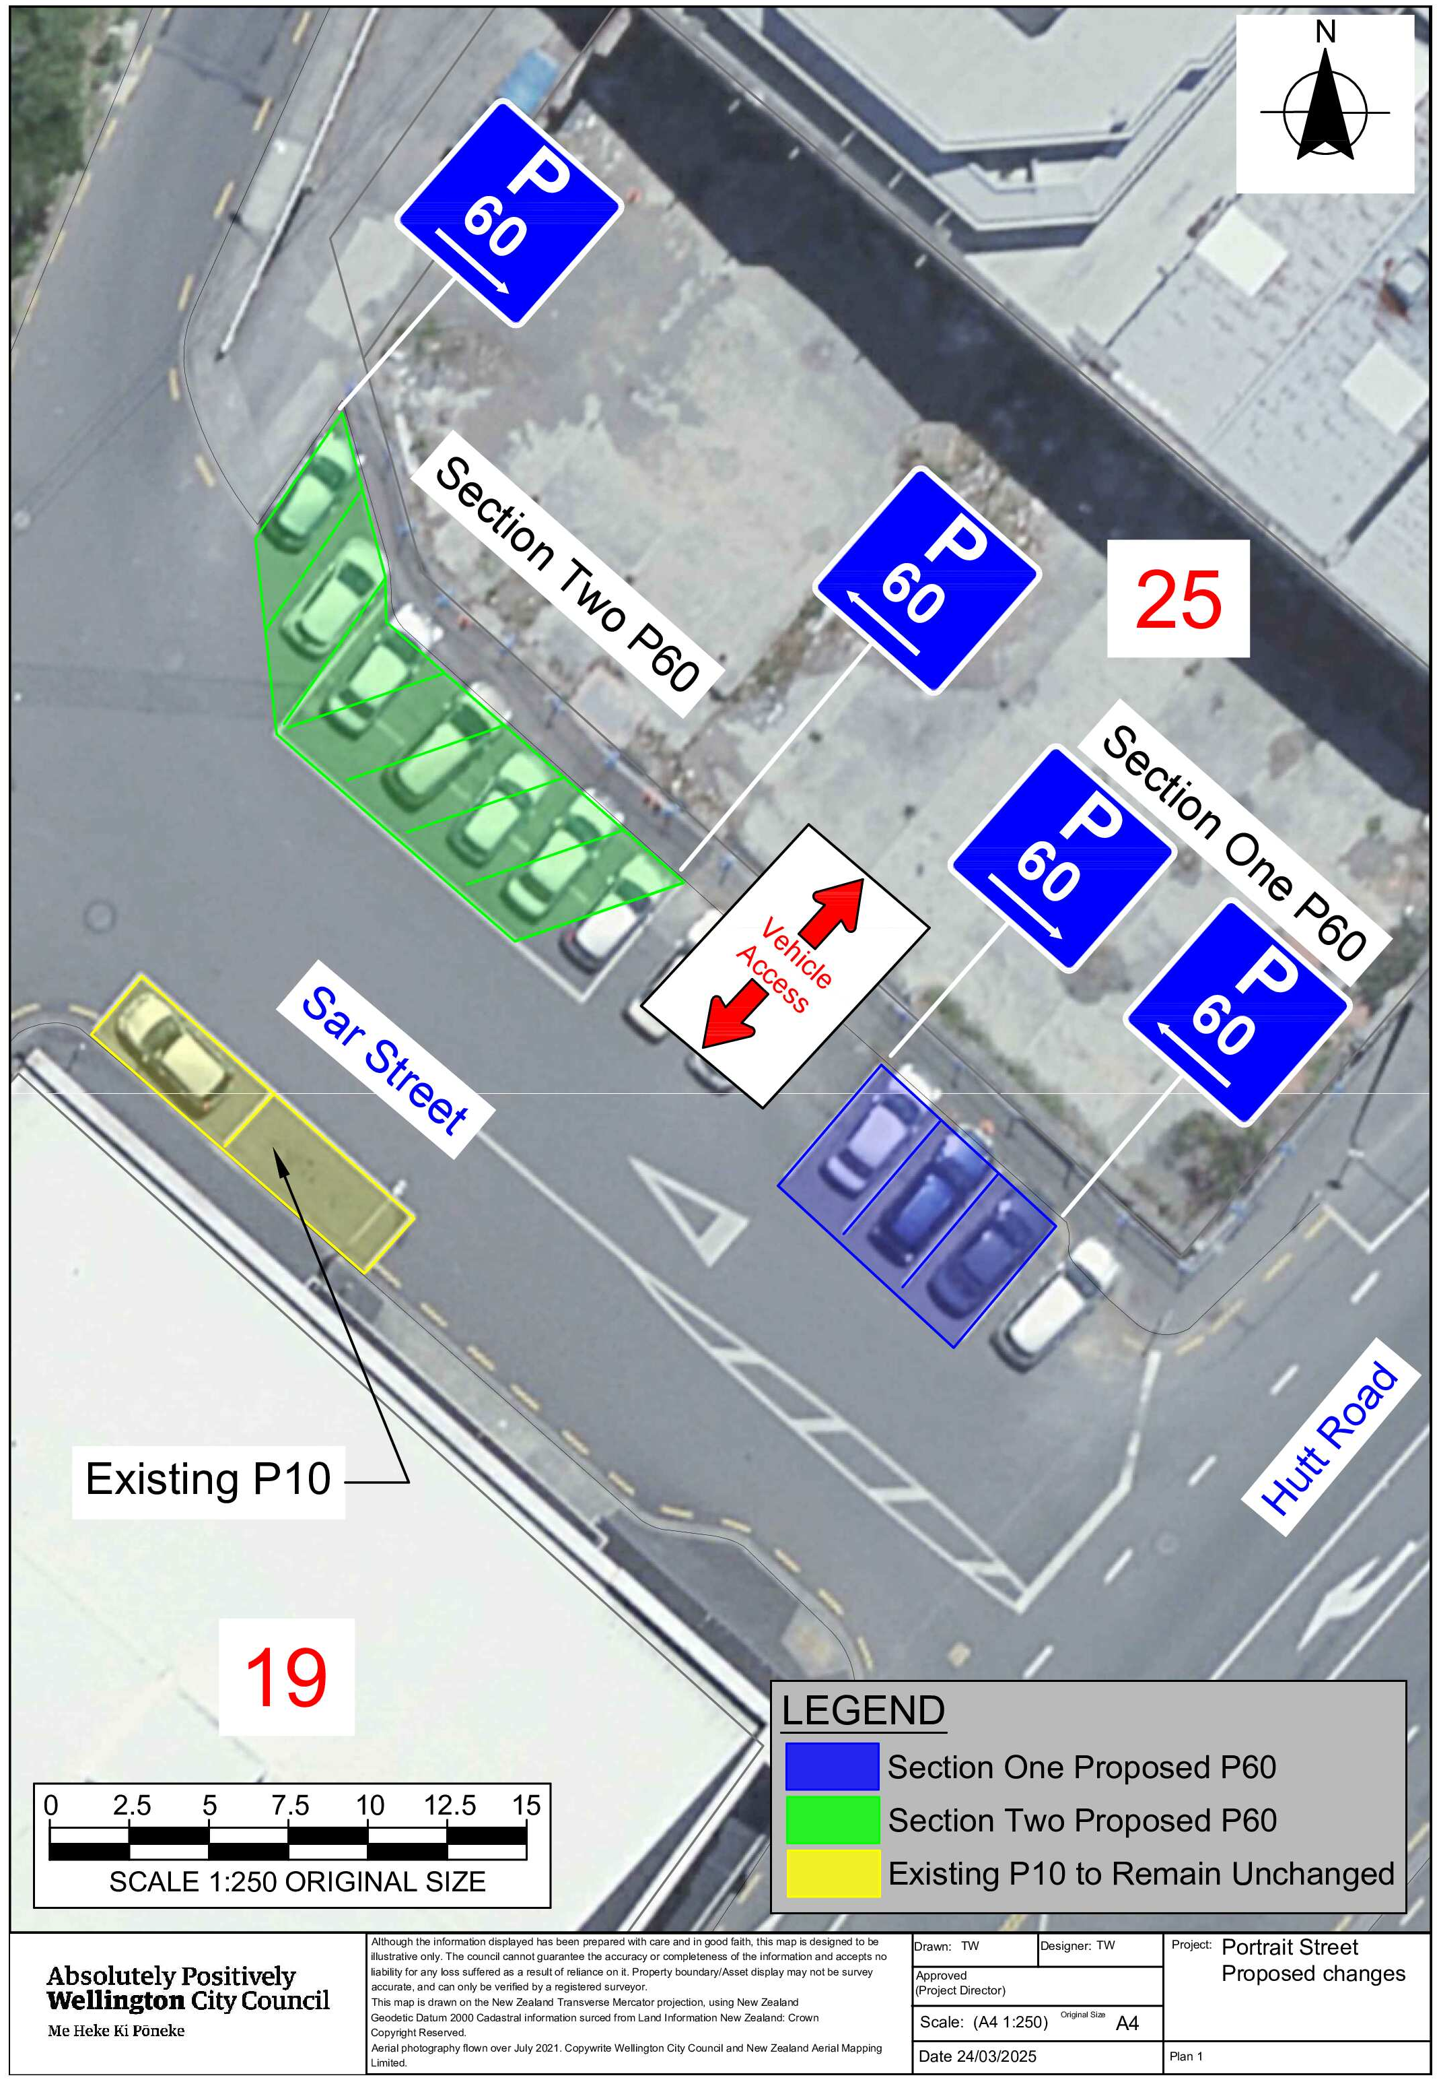
Traffic Resolution Plan: TR39-25 Sar Street, Pipitea - P60 Time Restriction

Legal Description:

Add to Schedule A (Time Limited) of the Traffic Restrictions Schedule

Column One | Column Two | Column Three
Sar Street | P60  8:00am – 6:00pm  (Monday – Sunday) | North side, commencing 6 metres west of its intersection with Hutt Road (Grid coordinates X=1,749,268.31m Y=5,430,111.83m) and extending in an Westerly direction following the northern kerb line for 7.5 metres.
Sar Street | P60  8:00am – 6:00pm  (Monday – Sunday) | North side, commencing 22 metres west of its intersection with Hutt Road (Grid coordinates X=1,749,268.31m Y=5,430,111.83m) and extending in an Westerly direction following the northern kerb line for 19 metres.

Prepared By: | Tommy Wilson | (Transport Engineering Assistant)
Approved By: | Kate Gourdie | (Team Leader Traffic & Resolutions)
Approved Date: | 10/04/2025

