Kia ora,

This leaflet is to let you know about a change we are making in your neighbourhood. These changes are required by the Land Transport Rule: Setting of Speed Limits 2024. We are seeking your feedback on specific parts of the changes.

Reference | - TR 62-26 TKKM o Ngā Mokopuna – Variable Speed Limit Scope Amendment
Location – where we propose to make the change | Marine Parade, Falkirk Avenue, Forres Street, and Inglis Street from 8:20am-9:10am and 2:40pm-3:40pm School Days Only  Ventnor Street: The amendment is to include variable speed 30km/hr 8:20am-9:10am and 2:40pm-3:40pm School Days Only on Ventnor Street. The previous 50km/hr signs have now been removed.
What is the change | - The proposed change is to is remove the location the 50km/hr signs originally approved on 28th August 2025 (TR82-25) on Ventnor Street.  - After further consultation, it was found that the school have an additional school gate on Ventnor Street which means this needs to be part of the variable speed limit zone, operating at 30 km/hr speed during school pick up and drop off hours. Therefore, this proposal seeks to update the zone to include Ventnor Street.  - By moving the sign locations, this also requires an update to the legal description database which is included in this traffic resolution.  - For more details, please refer to original and amended plans included below.
Why is the change being made | - This change is an amendment to the initial changes required by the Land Transport Rule: Setting of Speed Limits 2024.
Impact | - Pedestrian/vehicle impact – Improves pedestrian safety by slowing down vehicle speed around schools during drop off and pick up times. In the event of an incident lower vehicle speed reduces the risk for the crash and the severity of injury. As a result, the outcome of the incident is likely to be less severe than if the vehicle was travelling at a higher speed.
Additional Information | - To view the legal description for this Traffic Resolution, an electronic copy of the report will be available on the Council’s website from 10 June 2026 at https://wellington.govt.nz/Your-Council/Projects/Safe-speed-limits-outside-schools
Privacy | - Your privacy is important to us. Please DO NOT add specific personal details to your feedback (i.e.: full name, address, etc)  - What we do with your personal information:  All submissions (including your first name, but not contact details) are provided in their entirety to elected members and made available to the public on our website and at our office. Personal information (including contact details) will also be used for the administration of the feedback process including informing you of the outcome of the feedback. All information collected will be held by Wellington City Council, 2 Harris Street, Wellington, with submitters having the right to access and correct personal information.  - For more information regarding our Privacy Statement please check our webpage: Privacy statement - Wellington City Council.
Feedback | - If you would like to provide us with specific feedback, which will be added to the Traffic Resolution following consultation and made public in full, you can do so by filling out an online submission form, downloading a printable submission form on https://www.letstalk.wellington.govt.nz/ or emailing us at trfeedback@wcc.govt.nz.  - Please note if you are giving feedback this period opens at 9.00 am 10 June 2026 and finishes at 5.00 pm 24 June 2026.
Next Steps | - Feedback collated by 25 June 2026.  - The proposal will go to the Te Takere| Regulatory Processes Committee meeting 5 August 2026.

Legal Description: (Delete)

Table 1: Proposed variable speed limits for TKKM o Ngā Mokopuna

Column One | Column Two | Column Three
Marine Parade | 30kph  8:20am-9:10am 2:40pm-3:40pm  School Days Only | Beginning 81 metres east from its intersection with Ferry Street (Grid coordinates X=1,753,189.325, Y=5,424,148.147) and extending in an easterly direction following the northern kerb line for 301 metres.
Falkirk Avenue | 30kph  8:20am-9:10am 2:40pm-3:40pm  School Days Only | Beginning 17 metres south of its intersection with Forres Street (Grid coordinates X=1,753,282.185, Y=5,423,897.467) and extending in a northerly direction for 138 metres.
Forres Street | 30kph  8:20am-9:10am 2:40pm-3:40pm  School Days Only | Beginning 17 metres east of its intersection with Ferry Street (Grid coordinates X= 1,753,120.221, Y= 5,423,962.703) and extending in an easterly direction for 276 metres.
Inglis Street | 30kph  8:20am-9:10am 2:40pm-3:40pm  School Days Only | Beginning 15 metres south of its intersection with Marine Parade (Grid coordinates X=1,753,420.218, Y=5,423,941.702) and extending in a northerly direction following the eastern kerb line for 15 metres.
Ventnor Street | 30kph  8:20am-9:10am 2:40pm-3:40pm  School Days Only | Beginning 17 metres south of its intersection with Marine Parade (Grid coordinates X= 1,753,211.366, Y= 5,424,096.511) and extending in a northerly direction for 17 metres.
Ventnor Street | 30kph  8:20am-9:10am 2:40pm-3:40pm  School Days Only | Beginning 29 metres south of its intersection with Forres Street (Grid coordinates X= 1,753,161.665, Y= 5,423,915.132) and extending in a northerly direction following the westerly kerb line for 57 metres.

Legal Description: (Add)

Table 2: Proposed variable speed limits for TKKM o Ngā Mokopuna

Marine Parade | 30kph  8:20am-9:10am 2:40pm-3:40pm  School Days Only | Beginning 81 metres east from its intersection with Ferry Street (Grid coordinates X=1,753,135.36 Y=5,424,173.11) and extending in an easterly direction following the northern kerb line for 295 metres.
Falkirk Avenue | 30kph  8:20am-9:10am 2:40pm-3:40pm  School Days Only | Beginning at its intersection with Marine Parade (Grid coordinates  X=1,753,320.05 Y=5,424,030.96) and extending in a southerly direction for 150 metres.
Forres Street | 30kph  8:20am-9:10am 2:40pm-3:40pm  School Days Only | Beginning 17 metres east of its intersection with Ferry Street (Grid coordinates X= 1,753,104.90 Y=5,423,966.00) and extending in an easterly direction for 276 metres.
Inglis Street | 30kph  8:20am-9:10am 2:40pm-3:40pm  School Days Only | Beginning at its intersection with Marine Parade (Grid coordinates X=  1,753,423.14 Y=5,423,956.80 and extending in a southerly direction for 15 metres.
Ventnor Street | 30kph  8:20am-9:10am 2:40pm-3:40pm  School Days Only | Beginning at its intersection with Marine Parade (Grid coordinates X=  1,753,217.25 Y=5,424,111.49) and extending in a southerly direction for 214 metres.

Amended Traffic Resolution Plan: TR62-26 TKKM o Ngā Mokopuna - Variable Speed Limit
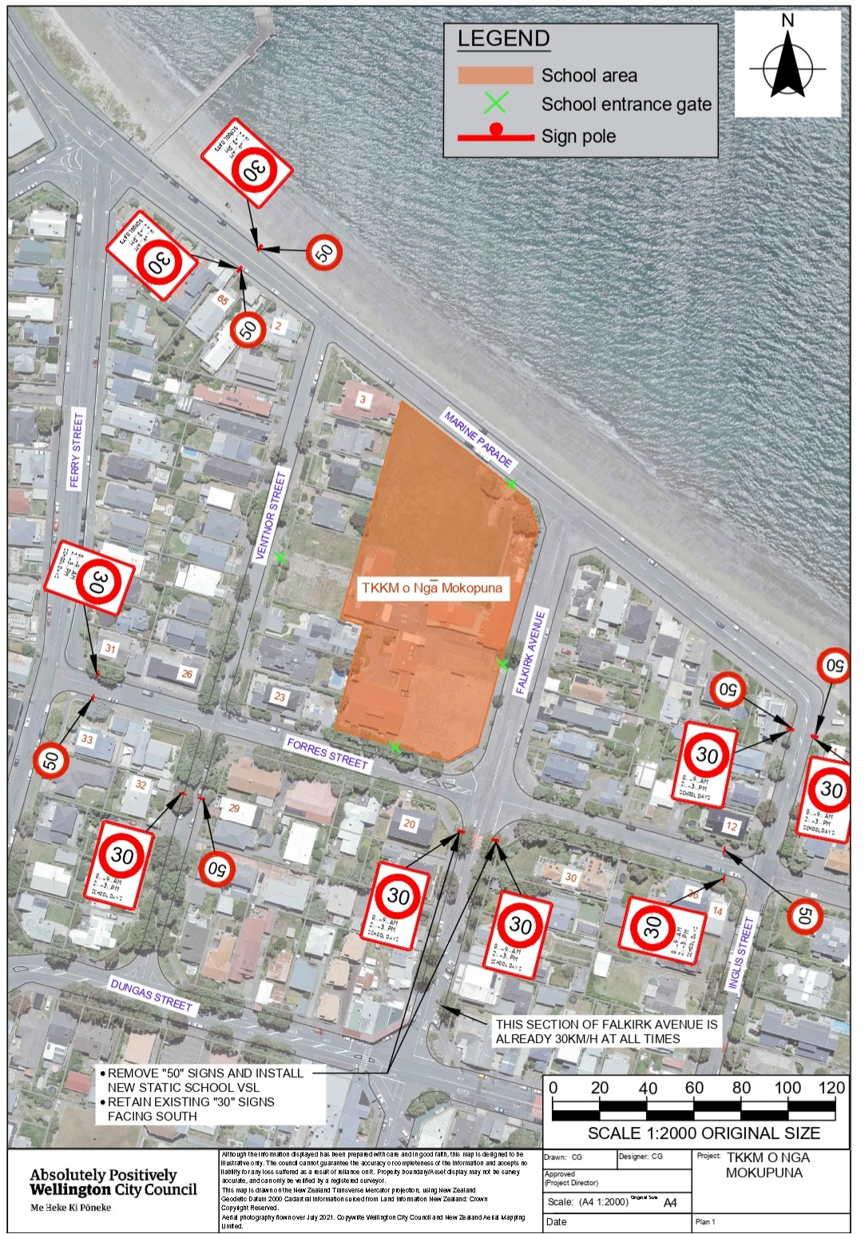
Original Traffic Resolution Plan: TR82-25 TKKM o Ngā Mokopuna - Variable Speed Limit
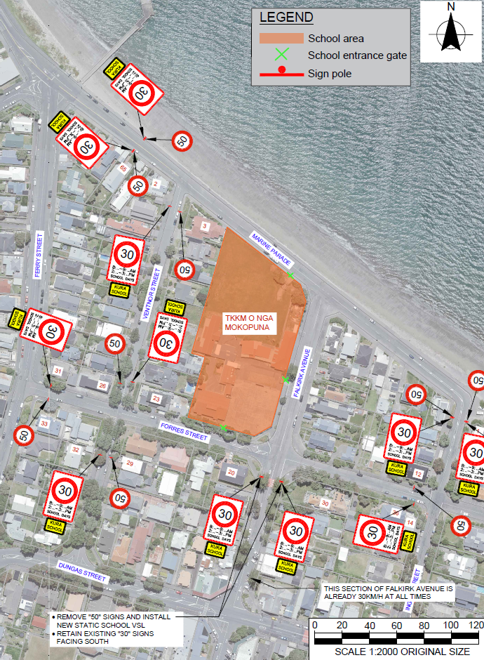

Location: 65 Marine Parade (eastbound)

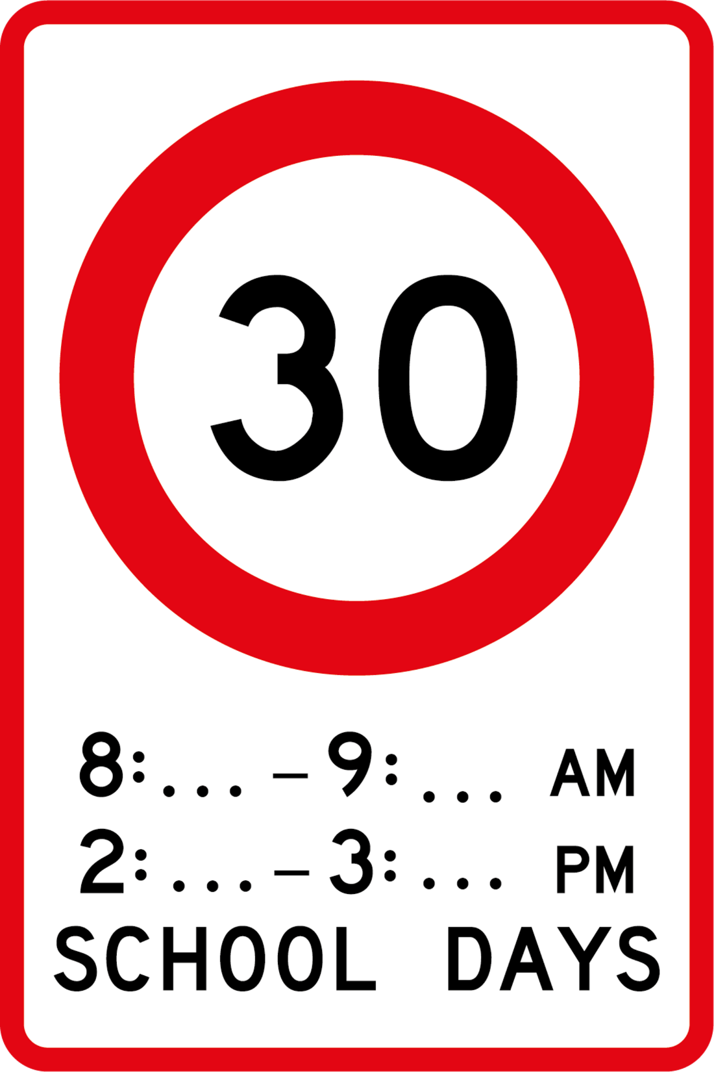
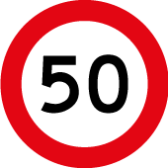
Signs at the back of each post
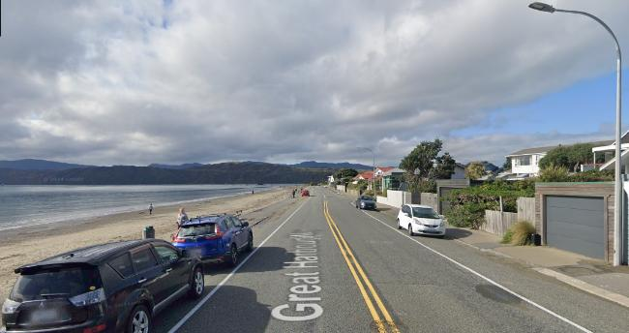
Location: 65 Marine Parade (westbound)
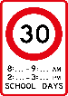
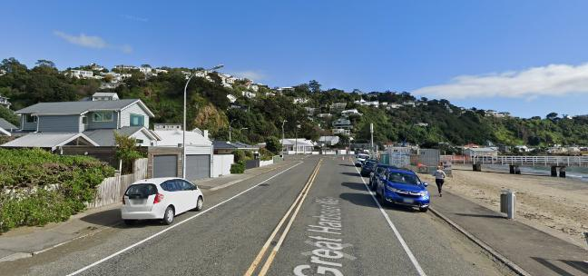
Sign at the back of each post
Existing Variable Speed Limit for TKKM o Ngā Mokopuna -Retain

Location: Forres Street- next to house in 31 Ferry Street
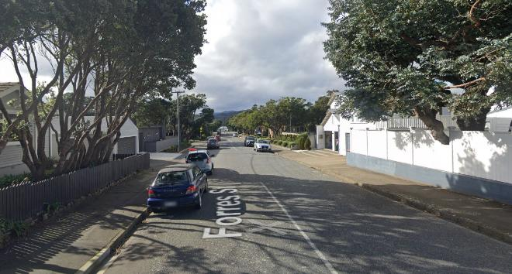
Location: Forres Street – next to house in 33 Ferry Street
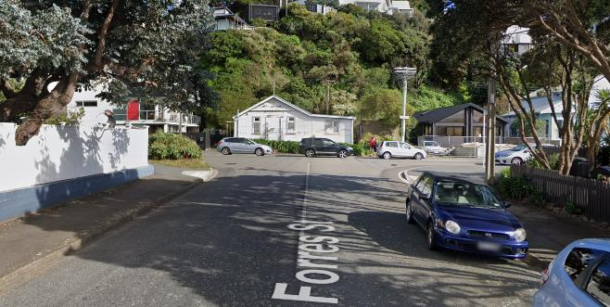

Location: 36 Forres Street (Eastbound) – corner with 12 Inglis Street
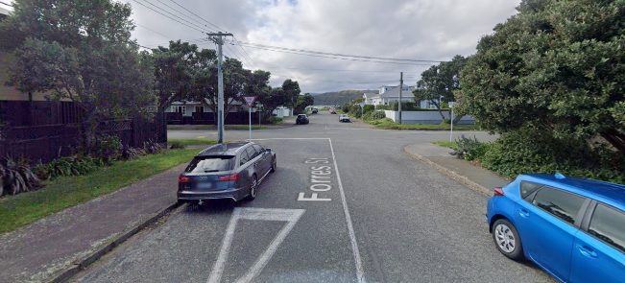
Location: 36 Forres Street (Westbound) – corner with 14 Inglis Street
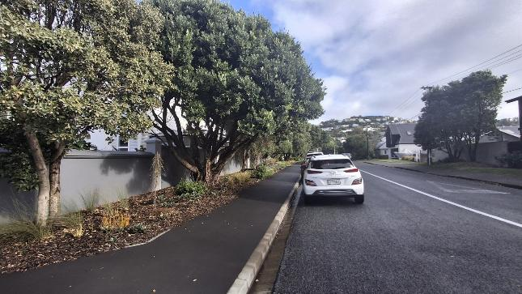

Location: 1 Inglis Street (northbound)
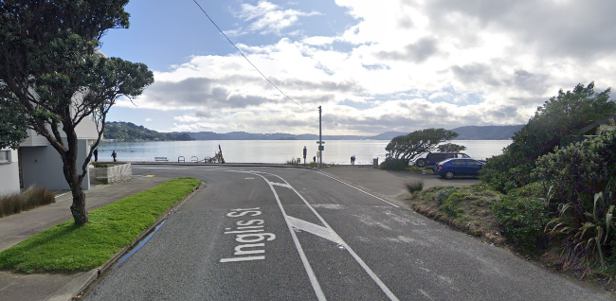
Location: 1 Inglis Street (southbound)
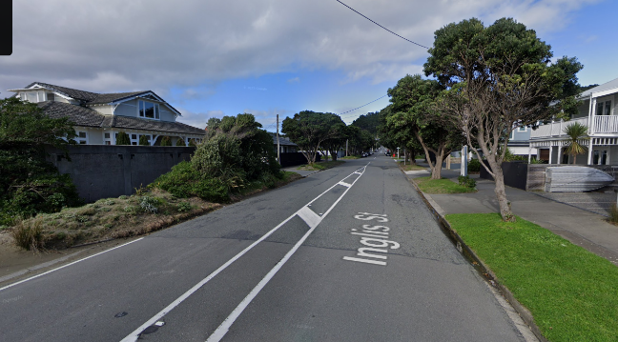
Sign at the back of each post
Signs at the back of each post

Location: 20 Falkirk Avenue (northbound)
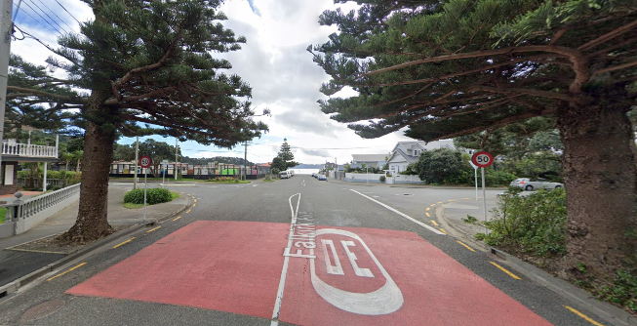
Remove existing “50” signs from poles and replace for VSL signs

Location: 32 Ventnor Street (northbound)
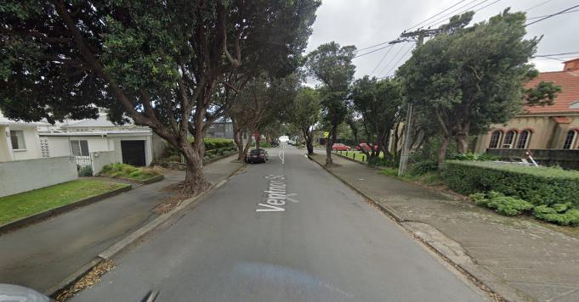
Location: 29 Ventnor Street (southbound)
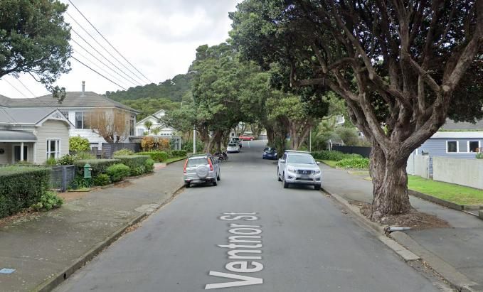

Existing Variable Speed Limit for TKKM o Ngā Mokopuna - Delete
Location: 3 Ventnor Street (southbound)
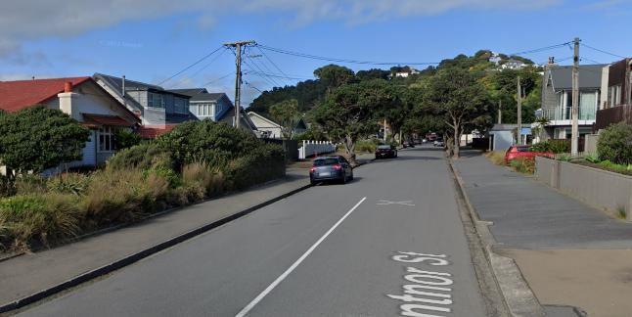
Location: 2 Ventnor Street (northbound)
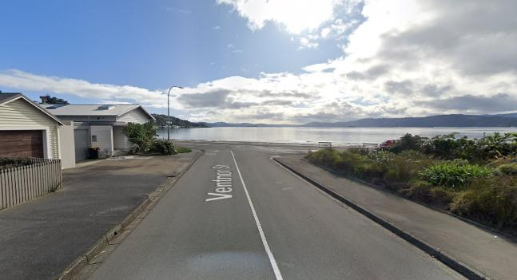
Location: 23 Ventnor Street (towards Forres Street)
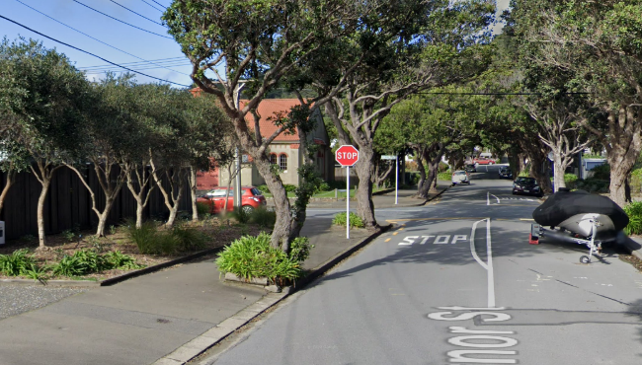
Location: 26 Ventnor Street
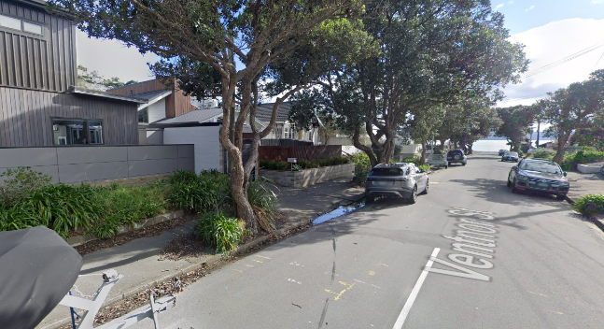
Prepared By: | Babitha Babu | (Transportation Engineer)
Approved By: | Kate Gourdie | (TL Traffic & Resolutions)
Approved Date: | 22/05/2026

