

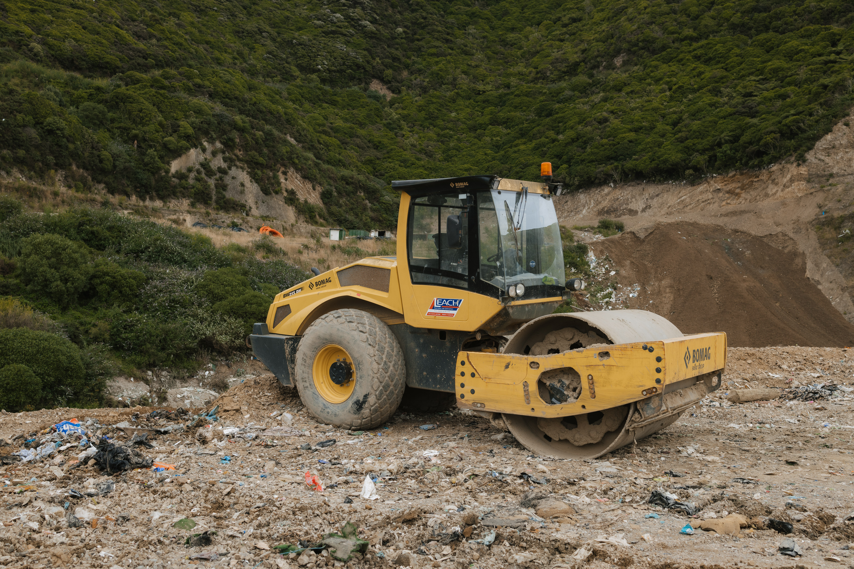
Para

Waste

Background report

March 2026

Contents

Purpose 2
Council Activities 2
What we do as a Council 3
Budget 3
Why is this activity important? 5
Current Direction 6
Direction from Legislation and National Regulations 6
Regional settings 7
Wellington City Council Settings 8
Indicators and trends 10
Change towards a circular economy is hard to measure 11
Community satisfaction and behaviour generally consistent 12
Infrastructure and systems to increase resource circularity are in development 12
Stakeholder views on Waste 14
Tākai Here partners 14
Key issues and opportunities 15
Changing context in landfill management 15
Life of the landfill and ongoing fill rates 15
Minimising emissions at the landfill 16
Gaps in resource recovery infrastructure 17
Unnecessary waste and divertible materials end up in landfill 17
Increasing Construction and Demolition (C&D) waste and minimal options for processing or reuse 17
Cost and other barriers make it difficult for community and business participation in waste minimisation 18
Responding to consumer and business behaviour 18
Engaging with the disabled community to ensure everyone can access waste services 18
Involving the community in waste minimisation 19
Partnering with Tākai Here partners and incorporating a te ao Māori approach to resource management 20
Regional collaboration can offer economies of scale 21

Purpose
This background report provides a clear, evidence‑based overview of Wellington City Council’s Waste activity. It sets out what the Council does, why it does it, how it is funded, how it is performing, and the key issues shaping future choices.

The report is intended to support informed engagement with the Council’s role in Waste. It provides advisory groups with shared context on Council responsibilities, settings, constraints, and strategic direction, and supports elected members by bringing together relevant information, performance insights, stakeholder views, and emerging challenges to inform deliberations through the Long-term Plan (LTP) 2027–2037 process.

This is not a strategy or a set of recommendations. Rather, it is a foundation document that identifies current settings, pressures, and opportunities, and surfaces the key trade‑offs that will need to be considered as the Council refreshes its strategic direction and investment approach for waste within a constrained fiscal environment.

Council Activities
A Council ‘activity’ is a formal Local Government Act 2002 (LGA 2002) term to refer to Council goods and services. Council activities are grouped for the purposes of the Long-term Plan and budgets – some are relatively stand-alone like transport.
This group of activities includes:
2.2 Waste
2.2.1 Waste minimisation, disposal and recycling
2.2.2 Closed landfills aftercare

What we do as a Council
This activity is responsible for:
- Providing and managing waste services and infrastructure, including kerbside collection of rubbish and recycling, and recyclables processing.
- Management of the Southern Landfill asset, including the transfer station, landfill operations on Stage 3, composting facilities and development and sales of Capital Compost products and the extension of the landfill to provide landfill capacity post-Dec 2027, when consents for Stage 3 expire. The Council also has a partial ownership stake in the Spicer Landfill in Porirua, which serves as the waste disposal site for the northern suburbs of Wellington. This is proposed for closure in 2030.
- Operating the Tip Shop and Recycle Centre, which diverts waste from the landfill by reselling reusable goods and provides for additional residential recycling.
- Managing Kiwi Point Quarry, which accepts clean concrete waste from nearby manufacturers, and recycles concrete by crushing it into various grades of aggregate that are then sold.
- Overseeing management of closed landfills, including gas monitoring and management.
- Working with regional partners, mana whenua and the Ministry for the Environment (MfE) on significant waste management and minimisation projects.
- Partnering with community partners for resource recovery, for example Te Aro Zero Waste Hub.
- Working with community organisations to undertake community education, business engagement, funding waste minimisation projects through the Waste Minimisation Fund, and supporting local composting hubs and events to transition away from single-use products.

Budget
You can find more information in the LTP 2024 Amendment.

Percentage of total council spend:
Opex – 3.7%
Capex – 2.1%

Operating Expenditure
Activity Component Name | Income/  Expense | 2024/25 | 2025/26 | 2026/27 | 2027/28 | 2028/29 | 2029/30 | 2030/31 | 2031/32 | 2032/33 | 2033/34
2.2.1 Waste minimisation, disposal and recycling | Expense | 35,419 | 37,387 | 40,866 | 54,978 | 57,644 | 61,188 | 64,279 | 66,321 | 68,489 | 70,983
2.2.1 Waste minimisation, disposal and recycling | Income | (32,592) | (35,017) | (36,537) | (32,855) | (35,241) | (36,802) | (38,825) | (40,848) | (42,926) | (45,049)
2.2.2 Closed landfills aftercare | Expense | 511 | 62 | 73 | 72 | 76 | 81 | 87 | 94 | 99 | 103
Total |  | 3,338 | 2,432 | 4,403 | 22,194 | 22,479 | 24,467 | 25,542 | 25,567 | 25,662 | 26,037
In addition to the income above we also receive a circa $4m annual revenue from the Ministry for the Environment waste levy. By law, this money is earmarked for waste minimisation activities.

Capital Expenditure
Activity Component Name | 2024/25 Published budget | 2024/25  Amendment budget | 2025/26 | 2026/27 | 2027/28 | 2028/29 | 2029/30 | 2030/31 | 2031/32 | 2032/33 | 2033/34
2.2.1 Waste minimisation, disposal and recycling | 15,334 | 9,494 | 16,615 | 35,840 | 28,987 | 11,160 | 5,059 | 5,439 | 6,951 | 7,181 | 7,521
Total | 15,334 | 9,494 | 16,615 | 35,840 | 28,987 | 11,160 | 5,059 | 5,439 | 6,951 | 7,181 | 7,521
From year 3 we are changing our services to: a new organics collection service in wheelie bins, a wheelie bin collection for rubbish, larger 240L recycling wheelie bins, and no change to the 45L glass crate collection service.
There will be a new targeted rate to fund the rubbish and organics changes. The recycling collection will continue to be funded through the landfill gate fees. We will also investigate implementation trials for the collection of waste at Multi-Unit Developments, and in the central city.

Waste Funding Sources
These activities, with the exception of the closed landfill provision, are entirely financed through user fees, charges and the waste minimisation levy. This means waste management has its own dedicated funding sources and does not rely on funding from general council rates.

Surplus revenue from the waste minimisation levy is reinvested into further waste minimisation initiatives. Waste finances are ringfenced, so waste management operates financially separate from other council services, ensuring its budget is independent and only used for waste-related purposes. However, there are impacts to the revenue streams when we work to remove waste from the landfill. This shift in funding approach reflects a complex combination of national and local policy decisions, which in turn are impacting the funding model, operating costs, and revenue streams for waste services. As a result, we will need to carefully consider our investment and operating model choices to ensure the long-term sustainability and effectiveness of these services.

Activity | User Fees (including Waste Levy) | Rates Contribution
Waste minimisation, disposal & recycling management | 100% | 0%
Closed Landfills Aftercare | 0% | 100%*
New Addition Y3:  Collection of Organics & Rubbish | 0% | 100%**
*General rates, **Residential targeted. Source: 2024 LTP Volume 2

Why is this activity important?
Effective waste management delivers significant benefits for the city. It extends the life of the landfill, lowers operational costs, emissions, odour, and the need for more land. It also prevents pollution, protects air, water, and soil, and safeguards public health by ensuring rubbish is managed safely. Waste services create jobs and support economic activity, especially for businesses focused on composting, recycling, and reuse. Maintaining clean public spaces enhances the city's appeal and quality of life. Public submissions on the Zero Waste Strategy and WMMP highlight the importance of these outcomes for environmental and community wellbeing. Waste management affects all aspects of city life, with lasting impacts on our environment, health, and carbon emissions.

Across the globe, patterns of consumption and waste are inflicting significant environmental harm on land, air, and water. The extraction of resources from the earth to manufacture products leads to packaging and goods that frequently end up in landfills, or worse, find their way into waterways and eventually the world’s oceans. This process of material extraction is also intrinsically connected to carbon emissions.

A circular economy, known as ōhanga āmiomio and emphasised in the Zero Waste Strategy, seeks to eliminate waste and pollution, keep products and materials circulating within the economy, and restore natural systems. This approach involves maximising the lifespan of resources, whether as finished products or as components and raw materials, thereby reducing the pressure for new resource extraction. Adopting a circular economy can unlock a range of benefits, including long-term cost savings, the creation of local jobs, the encouragement of technical innovation, a reduction in harmful waste, and a positive influence on the climate by decreasing the need for new raw materials.

While these wider benefits of a circular economy, such as job creation, innovation, and reduced resource extraction, are well-supported by both national and international evidence and are reflected in Council policy, local consultation feedback highlights that Wellingtonians specifically support waste reduction, improved resource recovery services, and actions that lessen environmental harm. These locally identified priorities continue to shape the Council’s waste minimisation and circular economy initiatives, guiding efforts toward a cleaner, healthier, and more sustainable future for Wellington.

Current Direction

Direction from Legislation and National Regulations
Local authorities are responsible for waste management and minimisation under the combined provisions of the Local Government Act 2002 and the Waste Minimisation Act 2008. In the proposed Local Government (System Improvements) Amendment Bill “waste management and minimisation” is included in the list of core services local authorities will be expected to consider in performing their role (proposed new section 11A of the LGA 2002).

The Waste Minimisation Act 2008 encourages waste minimisation and a decrease in waste disposal to protect the environment. It sets out that a territorial authority must promote effective and efficient waste management and minimisation within its district by adopting and implementing a Waste Management and Minimisation Plan that includes collection, recovery, recycling, treatment, disposal services and facilities, and education activities.

The Waste Minimisation Act also provides for a Waste Levy; a levy imposed on waste disposed at disposal facilities (such as landfills). A proportion of the levy, around 50%, is allocated to territorial authorities to "promote or achieve waste minimisation and in accordance with its waste management and minimisation plan”. How the government’s portion of the levy can be used has recently been changed (under urgency), expanding it from waste minimisation purposes only, to now include wider environmental benefit, emergency waste, and remediation of contaminated sites and closed landfills. So far, these changes don’t impact the territorial authority’s portion of the funding, although there are strong indications that the government intends to pass legislation that will change the proportional split to assist smaller councils, and what the local government proportion can be spent on will also change.

The Waste Minimisation Act legislation is currently being reviewed and is proposed to be amalgamated with the Litter Act 1979. The current Litter Act manages litter and the responsibility of territorial authorities to provide rubbish bins and mechanisms to prevent litter in public spaces.

The Resource Management Act 1991 (RMA) manages land use, water, air, soil and coastal resources, including matters such as biodiversity, natural hazards, landscapes, discharges, and land use zoning. The Southern Landfill and closed landfills must comply with the requirements of resource consents and the designation issued under the RMA. The RMA reform is likely to have impacts on resource consents into the future.

In late December 2025, the Resource Management (Duration of Consents) Amendment Act came into force. This means that the resource consents that were due to expire in 2026 can now continue until December 2027.

Regional settings
The primary regional document governing the waste activity is the Wellington Region Waste Management and Minimisation Plan, required by the Waste Minimisation Act.

In February 2024, the eight councils in the Wellington Region adopted the Wellington Region Waste Management and Minimisation Plan 2023-2029. The plan sets a vision, objectives, targets, and regional and local action plans, with the aim of taking us closer to a future where we collectively care for all our resources. The targets are to reduce the total amount of material that needs final disposal to landfill by 10% by 2027, and 30% by 2030.
The region’s councils will contribute to this by working towards the following objectives.
- Ensuring construction and demolition waste processing and recovery is available in the Wellington region by 2026.
- Ensuring organic processing systems are available to the Wellington region by 2029.
- Ensuring five new resource recovery locations are added to the existing network within the Wellington region by 2030.
- Reduce emissions from biogenic methane by reducing the total amount of organic waste disposed to landfill by 50% by 2030.
- Reduce emissions from the collection and transport of kerbside waste by 30% by 2030.
- Ensure all urban households have access to kerbside recycling collections by 2027.
- Ensure food scraps collection services are available to urban households by 2030.
- For each council to engage with and support 30% of the business community to minimise waste and implement waste minimisation activities by 2029.

Implementation of the WMMP is overseen by a Steering group made up of council officers and a Joint Committee consisting of elected members.

Greater Wellington Regional Council (GWRC)’s Natural Resources Plan sets out a framework for managing the natural resources for the Wellington region. Landfills must operate within this plan and meet resource consents issued by GWRC. Regulatory requirements are increasing, which has cost and resource implications for Councils.

Wellington City Council Settings
Waste services sit within the broader Activity Group Environment and Infrastructure in the Long-term Plan. It contributes primarily to the strategic priority “Transform our waste system to enable a circular economy”.
The primary strategy governing the waste activity is He anamata para kore mō Pōneke - Zero Waste Strategy, adopted by the Council in April 2023. It outlines the Council’s approach to zero waste and the circular economy. The intended outcomes and objectives are outlined in Table 1.

Table 1: Zero Waste Objectives
Intended Outcomes | Objectives
Wellington moves towards a circular economy | Products and services provided in Wellington are waste free.
The community is equipped to reduce waste. | Waste reduction is made attractive and accessible to Wellingtonians.
Resources are repurposed and regenerated in Wellington. | Infrastructure and systems to increase resource circularity are in place.
Landfill capacity is treated as a finite resource. | Waste that cannot be avoided, reduced, reused, repaired, or recycled is managed safely.

Five targets have been established.
- Reduce kerbside waste by 2030 by 40%
- Reduce waste to landfill by 2030 by 50%
- Reduce biogenic methane gas emissions by 2035 by at least 30%
- Divert organic waste from landfill by 2030 by 50–70%
- Divert construction waste from landfill by 2030 by 50%
- Divert construction waste from landfill by 2035 by 70%

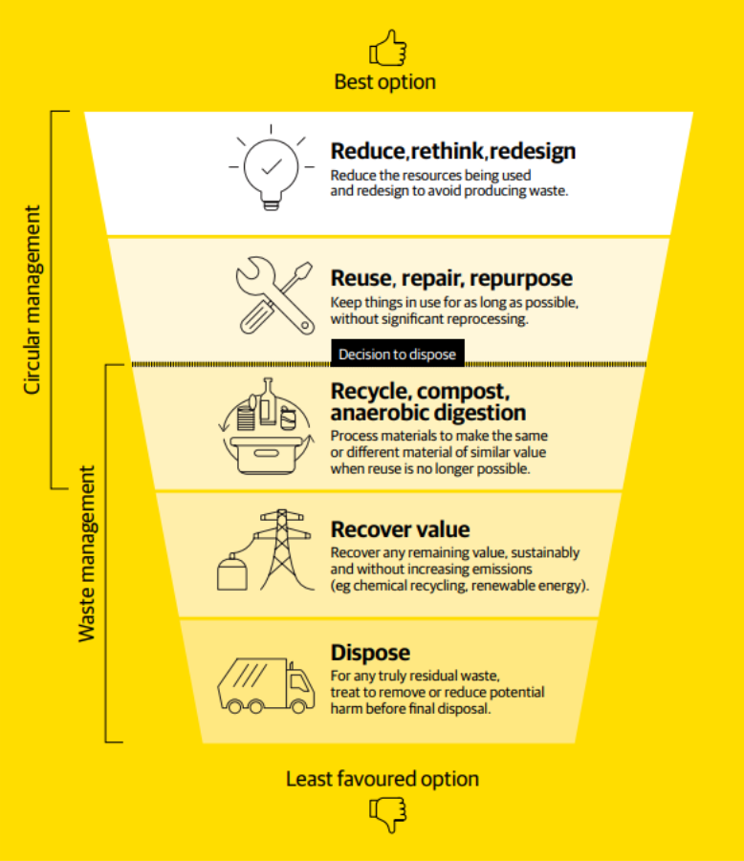
It sets out the waste hierarchy as follows:

The Economic Wellbeing Strategy and Te Atakura – First to Zero, support the direction and targets set out in the Zero Waste Strategy.

Indicators and trends
Total waste to landfill has reduced in the last few years but has increased since 2009.
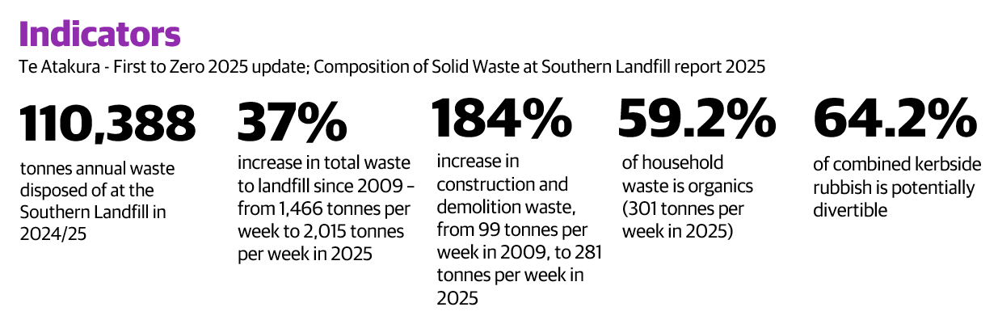
While unable to be determined for certain, it is likely that the reduction in total waste to landfill in the last few years can be attributed to the link between economic activity and waste volumes. Waste by source type is illustrated in the chart below. The recent increase in construction and demolition waste is likely due to the closure of the construction and demolition facilities.

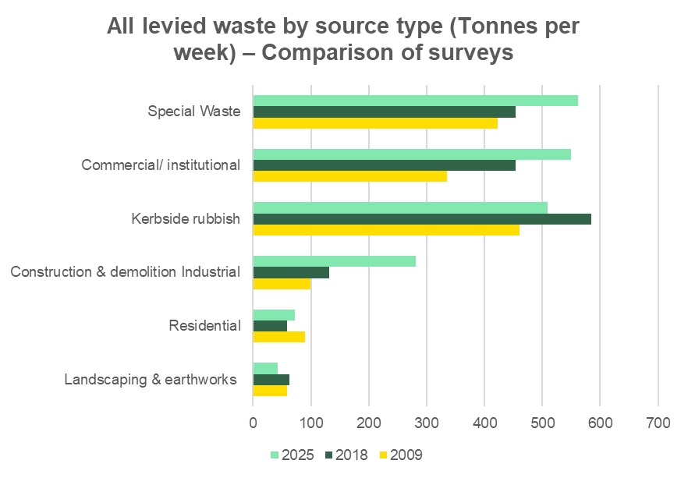
Note: Special Waste includes contaminated soil, sludge and asbestos.

There are different ways to look at waste. The waste by type is illustrated in the chart below.
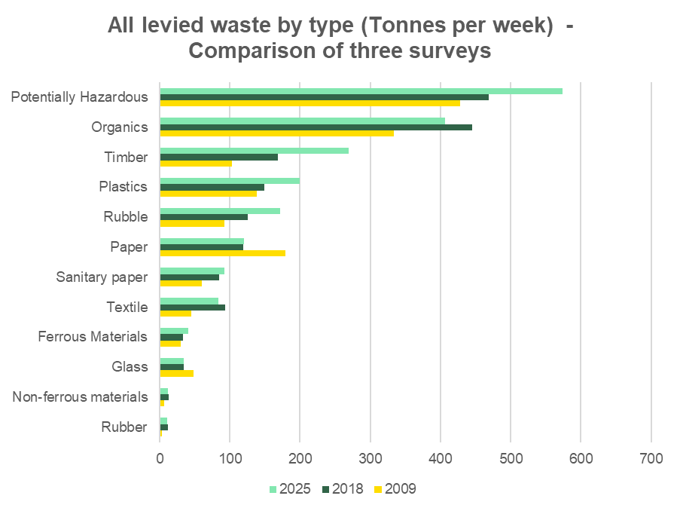
Note: Potentially hazardous waste includes material requiring special disposal, such as batteries and garden chemicals, as well as special wastes which include contaminated soil, sewage sludge, and asbestos.

Change towards a circular economy is hard to measure
Currently, we do not have suitable, centralised measures and processes for tracking progress towards a circular economy. However, some key observations include:
- The Sustainability Trust actively encourages zero waste activities across the Wellington region, such as hosting a Repair Cafe.
- The Newtown Tool Library is an example of community sharing initiative.
- The Council works with Waste Free Welly and other partners to support community-driven circular service schemes.
- The Council has comprehensive guidance on the website to encourage businesses to be resource efficient and minimise waste.

Community satisfaction and behaviour generally consistent
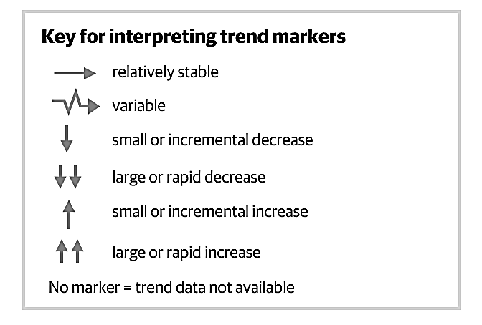
The 2025 Residents Monitoring Survey results indicate that residents generally feel positive about kerbside waste services, with consistent satisfaction levels, while most still rely on traditional methods for managing food scraps. These results were largely unchanged compared to 2024 and suggest that the introduction of kerbside organics collection could substantially reduce waste going to landfill.
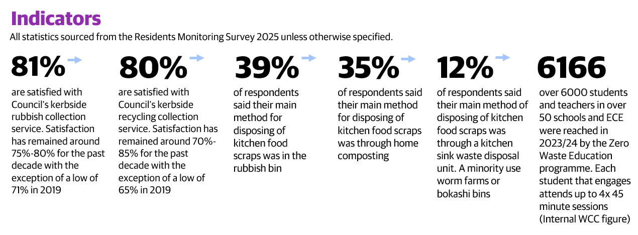

Infrastructure and systems to increase resource circularity are in development
The Council did not meet its KPI target of diverting 20,000 tonnes of waste from landfill in 2024/25. The diversion quantity is based on garden waste, scrap metal and hazardous waste taken to the transfer station at the Southern Landfill, Tip Shop sales, and recycling taken to Oji Solutions.

Until the Sludge Minimisation Facility (SMF) at Moa Point is operational, the 20,000 tonnes diversion remains a stretch target, and one we are unlikely to achieve, as the resource consent for the Southern Landfill requires a 4:1 mixing ratio of waste to sludge. This requirement to have sufficient waste to mix with sludge prevents significant waste diversion. The SMF, which will create a biosolid end-product rather than sludge, is a key enabler of future waste minimisation in Wellington. When operational, the new Sludge Minimisation Facility will further reduce total emissions from the landfill.

The 2024/34 Long-term plan approved a new operating model to introduce new kerbside collections, including organics. When operational, this is expected to divert at least 5000 tonnes from household waste per annum.

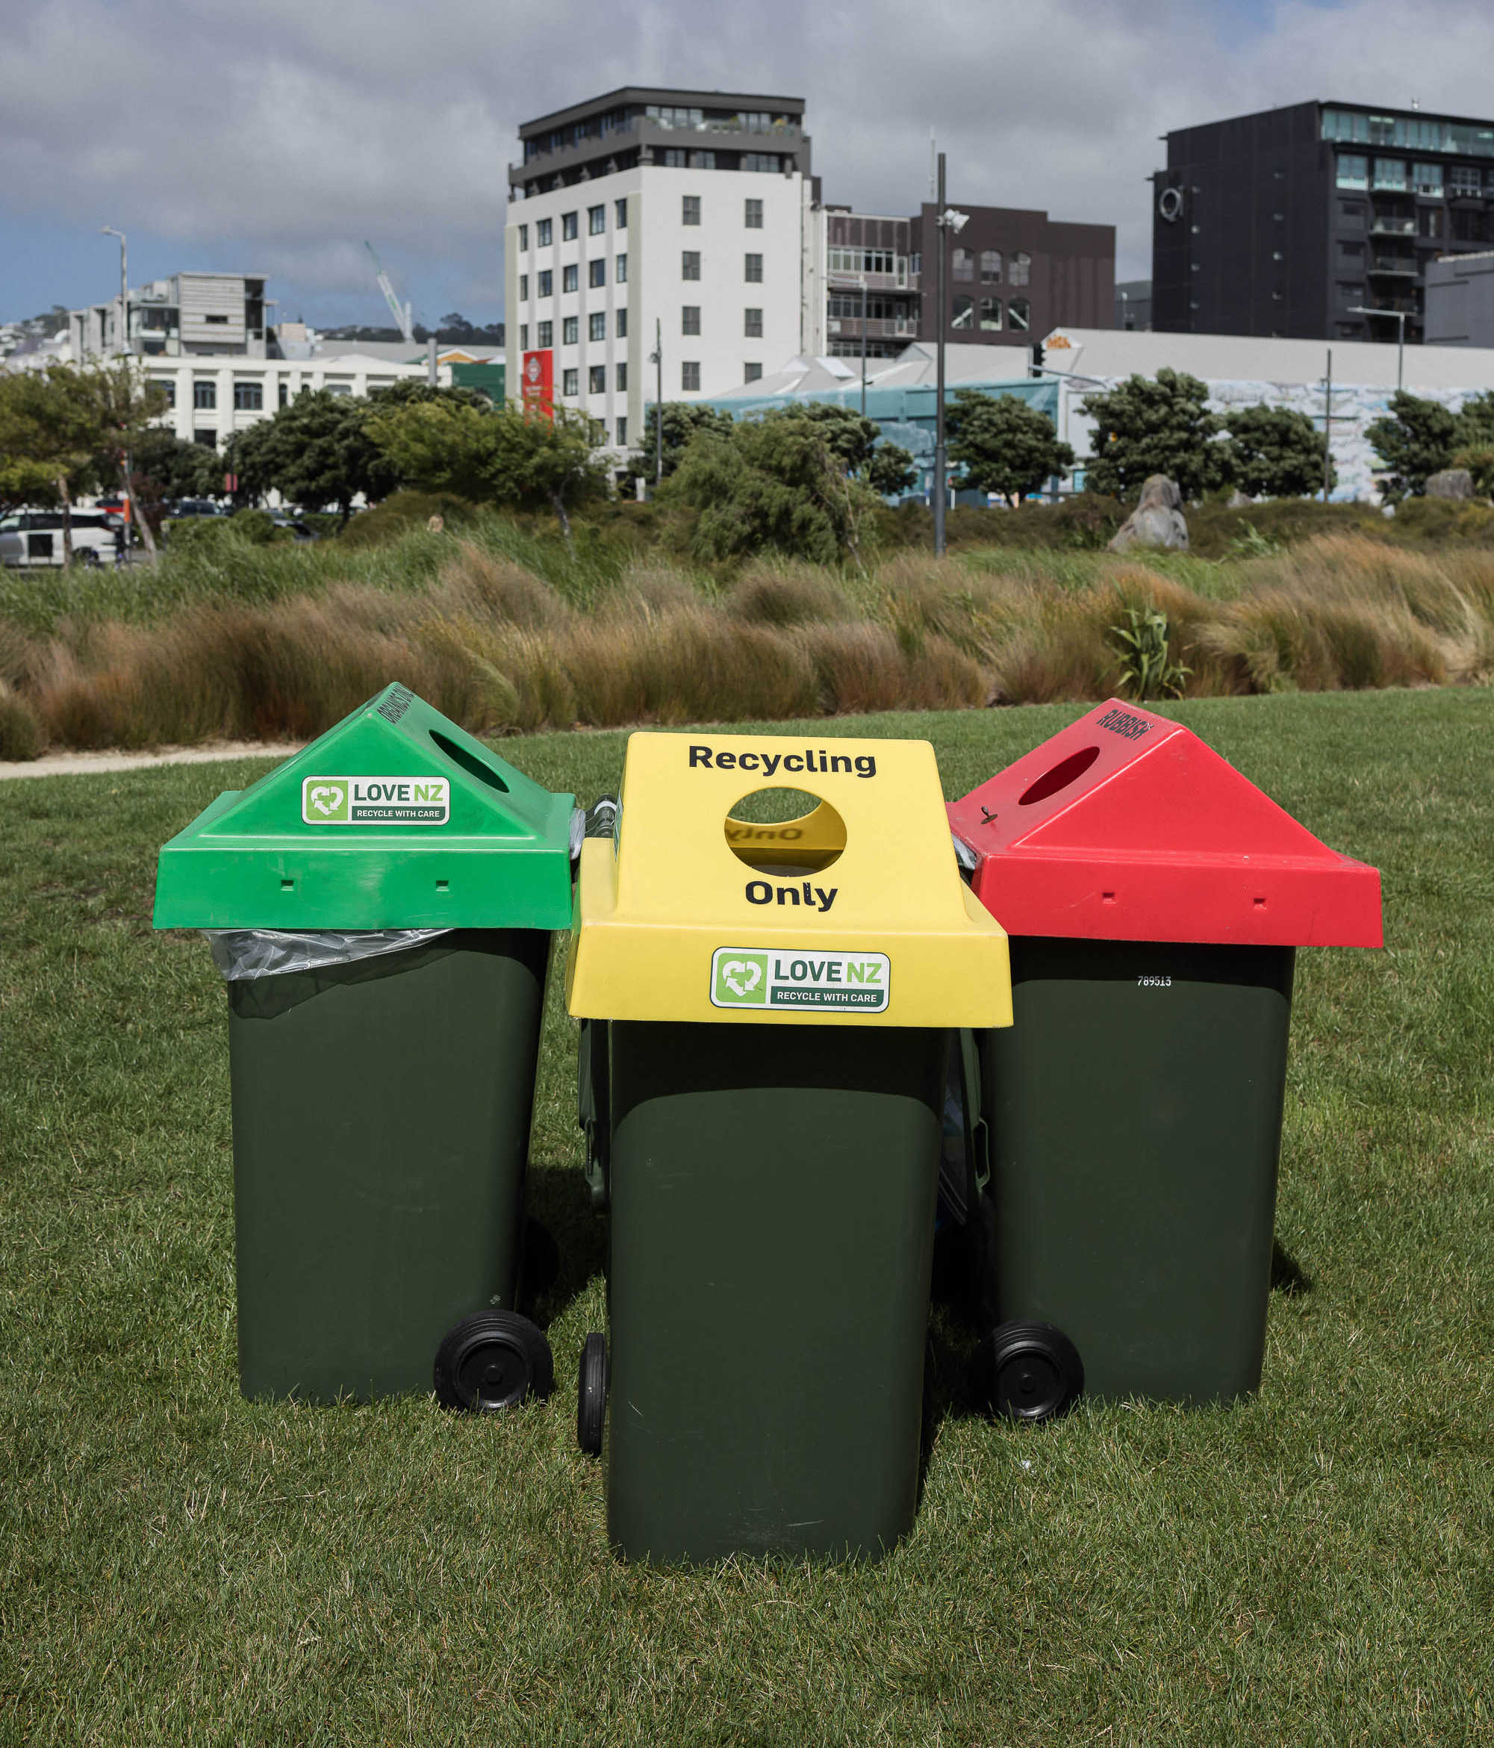
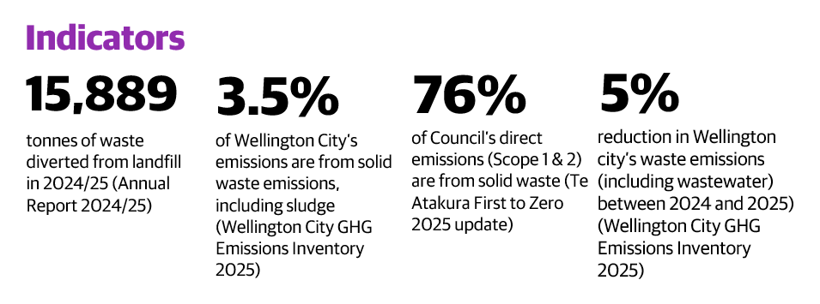

Stakeholder views on Waste
Across the community, there is strong agreement that Wellington must reduce waste. During consultation, submitters overwhelmingly endorsed the Zero Waste Strategy’s four zero-waste objectives. Wellingtonians want Council leadership (through better infrastructure and policy), alongside community action (through behaviour change and innovation).

There is broad awareness from stakeholders that reducing waste (especially organic waste and plastics) will cut pollution and carbon emissions, helping Wellington reach its net-zero carbon goals. Many cited the need to “design out” waste and keep resources in use (core principles of a circular economy) as essential for a sustainable, climate-friendly city.

Many residents support bold waste-reduction targets, but they also raise questions about affordability. Some emphasised that new waste initiatives must be efficient and fair. For instance, community feedback on the Long-term Plan noted the need to pace investments so that rate increases remain manageable for current and future generations.

Overall, people want Wellington to be ambitious on waste management, but also pragmatic, prioritising high-impact changes and securing funding support from central government or partnerships where possible.

Tākai Here partners
Tākai Here partners advocate for a true partnership in environmental management. During the development of the Zero Waste Strategy, Tākai Here representatives consistently pushed for bolder circular economy and waste-reduction measures. Tākai Here partners support improving whakahaere rauemi (resource management) and ensure sustainable materials management, building on the principles of the pūnaha whakarōpū para (waste hierarchy of reduce, reuse and recycle). Protecting te taiao (the environment) from waste is a shared kaupapa, and Tākai Here partners expect the Council to uphold its end by resourcing waste management solutions that align with te ao Māori values.

Key issues and opportunities
The waste system in Wellington is one that primarily relies on disposal to landfill and recycling. This is a problem because it creates environmental issues and is wasteful in regard to the use of finite resources available. Transitioning to a system that prioritises reduction in waste creation as well as the ability to recover resources at scale, while responding to complex regulatory changes, managing regional collaboration, and responding to social, economic and environmental pressures is challenging. The Council must balance ambition with pragmatism, securing funding and pacing investments to ensure affordability for all Wellingtonians, now and into the future.

Changing context in landfill management

Life of the landfill and ongoing fill rates
Wellington City Council owns and operates the Southern Landfill, which is a strategic asset, as defined in the Significance and Engagement Policy. Owning our own landfill means that the Council has control of waste management, including gathering revenue through gate fees, and repurposing biogas to create energy for homes. The landfill is close to the city centre and residents, which reduces waste transport costs and ensures access to waste services in an emergency. Council’s decision to own and operate landfill infrastructure reflects a long‑standing strategic position to retain direct control over waste disposal, costs, and system resilience. This position underpins current investment decisions and operational planning for the waste activity. As part of the LTP 2027 strategy refresh, this strategic position will be explicitly re‑tested alongside alternative delivery models to ensure it continues to represent the most effective way to achieve affordability, emissions reduction, resilience, and waste minimisation outcomes over the long term.

The Council gained consents for the Southern Landfill Extension Piggyback Option (SLEPO) in early 2024, and construction works are underway, with the site due to be ready to receive waste from mid-2026. SLEPO Stage 1 is consented for 35 years and will have the capacity to receive 2.2 million cubic metres of waste. The model we’ve chosen will be sufficient for a maximum of 20 years, depending on the levels of waste received. If waste isn’t reducing at a fast enough rate, there may only be 15 years of landfill life. The Council has limited influence on how much waste is produced, as much of waste generation is driven by the economy. This makes it is difficult to forecast waste volumes into the future. The proposed closure of the Spicer Landfill in Porirua in 2030 will also have an impact on the amount of waste going to landfill and the life of the Southern Landfill.

High costs are involved in operating landfills, especially with increased compliance costs. This makes creating new landfill capacity increasingly expensive. Future decisions will need to be made to balance the affordability of disposing waste, with the ongoing operating costs of the landfill.

Minimising emissions at the landfill
Landfills create substantial emissions and cause ongoing environmental and social impacts. Emissions from the Southern Landfill are counted towards Wellington City Council’s scope 1 emissions. The Landfill is about 80% of the Council’s scope 1 emissions. It also costs the Council approximately $1.5 million annually in carbon credits due to the Emissions Trading Scheme (ETS), although these costs are included in landfill user charges.

Wellington City's emissions from solid waste have decreased, following a reduction in landfill waste and technological improvements. However, to achieve the biogenic methane gas emission reduction target of at least 30% by 2035 set in the Zero Waste Strategy, additional measures are required. The Council has been working to reduce methane emissions from the landfill through a long-term partnership with LMS Energy (LMS). LMS took over the biogas operations at Southern Landfill in late 2021 and is converting the biogas into renewable energy, which is injected into the local electricity network to power local homes and businesses.

As the demand for biogas and biomethane increases, there may be opportunities to find further ways to reuse biomethane, such as increased gas capture and destruction, and the addition of a second generator, to further reduce emissions and produce more power for the grid.

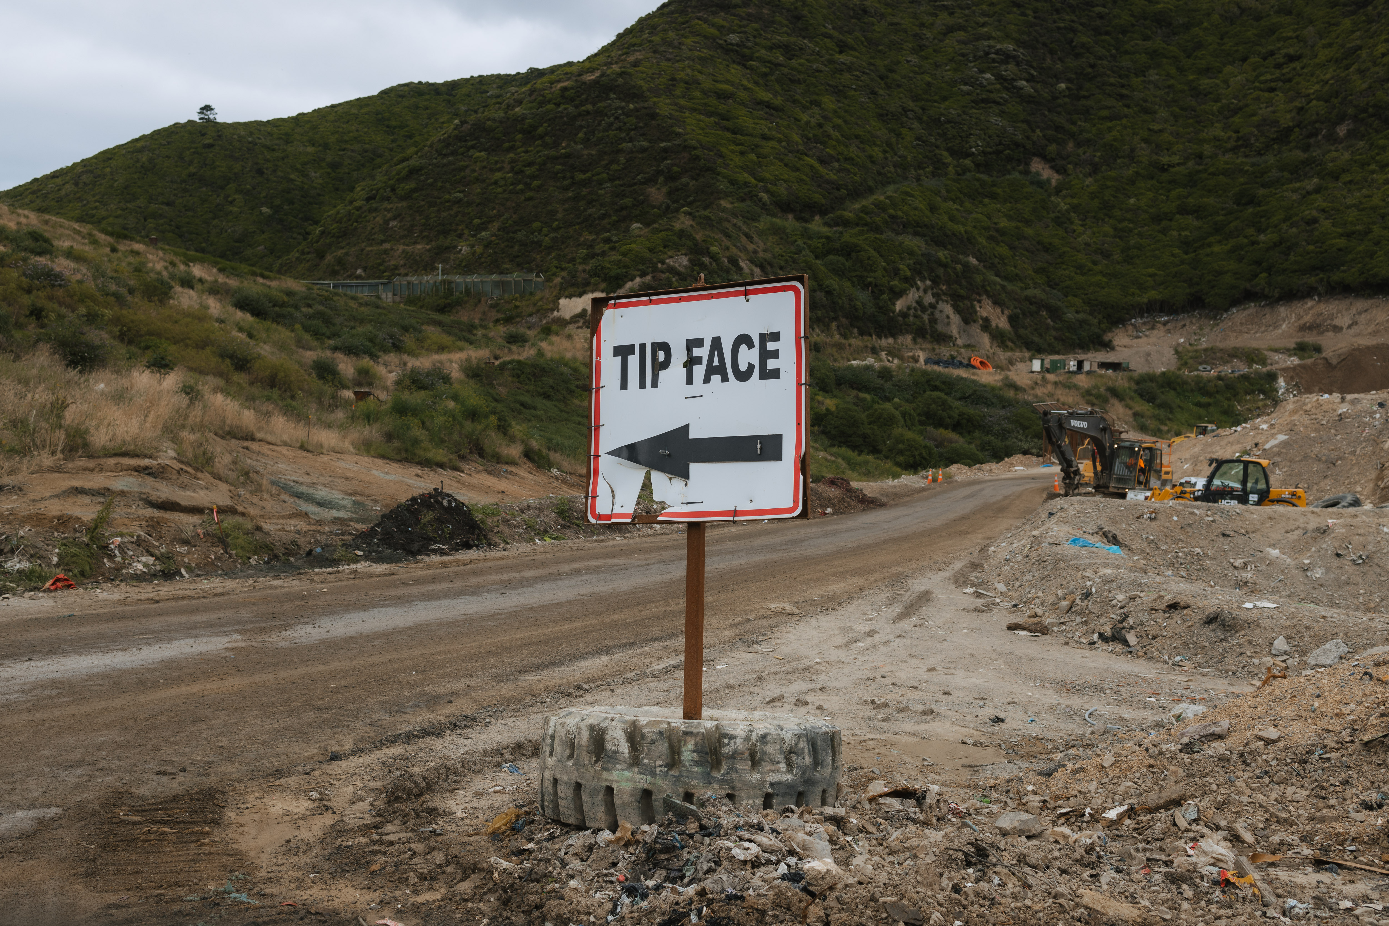

Gaps in resource recovery infrastructure

Unnecessary waste and divertible materials end up in landfill
Despite the Zero Waste Strategy and the Wellington Region Waste Management and Minimisation Plan (WMMP) prioritising the reduction and reuse of materials at the top of the waste hierarchy, the current waste management approach and infrastructure still largely focus on recycling and landfill disposal. Wellington doesn’t currently have sufficient resource recovery infrastructure (facilities that enable repurposing, reuse, organics processing, and a more comprehensive set of recycling capabilities) that is easy for businesses and residents to access. This results in potentially divertible material ending up in the landfill. To address this, the WMMP includes a regional action of creating five new regional resource recovery centres, to refocus the region on resource recovery and minimising resource use. The Council has also commissioned a Reuse Repair and Share Report, undertaken by Reuse Aotearoa, which provides a stocktake of these initiatives happening across Wellington and some recommendations for Wellington City Council to consider in this space. It’s important to note that while the Council can support reuse and recycling facilities, businesses and consumers play a significant role in what they produce, consume, and throw away.

Successful examples of resource recovery initiatives include the Council-funded ‘FillGood’ initiative, which provides reusable plates and cups for venues and events, and the Tip Shop, which provides for reuse and resource recovery. Without focusing on the top of the waste hierarchy and providing infrastructure for the reuse of products and materials, the Council will struggle to meet diversion targets, and Wellington will continue to need more landfill space into the future.

Increasing Construction and Demolition (C&D) waste and minimal options for processing or reuse
Construction and demolition waste can include timber, concrete, glass, steel, brick, packaging, metal, plasterboard and other items. The amount of this type of material disposed at the Southern Landfill has increased from 99 tonnes a week in 2009, to 281 tonnes a week in July 2025. The likely reasons for the increase in C&D waste are the closure of local C&D processing facilities, urban intensification and multi-unit developments.

The reduction and diversion of this waste stream relies significantly on industry, from architects reducing waste at the design stage, all the way to how the construction team separate and dispose of waste. There are currently few options for processing or reuse in Wellington, although some are in the pipeline. Reducing C&D waste is a focus of the WMMP, the Council’s contestable Waste Minimisation Fund, and the regional Build Cluster, which has council and industry representation. The Council has recently enabled a private landfill operation, West Gully, to operate on council land, recognising that such facilities are critical to reducing C&D waste to municipal landfills. The West Gully operation will include resource recovery facilities to be established within 12 months of the cleanfill being operational. The Council could choose to support the development of further C&D facilities and services to reduce C&D waste going to landfill in Wellington.

Cost and other barriers make it difficult for community and business participation in waste minimisation

Responding to consumer and business behaviour
Wellington, along with the rest of the world, is facing increased consumer driven behaviours. With the current cost-of-living crisis, consumers may have less money and time to choose the more sustainable, reusable options and may instead purchase cheap and convenient single-use items. This systemic problem is exacerbated by the lack of easy, affordable and accessible alternatives. Waste from household items, including plastic, textiles and paper, makes up a combined 404 tonnes (20.1%) per week at the Southern Landfill.

The current take-make-dispose model involves the extraction of raw materials to produce items such as plastic, metals, electronics, and paper products. The Council may consider options to encourage the use of reusable and repairable products by providing education, offering waste minimisation grant funding, advocating for sustainable practices, and reviewing procurement processes.

One of the WMMP regional projects has a focus on engagement with businesses. The Council may consider a more active role in supporting businesses to reduce resource use, packaging, and waste from their products. Currently, some engagement with businesses occurs, primarily through grant funding. However, there remain additional opportunities to assist or encourage businesses in minimising waste and transitioning towards a circular economy.

Engaging with the disabled community to ensure everyone can access waste services
The Council offers assisted collections for kerbside waste, where rubbish and recycling can be collected from the doorstep. This paid service is available to people with disabilities or health conditions that prevent them from taking their rubbish or recycling to the kerbside. It is provided free of charge when households demonstrate financial hardship. Despite this, a 2025 audience sentiment survey shows that disabled people are more likely to be dissatisfied with the Council’s performance with waste, rubbish, and recycling services (28% dissatisfaction), compared to people who are not disabled (16% dissatisfaction).

The proposed redesigned collections service was discussed with the Accessibility Advisory Group in March 2025, and they provided valuable feedback, including raising awareness of the assisted service collection, and public education and guidance on the placement of rubbish bags and bins on footpaths. Work is underway to assess and improve the assisted collection services and to make them more visible to the community. The Council will work with the Disabled Communities Advisory Group to inform the new kerbside collections service, to ensure bins and the service can be used by a range of users with disabilities.

Involving the community in waste minimisation
A core principle in the Zero Waste Strategy is community participation: actively involving the community in design and delivery of resource efficient systems, to contribute to a culture shift towards a reduction of waste. To embody this principle, there are always opportunities to strengthen the Council’s ongoing engagement with groups that the Council hasn’t heard much from in consultation, or done targeted engagement with, including ethnic communities and low-income families in Wellington. Through improving engagement and listening to the needs of diverse groups, there is an opportunity to understand wider needs and issues facing Wellingtonians regarding waste and waste minimisation. Further engagement may reveal barriers to participation in waste minimisation, and services such as kerbside collections. Ultimately, understanding and connecting with diverse groups supports many more people to be able to participate in waste minimisation and the circular economy, ensuring a more inclusive and equitable system.

While the Zero Waste Strategy and the WMMP were publicly consulted on, and specific engagement undertaken with interested parties, there is a lack of consistent engagement and visibility of the waste activity with Tākai Here partners and with hapori Māori. Building closer relationships will enable more co-design and shared projects with mana whenua and hapori Māori, as outlined in more detail below.



Partnering with Tākai Here partners and incorporating a te ao Māori approach to resource management
In te ao Māori, rawa taiao (natural resources) are imbued with mauri (life force) and must be respected, sustained, and restored. By maintaining the value of rawa taiao for as long as possible before they reach the end of their natural life, they are disposed of in a way that causes the least harm to Papatūānuku (mother earth). In this way, he tirohanga Māori i te para me te mahi hangarua (Māori views on waste and recycling) precedes the concept of a circular economy (ōhanga āmiomio) but similarly acknowledges the mauri (life force) of natural resources.

Through the Tākai Here agreement and Tūpiki Ora Strategy, Wellington City Council recognises this worldview and commits to managing resources in ways that uphold mana whenua values. This approach supports stronger co-governance and co-design with Tākai Here partners, particularly in areas like waste, water, climate, and land management.
The Council is working with Tākai Here partners on the Sludge Minimisation Facility project and the Southern Landfill Extension Piggyback Option (SLEPO). Tākai Here partners also support the increased funding available through the Waste Minimisation Fund and the updated criteria that prioritises projects led by mana whenua and hapori Māori.The Council may consider supporting projects led or initiated by mana whenua and hapori Māori to support the concept of rangatiratanga (self-governance) and the development of innovative solutions to waste.

Opportunities lie in continuing to build strong relationships with Tākai Here partners, hapori Māori, and Māori business groups to further co-design and collaborate, including:
- to develop Māori-led Waste KPIs,
- to collaborate with Te Matarau a Māui, a Māori business network,
- working with mana whenua on the Resource Recovery Network Expansion (RRNE) Project.



Regional collaboration can offer economies of scale
Working regionally can be a strength of the waste activity, creating regional waste solutions and economies of scale with infrastructure and processing facilities. It also speaks to how our city boundaries do not define where our waste goes, with the waste from the northern suburbs going to Spicer Landfill in Porirua, though this will change as Spicer Landfill is proposed to be closed in 2030. However, working regionally can delay projects if the political will, timelines, and budgets from all councils in the Wellington region don’t align.

Regulatory changes, in particular to the Waste Minimisation Act, create uncertainty and a possible threat to waste minimisation funding. In addition, non-waste specific legislation may also impose barriers to progress. For example, building legislation restricts the reuse of materials, and changes to the Resource Management Act affect the development of waste-related infrastructure.

These changes have the potential to impact how WMMP actions and waste infrastructure are delivered across the region. There is an opportunity for the region to continue improving collaboration on advocating and influencing government policy to ensure the Wellington Region’s needs are considered.

Wellington City Council. (2024). 2024-34 Long-term Plan.
OECD. (February 2019). Global Material Resources Outlook to 2060: Economic Drivers and Environmental Consequences.
Sunshine Yates Consulting. (2025). Composition of Solid Waste at Southern Landfill. Prepared for Wellington City Council.
Sunshine Yates Consulting. (2025). Composition of Solid Waste at Southern Landfill. Prepared for Wellington City Council.
Sunshine Yates Consulting. (2025). Composition of Solid Waste at Southern Landfill. Prepared for Wellington City Council.
Sunshine Yates Consulting. (2025). Composition of Solid Waste at Southern Landfill. Prepared for Wellington City Council.

