Kia ora,

We would like to inform you about a proposed change in your neighbourhood.

Proposal:

Reference | - TR65-26 Rata Road, Hataitai - No Stopping At All Times
Location – where we propose to make the change | Rata Road, Hataitai and the bend opposite no.47
What we’d like to do | - Install No Stopping At All Times (Broken Yellow Lines)
Why we are proposing the change | - Wellington City Council has received multiple complaints from concerned residents following the changes made on Evans Bay Parade, which have displaced beach visitors parking demand and resulted in increased parking on Rata Road.  - Residents have raised concerns about the sharp blind corner on Rata Road, particularly when a large number of vehicles are parked on the southern side of the road. This reduces available forward visibility and leaves limited reaction time for downhill drivers, while uphill vehicles may not have sufficient room to safely return to their side of the road to be clear from the centreline.  - As a result, downhill drivers are often required to stop at or near the bend to give way to uphill traffic, creating a potentially hazardous situation due to the limited forward visibility and constrained road space.  - To improve safety and accessibility, we are proposing to extend the No Stopping At All Times (broken yellow lines) on both sides along the road at the bend, as per the attached plan.
Impact | Improvements  - Improves safer turning movements  - Improves driver forward visibility  Net Parking Impact  - Removal of four unrestricted parking spaces  Pedestrian impact  - No Change
Other options considered | Option 1:  - Only extend the broken yellow lines on the south side of Rata Road. This is not the preferred option as this will push people to park on the north side instead and will not resolve the safety issue entirely adjacent to the narrow section of road and around the bend.
How this relates to the parking policy | - Support safe movement – facilitate the safe and efficient movement of people and goods by focusing on people moving along transport corridors rather than people parking or storing stationary vehicles.
Additional Information | - Average daily traffic count – 1,123  - An electronic copy of the report will be available on the Council’s website from 9.00am 10 August 2026 at https://www.letstalk.wellington.govt.nz/
Privacy | - Your privacy is important to us. Please DO NOT add specific personal details to your feedback (i.e.: full name, address, etc)  - What we do with your personal information:  All submissions (including your first name, but not contact details) are provided in their entirety to elected members and made available to the public on our website and at our office. Personal information (including contact details) will also be used for the administration of the consultation process including informing you of the outcome of the consultation. All information collected will be held by Wellington City Council, with submitters having the right to access and correct personal information.  - For more information regarding our Privacy Statement please check our webpage: Privacy statement - Wellington City Council.
Feedback | - If you would like to provide us with specific feedback, which will be added to the Traffic Resolution following consultation and made public in full, you can do so by filling out an online submission form, downloading a printable submission form on https://www.letstalk.wellington.govt.nz/ or emailing us at trfeedback@wcc.govt.nz.  Please note if you are giving feedback the consultation period opens at 9.00 am 10 August 2026 and finishes at 5.00 pm 24 August 2026.
Next Steps | - Feedback collated by 25 August 2026.  - The proposal will go to the Te Takere|Regulatory Processes Committee meeting on 7 October 2026.  - If approved, the proposal will be installed within the following six months.

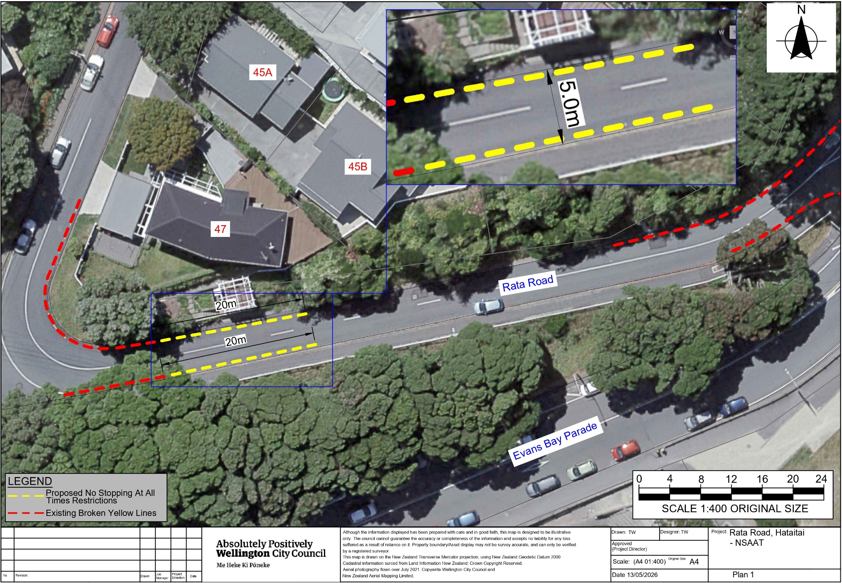
Traffic Resolution Plan: TR65-26 Rata Road, Hataitai - No Stopping At All Times

Legal Description:

Delete from Schedule D (No Stopping) of the Traffic Restrictions Schedule

Column One | Column Two | Column Three
Rata Street | No Stopping At All Times | West side, commencing 109.5 metres west of its intersection with Evans Bay Parade and extending in a southerly direction following the western kerbline for 30.5 metres.
Rata Street | No Stopping At All Times | South side, beginning 98 meters west of its intersection with Evans Bay Parade (X = 1,750,708.99, Y = 5,425,794.97) and extending in a westerly direction for 13 meters following the southern kerbline.

Add to Schedule D (No stopping) of the Traffic Restrictions Schedule

Column One | Column Two | Column Three
Rata Street | No Stopping At All Times | North side, commencing 93 metres west of its intersection with Evans Bay Parade (X = 1,750,712.10, Y = 5,425,815.76) and extending in a westerly direction following the northern kerbline for 51 metres.
Rata Street | No Stopping At All Times | South side, commencing 78 metres west of its intersection with Evans Bay Parade (X = 1,750,708.99, Y = 5,425,794.97) and extending in a westerly direction for 33 metres following the southern kerbline.

Prepared By: | Tommy Wilson | (Transport Engineering Assistant)
Approved By: | Kate Gourdie | (Team Leader Traffic & Resolutions)
Approved Date: | 3/07/2026

