Kia ora,

This leaflet is to let you know about a change we are making in your neighbourhood. These changes are required by the Land Transport Rule: Setting of Speed Limits 2024. We are seeking your feedback on specific parts of the changes.

Reference | - TR68-26 One School Global Wellington Campus – Variable Speed Limit
Location – where we propose to make the change | Aruba Grove: 8:00am -9:00am and 2:40pm-3:40pm  (Except on Wednesdays 2.00 pm-3.00 pm) School Days only
What is the change | - Change the posted speed limit from 50 kilometres per hour (kph) to 30kph during morning drop off and afternoon pick up school times.  - The times for the variable speed limit will be based on the starting and finishing times of the school which in this case is Monday, Tuesday, Thursday & Friday 8:40am Start and 3pm Finish, Wednesdays 8:40am Start and 2:10pm Finish.  - The proposed variable speed zones will be designated with static signs. The type of sign used is guided by the One Network Framework and engineering judgment.  - For more information on the types of signs and which sign will be used in your area visit: Safe speed limits outside schools - Projects - Wellington City Council  - Static signs show the timeframes when 30kph applies on the road.  - Sign type one is a static variable speed limit sign. This sign type will show 30kph with the time frames when the variable speed limit is valid on a supplementary sign below the 30kph sign. When motorists are travelling through the variable speed limit zone outside the times depicted on the sign the speed limit will revert to the posted speed limit indicated by other non-variable speed limit signs in the area.
Why is the change being made | - These changes are required by the Land Transport Rule: Setting of Speed Limits 2024.
What we would like your feedback on | We would like your feedback on:  - We would like to hear your feedback on the location of the signs themselves if they are located near your place of residence, please note however that these signs must be installed 150m from the school gate to be in line with Rule. If you would like to view each sign location in detail, please go to Safe speed limits outside schools - Projects - Wellington City Council
Impact | - Pedestrian/vehicle impact – Improves pedestrian safety by slowing down vehicle speed around schools during drop off and pick up times. In the event of an incident lower vehicle speed reduces the risk for the crash and the severity of injury. As a result, the outcome of the incident is likely to be less severe than if the vehicle was travelling at a higher speed.
Additional Information | - To view the legal description for this Traffic Resolution, an electronic copy of the report will be available on the Council’s website from 9.00am 10 August 2026 at Safe speed limits outside schools - Projects - Wellington City Council
Privacy | - Your privacy is important to us. Please DO NOT add specific personal details to your feedback (i.e.: full name, address, etc)  - What we do with your personal information:  All submissions (including your first name, but not contact details) are provided in their entirety to elected members and made available to the public on our website and at our office. Personal information (including contact details) will also be used for the administration of the feedback process including informing you of the outcome of the consultation. All information collected will be held by Wellington City Council, with submitters having the right to access and correct personal information.  - For more information regarding our Privacy Statement please check our webpage: Privacy statement - Wellington City Council.
Feedback | - If you would like to provide us with specific feedback, which will be added to the Traffic Resolution following consultation and made public in full, you can do so by filling out an online submission form, downloading a printable submission form on https://www.letstalk.wellington.govt.nz/ or emailing us at trfeedback@wcc.govt.nz.  - Please note if you are giving feedback the consultation period opens at 9.00am 10 August 2026 and finishes at 5.00pm 24 August 2026.
Next Steps | - Feedback collated by 25 August 2026.  - The proposal will go to the Te Takere|Regulatory Processes Committee meeting on 7 October 2026

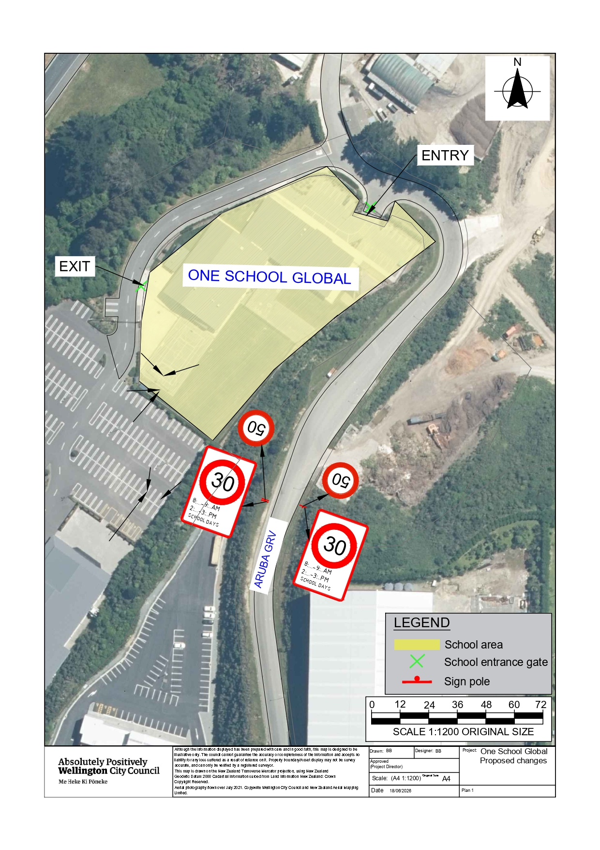
Traffic Resolution Plan: TR68-26 One School Global Wellington Campus- Variable Speed Limit

Legal Description:

Table 1: Proposed variable speed limit for One School Global Wellington Campus

Column One | Column Two | Column Three
Aruba Grove | 30kph  8:00am -9:00am and 2:40pm-3:40pm  (Except on Wednesdays 2.00 pm-3.00 pm) School Days only School Days Only | Beginning 270 meters north of its intersection with Grenada Drive (Grid coordinates X=  1,753,219.06, Y=5,437,373.32) and extending in a north-westerly direction following the northern kerb line for 185 meters.

Location: 35 Aruba Grove
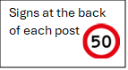
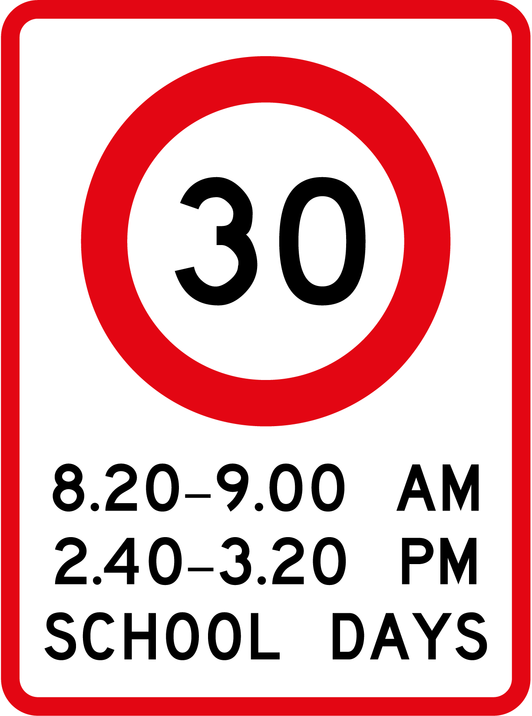

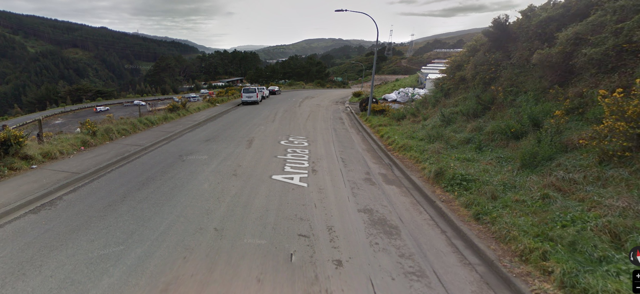
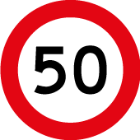
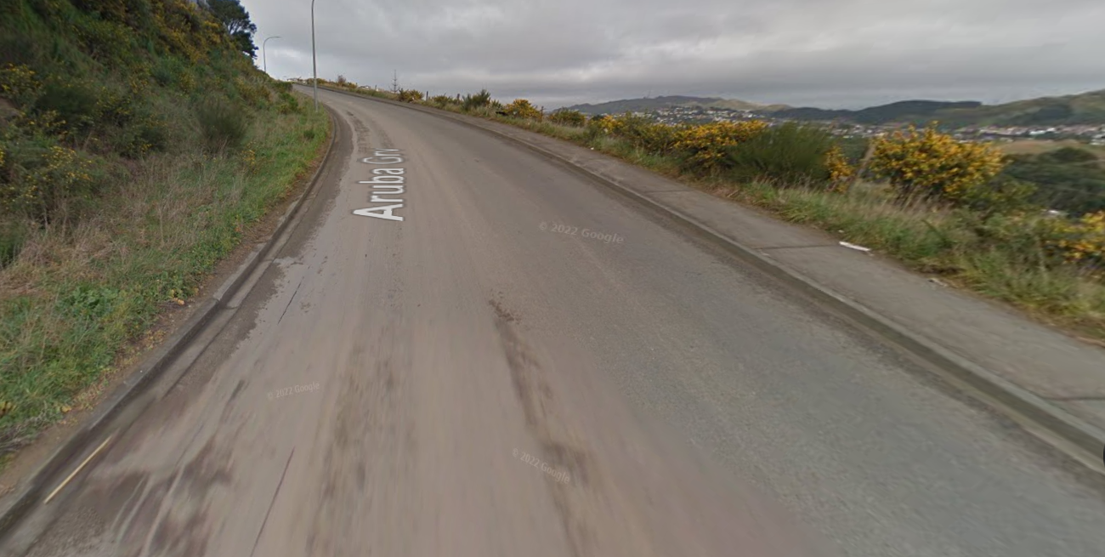

Prepared By: | Babitha Babu | (Transportation Engineer)
Approved By: | Kate Gourdie | (TL, Traffic and Resolutions)
Approved Date: | 20/07/2026

