Kia ora,

We would like to inform you about a proposed change in your neighbourhood.

Proposal:

Reference | - TR70-26 Bancroft Terrace, Newlands – No Stopping At All Times
Location – where we propose to make the change | Bancroft Terrace, Newlands between no.21 and no.37
What we’d like to do | - Install No Stopping At All Times (Broken Yellow Lines)
Why we are proposing the change | - Council was contacted by a resident of Bancroft Terrace who raised their concerns for the accessibility for both waste service vehicles and emergency service vehicles.  - Following an inspection of the street, officers observed that Bancroft Terrace is a narrow cul-de-sac that would be difficult for larger service vehicles to navigate when vehicles are parked on both sides of the road. As the street has only a single point of access, there is a risk that emergency service vehicles could be delayed or obstructed from reaching incidents located further along the street. The carriageway does not meet the minimum required width of 6.9 metres to allow parking on both sides of the street and provides access for larger service vehicles.  - On 18 June 2026, pre-consultation letters outlining the proposed changes detailed in this report were delivered to all properties on Bancroft Street, from the Kenmore intersection to the end of the cul-de-sac, including the school.  - Officers received eight submissions from residents whom all agreed with the proposal and expressed their shared concern for the ongoing safety issues caused by parked vehicles.  - In addition to the proposed changes outlined in this plan, officers intend to formalise and incorporate the existing broken yellow lines into a single resolution seen in the overview illustration.
Impact | Improvements  - Improves safety and accessibility for waste service vehicles  - Improves safety and accessibility for emergency service vehicles  - Improves safer turning movements  - Improves driver forward visibility  Net Parking Impact  - Removal of eight unrestricted parking spaces  Pedestrian impact  - No Change
How this relates to the parking policy | - Support safe movement – facilitate the safe and efficient movement of people and goods by focusing on people moving along transport corridors rather than people parking or storing stationary vehicles.
Additional Information | - Average daily traffic count – 629  - An electronic copy of the report will be available on the Council’s website from 9.00am 10 August 2026 at https://www.letstalk.wellington.govt.nz/
Privacy | - Your privacy is important to us. Please DO NOT add specific personal details to your feedback (i.e.: full name, address, etc)  - What we do with your personal information:  All submissions (including your first name, but not contact details) are provided in their entirety to elected members and made available to the public on our website and at our office. Personal information (including contact details) will also be used for the administration of the consultation process including informing you of the outcome of the consultation. All information collected will be held by Wellington City Council, with submitters having the right to access and correct personal information.  - For more information regarding our Privacy Statement please check our webpage: Privacy statement - Wellington City Council.
Feedback | - If you would like to provide us with specific feedback, which will be added to the Traffic Resolution following consultation and made public in full, you can do so by filling out an online submission form, downloading a printable submission form on https://www.letstalk.wellington.govt.nz/ or emailing us at trfeedback@wcc.govt.nz.  Please note if you are giving feedback the consultation period opens at 9.00 am 10 August 2026 and finishes at 5.00 pm 24 August 2026.
Next Steps | - Feedback collated by 25 August 2026.  - The proposal will go to the Te Takere|Regulatory Processes Committee meeting on 7 October 2026.  - If approved, the proposal will be installed within the following six months.

Traffic Resolution Overview: TR70-26 Bancroft terrace, Newlands – No Stopping At All Times

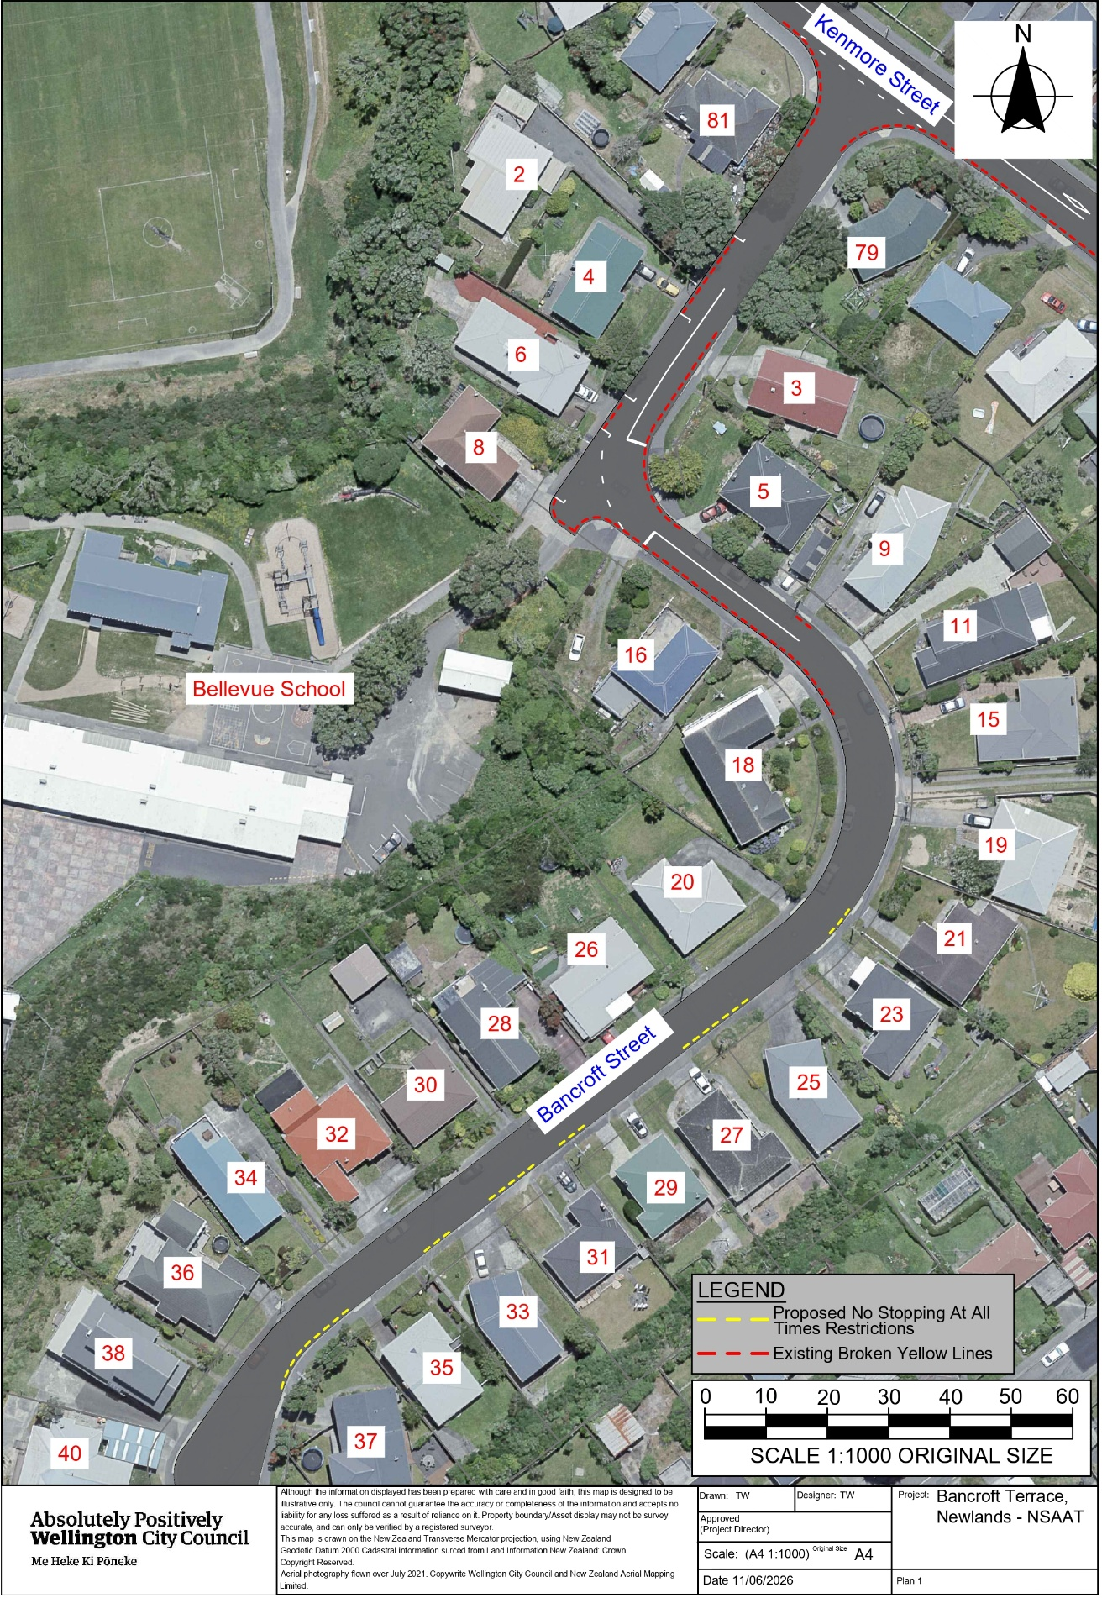
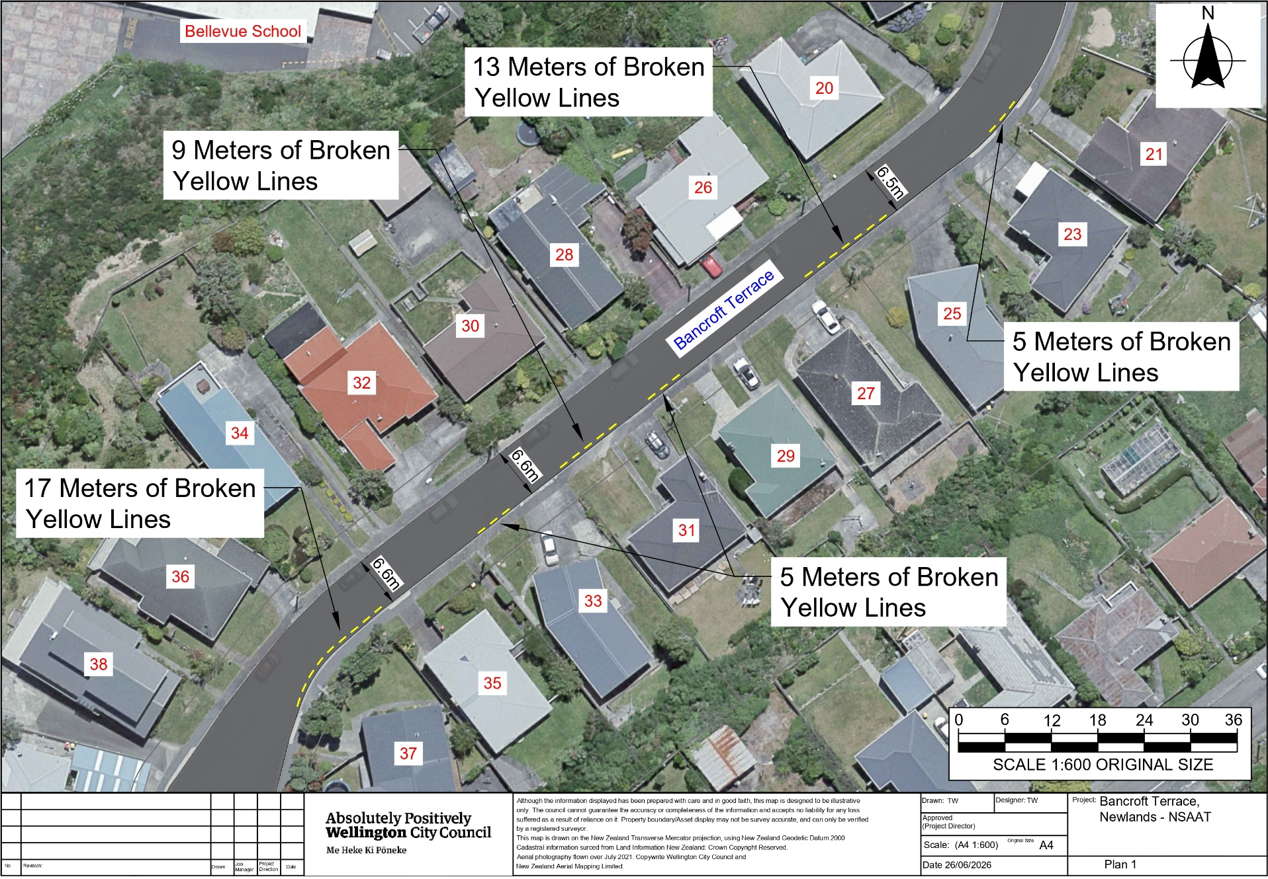
Traffic Resolution Plan: TR70-26 Bancroft terrace, Newlands – No Stopping At All Times

Legal Description:

Delete from Schedule D (No Stopping) of the Traffic Restrictions Schedule

Column One | Column Two | Column Three
Bancroft terrace | No Stopping At All Times | East side, commencing 62.5 metres south of its intersection with Kenmore Street and extending in a southerly direction following the eastern kerbline for 25.5 metres.
Bancroft terrace | No Stopping At All Times | East side, commencing 50.5 metres south of its intersection with Kenmore Street and extending in a southerly direction following the eastern kerbline for 7 metres.
Bancroft terrace | No Stopping At All Times | West side, commencing 84.5 metres south of its intersection with Kenmore Street and extending in a southerly direction following the western kerbline for 24 metres.
Bancroft terrace | No Stopping At All Times | West side, commencing 64.5 metres south of its intersection with Kenmore Street and extending in a southerly direction following the western kerbline for 6 metres.
Bancroft terrace | No Stopping At All Times | West side, commencing 32.5 metres south of its intersection with Kenmore Street and extending in a southerly direction following the western kerbline for 15 metres.

Add to Schedule D (No stopping) of the Traffic Restrictions Schedule

Column One | Column Two | Column Three
Kenmore Street | No Stopping At All Times | South side, commencing at its intersection with Bancroft Terrace (Grid coordinates x= 1,753,041.71m, y=5,434,684.01m) and extending in an northerly direction following the southern kerb line for 4 metres.
Bancroft Terrace | No Stopping At All Times | West side, commencing at its intersection with Kenmore Street (Grid coordinates x= 1,753,041.71m, y=5,434,684.01m) and extending in an southerly direction following the western kerb line for 19 metres.
Bancroft Terrace | No Stopping At All Times | North side, commencing 37 metres from its intersection with Kenmore Street (Grid coordinates x= 1,753,041.71m, y=5,434,684.01m) and extending in an southerly direction following the northern kerb line for 15 metres.
Bancroft Terrace | No Stopping At All Times | North side, commencing 70 metres from its intersection with Kenmore Street (Grid coordinates x= 1,753,041.71m, y=5,434,684.01m) and extending in an southerly direction following the northern kerb line for 5 metres.
Bancroft Terrace | No Stopping At All Times | South side, commencing 89 metres from its intersection with Kenmore Street (Grid coordinates x= 1,753,041.71m, y=5,434,684.01m) and extending in an southeastern direction following the southern kerb line for 64 metres.
Bancroft Terrace | No Stopping At All Times | South side, commencing 89 metres from its intersection with Kenmore Street (Grid coordinates x= 1,753,041.71m, y=5,434,684.01m) and extending in an southeastern direction following the southern kerb line for 64 metres.
Bancroft Terrace | No Stopping At All Times | East side, commencing 50 metres from its intersection with Kenmore Street (Grid coordinates x= 1,753,060.85m, y=5,434,669.10m) and extending in an southerly direction following the eastern kerb line for 37 metres.
Bancroft Terrace | No Stopping At All Times | East side, commencing 111 metres from its intersection with Kenmore Street (Grid coordinates x= 1,753,060.85m, y=5,434,669.10m) and extending in an southerly direction following the eastern kerb line for 3 metres.
Bancroft Terrace | No Stopping At All Times | South side, commencing 165 metres from its intersection with Kenmore Street (Grid coordinates x= 1,753,060.85m, y=5,434,669.10m) and extending in an southerly direction following the southern kerb line for 5 metres.
Bancroft Terrace | No Stopping At All Times | South side, commencing 187 metres from its intersection with Kenmore Street (Grid coordinates x= 1,753,060.85m, y=5,434,669.10m) and extending in an southerly direction following the southern kerb line for 13 metres.
Bancroft Terrace | No Stopping At All Times | South side, commencing 221 metres from its intersection with Kenmore Street (Grid coordinates x= 1,753,060.85m, y=5,434,669.10m) and extending in an southerly direction following the southern kerb line for 5 metres.
Bancroft Terrace | No Stopping At All Times | South side, commencing 234 metres from its intersection with Kenmore Street (Grid coordinates x= 1,753,060.85m, y=5,434,669.10m) and extending in an southerly direction following the southern kerb line for 9 metres.
Bancroft Terrace | No Stopping At All Times | South side, commencing 249 metres from its intersection with Kenmore Street (Grid coordinates x= 1,753,060.85m, y=5,434,669.10m) and extending in an southerly direction following the southern kerb line for 5 metres.
Bancroft Terrace | No Stopping At All Times | South side, commencing 270 metres from its intersection with Kenmore Street (Grid coordinates x= 1,753,060.85m, y=5,434,669.10m) and extending in an southerly direction following the southern kerb line for 17 metres.

Prepared By: | Tommy Wilson | (Transport Engineering Assistant)
Approved By: | Kate Gourdie | (Team Leader Traffic & Resolutions)
Approved Date: | 6/07/2026

