Kia ora,

We would like to inform you about a proposed change in your neighbourhood.

Proposal:

Reference | - TR29-25 Karori Road, Karori – P10 Time Limited Parking
Location – where we propose to make the change | Karori Road, Karori – outside no. 270
What we’d like to do | - Convert the existing two P5 to P10 Time Limited Parking spaces
Why we are proposing the change | - Council have received a request to extend the parking restriction time outside the laundromat.  - Previously, this location was a dairy, and the P5 restriction outside the shop was suitable for quick customer turnover. However, since it has become a laundromat, patrons now need a longer parking duration to effectively use the laundromat services.  - To address this, Council Officers are proposing a P10 parking restriction.
Impact | Improvements  - Improves the viability of business wellbeing  - Improves safety and accessibility for laundromat patrons  Net Parking Impact  - Converting two P5 parking spaces to two P10 parking spaces  Pedestrian impact  - No Change
Other options considered | Option 1:  - Retain the two P5 parking spaces. This option is not preferred as changing this parking to P10 aligns with the practicality of using the Laundromat services.  Option 2:  - Increase the time restriction to longer than P10. This option is not preferred as it would not be consistent with the existing restrictions in the area.
How this relates to the parking policy | - Support business wellbeing – ensure parking management and pricing controls support economic activity in the central city, suburban centres and mobile trades and services.  - Support city place-making, amenity and safety – ensure on-street parking design and placement supports overall city amenity, safety, community building, heritage, creative arts, good urban design outcomes and attractive streetscapes.
Additional Information | - Average daily traffic count – 14,196  - To view the legal description for this Traffic Resolution, an electronic copy of the report will be available on the Council’s website from 9.00am Friday 21 March 2025 at https://www.letstalk.wellington.govt.nz/ or you can call (04) 499 4444 and we will send one out to you.
Privacy | - Your privacy is important to us. Please DO NOT add specific personal details to your feedback (i.e.: full name, address, etc)  - What we do with your personal information:  All submissions (including your first name, but not contact details) are provided in their entirety to elected members and made available to the public on our website and at our office. Personal information (including contact details) will also be used for the administration of the consultation process including informing you of the outcome of the consultation. All information collected will be held by Wellington City Council, 113 The Terrace, Wellington, with submitters having the right to access and correct personal information.  - For more information regarding our Privacy Statement please check our webpage: Privacy statement - Wellington City Council.
Feedback | - If you would like to provide us with specific feedback, which will be added to the Traffic Resolution following consultation and made public in full, you can do so by filling out an online submission form, downloading a printable submission form on https://www.letstalk.wellington.govt.nz/ or emailing us at trfeedback@wcc.govt.nz.  Please note if you are giving feedback the consultation period opens at 9.00am Friday 21 March 2025 and finishes at 5.00pm Friday 4 April 2025.
Next Steps | - Feedback collated by Monday 7 April 2025.  - The proposal will go to the Koata Hātepe|Regulatory Processes Committee meeting on Thursday 15 May 2025.  - If approved, the proposal will be installed within the following three months.

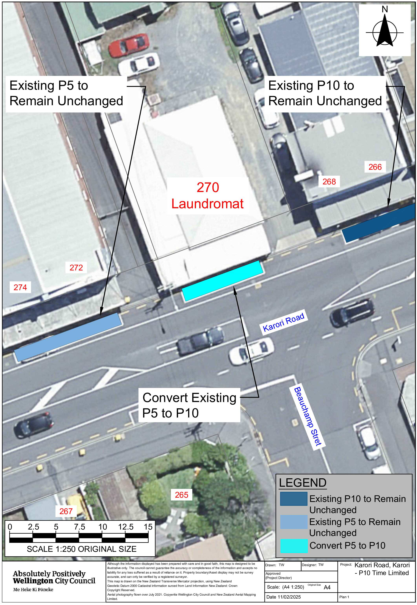
Traffic Resolution Plan: TR29-25 Karori Road, Karori - P10 Time Limited Parking
Legal Description:

Delete to Schedule A (Time Limited) of the Traffic Restrictions Schedule

Column One | Column Two | Column Three
Karori Road | P5  Monday – Sunday, 8:00am – 6:00pm | North side, commencing 97 metres north of its intersection with Chamberlain Road and extending in an easterly direction following the northern kerbline for 10.5 metres.

Add to Schedule A (Time Limited) of the Traffic Restrictions Schedule

Column One | Column Two | Column Three
Karori Road | P10  Monday – Sunday  8:00am – 6:00pm | North side, commencing 97 metres north of its intersection with Chamberlain Road and extending in an easterly direction following the northern kerbline for 10.5 metres.

Prepared By: | Tommy Wilson | (Transport Engineering Assistant)
Approved By: | Kate Gourdie | (Team Leader Traffic & Resolutions)
Approved Date: | 27/02/2025

