Kia ora,

We would like to inform you about a proposed change in your neighbourhood.

Proposal:

Reference | - TR66-26 Birdwood Street, Karori – Shared Path Removal
Location – where we propose to make the change | - Birdwood Street – from a point 50 metres west of its intersection with Chaytor Street and extending to its intersection with Braithwaite Street.
What we’d like to do | - Remove the shared path traffic resolution (TR91-10) designating 475 metres of shared path, and remove the existing shared path signs.  - Removing the shared path designation will not affect the recent change in the Government’s Land Transport Rules Reform programme which allows children under 12 and their accompanying older rider to ride on the footpath.
Why we are proposing the change | - We have received safety concerns from pedestrians using this path that some cyclists use the Birdwood Street uphill only shared path for downhill travel.  - Officers have visited the site and found that the path averages around 1.5 metres in width. The standard recommends a minimum of 2 metres of width for a local access shared path. This minimum width is also for scenarios where cyclist volumes and speeds remain low. Cyclist speeds are not likely to be low if travelling downhill.  - Wellington City Council traffic cameras capture that there is approximately one cyclist a day using the path downhill, and two cyclists a day using the path uphill. In comparison, typical pedestrian totals at the same time are around 50 pedestrians.  - The majority of cyclists are using the uphill on-road cycle path or cycling in the traffic lane downhill.  - Removing the shared path designation will remove conflict between fast downhill cyclists and pedestrians.  Background information:  - In September 2010, TR91-10 proposed an uphill only shared path along the footpath of Birdwood Street, from 50m west of its intersection with Chaytor Street to its intersection with Braithwaite Street. This was approved in the September 2010 Strategy and Policy Committee meeting.  - The purpose of an uphill shared path was to improve cyclists safety along this street as the road at the time did not have a separated uphill cycle lane.  - TR91-10 stated that downhill cyclists are still able to safely use the road as they travel at a speed where vehicles don’t feel the need to overtake them.  - In August 2023, TR92-23 proposed a painted uphill cycleway on Birdwood and Braithwaite Street. This was approved at the 24 August 2023 Regulatory Processes Committee meeting.  - The Committee also agreed to retain the uphill shared path on Birdwood Street for the time being.  - Due to ongoing pedestrian concerns about cyclists travelling downhill at speed on this path and given that it has been approximately three years since TR92-23 was approved and the painted uphill cycleway was installed, officers are seeking feedback on the proposal to remove the uphill shared path and make it a public footpath for pedestrians only.
Impact | - Improves safety and accessibility for pedestrians and cyclists.  - Pedestrian impact - positive due to the removal of 475 metres of existing uphill shared path designation on the footpath up Birdwood Street. Confirming that this public footpath is for pedestrian only and also makes the narrow footpath more attractive for pedestrians.
Other options considered | Option 1:  - Do not remove the shared path designation but have ‘uphill only’ signs added to the existing signs. This option is not recommended by officers as there have been safety concerns raised by pedestrians using the shared path that cyclists are using this path for downhill travel at an inappropriate speed. Even though cyclists may still ride downhill on the footpath, completely removing the signage will discourage cyclists instead of additional signs. The path is also approximately 1.5 metres wide, which is narrower than the recommended shared path width of 2 metres. Cyclists can now safely ride uphill within the painted cycle lane on Birdwood Street.
How this relates to the parking policy | - Support shift in type of transport used – facilitate a shift to using active (eg, walking and cycling) and public transport through parking management and pricing, to move more people driving fewer vehicles.  - Support safe movement – facilitate the safe and efficient movement of people and goods by focusing on people moving along transport corridors rather than people parking or storing stationary vehicles.
Additional Information | - Average daily traffic count – 4,390.  - Average daily cyclist count - 127  - An electronic copy of the report will be available on the Council’s website from 9.00am Friday 10 August 2026 at https://www.letstalk.wellington.govt.nz/
Privacy | - Your privacy is important to us. Please DO NOT add specific personal details to your feedback (i.e.: full name, address, etc)  - What we do with your personal information:  All submissions (including your first name, but not contact details) are provided in their entirety to elected members and made available to the public on our website and at our office. Personal information (including contact details) will also be used for the administration of the consultation process including informing you of the outcome of the consultation. All information collected will be held by Wellington City Council, with submitters having the right to access and correct personal information.  - For more information regarding our Privacy Statement please check our webpage: Privacy statement - Wellington City Council.
Feedback | - If you would like to provide us with specific feedback, which will be added to the Traffic Resolution following consultation and made public in full, you can do so by filling out an online submission form, downloading a printable submission form on https://www.letstalk.wellington.govt.nz/ or emailing us at trfeedback@wcc.govt.nz.  Please note if you are giving feedback the consultation period opens at 9.00am 10 August 2026 and finishes at 5.00pm 24 August 2026.
Next Steps | - Feedback collated by 24 August 2026.  - The proposal will go to the Te Takere|Regulatory Processes Committee meeting on 7 October 2026.  - If approved, the proposal will be installed within the following six months.

Traffic Resolution Plan: TR66-26 Birdwood Street, Karori – Shared Path Removal

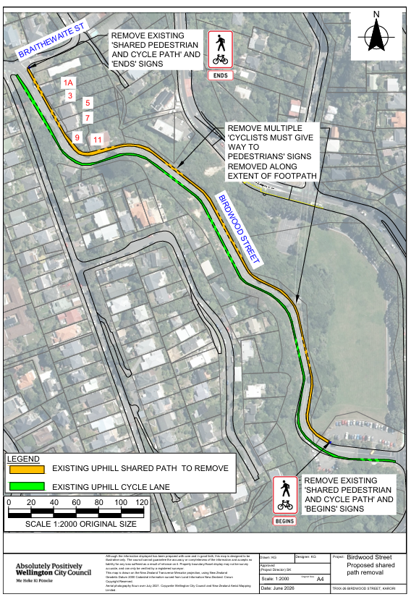

Legal Description:

Delete from Schedule C (special user lane) of the Traffic Restrictions Schedule

Column One | Column Two | Column Three
Birdwood Street | Shared cycle path, Northbound (uphill) only, Cyclists must give way to pedestrians. | East side footpath, commencing from a point 50m west of its intersection with Chaytor Street (Grid Coordinates x= 1746877.0 m. y= 5427941 m), and extending to its intersection with Braithwaite Street

Prepared By: | Kaylie Gleeson | (Intermediate Transport Engineer)
Approved By: | Kate Gourdie | (Team Leader Traffic & Resolutions)
Approved Date: | 3/07/2026

