Kia ora,

We would like to inform you about a proposed change in your neighbourhood.

Proposal:

Reference | - TR77-26 John Sims Drive (western approach), Broadmeadows – Stop Control
Location – where we propose to make the change | John Sims Drive intersection with Rajkot Terrace
What we’d like to do | - Convert the intersection control from the existing Give Way Control to a Stop Control on John Sims Drive (western approach).
Why we are proposing the change | - Council have received a request to assess the safety of the intersection of John Sims Drive and Rajkot Terrace.  - The intersection is currently a Give Way priority control on John Sims Drive (western approach).  - Officers have assessed the sight distance at this intersection and concluded that the visibility on the approach to this intersection is restricted due to the vertical crest of the road which meets the criteria for a Stop control on the John Sims Drive western approach.  - To improve safety at this intersection, we are proposing to convert the existing Give Way control into a Stop control.
Impact | Improvements  - Improves safer turning movements  Net Parking Impact  - No Change  Pedestrian impact  - No Change
Additional Information | - Average daily traffic count – John Sims Drive (western approach) – 350 vehicles per day, Rajkot Terrace 1039 vehicles per day.  - An electronic copy of the report will be available on the Council’s website from 9.00am 19th October 2026 at https://www.letstalk.wellington.govt.nz/
Privacy | - Your privacy is important to us. Please DO NOT add specific personal details to your feedback (i.e.: full name, address, etc)  - What we do with your personal information:  All submissions (including your first name, but not contact details) are provided in their entirety to elected members and made available to the public on our website and at our office. Personal information (including contact details) will also be used for the administration of the consultation process including informing you of the outcome of the consultation. All information collected will be held by Wellington City Council, with submitters having the right to access and correct personal information.  - For more information regarding our Privacy Statement please check our webpage: Privacy statement - Wellington City Council.
Feedback | - If you would like to provide us with specific feedback, which will be added to the Traffic Resolution following consultation and made public in full, you can do so by filling out an online submission form, downloading a printable submission form on https://www.letstalk.wellington.govt.nz/ or emailing us at trfeedback@wcc.govt.nz.  Please note if you are giving feedback the consultation period opens at 9.00 19th October 2026 and finishes at 5.00 pm 3rd November 2026.
Next Steps | - Feedback collated by 4th November 2026.  - The proposal will go to the Te Takere|Regulatory Processes Committee meeting on 2nd December 2026.  - If approved, the proposal will be installed within the following six months.

Traffic Resolution Plan: TR77-26 John Sims Drive and Rajkot Terrace, Broadmeadows – Stop control

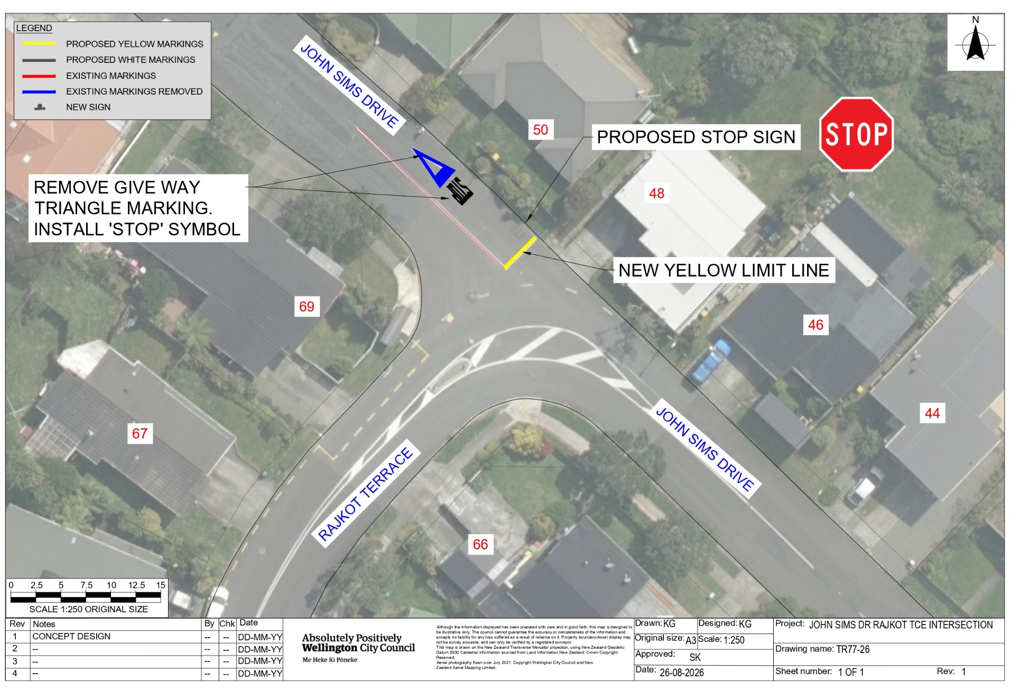

Legal Description:

Remove from Schedule G (Give Way and Stop) of the Traffic Restrictions Schedule

Column One | Column Two | Column Three
John Sims Drive | Give Way control | John Sims Drive at its western approach to its intersection with Rajkot Terrace

Add to Schedule G (Give Way and Stop) of the Traffic Restrictions Schedule

Column One | Column Two | Column Three
John Sims Drive | Stop Control | John Sims Drive at its western approach to its intersection with Rajkot Terrace

Prepared By: | Kaylie Gleeson | (Intermediate Transport Engineer)
Approved By: | Kate Gourdie | (Team Leader Traffic & Resolutions)
Approved Date: | 10/09/2026

