Kia ora,

We would like to inform you about a proposed change in your neighbourhood.

Reference | - TR129-24 Willowbank Reserve, Boscobel Lane, Tawa – P120 Time Limited Parking
Location – where we propose to make the change | Outside 16 Boscobel Lane, Tawa
What we’d like to do | - Install P120 Time Limited Parking Spaces in the Willowbank Reserve Carpark
Why we are proposing the change | - We have received requests from park users to time limit the Willowbank Reserve and Playground off-street parking area due to vehicles consistently parking here all day leaving no available parking spaces for users of the Reserve.  - We propose to introduce P120 At All Times to seven parking spaces as well as converting the existing five P120 Mon-Fri 8am-6pm to At All Times.
Impact | Improvements  - Improves car turnover for people to access the park and Reserve area  Net parking Impact  - Convert seven unrestricted parking spaces to P120 At All Times  - Convert five P120 Mon-Fri 8am-6pm parking spaces to P120 At All TImes  Pedestrian Impact  - No change
Other Options Considered | Option 1: Install P180 Time Limited Parks  - This is not the preferred option as it can be challenging to enforce and does not align with the rest of the carparks which are currently P120.
How this relates to the parking policy | - Support business wellbeing – ensure parking management and pricing controls support economic activity in the central city, suburban centres and mobile trades and services.
Additional Information | - Annual parking revenue impact – No impact  - To view the legal description for this Traffic Resolution, an electronic copy of the report will be available on the Council’s website from 9.00am Thursday 26 September at https://www.letstalk.wellington.govt.nz/ or you can call (04) 499 4444 and we will send one out to you.
Privacy | - Your privacy is important to us. Please DO NOT add specific personal details to your feedback (i.e.: full name, address, etc)  - What we do with your personal information:  All submissions (including your first name, but not contact details) are provided in their entirety to elected members and made available to the public on our website and at our office. Personal information (including contact details) will also be used for the administration of the consultation process including informing you of the outcome of the consultation. All information collected will be held by Wellington City Council, 113 The Terrace, Wellington, with submitters having the right to access and correct personal information.  - For more information regarding our Privacy Statement please check our webpage: Privacy statement - Wellington City Council.
Feedback | - If you would like to provide us with specific feedback, which will be added to the Traffic Resolution following consultation and made public in full, you can do so by filling out an online submission form, downloading a printable submission form on https://www.letstalk.wellington.govt.nz/ or emailing us at trfeedback@wcc.govt.nz.  Please note if you are giving feedback the consultation period opens at 9.00am Thursday 26 September and finishes at 5.00pm Thursday 10 October.
Next Steps | - Feedback collated by Friday 11 October.  - The proposal will go to the Koata Hātepe|Regulatory Processes Committee meeting on Thursday 14 November.  - If approved, the proposal will be installed within the following three months.

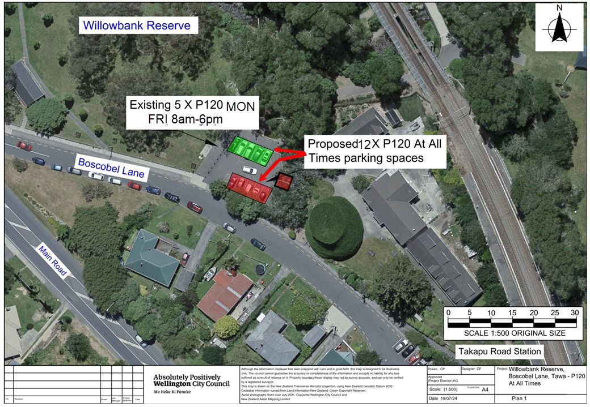
- Traffic Resolution Plan: TR129-24 Willowbank Reserve, Boscobel Lane, Tawa – P120 At All Times

Legal Description:

Delete from Schedule (A) Time Limited Parking of the Traffic Restrictions Schedule

Column One | Column Two | Column Three
Boscobel Lane, Tawa (Willowbank Reserve off-street carpark) | P120, Mon-Fri 8am-6pm | North side, commencing 19.2 metres north and 2.3 metres east of its intersection with Boscobel Lane, (Grid coordinates x = 1753219.3 m, y = 5439141.8 m), and extending in an easterly direction following the kerbline for 15.2 metres.  (6 car parking spaces) Off Street Parking Area

Add to Schedule (A) Time Limited Parking of the Traffic Restrictions Schedule

Column One | Column Two | Column Three
Boscobel Lane, Tawa  (Willowbank Reserve off-street carpark) | P120, At All Times | Red and green rectangles, refer to attached plan. (12 carparking spaces)

Prepared By: | Corey Pugh | (Reserves Planner)
Approved By: | Kate Gourdie | (Team Leader Traffic & Resolutions)
Approved Date: | 6/9/2024

