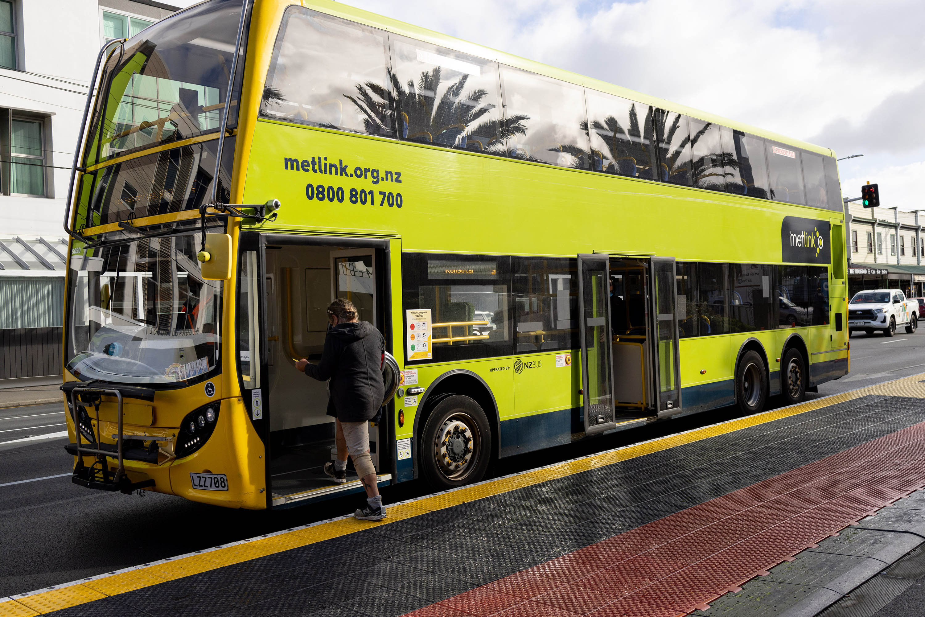
Audience sentiment


March 2026

Tūnuku

Transport

Background report
Contents

Purpose 4
Council Activities 4
What we do as a Council 5
Budget 6
Why is this activity important? 10
Current Direction 11
Direction from Legislation and National Regulations 11
Regional settings 12
Wellington City Council settings 13
Indicators and trends 15
Meeting some but not all the transport-related key performance indicators 16
Stakeholder views about Transport 17
Advisory groups’ feedback 18
Accessibility Advisory Group (AAG) 18
Ethnic Communities Advisory Group (ECAG) 19
Pacific Communities Advisory Group (PCAG) 19
Takatāpui Rainbow Communities Advisory Group (TRCAG) 19
Rangatahi Youth Communities Advisory Group (RYCAG) 19
Key Issues for Transport in Wellington City 21
Transport planning and investment misalignment 21
Transport funding limits the ability to address current deficiencies and future aspirations 21
Design and integration of Roads of National Significance (RoNS) / State Highway upgrades 22
Traffic congestion during peak periods 22
Regional growth strains transport, increases congestion and emissions 23
Increasing costs of infrastructure, ageing assets and impacts from severe weather events 24
Increasing costs, infrastructure maintenance and ageing infrastructure 24
Climate adaptation in Wellington’s transport system 26
Challenges in shifting more trips from private vehicles to walking, cycling, and public transport 26
Addressing road safety, emissions and air pollution 27
Road safety challenges 27
Transport emissions in Pōneke 28
Negative impacts of air pollution 28
Transport accessibility and equity 29
Accessibility barriers 29
Inconsistent inclusion, safety gaps, unmet community needs 29
Inconsistent Māori engagement, integration, and transport equity challenges 29

Purpose
This background report provides a clear, evidence‑based overview of Wellington City Council’s Transport activity. It sets out what the Council does, why it does it, how it is funded, how it is performing, and the key issues shaping future choices.

The report is intended to support informed engagement with the Council’s role in Transport. It provides advisory groups with shared context on Council responsibilities, settings, constraints, and strategic direction, and supports elected members by bringing together relevant information, performance insights, stakeholder views, and emerging challenges to inform deliberations through the Long-term Plan (LTP) 2027–2037 process.

This is not a strategy or a set of recommendations. Rather, it is a foundation document that identifies current settings, pressures, and opportunities, and surfaces the key trade‑offs that will need to be considered as the Council refreshes its strategic direction and investment approach for Transport within a constrained fiscal environment.

Council Activities
A Council ‘activity’ is a formal Local Government Act 2002 (LGA 2002) term to refer to Council goods and services. Council activities are grouped for the purposes of the Long-term Plan and budgets – some are relatively stand-alone like transport.
This group of activities includes:
7.1 Transport network
7.1.1 Transport planning
7.1.2 Vehicle network
7.1.3 Cycle network
7.1.4 Passenger transport network
7.1.5 Pedestrian network
7.1.6 Network-wide control and management
7.1.7 Road safety
7.1.8 Major City Upgrades
7.1.9 Roads open spaces
7.2 Parking
7.2.1 Parking

What we do as a Council
As part of the transport activity, the Council is responsible for:
- Strategic long-term planning for the local transport network’s current and future needs.
- Allocation and design of street space within road reserves.
- Managing road corridors which include vehicle lanes, traffic lights, parking, bus stops and shelters, bus lanes, cycling facilities, crossings and footpaths.
- Managing related transport infrastructure such as roadways, walkways, retaining walls, bridges, tunnels and street lighting.
- Managing open spaces, street furniture, and vegetation within the road reserve.
- Managing public parking.
- Operating the transport network and clearing slips and debris to ensure the transport network can continue to function in emergencies and after storms.
- Promoting of traffic safety, walking, biking, and public transport usage.
- Ensuring the city’s transport system is safe for all users.
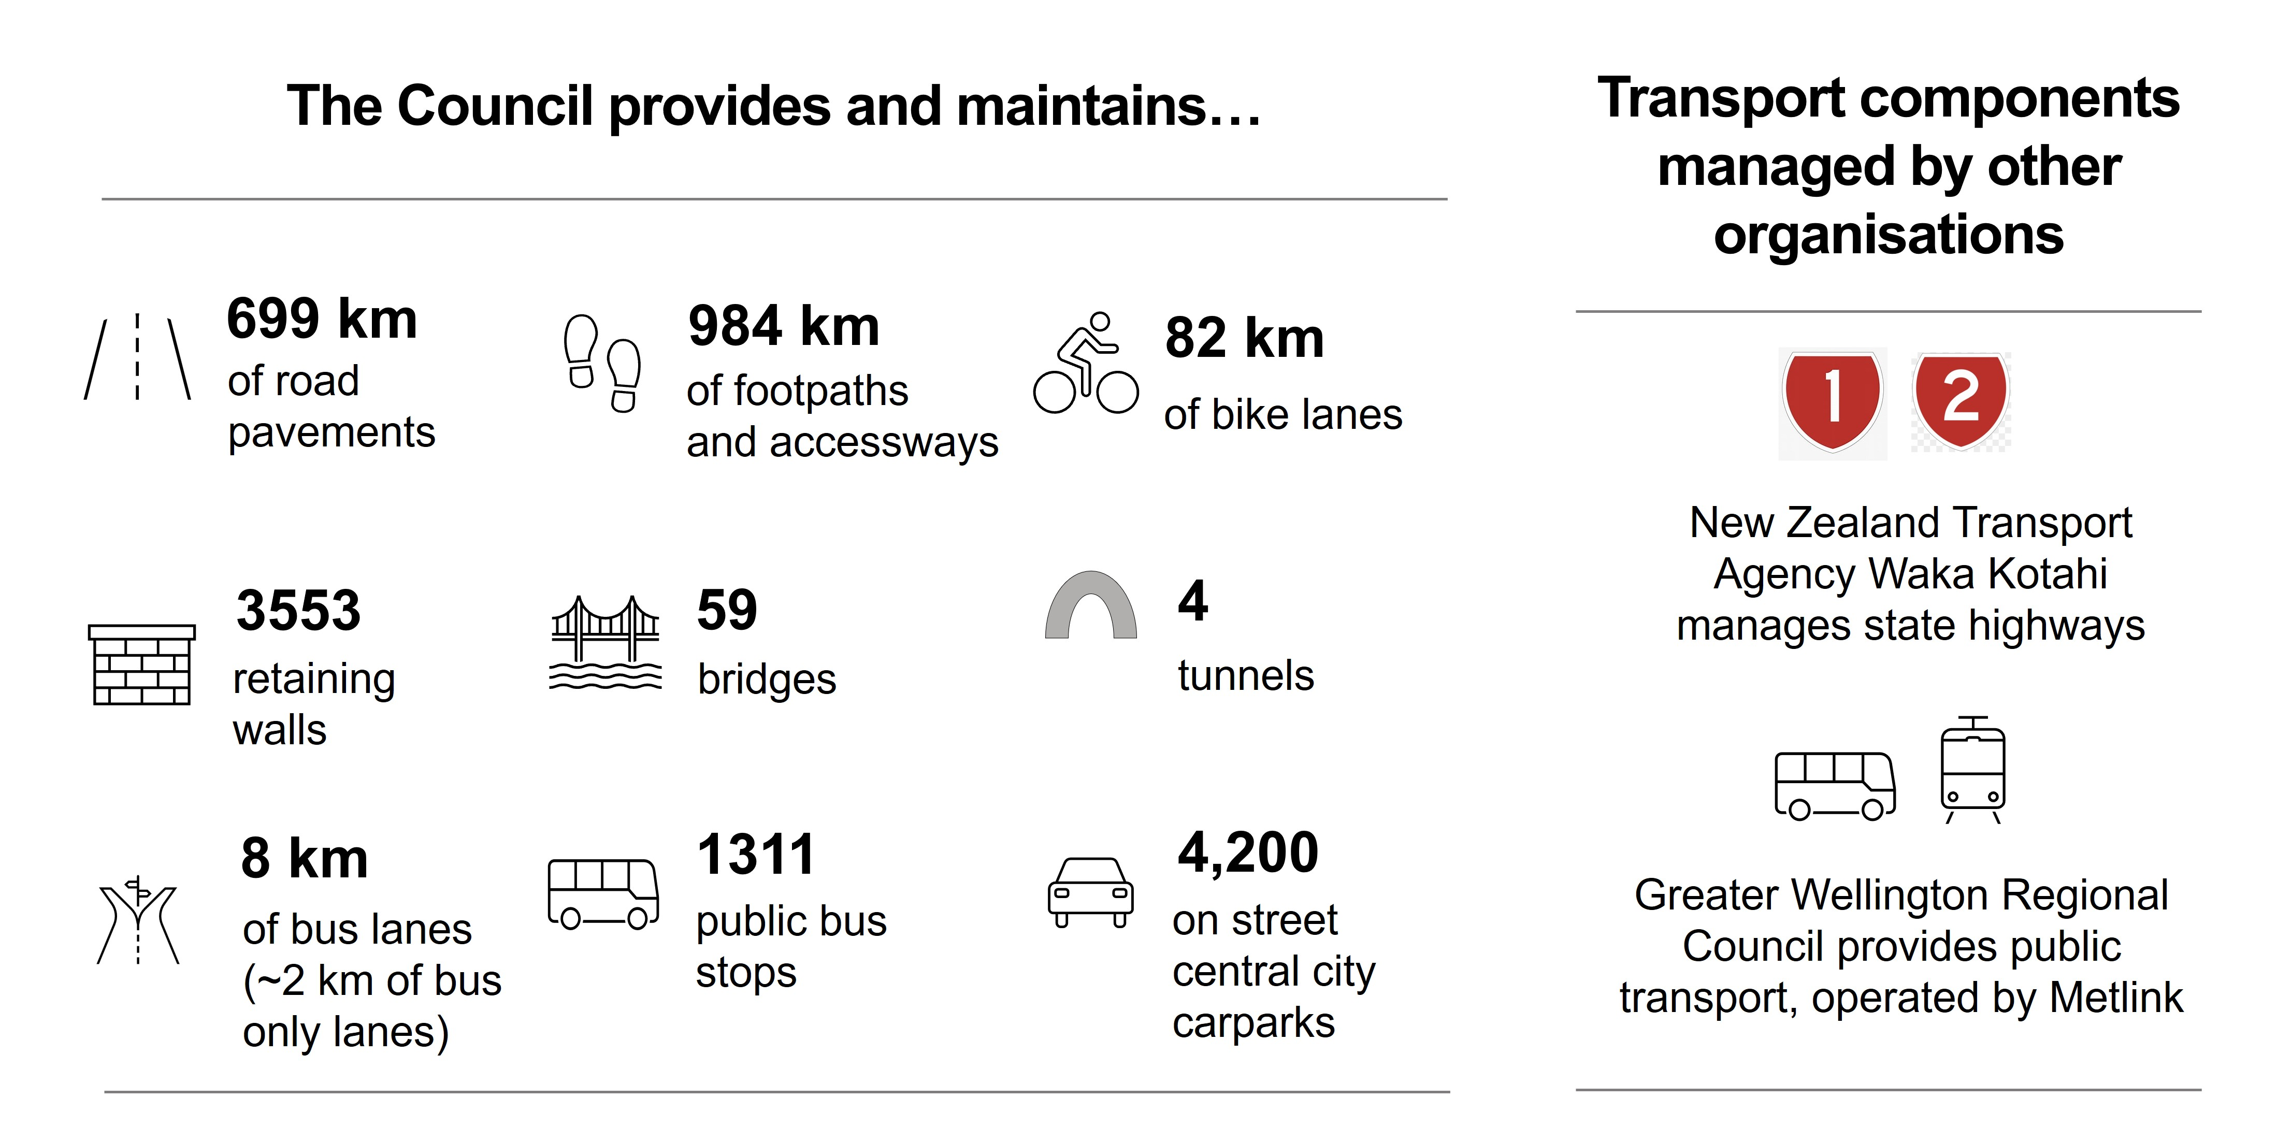
Following the recent water reforms, from 1 July 2026 the Council will no longer be responsible for managing the water infrastructure network. However, the Council continues to have responsibility for stormwater management on land inclusive of the transport corridor stormwater infrastructure. Legislation requires council to enter into a service agreement with the new water organisation to ensure an integrated approach to stormwater management.

Budget
You can find more information in the LTP 2024 Amendment.
Percentage of total Council spend:
Opex – 15.4%
Capex – 19.7%
Operating Expenditure
Activity Component Name | Income/  Expense | 2024/25 | 2025/26 | 2026/27 | 2027/28 | 2028/29 | 2029/30 | 2030/31 | 2031/32 | 2032/33 | 2033/34
7.1.1 Transport Planning | Expense | 1,567 | 1,806 | 1,814 | 1,851 | 1,870 | 1,920 | 1,962 | 2,012 | 2,053 | 1,758
7.1.1 Transport Planning | Income | 0 | (48) | (50) | 0 | 0 | 0 | 0 | 0 | 0 | 0
7.1.2 Vehicle network | Expense | 62,330 | 64,474 | 84,443 | 84,712 | 93,755 | 103,497 | 122,494 | 131,068 | 128,474 | 139,333
7.1.2 Vehicle network | Income | (3,749) | (4,544) | (4,716) | (4,114) | (4,204) | (4,291) | (4,358) | (4,444) | (4,532) | (4,618)
7.1.3 Cycle network | Expense | 7,129 | 4,994 | 6,029 | 7,277 | 7,984 | 8,920 | 9,176 | 9,710 | 10,772 | 12,123
7.1.3 Cycle network | Income | (1,777) | (111) | (115) | (296) | (311) | (327) | (380) | (435) | (492) | (550)
7.1.4 Passenger transport network | Expense | 3,413 | 3,466 | 3,090 | 5,856 | 5,439 | 3,115 | 3,252 | 3,389 | 3,457 | 3,571
7.1.4 Passenger transport network | Income | (1,670) | (1,705) | (1,743) | (1,781) | (1,819) | (1,855) | (1,892) | (1,928) | (1,965) | (2,002)
7.1.5 Pedestrian network | Expense | 15,513 | 15,891 | 18,038 | 18,315 | 19,221 | 20,796 | 22,531 | 24,456 | 25,879 | 26,947
7.1.5 Pedestrian network | Income | (857) | (501) | (518) | (899) | (919) | (938) | (957) | (976) | (996) | (1,014)
7.1.6 Network-wide control and management | Expense | 14,945 | 16,183 | 14,519 | 12,947 | 13,256 | 13,864 | 14,452 | 15,132 | 14,366 | 14,910
7.1.6 Network-wide control and management | Income | (3,885) | (4,036) | (4,170) | (4,222) | (4,313) | (4,401) | (4,487) | (4,575) | (4,664) | (4,751)
7.1.7 Road safety | Expense | 9,131 | 11,164 | 11,718 | 11,975 | 12,574 | 13,243 | 13,955 | 14,753 | 15,451 | 16,171
7.1.7 Road safety | Income | (2,445) | (2,846) | (2,952) | (2,923) | (2,986) | (3,048) | (3,109) | (3,171) | (3,233) | (3,295)
7.1.8 Major City Upgrades | Expense | 8,352 | 3,314 | 3,729 | 2,361 | 1,600 | 605 | 617 | 629 | 640 | 653
7.1.9 Roads open spaces | Expense | 11,025 | 12,202 | 12,593 | 12,900 | 13,177 | 13,512 | 13,807 | 14,089 | 14,355 | 14,675
7.1.9 Roads open spaces | Income | (1,397) | (1,800) | (1,907) | (1,577) | (1,616) | (1,652) | (1,689) | (1,725) | (1,761) | (1,797)
Total |  | 117,622 | 117,904 | 139,802 | 142,381 | 152,708 | 162,959 | 185,375 | 197,985 | 197,804 | 212,115

Activity Component Name | Income/  Expense | 2024/25 | 2025/26 | 2026/27 | 2027/28 | 2028/29 | 2029/30 | 2030/31 | 2031/32 | 2032/33 | 2033/34
7.2.1 Parking | Expense | 22,510 | 22,582 | 23,603 | 24,170 | 25,133 | 25,949 | 26,291 | 26,257 | 26,893 | 27,784
7.2.1 Parking | Income | (38,077) | (38,127) | (38,921) | (39,787) | (40,634) | (41,457) | (42,256) | (43,071) | (43,901) | (44,703)
Total |  | (15,567) | (15,545) | (15,317) | (15,617) | (15,501) | (15,508) | (15,965) | (16,813) | (17,008) | (16,919)

Capital Expenditure
Activity Component Name | 2024/25 Published budget | 2024/25 Amendment budget | 2025/26 | 2026/27 | 2027/28 | 2028/29 | 2029/30 | 2030/31 | 2031/32 | 2032/33 | 2033/34
7.1.2 Vehicle network | 41,777 | 34,621 | 53,271 | 48,808 | 45,025 | 48,432 | 58,872 | 48,399 | 58,618 | 46,042 | 51,622
7.1.3 Cycle network | 25,215 | 19,765 | 13,666 | 10,503 | 5,762 | 5,148 | 3,149 | 4,768 | 5,114 | 2,665 | 880
7.1.4 Passenger transport network | 150 | 0 | 148 | 102 | 105 | 108 | 112 | 115 | 118 | 122 | 125
7.1.5 Pedestrian network | 6,738 | 6,294 | 9,075 | 9,217 | 6,097 | 6,501 | 6,360 | 6,768 | 6,882 | 7,312 | 7,151
7.1.6 Network-wide control and management | 3,096 | 3,096 | 3,838 | 3,925 | 4,015 | 4,102 | 4,187 | 4,270 | 4,355 | 4,441 | 4,525
7.1.7 Road safety | 7,507 | 7,625 | 10,825 | 5,702 | 5,888 | 6,210 | 6,493 | 6,624 | 6,521 | 6,650 | 6,778
7.1.8 Major City Upgrades | 56,552 | 32,258 | 58,060 | 43,127 | 32,631 | 15,632 | 0 | 0 | 0 | 0 | 0
7.1.10 Charged Up Capital | 864 | 864 | 0 | 0 | 0 | 0 | 0 | 0 | 0 | 0 | 0
Total | 141,899 | 104,523 | 148,883 | 121,384 | 99,523 | 86,134 | 79,172 | 70,945 | 81,610 | 67,233 | 71,081

Following the LTP Amendment capital programme review, the cycling network programme will now be completed over 20 years. The primary network will be finished within the first 10 years, including ongoing projects like Evans Bay and Brooklyn to City, as well as the remaining 17.6 km. Work on the secondary network will follow in the later years, aligned with adjusted priorities and funding. This means delivery of the network will still be achieved in the next 10 years, but with lower levels of grade separation of bike and vehicle lanes. The People-friendly city streets programme is being scaled back. The Hutt Rd portion of the Thorndon Quay/Hutt Rd project will also not be funded. Road surface renewals are to be deferred, with more chipseal repairs (rather than asphalt). Reductions to NLTP funding have also impacted planned work programmes.

Activity Component Name | 2024/25 Published budget | 2024/25 Amendment budget | 2025/26 | 2026/27 | 2027/28 | 2028/29 | 2029/30 | 2030/31 | 2031/32 | 2032/33 | 2033/34
7.2.1 Parking | 5,930 | 1,916 | 5,517 | 2,283 | 1,914 | 937 | 1,186 | 1,030 | 2,023 | 2,465 | 2,102
Total | 5,930 | 1,916 | 5,517 | 2,283 | 1,914 | 937 | 1,186 | 1,030 | 2,023 | 2,465 | 2,102

Roll out of EV chargers continued for Year 1 only. Parking upgrades and Parking management plan projects reduced as result of LTP Amendment capital programme review.

Transport Funding Sources
The interest and depreciation costs relating to capital expenditure are incorporated in the operating costs of each activity. Transport capital expenditure projects are funded through a combination of NZTA subsidies, rates funded depreciation and borrowings. Parking expenditure is fully funded by parking fees.

Transport activity | User Fees | Rates Contribution* | Other Income (Grants/Sub-sidies)
Transport Planning | 0% | 100%
Vehicle Network | 0% | 90%-100% | 0%-10%
Cycle Network | 0% | 90%-100% | 0%-10%
Passenger Transport Network | 0% | 10%-20% | 80%-90%
Pedestrian Network | 0% | 90%-100% | 0%-10%
Network-wide control and management | 10-20% | 80%-90% | 10%-20%
Road Safety | 0% | 70%-80% | 20%-30%
Major City Upgrades | 0% | 0% | 100%**
Roads open spaces | 0% | 90%-100% | 0%-10%
Parking | 100% | 0%
*General rates, **From borrowing. Source: 2024 LTP Volume 2.

Why is this activity important?
A well-functioning transport network is essential for access to jobs, education, healthcare, social opportunities, and the efficient movement of goods and services. The Council’s current strategic priority is to transform the transport system to move more people with fewer vehicles. By focusing on the Sustainable Transport Hierarchy, the Council has sought to implement efficient, safe and low-carbon transport outcomes.

The Spatial Plan and Economic Wellbeing strategy also emphasise that good transport planning supports well-connected communities, higher-density housing, regeneration, reduced emissions, improved safety, and long-term resilience. Transport and urban development are closely interlinked, with each influencing the outcomes of the other. Effective transport systems support well-connected communities and enable higher-density development and urban regeneration. Additionally, a well-designed transport system can help reduce carbon emissions and air pollution, improve safety and resilience, and ensure that all residents, regardless of ability or background, can participate in city life. This is supported by research that shows a well-planned local transport network is vital for community wellbeing, supporting access, safety, reduced emissions, and resilience, and is most effective when developed collaboratively with local communities. While active transport reduces diseases from inactivity, enhances mental wellbeing, and presents substantial monetised health benefits.

Conversely, poor planning can lead to congestion, reduced accessibility, and missed opportunities for vibrant, resilient communities.

Wellington is also a nationally significant freight hub, with CentrePort (national and international shipping and inter-island ferry services), Wellington International Airport, Wellington rail yards and depot, and State Highway 1 connections located within Wellington City. Efficient, safe, and reliable road and rail corridors are critical for supporting these connections.

Current Direction

Direction from Legislation and National Regulations
New Zealand legislation sets a framework for planning and delivery of transport services, as a local government entity, a road controlling authority and as an employer. As we develop, operate and maintain our transport network, we are obligated to meet the current and future needs of our community through the provision of infrastructure, operate it in a cost-effective and democratic manner, minimise environmental impacts, and comply with health and safety requirements.

The Local Government Act 2002 provides powers for the provision of roads and footpaths and outlines the decision-making process for every major transport decision that the Council makes. The Local Government (System Improvements) Amendment Bill (the Bill) proposes to remove the social, economic, environmental and cultural well-being (the four well-beings) from the purpose of the Local Government Act 2002 (LGA 2002 section 10 refers) and refocus the purpose on core infrastructure and services, although it includes the need to consider "the overall impact of any allocation of liability for revenue needs on current and future communities". Network infrastructure (which includes roads) and public transport services are both noted in the Bill as core services to be considered in the Council’s role (proposed new section 11A of the LGA 2002). The Land Transport Management Act 2008 sets out the requirements and processes to obtain funding for roading construction and maintenance from central government.

Central government gives direction and rationale for delivering the Transport Activity Group. Key regulatory instruments are:
- The Government Policy Statement (GPS) on Land Transport sets the Government’s priorities and funding envelopes for land transport investment for a 10-year period. The current GPS priorities are focused on economic growth and productivity, increased maintenance and resilience, safety and value for money.
- The Transport Outcomes Framework 2018 sets the purpose for the transport system centred around the wellbeing of New Zealanders and the liveability of places. Outcome areas include inclusive access, healthy and safe people, environmental sustainability, resilience and security and economic prosperity.

Table 1: Objectives and priorities in key national transport-related strategic documents
National strategic documents | Objectives and priorities
Government Policy Statement on Land Transport 2024-34 | Current strategic priorities for the Government’s investment in land transport:  Priority 1: Economic growth and productivity  Priority 2: Increased maintenance and resilience  Priority 3: Safety  Priority 4: Value for money
Ministry of Transport’s Outcomes Framework (2018) | The purpose of the transport system is to improve people’s wellbeing and the liveability of places:  Outcome 1: Inclusive access  Outcome 2: Healthy and safe people  Outcome 3: Environmental sustainability  Outcome 4: Resilience and security  Outcome 5: Economic prosperity

Additional relevant documents are New Zealand’s Second Emissions Reduction Plan 2026-30 which signals a shift toward cleaner, tech-enabled infrastructure – like electric buses, rail upgrades, and smarter pricing and the National Policy Statement on Urban Development which directs district plans to enable more houses, business and community services in areas near public transport.

Regional settings
The Council must take into account or give effect to regional strategies and policies. The Wellington Regional Land Transport Plan (RLTP) sets the strategic objectives for the transport network for the region for the next 10 to 30 years.

The 30-year Vision is: A connected region, with safe, accessible and liveable places – where people can easily, safely and sustainably access the things that matter to them and where goods are moved efficiently, sustainably and reliably.

The five strategic objectives are as follows.
- People in the Wellington Region have access to good, affordable travel choices.
- Transport and land use are integrated to support compact urban form, liveable places and a strong regional economy.
- People can move around the Wellington Region safely.
- The impact of the transport and travel on the environment is minimised.
- Journeys from, to and within the Wellington Region are connected, resilient and reliable.

The 2030 targets identified in the RLTP 2021-2031 are:
- 40% reduction in road deaths and serious injuries,
- 35% reduction in transport-generated carbon emissions and
- 40% increased mode share in active modes and public transport.

Other relevant regional strategic documents:
- Greater Wellington Regional Council. (2025). Wellington Regional Public Transport Plan 2025-2035.
- Greater Wellington Regional Council. (2024). Wellington Regional Transport Emissions Reduction Pathway (WTERP)
- Greater Wellington Regional Council. Regional Policy Statement for the Wellington region [including Change 1].
- Wellington Regional Leadership Committee. (2024). Wairarapa-Wellington-Horowhenua Future Development Strategy 2024-2054.

Wellington City Council settings
The key council strategies applicable to the Transport Activity Group are Long-term Plan (LTP) 2024-2034, Wellington City Spatial Plan 2021 and Te Atakura First to Zero (2019), including the 2025 update. The Council’s current LTP 2024-2034 has a strategic priority to “transform our transport system to move more people with fewer vehicles”. The Wellington City Spatial Plan 2021 is a strategic document that guides how the city grows, develops, and changes over the next 30 years, including how land use, transport and other infrastructure should be integrated and prioritised. The plan states the vision for transport in Wellington City (see infographic below). Te Atakura is the climate action plan to guide Wellington City to a zero-carbon capital (net zero emissions) by 2050 and includes the action area “Sustainable transport networks”.
The Council designs and builds the transport network for all modes and prioritises active modes through the Sustainable Transport Hierarchy, as illustrated in Figure 1 below.
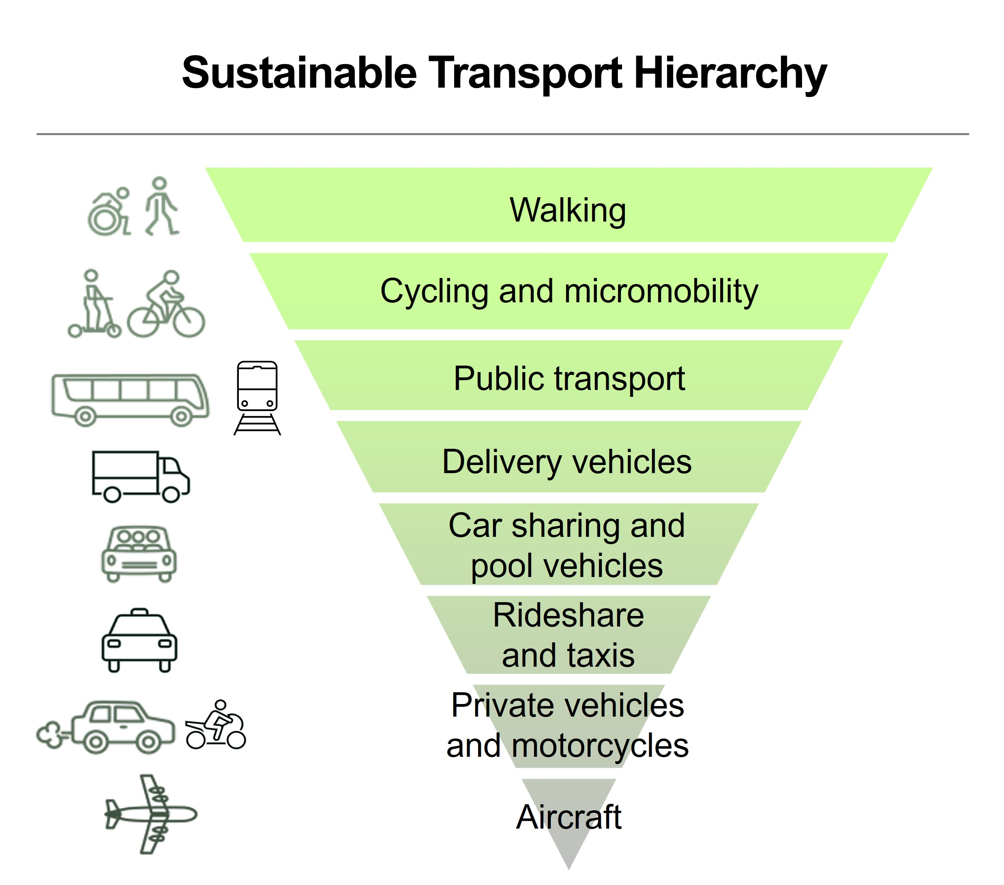
Figure 1
Table 2: Objectives and priorities in key Council’s transport-related strategic documents
Council’s strategic documents | Objectives and priorities
Long-term Plan 2024-34 | Transport-related investment priority:  “Transform our transport system to move more people with fewer vehicles”
Wellington City Spatial Plan 2021 | The vision for transport in Wellington City: “We want our transport system to:  - Safely and efficiently move more people with fewer vehicles  - Help Wellington achieve the goal of net zero carbon emissions  - Give convenient, safe, and accessible choices for people to travel without using cars  - Make city streets more attractive and safer places to be  - Support urban growth and regeneration”
Te Atakura – First to Zero 2019 | Transport-related initiatives include investing in walking, cycling and public transport projects, enabling car sharing, electric vehicle charging and bike and scooter sharing, and providing practical support to change travel habits.

Other relevant Wellington City Council strategic documents:
- Infrastructure strategy 2024, in the Long-term Plan 2024-34 Volume 3 (amended)
- Walking Policy 2008
- Paneke Pōneke - Bike Network Plan 2022
- Draft Bus Priority Action Plan 2019 (with Greater Wellington Regional Council)
- Parking Policy 2020
- Te Aro Tātou - Traffic circulation plan investigation 2021 (report by MRCagney for Wellington City Council)
- Green Network Plan 2022
- Te Whai Oranga Pōneke - Open Space and Recreation Strategy 2023
- Wellington City District Plan 2024

Indicators and trends
Wellington’s compact urban form and well-connected multi-modal network are key features of the city’s transport system. This enables residents to choose between walking, biking, public transport, or driving. Compact urban form, combined with historic land use planning, transport investment and network management, have contributed to high rates of public transport and active transport. Compared to other New Zealand cities, Wellington has substantially higher rates of walking, biking, and public transport usage as the main mode of transport to get to work (Census 2023). In 2023, less than half of Wellington City residents who travelled to work used a private vehicle, a quarter used public transport and a quarter travelled by active modes (Census 2023). People living closer to work more frequently walked or rode a bike to work compared to those living further away.

Recent investment in Wellington City’s transport system has contributed to improvements in accessibility, safety, and mode choice. Public transport usage has remained high for decades, and there has been growth in active modes in recent years, reflecting broader efforts to reduce emissions, alleviate congestion, improve safety of walking and cycling, and the increase in inner-city living.

Key findings from the State of Transport Report 2026 show that Wellington City has good accessibility to footpaths and public bus stops, and well-connected road networks. The city also has a number of injuries from road crashes, particularly for people walking and biking. Residents have low satisfaction and perceived safety for people on bikes. One third of residents perceive that public transport is affordable. Other key findings are summarised in the infographic on the next page.

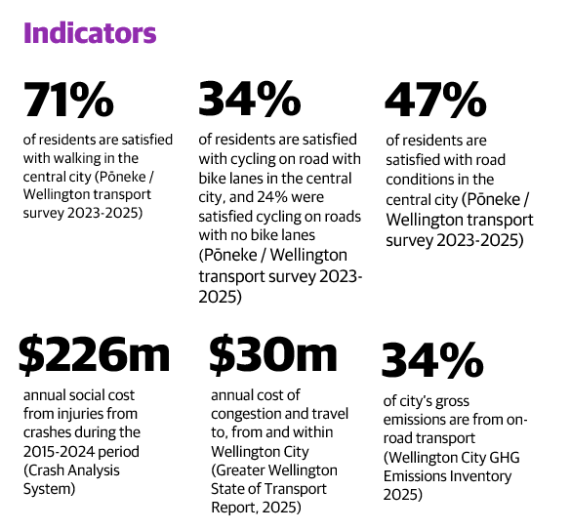

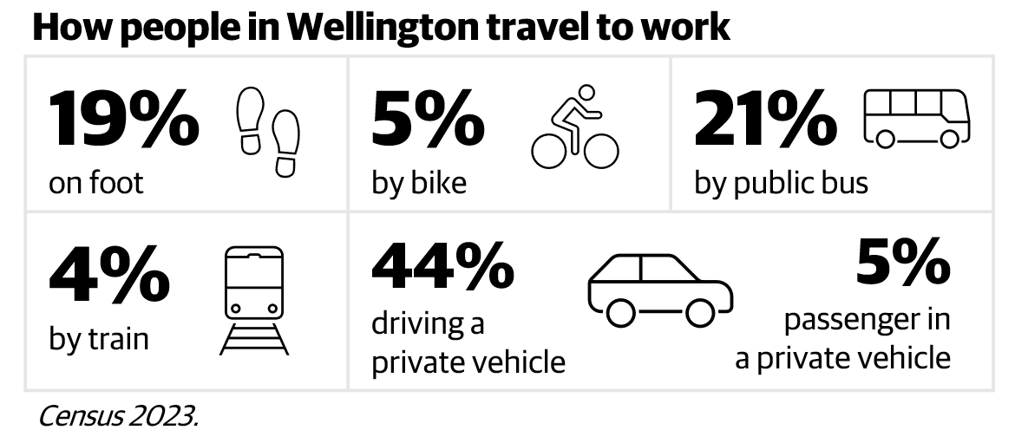

In recent years, the proportion of people working from home increased from 8% in 2018 to 19% in 2023. Many more are working from home part-time or occasionally. This is reducing travel demand during rush hours and is particularly noticeable on Mondays and Fridays. The update to the Wellington City Spatial Plan 2021 can identify growth ranges for land use and infrastructure planning and prioritisation. Government proposals are for councils to use two different ranges: one for land use planning (high growth projections plus 20% to encourage market flexibility and lower land prices), and another for infrastructure planning (a “most likely demand scenario”). This will increase demand for travel and will likely impact transport levels of service and related costs. This growth can help pay for improvements to transport infrastructure and services. Higher density growth located in areas where there is existing infrastructure provision is generally more affordable (per ratepayer).

Meeting some but not all the transport-related key performance indicators
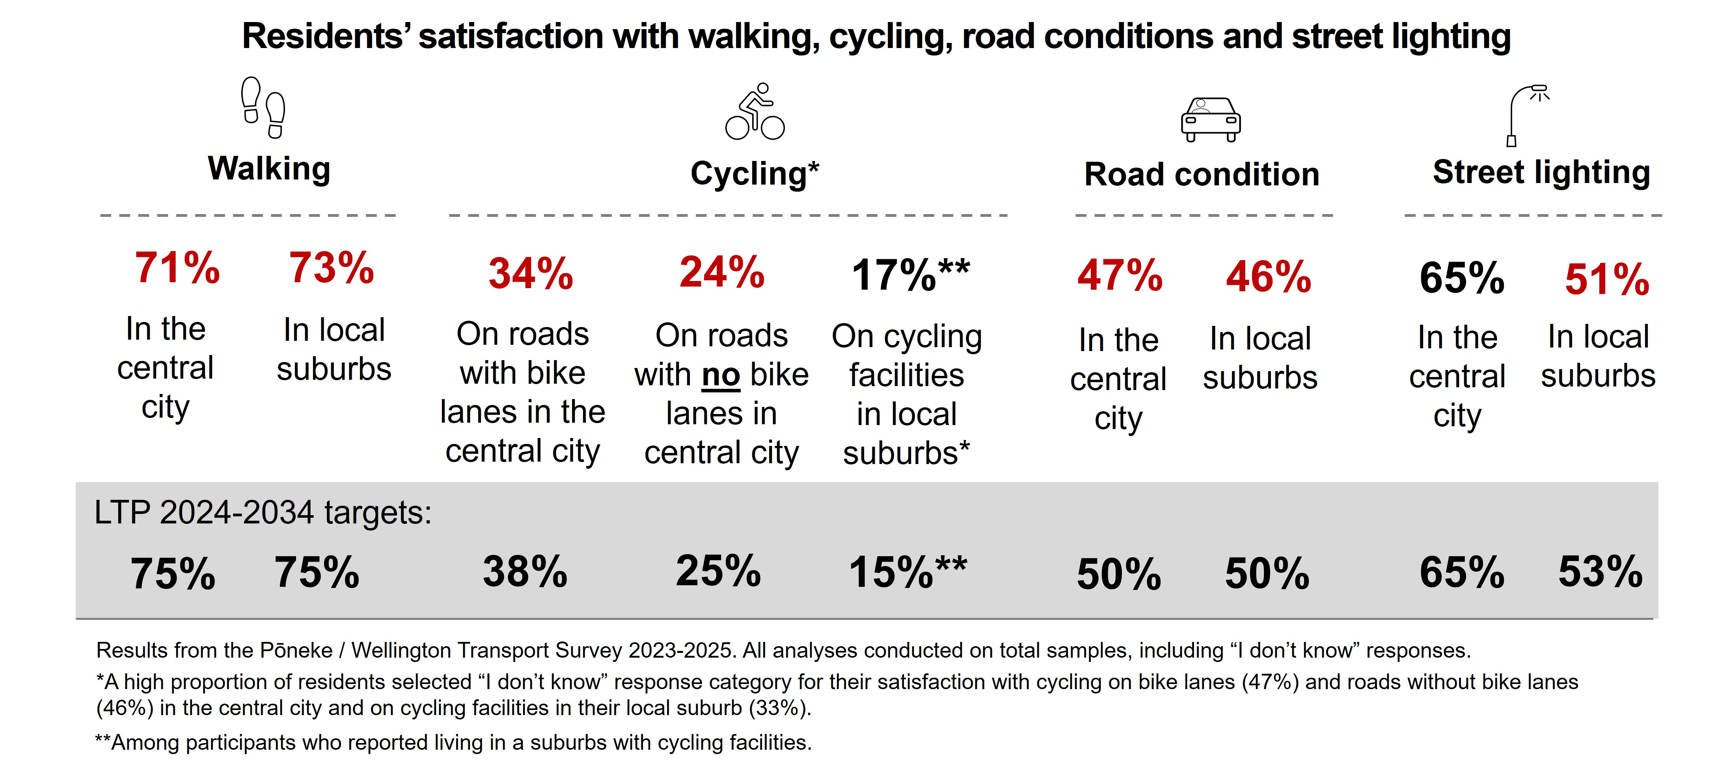
The Council is meeting some of its own transport-related key performance indicators and is close to meeting others, as summarised in the infographics below.

Stakeholder views about Transport
Transport by its nature needs to consider a wide range of perspectives, issues and challenges that affect the people and the economy of the city.

Wellingtonians want a transport system that is safe, reliable, accessible, and less dependent on private vehicles. In the 2023 Let’s Talk survey, residents ranked “better public transport infrastructure”, “making it safer and easier to walk around the city”, and “reducing carbon emissions” among the top priorities for Wellington’s future.

Wellington City’s transport system generally provides good accessibility to footpaths and public bus stops and provides a well-connected road network. Nearly three-quarters of residents are satisfied with walking and less than half are satisfied with road conditions in the central city and local suburbs. Residents have low satisfaction and perceived safety for riding a bike in the city although the perceived ease of biking around the city has been improving in recent years. Residents’ satisfaction with street lighting is greater for the central city compared to local suburbs.

Public transport in Wellington City is provided by Greater Wellington Regional Council and operated by Metlink. Although 85% of residents have access to a bus stop within 500 meters of their home, Pōneke / Wellington Transport Survey 2023-2024 found that 74% of residents perceive public transport to be easily accessible from their home, 55% perceived it as convenient, 45% frequent, 44% reliable and 35% affordable. Overall, only 19% of residents perceived public transport to be easily accessible from their home as well as reliable, affordable and convenient, with a greater proportion of residents in the central city (29%) compared to inner city (20%) and outer suburbs (15%).

The Pōneke / Wellington Transport Survey 2024 showed that nearly half of respondents placed emphasis on prioritising road safety over shorter travel time when considering speed limits in Wellington city. Residents who frequently walk, bike or use public transport place a greater emphasis on road safety over travel time. They supported lower speed limits and perceived greater safety concerns compared to those who frequently travel by private vehicle.

Feedback from businesses and residents along routes where transport upgrades are taking place is that disruption needs to be further minimised. The Council must remain mindful of the short and long-term impacts of transport work and continue to regularly communicate with affected businesses and residents. The Council will also need to continue to find project-specific ways to lessen disruptions, minimise the loss of foot traffic, and reduce the noise and dust during construction.

The community and organisations have shared their views on urban development in a recent consultation on the Long-term Plan (2024). These views included aspects related to land use and transport alignment:
- Calls for better alignment between land use and transport planning.
- General support for improvements to public transport services and alternative transport modes.

The Audience Sentiment survey 2025 showed that a lower proportion of disabled people were aware that the Council is the provider of various transport-related services, as compared to non-disabled people. In addition, disabled people showed higher levels of dissatisfaction with the Council’s performance in regard to public transport infrastructure / bus lanes and shelters (43% vs 26%) and pedestrian infrastructure / footpaths (34% vs 22%) compared to non-disabled people.

The Priorities Engagement Report for 2024-34 LTP showed:
- strong demand for improved public transport
- mixed views on cycling infrastructure, including strong support for separate cycling infrastructure especially at intersections, and strong opposition to cycling infrastructure due to the loss of parking
- the need for improved accessibility of transport infrastructure
- concerns about affordability of public transport and cost of living; and
- the importance of aligning transport improvements with urban development and ensuring resilience to natural hazards.

Advisory groups’ feedback
The multiple advisory groups consistently call for early and meaningful engagement in transport planning, beyond feedback at the project stage, so that advice informed by diverse identities can shape strategic direction. The panel also stresses the importance of embedding intersectional inclusion into design standards and business cases, addressing considerations such as accessibility, cultural safety, affordability, and gender diversity.
Note, although the feedback is provided here, it is GWRC not WCC that plans and delivers public transport services.

Accessibility Advisory Group (AAG)
The Accessibility Advisory Group (AAG) emphasises the importance of ensuring accessibility throughout the entire journey for all travellers, including features such as well-designed footpaths, kerb ramps, bus stops and shelters, adequate lighting, and wayfinding. They advocate for systemic solutions rather than ad-hoc upgrades, calling for universal design principles to be embedded in renewals and capital projects, supplemented by comprehensive audits and a long-term programme to address severance points like crossings, gradients, and tactile paving. The group also highlights the need for transport information, both real-time and static, to be available in accessible formats, such as plain language and screen-reader friendly versions. Frequently raised issues include inconsistent shelter coverage and lighting at bus stops and their approaches, which impact safety and comfort for disabled people, women, and children, as well as variability in boarding interfaces, such as bus kneeling, ramps, and raised kerbs, leading to unpredictable travel experiences.

Ethnic Communities Advisory Group (ECAG)
The Ethnic Communities Advisory Group (ECAG) emphasises the need for safety and respect within public transport spaces, advocating for transport corridors and hubs that are free from harassment and racism. They call for anti-racism training and improved reporting of racially motivated incidents to guide effective interventions. The group also stresses the importance of engaging ethnic and faith communities early and meaningfully in decisions about transport changes, such as speed limits and corridor reallocations, rather than relying on late-stage consultations. Common concerns raised include the affordability of travel for newcomers and low-income households, with a particular desire for clear concessions and accessible, multilingual communications regarding route and service changes.

Pacific Communities Advisory Group (PCAG)
The Pacific Communities Advisory Group (PCAG) highlights the importance of family-centred travel, advocating for transport designs and timetables that accommodate larger family groups, including prams, elders, and children. They stress the need for enhanced shelter, seating, and toilet facilities near transport hubs, as well as a range of family-friendly programmes around these nodes. Affordability and proximity remain significant concerns, with cost and distance identified as barriers to access. The PCAG supports the development of walkable, welcoming transport hubs and reliable bus services specifically serving Pacific communities in Newtown, Berhampore, and the Northern suburbs. A frequently raised issue is the need for dependable service reliability and frequency, as connections to jobs, schools, churches, and community centres are essential for families making multi-stop journeys.

Takatāpui Rainbow Communities Advisory Group (TRCAG)
The Takatāpui Rainbow Communities Advisory Group (TRCAG) advocates for public transport and street environments that are inclusive and safe for everyone, highlighting the need for gender-neutral facilities and designs that foster a sense of belonging, such as well-lit waiting areas, clear sightlines, and inclusive wayfinding. They urge partnerships with transport operators and City Safety teams to address harassment both at stops and on vehicles, prioritising harassment-free journeys for all users. Frequently raised concerns include improving night-time safety through better lighting along paths between destinations and stops and supporting the collection of data on incidents to inform future design improvements.

Rangatahi Youth Communities Advisory Group (RYCAG)
The Rangatahi Youth Communities Advisory Group (RYCAG) highlights the need for affordable and frequent public transport options connecting schools, tertiary campuses, workplaces, and recreational facilities, along with integrated active travel infrastructure such as bike parking and safer crossings near education hubs. Youth strongly advocate for transport policies that support climate leadership, viewing mode shift as a critical tool for reducing emissions and wanting transport corridors and amenities to exemplify sustainability. Common issues raised include inadequate shelter and lighting along popular youth routes and a desire for rangatahi to co-design local improvements.

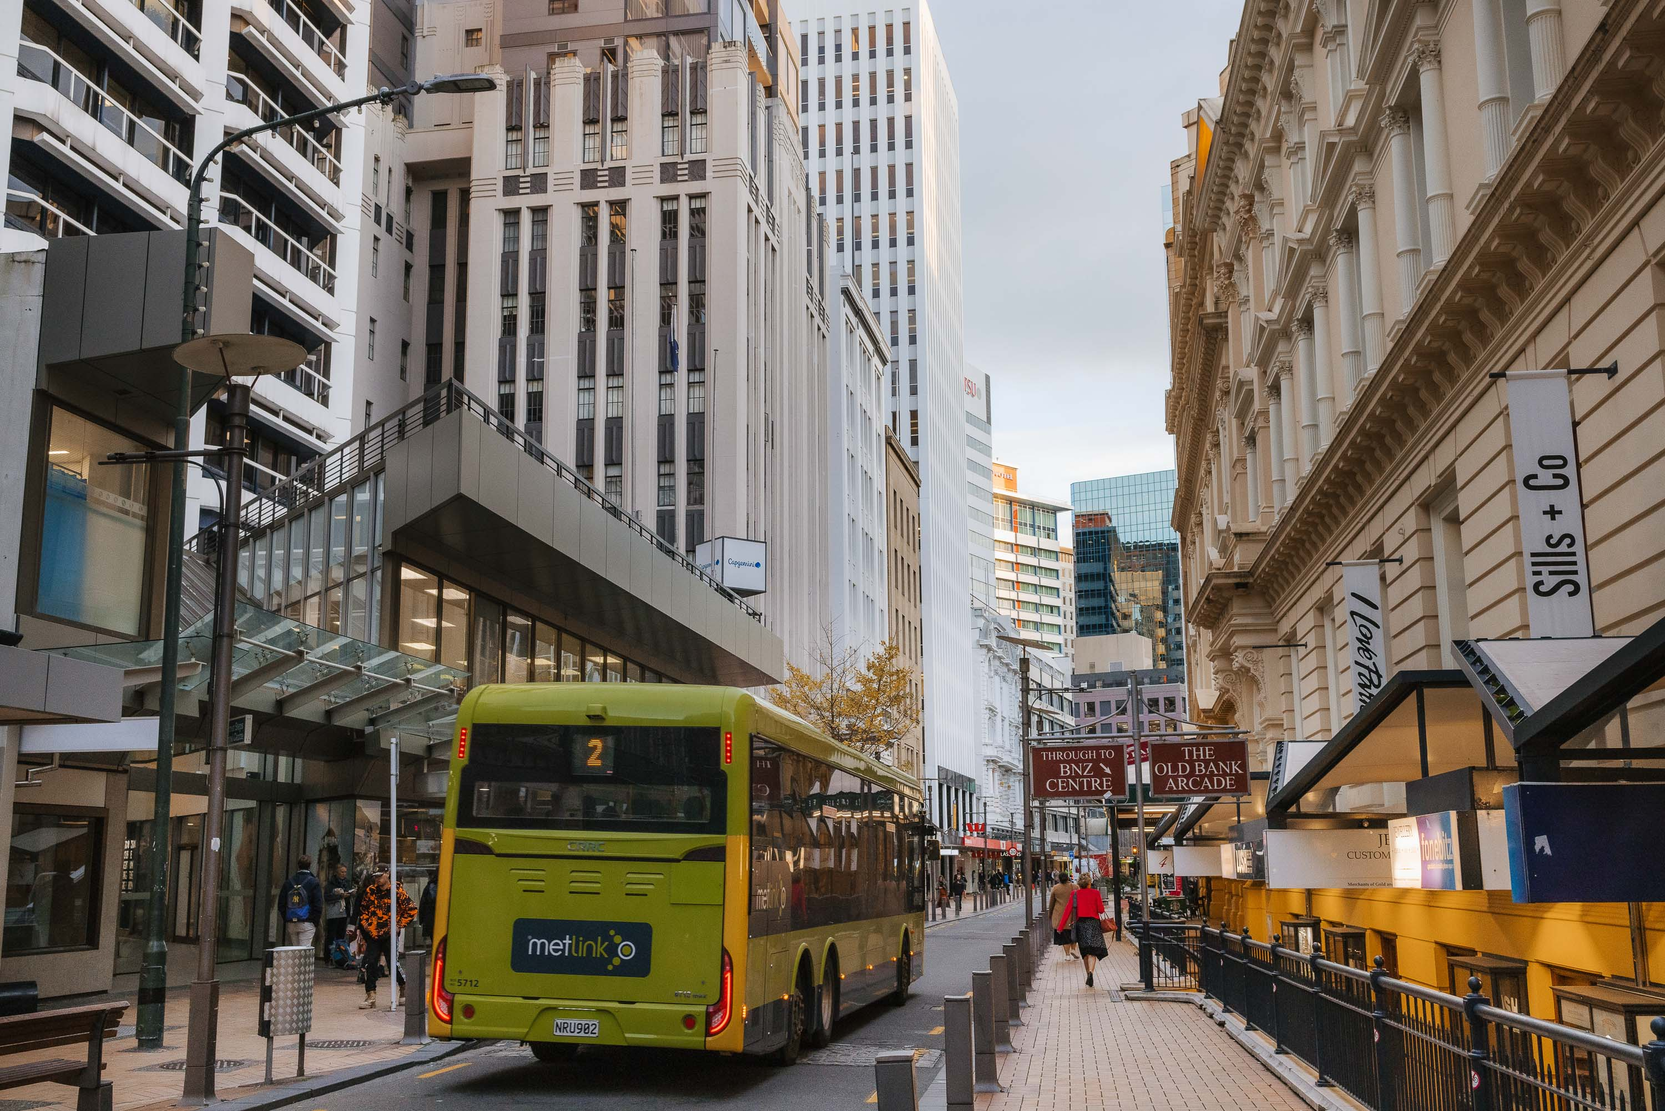

Key Issues for Transport in Wellington City
Delivering a transport network that is accessible and fit for the future while managing existing demands and meeting logistics needs is challenging. Given the city’s topography and narrow, hilly streets, transport decisions often involve balancing competing needs and priorities among various users and uses of the street space available for movement, public place and parking. This often results in challenging choices and strong, conflicting opinions within the community.

Key transport issues for Wellington City Council include the integration of State Highway upgrades, persistent road safety challenges, negative impacts of air pollution, targets to reduce on-road transport carbon emissions, traffic congestion during peak periods, high reliance on private vehicle travel, accessibility barriers for disabled people, and space and funding constraints. In response to these issues, the Council has adopted mode shift initiatives (encouraging a transition from private vehicle use to low-carbon, active, and public transport) as a strategic solution. Moving more people to active and public modes of transport also means less congestion for those who continue to need to travel by private motor vehicle. The key to achieving meaningful mode shift is ensuring that active and public transport options are safe, accessible, reliable, and convenient for all users. Without improvements in integration, infrastructure quality, and service provision, it will be difficult to encourage more people to choose these sustainable modes for their daily travel.

Transport planning and investment misalignment
Wellington City faces a strategic challenge due to a lack of alignment between its long-term transport objectives, actual investment, and operational activities. Over time, many documents and decision have been made, but there is currently no fully integrated transport plan that connects specific programmes and projects with these ambitions. This challenge is compounded by the need to improve coordination between the Council’s infrastructure activities and those of external providers, including the new water entity, especially following the dissolution of Let’s Get Wellington Moving. Coordinating projects to minimise periods of digging, construction, and reinstatement can help reduce costs and disruption for ratepayers, businesses, and residents, although such coordination can also introduce additional complexity and risk.

Transport funding limits the ability to address current deficiencies and future aspirations
The funding for our transport planning and delivery is closely tied to central government funding priorities set through the Government Policy Statement (GPS) on Land Transport. This includes legislative changes and shifts in NZTA’s funding priorities. The Council receives significant funding through the National Land Transport Fund. This presents both challenges and opportunities for transport planning.

The previous government increased funding for cycling infrastructure, so the opportunity was taken to close the cycling infrastructure deficit.

Differences between the Council’s current strategic transport priorities and the direction set by current central government have contributed to reduced National Land Transport Fund allocations for upgrade projects. As a result of national funding constraints and shifting government priorities in the 2024–27 National Land Transport Plan (NLTP), Wellington City received $68 million less than requested. The LTP amendment 10-year budget 2024–34 allocated $534 million for transport upgrades.

Co-funding of maintenance and renewal projects has remained consistent with previous NLTPs.

Funding is expected to remain in place to support further connection of the cycling network and maximise the value of this investment, but delivery will progress more slowly. Future opportunities are likely to be in improving public transport infrastructure and walking connections.

Design and integration of Roads of National Significance (RoNS) / State Highway upgrades
The Government has identified two Roads of National Significance in Wellington City:
- State Highway 1 Second Mt Victoria Tunnel and Basin Reserve upgrade (including a parallel Terrace Tunnel), and
- the Petone to Grenada Link Road.

Initial RoNS SH1 plans have now been made available to us, and engagement with the Council has commenced prior to the planned lodgement of a Fast Track consenting application in mid-2026. The integration of these Roads of National Significance projects will directly impact the surrounding transport network, requiring additional investment to maintain and enhance local connectivity. This will likely result in extra costs associated not only with the consenting and connection of these investments, but also with mitigating disruption and ensuring seamless access for local communities as the roads are constructed.

Traffic congestion during peak periods
The city currently experiences a degree of traffic congestion particularly during morning and afternoon commute times. Wellington City internal trips show a relatively low level of congestion when compared with the trips coming into the city from other territorial authorities. The estimated annual cost of congestion is $10 million for travel within the city, and $20 million for travel to and from Wellington City via State Highway 1 and 2. This is the cost of transport inefficiency only based on increased travel time and does not take into account any consequential effects on the wider economy. Congestion not only affects travel times, but it also contributes to increased transport-related carbon emissions and air pollution. The level of congestion in Wellington City is similar to other cities of similar size around the globe.

The Government’s proposed time of use (congestion) charging legislation was passed in November 2025 and will come into effect in November 2026. This provides a new tool for managing traffic congestion in the coming years. With the legislation now in place, there is an opportunity to apply a pricing mechanism aimed at reducing congestion during peak travel times, improving travel time reliability, lowering emissions, encouraging a shift from private vehicles to public and active transport, and funding multi-modal transport upgrades. The legislation comes into effect in November 2026, at which time the Council may establish a process to develop a time of use charging scheme and decide whether to join NZTA in advancing such a proposal.

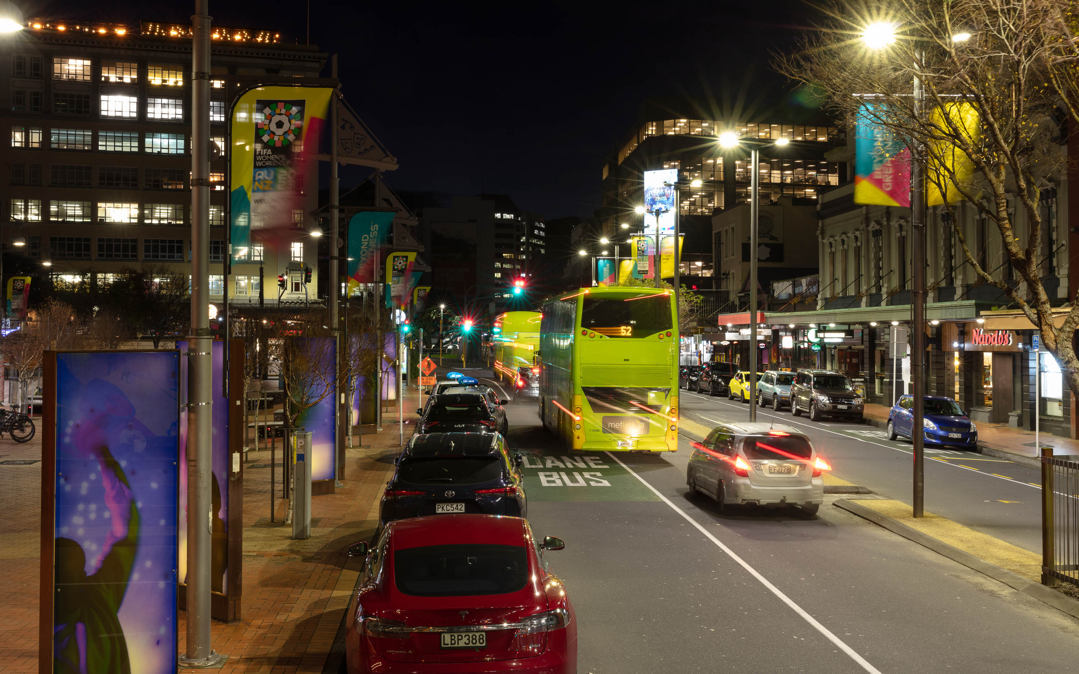

Regional growth strains transport, increases congestion and emissions
Recent housing and business growth in the Wellington region has primarily occurred in the Kapiti Coast, Hutt Valley and Wairarapa. This is driven by many factors, such as improved transport options (including motorways and rail improvements), increased zoning for medium density housing and “greenfield” (new) urban areas, and comparatively higher housing prices within Wellington City (as discussed in Urban Development Background Report). This has given people, particularly families, more affordable housing and lifestyle options in the wider region.

Wellington City still has over 60% of the region’s jobs, tertiary education and a significant number of secondary education destinations. Consequently, the growth in outer urban areas has led to increased private vehicle use to and within Wellington City, even though some travel occurs by train and bus. These patterns present challenges for reducing emissions and improving urban accessibility. However, some of this is mitigated by the increase in working from home, especially for those who travel further. Tackling these challenges may include ongoing regional collaboration, considering investment in urban areas near Wellington City’s centres and public transport hubs, and exploring further support for public transport options.

To enhance the reliability of public transport, consideration of the role of Harbour Quays within the network is needed. Harbour Quays is a strategic location that could improve integration between rail, bus, and active transport connections. Enhancing access and connectivity at Harbour Quays may help to reduce pressure on the city’s main transit corridors, provide more efficient transfer points, accommodate future regional growth, and support a balanced distribution of commuter flows. Ensuring this area is well-connected to other key destinations will contribute to a reliable and adaptable public transport system.

Increasing costs of infrastructure, ageing assets and impacts from severe weather events

Increasing costs, infrastructure maintenance and ageing infrastructure
Wellington’s transport sector faces significant strategic challenges and risks stemming from rising costs and the ongoing need to maintain and renew ageing infrastructure.
Escalating costs across the economy and more so New Zealand’s roading material costs, especially bitumen and aggregates, have experienced significant upward pressure over the past 5 years, driven by supply chain shifts, market concentration, import dependence, and long‑term aggregate supply constraints, according to the Transport Agency research report. These have the potential to restrict the Council’s financial capacity to fund both essential maintenance and renewals to the transport network, and limit investment in upgrades intended to enhance the city’s resilience and liveability.

A key strategic risk is the growing burden of maintaining an ageing infrastructure portfolio. By 2025, the value of Wellington City’s street network surpassed $2.8 billion. The proportion of transport assets nearing or past their useful life has increased markedly.
The local transport network in Wellington is built on difficult terrain - it is steep, winding with lots of tight corners, narrow, and is exposed to extreme natural events such as earthquakes, slips and storms. The CBD, which is largely built on reclaimed land, is at particular risk. This has resulted in a greater need for structures to support road surfaces, leading to Wellington having the highest number of sea and retaining walls per square kilometre in the country.

Although future overall traffic volume is uncertain, certain key corridors are becoming more heavily used. Increased volumes and vehicle loading create additional stress upon the road, accelerating defects and reducing the asset life of both the road surface and sub-structure. This is particularly a challenge given the expected increases in heavy vehicles and public transport traffic volumes. A large portion of the network’s roads are built on weak subgrades, which results in road failures when exposed to moisture. Ageing water infrastructure also undermines the structure of the road, causing further deterioration of assets.

The condition and criticality of transport assets are influenced by factors such as age, usage, and the unique characteristics of Wellington’s terrain, which includes a high number of bridges and structures. Effective asset management therefore requires a mature, coordinated approach. The city’s Long‑Term Plan (2024–2034) baseline assessment highlights a number of infrastructure priorities, including several key bridges and other important structures that will require attention over time. One of these bridges is scheduled for progression by 2026/27, with planning for others to be developed as part of the next long‑term planning cycle. Proactively managing these assets supports the ongoing safety, reliability, and resilience of the transport network and helps maintain community confidence in its performance.

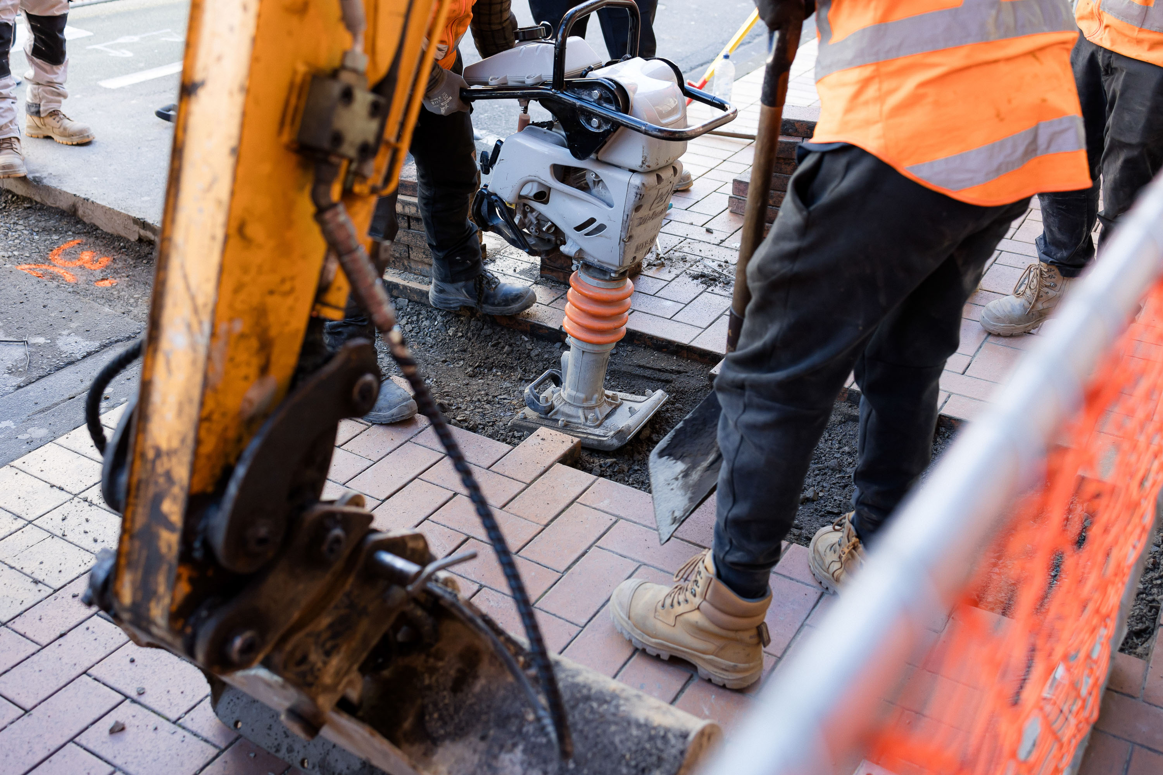

Climate adaptation in Wellington’s transport system
Integrating climate adaptation into Wellington’s transport planning presents ongoing challenges. There is uncertainty about whether current investments fully address both climate mitigation and adaptation. Rising maintenance costs, especially for coastal and hillside roads, add further pressure to the system. Wellington City is projected to experience a temperature rise in the coming decades, with more frequent storms and increased rainfall likely to result in more slips across Wellington hillsides. This could impact the roading corridors due to the region’s slip-prone clay and greywacke terrain.

Further adaptation challenges include the integration of climate adaptation into infrastructure planning, funding constraints for resilience upgrades, and the potential misalignment between central and local government priorities. The split responsibilities between local, regional, and central agencies can also slow the delivery of integrated and adaptive transport solutions.

Challenges in shifting more trips from private vehicles to walking, cycling, and public transport
Shifting more trips from private vehicles to low-carbon modes, such as walking, cycling and public transport, has been identified as a priority by Wellingtonians, and provides environmental, social, economic, and health benefits. The Council’s current strategic response to address congestion, carbon emissions, and air pollution includes encouraging greater uptake of active and public transport. Although Wellington already has higher rates of walking, biking, and public transport use for travel to work compared to other New Zealand cities, several barriers remain. Safety concerns due to frequent road crashes, inadequate walking and cycling infrastructure, and the city’s challenging natural topography discourage many residents from choosing these alternatives. Public transport is affected by issues with reliability and affordability. Additionally, factors such as the distance between homes and key destinations, and connectivity to public and active transport networks continue to drive dependence on private vehicles. In addition, residents frequently raise concerns about the loss of parking during transport network upgrades, which can also impact Council budgets through reduced parking revenue and increased demands for alternative parking solutions.

Construction required for transport network upgrades can create challenges for nearby businesses. Although these projects aim to enhance the urban environment, construction works can temporarily affect business operations by limiting customer access, reducing parking availability, and generating noise or visual disruption along retail corridors. As a result, some businesses may experience short‑term declines in foot traffic and sales, especially during major streetscape upgrades. To help minimise these impacts, the Council can communicate proactively with affected businesses, provide clear signage and alternative access routes, and engage business owners early in project planning. Over time, the improved transport infrastructure is expected to enhance accessibility and increase foot traffic, benefiting commercial areas. Managing and mitigating short‑term disruption is important to ensure that the temporary burdens of construction and modal shift are not disproportionately felt by a small number of businesses.

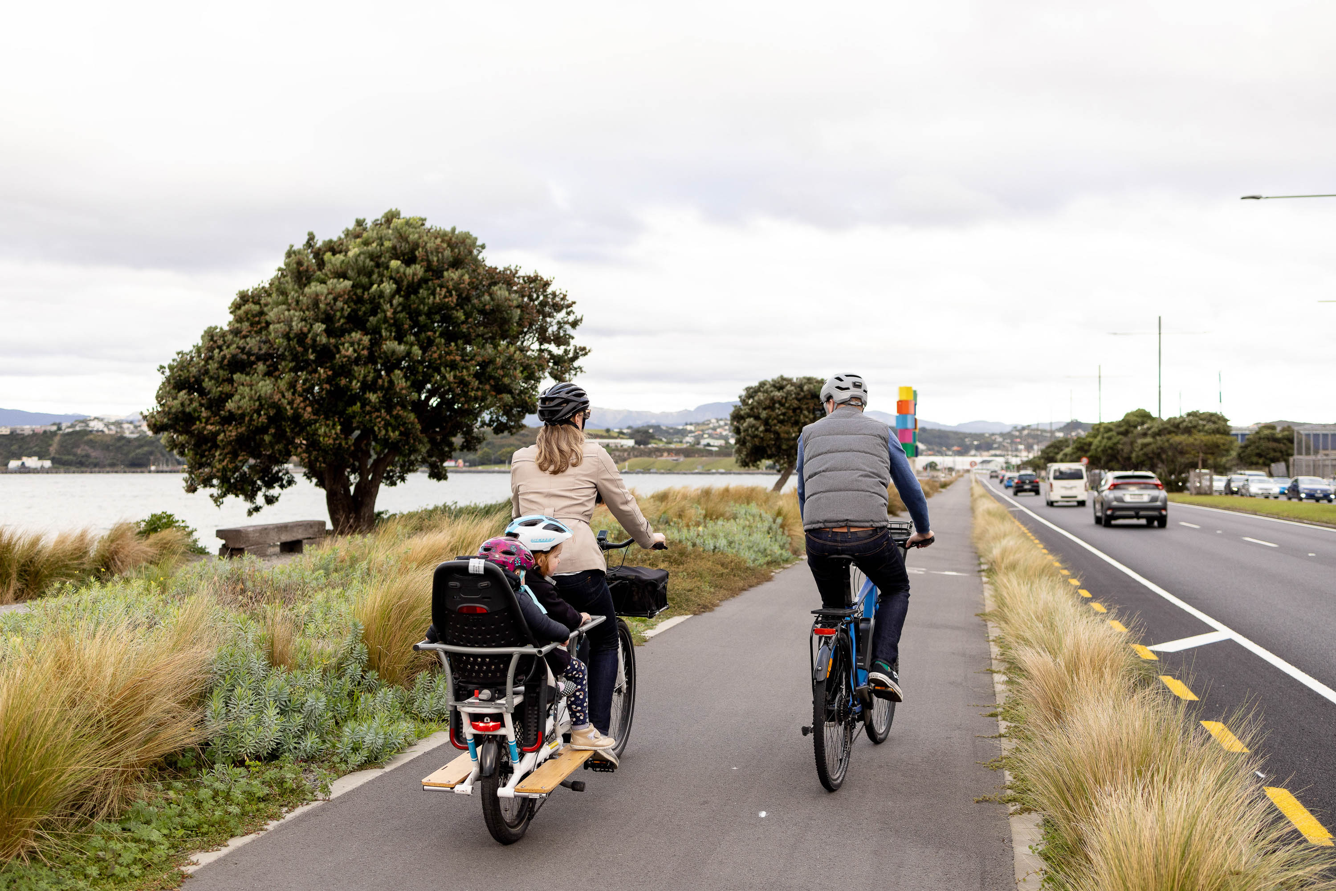

Addressing road safety, emissions and air pollution

Road safety challenges
Road safety remains a challenge for Wellington City with the number of injuries from road crashes, particularly for people walking and biking. Between 2015 and 2024, Crash Analysis System data showed that road crashes on Wellington streets resulted in 33 deaths and nearly 4000 injuries (including 634 serious injuries) with a social cost of $2.23 billion. Overall, 80% of injuries from road crashes occurred on city streets and 20% occurred on state highways. Survey findings consistently show concerns for safety of people on bikes on city streets, particularly in the central city, town centres and on arterial streets. In 2022, New Zealand had approximately 7.5 deaths from road crashes per 100,000 inhabitants compared to 4.5 in Australia and 2.0 in Norway and was ranked 29th out of 35 OECD countries for this outcome. Wellington City has a low rate of deaths and serious injuries per capita, compared with other parts of New Zealand.

Transport emissions in Pōneke
On-road transport contributes to 34 percent of emissions in Pōneke. Wellington’s compact urban form presents opportunities for the Council to support more central living and travel with fewer vehicles, through District Plan settings and investments in transport networks. Reducing transport emissions is a key aspect of the city’s climate action goals. The Council has set out strong policy foundations, including a sustainable transport hierarchy and Te Atakura – First to Zero 2019, and is investing in infrastructure to support sustainable travel. Wellington has comparatively high rates of active and public transport use, and there is broad public awareness of, and support for, climate action and sustainable transport initiatives. According to the latest Climate Action Monitor, 25% of residents use only electric vehicles, bus, bike or walking for travel.

Council efforts to improve transport in Pōneke have historically depended on central government funding and policy settings. Currently, central government policy settings are not primarily focused on emissions reductions. New public and active transport projects in Pōneke received limited funding for the 2024 LTP period; however, Council investment in transport networks is continuing, alongside supporting services for residents to use new transport options. Recent investments include the Paneke Pōneke bike network, rapid transit bus corridors, and improved pedestrian environments, which are intended to encourage walking, cycling, and public transport use, and make low-emission travel more welcoming.

Despite these efforts, challenges remain. There is high car dependency in outer suburbs, funding constraints for both resilience upgrades and low-carbon transition investments, a shift in national transport or emission reduction priorities, and split responsibilities between local, regional, and central agencies which can slow the delivery of integrated transport.

Negative impacts of air pollution
Transport is the largest contributor to air pollution-related health impacts in Wellington City, causing an estimated 60 premature deaths and $280 million in social costs in 2019. The 2024 Quality of Life survey indicates a significant rise in negative perceptions of air pollution among Wellington residents, with 44% considering it a major or moderate issue. These results are consistent with those observed in the other seven New Zealand cities included in the survey. However, the Ministry of Environment, Our Environment 2025 report, shows slight improvements in Wellington City’s air quality since 2016.

Transport accessibility and equity

Accessibility barriers
Being able to get around Pōneke safely is essential for all residents. Consistent feedback from the disabled community indicates that accessible transport networks are a priority. While aspects of the current transport network present challenges for disabled people, making navigation difficult for some, the Council is making progress by incorporating accessibility enhancements during scheduled maintenance activities. The Council also has a commitment to universal design principles, which aims to improve outcomes on new and upgraded assets. However, limited funding for pedestrian upgrades, and significant gaps in data specific to disabled and elderly users remain ongoing challenges.

Inconsistent inclusion, safety gaps, unmet community needs
The Council has made progress in embedding inclusion within its transport activities. This includes active engagement with diverse communities, incorporating inclusive design elements such as rainbow crossings and culturally significant overlays, and developing a transport network that increasingly reflects the social diversity of Wellington. There are further opportunities to strengthen inclusion by more deliberately telling the city’s diverse stories through design, embedding inclusive features into future upgrades, and improving engagement processes so that more people feel a sense of belonging and connection.

Despite these strengths, several challenges remain. Feedback from stakeholders indicates that aspects of the network do not consistently support safety or comfort for all users. For example, insufficient bus stop shelters, and poorly lit areas can disproportionately affect women, children, disabled people, and other marginalised groups. Inclusive outcomes are also not systematically integrated into project scoping and design, resulting in infrastructure gaps that can unintentionally perpetuate exclusion. There is a risk that inclusive initiatives may become politicised if not clearly and consistently embedded across programmes, and community expectations may not be met if inclusion is applied unevenly. Strengthening the consistency and depth of inclusion across all transport activities will be critical to ensuring the network meets the needs of Wellington’s diverse communities.

Inconsistent Māori engagement, integration, and transport equity challenges
Te ao Māori considerations within the Council’s transport activity highlight a growing commitment to partnership and cultural integration, with strengths including the incorporation of Māori narratives and design elements into street upgrades, and a foundation of collaboration with Tākai Here partners. These actions reflect an intention to acknowledge and celebrate Māori identity within the urban environment.

Tākai Here partners emphasise that housing development for iwi must also go hand in hand with access to robust transport infrastructure to ensure whānau wellbeing and cultural aspirations. Partners note that without reliable public transport, safe roads, and active travel options, new papakāinga or iwi-led housing projects may inadvertently isolate communities from essential services, including employment, education, healthcare, and marae connections. They advocate for transport planning to be embedded within housing initiatives to ensure mobility, economic participation, and social cohesion, and to promote sustainable practices. This integrated approach reflects Te Tiriti o Waitangi principles and iwi aspirations for connected, thriving communities where housing solutions are not only affordable and culturally grounded but also empower whānau to flourish across generations.

However, there are ongoing challenges in the consistency and depth of engagement with Māori stakeholders. Gaps in planning for Māori outcomes and insufficient communication throughout project lifecycles remain. Limited collection and use of Māori-specific data also restricts the ability to measure progress and ensure accountability. As a result, Māori perspectives may sometimes be incorporated only superficially or late in the process, rather than being embedded from the outset.

There is an opportunity to improve engagement in the transport area to ensure alignment with Tūpiki Ora and Tākai Here expectations. Strengthening relationships and mutual understanding can be achieved by embedding tikanga Māori within engagement processes. By expanding the use of cultural overlays in transport projects, the Council can better showcase the unique identity and history of mana whenua. Additionally, increasing Māori representation in governance and decision-making structures will help ensure that Māori voices are heard and considered at every level.

Long-term Plan 2024-34 - Plans, policies and bylaws - Wellington City Council
Waka Kotahi New Zealand Transport Agency. (September 2020). Transport Impacts on wellbeing and liveability. Research Report 669.
Te Manatū Waka Ministry of Transport. (June 2023). Domestic transport costs and charges study. Prepared by University of Otago in association with Ian Wallis Associates LTD.
Wellington City Council. (January 2026). The State of Transport in Wellington City.
Stats NZ. (2023). 2023 census population, dwelling, and housing highlights.
Wellington Transport Analytics Unit. (June 2025). RLTP 2027 – State of Transport Network. Prepared for Greater Wellington Regional Council.
Waka Kotahi NZ Transport Agency. (August 2022). Research report 693.
Stats NZ. (2023). Census 2023.
Wellington Transport Analytics Unit. (June 2025). RLTP 2027 – State of Transport Network. Prepared for Greater Wellington Regional Council.
Wellington City Council. (2024). Pōneke Wellington transport survey.
International Transport Forum. (2023). Road Safety Annual Report 2023. OECD Publishing.
Wellington Transport Analytics Unit. (June 2025). RLTP 2027 – State of Transport Network. Prepared for Greater Wellington Regional Council.
Emission Impossible. (March 2022). Health and air pollution in New Zealand 2016 (HAPINZ 3.0). Prepared for Ministry for the Environment, Ministry of Health, Ministry of Transport, NZ Transport Agency.
Manatū Mō Te Taiao Ministry for the Environment. (8 April 2025). Air in Our environment 2025 Tō tatou taiao.

