Kia ora,

This leaflet is to let you know about a change we are proposing to make in your neighbourhood.

Proposal:

Reference | - TR121-25 Te Ngākau Precinct Street Scape – Harris Street
Location – where we propose to make the change | The entirety of Harris Street
What we’d like to do | - Build out the kerb line 42 metres and 9.3 metres on Northern side, 24.25 metres and 80 metres on Southern side  - Remove All Parking Spaces on the Both sides  - Remove 8.5 metres, 10.5 metres, 24.5 metres and 14 metres of No Stopping Line on Northern side  - Remove 5 metres,18 metres,8.5 metres and 10 metres of No Stopping Line on Southern side  - Install 19.5 metre long Police Parking (three parking spaces) on Northern side  - Install 12.5 metre long Metered Parking (two parking spaces) on Northern side  - Install perpendicular Courtesy Crossing  - Install 7.5 metre long Metered Mobility Parking (One parking space) on the Northen side  - Install 12 metre long Metered Parking (two parking spaces) on Southern side  - Install 6.2 metre long P10 Parking (One parking space) At All Times on Southern side  - Install 9 metres,15metres,45metres and 27metres No Stopping Line on Northern side  - Install 5metres, 25metres and 33 metres of No Stopping Line on Southern side  - Install 14.4 metre long Metered Mobility Parking (two parking spaces) on the Southern side  - Install 30 metre long P30 Tour Buses Parking (two parking spaces) on the Southern side
Why we are proposing the change. | - These changes are part of the Te Ngakau Streetscape Project which is poised to significantly enhance the urban environment within the Te Ngakau precinct in Wellington, which coincides with the opening of several key civic facilities, including the new Wellington Central Library (Te Matapihi), the Wellington Town Hall, and the Wellington City Council offices at 68 Jervois Quay.  - This project is vital in catering to the increasing demand for public amenities and improved pedestrian and roading infrastructures.  - The changes will also provide improved pick-up, drop-off and accessibility facilities to ensure equitable access to the Te Ngākau precinct for all users.  - Harris Street serves as an essential thoroughfare within this precinct. Ensuring its transformation into vibrant, accessible spaces aligns with the objectives set out by the Wellington City Council (WCC).  - The streetscape design will integrate landscaping elements and civil improvements to facilitate better traffic flow, safety, and aesthetic appeal in the area, while also contributing to the overall urban renewal of Wellington.
Impact | - Improves safety and accessibility for vehicles and pedestrians  - Net parking impact  - removal of 21 metered, times vary car parking bays  - removal of seven P10 parking bays from 8am to 6pm at Mon-Fri on Southern side, Metered Parking at other times  - addition of four metered, times vary car parking bays  - addition of one P10 loading bay  - Proposed total 13 parking bays, include four Metered Parking, three Police Parking, three Metered Mobility Parking, two P30 Tour Buses Parking and one P10 Parking.  - Pedestrian Impact: Positive. An additional pedestrian courtesy crossing, along with the widened footpath, would enhance accessibility and visibility when crossing Harris Street to and from Te Ngākau, thereby improving safety.
Other options considered | Option 1:  - Angled courtesy crossing  - Two P10 parking bays on the southern side  - Kerb build out on the southern side of the intersection between Harris Street and Jervois Quay  This option was reviewed and had the following challenges/issues:  - The angled crossing reduces visibility, increases crossing distance, and is more difficult for pedestrians with mobility impairments.  - The two P10 parking bays significantly reduce the size of the garden.  - The proposed kerb shape cannot accommodate the left-turning movement of vehicles entering Harris Street.  Option 2:  - Increase the width of the driveways along the corridor.  - Retain the existing kerb on both sides of the pedestrian crossing at intersection between Harris Street and Jervois Quay.  This option was reviewed and had the following challenges/issues:  - The garden size has been reduced.  - The shape of the tie in kerb may cause drainage issue.
How this relates to the parking policy | - Support shift in type of transport used – facilitate a shift to using active (eg, walking and cycling) and public transport to move more people driving fewer vehicles.  - Support business wellbeing – ensure parking management and pricing controls support economic activity in the central city, suburban centres and mobile trades and services.  - Support city place-making, amenity and safety – ensure on-street parking design and placement supports overall city amenity, safety, community building, heritage, creative arts, good urban design outcomes and attractive streetscapes.
Additional Information | - Average daily traffic count:  - Harris Street: 2573 (2020 data)  - Annual parking revenue impact - $50,872.40 (Estimated average revenue loss based on a loss of 17 metered parking spaces)  - To view the legal description for this Traffic Resolution, an electronic copy of the report will be available on the Council’s website from 9.00am Friday the 11 July 2025 at https://www.letstalk.wellington.govt.nz/
Privacy | - Your privacy is important to us. Please DO NOT add specific personal details to your feedback (i.e.: full name, address, etc)  - What we do with your personal information:  All submissions (including your first name, but not contact details) are provided in their entirety to elected members and made available to the public on our website and at our office. Personal information (including contact details) will also be used for the administration of the consultation process including informing you of the outcome of the consultation. All information collected will be held by Wellington City Council, 113 The Terrace, Wellington, with submitters having the right to access and correct personal information.  - For more information regarding our Privacy Statement please check our webpage: Privacy statement - Wellington City Council.
Feedback | - If you would like to provide us with specific feedback, which will be added to the Traffic Resolution following consultation and made public in full, you can do so by filling out an online submission form, downloading a printable submission form on https://www.letstalk.wellington.govt.nz/ or emailing us at trfeedback@wcc.govt.nz.  Please note if you are giving feedback the consultation period opens at 9.00 am Friday the 11 July 2025 and finishes at 5.00 pm Friday the 25 July 2025.
Next Steps | - Feedback collated by Monday the 28 July 2025.  - The proposal will go to the Koata Hātepe|Regulatory Processes Committee meeting on Thursday the 28th of August 2025.  - If approved, the proposal will be installed within the following six months.

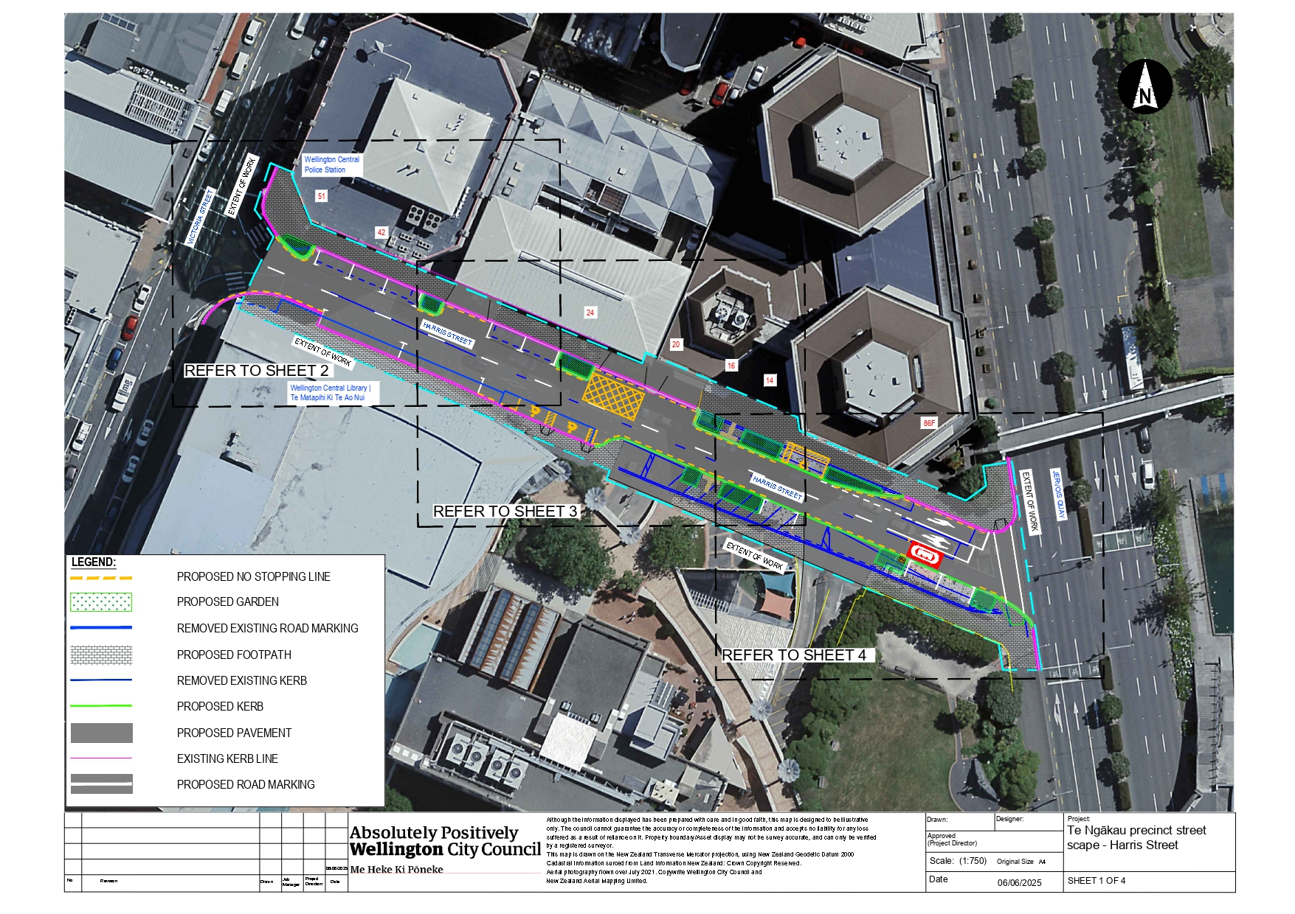
Traffic Resolution Plan: TR121-25 Te Ngākau precinct street scape – Harris Street

Traffic Resolution Plan: TR121-25 Te Ngākau precinct street scape – Harris Street
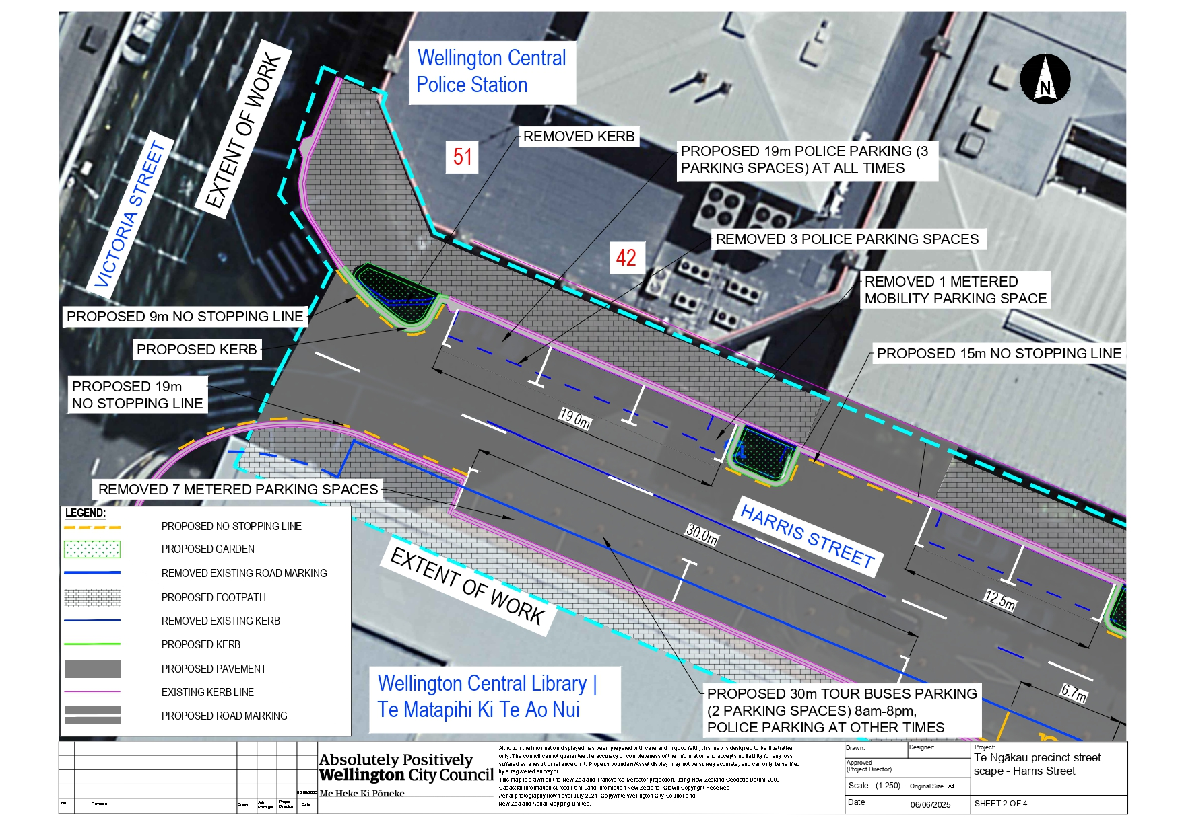

Traffic Resolution Plan: TR121-25 Te Ngākau precinct street scape – Harris Street
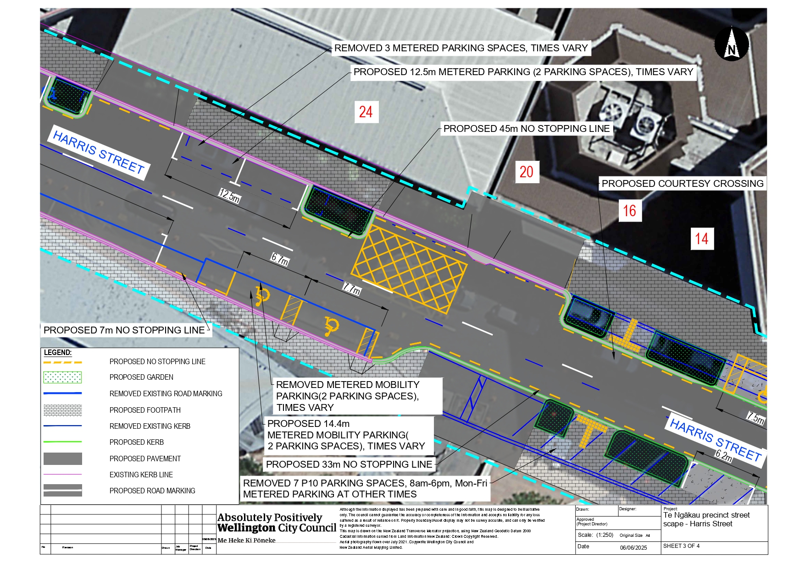

Traffic Resolution Plan: TR121-25 Te Ngākau precinct street scape – Harris Street
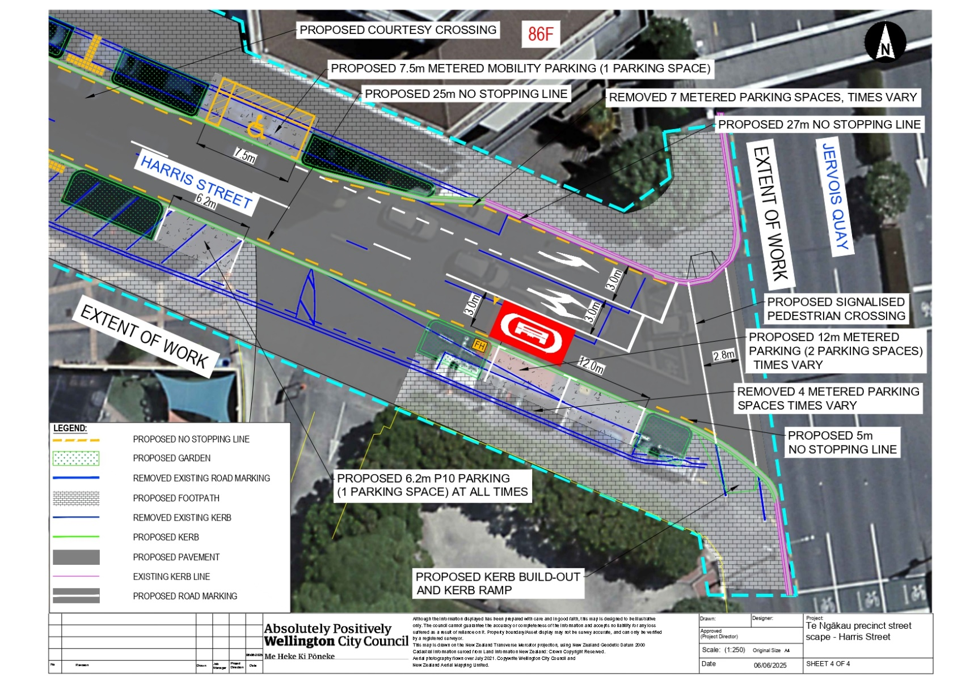

Legal Description:

Delete from Schedule A (Time Limited) of the Traffic Restrictions Schedule

Column One | Column Two | Column Three
Harris Street | P10 Time Limited Parking, Monday-Friday 8am-6pm,  Metered Parking At Other Times | Southwest side, commencing 48 metres northwest of its intersection with Jervois Quay (Grid Coordinates X=2658926.244986 m, Y=5989426.747924 m) and extending in a north-westerly direction following the kerbline for 20.5 metres. (7 angle carparks)

Delete from Schedule B (Class Restricted) of the Traffic Restrictions Schedule

Column One | Column Two | Column Three
Harris Street | Police Parking, At All Times | Northeast side, commencing 114 metres northwest of its intersection with Jervois Quay (Grid coordinates x= 1748902.5m, y= 5427730.8m), and extending in a north-westerly direction following the kerb line for 17.5 metres. (3 parallel car parks).
Harris Street | Metered Mobility Parking At All Times,  P120 Maximum, Monday to Friday 8:00am – 5:00pm  P180 Maximum, Monday to Friday 5:00pm – 8:00pm, Saturday to Sunday 8:00am – 8:00pm | Northeast side, commencing 109 metres northwest of its intersection with Jervois Quay (Grid coordinates x= 1748902.5 m, y= 5427730.8 m), and extending in a north-westerly direction following the kerbline for 5 metres.
Harris Street | Metered Mobility Parking At All Times,  P120 Maximum, Monday to Friday 8:00am – 5:00pm  P180 Maximum, Monday to Friday 5:00pm – 8:00pm, Saturday to Sunday 8:00am – 8:00pm | South side, commencing 49 metres east of  its intersection with Victoria Street (Grid  co-ordinates x= 1,748,765.94m,  y=5,427,776.78m), and extending in an  easterly direction for 13.4 metres following  the southern kerbline. (2 spaces)
Harris Street | Bus Parking,  P30 Time Limited  At All Times | South side, commencing 12 metres east of  its intersection with Victoria Street (Grid  co-ordinates x= 1,748,765.94m,  y=5,427,776.78m), and extending in an  easterly direction for 30 metres following  the southern kerbline. (2 spaces)

Delete from Schedule D (No Stopping) of the Traffic Restrictions Schedule

Column One | Column Two | Column Three
Harris Street | No Stopping At All Times | Northeast side, commencing 131.5 metres northwest of its intersection with Jervois Quay (Grid Coordinates X=2658924.399296 m, Y=5989442.917998 m) and extending in a north-westerly direction following the kerbline for 9 metres.
Harris Street | No Stopping At All Times | Northern side, commencing 40 metres east of its intersection with Victoria Street (Grid coordinates X= 400054.43m Y= 801481.82m) and extending in an easterly direction following the northern kerb line for 10.5 metres.
Harris Street | No Stopping At All Times | Northeast side, commencing 98 metres northwest of its intersection with Jervois Quay (Grid Coordinates X=2658924.399296 m, Y=5989442.917998 m) and extending in a north-westerly direction following the kerbline for 11 metres.
Harris Street | No Stopping At All Times | Northeast side, commencing 59.5 metres northwest of its intersection with Jervois Quay (Grid Coordinates X=2658924.399296 m, Y=5989442.917998 m) and extending in a north-westerly direction following the kerbline for 20 metres.
Harris Street | No Stopping At All Times | Northeast side, commencing 7 metres northwest of its intersection with Jervois Quay (Grid Coordinates X=2658924.399296 m, Y=5989442.917998 m) and extending in a north-westerly direction following the kerbline for 12.5 metres.
Harris Street | No Stopping At All Times | Southwest side, commencing 29 metres northwest of its intersection with Jervois Quay (Grid Coordinates X=2658926.244986 m, Y=5989426.747924 m) and extending in a north-westerly direction following the kerbline for 19 metres.
Harris Street | No Stopping At All Times | Southwest side, commencing 68.5 metres northwest of its intersection with Jervois Quay (Grid Coordinates X=2658926.244986 m, Y=5989426.747924 m) and extending in a north-westerly direction following the kerbline for 13 metres.
Harris Street | No Stopping At All Times | Southwest side, commencing 4.5 metres northwest of its intersection with Jervois Quay (Grid Coordinates X=2658926.244986 m, Y=5989426.747924 m) and extending in a north-westerly direction following the kerbline for 2.5 metres.

Delete from Schedule F (Metered Parking) of the Traffic Restrictions Schedule

Column One | Column Two | Column Three
Harris Street | Metered Parking,  P120 Monday – Friday 8am – 5pm, P180 Monday – Friday 5pm – 8pm, P180 Saturday to Sunday 8am – 8pm | Northeast side, commencing 79.5 metres northwest of its intersection with Jervois Quay (Grid coordinates x= 1748902.5 m, y= 5427730.8 m), and extending in a north-westerly direction following the kerbline for 18.5 metres. (3 parallel carparks)
Harris Street | Metered Parking,  P120 Monday – Friday 8am – 5pm, P180 Monday – Friday 5pm – 8pm, P180 Saturday to Sunday 8am – 8pm | Northeast side, commencing 19.5 metres northwest of its intersection with Jervois Quay (Grid coordinates x= 1748902.5 m, y= 5427730.8 m), and extending in a north-westerly direction following the kerbline for 40 metres. (7 parallel carparks)
Harris Street | Metered Parking,  P120 Monday – Friday 8am – 5pm, P180 Monday – Friday 5pm – 8pm, P180 Saturday to Sunday 8am – 8pm | Southwest side, commencing 7 metres northwest of its intersection with Jervois Quay (Grid coordinates x= 1748904.4 m, y= 5427714.6 m), and extending in a north-westerly direction following the kerbline for 22 metres. (4 parallel carparks)
Harris Street | Metered Parking,  P120 Monday – Friday 8am – 5pm, P180 Monday – Friday 5pm – 8pm, P180 Saturday to Sunday 8am – 8pm | Southwest side, commencing 98.5 metres northwest of its intersection with Jervois Quay (Grid coordinates x= 1748904.4 m, y= 5427714.6 m), extending in a north-westerly direction following the kerbline for 41.5 metres. (7 parallel carparks)

Delete from Schedule H (Pedestrian Crossing) of the Traffic Restrictions Schedule

Column One | Column Two | Column Three
Harris Street | Pedestrian Crossing | At its intersection with Jervois Quay, with a length of 18 metres.

Add to Schedule A (Time Limited) of the Traffic Restrictions Schedule

Column One | Column Two | Column Three
Harris Street | P10 Time Limited Parking, At All Times | Southern side, commencing 44 metres west of its intersection with Jervois Quay (Grid coordinates X=1,748,904.03m, Y = 55,27,714.82m) and extending in a westerly direction following the southern kerb line for 6.2 metres (1 parking space)

Add to Schedule B (Class Restricted) of the Traffic Restrictions Schedule

Column One | Column Two | Column Three
Harris Street | Police Parking, At All Times | Northern side, commencing 16.7 metres east of its intersection with Victoria Street (Grid coordinates X=1,748,772.67m, Y=5,427,793.62m) and extending in an easterly direction following the northern kerb line for 19.5 metres (3 parking spaces).
Harris Street | Mobility Parking, Metered P120 Monday – Friday 8am – 5pm,  P180 Monday – Friday 5pm – 8pm, P180 Saturday and Sunday 8am – 8pm | Northern side, commencing 104.5 metres east of its intersection with Victoria Street (Grid coordinates X= 1,748,902.5m, Y= 5,427,730.8m) and extending in an easterly direction following the northern kerb line for 7.5 metres (1 parking space).
Harris Street | Mobility Parking, Metered P120 Monday – Friday 8am – 5pm,  P180 Monday – Friday 5pm – 8pm, P180 Saturday and Sunday 8am – 8pm | Southern side, commencing 81 metres west of its intersection with Jervois Quay (Grid coordinates X=1,748,904.03m, Y = 55,27,714.82m) and extending in an westerly direction following the southern kerb line for 14.4 metres (2 parking spaces).
Harris Street | Tour Bus Parking, P30 8am-8pm Monday-Sunday,  Police parking, At All Other Times | Southern side, commencing 102 metres west of its intersection with Jervois Quay (Grid coordinates X=1,748,904.03m, Y = 55,27,714.82m) and extending in an westerly direction following the southern kerb line for 30 metres (2 parking spaces).

Add to Schedule D (No Stopping) of the Traffic Restrictions Schedule

Column One | Column Two | Column Three
Harris Street | No Stopping At All Times | Northern side, commencing 8.3 metres east of its intersection with Victoria Street (Grid coordinates X= 1,748,902.5m, Y= 5,427,730.8m) and extending in an easterly direction following the northern kerb line for 9 metres.
Harris Street | No Stopping At All Times | Northern side, commencing 36.5 metres east of its intersection with Victoria Street (Grid coordinates X= 1,748,902.5m, Y= 5,427,730.8m) and extending in an easterly direction following the northern kerb line for 15 metres.
Harris Street | No Stopping At All Times | Northern side, commencing 62.5 metres east of its intersection with Victoria Street (Grid coordinates X= 1,748,902.5m, Y= 5,427,730.8m) and extending in an easterly direction following the northern kerb line for 45 metres.
Harris Street | No Stopping At All Times | Northern side, commencing 115.5 metres east of its intersection with Victoria Street (Grid coordinates X= 1,748,902.5m, Y= 5,427,730.8m and extending in an easterly direction following the northern kerb line for 27 metres.
Harris Street | No Stopping At All Times | Southern side, commencing 5.5 metres west of its intersection with Jervois Quay (Grid coordinates X=1,748,904.03m, Y = 55,27,714.82m) and extending in a westerly direction following the southern kerb line for 5 metres.
Harris Street | No Stopping At All Times | Southern side, commencing 23.5 metres west of its intersection with Jervois Quay (Grid coordinates X=1,748,904.03m, Y = 55,27,714.82m)and extending in a westerly direction following the southern kerb line for 25 metres.
Harris Street | No Stopping At All Times | Southern side, commencing 50 metres west of its intersection with Jervois Quay (Grid coordinates X=1,748,904.03m, Y = 55,27,714.82m) and extending in a westerly direction following the southern kerb line for 33 metres.
Harris Street | No Stopping At All Times | Southern side, commencing 96 metres west of its intersection with Jervois Quay (Grid coordinates X=1,748,904.03m, Y = 55,27,714.82m) and extending in a westerly direction following the southern kerb line for 7 metres.
Harris Street | No Stopping At All Times | Southern side, commencing 132 metres west of its intersection with Jervois Quay (Grid coordinates X=1,748,904.03m, Y = 55,27,714.82m) and extending in a westerly direction following the southern kerb line for 19 metres.

Add to Schedule F (Metered Parking) of the Traffic Restrictions Schedule

Column One | Column Two | Column Three
Harris Street | Metered Parking,  P120 Monday – Friday 8am – 5pm, P180 Monday – Friday 5pm – 8pm, P180 Saturday and Sunday 8am – 8pm | Northern side, commencing 49 metres east of its intersection with Victoria Street (Grid coordinates X= 1,748,902.5m, Y= 5,427,730.8m) and extending in an easterly direction following the northern kerb line for 12.5 metres (2 parking spaces).
Harris Street | Metered Parking,  P120 Monday – Friday 8am – 5pm, P180 Monday – Friday 5pm – 8pm, P180 Saturday and Sunday 8am – 8pm | Southern side, commencing 11 metres west of its intersection with Jervois Quay (Grid coordinates X=1,748,904.03m, Y = 55,27,714.82m) and extending in a westerly direction following the southern kerb line for 12 metres (2 parking spaces).

Prepared By: | Farzad Zamani | Program Manager
Approved By: | Kate Gourdie | (Team Leader Traffic & Resolutions)
Approved Date: | 2/07/2025

