Kia ora,

We would like to inform you about a proposed change in your neighbourhood.

Proposal:

Reference | - TR41-25 Karori Park - Proposed Parking Changes
Location – where we propose to make the change | Karori Road, Karori – outside 418  Karori Road, Karori – outside 338  Sunshine Avenue, Karori – outside 21A
What we’d like to do | - Install 80 X P120 At All Times parking spaces  - Install 29 X P180 At All times parking spaces  - Formalise 3 X P120 At All Times mobility parking spaces  - Install 1 X P5 10am-12pm Saturday and Sunday, P120 At All other Times  - Formalising 280 metres of No Stopping Lines
Why we are proposing the change | - Council have received concerns from park and sports field users who are struggling to find parking during peak times. This issue is largely due to the misuse of available spaces by inappropriate long-term parking by non-recreational users, limiting access for those who wish to engage in recreational activities. The installation of the Karori cycleway has further exacerbated the problem by reducing on-street parking in the area, leading to increased demand for parking within Karori Park. As a result, spaces intended for recreational users are frequently occupied by long-term parkers who do not use the park for it’s designated purpose.  - Area’s classified under the Reserves Act 1977 are designated for recreation purposes, meaning that parking facilities within these areas serve park and sports field visitors. The continued use of these parking spaces by non-recreational users is inconsistent with the Act’s intent. Karori Park hosts a variety of competing recreational activities, and it is essential to balance parking use so that it accommodates the needs of the majority of users. Implementing time restrictions, confirming mobility parking and installing No Stopping lines will help ensure fair access and prioritise availability for those utilising Karori Park for it’s intended recreational function.  - Introducing time restrictions will help restore parking availability for the majority of park users and align with legislative requirements under the Reserves Act by ensuring that parking spaces serve their intended purpose.
Impact | Improvements  - Improves safety by formalising No Stopping lines so that they can be enforced  - Improves safety and accessibility for mobility park users with the mobility parking being able to be enforced  - Reduced Misuse of Parking Spaces through installing time-limited parking spaces  - Improves parking availability for a variety of park and sports users  Net Parking Impact  - Converting 80 non-restricted parking spaces to P120 At All Times  - Converting 29 non-restricted parking spaces to P180 At All times  - Formalising three mobility parking spaces  - Converting one non-restricted parking space to P5 10am-12pm Saturday and Sunday, P120 At All other Times  - Formalising 280 metres of No Stopping Lines  Pedestrian impact  - No Change
Other options considered | Option 1:  - P120 time restricted parking in all areas – too short to accommodate most sporting activities happening in the park.  Option 2:  - P240 time restricted parking in all areas– Difficult for Parking Services to enforce.
How this relates to the parking policy | - The proposed changes align with the priorities outlined in the Wellington City Council’s Parking Policy for Park, Sport, and Recreation facilities. The policy acknowledges that improvements to support active and public transport require additional road space to operate safely and efficiently, which impacts off-street parking at parks and sports fields. It also notes that land held under the Reserves Act 1977 and the Wellington Town Belt Act 2016 can only be used for recreation and related purposes (page 23), ensuring parking is for park and sports field users.  - The policy further supports the use of parking management tools, specifically noting that off-street parking at Council sports, recreation, and community facilities is intended for the customers and users of these spaces. With increased parking pressure in certain areas, the policy emphasizes the need for tools to manage parking demand, particularly when this demand conflicts with recreational users. In response to such high demand, the introduction of time restrictions is recommended to ensure parking availability is aligned with the needs of facility users.
Additional Information | - Annual parking revenue impact – NA  - To view the legal description for this Traffic Resolution, an electronic copy of the report will be available on the Council’s website from 9.00am Wednesday 30 April 2025 at https://www.letstalk.wellington.govt.nz/ or you can call (04) 499 4444 and we will send one out to you.
Privacy | - Your privacy is important to us. Please DO NOT add specific personal details to your feedback (i.e.: full name, address, etc)  - What we do with your personal information:  All submissions (including your first name, but not contact details) are provided in their entirety to elected members and made available to the public on our website and at our office. Personal information (including contact details) will also be used for the administration of the consultation process including informing you of the outcome of the consultation. All information collected will be held by Wellington City Council, 113 The Terrace, Wellington, with submitters having the right to access and correct personal information.  - For more information regarding our Privacy Statement please check our webpage: Privacy statement - Wellington City Council.
Feedback | - If you would like to provide us with specific feedback, which will be added to the Traffic Resolution following consultation and made public in full, you can do so by filling out an online submission form, downloading a printable submission form on https://www.letstalk.wellington.govt.nz/ or emailing us at trfeedback@wcc.govt.nz.  Please note if you are giving feedback the consultation period opens at 9.00am Wednesday 30 April 2025 and finishes at 5.00pm Wednesday 14 May 2025.
Next Steps | - Feedback collated by Thursday 15 April 2025.  - The proposal will go to the Koata Hātepe|Regulatory Processes Committee meeting on Wednesday 18 June 2025.  - If approved, the proposal will be installed within the following three months.

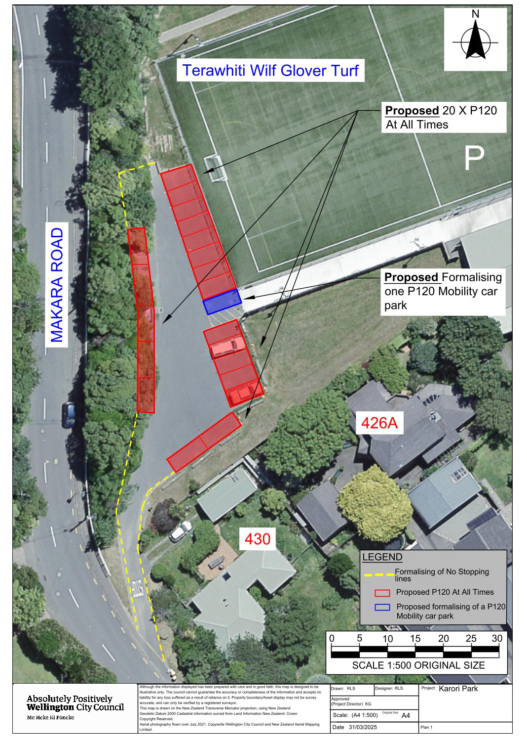
Traffic Resolution Plan: TR41-25 Karori Road, Karori - Proposed parking changes

Traffic Resolution Plan: TR41-25 Karori Road, Karori - Proposed parking changes
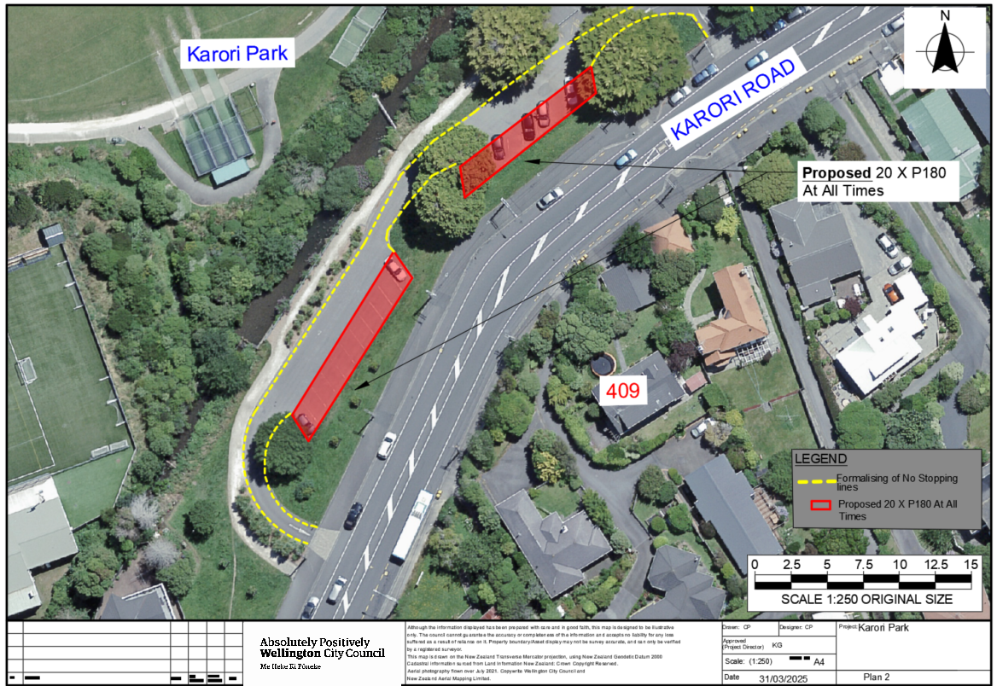

Traffic Resolution Plan: TR41-25 Karori Road, Karori - Proposed parking changes
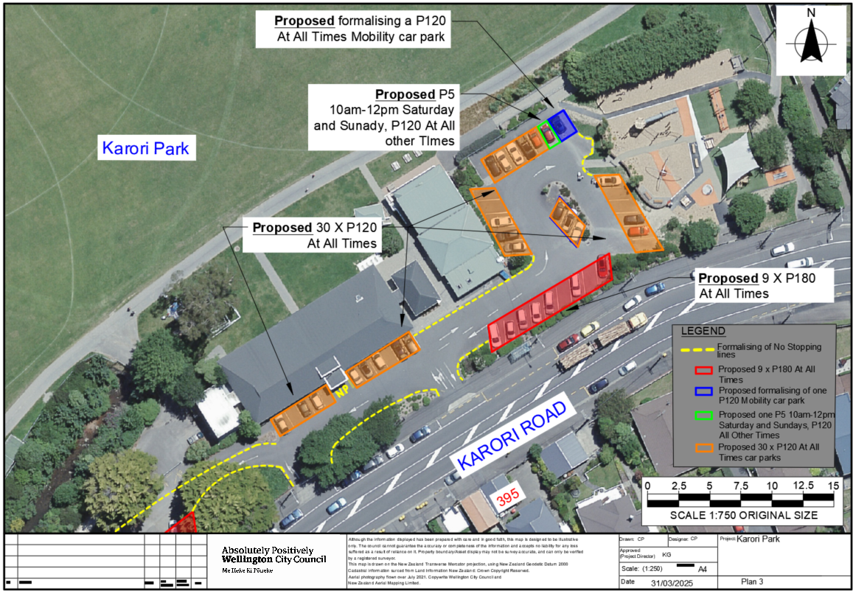

Traffic Resolution Plan: TR41-25 Karori Road, Karori - Proposed parking changes
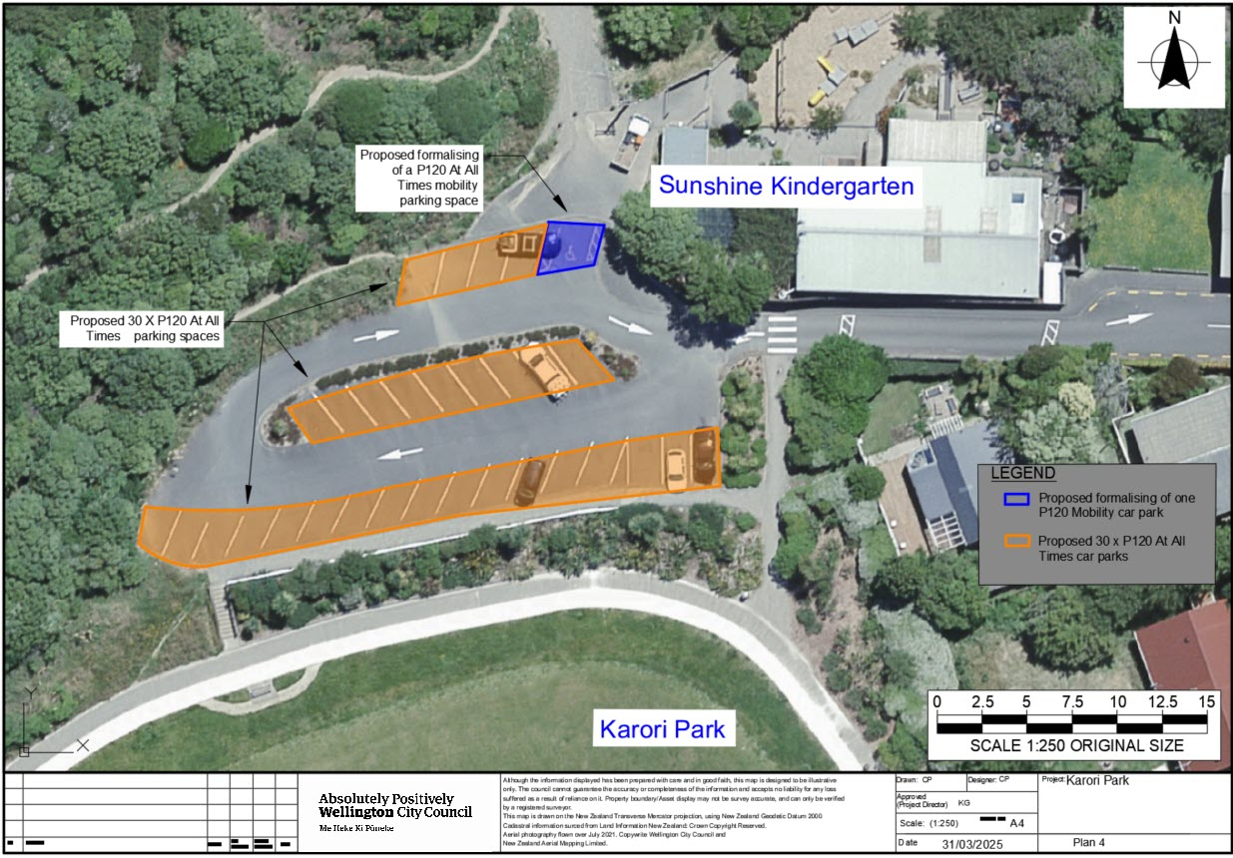

Legal Description:

Add to Schedule A (Time Limited) of the Traffic Restrictions Schedule

Column One | Column Two | Column Three
Karori Park Main Carpark | P120 At All Times | Refer to orange hatching in plan 3 (30 parking spaces)
Karori Park Main Carpark | P180 At All Times | Refer to red hatched area in plans 2 and 3 (29 parking spaces)
Karori Park Main Carpark | P5 Saturday and Sunday 10am-12pm, P120 At All Other Times | Refer to Green box in plan 3 above (1 parking space)
Karori Park Carpark off Makara Road | P120 At All Times | Refer to red hatching in plan 1 above (20 parking spaces)
Karori Park Carpark – off Sunshine Avenue | P120 At All Times | Refer to orange hatching in plan 4 above (30 parking spaces)

Add to Schedule D (No Stopping) of the Traffic Restrictions Schedule

Column One | Column Two | Column Three
Karori Park Main Carpark and off Makara Road | No Stopping At All Times | Please refer to plan 1,2,3 above Highlighted in yellow dashes (280 metres)

Add to Schedule B (Class Restricted) of the Traffic Restrictions Schedule

Column One | Column Two | Column Three
Karori Park Main Park | P120 Mobility Parking At All Times, Displaying an Operation Mobility Permit Only | Please refer to blue hatched areas in plan 1, 3 and 4 above (3 x P120 At All Times Mobility carparks)

Prepared By: | Corey Pugh | (Reserves Planner)
Approved By: | Kate Gourdie | (Team Leader Traffic & Resolutions)
Approved Date: | 10/04/2025

