Kia ora,

We would like to inform you about a proposed change in your neighbourhood.

Proposal:

Reference | TR01-26 Main Road, Tawa – Mobility Parking Changes
Location – where we propose to make the change | Main Road, Tawa – outside no. 204
What we’d like to do | - Install P120 Mobility Parking ‘At All Times’.
Why we are proposing the change | - Council has received a request from the Tawa business community to install additional accessible parking on Main Road, Tawa.  - The location identified in this report already features a drop kerb, making it well-suited for the installation of an additional mobility parking space with minimal impact on existing parking restrictions.  - By converting a single P60 parking space, we can create an additional mobility parking space, resulting in two accessible parking spaces with a centrally located drop kerb serving both.
Impact | Improvements  - Improves the viability of business wellbeing  - Improves safety and accessibility for mobility park users  Net Parking Impact  - Convert one P60 parking space into P120 mobility parking space  Pedestrian impact  - No Change
How this relates to the parking policy | - Support business wellbeing – ensure parking management and pricing controls support economic activity in the central city, suburban centres and mobile trades and services.  - Support city place-making, amenity and safety – ensure on-street parking design and placement supports overall city amenity, safety, community building, heritage, creative arts, good urban design outcomes and attractive streetscapes.  - Support access for all – ensure disabled people, older people, people who are pregnant, and people with babies can access the city, Council facilities, and venues. This will be achieved, in part, through an improvement in mobility parking across the city.
Other options considered | - Other locations were considered for additional mobility parking; however, the site identified in this report offers ideal conditions, including an existing drop kerb, appropriate dimensions, and proximity to key businesses.  - Our preference is to designate these mobility spaces as P120 to encourage higher turnover and align with time restrictions for standard parks in the area. However, the existing mobility space has operated without time restrictions for many years, and Council officers have chosen to retain this as an option.
Additional Information | - Average daily traffic count – 6,267  - An electronic copy of the report will be available on the Council’s website from 9.00am Wednesday the 14 January 2026 at https://www.letstalk.wellington.govt.nz/
Privacy | - Your privacy is important to us. Please DO NOT add specific personal details to your feedback (i.e.: full name, address, etc)  - What we do with your personal information:  All submissions (including your first name, but not contact details) are provided in their entirety to elected members and made available to the public on our website and at our office. Personal information (including contact details) will also be used for the administration of the consultation process including informing you of the outcome of the consultation. All information collected will be held by Wellington City Council, 113 The Terrace, Wellington, with submitters having the right to access and correct personal information.  - For more information regarding our Privacy Statement please check our webpage: Privacy statement - Wellington City Council.
Feedback | - If you would like to provide us with specific feedback, which will be added to the Traffic Resolution following consultation and made public in full, you can do so by filling out an online submission form, downloading a printable submission form on https://www.letstalk.wellington.govt.nz/ or emailing us at trfeedback@wcc.govt.nz.  Please note if you are giving feedback the consultation period opens at 9.00 am Wednesday the 14 January 2026 and finishes at 5.00 pm Thursday the 29 January 2026.
Next Steps | - Feedback collated by Friday the 30 January 2026.  - The proposal will go to the Te Takere|Regulatory Processes Committee meeting on Wednesday the 4 March 2026.  - If approved, the proposal will be installed within the following six months.

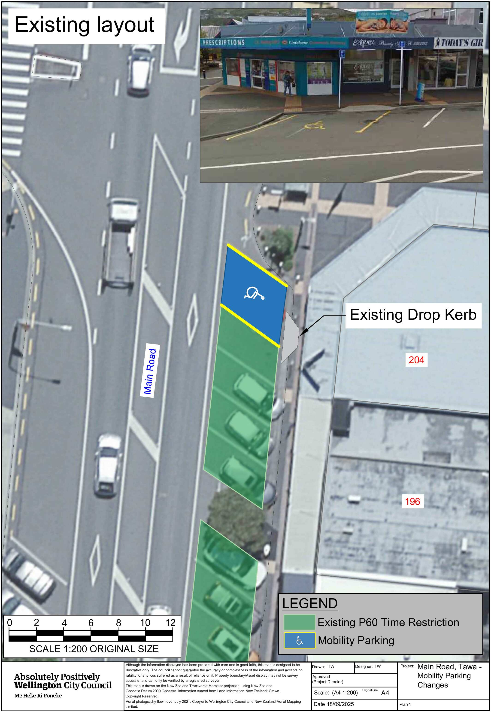
Existing Layout for 204 Main Road, Tawa
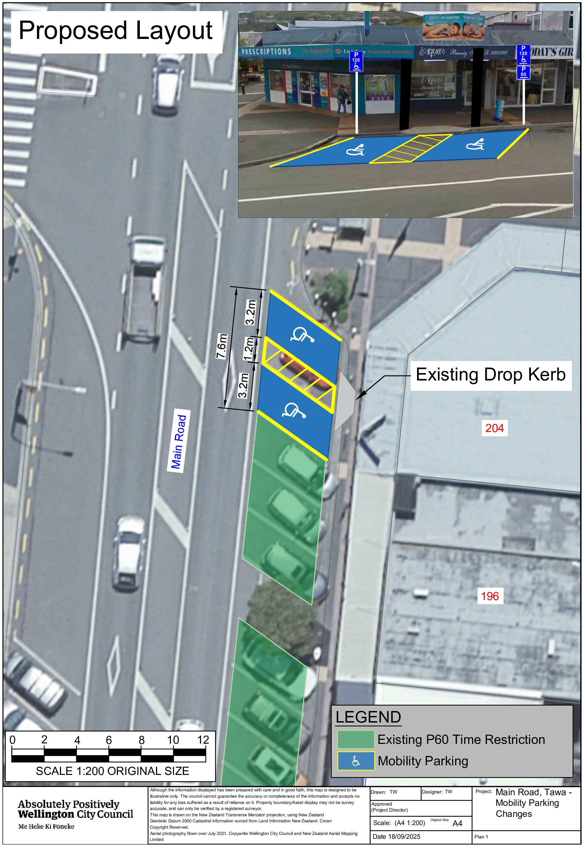
Traffic Resolution Plan: TR01-26 Main Road, Tawa – Mobility Parking Changes

Legal Description:

Delete from Schedule A (Time Limited) of the Traffic Restrictions Schedule

Column One | Column Two | Column Three
Main Road | Monday to Sunday , 8:00am - 6:00pm | East side, commencing 254 metres south of its intersection with Surrey Street (Grid coordinates x= 1753128.69 m, y= 5441029.35 m), and extending in a southerly direction following the eastern kerbline for 39.7 metres.

Delete from Schedule B (Class Restricted) of the Traffic Restrictions Schedule

Column One | Column Two | Column Three
Main Road | Vehicles Displaying an Operation Mobility Card Only, P120 Maximum, Monday to Friday, 8:00am - 6:00pm | East side, commencing 249.8 metres south of its intersection with Surrey Street and extending in a southerly direction following the eastern kerbline for 4.2 metres.

Add to Schedule A (Time Limited) of the Traffic Restrictions Schedule

Column One | Column Two | Column Three
Main Road | Monday to Sunday, 8:00am - 6:00pm | East side, commencing 130 metres north of its intersection with Cambridge Street (Grid coordinates X=1,753,086.40m Y=5,440,611.00m) and extending in an northerly direction following the eastern kerb line for 43 metres.

Add to Schedule B (Class Restricted) of the Traffic Restrictions Schedule

Column One | Column Two | Column Three
Main Road | Mobility Park At All Times, P120 Maximum | East side, commencing 173 metres north of its intersection with Cambridge Street (Grid coordinates X=1,753,086.40m Y=5,440,611.00m) and extending in an northerly direction following the eastern kerb line for 7.6 metres.

Prepared By: | Tommy Wilson | (Transport Engineering Assistant)
Approved By: | Kate Gourdie | (Team Leader Traffic & Resolutions)
Approved Date: | 28/11/2025

