We are proposing a change in your area

Kia ora,

This leaflet is to let you know about a change we are proposing to make in your neighbourhood.

Proposal

Reference
TR16-24 Tyne Street, Island Bay- No Stopping At All Times

Location – where we propose to make the change
Tyne Street, Island Bay along the southern side between Nos. 3-21.

What we’d like to do
Install No Stopping At All Times (Broken Yellow Lines) on the south side of Tyne Street between Nos. 3-21.

Why we are proposing the change
Wellington City Council (WCC) have received a request from 16 residents who agreed and signed a request for action form to install broken yellow lines along the southern side of Tyne Street with five residents against the proposal.
Due to the narrowness of the road with bends, vehicles parked on both sides of the street are preventing safe access along the street.
Vehicles parked in this location also obstruct emergency vehicles from getting past to attend to incident.
To improve safety and accessibility, we are proposing to install No Stopping At All Times (broken yellow lines) along the road between property nos. 3 and 21 where the width of the road is too narrow for vehicles to park on both sides of the road, preventing accessibility for road users including emergency vehicles.
Unrestricted parking is retained where the roadway is wide enough for larger vehicles to pass including emergency vehicles to access the street.

Impact
- Improves safety and accessibility for all road users including emergency vehicles
- Removal of 13 unrestricted parking spaces
- No pedestrian impact

How this relates to the parking policy
Support safe movement – facilitate the safe and efficient movement of people and goods by focusing on people moving along transport corridors rather than people parking or storing stationary vehicles.

Additional information
Average daily traffic count – 170 (estimate)
To view the legal description for this Traffic Resolution, an electronic copy of the report will be available on the Council’s Let’s Talk engagement website from 9.00am Wednesday 6 December 2023 at https://www.letstalk.wellington.govt.nz/ or you can call (04) 499 4444 and we will send one out to you.

Privacy
Your privacy is important to us. Please DO NOT add specific personal details to your feedback (i.e.: full name, address, etc)

What we do with your personal information:
All submissions (including your first name, but not contact details) are provided in their entirety to elected members and made available to the public on our website and at our office. Personal information (including contact details) will also be used for the administration of the consultation process including informing you of the outcome of the consultation. All information collected will be held by Wellington City Council, 113 The Terrace, Wellington, with submitters having the right to access and correct personal information.
For more information regarding our Privacy Statement please check our webpage: Privacy statement – Wellington City Council.

Feedback
If you would like to provide us with specific feedback, which will be added to the Traffic Resolution following consultation and made public in full, you can do so by filling out an online submission form, downloading a printable submission form on https://www.letstalk.wellington.govt.nz/ or emailing us at trfeedback@wcc.govt.nz.
Please note if you are giving feedback the consultation period opens at 9.00 am Wednesday 6 December 2023 and finishes at 5.00 pm Monday 15 January 2024.

Next steps
Feedback collated by Tuesday 16 January 2024.
2The proposal will go to the Koata Hātepe Regulatory Processes Committee meeting on Thursday 22 February 2024.
If approved, the proposal will be installed within the following three months.

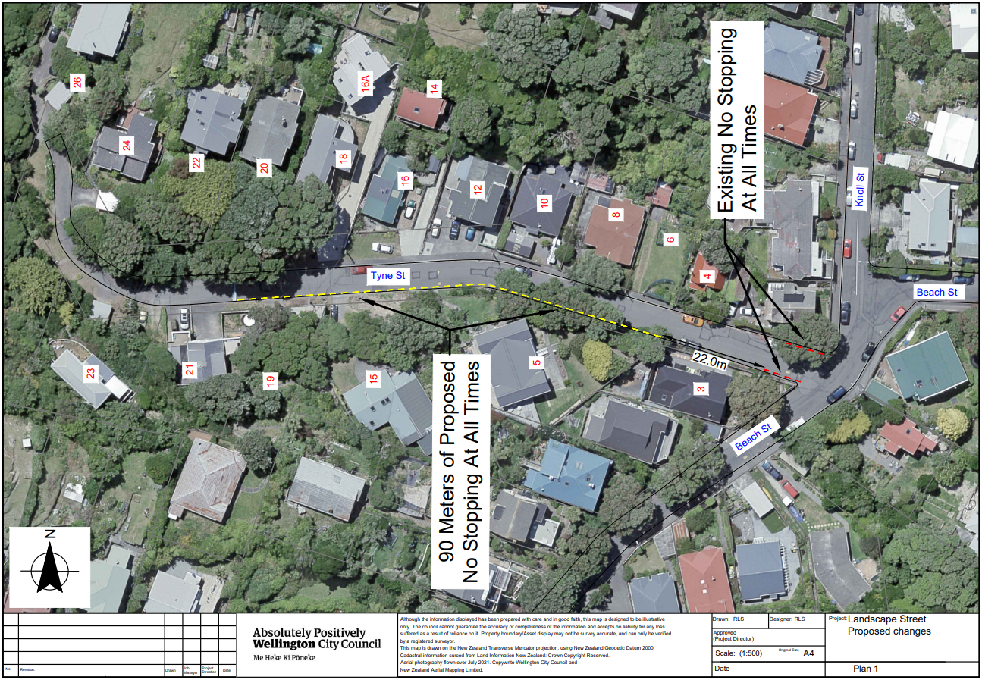

Legal description

Add to Schedule D (No Stopping) of the Traffic Restrictions Schedule

Column One
Tyne Street

Column Two
No Stopping, At All Times

Column Three
South side, commencing 30 metres from the intersection with Beach Street (Grid coordinates X= 1747937757.73 m, Y= 5421362236.45) and extending in a westerly direction for 90 metres following the southern kerb line.

Legal description
- Prepared by Karl Rudge (Transport Engineering Assistant)
- Approved by Soon Teck Kong (Engineering and Operations Manager)
- Date prepared: 21/11/2023

