Kia ora,

We would like to inform you about a proposed change in your neighbourhood.

Proposal:

Reference | - TR52-26 Henry Street, Kilbirnie – Formalise Resident Parking and No Stopping At All Times
Location – where we propose to make the change | Henry Street and the corner of Kilbirnie Crescent
What we’d like to do | - Reinstate 6 metres of No Stopping At All Times (Broken Yellow Lines) at the intersection with Kilbirnie Crescent.  - Formalise existing Residents Parking At All times.  - Formalise all other existing No Stopping At All Times (Broken Yellow Lines).
Why we are proposing the change | - Council officers identified that the resident parking on Henry Street had not been correctly formalised due to a former vehicle crossing that divided the parking area into two separate sections.  - As the vehicle crossing is no longer being used and replaced with kerbside residents parking, this report seeks to formalise the resident parking in our database.  - Officers have also observed that a short 6-metre section of broken yellow lines at the intersection with Kilbirnie Crescent is missing. These markings will be reinstated to ensure vehicles do not park within 6 metres of the intersection.  - In addition, we are proposing to formalise all existing broken yellow lines on the street to improve the accuracy and consistency of our records.
Impact | Improvements  - Improves safer turning movements  - Improves driver visibility  Net Parking Impact  - No change to legal parking numbers  - Formalising the already in use parking spaces as residents parking  Pedestrian impact  - No Change
Other options considered | Option1:Do not reinstate the broken yellow lines on the northern side of Henry Street at its intersection with Kilbirnie Crescent. This is not recommended, as parking within 6 metres of an intersection is already prohibited under the Road User Rule 2004.
How this relates to the parking policy | - Support safe movement – facilitate the safe and efficient movement of people and goods by focusing on people moving along transport corridors rather than people parking or storing stationary vehicles.  - Support city place-making, amenity and safety – ensure on-street parking design and placement supports overall city amenity, safety, community building, heritage, creative arts, good urban design outcomes and attractive streetscapes.
Additional Information | - An electronic copy of the report will be available on the Council’s website from 9.00am 10 June 2026 at https://www.letstalk.wellington.govt.nz/
Privacy | - Your privacy is important to us. Please DO NOT add specific personal details to your feedback (i.e.: full name, address, etc)  - What we do with your personal information:  All submissions (including your first name, but not contact details) are provided in their entirety to elected members and made available to the public on our website and at our office. Personal information (including contact details) will also be used for the administration of the consultation process including informing you of the outcome of the consultation. All information collected will be held by Wellington City Council, with submitters having the right to access and correct personal information.  - For more information regarding our Privacy Statement please check our webpage: Privacy statement - Wellington City Council.
Feedback | - If you would like to provide us with specific feedback, which will be added to the Traffic Resolution following consultation and made public in full, you can do so by filling out an online submission form, downloading a printable submission form on https://www.letstalk.wellington.govt.nz/ or emailing us at trfeedback@wcc.govt.nz.  Please note if you are giving feedback the consultation period opens at 9.00 am 10 June 2026 and finishes at 5.00 pm 24 June 2026.
Next Steps | - Feedback collated by 25 June 2026.  - The proposal will go to the Te Takere|Regulatory Processes Committee meeting on 5 August 2026.  - If approved, the proposal will be installed within the following six months.

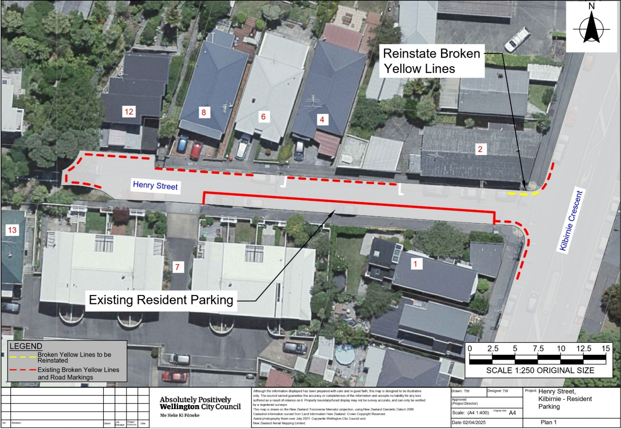
Traffic Resolution Plan: TR52-26 Henry Street, Kilbirnie – Formalise Resident Parking and No Stopping At All Times

Legal Description:

Delete from Schedule D (No stopping) of the Traffic Restrictions Schedule

Column One | Column Two | Column Three
Kilbirnie Crescent | No Stopping At All Times | West side, commencing 91 metres south of its intersection with Wellington Road and extending in a southerly direction following the western kerbline for 5.5 metres to its intersection with Henry Street.
Kilbirnie Crescent | No Stopping At All Times | West side, commencing from its intersection with Henry Street and extending in a southerly direction following the western kerbline for 11 metres.
Henry Street | No Stopping At All Times | North side, commencing from its intersection with Kilbirnie Crescent and extending in a westerly direction following the northern kerbline for 6.5 metres.
Henry Street | No Stopping At All Times | North side, commencing 25 metres west of its intersection with Kilbirnie Crescent and extending in a westerly direction following the kerbline for 20.5 metres
Henry Street | No Stopping At All Times | North side commencing 52 metres west of its intersection with Kilbirnie Crescent and extending in a westerly direction following the northern kerbline for 65m
Henry Street | No Stopping At All Times | South side, commencing at its intersection with Kilbirnie Crescent and extending in a westerly direction following the southern kerbline for 6 metres.

Delete from Schedule E (Residential Parking) of the Traffic Restrictions Schedule

Column One | Column Two | Column Three
Henry Street | No Stopping Except for Authorised Resident Vehicles, At All Times | South side, commencing 36 metres west of its intersection with Kilbirnie Crescent and extending in a westerly direction following the southern kerbline for 18.5 metres.

Add to Schedule D (No stopping) of the Traffic Restrictions Schedule

Column One | Column Two | Column Three
Kilbirnie Crescent | No Stopping At All Times | West side, commencing at its intersection with Henry Street (Grid coordinates x= 1,750,084.65m, y=5,424,948.45m) and extending in an north direction following the western kerb line for 6 metres.
Kilbirnie Crescent | No Stopping At All Times | West side, commencing at its intersection with Henry Street (Grid coordinates x= 1,750,082.76m, y=5,424,940.97m) and extending in an south direction following the western kerb line for 8 metres.
Henry Street | No Stopping At All Times | North side, commencing at its intersection with Kilbirnie Crescent (Grid coordinates x= 1,750,084.65m, y=5,424,948.45m) and extending in an westerly direction following the northern kerb line for 6 metres.
Henry Street | No Stopping At All Times | North side, commencing 25 meters from its intersection with Kilbirnie Crescent (Grid coordinates x= 1,750,084.65m, y=5,424,948.45m) and extending in an western direction following the northern kerb line for 19 metres.
Henry Street | No Stopping At All Times | North side, commencing 50 meters from its intersection with Kilbirnie Crescent (Grid coordinates x= 1,750,084.65m, y=5,424,948.45m) and extending in an western direction following the northern kerb line for 17 metres.
Henry Street | No Stopping At All Times | North side, commencing 69 meters from its intersection with Kilbirnie Crescent (Grid coordinates x= 1,750,084.65m, y=5,424,948.45m) and extending in an western direction following the northern kerb line for 11 metres.
Henry Street | No Stopping At All Times | West side, commencing 80 meters from its intersection with Kilbirnie Crescent (Grid coordinates x= 1,750,084.65m, y=5,424,948.45m) and extending in an southerly direction following the western kerb line for 5 metres.
Henry Street | No Stopping At All Times | South side, commencing at its intersection with Kilbirnie Crescent (Grid coordinates x= 1,750,082.76m, y=5,424,940.97m) and extending in an westerly direction following the southern kerb line for 7 metres.
Henry Street | No Stopping At All Times | South side, commencing 77 meters from its intersection with Kilbirnie Crescent (Grid coordinates x= 1,750,082.76m, y=5,424,940.97m) and extending in an westerly direction following the southern kerb line for 5 metres.

Add to Schedule E (Residential Parking) of the Traffic Restrictions Schedule

Column One | Column Two | Column Three
Henry Street | No Stopping Except for Authorised Resident Vehicles, At All Times | South side, commencing 7 meters from its intersection with Kilbirnie Crescent (Grid coordinates x= 1,750,082.76m, y=5,424,940.97m) and extending in an westerly direction following the southern kerb line for 51 metres.

Prepared By: | Tommy Wilson | (Transport Engineering Assistant)
Approved By: | Kate Gourdie | (Team Leader Traffic & Resolutions)
Approved Date: | 19/05/2026

