Kia ora,

We would like to inform you about a proposed change in your neighbourhood.

Proposal:

Reference | TR28-25 Alexandra Road, Hataitai Formalise Bus Stop
Location – where we propose to make the change | Alexandra Road, Hataitai – outside no. 55 and 57
What we’d like to do | - Formalise Bus Stop #6571 by installing adequate road markings
Why we are proposing the change | - Council have received a request from the public regarding concerns about vehicles parking within the intersection and bus stop on Alexandra Road near Upoko Road.  - In the past 12 months, Council has received 26 parking complaints regarding vehicles parking at this intersection and bus stop. This has highlighted the need to formalise the bus stop to prevent obstruction in this area.  - Council Officers have been in contact with Greater Wellington Regional Council (GWRC) and have confirmed that they are experiencing issues with this specific bus stop.  - To improve safety and accessibility for the bus service, we are proposing to formalise the bus stop outside no. 57 Alexandra Road and install entry tapers (broken yellow lines) outside no. 55, as per the attached plans.
Impact | Improvements  - Improves bus services  - Improves safer turning movements  - Improves driver visibility  Net Parking Impact  - No legal parking spaces will be affected  Pedestrian impact  - Improved service for passengers
Other options considered | Option 1:  - An alternative option is to maintain the standard bus entry taper of 15 metres in length. This option is not preferred as it would eliminate legal parking spaces and GWRC have also confirmed they are satisfied with a 9 meter taper.
How this relates to the parking policy | - Support shift in type of transport used – facilitate a shift to using active (eg, walking and cycling) and public transport through parking management and pricing, to move more people driving fewer vehicles.  - Support safe movement – facilitate the safe and efficient movement of people and goods by focusing on people moving along transport corridors rather than people parking or storing stationary vehicles.
Additional Information | - Average monthly passenger number – Stop 6571: 11 Boarding, 529 Alighting (January 2025)  - Average daily traffic count – 972  - To view the legal description for this Traffic Resolution, an electronic copy of the report will be available on the Council’s website from 9.00am Friday 21 March 2025 at https://www.letstalk.wellington.govt.nz/ or you can call (04) 499 4444 and we will send one out to you.
Privacy | - Your privacy is important to us. Please DO NOT add specific personal details to your feedback (i.e.: full name, address, etc)  - What we do with your personal information:  All submissions (including your first name, but not contact details) are provided in their entirety to elected members and made available to the public on our website and at our office. Personal information (including contact details) will also be used for the administration of the consultation process including informing you of the outcome of the consultation. All information collected will be held by Wellington City Council, 113 The Terrace, Wellington, with submitters having the right to access and correct personal information.  - For more information regarding our Privacy Statement please check our webpage: Privacy statement - Wellington City Council.
Feedback | - If you would like to provide us with specific feedback, which will be added to the Traffic Resolution following consultation and made public in full, you can do so by filling out an online submission form, downloading a printable submission form on https://www.letstalk.wellington.govt.nz/ or emailing us at trfeedback@wcc.govt.nz.  Please note if you are giving feedback the consultation period opens at 9.00am Friday 21 March and finishes at 5.00pm Friday 4 April 2025.
Next Steps | - Feedback collated by Monday 7 April 2025.  - The proposal will go to the Koata Hātepe|Regulatory Processes Committee meeting on Thursday 15 May 2025.  - If approved, the proposal will be installed within the following three months.

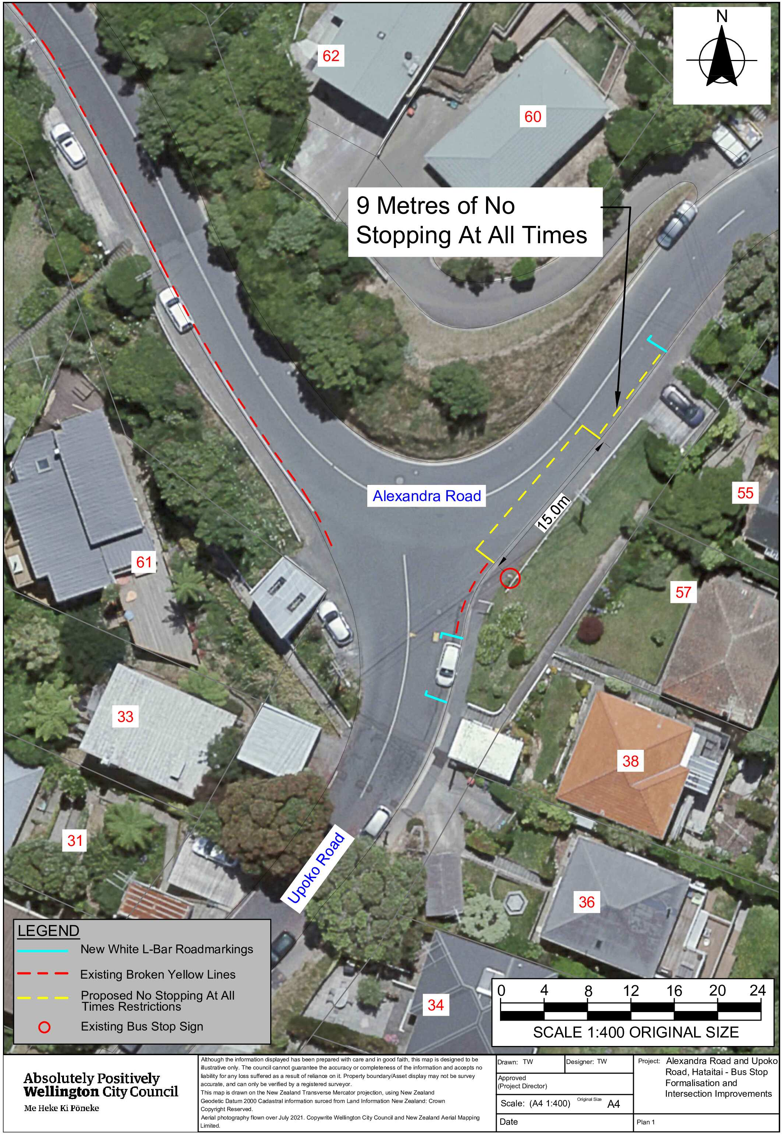
Traffic Resolution Plan: TR28-25 Alexandra Road, Hataitai – Formalise Bus Stop

Legal Description:

Add to Schedule B (Class Restricted) of the Traffic Restrictions Schedule

Column One | Column Two | Column Three
Alexandra Road | Bus Stop, At All Times | East side, commencing of its intersection with Upoko Road (Grid coordinates X = 1,750,304.89 Y = 5,426,649.58) and extending in a northerly direction following the eastern kerb line for 15 metres.

Add to Schedule D (No Stopping) of the Traffic Restrictions Schedule

Column One | Column Two | Column Three
Alexandra Road | No Stopping At All  Times | East side, commencing 15 metres of its intersection with Upoko Road (Grid coordinates X = 1,750,304.89 Y = 5,426,649.58) and extending in a northerly direction following the eastern kerb line for 9 metres.

Prepared By: | Tommy Wilson | (Transport Engineering Assistant)
Approved By: | Kate Gourdie | (Team Leader Traffic & Resolutions)
Approved Date: | 26/02/2025

