Kia ora,

We would like to inform you about a change in your neighbourhood.

Proposal:

Reference | TR128-24 Adelaide Road, Berhampore - Southbound Bus Stop #6126 Relocation
Location – where we propose to make the change | Adelaide Road, Berhampore – outside no.547 and no.549
What we’d like to do | - Move Bus Stop #6126 for public safety reasons
Why we are proposing the change | - The bus stop platforms at Duppa Street were installed as part of the Berhampore to Newtown bus, bike and pedestrian improvements project. This project seeks to provide a wider range of safe transport options for the community.  - The bus stop platforms are an important part of keeping people on bikes safe around bus stops and maintaining good access for bus users to the bus service. The new platform design seeks to minimise conflict between pedestrians and people on bikes by providing a wider on/off boarding area, as well as separate spaces for people on bikes and the footpath.  - The raised pedestrian crossing was installed to provide a safer crossing point for pedestrians near the Duppa and Lavaud Street steps and improve safe access to these busy bus stops.  - When the bus stop was installed, construction adaptations onsite resulted in the bus box being closer to the crossing than designed.  - Since installation, Council officers have observed, and received feedback from the community, that the proximity of the bus to the crossing has resulted in restricted visibility of people crossing.  - To improve this situation, we have had to relocate the bus stop around 20 metres south away from the crossing for safety reasons. The proposal is to formalise the changes thought the traffic resolution process which is still subject to to committee’s approval.  - Council officers contacted residents living adjacent to the new stop location and met with those directly affected to discuss the change.  - The changes include: replacing the existing bus stop box with No Stopping At All Times (broken yellow lines) adjacent to the zebra crossing and outside property nos.543 and 545 Adelaide Road, and installing bus stop road markings outside nos.547 and 549 Adelaide Road as per the attached plans.
Impact | Improvements  - Improves safety and accessibility for all users of the pedestrian crossing  - Improves accessibility and safety for public transport users needing to cross the road to the bus stop  - Improves driver visibility of pedestrians  Net Parking Impact  - No Change  Pedestrian impact  - Positive – improves visibility of pedestrians on the crossing and increases safety for pedestrians of all ages.
Other options considered | Option 1: Locating the bus stop before the crossing  - The road width is more constrained here and this would have meant creating a completely new bus stop platform and drainage. This would have been costly and taken several weeks longer than extending the current platform for which drainage was already in place.  - In addition, it would have created a very tight situation when two buses were in the stops. From our discussions with emergency services we know they would like as much space as possible between opposing in-lane bus stops.
How this relates to the parking policy | - Support shift in type of transport used – facilitate a shift to using active (eg, walking and cycling) and public transport through parking management and pricing, to move more people driving fewer vehicles.  - Support safe movement – facilitate the safe and efficient movement of people and goods by focusing on people moving along transport corridors rather than people parking or storing stationary vehicles.
Additional Information | - Average monthly passenger number – 70 Boarding, 1,880 Alighting  - Average daily traffic count – 12,800, 8% heavy  - Annual parking revenue impact – N/A  - To view the legal description for this Traffic Resolution, an electronic copy of the report will be available on the Council’s website from 9.00am Thursday 26 September at https://www.letstalk.wellington.govt.nz/ or you can call (04) 499 4444 and we will send one out to you.
Privacy | - Your privacy is important to us. Please DO NOT add specific personal details to your feedback (i.e.: full name, address, etc)  - What we do with your personal information:  All submissions (including your first name, but not contact details) are provided in their entirety to elected members and made available to the public on our website and at our office. Personal information (including contact details) will also be used for the administration of the consultation process including informing you of the outcome of the consultation. All information collected will be held by Wellington City Council, 113 The Terrace, Wellington, with submitters having the right to access and correct personal information.  - For more information regarding our Privacy Statement please check our webpage: Privacy statement - Wellington City Council.
Feedback | - If you would like to provide us with specific feedback, which will be added to the Traffic Resolution following consultation and made public in full, you can do so by filling out an online submission form, downloading a printable submission form on https://www.letstalk.wellington.govt.nz/ or emailing us at trfeedback@wcc.govt.nz.  Please note if you are giving feedback the consultation period opens at 9.00am Thursday 26 September 2024 and finishes at 5.00pm Thursday 10 October.
Next Steps | - Feedback collated by Friday 11 October, 2024.  - The proposal will go to the Koata Hātepe|Regulatory Processes Committee meeting on Thursday 14 November.  - If approved, the proposal will be installed within the following three months.

Traffic Resolution Plan: TR128-24 Adelaide Road, Berhampore - Southbound Bus Stop #6126 Relocation

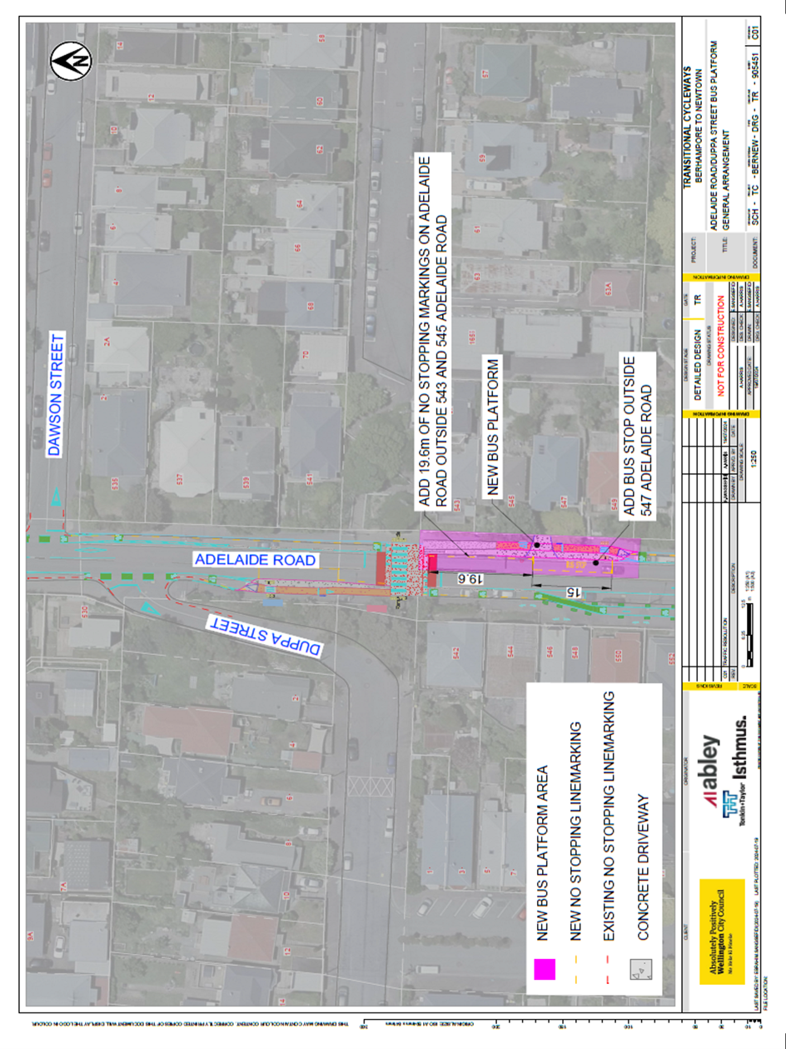

Legal Description:

Delete from Schedule B (Class Restricted) of the Traffic Restrictions Schedule

Column One | Column Two | Column Three
Adelaide Road | Bus Stop, At All Times | East side, commencing 75 metres south of its intersection with Dawson Street (Grid coordinates x= 1748566.51 m, y= 5423845.54 m), and extending in a southerly direction following the eastern kerb line for 15 metres.

Add to Schedule B (Class Restricted) of the Traffic Restrictions Schedule

Column One | Column Two | Column Three
Adelaide Road | Bus Stop, At All Times | East side, commencing 83 metres south  of its intersection with Dawson Street  (Grid coordinates X= 1,748,566.54m  Y= 5,42,3845.88m) and extending in a  southerly direction following the eastern  kerb line for 15 metres.

Add to Schedule D (No Stopping) of the Traffic Restrictions Schedule

Column One | Column Two | Column Three
Adelaide Road | No Stopping At All  Times | East side, commencing 63.4 metres south  of its intersection with Dawson Street  (Grid coordinates X= 1,748,566.54m  Y= 5,42,3845.88m) and extending in a  southerly direction following the eastern  kerb line for 19.6 metres.

Prepared By: | Nicola Mitchell | (Project Manager – Transitional Team – City Design)
Approved By: | Kate Gourdie | (Team Leader Traffic & Resolutions)
Approved Date: | 9/9/2024

