

October 2026

Whakatauranga
Arotake Kaupapa Here
Rating Policies Review
  - Consultation document

Version | Date | Author | Approver
1 | 06/10/2026 | Financial Planning and Policy team | Te Taurapa | Council Planning and Finance Committee

Contents
Kia ora
Welcome 5
Reviewing how we allocate rates 5
What is this document? 5
We need your voice 6
Have your say 6
What happens next? 6
We reflect the principles of Te Tiriti o Waitangi 7
We work in partnership with mana whenua 7
Kupu Whakataki
Introduction 8
What is a rating policies review? 8
What are rates for, and why are they important? 9
Ngā tono
The proposals 10
Key proposal 1: Changing from a capital value to a land value rating base 10
Why is Wellington City Council considering this change? 11
What do other councils do? 12
High-level impacts of the proposal 12
Other considerations 12
Examples of the change 13
Key proposal 2: Changing the general rates split 15
Affordability 16
Changes proposed 17
Key proposal 3: Extending the vacant land differential area 19
What is vacant land? 19
Why do we have this rating differential? 20
Changes proposed 20
Key proposal 4: New general rate differential for Tiaki Wai 21
Impact of rates charged to Tiaki Wai 21
The proposal 21
Key proposal 5: Rates remissions and postponements 22
Earthquake prone buildings remission 22
The proposal 22
Special circumstances remission 23
Ngā tono kē kīhei i tūtohua
Other proposals not recommended 24
Changes to the Downtown targeted rate 24
Additional changes to existing rate remission policies 24
Introducing new targeted rates 25
Ngā pātai me ngā whakautua matua
Key questions and answers 26

Kia ora
Welcome

Reviewing how we allocate rates
We are developing our next Long-term Plan (LTP) for the 10 years from 2027 to 2037. This plan sets Wellington City Council’s direction, outlines our priorities, what they will cost, and how they will be funded.
We review it every three years because times change and we need to make sure it is still delivering the services and facilities that communities need and guiding us to a liveable, resilient and affordable city.
Most of the Council’s operational income for day-to-day expenses comes from rates collected from property owners. So, as part of the development of the 2027–37 LTP, we are reviewing our rating policies to ensure the way your rates are calculated and how rates are shared across the city is fair, reasonable, and appropriate.
The rating policies review is also a priority in the Triennium Plan, which directed the Council to investigate ways to improve the residential rating system and encourage housing development, including considering Land Value Rating and other options.
No decisions have been made yet. This review is a chance to consider whether there is a better way to structure and divide rates across Wellington properties.

What is this document?
The Council is now seeking your views on the proposals in this document, including possible changes to how rates are structured and allocated among Wellington’s households and businesses.
This includes changes to the value of your property on which rates are calculated, the share paid by residential and commercial ratepayers, and the treatment of vacant land, Tiaki Wai charges, and some rates remissions.
Your feedback will help inform decisions on which proposals, if any, should be developed further and included in the draft 2027–37 LTP for formal public consultation in 2027.
The conversation this year is not about the total amount of rates the Council collects, but about how the rates pie is shared between different groups of ratepayers. Conversations about our budgets for the next 10 years, and the impact on ratepayers will be part of a consultation with our community in 2027.
Visit wcc.nz/rating-policies-review to find out more.

We need your voice
Our proposals are draft. Before we decide on our final proposals, we need to hear from you.

Have your say
The consultation is open from 19 October to 15 November 2026.
There are multiple ways to let us know what you think:
- An online submission – via the form at wcc.nz/rating-policies-review. You can upload supporting documents with your submission.
- By email – email your submission using the form downloadable at wcc.nz/rating-policies-review
or send your thoughts to ratingpoliciesreview@wcc.govt.nz
- Hard copy form – print a form at wcc.nz/rating-policies-review or pick one up from any of our libraries. Completed forms can be returned by free post or dropped into our offices at 2 Harris St.
- Oral submission – Everyone making a submission has an opportunity to speak to that submission
at Oral Hearings in November. Please indicate this preference clearly when you make your submission.
- Note: you can make an oral submission without providing a written submission first. Please email ratingpoliciesreview@wcc.govt.nz or call our contact centre on 04 499 4444 by 15 November 2026 to let us know if you want to do this.

What happens next?
We appreciate your feedback and we do take time to consider it.
We send copies of all the feedback and main themes of the engagement to the Mayor, Councillors and Pou Iwi. The Council may decide to progress one or more proposals, modify them, or not proceed with them.
Any proposed changes included in the draft LTP would then be subject to separate public consultation in 2027. Changes take effect from 1 July 2027 only if the Council adopts them following that process.
We considered sections 101(3)(a) and (b) of the Local Government Act 2002 when we created this document and background information.
The Funding Needs Analysis will be finalised as part of the review of the Revenue & Financing Policy and these policies will be prepared for public consultation in April 2027.

We reflect the principles of Te Tiriti o Waitangi
We recognise that Te Tiriti o Waitangi forms the underlying foundation of the Council and mana whenua relationship, and that the Council acts in accordance with Te Tiriti o Waitangi.

The design for the 2026 WAITUHI project by artists Kauia Moriarty and Vianney Parata. Credit: Wellington City Council.

We work in partnership with mana whenua
We have strong partnerships with local mana whenua, set out in the Tākai Here partnership agreement. In 2022, we signed Tākai Here 182 years to the day that Te Tiriti o Waitangi was signed in Te Whanganui ā Tara.
This partnerships agreement allows for a stronger governance relationship and sets out the principles, values, and priorities for the way in which we work together.
Through Tākai Here, we work in partnership with:
- Taranaki Whānui Ki Te Upoko o Te Ika (Port Nicholson Block Settlement Trust)
- Te Rūnanga o Toa Rangatira
- Te Rūnanganui o Te Āti Awa Ki Te Upoko o Te Ika a Māui.
We also have relationships with the Te Aro Pā Trust and the Wellington Tenths Trust. While these relationships sit outside the Tākai Here partnership, both entities represent mana whenua landowner interests in Wellington.
As mana whenua landowners in the city, all these groups may have a particular interest in this review, and we will engage with them directly as part of this process, alongside this public consultation.

Kupu Whakataki
Introduction

What is a rating policies review?
Each year, the Council sets its overall budget as part of the LTP or Annual Plan (AP) process. The rates-funded component of that budget is then collected from property owners.
A rating policies review helps the Mayor, Councillors, Pou Iwi, and the community ensure there is a fair system for how we structure and divide rates between households and businesses in Wellington.
The review is not about the total amount the Council collects in rates.
It is about how the total is shared, balancing affordability for households and businesses with ensuring different groups pay a reasonable and proportionate share.
The Mayor, Councillors and Pou Iwi representatives have agreed that the 2026/27 rating policies
review will focus on:
- Considering land value rather than capital value as the rating base
- Extending the vacant land differential
- Changing the general rates differential for businesses
- New differential for Tiaki Wai
- Rates remissions for earthquake prone buildings

What are rates for, and why are they important?

Rates are a property tax set by local and regional councils. In the same way
national taxes are used to run the country; your rates are important to ensure
Wellington continues to function.
Looking across Evans Bay to the airport and Cook Strait. Credit: Wellington City Council.
They contribute to the day-to-day running of the city including fixing roads and footpaths, operating libraries and swimming pools, helping our community through the Contact Centre and looking after our parks, beaches and native bush.
If you rent, you will pay rates indirectly as part of your rent. If you own a home or a commercial property in Wellington, you pay rates directly to the Council.
There are different types of rates.
- All household and business ratepayers pay general rates. General rates pay for services that benefit the whole community. Businesses pay a higher general rate than a household because a differential (a multiplier) is applied.
- Ratepayers who receive other services pay targeted rates on top of their general or commercial rates.

Ngā tono
The proposals
This section explains our five key proposals and also outlines other potential changes that we have considered but are not pursuing at this stage.

Key proposal 1: Changing from a capital value
to a land value rating base
We want your feedback on whether to change our rating policy to be set on a land value-based rating system for the general rate.
The Council currently calculates general rates using a property’s capital value. This system has been in place since the late 1990s.
Capital value includes the value of the land as well as the value of buildings and other improvements on the land. Rateable properties with the same capital value pay the same general rates, regardless of the size or value of the land.
The Council is considering changing to a land-value rating system. Under this system, general rates would be calculated using the value of the land only. The value of houses, apartments, commercial buildings and other improvements would not be included.
Rateable properties with the same land value pay the same general rates, regardless of the type of land or value of the buildings or other improvements on the land.
This review is considering both how rates are calculated and how rates are shared across the city.
The current commercial differential of 3.7:1 operates within the existing capital value rating system. The examples in this section assume that the commercial to residential rates split under the current capital value system would continue.
If the Council were to decide to change to a land value rating system, further work would be required to determine the appropriate commercial differential and how any changes should be implemented.
No final decisions have been made. The review is a chance to consider whether there is a better way to calculate rates across Wellington properties, and we want your feedback on this.

Why is Wellington City Council considering this change?
The reason for considering land-value rating is that it may encourage land
to be developed and used more efficiently.
Property owners do not pay higher general rates simply because they build new homes, add additional dwellings, or improve existing buildings.
Advocates also argue that land value rating can discourage land banking and under-utilisation of valuable urban land, helping to support housing development and more efficient urban growth.
The Productivity Commission (2015) encourages councils to consider the merits of land value rating in encouraging the efficient use of land when reviewing their rating policies. There is also evidence that land value rating is a better proxy for income than capital value.
There are, however, also arguments presented for maintaining the current capital value system.
Advocates argue that properties with higher capital values often place greater demands on Council services and therefore capital value may provide a better indication of a property owner's ability to pay rates.
The Shand Report (2007) noted the increasing pressure on councils to move to capital value
rating as a way of better reflecting the costs of providing services.
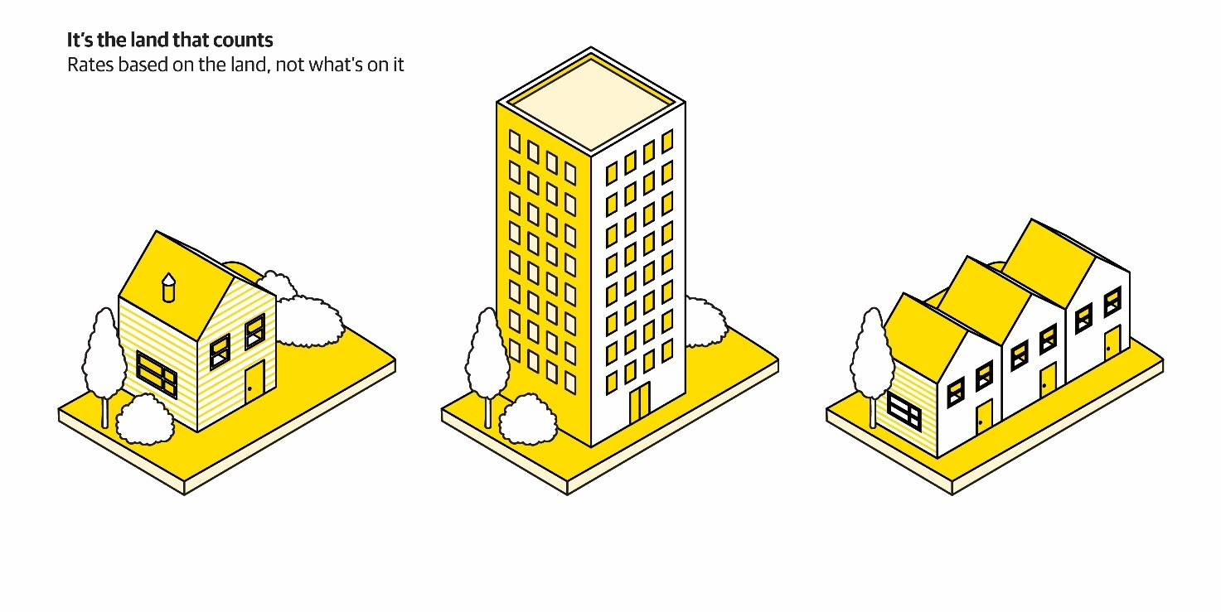
The difference between capital value rating and land value rating. Capital value is based on the value of your land, buildings and other improvements. Land value is the value of your land only. In this illustration, the size and shape of the land is the same. Credit: Wellington City Council.

What do other councils do?
Most councils in New Zealand use capital value as their rating base.
The trend in New Zealand has been for councils using land value to move to a capital value rating base. However, this has been largely because improvements to the land, such as buildings, are viewed as a reflection on the ability to pay rates. We are considering this change for a different reason, as above.
- In 2026, 65 percent of councils use capital value for their general rates
- 10 years ago, 58 percent used capital value
- 20 years ago, 50 percent used capital value
- Our closest neighbouring councils (Porirua, Hutt City, Upper Hutt) use a capital value rating base.

High-level impacts of the proposal
Moving to a land value-based rating system would not change the total amount of rates collected by the Council. Instead, it would change how rates are distributed between different properties. In general, a move to a land-value rating system would result in some properties paying higher rates and others paying less.
When compared with the current system:
- properties with high land values but relatively little development could pay a greater share of rates
- properties that were developed more intensively, such as sites with multiple homes or apartment buildings, could pay a smaller share of rates
- owners would not pay more general rates simply because they build or improve buildings on their land
- commercial properties with underdeveloped land, such as outdoor car parks, could pay a greater share of rates, and
- utilities could pay considerably less because much of their current capital value comes from infrastructure rather than land. As a result, a greater share of the rates burden would shift to other commercial ratepayers unless further adjustments were made.

Other considerations
The potential for councils in the region to amalgamate will have an impact on the implementation and timeline for any change to the rating system.
However, we still want to hear from you on this proposal ahead of any possible future decisions on amalgamation.
Also, any change in the rating base must consider how the general rate would work with other parts of the rating system, such as rates for utility providers, differentials, and possible transition considerations.
Any changes to the rating base will be supported by a transition plan to be considered by Council in their development of the 2027–37 LTP. This may also impact how we implement the other proposals in this document as they are based on a capital value system. This would be part of any transition plan as required.
If Council decided to change to land value rating, there would be implementation costs which are estimated at between $600,000 to $2 million. This would be paid for through rates and would be an addition to the budget.

Examples of the change

Check your own property

There is an online rates comparison tool at wcc.nz/rating-policies-review
It uses information dated 30 June 2026 and lets you:
- search your property
- see estimated rates using the current capital value system and using land values
- compare the differences under each rating system.

The tool uses the same assumptions we used for the hypothetical street below, and as outlined in the “Modelling assumptions for land value rates section” below.

Hypothetical street
This diagram shows the difference in the rates bill for different properties on a hypothetical street in Wellington.
- CV shows what the rates would be using a capital value rating system
- LV shows what the rates would be using a land value-based system

Examples of capital value vs land value rating for different types of properties in Wellington City
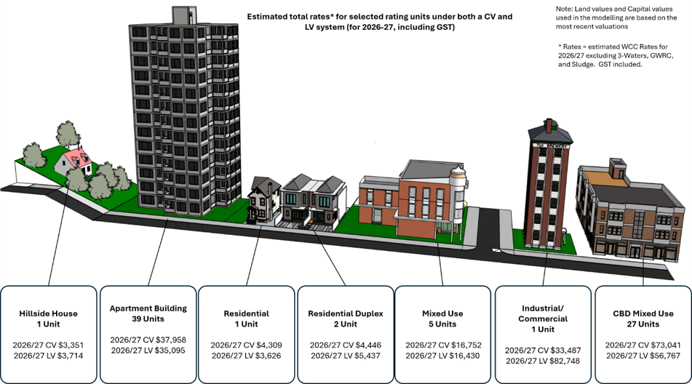

Modelling assumptions for land value rates
Our hypothetical rates examples use the following assumptions:
- We keep the current (based on the 2026/27 Annual Plan) rates split at 51:49 (residential to commercial). Noting that under a land value rating system, the commercial differential rate would need to be 5.8 times the base rate to maintain the 51:49 split (residential to commercial).
- We assume there will be land-value system without any modifications (e.g. fixed charges or targeted rates).
- Only general rates will be set on land-value. The sector targeted rates and Downtown targeted rate will continue to be set on capital value.

Key proposal 2: Changing the general rates split
This review is considering both how rates are calculated and how rates are shared across the city.
Wellington's central city businesses and commercial property owners have faced several cost pressures in recent years, including insurance, financing, construction and earthquake-strengthening costs, alongside reduced office occupancy, lower levels of city centre activity and significant job losses.
At the same time, residential ratepayers are facing their own affordability pressures.
Commercial properties currently pay 3.7 times the base general rate (3.7:1). Council is considering reducing this to 3 times the base general rate (3.0:1) over six years. If Council were to decide to change to a land value rating system, further work would be required to determine the appropriate commercial differential and how any changes should be implemented.
We want your feedback on whether the current balance between commercial and residential rates remains appropriate, or whether a different allocation would better support the city's long-term economic and community outcomes.
We currently split the general rate between four categories:
- base (residential and rural land)
- commercial, industrial and business
- short-term accommodation, and
- vacant land/derelict buildings.
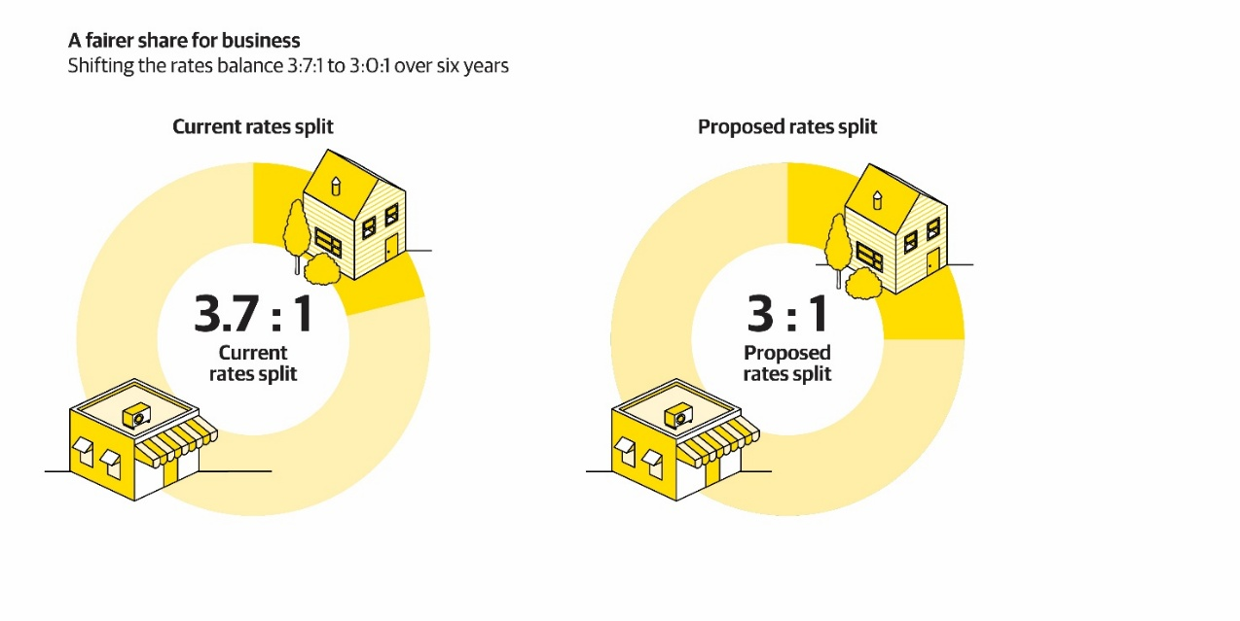
Dividing the rates pie between residential and commercial property ratepayers. Credit: Wellington City Council.
Currently, commercial general rates are set at 3.7 times the base/residential general rates. This means a commercial property pays $3.70 in general rates for every $1 that a residential property pays (assuming the properties have the same capital value).
Wellington’s businesses also pay the commercial sector targeted rate and the downtown targeted rate to encourage business development and tourism in Wellington. Commercial ratepayers currently contribute 49 percent of the Council’s total rates revenue.
The rationale for a higher commercial differential is three-fold.
- First, there is a large commuter base that comes into the City for work and uses the infrastructure (on average 38,000 commuters daily).
- Second, businesses can deduct GST from their rates and deduct rates from their taxable income, which is not available to residential ratepayers.
- Third, reducing this differential would have a substantial impact on residential ratepayers.
Our current commercial rates are among the highest in the country when the commercial rate, the downtown targeted rate, and the commercial sector targeted rate are added together.

Affordability
The Council identified the commercial rating differential as an area for review in its Triennium Plan.
In April 2026, the Mayor, Councillors and Pou Iwi considered a report written by Infometrics that showed Wellington’s commercial rates were a higher percentage of capital value than other main cities and our neighbouring councils.
The comparison to Hamilton City Council is useful because Hamilton also has a relatively large commuter base and a compact central business district like Wellington.

Other councils’ business and commercial rates differentials
- Porirua City Council has a 3.1:1 business rate.
- Hutt City Council has a 3.6:1 commercial central rate for inner city ratepayers.
- Auckland has an urban business rate of 2.39:1.
- Christchurch has a business rate of 2.22:1.
- Hamilton has a commercial rate of 2.98:1.
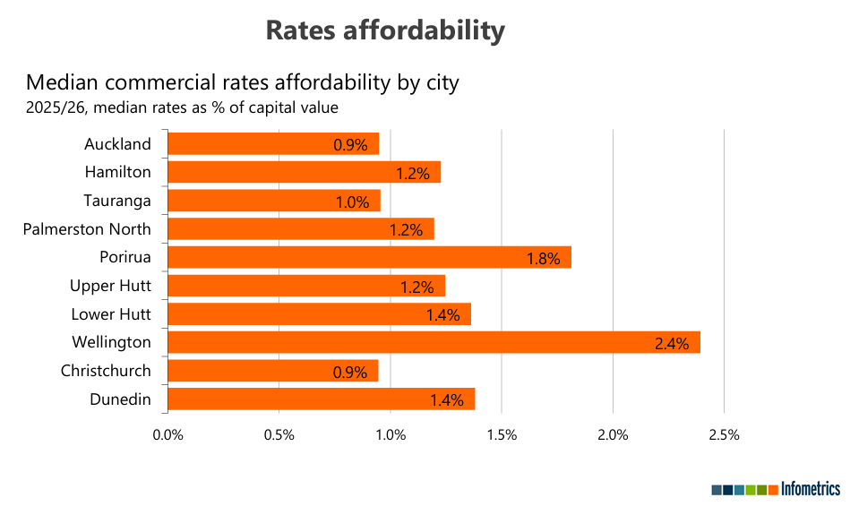

Changes proposed
Our proposal is to change the general rates differential for commercial, industrial and business rate payers over six years from 3.7:1 to 3.0:1. Retaining the status quo, or other differentials are also viable options.
If the Council reduces the commercial rate, commercial ratepayers will pay a smaller piece of the total rates pie. If the commercial rates take is lower, residential ratepayers will pay more of the total rates pie. Using 2026/27 rates as an example, this would have the following potential impact.
- For an average $1.5 million downtown commercial property, their general rate would reduce from $18,280 per year to $16,704 per year (down 8.6 percent).
- For an average $1.5 million residential property, their general rate will increase from $4,460 per year to $4,861 per year (up 9 percent).
If this proposal went ahead, the Council would spread the change over six years. This would help make it easier for ratepayers to budget for the change, instead of making the change all in one year.
The proposed changes aim to increase economic investment and job creation. However, it remains uncertain whether a reduction in commercial rates will be passed on by commercial landlords to businesses.
Table 1 shows our proposed option alongside other potential options and the status quo for an average downtown commercial property and an average residential property that both have a capital value of $1.5 million. It shows the corresponding increase in residential rates for any reduction in commercial rates.

Table 1. Impact on total rates after reducing the commercial rate (4 options)
 | Current | Preferred option* | Other option | Other option | Other option
Commercial differential options | 3.7 : 1 differential | 3.0 : 1 differential | 3.4 : 1 differential | 3.25 : 1 differential | 2.8 : 1 differential**
A $1.5m downtown commercial property | Pays $18,280 in WCC rates now | Would pay $16,704 in WCC rates.  A decrease of 8.6% | Would pay $17,769 in WCC rates  A decrease of 3.3% | Would pay $17,326 in WCC rates  A decrease of 5.2% | Would pay $16,173 in WCC rates  A decrease of 11.5%
A $1.5m residential property | Pays $4,460 in WCC rates now | Would pay $4,861 in WCC rates.  An increase of 9% | Would pay $4,620 in WCC rates  An increase of 3.6% | Would pay $4,707 in WCC rates  An increase of 5.5% | Would pay $4,992 in WCC rates  An increase of 11.9%
General rates split (excluding Greater Wellington rates and the sludge levy) | - 48% commercial  - 52% residential | - 43.5% commercial  - 56.5% residential | - 46.5% commercial  - 53.5% residential | - 45.5% commercial  - 54.5% residential | - 42% commercial  - 58% residential
Total rates split (including Greater Wellington rates and the sludge levy) | - 49% commercial  - 51% residential | - 45% commercial  - 55% residential | - 48% commercial  - 52% residential | - 47% commercial  - 53% residential | - 43.5% commercial  - 56.5% residential
All rates amounts do not include GST. They reflect Wellington City Council’s 2026/27 general and targeted rates. Greater Wellington rates, water services charges (Tiaki Wai charges), and the sludge levy are not included.
* The Council proposes that the preferred option would be introduced over six years, to smooth the increases for residential ratepayers.
** The Council proposes that this option would be introduced over five to six years, to smooth the increases for residential ratepayers.

Key proposal 3: Extending the vacant land differential area
Wellington has many under-used sites that owners could develop into housing or businesses by using planning rules and market conditions.
In the 2024–34 LTP, we introduced an inner-city vacant land / derelict buildings differential rate to encourage owners to develop their sites. Properties in this category pay 5.0 times the base general rate.
We would like your feedback on whether we should include more areas in this policy, offer rates remissions in particular instances, and make some policy wording changes to make the purpose of this rate clearer.

What is vacant land?
We want the definition of vacant land to be clear and understandable.
The Council has four ways to define vacant land as part of charging the vacant land rate:
- The QV code for the site is ‘vacant’
- It is not under development
- It has no active use
- Exemption when not economical
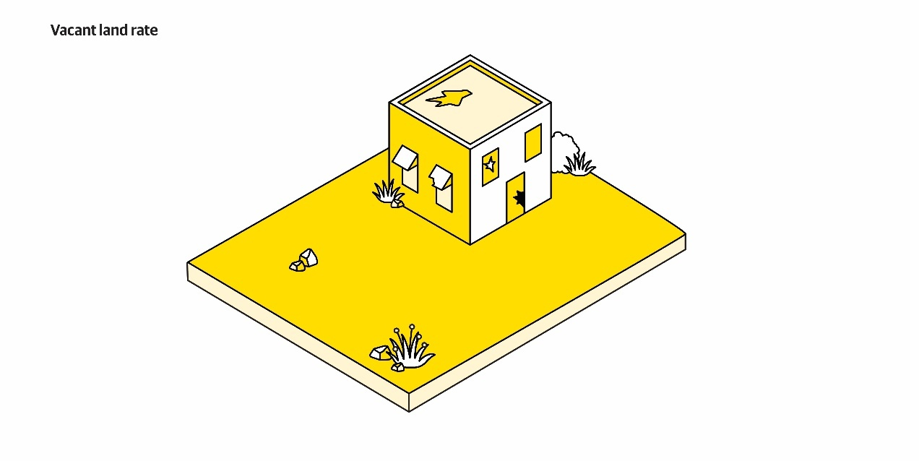

An artist’s impression of a rundown building on untidy vacant land. The Council is proposing to make the criteria for the vacant land / derelict building differential rate easier to understand. Credit: Wellington City Council.

Why do we have this rating differential?
A higher rate on vacant land promotes development in the city and city fringes and makes sure owners of vacant land / derelict buildings pay their fair share of costs.
Without a vacant land /derelict buildings rate:
- the property has low rates compared with other properties in the inner city because the capital value is low.
- owners of vacant central city land (whether commercial or residential) pay less to benefit from the Council’s general activities in the area, for example, roads, footpaths, and inner-city safety.
- vacant / derelict sites have a negative impact on the perceptions of the central city.

Changes proposed
We are proposing to make the following changes:
- To extend the area under the vacant land and derelict buildings rating area to include undeveloped property along Adelaide Road, including areas around the Basin Reserve and up to Wellington Regional Hospital
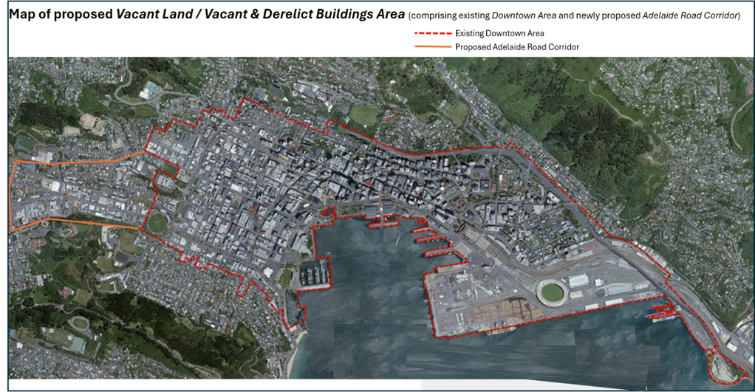
- To make a minor policy wording change to make the purpose of the vacant land rate clearer.
This map shows the current rating zone for vacant and derelict land (shown by a red dotted line) and the proposed extended rating zone, shown by an orange line. There is no change to the area in red.
If you need the exact boundary lines for the current and proposed vacant land and derelict buildings rating zone, please email ratingpoliciesreview@wcc.govt.nz

Key proposal 4: New general rate differential for Tiaki Wai
Since 1 July 2026, the new regional water entity, Tiaki Wai, has been responsible for delivering water services across the Wellington region and bills customers separately from council rates.
Tiaki Wai’s infrastructure is subject to Council rates, and as it invests in new pipes, pumping stations, and treatment facilities, the value of its infrastructure is expected to increase. Over time, this could result in Tiaki Wai paying a larger share of general rates.
We would like your feedback on our proposal to create a new Tiaki Wai general rate differential. This would initially be set at the same level as the commercial differential (currently 3.7:1), but it could be adjusted to smooth out the impact of large revaluation changes.

Impact of rates charged to Tiaki Wai
The general rates revenue from commercial ratepayers is apportioned across all commercial ratepayers using capital values. Property revaluations undertaken every three years can cause the rates paid by one property to be significantly different compared to another property if the value increases differently.
We expect that the capital value of Tiaki Wai infrastructure will increase significantly as it invests more in the city’s pipes, pumping stations, and treatment facilities. This increase would be confirmed every three years when city-wide property valuations are done, and therefore their proportion of the total rates will increase.
Higher rates for Tiaki Wai would increase their costs and it is likely any increase to their rates would be passed onto all ratepayers through water charges.

The proposal
Having the flexibility to set Tiaki Wai’s rates differently from other commercial ratepayers would allow the Council to maintain the relativity of commercial rates between Tiaki Wai and other commercial ratepayers.
Hutt City Council has recently implemented a new water utility differential alongside their differentials for non-water utilities and other commercial ratepayers.
In the same way, we could implement a new general rates differential for Tiaki Wai. The separate Tiaki Wai differential will allow their share of the rates pie to be managed even when revaluations substantially change their rateable value compared to other commercial properties. Any future changes in the Tiaki Wai differential will be part of public consultations in future annual plans or long-term plans.

Key proposal 5: Rates remissions and postponements
A rates remission is a partial reduction in the amount of rates you must pay. They are available for ratepayers that meet set criteria for different types of remission.
We made minor changes to our rates remissions and postponements policies as part of the 2024–34 Long-term Plan (LTP).
While most rates remission policies are working well, we have identified improvement opportunities for rates remission policies related to both earthquake-prone buildings, and for special circumstances.
No decision has yet been made to change our policies. Depending on any decisions made through this process, the Council may ask for further feedback on rates remissions as part of the public consultation on the 2027–37 LTP next year.

Earthquake prone buildings remission
Owners of earthquake prone buildings tell us that our current rates remission policy for earthquake prone buildings is difficult to understand.
There are also challenges with:
- complex eligibility criteria
- matching the timing of strengthening work and application deadlines
- the potential loss of the rates remission when a strengthened property is sold.
We are seeking your feedback on adopting a simpler and more streamlined approach to earthquake-prone building remissions that is easier for property owners to understand and apply for.

The proposal
We propose adopting an earthquake-prone building remission policy which:
- is based on the consented value of strengthening work (or demolition work).
- is available for a maximum of three years following the building being removed from the Earthquake Prone Buildings list.
- may include a variable factor (multiplier) set by Council to incentivise earthquake strengthening where risk and equity considerations are greatest.
- will be attached to the building’s rating unit rather than the owner/developer at the time of strengthening. This means the remission stays in place for the full three years even if the building changes ownership.
- is capped in each year at the total amount of general and targeted rates on the rating unit for that year.

- will apply from the start of the rating year immediately following the date the building is removed from the Earthquake Prone Building list (providing the remission is applied for prior to the commencement of that rating year).
Gardens Magic 2024 wildflowers. Credit: Wellington City Council.

Special circumstances remission
The Council has a special circumstances remission that may be available for circumstances that have not been specifically included in the Council’s other rates remission and postponement policies.
We believe this remission can be simplified and slightly broadened in scope.
We propose amending this policy to allow:
- the possibility of a rates remission in special circumstances where Council considers it is equitable and fair to do so.

Ngā tono kē kīhei i tūtohua
Other proposals not recommended
These are options and ideas to change the rating policies that were considered by the Council but are not recommended.

Changes to the Downtown targeted rate
Research from economic consultancy BERL shows that businesses in the central business district get a high return on investment.
Since 2023, the estimated average return on investment across the central business district is between $2.90 and $4.60 for every $1 businesses pay through the downtown targeted rate, with $3.80 being the mid-range return on investment for this rate.
The principle behind the downtown targeted rate is that businesses benefit from Council investment in the area, so removing or substantially altering the downtown targeted rate would be inconsistent with the benefit principle.
Any changes to the Downtown targeted rate would shift rates onto other groups. If this was transferred to all commercial ratepayers, it would undermine the proposal of lowering commercial rates from 3.7 times to 3.0 times. Shifting it to residential ratepayers would likely make residential rates higher and affordability is already a significant concern.

Additional changes to existing rate remission policies
Rate remissions represent a significant cost to the Council, as they are subsidised by other ratepayers.
This cost is expected to increase over time, as economic conditions, along with rates and charges rising faster than wage growth, place greater financial pressure on households.
However, remissions provide important and targeted support to vulnerable groups, and any changes would need to carefully balance financial sustainability with social outcomes.
At this stage, there is not enough certainty around the design, timing, and effectiveness of the government’s proposed Ratepayer Assistance Scheme, to know whether it could be a practical alternative or replacement to some of our rate remissions.

Introducing new targeted rates
This is for new targeted rates except as a transition tool in the case of moving to a land value rating system.
Targeted rates are most effective when we use them to pay for a separate activity that can be isolated from broader Council functions, and the activity has a clear and direct benefit, for example, tourism promotion.
This means that targeted rates for broader activities, such as transport are difficult to implement and monitor.
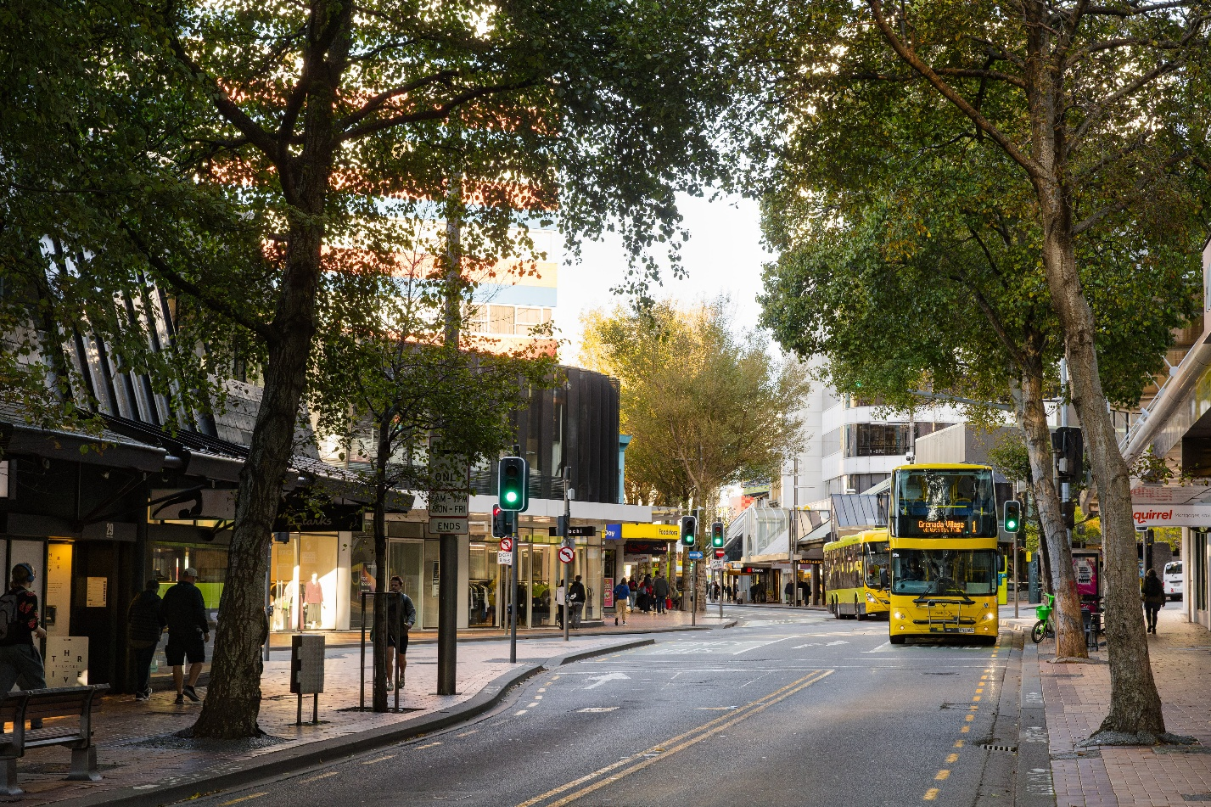 Manners Street, Wellington. Credit: Wellington City Council.
The government’s Going for Growth programme potentially allows future targeted rates for a limited geographical area. However, there is not enough clarity yet how development levies and targeted rates could supplement and/or substitute other rates.

Ngā pātai me ngā whakautua matua
Key questions and answers
We know that Council finances and rates can be complicated, so this section provides some answers that have cropped up as we have planned and drafted these proposals.
If you have any questions on the proposals, please ask at wcc.nz/rating-policies-review or email ratingpoliciesreview@wcc.govt.nz

What is a rating policies review?
A rating policies review is a process through which elected members and the community can consider what allocation of rates would be reasonable and appropriate. No decisions have been made at this stage.
The review looks at how the total rates bill is divided up – the proportion each property owner pays in rates. The review will not decide the total amount of rates to be collected or any proposed rates increases.

When was the last rating policies review completed?
The last full rating policies review was completed as part of the 2024–34 LTP. Every so often, the Council has reviewed aspects of the rating system, for example, the differential between commercial and residential rates.

Why are you completing a rating policies review now?
It is appropriate to conduct a comprehensive rating policy review ahead of the 2027–37 LTP to understand what Wellingtonians feel about potential changes to the rating system.

Why can’t I find the Council’s current rates policy?
The Council’s “rates policy” is not a single document but is drawn from the Council’s revenue and financing policy, remissions and postponements policies, funding impact statements, and the rates resolution. The current Wellington City policies can be viewed at https://wellington.govt.nz/your-council/plans-policies-and-bylaws

When do you decide how much the rates will be?
The Council has not yet made any decisions about future rates increases. We are currently developing our 2027–37 LTP and this includes the budgets for delivering our services and investing in our city. We will be asking for feedback on the future rates next year during our next LTP public consultation.
Before adopting the LTP, the Council will publish its proposals, invite and consider your feedback, and then make its decision. Public consultation is expected to take place next year. You can sign up for updates at https://www.letstalk.wellington.govt.nz/letstalk-newsletter.

What are general rates?
The general rate is paid by all ratepayers where:
- the whole community benefits from a service
- there is little or no benefit, or it costs too much to pay for the activity separately from other ones.
Local authorities can use two types of general rates:
- a value-based general rate: a rate that is calculated based on the value of your property.
- a uniform annual general charge: a fixed dollar amount irrespective of property value.
Wellington City Council does not charge any uniform annual general charge.

What are targeted rates?
A targeted rate pays for a particular activity or group of activities. It is charged only to a group of properties for a particular service, or to all properties for a set period of time and reason, or to a mix of these.
Targeted rates are generally set when a council believes:
- there is some benefit to paying for the service separately from others, and paying for it separately in this way carries little or no transaction costs.
- some categories of ratepayer should not pay the rate or that some categories should pay a different amount to others.

What is the difference between a rates postponement and a rates remission?
A rates remission involves the Council permanently foregoing payment of all or part of any rates that is lawfully owed by a ratepayer.
A postponement of rates involves the delaying or deferral of payment of rates until either a specified time or a specified event occurs, such as the death of the ratepayer. All councils must have a policy on the remission and postponement of rates on Māori freehold land.
If you want the Council to remit or postpone rates there must be a policy in place. The current Wellington City policies can be viewed at https://wellington.govt.nz/your-council/plans-policies-and-bylaws

Is this review likely to lead to using land value instead of capital value for the rating base?
This review is considering whether land value, rather than capital value, should be used as the basis for setting rates. No decision has yet been made to change the rating basis.
Feedback received through this review will help inform whether the Council wishes to give further consideration to that option. If the Council resolves to progress the option, further detailed work would be undertaken on the potential rating impacts, design and implementation options as part of the development of the 2027–37 LTP. This more detailed work will be consulted on next year.

What is the cost of moving to a land value system?
The level of work required to support a potential change to the rating base—including modelling, research, and engagement—is significant. A rough estimate of cost ranges between $600,000 to $2 million, excluding business as usual implications. Changing the rating system would require additional resources and result in increased costs for the Council.
This is a preliminary estimate only. The final cost would depend on the option considered, the scope of any further work and the approach to engagement and implementation. Further work, including more detailed cost estimates, would be required before any proposal could be progressed through the 2027–37 LTP process.

Is this review likely to lead to a different allocation between commercial and residential ratepayers?
This is a comprehensive review, and we’ll be looking into a wide variety of matters relevant to how rates are allocated. However, no decisions have been made yet – we want to have an open conversation with Wellingtonians about what a fair and reasonable allocation of rates should look like in the future.

How can I be involved?
We have already engaged with some stakeholders and will continue to do so throughout the duration of the rating policies review.
If you would like us to engage with you or your community group, please email us at ratingpoliciesreview@wcc.govt.nz. Otherwise please have your say through our website or one of the ways listed on page 6.

When will this have an impact on the rates I pay?
The outcome of the review will inform the direction of the 2027–37 LTP, the results of which will implemented from the commencement of the 1 July 2027 to 30 June 2028 financial year.

ratingpoliciesreview@wcc.govt.nz
wcc.nz/rating-policies-review

Infometrics: “Wellington City Rates Affordability”; 7 April 2026 (https://wellington.govt.nz/-/media/Your-council/meetings/Committees/Te-Taurapa-Council-Planning-and-Finance-Committee/Briefing-Materials/2026-04-07-Infometrics-Slide-Deck-2026-04-07---Wellington-rates-affordability)

