We are proposing a change in your area

Kia ora,

This leaflet is to let you know about a change we are proposing to make in your neighbourhood.

Proposal

Reference
TR01-24 Lyndhurst Park, Tawa – Mobility Parking At All Times

Location – where we propose to make the change
Lyndhurst Park, Tawa, outside of Tawa Rugby club opposite 16 Lyndhurst Road

What we’d like to do
Formalise the current Mobility Parking space by painting one 5.0m x 3.0m park with mobility parking symbol.
Replace the current mobility parking sign and install a new mobility parking sign.
Install No Parking At All Times Roadmarkings to the west of the formalised mobility park.

Why we are proposing the change
We have received request from a member of the public to improve the current signage which denotes the mobility parking space at Lyndhurst Park.
By formalising the current mobility park with current specifications, the mobility parking space will become more visible to mobility permit holders and non-mobility permit holders.
Additionally, the formalisation of the mobility park will allow for greater continuity between mobility parking spaces across the region.

Impact
- Improves safety and accessibility for mobility permit holders.
- No impact due to the mobility parking space only being formalised and the space is only wide enough for a single parking space.
- No Pedestrian impact

How this relates to the parking policy
Support safe movement – facilitate the safe and efficient movement of people and goods by focusing on people moving along transport corridors rather than people parking or storing stationary vehicles.

Additional information
To view the legal description for this Traffic Resolution, an electronic copy of the report will be available on the Council’s Let’s Talk engagement website from 9.00am Wednesday 6 December 2023 at https://www.letstalk.wellington.govt.nz/ or you can call (04) 499 4444 and we will send one out to you.

Privacy
Your privacy is important to us. Please DO NOT add specific personal details to your feedback (i.e.: full name, address, etc)

What we do with your personal information:
All submissions (including your first name, but not contact details) are provided in their entirety to elected members and made available to the public on our website and at our office. Personal information (including contact details) will also be used for the administration of the consultation process including informing you of the outcome of the consultation. All information collected will be held by Wellington City Council, 113 The Terrace, Wellington, with submitters having the right to access and correct personal information.
For more information regarding our Privacy Statement please check our webpage: Privacy statement – Wellington City Council.

Feedback
If you would like to provide us with specific feedback, which will be added to the Traffic Resolution following consultation and made public in full, you can do so by filling out an online submission form, downloading a printable submission form on https://www.letstalk.wellington.govt.nz/ or emailing us at trfeedback@wcc.govt.nz.
Please note if you are giving feedback the consultation period opens at 9.00 am Wednesday 6 December 2023 and finishes at 5.00 pm Monday 15 January 2024.

Next steps
Feedback collated by Tuesday 16 January 2024.
2The proposal will go to the Koata Hātepe Regulatory Processes Committee meeting on Thursday 22 February 2024.
If approved, the proposal will be installed within the following three months.

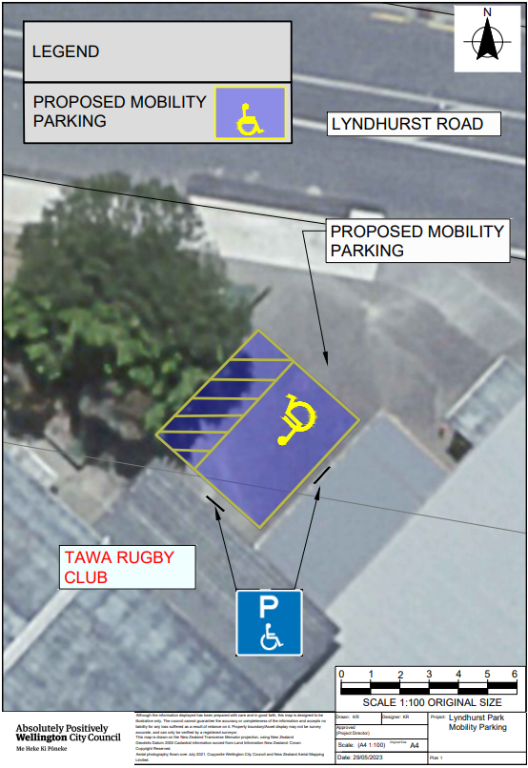

Legal description

Add to Schedule B (Class Restricted) of the Traffic Restrictions Schedule

Column One
Lyndhurst Park Northern Carpark

Column Two
Mobility Parking At All Times, Displaying an Operation Mobility Permit Only

Column Three
Infront of the north west wall of Tawa RFC building (Refer to attached plan, blue)

Legal description
- Prepared by Karl Rudge (Transport Engineering Assistant)
- Approved by Soon Teck Kong (Engineering and Operations Manager)
- Date prepared: 21/11/2023

