

He mahi toi, he mahi ahurea

Arts and Culture

Background report
March 2026

Contents

Purpose 2
Council Activities 2
What we do as a Council 3
Budget 4
Arts & Culture Funding Sources 6
Why is this activity important? 7
Current direction 8
Direction from legislation and national regulations 8
Regional settings 9
Wellington City Council settings 9
Indicators and trends: Arts and Culture 10
Stakeholder views about Arts & Culture 12
Tākai Here partners' views on arts and culture 13
Key issues and opportunities 14
Structural pressures on arts & culture provision and funding 14
Future cultural prominence challenged 14
Interaction between provision and funding constraints 15
Under-performing and costly arts and culture assets 16
Council-owned assets are expensive to own, yet inefficient and underutilised 16
Misalignment between the current asset base and strategic outcomes 17
Growing pressure to demonstrate clear value from arts and culture spending 17
Barriers to inclusion and equitable access in arts and culture participation 18
Social disparity and accessibility challenges 18
Strengthen te ao Māori partnership 18

Purpose
This background report provides a clear, evidence‑based overview of Wellington City Council’s Arts and Culture activity. It sets out what the Council does, why it does it, how it is funded, how it is performing, and the key issues shaping future choices.

The report is intended to support informed engagement with the Council’s role in arts and culture. It provides advisory groups with shared context on Council responsibilities, settings, constraints, and strategic direction, and supports elected members by bringing together relevant information, performance insights, stakeholder views, and emerging challenges to inform deliberations through the Long-term Plan (LTP) 2027–2037 process.

This is not a strategy or a set of recommendations. Rather, it is a foundation document that identifies current settings, pressures, and opportunities, and surfaces the key trade‑offs that will need to be considered as the Council refreshes its strategic direction and investment approach for arts and culture within a constrained fiscal environment.

Council Activities
A Council ‘activity’ is a formal Local Government Act 2002 (LGA 2002) term to refer to Council goods and services. Council activities are grouped for the purposes of the Long-term Plan and budgets – some are relatively stand-alone like transport. This group of activities includes:

4.1 Arts and Cultural Activities
4.1.1 City Galleries and Museums
4.1.2 Visitor attractions
4.1.3 Arts and cultural festivals
4.1.4 Cultural Grants
4.1.5 Access and support for community art
4.1.6 Arts Partnership
4.1.7 Regional Amenities Fund

What we do as a Council
The Council plays various roles in a wide mix of arts and culture activities in the city, ranging between venue owner, regulator, funder, amongst others. The Council:
- directly organises and/or supports a range of community arts and/or culture events and festivals to provide a significant annual programme of arts and culture activities, including major events such as World of Wearable Arts
- maintains and operates the key venue infrastructure for the performing arts, an integrated network of creation, rehearsal, performance, and recording venues (theatres, concert halls, auditoria, dance studios, music recording studios, and others). Also provided is the opportunity for arts and culture tenancies in some of this infrastructure, as is seen with Te Whaea
- operates as principal funder of key museums and art galleries, in many cases through the Council Controlled Organisation, Wheako Pōneke Experience Wellington (managing more than 600 works), as well as other key visitor attractions (including Capital E)
- regulates across a range of areas that have a direct influence on activity, including heritage protections, seismic strengthening, venue regulation, noise regulation, organisation of street activity, alcohol and traffic management regulation, health and safety requirements, and resource consents
- collaborates with various stakeholders for the benefit of arts and culture activities in Wellington City to deliver positive outcomes, as well as leading engagement across the city to support informed decision-making and advocating for additional funding and policy support for the sector.

Civic arts and/or cultural spaces the Council (or a Council Controlled Organisation) own as attractions includes a number of museums and galleries. The Council also owns major civic arts and/or cultural civic event spaces (wholly or partially) which are available as art and/or culture event spaces. Toi Pōneke Arts Centre which is leased (not owned) by the Council is also available as an arts and/or culture space, which the Council uses to connect and support artists by offering office and studio space for lease for creative projects.

Budget
You can find more information in the LTP 2024 Amendment.
Percentage of total council spend:
Opex – 3%
Capex – 0.9%

Operating Expenditure
Activity Component Name | Income/ Expense | 2024/25 | 2025/26 | 2026/27 | 2027/28 | 2028/29 | 2029/30 | 2030/31 | 2031/32 | 2032/33 | 2033/34
4.1.1 Galleries and museums (WMT) | Expense | 11,382 | 11,911 | 12,371 | 12,654 | 12,908 | 13,132 | 13,322 | 13,490 | 13,649 | 13,784
4.1.2 Visitor attractions (Te Papa / Carter Observatory) | Expense | 3,163 | 3,198 | 3,283 | 3,292 | 3,334 | 3,376 | 3,418 | 3,465 | 3,501 | 3,458
4.1.3 Arts and cultural festivals | Expense | 5,414 | 5,674 | 5,790 | 5,897 | 5,998 | 6,109 | 6,205 | 6,307 | 6,635 | 6,518
4.1.3 Arts and cultural festivals | Income | (80) | (82) | (83) | (85) | (87) | (89) | (90) | (92) | (94) | (96)
4.1.4 Cultural grants | Expense | 3,024 | 3,122 | 3,024 | 3,024 | 3,024 | 3,024 | 3,024 | 3,024 | 3,024 | 3,024
4.1.5 Access and support for community arts | Expense | 2,650 | 2,413 | 2,326 | 2,368 | 2,402 | 2,455 | 2,410 | 2,446 | 2,477 | 2,527
4.1.5 Access and support for community arts | Income | (24) | (24) | (25) | (26) | (26) | (27) | (27) | (28) | (28) | (29)
4.1.6 Arts partnerships | Expense | 2,816 | 3,271 | 3,232 | 3,422 | 3,477 | 3,547 | 3,603 | 3,659 | 3,711 | 3,761
4.1.6 Arts partnerships | Income | (483) | (492) | (503) | (514) | (525) | (536) | (546) | (556) | (567) | (577)
4.1.7 Regional amenities fund | Expense | 609 | 609 | 609 | 609 | 609 | 609 | 609 | 609 | 609 | 609
Total |  | 28,472 | 29,600 | 30,025 | 30,641 | 31,114 | 31,600 | 31,929 | 32,324 | 32,917 | 32,979

Capital Expenditure
Activity Component Name | 2024/25 Published budget | 2024/25 Amendment budget | 2025/26 | 2026/27 | 2027/28 | 2028/29 | 2029/30 | 2030/31 | 2031/32 | 2032/33 | 2033/34
4.1.1 Galleries and museums (WMT) | 1,686 | 219 | 0 | 0 | 0 | 0 | 0 | 0 | 13,836 | 5,755 | 967
4.1.2 Visitor attractions (Te Papa / Carter Observatory) | 354 | 178 | 175 | 0 | 0 | 0 | 0 | 0 | 0 | 0 | 0
4.1.4 Cultural grants | 1,068 | 0 | 1,068 | 0 | 0 | 0 | 0 | 0 | 0 | 0 | 0
4.1.5 Access and support for community arts | 120 | 114 | 82 | 78 | 80 | 82 | 83 | 85 | 86 | 88 | 89
4.1.6 Arts partnerships | 275 | 275 | 5,641 | 0 | 0 | 0 | 0 | 0 | 0 | 0 | 0
Total | 3,503 | 787 | 6,966 | 78 | 80 | 82 | 83 | 85 | 13,922 | 5,842 | 1,056

The CAPEX allocation in this budget is designated specifically for the relocation and fit out of Toi Pōneke at Market Lane. This investment will support the transition to the new premises, ensuring that the facility meets operational requirements and continues to serve the needs of the creative community. The project includes costs associated with moving, renovations, and outfitting the new space to provide an accessible and vibrant environment for artists and visitors.

Arts & Culture Funding Sources
Sub activities | Fees and Charges | General Rates | Targeted Rates | Grants, Subsidies, Other Income
Galleries and museums (WMT) | 0% | 75% | 25%* | 0%
Visitor attractions (Te Papa / Carter Observatory) | 0% | 30% | 70%* | 0%
Arts and cultural festivals | 0% | 90%-100% | 0% | 0%-10%
Cultural grants (creative sector grants) | 0% | 0% | 100%** | 0%
Access and support for community arts (City Arts projects and venues access) | 0% | 90%-100% | 0% | 0%-10%
Arts partnerships (City Arts partnerships) | 0% | 80%-90% | 0% | 10%-20%
Regional amenities fund (creative sector initiatives) | 0% | 100% | 0% | 0%
* Downtown targeted ** Residential target. Source: 2024 LTP Volume 2

Why is this activity important?
Wellington’s arts and creative sector is made up of a diverse range of institutions, organisations, businesses, agencies, groups, and individuals. By actively connecting people, they help build and strengthen community. This sector shapes Wellington’s identity and the way its citizens experience the world, influencing understanding of the city’s landscape, cultural life, and digital engagement. The arts and creative sector is a hub of expertise and knowledge, with the potential to guide the community towards a more resilient and improved future.

Investment in the arts strengthens social cohesion, stimulates economic activity, and celebrates diverse cultural narratives. Statistically, Wellington residents are considered to be the strongest advocates for art in the country, with 67% agreeing that arts improve our society, and 85% having attended or participated in the arts within the last 12 months.⁴ The arts represent a key area of interest for tangata whenua; a dynamic cultural meeting point; and are a builder and reinforcer of “community”, promoting inclusion of all people and cultures.

Arts and cultural activities and events attract tourists, both domestic and international, which boosts the local economy. Wellington's cultural events and visitor attractions generate significant visitor spending which supports the city’s businesses including retail, hospitality, and accommodation providers. Of note, the World of Wearable Arts annual arts events contributed more than $32 million alone to Wellington’s economy in 2024⁵, with over $323 million contributed over the last 20 years.⁶

Arts and culture funding and support by the Council has promoted social inclusion by providing platforms for diverse voices and perspectives. Examples from the 2025 Community Events Calendar include the Council supporting and/or hosting at least eight multicultural events in 2025 that reflect the city’s ethnic and cultural diversity. These included: Waitangi Day; Pride Week; Refugee Week; Matariki; Te Wiki o Te Reo Māori; Neighbours Month Aotearoa; and the Pasifika Festival Ethnic Communities Forum. The reach of inclusion and diversity programming is also significant through grants funding and the activities of Council’s own facilities and those of partner organisations.

Current direction

Direction from legislation and national regulations
The purpose of local government requires councils to promote social, economic, environmental and cultural well-being (the four well-beings) of communities (Local Government Act (LGA) 2002 section 10 refers). The Local Government (Systems Improvement) Amendment Bill seeks to refocus council responsibilities on core infrastructure and services and remove the four well-beings. In a new section, “Core services to be considered in performing role” (proposed new section 11A of the LGA 2002) several are listed and include “libraries, civil defence, museums, reserves and other community and recreational facilities.” Subject to final amendments to the LGA 2002, the role of the Council in delivering some programmes and services, particularly those that are not directly referenced, may need to be assessed. This would be an incremental process, as any changes to services or levels of service would remain subject to democratic decision-making processes.

There are also legislated local authority roles in several other acts, such as the Arts Council (Creative NZ) Act 2014 (the Arts Council Act), the Protected Objects Act 1975, and the Heritage New Zealand Pouhere Taonga Act 2014 - these continue to define council roles in supporting the arts, protecting cultural heritage, and ensuring inclusive access. While the Human Rights Act 1993 does not directly impose statutory duties on councils, it reinforces the importance of cultural inclusion and diversity.

The Arts Council Act established Creative New Zealand to fund and advocate for the arts; and encourages local authorities and community arts bodies to align their activities with national standards and priorities to access funding and maintain recognition. Section 18 of the Arts Council of New Zealand Toi Aotearoa Act 2014 allows Creative New Zealand to appoint a local authority to provide administrative and secretarial support to a community arts council; this is discretionary and does not create a general obligation to fund or administer community arts.

The Arts Council Act also requires recognition of Māori as tangata whenua, Pacific arts, and cultural diversity, alongside principles of participation, access, excellence, and advocacy. This aligns with the Council’s strategies (such as Aho Tini) and reinforces obligations to embed these principles in planning and funding decisions.

Regional settings
Councils also operate within a broader regional context that includes strategies and policies which influence their support for arts and culture delivery. The Wellington Regional Economic Development Plan, and associated tourism initiatives, play a key role in promoting cultural tourism, supporting creative industries, and fostering collaboration across councils. These regional settings provide strategic direction and enable coordinated efforts to enhance the cultural vibrancy of the region. The plan states that:
- screen, creative, and digital industries are a regional priority, with initiatives that strengthen Wellington’s position as a hub for film, gaming, and creative technology. These sectors provide opportunities for arts and culture to connect with innovation and economic growth.
- Māori economic development and cultural inclusion are central to regional strategies, requiring councils to embed kaupapa Māori approaches and support diverse creative enterprises as part of arts and culture delivery.
- Skills development and talent pathways are emphasised across the region, creating links between arts, education, and workforce initiatives to build capability in creative sectors and ensure long-term sustainability.

Wellington City Council settings
At the local level, Wellington City Council has adopted several strategies that guide its approach to arts and culture. The Aho Tini: Arts, Culture, and Creative Strategy envisions Wellington as the ‘creative capital’ where arts and culture are accessible to all. Its core focus areas - Aho Tangata, Aho Hononga, Aho Whenua, and Aho Mahi - emphasise inclusive participation, partnership with Māori, activation of public spaces, and support for creative careers. The Tākai Here Partnership Agreement supports the expression of Māori heritage through public art and cultural programming, and the Tūpiki Ora Māori Strategy outlines outcomes that prioritise Māori identity, language, and participation in decision-making, with arts and culture as key enablers. Together, these strategies guide the Council’s contribution towards fostering a culturally rich, inclusive, vibrant city.

Indicators and trends: Arts and Culture
The Council’s 2024/25 Annual Report confirms that arts and culture activities continue to perform strongly, with most of the Council's targets met and high levels of public engagement reported. It also shows that the Council’s venues and programmes are well-received, however overall resident satisfaction with the city’s arts and culture scene has declined slightly, reflecting broader sentiment shifts.

Utilisation rates across most civic venues, with the exception of Hannah Playhouse, remained at or below 50% in FY24. This pattern reflects a combination of operational constraints and booking strategies, as well as broader issues of venue accessibility.
In this context, ‘venue accessibility’ refers specifically to the ease with which audiences and artists are able to book, use, and access venues for arts and cultural events, for example, the availability of suitable times, affordability, public awareness, and logistical convenience. It does not refer to physical accessibility for individuals with disabilities, but rather to the general barriers that may discourage participation or limit the appeal of these spaces. Additionally, the ongoing cost of living pressures are likely to influence public engagement and bookings.

Venue utilisation is influenced by how well programming connects with local audiences. Events that reflect community interests and cultural backgrounds tend to attract greater participation, while those that don't may see lower attendance. To boost utilisation and maintain vibrant arts activity, event content should align with local preferences and showcase the city's cultural diversity.

Groups differ in their views on arts and culture. For example, when looking at the Resident’s Monitoring Survey (RMS) 2025:
- Younger people (18-29), those with dependent children, and female respondents are more likely to support Wellington’s arts capital status, while older respondents (60+) show lower levels of agreement, highlighting demographic differences in perception. Decreasing sentiment aligns with wider shifts in public sentiment about the city, despite a diverse programme of events.
- Whilst the majority of both Māori and non-Māori broadly agree with Māori cultural recognition/visibility measures, there are some indications that Māori respondents may feel less positively around Māori representation in the city. For example, Māori are significantly more likely than non-Māori to disagree that Māori culture and te Reo is recognised in the city (21% disagreement for Māori, vs 8% for non-Māori), and agreement with Māori cultural visibility measures tends to be lower for Māori across the board.
- People aged 60+, Northern ward residents, disabled people, and men were less likely to agree that they feel welcome and included in cultural events and activities in Wellington, and/or that they see their community reflected in Wellington’s cultural activities (about 10-20 percentage points lower for each group compared to others).

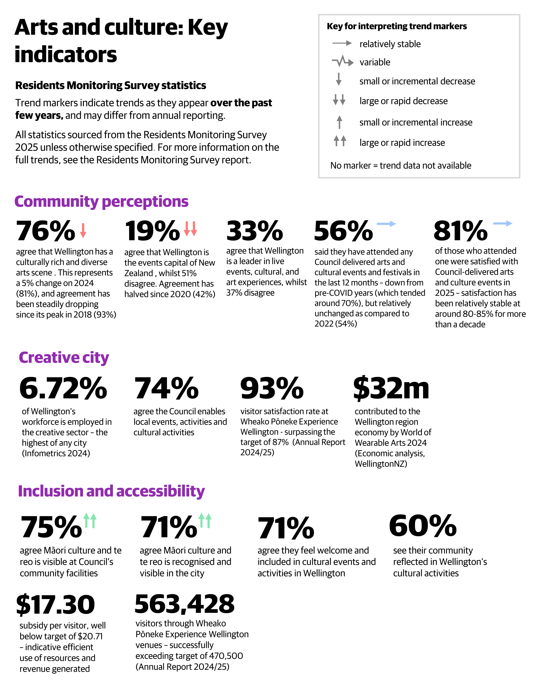

Stakeholder views about Arts & Culture
While satisfaction with Council-run cultural events remains high, concerns are also raised in the RMS regarding affordability, the need for balanced investment, and ensuring that cultural initiatives support all residents, especially marginalised groups. There has been a significant drop (8%) in Wellingtonian's pride and perceptions about the city as a place to live and enjoy.

Residents increasingly, and at a growing volume, urge the Council to focus on “core services”, such as infrastructure, public safety, and facility maintenance, over new or non-essential cultural projects. While many appreciate the vibrancy that arts and events bring, they want clearer evidence of community and economic benefit. The tension between cultural investment and fiscal restraint is a recurring theme. Cultural ambition needs to be balanced with affordability for ratepayers, and recalibration of investment levels during periods of economic and fiscal constraint. It also highlights the importance of content quality and audience demand, as arts and culture investment is most economically effective where programming attracts paying audiences and drives spillover economic benefit.

Māori participants in the RMS and Quality-of-Life surveys strongly support initiatives aligned with te ao Māori values, emphasising the importance of a genuine and deep partnership with mana whenua.

The Accessibility Advisory Group (AAG) has highlighted the need for Council to embed accessibility in all planning and delivery, as this will help make Wellington a destination of choice for people living with disabilities.

Organisations receiving stable multi-year funding express strong appreciation for the Council’s commitment to sustained investment. This funding enables long-term planning, staff retention, and consistent programming – with funded organisations required to align their work with the Council’s Aho Tini 2030 (the Arts, Culture and Creativity Strategy). Some stakeholders, particularly smaller or emerging groups representing ethnic communities, youth, or people with disabilities, feel underrepresented in funding decisions. They call for more inclusive processes and support mechanisms to ensure a broader range of voices and creative expressions are supported.

Artists and creative workers have raised concerns about the precarity of creative careers in Wellington, and stakeholders suggest more could be done to support sustainable employment in the arts.

Tākai Here partners' views on arts and culture
Tākai Here partners emphasise that arts and culture are central to expressing Māori identity and wellbeing in Wellington. Feedback calls for Māori stories, language, and creative practices to be visible and valued across the city’s cultural life. They want to see genuine co-design in public art, events, and place-making, with Tākai Here partners involved from the outset. Feedback highlights the need for targeted support for ngā toi Māori (Māori arts), including direct funding, opportunities for Māori artists, and the integration of te reo and tikanga in Council programmes. Tākai Here partners see these actions as essential for honouring Te Tiriti o Waitangi, strengthening community connection, and ensuring Wellington’s creative identity is authentically grounded in mana whenua perspectives.

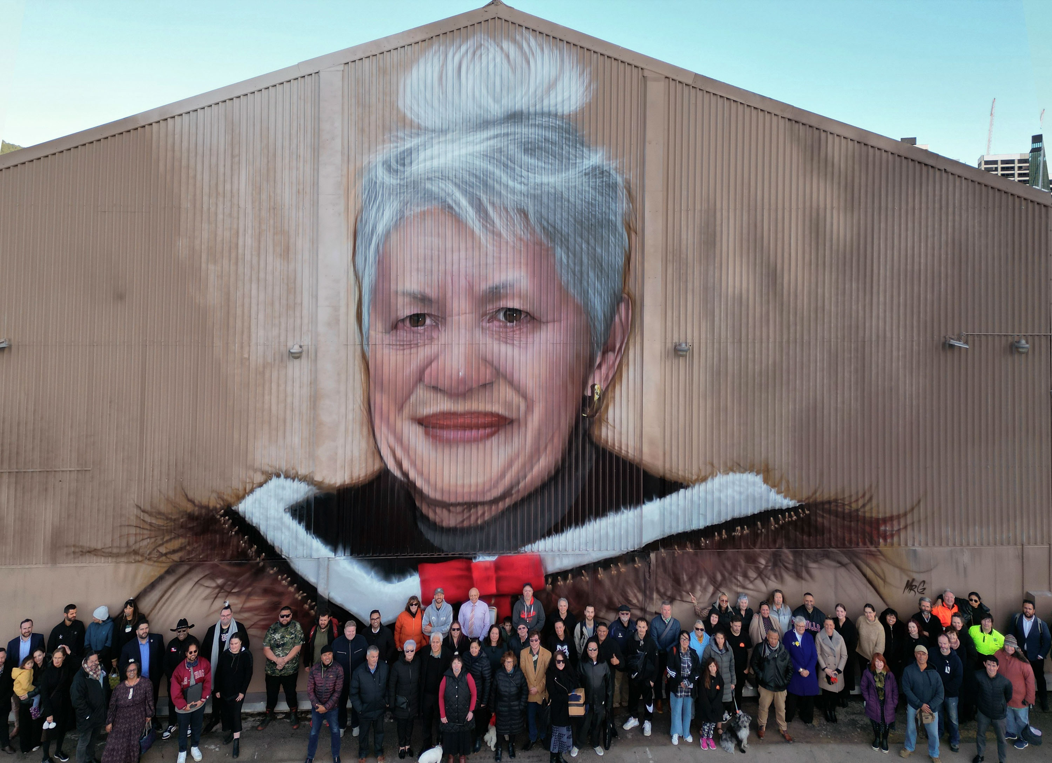

Key issues and opportunities
This section provides a strategic overview of the key issues shaping Wellington’s arts and culture sector. Drawing on performance data, stakeholder feedback, and recent situational analysis, it identifies persistent gaps, highlights recent successes, and examines strategic implications for the city’s cultural future. The sector faces mounting challenges, ranging from social disparity and shifting audience profiles to loss of major events, resource limitations, and declining funding, which are impacting participation and sustainability.

Structural pressures on arts & culture provision and funding

Future cultural prominence challenged
Arts and culture remain a significant contributor to Wellington’s economic, social, and cultural wellbeing, with 6.72% of the city’s workforce employed in the creative sector, the highest share nationally according to the Infometrics creative index.

Evidence increasingly points to structural pressures that extend beyond overall funding levels and relate to how arts and culture provision is shaped, sustained, and delivered in Wellington. Other cities are continuing to invest in arts and culture, intensifying competition for audiences, funding, and creative talent. While national perceptions of Wellington as a city with a rich and diverse arts scene remain relatively strong, confidence in the city’s status as New Zealand’s events capital has declined to its lowest level in recent years.

This shift suggests that challenges are not solely financial, but also relate to the mix, reach, and accessibility of arts and cultural offerings, and how well these align with changing audience expectations and demographics.

Demographic evidence reinforces this point. Younger people, those with dependent children, and women are more likely to support Wellington’s arts capital status, while older residents (60+) show lower levels of agreement according to the 2025 Residents Monitoring Survey. These differences point to uneven experiences of, and connection with, current provision. They also suggest that the issue is not simply maintaining existing activity, but ensuring that the range, format, and distribution of arts and culture opportunities remain relevant and inclusive across the population.

Internal reviews and commissioned analysis indicate that the performance of Wellington’s civic venues is currently suboptimal, with long-standing concern from sector stakeholders about how well the venue network is functioning overall. Event activity data shows wide variation in use across the portfolio in FY24 with some venues hosting high numbers of events while others record materially lower activity, and at least one major venue not operating during that period. Recent utilisation has also been affected by asset condition and risk mitigation decisions, with bookings at some venues deliberately constrained, suppressing activity regardless of demand. Portfolio reviews further identify venue accessibility and customer experience as recurring issues alongside utilisation, suggesting that layout, operational settings and physical access may be limiting participation for some audiences. For example, feedback from attendees at a major arts event noted that unclear wayfinding signage and limited seating options made the venue challenging to navigate and enjoy, particularly for older visitors and those with mobility needs. Taken together, these indicators point to uneven utilisation across the network, driven by a combination of asset condition, accessibility constraints, content mix, and operating models, rather than overall lack of interest in arts and cultural events.

Interaction between provision and funding constraints
Funding constraints are a critical part of this picture, but they interact closely with provision. Arts and culture funding in Wellington is increasingly tight, fragmented, and inequitable, with city residents subsidising assets and activities that are used regionally. At the same time, reductions are occurring across all major funding sources, including central government, philanthropy, and user-pays, increasing pressure on local funding streams.

A key structural challenge is that much of the arts and culture sector looks to Wellington City Council as the primary and, in many cases, default funder - not only for Council-owned venues (which pose another significant challenge and are considered separately), but for a wide range of programmes, organisations, events, and community-based activity. This reliance places increasing pressure on Council budgets to sustain both the scale and diversity of provision, particularly in a constrained fiscal environment. It also limits the sector’s resilience, as alternative revenue streams and co-investment models have not kept pace with rising costs and changing participation patterns.

As a result, funding pressures manifest not only as reduced capacity to invest, but also as constraints on what can be provided, where, and for whom. Fragmented regional coordination, transport and affordability barriers, limited venue capacity, and insufficient targeted marketing further restrict participation and audience growth, reducing the overall impact and value realised from existing investment.

Addressing risks to Wellington’s cultural prominence therefore requires a dual focus: improving the sustainability and diversification of funding, and reshaping provision to maximise reach, relevance, and value. Opportunities include adopting new technologies to create different types of cultural experiences, increasing the use of existing facilities for a broader range of activity, improving the visibility and coherence of Council-supported initiatives, and deepening engagement with communities to better understand and respond to audience needs. Strengthening these areas would support more effective use of limited resources, reduce over-reliance on Council funding over time, and help maintain Wellington’s position as a creative capital in a more competitive and constrained environment.

The challenges outlined above relate primarily to the sustainability and mix of arts and culture provision and the sector’s reliance on Council funding for programmes and activity; issues relating specifically to Council-owned venues and physical assets are considered separately in the sections that follow.



Under-performing and costly arts and culture assets

Council-owned assets are expensive to own, yet inefficient and underutilised
Many of the Council’s key arts and culture facilities are expensive to operate and maintain, yet are not generating commensurate cultural, social or economic benefits. A number of venues suffer from low utilisation and limited audience reach, meaning they are not used to their full potential. This under-performance constrains artistic outcomes and reduces spill-over benefits such as city centre vibrancy, tourism, and local spending. At the same time, the facilities themselves are aging and require ongoing capital investment (including seismic strengthening and modernisation) just to remain safe and functional.

The result is a high cost per user and an unsustainable subsidy burden on ratepayers. In a constrained fiscal environment, it will be increasingly difficult to justify pouring significant funds into under-utilised or inefficient assets without evidence of improved performance.

Going forward, the Council must carefully evaluate which facilities and services deliver the greatest public value and focus resources on those that attract diverse audiences and achieve clear outcomes. There is an opportunity to repurpose or rationalise poorly performing venues and explore new management or partnership models that can improve utilisation, reduce net costs, and deliver stronger returns for the city.

Misalignment between the current asset base and strategic outcomes
Wellington’s collection of arts and culture assets has developed over time and is not optimally aligned with the city’s evolving needs or the Council’s own strategic objectives. Many venues still operate under legacy business models and short-term decision-making that prioritise the physical upkeep of buildings over creative programming, community impact, and cross-venue coordination. For example, operating and funding arrangements have historically been siloed by venue, hindering a cohesive, city-wide approach to programming and audience development.

There is also insufficient data and evaluation of how each facility contributes to the Council’s desired outcomes (such as economic impact and broad community participation). This makes it difficult to identify gaps or decide whether the mix of assets is still fit-for-purpose. The Council may be investing relatively too much time and resources on fringe arts and not enough on popular content that drives audience, creative sector jobs and spillover economic benefit for the city. The Council may be over-invested in certain types of spaces while lacking capacity in others. There is opportunity to realign the portfolio – and the associated operating models – to better support the outcomes Council wants to achieve.

This could involve divesting under-performing assets. Adopting more outcome-focused approaches to cultural asset management could help ensure that every council-owned venue contributes meaningfully to Wellington’s creative future, rather than being preserved for its own sake.

Growing pressure to demonstrate clear value from arts and culture spending
The public and elected members are increasingly questioning what return they get on the rates and funding allocated to arts and culture. Wellingtonians greatly value the cultural life of their city, but they also face competing priorities in an era of fiscal constraint and rising costs. Recent community feedback reflects a call for the Council to focus on “core” services like infrastructure, safety, and facility maintenance, unless cultural investments can show compelling benefits to residents.

Creative sector views also emphasise that more funding should be available for artists. While arts and culture activity supports jobs and career pathways in the creative sector, these outcomes are primarily spillover benefits of the Council performing its core functions well, including managing venues effectively and enabling popular, high-quality programming that attracts audiences. The Council’s influence on creative employment is therefore strongest where venues are well run, content is compelling, and demand is sustained, rather than through a direct or stand-alone focus on job or career creation. Supporting employment in the sector is therefore a consequence of successful venues and events delivering strong cultural, community, and economic outcomes.

In short, the onus is on the Council to prove that its arts and culture spending is achieving tangible outcomes – whether economic (e.g. attracting visitors, supporting jobs, revitalising the central city) or social (e.g. community pride, inclusion, wellbeing). Best-practice frameworks in the cultural sector, including the Government’s new Amplify – Creative and Cultural Strategy 2025–2030, echo this emphasis on “investing for maximum impact”, with rigorous measurement of outcomes and a focus on growing the cultural sector’s contribution to economic and community goals.

This presents an opportunity for Wellington; making considered decisions to allocate resources where they can deliver the greatest public benefit. Introducing clear performance indicators and regular reporting on results (for instance, venue utilisation rates, audience diversity, and economic impact metrics) could help to build confidence that ratepayer investment in arts and culture is being used effectively. By strengthening accountability and linking investment to results, the Council may be able to maintain support for arts and culture even under financial pressures. This can also encourage a shift in focus from costs to benefits, highlighting the role of arts and culture as an important contributor to the city’s success.

Barriers to inclusion and equitable access in arts and culture participation

Social disparity and accessibility challenges
The Wellington arts and culture sector faces several interconnected challenges that reflect the city’s evolving social landscape. Māori participants in recent surveys have strongly advocated for initiatives grounded in te ao Māori values, emphasising the need for authentic, enduring partnerships with mana whenua.

Artists and creative practitioners have identified ongoing challenges in accessing affordable, available, and fit-for-purpose facilities, with barriers relating to venue availability, cost, booking settings, and suitability of spaces limiting opportunities for creation, rehearsal, and performance. This was identified during the development of Aho Tini.

Strengthen te ao Māori partnership
The Council’s arts and culture activities are guided by a deep commitment to te ao Māori, expressed through a suite of interlinked strategies and partnerships. Central to this approach is the Tākai Here Partnership Agreement, ensuring Māori voices, values, and aspirations are embedded in decision-making and delivery.

Tūpiki Ora provides the overarching framework for Māori wellbeing, setting out four key outcomes. These outcomes are operationalised through collaborative initiatives, such as co-designed public art, bilingual signage, and iwi-led events, that make Māori heritage and narratives visible throughout the city. The Council’s arts and culture strategy, Aho Tini 2030, weaves these commitments into its vision, ensuring that creativity, cultural expression, and Māori knowledge (mātauranga Māori) are central to Wellington’s identity as a creative capital.

This strategic approach is continually strengthened through ongoing engagement, monitoring, and shared action planning with Tākai Here partners. Recent initiatives include the integration of Māori artists and narratives in major civic projects, the development of a Māori resource hub (Te Pātaka), and the embedding of te ao Māori principles in facility planning, events, and grants.

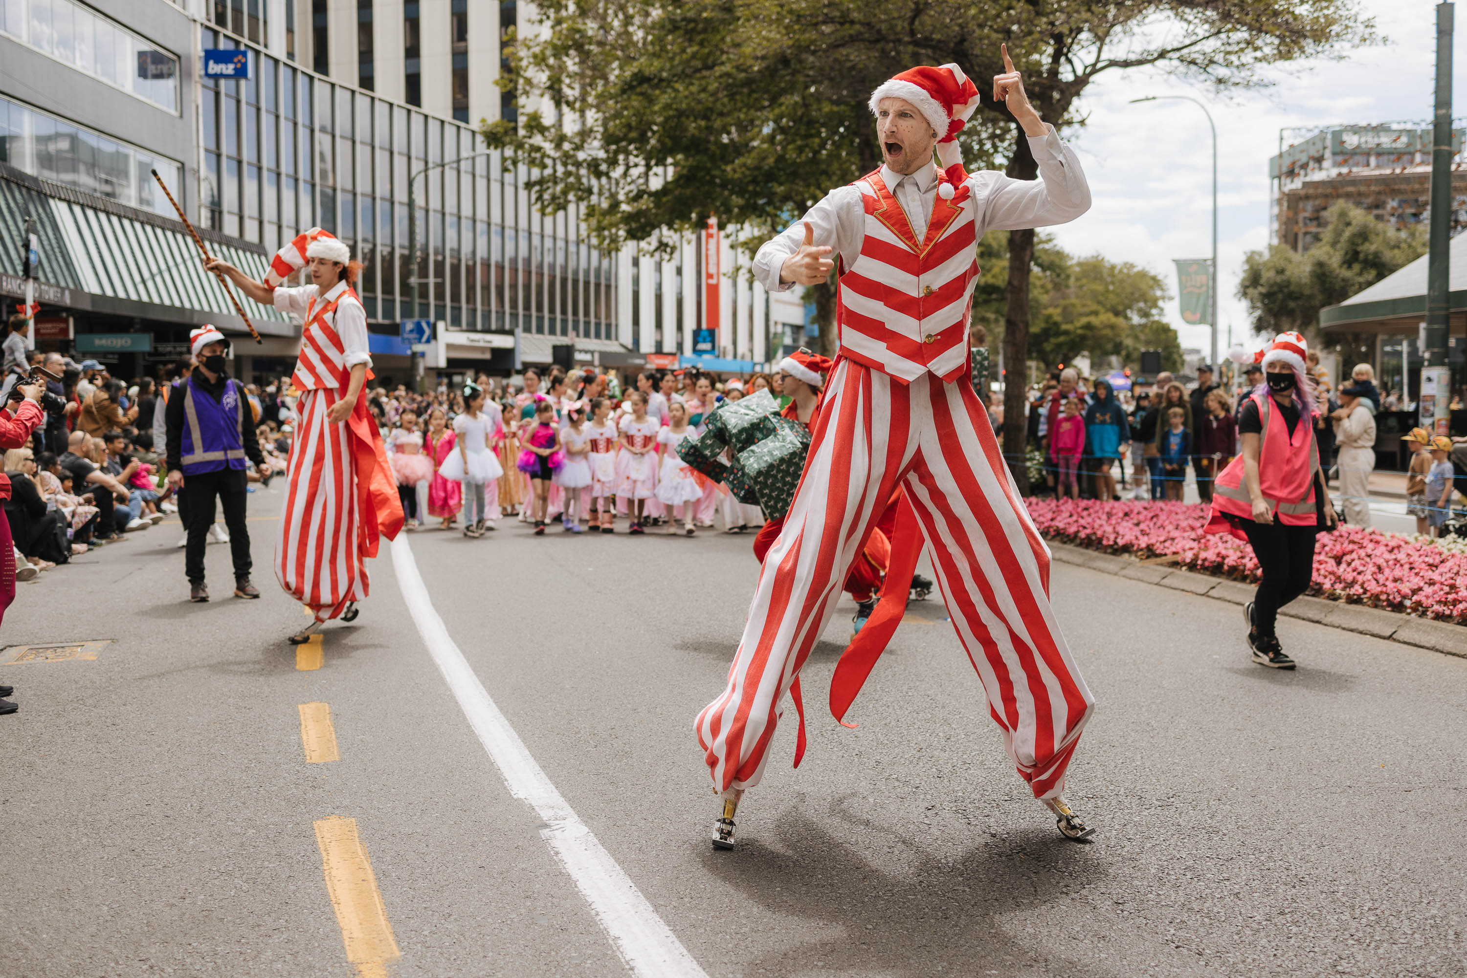

Wellington Museum, Cable Car Museum, City Gallery Te Whare Toi, Carter Observatory, Capital E, Nairn St Cottage, and the NZ Cricket Museum.
St James theatre, the Wellington Town Hall, Hannah Playhouse, the Opera House, Michael Fowler Centre, TSB Arena, Shed 6, and Tākina Convention and Exhibition Centre. Council is also the owner of the Te Whaea complex in Newtown, which houses the national schools of drama and dance Toi Whakaari, the New Zealand School of Dance, and is also utilised by multiple arts groups as a rehearsal and performance space, as well as the Warehouse performing arts venue, and the Circus hub.
Long-term Plan 2024-34 - Plans, policies and bylaws - Wellington City Council
Olsen & Whiteford. (24 September 2025). New Zealand’s most creative city in 2024. Infometrics.
A review of adopted Long-term Plans for comparator councils (Whangārei, Auckland, Hamilton, Tauranga, New Plymouth, Whanganui, Nelson, Christchurch, Dunedin and Queenstown Lakes) shows that all include operating expenditure for arts, culture or related creative activities, with most signalling stable or increasing investment over the life of their plans, thereby intensifying competition for audiences, funding and creative talent. None propose wholesale withdrawal from arts and culture services, despite significant fiscal constraint.

