Tauākī Tono Statement of Proposal | June 2024

Draft Alcohol Fees Bylaw 2024

1. He whakarāpopoto pārongo | Summary of information
This Statement of Proposal relates to a review of the Alcohol Fees Bylaw (the Bylaw) at Wellington City Council (the Council). The Bylaw enables the Council to set its own fees for alcohol licensing that differ from the national default fees.
The Bylaw was first introduced in October 2019 to ensure the Council could recover more of the costs of the licensing programme than the default fees allowed. The purpose of alcohol licensing is to maintain the health and safety of the public and minimise the negative impacts caused by excessive or inappropriate consumption of alcohol.
The 2019 Bylaw increased alcohol licence fees to meet a cost-recovery rate of 71%, with the remaining 29% of costs subsidised by general rates. The Bylaw was amended in July 2021 to increase cost-recovery to 85%, with proportionate fee increases for licensed premises in the high and very high-risk fee categories. This enabled the Council to recover the increased licensing costs and ensuring compliance of these higher risk licences.
Our review found that the Bylaw
- remains the appropriate mechanism under the Sale and Supply of Alcohol Act 2012 to meet cost-recovery
- has partly achieved its cost-recovery goals
- industry stakeholder feedback has expressed a desire for a more flexible fees framework that recognises compliant practices and is proportional to cost
- it is administratively burdensome to adjust fees to meet cost-recovery rates.

Summary of proposed Bylaw amendments
A marked-up version of the Bylaw follows this section and shows the amendments to the current Bylaw. The proposed amendments are summarised below.
Proposed change one: Future-proofing the Bylaw to support a sustainable cost-recovery model by:
- adding a new clause which allows alcohol licence fees to be set by Council resolution, as part of annual planning or long-term planning, which is consistent with other fee regimes at the Council. The fees payable will be updated in a schedule appended to the Bylaw
- specifying the cost-recovery rate in the Bylaw to provide certainty for future fee adjustments.
Proposed change two: Enable new fee components to make licensing fees more proportional to cost including:
- pre-application meetings – for Council officers to support new applicants to understand their licensing responsibilities and help them to complete their applications
- two-tier late application fee penalties – for special licence and licence renewal applications submitted past the deadline
  - between 11 and 20 days from the licence date
  - within 10 days of the licence date.
Proposed change three: Make minor technical amendments to the Bylaw to improve its clarity and readability, including:
- specifying the legislation that give effect to the Bylaw and its powers
- updating defined terms
- additional clauses to clarify the scope of the Bylaw
- explanatory notes to support the application of the Bylaw and its context.
The Council is seeking feedback on these proposals and the Alcohol Fees Bylaw.
Ngā rangi matua | Key dates:
22 March to 12 April 2024 | Early engagement was carried out with key stakeholders, through a survey with licensees.
6 June 2024 | Kōrau Mātinitini | Social, Cultural, and Economic Committee approves public consultation of the draft proposal for the Alcohol Fees Bylaw.
17 June to midday 22 July 2024 | Public consultation is open.
7 August 2024 | The Social, Cultural, and Economic Hearings Panel receives oral submissions.
22 August 2024 | The Council will provide a summary of submissions report, detailing the outcomes of formal consultation and its impact on the final proposal. This will include recommendations for the final Alcohol Fees Bylaw.
29 August 2024 | Kōrau Mātinitini | Social, Cultural, and Economic Committee considers amendments to the draft bylaw and decides whether to recommend to the Council to adopt the new Alcohol Fees Bylaw.
5 September 2024 | The Council decides whether to adopt the new Alcohol Fees Bylaw.
1 October 2024 | The Alcohol Fees Bylaw 2024, if adopted, comes into force.

2. Me pehea te whakarato i to urupare i runga i nga huringa e whakaarohia ana | How to provide your feedback on the proposed changes
Please let us know what you think about the review and proposed changes to the Alcohol Fees Bylaw. You can comment on any part of the Bylaw. Public consultation opens on 10 June and closes at midday, 15 July 2024.
To provide your feedback, you can:
- make a submission online at letstalk.wellington.govt.nz
- download a submission form from the website and email it to policy.submission@wcc.govt.nz
- fill in the submission form and send it to:
Freepost 2199
Alcohol Fees Bylaw Review
Policy Team
PO Box 2199
Wellington 6140
- drop off your submission form to Arapaki Service Centre, 12 Manners Street or any Council library.
- You can get physical copies of the submission form at Arapaki Service Centre and Council libraries. If you need more copies, please email policy.submission@wcc.govt.nz or phone the Council on 04 499 4444.
If you wish to make an oral submission to Councillors on 7 August 2024, please indicate this on your submission form and ensure you have included your contact details. We will contact you to arrange a time for you to speak. Information on the hearings process and what to expect can be found at wellington.govt.nz/your-council/meetings/speaking-at-meetings.

Ka pēhea te whakamahia o aku taipitopito whaiaro? | How will my personal details be used?
Submissions including your name and opinions on the draft Bylaw may be published online as part of the summary of submissions report. They are made available to elected members and the public. Contact details may be used by Council staff for administration of the consultation process. Council staff will have access to complete submissions for the purposes of analysing feedback.
Except for your name, personal details collected in the ‘your details’ section of the submission form will be redacted before publishing. Please note that you should not include any personal information in the open text fields of the form if you do not wish it to be made public.
For further details around privacy, please see our extended Privacy Statement on the Wellington City Council website. All information collected will be held by Wellington City Council in accordance with the Privacy Act 2020. You have a right to ask for a copy of any personal information we hold about you, and to ask for it to be corrected if you think it is wrong. Please contact us at policy.submission@wcc.govt.nz.

3. Takenga | Background
The Council has a role in regulating the sale and supply of alcohol by operating the local alcohol licensing programme in accordance with the Sale and Supply of Alcohol Act 2012 (the Act). This involves appointing the District Licensing Committee (DLC), which is the independent decision-making body for local licence applications. Selling or supplying alcohol without a licence is illegal. Alcohol licensing aims to protect public health and safety and reduce the harmful effects of excessive or inappropriate alcohol consumption.
Alcohol licensing fees are set by the Sale and Supply of Alcohol (Fees) Regulations 2013 (the Regulations) and the Alcohol Fees Bylaw (the Bylaw), under the authority of the Sale and Supply of Alcohol (Fee-setting Bylaws) Order 2013. Fees are intended to recover the costs of the licensing programme.

How do we decide who pays?
Section 103 of the Local Government Act 2002 requires councils to adopt a Revenue and Financing Policy to provide a basis for deciding how to fund their activities. Activities can be funded through various means, including a combination of the following:
- User charges can be set for services with benefit to an individual or entity and include, for example, fees for rent, permits, regulatory charges, and licences.
- General rates are used to fund services that provide benefit to the wider community, contributing to the social, economic, environmental, and cultural wellbeing of the community.
The Bylaw was first introduced in October 2019 to ensure the Council could recover more of the costs of the licensing programme than the default fees in the Regulations. The 2019 Bylaw increased alcohol licence fees to meet a cost-recovery rate of 71%, with the remaining 29% of costs subsidised by general rates.
Since July 2021, alcohol licensing fees at the Council are set to recover 85% of its costs through fees on a user-pays basis, reserving 15% to be funded by general rates. This general rate component is to recognise the public good in enabling natural justice, allowing community members to participate in the licensing process and raise objections to licence applications at District Licencing Committee hearings.

Costs to the Council across fee categories
In 2021 user fees were increased proportionately to charge a higher rate for high risk and very high risk-rated licensed premises, according to their prescribed fee category under the Regulations. This recognised the additional costs to Council for ensuring that these premises are safe and compliant through licensing.
The Council is restricted by legislation and must set fees by the fee categories in the Alcohol Fees Bylaw using the risk weighting criteria of the Regulations (clauses 4 to 6) for licensed premises. The fee categories are determined by the sum of scores that vary depending on:
- The type of premises (for example, a restaurant, bottle store or social club)
- The latest trading hour permitted for the licence
- Number of enforcement holdings against the premises in the last 18 months (breaches under section 288 of the Act).
These criteria and the fee category assessment in the Regulations are detailed in Appendix One.
The Bylaw sets higher fees for higher risk-rated licences, recognising that there are generally more activities required in the application process for higher risk-rated fee categories. This does not mean that all licensees across a fee category attract the same amount of scrutiny and therefore Council officer time on their applications.
Additional information on the breakdown of activities and costs to the Council in administering the licensing regime is detailed in Appendix Two.

Additional fee components
The Bylaw must set fees that follow the fee categories in the Regulations. However, we propose introducing fee components across all fee categories that aim to reward compliant, long-standing operators who submit timely and complete applications consistently. These will also aim to address industry feedback from 2019 and 2021 for alternative fee structures to make fees more proportionate to costs, and improvements to the application process.
These fee components are permitted under section 405(1) of the Act and clause 3(1) of the Sale and Supply of Alcohol (Fee-setting Bylaws) Order 2013 (the Order), the Alcohol Fees Bylaw can set fees payable to the Council for any matters that can be prescribed by regulations (criteria in section 402 of the Act).

4. Ngā kitenga arotakenga tōmua me ngā whakahoutanga ture ā-rohe e tāpaetia ana | Early review findings and proposed Bylaw amendments
The Bylaw is being reviewed as it is nearly five years from its first adoption in October 2019. Best practice at the Council requires all new bylaws to be reviewed in their first five years to make sure they are the most appropriate form for addressing the perceived problem.
The Council has almost increased the cost-recovery rate towards the 85% target. Each year, the Council reports the income and costs of the licensing programme to the Alcohol Regulatory and Licensing Authority (ARLA), and the cost-recovery rates of the last five financial years are as follows:
Financial year | 2022/23 | 2021/22 | 2020/21 | 2019/20 | 2018/19
Cost-recovery rate for alcohol licensing | 62%* | 89%** | 88%** | 64%* | 65%
Cost recovery target | 85% | 85% | 71% | 71% | No target set
* $1 annual fees were in place during this period.
** Some of the fees received in this period were due to backlogs from the previous financial year.
When the Bylaw was introduced in October 2019, the initial aim was to increase cost-recovery to 71%, then to 85% in July 2021. As businesses faced the impact of the Covid-19 pandemic, the Council provided temporary fee relief during the last quarter of the 2019/20 financial year (April to June 2020) and the 2022/23 financial year, through $1 annual fees for alcohol licences to assist with cost-of-living and inflationary pressures faced by businesses. This fee relief impacted the revenue that the Council received from alcohol licence fees and therefore the annual cost-recovery rates were below their respective targets.
Between 2020 and 2022, fee payment backlogs from previous years lifted the cost-recovery rates.
- In 2020/21, the 88% cost-recovery was well above the 71% target rate.
- In 2021/22 the 89% cost-recovery was slightly above the target rate of 85%.
It is unclear if the current fees will continue to be sustainable for cost-recovery because of these irregular periods. Currently alcohol licence fees can only be changed by amending the Bylaw which is administratively burdensome.

Flexibility of the alcohol fees framework
Submitter feedback from the 2019 and 2021 consultations on the previous Alcohol Fees Bylaw and additional industry engagement carried out in 2019 indicated that licensees wanted a more flexible framework for determining fees that took into account each licence on its own merit (eg being in the suburbs, being primarily food-focused, or making consistently timely applications and payments with a good track record). The prescribed risk fee categories given by the Regulations were not always viewed as reflective of the alcohol-harm risk of individual licences.
This view is shared by some licensees in the 2024 licensee early engagement survey, with some commenting that they believed their fee category (risk rating) did not match their specific licence because it did not take into account the size of their venue or amount of alcohol sales.

5. He aha tāu e tāpae nei kia whakahoua, ā, he aha ai? | What are you proposing to amend and why?

Proposed change one: Enable the Council to change alcohol licence fees by resolution and state the cost-recovery rate in the Bylaw for transparency.
The Council proposes to make the Bylaw more flexible so that in future the fees can be adjusted by Council resolution to meet the target cost-recovery rate without changing the Bylaw each time (a review can take between 12-18 months). This approach aligns with other fees and charges at the Council which can be set through the annual planning and long-term plan process, such as waste collection fees set by the Collection and Transportation of Waste Bylaw 2014. This will also support the Council’s efforts to ensure that future fees will be proportionate to any changes in the costs of the licensing operation.
We propose that the agreed cost-recovery rate be stated in the Bylaw, to provide more certainty that fees will be adjusted to meet this target. We recognise that this aim will not always be possible due to factors such as varying cost estimates or future fee relief.
These amendments aim to make the Bylaw more fit-for-purpose and future-proofed.

Proposed change two: Enable new fee components to make licensing fees more proportional to cost.
These fee components have previously been workshopped with industry stakeholders in 2020 and include:
Pre-application meetings
We propose that pre-application meetings be introduced for all new applicants to meet with an alcohol licence inspector prior to submitting an application. This helps new applicants understand their licensing responsibilities and supports them to submit the correct information in their application. This meeting can be waived for new applicants who have proven licensing experience.
In the 2024 licensee early engagement survey, 43% of first-time applicants disagreed or strongly disagreed with the statement “I find it easy to understand and follow the licence application process”. This compared to 15% of all licensees who disagreed or strongly disagreed.
The same survey found 64% of first-time applicants agreed or strongly agreed with the statement “A pre-application meeting with Council officers will help me to complete a licence application and attach the correct accompanying documents”, compared to 49% of all licensees.
The initial meeting will be an hour long and will be free of charge. Further meetings will be charged at $100 per hour for the inspector’s time.
We propose that we waive this charge in the first year that pre-application meetings are implemented for all new applicants and the new fee would be charged from 1 October 2025.
Late application fee penalty for special licences and licence renewals
The statutory timeframe for alcohol licence applications to be submitted is more than 20 days from the date of the event or when the licence takes effect.
While the majority (88%) of licensees submit their applications on time, there are around 12% that submit late. These late applications require an additional waiver from the DLC and for Council officers (inspectors, administration officers, DLC members and DLC secretary) to prioritise these applications over other applications that were submitted on time.
In the 2024 licensee early engagement survey, 57% of respondents said that they would support charging for the officer time spent on processing late special licence applications and licence renewals. 36% did not support this, and 7% said it would depend on circumstances, for example, if lateness was due to exceptional circumstances or due to Council officers’ responsiveness.
We propose a two-tier late fee penalty for special licence applications and licence renewals, as they usually have a set date that they need approval by.
- For applications submitted between 11 and 20 days before the licence start date, the penalty fee will be 10% of the application fee.
- For applications submitted within 10 days of the licence start date, the penalty fee will be 20% of the application fee.

Determination of whether the Bylaw is appropriate
Without providing for these fee components in the Bylaw, the Council does not have the power to set fees for the same matters, as the default fees in the Regulations apply. This would not achieve a more flexible fee structure that seeks to be more proportional to cost, which is desired by stakeholders and would be more equitable across prescribed licence categories. We consider that this Bylaw is the most appropriate way of addressing the perceived problem, to provide a robust and fair cost-recovery regime that promotes public safety, which is appropriately funded through a fair proportion of user charges and general rates.
The Council does not believe the proposal to provide for fee components in the Bylaw gives rise to any human rights implications under the New Zealand Bill of Rights Act 1990, and it does not unjustifiably restrict the rights of persons in a free and democratic society.

Marked up version – compare with current Alcohol Fees Bylaw
Wellington Alcohol Fees Bylaw 2024
Adopted by Council resolution [insert date].
Effective 1 October 2024.
This bylaw is made under pursuant to section 405 of the Sale and Supply of Alcohol Act 2012 and the Sale and Supply of Alcohol (Fees) Regulations 2013, and under the authority of the Sale and Supply of Alcohol (Fee-setting Bylaws) Order 2013. This bylaw comes into force on 1 July 2021.
Contents
1. Purpose
2. Interpretation
3. Fees
1. Title
1.1 This bylaw is the Wellington Alcohol Fees Bylaw 2024.
2. Commencement
2.1 This bylaw comes into force on 1 October 2024.
3. Application
3.1 This bylaw applies to the Wellington City District.
14. Purpose
4.1 The purpose of this bylaw is to set the Council’s fees for any matters for which a fees payable to territorial authorities are prescribed in the Sale and Supply of Alcohol (Fees) Regulations 2013, and additional fees payable relating to functions exercised by territorial authorities under the Sale and Supply of Alcohol Act 2012.
25. Interpretation
25.1 Unless the context otherwise requires, words and phrases in the Sale and Supply of Alcohol Act 2012 and the Sale and Supply of Alcohol (Fees) Regulations 2013 have the same meaning in this bylaw.
Act means the Sale and Supply of Alcohol Act 2012.
Council means the Wellington City Council.
Regulations means the Sale and Supply of Alcohol (Fees) Regulations 2013.
25.2 Any explanatory notes and attachments are for information purposes, do not form part of this bylaw, and may be made, amended and revoked without formality.
2.3 The Interpretations Act 1999 applies to this bylaw
5.3 The Legislation Act 2019 applies to this bylaw.
5.4 All fees include GST where applicable.
6. Fees Payable
6.1 The fees payable to Council are set out in Schedule 1 of this bylaw.
6.2 Fees will be set by Council resolution to meet a cost-recovery rate of 85%, whereby 85% of the total costs to Council relating to licensing and other matters under the Act are recovered in the fees payable.
6.3 Fees payable for on-licence, off-licence, or club licence premises in this bylaw must follow the fee category framework consistent with clause 7(2) of the Regulations.
6.4 Fees may be set for additional functions exercised by Council under the Act including:
6.4.1 Pre-application meetings between Council officers and an applicant
6.4.2 Late fee penalties for special licence applications and licence renewals.
Any such fees will be set by Council resolution and are set out in Schedule 1 of this bylaw.

Explanatory Note:
Application and annual fees for premises must be set within the fee categories provided in clauses 4 to 6 in the Regulations. The new fees set in Schedule 1 of this bylaw will replace the fees payable, under clause 7 of the Regulations.
Fees for manager’s certificates are set in the Regulations and as provided in clause 11(2)(a) must be the same as the fees charged by every other territorial authority.
Pre-application meetings are mandatory for new applicants but can be waived if they demonstrate prior licensing experience.

Related legislation:
Statutory Instrument | Scope and purpose
Sale and Supply of Alcohol Act 2012 | The purpose of this Act is to provide a legal framework for the sale, supply and consumption of alcohol and the associated systems of control and licensing.
Sale and Supply of Alcohol (Fees) Regulations 2013 | Provides regulations for the fees that can be charged and how fees are established for alcohol licensing related functions of territorial authorities.
Sale and Supply of Alcohol (Fee-setting Bylaws) Order 2013 | Every territorial authority is authorised to prescribe, by bylaw, fees for any matter for which a fee payable to territorial authorities can be prescribed by regulations made under the Sale and Supply of Alcohol Act 2012.

Schedule 1 – Fees payable prescribed by Council resolution as at 1 October 2024
3. Fees
Fees apply from 1 July 2021.
Application fees for premises
Risk Fees Category (based on cost/risk rating in the Regulations):
Very Low - $486.00
Low - $805.00
Medium - $1078.00
High - $2351.00
Very High - $3594.00
Annual fees for premises
Risk Fees Category (based on cost/risk rating in the Regulations):
Very Low - $213.00
Low - $516.00
Medium - $835.00
High - $2366.00
Very High - $3898.00
Special licence fees
Special Licence Class:
Class 1 - $759.00
Class 2 - $273.00
Class 3 - $83.00
Other licence fees
Temporary Authority - $392.00
Temporary Licence - $392.00
Additional fee components
Pre-application meeting - $100 per hour (first meeting will not be charged). Charges will take effect from 1 October 2025.
Late application fee penalties for special licence applications and licence renewals:
Between 11 to 20 days from the licence start date – 10% of the application fee
Within 10 days from the licence start date – 20% of the application fee.

Alcohol Fees Bylaw 2024 – without tracked changes
Wellington City Council Alcohol Fees Bylaw 2024
Adopted by Council resolution [insert date].
Effective 1 October 2024.
This bylaw is made pursuant to section 405 of the Sale and Supply of Alcohol Act 2012 and the Sale and Supply of Alcohol (Fees) Regulations 2013 and under the authority of the Sale and Supply of Alcohol (Fee-setting Bylaws) Order 2013.
1. Title
1.1 This bylaw is the Wellington Alcohol Fees Bylaw 2024.
2. Commencement
2.1 This bylaw comes into force on 1 October 2024.
3. Application
3.1 This bylaw applies to the Wellington City District.
4. Purpose
4.1 The purpose of this bylaw is to set Council’s fees for matters which fees payable to territorial authorities are prescribed in the Sale and Supply of Alcohol (Fees) Regulations 2013, and additional fees payable relating to functions exercised by territorial authorities under the Sale and Supply of Alcohol Act 2012.
5. Interpretation
5.1 Unless the context otherwise requires, words and phrases in the Sale and Supply of Alcohol Act 2012 and the Sale and Supply of Alcohol (Fees) Regulations 2013 have the same meaning in this bylaw.
Act means the Sale and Supply of Alcohol Act 2012.
Council means the Wellington City Council.
Regulations means the Sale and Supply of Alcohol (Fees) Regulations 2013.
5.2 Any explanatory notes and attachments are for information purposes, do not form part of this bylaw, and may be made, amended and revoked without formality.
5.3 The Legislation Act 2019 applies to this bylaw.
5.4 All fees include GST where applicable.
6. Fees Payable
6.1 The fees payable to Council are set out in Schedule 1 of this bylaw.
6.2 Fees will be set by Council resolution to meet a cost-recovery rate of 85%, whereby 85% of the total costs to Council relating to licensing and other matters under the Act are recovered in the fees payable.
6.3 Fees payable for on-licence, off-licence, or club licence premises in this bylaw must follow the fee category framework consistent with clause 7(2) of the Regulations.
6.4 Fees may be set for additional functions exercised by Council under the Act including:
6.4.1 Pre-application meetings between officers and an applicant
6.4.2 Late fee penalties for special licence applications and licence renewals.
Any such fees will be set by Council resolution and are set out in Schedule 1 of this bylaw.
Explanatory Note:
Application and annual fees for premises must be set within the fee categories provided in clauses 4 to 6 in the Regulations. The new fees set in Schedule 1 of this bylaw will replace the fees payable, under clause 7 of the Regulations.
Fees for manager’s certificates are set in the Regulations and as provided in clause 11(2)(a) must be the same as the fees charged by every other territorial authority.
Pre-application meetings are mandatory for new applicants but can be waived if they demonstrate prior licensing experience.

Related legislation:
Statutory Instrument | Scope and purpose
Sale and Supply of Alcohol Act 2012 | The purpose of this Act is to provide a legal framework for the sale, supply and consumption of alcohol and the associated systems of control and licensing.
Sale and Supply of Alcohol (Fees) Regulations 2013 | Provides regulations for the fees that can be charged and how fees are established for alcohol licensing related functions of territorial authorities.
Sale and Supply of Alcohol (Fee-setting Bylaws) Order 2013 | Every territorial authority is authorised to prescribe, by bylaw, fees for any matter for which a fee payable to territorial authorities can be prescribed by regulations made under the Sale and Supply of Alcohol Act 2012.

Schedule 1 – Fees payable prescribed by Council resolution as at 1 October 2024
Application fees for premises
Fees Category (based on cost/risk rating in the Regulations):
Very Low - $486.00
Low - $805.00
Medium - $1078.00
High - $2351.00
Very High - $3594.00

Annual fees for premises
Fees Category (based on cost/risk rating in the Regulations):
Very Low - $213.00
Low - $516.00
Medium - $835.00
High - $2366.00
Very High - $3898.00

Special licence fees
Special Licence Class:
Class 1 - $759.00
Class 2 - $273.00
Class 3 - $83.00

Other licence fees
Temporary Authority - $392.00
Temporary Licence - $392.00

Additional fee components
Pre-application meeting - $100 per hour (first meeting will not be charged). Charges will take effect from 1 October 2025.
Late application fee penalties for special licence applications and licence renewals:
Between 11 to 20 days from the licence start date – 10% of the application fee
Within 10 days of the licence start date – 20% of the application fee.

Appendix One – Fee category risk weighting criteria in the Sale and Supply of Alcohol (Fees) Regulations 2013
The following summarises the criteria in clauses 4 to 6 of the Regulations, and their weighting scores which sum to provide the cost/risk ratings and therefore fee categories for licensed premises.

Type of premises
Licence held or sought | Type of premises | Weighting
On- Licence | Class 1 restaurant, night club, tavern, adult premises | 15
On- Licence | Class 2 restaurant, hotel, function centre | 10
On- Licence | Class 3 restaurant, other premises not otherwise specified | 5
On- Licence | BYO restaurant, theatres, cinemas, winery cellar doors | 2
Off- Licence | Supermarket, grocery store, bottle store | 15
Off- Licence | Hotel, Tavern | 10
Off- Licence | Class 1, 2, or 3 club, remote sale premises, premises not otherwise specified | 5
Off- Licence | Winery cellar doors | 2
Club Licence | Class 1 Club | 10
Club Licence | Class 2 Club | 5
Club Licence | Class 3 Club | 2

Premise type definitions:
Note it is on the opinion of the territorial authority if the definitions are met for these premise types, aside from the member number limit for club licences.
Class 1 restaurants – restaurants with a significant separate bar area which operate that bar at least one night a week in the manner of a tavern.
Class 2 restaurants – restaurants that have a separate bar and does not operate that area in the manner of a tavern at any time.
Class 3 restaurants – restaurants that only serve alcohol to the table and do not have a separate bar area.
Class 1 clubs – clubs which have at least 1,000 members of purchase age which operate any part of the premises in the nature of a tavern at any time.
Class 2 clubs – clubs which are not class 1 or class 2 clubs.
Class 3 clubs – clubs which have fewer than 250 members of purchase age which operate a bar for no more than 40 hours each week.

Latest time of operation allowed by licence
Type of Premises | Latest trading time allowed | Weighting
Premises for which an on-licence is held or sought | 2am or earlier | 0
Premises for which an on-licence is held or sought | Between 2:01 and 3 am | 3
Premises for which an on-licence is held or sought | Any time after 3 am | 5
Premises for which an off-licence is held or sought (other than remote sales premises) | 10 pm or earlier | 0
 | Any time after 10 pm | 3
Remote sales premises | Not applicable | 0

Number of enforcement holdings in the last 18 months
Enforcement holding has the same meaning as a "Holding" under section 288 of the Act, or a previous offence for which a holding may have been issued if the offence had occurred before 18 December 2013.

Number of enforcement holdings in last 18 months (applies to all types of premises) | Weighting
None | 0
1 | 10
2 or more | 20

Cost/risk rating and fee category
Adding up the total weighting score will give the prescribed cost/risk rating and fee category for the premises.

Total weighting | Cost/risk rating and fee category
0-2 | Very low
3-5 | Low
6-15 | Medium
16-25 | High
26 plus | Very High

Appendix Two – Summary of the application process and breakdown of costs across the licensing programme

Licence application process
The following diagram shows the steps required for Council officers to process each licence application. Applications cannot progress past the first step if they are not complete with all of the required information. Licences of greater risk require more officer time in these steps or additional actions to ensure they meet their regulatory obligations.
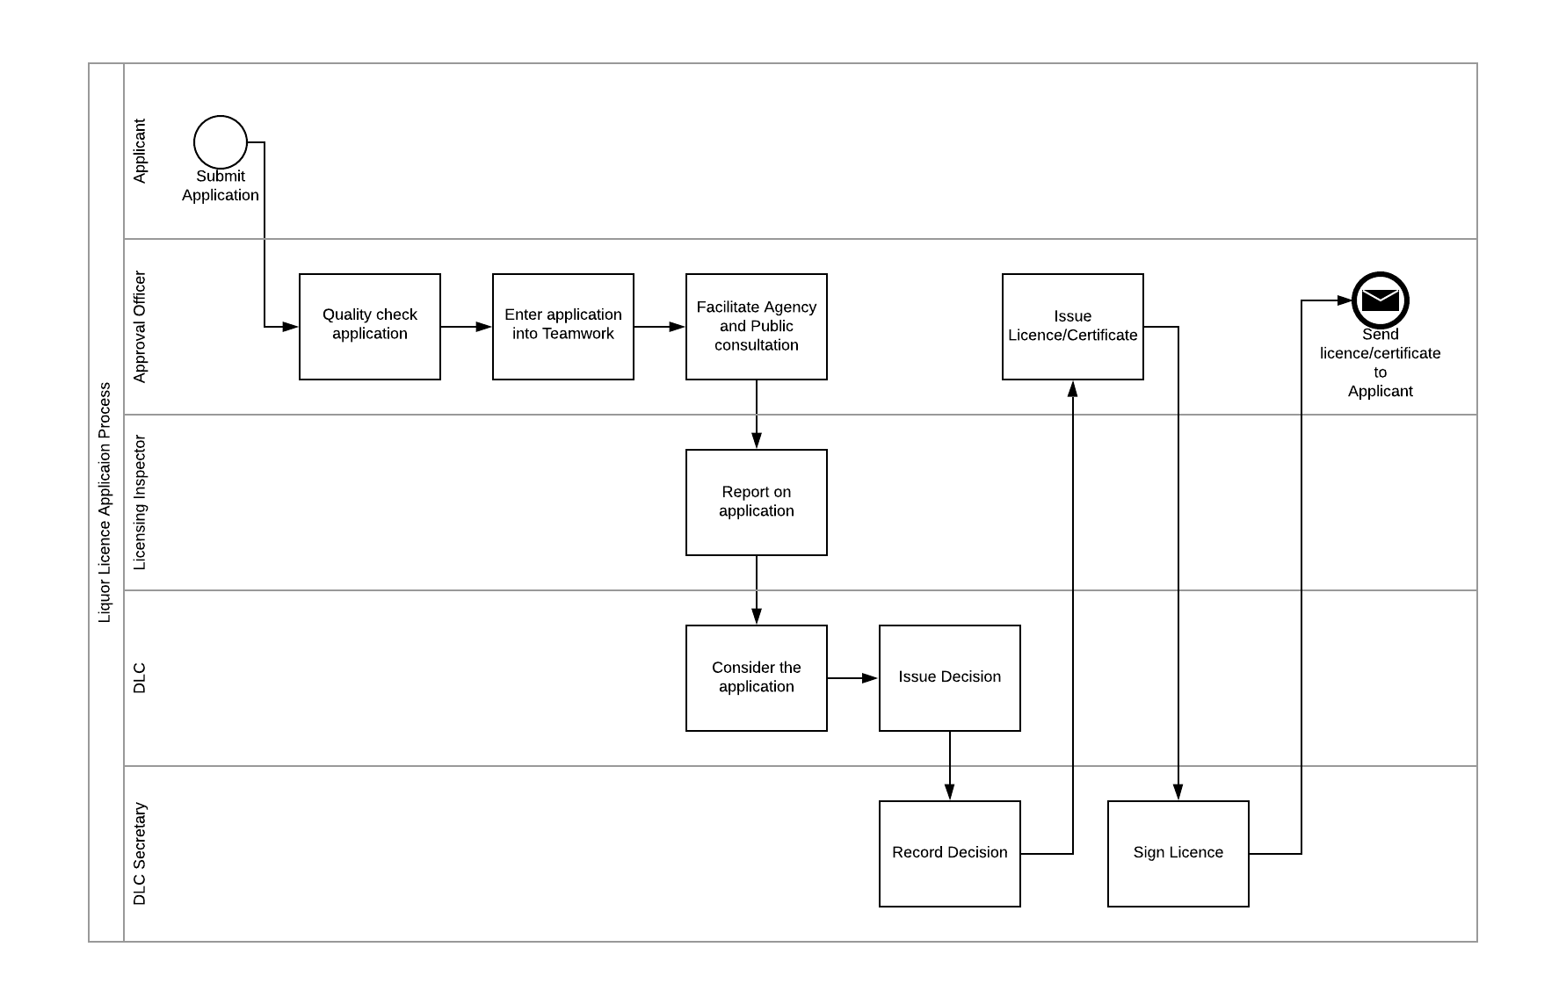
Note that this diagram does not show the steps involved if the licence has been objected to and requires a hearing with the DLC.

The following diagram shows the steps involved if there is public or agency objection to a licence application, and therefore a DLC hearing is held.

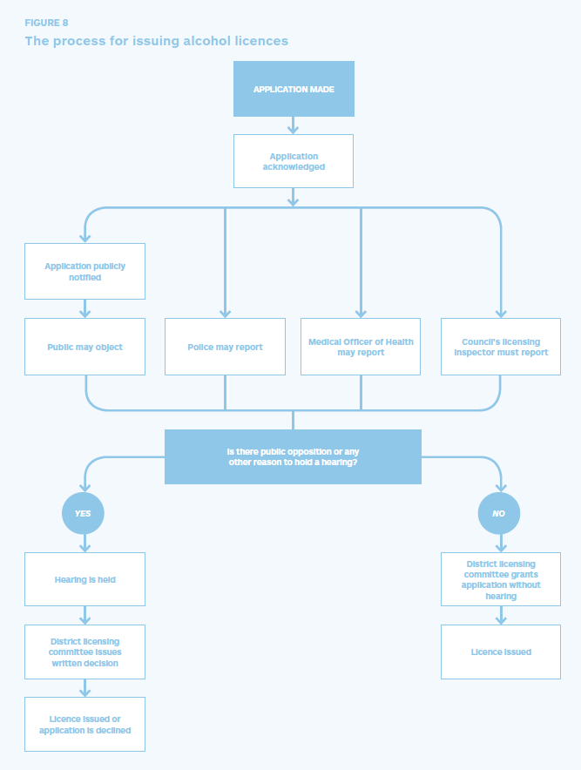
Source: page 13, “Applying for a licence to sell or supply alcohol, a guide to applications and hearings” – Health Promotion Agency 2015

Cost-recovery of the licensing programme
There are various activities that the Council needs to undertake when scrutinising an application, which are more significant for higher-risk licence applications and are less prevalent in the lower risk licence categories.
Cost-recovery recognises that these activities, while not charged out on an individual basis for licence applications in the interests of natural justice, tend to attract these additional costs with higher-risk licences:
- Compliance activities including site visits and monitoring by inspectors
  - Peak time inspections are required for higher-risk premises which are outside of inspectors’ business hours
- District Licensing Committee (DLC) costs
- Controlled purchase operations
- Gradual Response Model (GRM) meetings
- Responding to complaints
- Costs associated with hearings and attendance:
  - Legal costs – in-house advice within Council and legal representation at DLC hearings and Alcohol Regulatory and Licensing Authority (ARLA) hearings
  - Personnel time for attendees including DLC members, inspector, or DLC secretary
  - Venue costs for DLC hearings
  - DLC hearing transcripts if the decision is appealed to ARLA.
We recognise that the nature of operating higher-risk licences attracts additional costs to Council for the licensing process, such as later closing times, the resultant increase in alcohol-related harm and therefore compliance costs. For fairness, fees are set to be proportional to the total costs associated with different licence risk groups which are set by legislation.

Alcohol licensing in Wellington City
As of 30 June 2023, in Wellington there were:
- 511 on-licences
- 106 off-licences
- 49 club licences.
In the 2022/23 year, there were:
- 243 on/off/club licences renewals
- 775 managers certificate renewals
- 641 managers certificates issued.
For April 2024, the numbers of licences held in Wellington under the following fee categories (risk ratings) were:
- Very low – 48
- Low – 235
- Medium – 319
- High – 99
- Very high – 1.

Note: these are indicative dates only and may be subject to change depending on Committee schedule and the number of submissions received during the consultation process.
Section 402(1)(b) of the Act intends for fees regulations and fee-setting bylaws to do anything reasonably necessary to ensure that, so far as is practicable, the total costs to the territorial authority are recovered out of the fees paid to it under the Act.
Bylaws made under the Local Government Act 2002, or the Maritime Transport Act 1994 legally must be reviewed within five years from when they are made.

