The Occupier TR41-26
McMillan Court
Newlands
Wellington 6037

Kia ora,

We would like to inform you about a proposed change in your neighbourhood.

Proposal:

Reference | - TR41-26 McMillan Court, Newlands - P10 Time Limited Parking
Location – where we propose to make the change | McMillan Court, Newlands Parking Area
What we’d like to do | - Convert the two existing P120 parking spaces outside the public toilets to two P10 parking spaces.
Why we are proposing the change | - Council has received a request from a member of the public to reduce the time limit for parking outside the public toilets within the McMillan Court parking area, as the current two-hour restriction is not considered effective at this location.  - Additionally, a local Councillor has requested Council officers to investigate this change.  - Council officers have agreed to amend the restriction by converting the two existing P120 spaces to a more suitable P10 restriction to encourage higher turnover.  - The reduction in longer-stay parking is not expected to have a significant impact, as there are 25 unrestricted parking spaces available on the opposite side of McMillan Court, closer to the Community Centre.
Impact | Improvements  - Improves the use for the public toilets  - Improves parking availability  Net Parking Impact  - Converting of two P120 parking spaces to two P10 parking spaces  Pedestrian impact  - No Change
Other options considered | Option 1:  - Extending the time limit for these two spaces is an option; however, this is not preferred, as the intention is for them to be used primarily for access to the public toilets or for short visits to nearby businesses.
How this relates to the parking policy | - Support safe movement – facilitate the safe and efficient movement of people and goods by focusing on people moving along transport corridors rather than people parking or storing stationary vehicles.  - Support city place-making, amenity and safety – ensure on-street parking design and placement supports overall city amenity, safety, community building, heritage, creative arts, good urban design outcomes and attractive streetscapes.
Additional Information | - An electronic copy of the report will be available on the Council’s website from 9.00am March 9 2026 at https://www.letstalk.wellington.govt.nz/
Privacy | - Your privacy is important to us. Please DO NOT add specific personal details to your feedback (i.e.: full name, address, etc)  - What we do with your personal information:  All submissions (including your first name, but not contact details) are provided in their entirety to elected members and made available to the public on our website and at our office. Personal information (including contact details) will also be used for the administration of the consultation process including informing you of the outcome of the consultation. All information collected will be held by Wellington City Council, 113 The Terrace, Wellington, with submitters having the right to access and correct personal information.  - For more information regarding our Privacy Statement please check our webpage: Privacy statement - Wellington City Council.
Feedback | - If you would like to provide us with specific feedback, which will be added to the Traffic Resolution following consultation and made public in full, you can do so by filling out an online submission form, downloading a printable submission form on https://www.letstalk.wellington.govt.nz/ or emailing us at trfeedback@wcc.govt.nz.  Please note if you are giving feedback the consultation period opens at 9.00 am March 9 2026 and finishes at 5.00 pm March 23 2026.
Next Steps | - Feedback collated by 24 March 2026.  - The proposal will go to the Te Takere|Regulatory Processes Committee meeting on 6 May 2026.  - If approved, the proposal will be installed within the following six months.

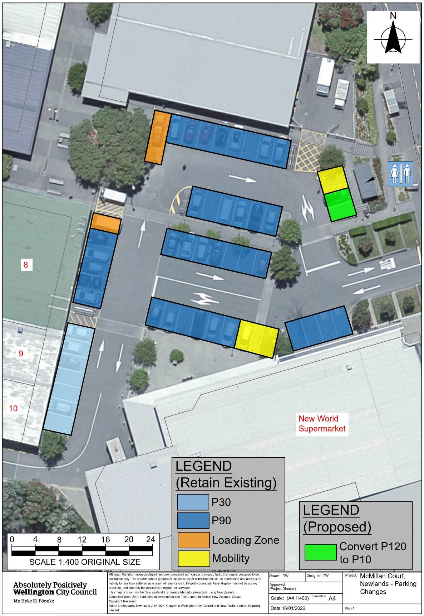
Traffic Resolution Plan: TR41-26 McMillan Court, Newlands - P10 Time Limited Parking

Legal Description:

Delete from Schedule A (Time Limited) of the Traffic Restrictions Schedule

Column One | Column Two | Column Three
McMillan Court | P120, Monday to Sunday 8:00am – 6:00pm. | Refer to the attached plan (Area Highlighted in Green)

Add to Schedule A (Time Limited) of the Traffic Restrictions Schedule

Column One | Column Two | Column Three
McMillan Court | P10  Monday to Sunday 8:00am – 6:00pm. | Refer to the attached plan (Area Highlighted in Green)

Prepared By: | Tommy Wilson | (Transport Engineering Assistant)
Approved By: | Kate Gourdie | (Team Leader Traffic & Resolutions)
Approved Date: | 13/02/2026

