Kia ora,

This leaflet is to let you know about a change we are proposing to make in your neighbourhood.

Proposal:

Reference | - TR120-25 Te Ngākau Precinct Street Scape – Wakefield Street
Location – where we propose to make the change | Wakefield Street between Victoria Street and Cuba Street
What we’d like to do | - Build out the kerb line 120 metres on northern side and 139 metres on southern side.  - Widen the footpath on the northern side of the road by 3 metres  - Widen the footpath on the southern side of the road by 2.7 metres and provide 2.2 metres wide parking at footpath level.  - Eastbound and westbound traffic lanes to become 3 metres wide  - Install nine metered car parking bays on the southern side of the road, at footpath level.  - Install 6 metres of motorcycle parking on the southern side of the road, at footpath level.  - Install two P10 Pick up/Drop-off parking bays on the southern side of the road, at footpath level.  - Install two metered mobility parking bays on the southern side of the road, at footpath level.  - Install one P10 Loading Bay on the southern side of the road, at footpath level.  - Install a 30 metre Tour Bus bay on the northern side of the road, at footpath level.  - Install 37 metres, 27 metres, 19 metres, 11 metres and 6.8 metres of No Stopping Line At All Times on northern side of the road.  - Install 11 metres, 4 metres, 4 metres and 9 metres of No Stopping Line At All Times on southern side of the road.  - Remove existing zebra crossing and refuge islands.  - Install new give way controlled raised zebra pedestrian crossing.
Why we are proposing the change. | The key drivers for these changes are as follows:  - To accommodate the anticipated increase in pedestrian traffic to and through the area, particularly with the opening of key civic facilities.  - To support high peak pedestrian flows during events, with a focus on enhancing pedestrian safety through measures such as footpath widening.  - To enhance the street’s place value and create a more welcoming and attractive entrance to the Te Ngākau precinct and the Town Hall.  - To provide improved pick-up, drop-off and accessibility facilities to ensure equitable access to the Te Ngākau precinct for all users.
Impact | - Improves safety and accessibility for vehicles, pedestrians and tour buses.  - Total parking provision:  - Nine metered, time varied car parking bays  - 6 metres of motorcycle parking at all times  - Two P10 pick up/drop-off car parking bays  - Two metered, time varied mobility parking bays  - One P10 loading bay  - One tour bus bay  - Net parking impact:  - removal of two metered, time varied car parking bays  - removal of 0.6 metres of motorbike parking at all times  - removal of Roam car share at all times parking bay  - addition of two metered, time varies mobility parking bays  - addition of one P10 loading bay  - addition of one tour bus bay  - Pedestrian impact – Positive. The relocated giveaway-controlled pedestrian crossing, along with the widened footpath, would enhance accessibility and visibility when crossing Wakefield Street to and from Te Ngākau, thereby improving safety.
Other options considered | Option 1:  - Raised pedestrian crossing more centralized along Wakefield Street.  - 2.8 metre wide lanes in both directions.  - Northern footpath widened by 3.2 metres.  - Southern footpath widened by 3.1 metres.  - Three P10 parking bays  - Loading zone on the western side of the raised pedestrian crossing.  This option was reviewed and had the following challenges/issues:  - The 2.8 metre wide lanes were too narrow for the tour bus tracking.  - As a result, the proposed widening of the footpaths was reduced to allow for wider lanes.  - The RSP was not positioned where the maximum pedestrian flows would be experienced.  Option 2:  - Same as the proposed design but with only one mobility parking bay on the eastern side of the zebra crossing  This option was reviewed and had the following challenges/issues:  - A buffer in the parking bays was required to allow access to a fire hydrant. This buffer provided the opportunity to include an additional mobility park.
How this relates to the parking policy | - Support shift in type of transport used – facilitate a shift to using active (eg, walking and cycling) and public transport to move more people driving fewer vehicles.  - Support city place-making, amenity and safety – ensure on-street parking design and placement supports overall city amenity, safety, community building, heritage, creative arts, good urban design outcomes and attractive streetscapes.
Additional Information | - Average daily traffic count:  - Wakefield Street: 4179  - Annual parking revenue impact - $24,383.08 (Estimated average annual revenue loss)  - To view the legal description for this Traffic Resolution, an electronic copy of the report will be available on the Council’s website from 9.00am Friday the 11 July 2025 at https://www.letstalk.wellington.govt.nz/
Privacy | - Your privacy is important to us. Please DO NOT add specific personal details to your feedback (i.e.: full name, address, etc)  - What we do with your personal information:  All submissions (including your first name, but not contact details) are provided in their entirety to elected members and made available to the public on our website and at our office. Personal information (including contact details) will also be used for the administration of the consultation process including informing you of the outcome of the consultation. All information collected will be held by Wellington City Council, 113 The Terrace, Wellington, with submitters having the right to access and correct personal information.  - For more information regarding our Privacy Statement please check our webpage: Privacy statement - Wellington City Council.
Feedback | - If you would like to provide us with specific feedback, which will be added to the Traffic Resolution following consultation and made public in full, you can do so by filling out an online submission form, downloading a printable submission form on https://www.letstalk.wellington.govt.nz/ or emailing us at trfeedback@wcc.govt.nz.  Please note if you are giving feedback the consultation period opens at 9.00 am Friday the 11 July 2025 and finishes at 5.00 pm Friday the 25 July 2025.
Next Steps | - Feedback collated by Monday the 28 July 2025.  - The proposal will go to the Koata Hātepe|Regulatory Processes Committee meeting on Thursday the 28 August 2025.  - If approved, the proposal will be installed within the following six months.

Traffic Resolution Plan: TR120-25 Te Ngākau Precinct Street Scape – Wakefield Street
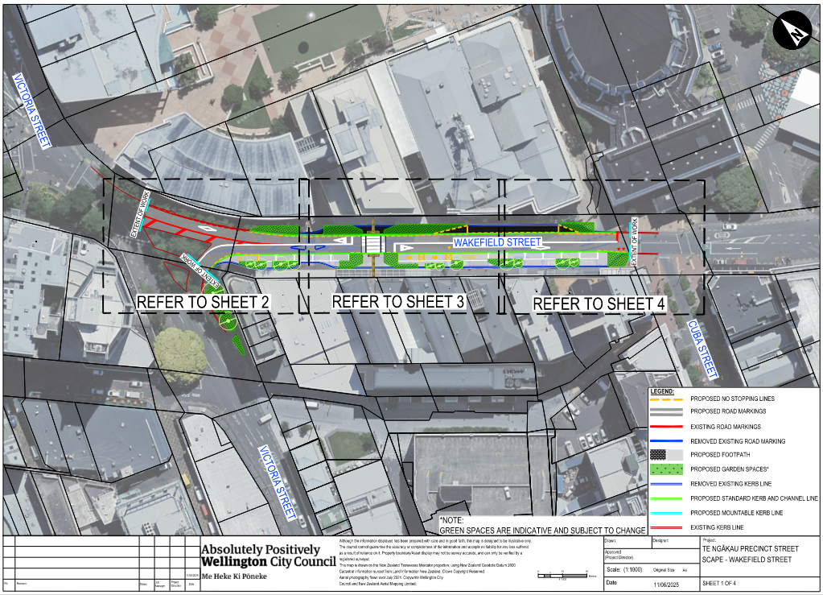
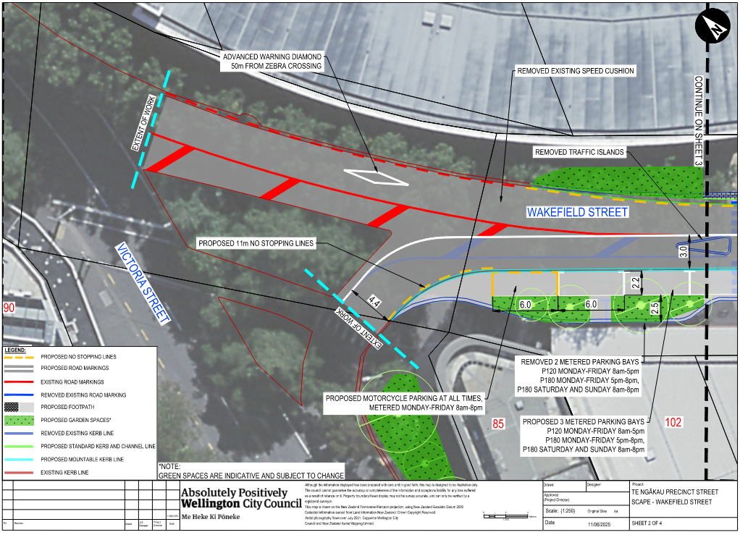
Traffic Resolution Plan: TR120-25 Te Ngākau Precinct Street Scape – Wakefield Street
Traffic Resolution Plan: TR120-25 Te Ngākau Precinct Street Scape – Wakefield Street
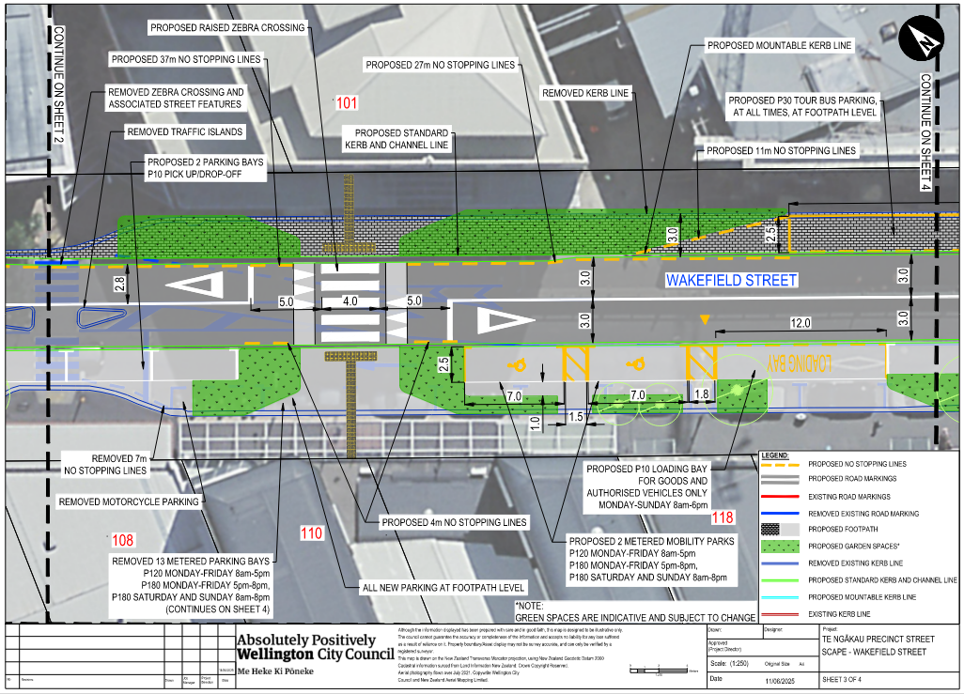
Traffic Resolution Plan: TR120-25 Te Ngākau Precinct Street Scape – Wakefield Street
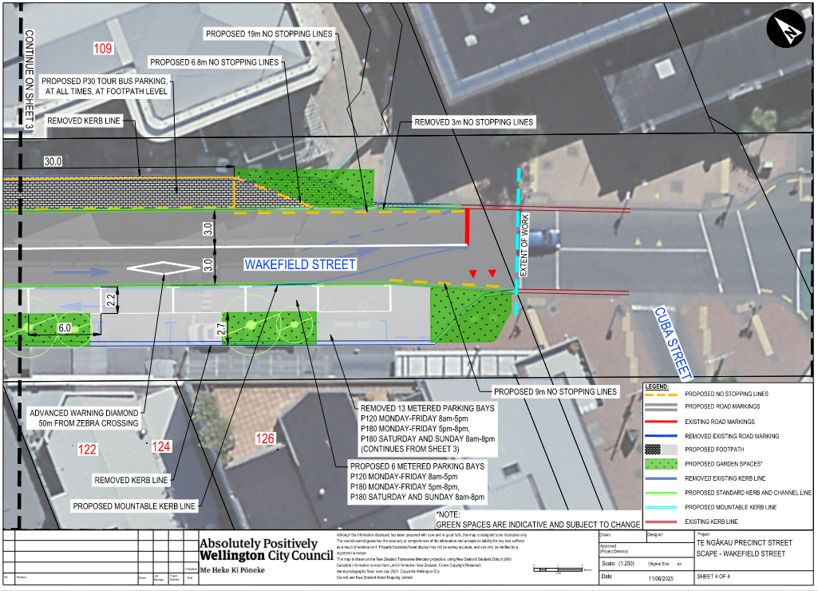
Legal Description:

Delete from Schedule B (Class Restricted) of the Traffic Restrictions Schedule

Column One | Column Two | Column Three
Wakefield Street | Motorcycle Parking At All Times | South side, commencing 108 metres north-west of its intersection with Cuba Street, and extending in a north-westerly direction following the southern kerbline for 6.5 metres.
Wakefield Street | Car Share Parking At All Times | South side, commencing 19 metres north-west of its intersection with Cuba Street (Grid Coordinates X= 1748838.4185 m, 5427523.5982m) and extending in a north-westerly direction following the southern kerbline for 3 metres (1 angled parking space)
Wakefield Street | Mobility At All Other Times, Displaying an Operation Mobility Permit Only | Northeast side, commencing 75.5 metres southeast of its intersection with the eastern kerbline of Victoria Street (Grid coordinates x= 1748727.3 m, y= 5427666.8 m), and extending in a southeasterly direction following the kerbline for 16 metres. (2 parallel parking spaces)
Wakefield Street | Tour Bus Stop At All Times | Northeast side, commencing 91.5 metres southeast of its intersection with the easterly kerbline of Victoria Street (Grid coordinates x= 1748727.3 m, y= 5427666.8 m), and extending in a southeasterly direction following the kerbline for 27 metres.

Delete from Schedule D (No Stopping) of the Traffic Restrictions Schedule

Column One | Column Two | Column Three
Wakefield Street | No Stopping At All Times | Southern side, commencing 14 metres north-west of its intersection with Cuba Street (Grid Coordinates X= 1748838.4185 m, 5427523.5982m)and extending in a north-westerly direction for 7 metres
Wakefield Street | No Stopping At All Times | South side, commencing 114.5 metres north-west of its intersection with Cuba Street, and extending in a north-westerly direction following the southern kerbline for 6.5 metres.
Wakefield Street | No Stopping At All Times | Northeast side, commencing 15.2.5 metres southeast of its intersection with the eastern kerbline of Victoria Street (Grid Coordinates X=2658749.133907 m, Y=5989378.874912 m) and extending in a south-easterly direction following the kerbline for 6.5 metres.
Wakefield Street | No Stopping At All Times | Northeast side, commencing 150.5 metres southeast of its intersection with the eastern kerbline of Victoria Street and extending in a south-easterly direction following the kerbline for 14.5 metres.
Wakefield Street | No Stopping At All Times | Northeast side, commencing 67 metres southeast of its intersection with the eastern kerbline of Victoria Street (Grid Coordinates X=2658749.133907 m, Y=5989378.874912 m) and extending in a south-easterly direction following the kerbline for 8.5 metres.

Delete from Schedule F (Metered Parking) of the Traffic Restrictions Schedule

Column One | Column Two | Column Three
Wakefield Street | Metered Parking,  P120 Monday – Friday 8am – 5pm, P180 Monday – Friday 5pm – 8pm, P180 Saturday to Sunday 8am – 8pm | South side, commencing 22 metres north-west of its intersection with Cuba Street (Grid Coordinates X= 1748838.4185 m, 5427523.5982m) and extending in a north- westerly direction following the southern kerbline for 54 metres (14 parking spaces)
Wakefield Street | Metered Parking,  P120 Monday – Friday 8am – 5pm, P180 Monday – Friday 5pm – 8pm, P180 Saturday to Sunday 8am – 8pm | South side, commencing 79.5 metres north-west of its intersection with Cuba Street, and extending in a north-westerly direction following the southern kerbline for 28.5 metres (4 angle and 2 parallel parking spaces).
Wakefield Street | P30 Maximum, Monday to Thursday 8:00am - 6:00pm, Friday 8:00am - 8:00pm, Saturday and Sunday 8:00am - 6:00pm | Northeast side, commencing 118.5 metres southeast of its intersection with the eastern kerbline of Victoria Street (Grid coordinates x= 1748727.3 m, y= 5427666.8 m), and extending in a southeasterly direction following the kerbline for 34 metres. (6 parallel parking spaces)

Delete from Schedule H (Pedestrian Crossing) of the Traffic Restrictions Schedule

Column One | Column Two | Column Three
Wakefield Street | Pedestrian Zebra Crossing | Northeast side, 66 metres southeast of its intersection with the eastern kerbline of Victoria Street (Grid Coordinates X=2658749.133907 m, Y=5989378.874912 m).
Wakefield Street | Pedestrian Zebra Crossing | South side, commencing 121 metres north-west of its intersection with Cuba Street, and extending in a north-westerly direction occupying the southern kerbline for 3.5 metres.

Add to Schedule A (Time Limited Parking) of the Traffic Restrictions Schedule

Column One | Column Two | Column Three
Wakefield Street | P10 Pick up/Drop-off | Southern side, commencing 101.1 metres north-west of its intersection with Cuba Street (Grid coordinates X=1,748,839.80m Y=5,427,527m) and extending in a north-westerly direction for 12 metres (2 car parks)

Add to Schedule B (Class Restricted) of the Traffic Restrictions Schedule

Column One | Column Two | Column Three
Wakefield Street | P10 Loading Bay  For Goods and Authorised vehicles only  Monday-Sunday 8am-6pm | Southern side, commencing 55.4 metres north-west of its intersection with Cuba Street (Grid coordinates X=1,748,839.80m Y=5,427,527m) and extending in a north-westerly direction for 12 metres
Wakefield Street | Metered Mobility Parking  P120 Monday-Friday 8am-5pm,  P180 Monday-Friday 5pm-8pm,  P180 Saturday and Sunday 8am-8pm | Southern side, commencing 67.5 metres north-west of its intersection with Cuba Street (Grid coordinates X=1,748,839.80m Y=5,427,527m) and extending in a north-westerly direction for 17.6 metres (2 car parks)
Wakefield Street | Motorcycle Parking, At All Times, Metered  Monday-Friday 8am-8pm | Southern side, commencing 131.2 metres north-west of its intersection with Cuba Street (Grid coordinates X=1,748,839.80m Y=5,427,527m) and extending in a north-westerly direction for 6 metres
Wakefield Street | P30 Tour Bus Parking, At All Times | Northern side, commencing 107.2 metres south-east of its intersection with Victoria Street (Grid coordinates X= 1,748,730.05, Y=5,427,670.57m) and extending in a south-easterly direction for 30 metres (2 parking spaces)

Add to Schedule D (No Stopping) of the Traffic Restrictions Schedule

Column One | Column Two | Column Three
Wakefield Street | No Stopping At All Times | Northern side, adjacent to gardens, commencing 96.5 metres south-east of its intersection with Victoria Street (Grid coordinates X= 1,748,730.05, Y=5,427,670.57m) and extending in a south-easterly direction for 11 metres
Wakefield Street | No Stopping At All Times | Northern side, adjacent to gardens, commencing 137.2 metres south-east of its intersection with Victoria Street (Grid coordinates X= 1,748,730.05, Y=5,427,670.57m) and extending in a south-easterly direction for 6.8 metres
Wakefield Street | No Stopping At All Times | Southern side, commencing 10.3 metres north-west of its intersection with Cuba Street (Grid coordinates X=1,748,839.80m Y=5,427,527m) and extending in a north-westerly direction for 9 metres
Wakefield Street | No Stopping At All Times | Southern side, commencing 85.1 metres north-west of its intersection with Cuba Street (Grid coordinates X=1,748,839.80m Y=5,427,527m) and extending in a north-westerly direction for 4 metres
Wakefield Street | No Stopping At All Times | Southern side, commencing 97.1 metres north-west of its intersection with Cuba Street (Grid coordinates X=1,748,839.80m Y=5,427,527m) and extending in a north-westerly direction for 4 metres
Wakefield Street | No Stopping At All Times | Northern side, commencing 35.4 metres south-east of its intersection with Victoria Street (Grid coordinates X= 1,748,730.05, Y=5,427,670.57m) and extending in a south-easterly direction for 37 metres
Wakefield Street | No Stopping At All Times | Northern side, commencing 80.3 metres south-east of its intersection with Victoria Street (Grid coordinates X= 1,748,730.05, Y=5,427,670.57m) and extending in a south-easterly direction for 27 metres
Wakefield Street | No Stopping At All Times | Northern side, commencing 137.2 metres south-east of its intersection with Victoria Street (Grid coordinates X= 1,748,730.05, Y=5,427,670.57m) and extending in a south-easterly direction for 19 metres

Add to Schedule F (Metered Parking) of the Traffic Restrictions Schedule

Column One | Column Two | Column Three
Wakefield Street | Metered Parking, P120 Monday-Friday 8am-5pm,  P180 Monday-Friday 5pm-8pm,  P180 Saturday and Sunday 8am-8pm | Southern side, commencing 19.3 metres north-west of its intersection with Cuba Street (Grid coordinates X=1,748,839.80m Y=5,427,527m) and extending in a north-westerly direction for 36 metres (6 car parks)
Wakefield Street | Metered Parking, P120 Monday-Friday 8am-5pm,  P180 Monday-Friday 5pm-8pm,  P180 Saturday and Sunday 8am-8pm | Southern side, commencing 113.1 metres north-west of its intersection with Cuba Street (Grid coordinates X=1,748,839.80m Y=5,427,527m) and extending in a north-westerly direction for 18 metres (3 car parks)

Add to Schedule H (Pedestrian Crossing) of the Traffic Restrictions Schedule

Column One | Column Two | Column Three
Wakefield Street | Raised Pedestrian Zebra Crossing | Outside 110 Wakefield Street, 74.3 metres south-east of its intersection with Victoria Street (Grid coordinates X=1,748,727.36m Y=5,427,649.7m) and is 4 metres wide

Prepared By: | Farzad Zamani | Program Manager
Approved By: | Kate Gourdie | (Team Leader Traffic & Resolutions)
Approved Date: | 2/07/2025

