

Glenside Reserve

Statement of Proposal

September 2026
Contents
1. About this consultation 3
2. Why are we consulting 3
3. Key dates 3
4. Timeframes 3
5. What will happen with my feedback? 3
6. How to have your say 4
7. Definitions 4
8. Background 5
9. The Proposal 5
10. About Glenside Reserve 5
11. What has prompted the review 6
12. Your views 6

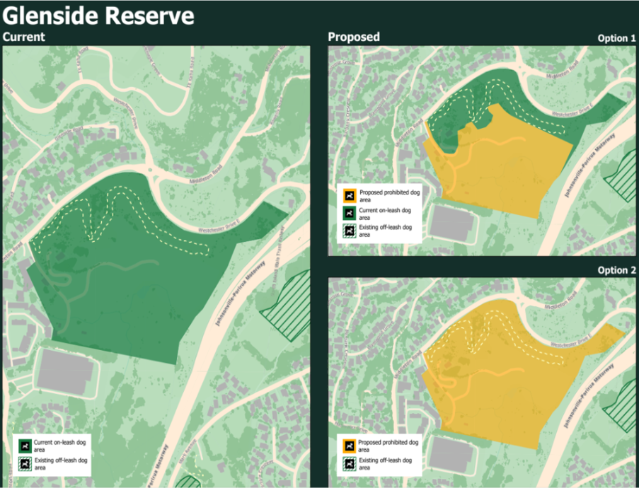

About this consultation
Wellington City Council is seeking public feedback on proposed dog access rules at Glenside Reserve. Your feedback will help elected members decide whether the current dog access rules should change.

Why are we consulting
The Wellington Dog Policy and Animal Bylaw (2024) specifies where dogs are:
- prohibited
- required to be on-leash
- allowed to exercise off leash.
This consultation will help the Council understand community views before making a decision. Feedback will help elected members consider how best to balance the needs of dog owners, recreational use, and the protection of wildlife and natural habitats.

Key dates
Key dates for this consultation are outlined below. Dates could change in response to Council priorities or unforeseen circumstances.
Date | Activity
12 August 2026 | The Council approved the Statement of Proposal for public consultation.
1 September – 30 September 2026 | Public consultation period.
1 October – 16 October 2026 | Council officers will analyse all feedback.
5 November 2026 | The Council considers the feedback received and decides whether to change dog access rules at Glenside Reserve.
13 November 2026 | Any amendment is published on the Council’s website.

Timeframes
Public consultation runs from 1 September to 30 September 2026.

What will happen with my feedback?
Council officers will review all feedback and present it to elected members for consideration. Once a decision has been made, any changes to Glenside Reserve’s designations will be published on the Council’s website, together with a summary of submissions and how community feedback informed the decision. You will be able to view this information here: wcc.nz/glenside-reserve.

How to have your say
Please provide your feedback by 5 pm on 30 September 2026.
You can:
- Complete the online survey at wcc.nz/glenside-reserve.
- Download a submission form from wcc.nz/glenside-reserve and email it as a PDF to policy.submissions@wcc.govt.nz.
- Via email at policy.submissions@wcc.govt.nz.
If you have any questions or want more information about the submission process, please email: policy.submissions@wcc.govt.nz

Definitions
The Dog Policy and Animal Bylaw define dog access areas as follows:
Beach exercise area: These are specific beach locations where dogs can exercise and socialise off-leash under the control of their owner at all times.
Exercise area: Dogs are permitted to exercise and socialise off-leash under the control of their owner in these areas at all times.
Exercise area (specified time): Dogs are permitted to exercise and socialise off-leash at specified times of day and dependent on the season.
Prohibited area: Dogs are not allowed in these areas at any time. This rule applies whether the dog is under control or not.
Prohibited area (specified time): Where dogs are prohibited during the times specified.
Public places: Under section 2 of the Dog Control Act 1996, a public place means a place that is open to, or being used by, the public. This includes roads, parks, recreation grounds, sports fields, reserves, beaches, the Wellington Town Belt, the Waterfront, pools, pedestrian malls, public open spaces, and community facilities.
The Wellington Animal Bylaw: Animal Bylaw 2024 - Plans, policies and bylaws - Wellington City Council.

Background
The Council adopted the Wellington Dog Policy and Animal Bylaw in 2024. Together, these documents provide guidance for dog owners using public spaces and identify where dogs are prohibited, must be on-leash, or may be exercised off-leash, either at all times or during specified periods. The Policy and Bylaw seek to balance the needs of dog owners with those of other public space users, while protecting local wildlife and the natural environment.
Under the Animal Bylaw 2024, dog owners and anyone responsible for a dog must keep it under control at all times in public places. Current rules include:
11.4.1. Dog owners or the person in charge of a dog must keep their dog under control at all times in any public place.
11.4.2. Dogs must be on-leash at all times unless in a designated exercise area, exercise area (within the specified times) or Beach exercise area.

The proposal
This proposal seeks public feedback on dog access at Glenside Reserve. It responds to changes in land use, evolving community interest, and the need to strengthen protection for sensitive wildlife habitats. The options below are provided for public feedback.

About Glenside Reserve
Glenside Reserve (the Reserve) is a public reserve administered under the Reserves Act 1977 and comprises two reserve classifications. The area containing the historic Halfway House is classified as a Historic Reserve and is zoned Open Space under the Wellington City Council District Plan. The remainder of the Reserve is classified as a Recreation Reserve and is zoned Natural Open Space.
The Reserve is a site of significance and holds cultural, historical and ecological values. The Halfway House is listed as a heritage building, while the stream that flows through the southern part of the Reserve is identified as a Site and Area of Significance to Māori (Wāhi Tūpuna, Mahinga Kai - Ngāti Toa Rangatira). The stream is also recognised as a stream corridor on the Council's flood hazard maps.
Located between Tawa, Churton Park, and Grenada, Glenside Reserve covers approximately 13 hectares and provides recreational and open space opportunities for the Glenside community and surrounding neighbourhoods.

What has prompted the review
Dogs are currently allowed on the Reserve but must be kept on-leash. Following the end of the horse grazing lease, the Council has received requests to review dog access on the Reserve and consider whether it should be designated as a dog prohibited area.
The potential to enhance birdlife at the Reserve and develop a sanctuary like environment over time has been raised as a long-term aspiration. Community observations indicate that ground-nesting bird species are present, and that some species nest and breed within the Reserve. Off-leash dogs can pose a risk to nesting and breeding success. For this reason, decisions about dog access should consider the Reserve’s ecological values and the long-term community aspiration to support greater birdlife.
There is community support for a future management approach that enhances recreational opportunities while preserving the Reserve’s historic values and rural character.

Your views
Glenside Reserve is a public space for the use and enjoyment of the community. The Council encourages everyone, whether or not they own a dog to provide feedback.
Your feedback on the options below will help elected members consider different community views including interest of dog owners, wildlife protection, recreation, and the equitable use of public resources.
Options for consideration.
Option 1: Dogs are allowed on-leash on existing walking tracks but are prohibited on the rest of the Reserve.
Option 2: Dogs are prohibited from the Reserve at all times.
Option 3 (current rule): Dogs must be kept on-leash at all times, supported by increased signage and education on the Reserve.

