Kia ora,

We would like to inform you about a proposed change in your neighbourhood.

Proposal:

Reference | - TR56-26 Ohiro Road, Brooklyn - No Stopping At All Times
Location – where we propose to make the change | Ohiro Road – on either side of its intersection with Borlase Street, from 313 Ohiro Road to opposite 320 Ohiro Road.
What we’d like to do | - Remove approximately three unrestricted parking spaces north of its intersection with Borlase Street and replace with 16m of No Stopping At All Times (broken yellow) lines.  - Remove approximately two unrestricted parking spaces south of its intersection with Borlase Street and replace with 12m of No Stopping At All Times (broken yellow) lines.
Why we are proposing the change | - Council have received safety concerns from residents about the visibility at the intersection of Ohiro Road and Borlase Street when exiting, due to the vehicles parked on Ohiro Road.  - Officers have investigated the site and have found that sight distance at this intersection is less than half the acceptable length because of parked vehicles.  - This situation has arisen from the road layout changes in the Ohiro Road South improvements project, which addressed the safety issue of vehicles parking on the footpath. This sight distance issue was identified in the post-construction Safe System Audit for the Ohiro Road South improvements project and was added to the Transport Engineering team’s monitoring list.  - To improve visibility and safety, we are proposing to install No Stopping At All Times (broken yellow lines) along the road between property nos. 313 Ohiro Road and opposite 320 Ohiro Road, as per the attached plans.  - The proposed length of broken yellow lines is the minimum length that we can install to increase sight distance to the Austroads and NZTA recommended length.  - This proposed change will remove approximately five on street parking spaces on the eastern side of Ohiro Road. Currently there are approximately 26 parking spaces from Butt Street to 325 Ohiro Road.
Impact | Improvements  - Improves safety and accessibility for vehicles exiting Borlase Street, and for road users on Ohiro Road  - Improves safer turning movements  - Improves driver visibility  Net Parking Impact  - Removal of five unrestricted parking spaces  Pedestrian impact  - No Change
Other options considered | Option 1:  - Reduce scope of No Stopping At All Times lines to remove less parking. This option is not preferred as it will mean that the visibility at this intersection is less than the recommended length in NZTA and Austroad standards.  Option 2:  - Increase the length of the No Stopping At All Times lines to increase the visibility at the intersection. This option is not recommended as it would remove more parking spaces than necessary.
How this relates to the parking policy | - Support safe movement – facilitate the safe and efficient movement of people and goods by focusing on people moving along transport corridors rather than people parking or storing stationary vehicles.
Additional Information | - Average daily traffic count – Ohiro Road – 7,790 vehicles  - Annual parking revenue impact – none  - An electronic copy of the report will be available on the Council’s website from 9.00am 10 June 2026 at https://www.letstalk.wellington.govt.nz/
Privacy | - Your privacy is important to us. Please DO NOT add specific personal details to your feedback (i.e.: full name, address, etc)  - What we do with your personal information:  All submissions (including your first name, but not contact details) are provided in their entirety to elected members and made available to the public on our website and at our office. Personal information (including contact details) will also be used for the administration of the consultation process including informing you of the outcome of the consultation. All information collected will be held by Wellington City Council, with submitters having the right to access and correct personal information.  - For more information regarding our Privacy Statement please check our webpage: Privacy statement - Wellington City Council.
Feedback | - If you would like to provide us with specific feedback, which will be added to the Traffic Resolution following consultation and made public in full, you can do so by filling out an online submission form, downloading a printable submission form on https://www.letstalk.wellington.govt.nz/ or emailing us at trfeedback@wcc.govt.nz.  Please note if you are giving feedback the consultation period opens at 9.00 am 10 June 2026 and finishes at 5.00 pm 24 June 2026.
Next Steps | - Feedback collated by 25 June 2026.  - The proposal will go to the Te Takere|Regulatory Processes Committee meeting on 5 August 2026.  - If approved, the proposal will be installed within the following six months.

Traffic Resolution Plan: TR56-26 Ohiro Road, Brooklyn - No Stopping At All Times

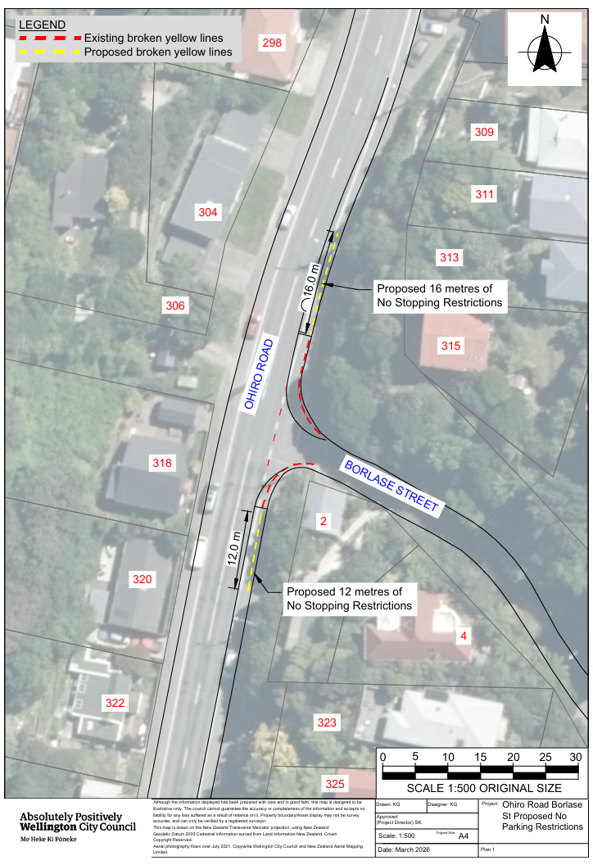

Legal Description:

Remove from Schedule D (No Stopping) of the Traffic Restrictions Schedule

Column One | Column Two | Column Three
Ohiro Road | No Stopping At All Times | East side, commencing north  of its intersection with Borlase Street  (Grid coordinates X= 1747496355.154m  Y= 5425144591.942m) and extending in a  northernly direction following the eastern  kerb line for 20 metres.
Ohiro Road | No Stopping At All Times | East side, commencing south  of its intersection with Borlase Street  (Grid coordinates X= 1747492091.573m  Y= 5425139487.197m) and extending in a  Southerly direction following the eastern  kerb line for 14 metres.

Add to Schedule D (No stopping) of the Traffic Restrictions Schedule

Column One | Column Two | Column Three
Ohiro Road | No Stopping At All Times | East side, commencing north  of its intersection with Borlase Street  (Grid coordinates X= 1747496355.154m  Y= 5425144591.942m) and extending in a  northernly direction following the eastern  kerb line for 33 metres.
Ohiro Road | No Stopping At All Times | East side, commencing south  of its intersection with Borlase Street  (Grid coordinates X= 1747492091.573m  Y= 5425139487.197m) and extending in a  Southerly direction following the eastern  kerb line for 21 metres.

Prepared By: | Kaylie Gleeson | (Intermediate Transport Engineer)
Approved By: | Kate Gourdie | (Team Leader Traffic & Resolutions)
Approved Date: | 19/05/2026

